**File Transfer Between Partners**

First we need to create the "**Communities**" or we can use the existed Communities.

**Create Communities** :

You must create an Advanced File Transfer community to organize the protocols and options that are available to member Advanced File Transfer partners.

Click on the "Communities" in the Participants tab.

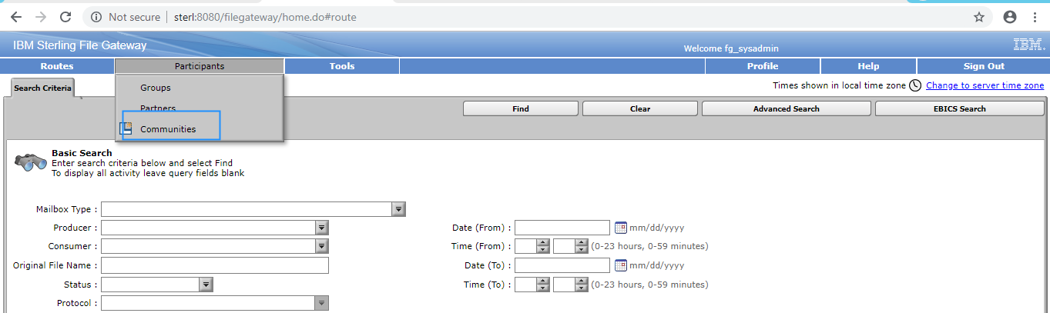

after click on the "Communities" the following window will open and If you want to create new Community click on the "add " button or If you can use existed Communities as shown below.

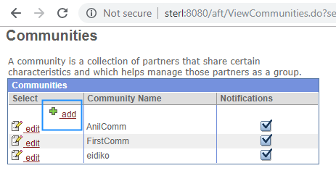

After click on the "add" the below window will open and give the "Community" name as below and click on "Next" button.

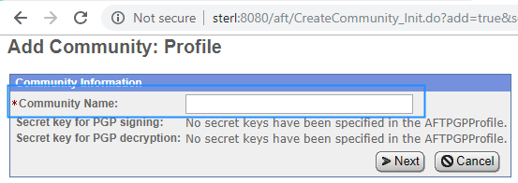

After we need to select either of the following options then click on next button.

"Partner Initiates Protocol Connections to Mailbox" -- Select to make this option available when creating AFT partners belonging to this AFT community. A unique mailbox is created for AFT partners that initiate connections. Depending on other selections, sub mailboxes are created for AFT partners to enable them to drop files off for routing, or pick up files routed to them.

"Partner Listens for Protocol Connections" --Select to enable protocols available to listening AFT partners belonging to this AFT community. When selected, the following choices are available when creating AFT partners belonging to this AFT community:

1.FTP or FTPS

2.Sterling Connect:Direct®

3.SSH/SFTP

If the administrator adds other protocols to the AFTExtensionsCustomer.xml file, they are also provided as choices here.

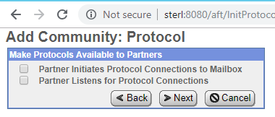

If partners wants notifications then select "Yes" or no need to receive the notifications then select "No" and click next button.

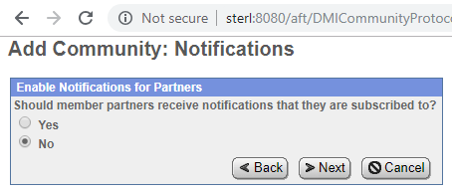

Final Summary of the community as like below and click Finish to save it.

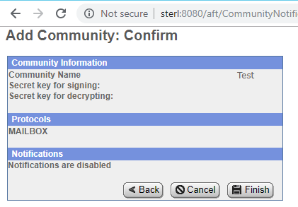

**Create Partners** :

After creating an Advanced File Transfer community, you can create an Advanced File Transfer partner and determine their role as a consumer or producer of data.

You must create an AFT community before you create an AFT partner. When you create an AFT partner, you select from a list of available AFT communities created in Sterling B2B Integrator.

After creating the "Communities " we need to create the partners as below.

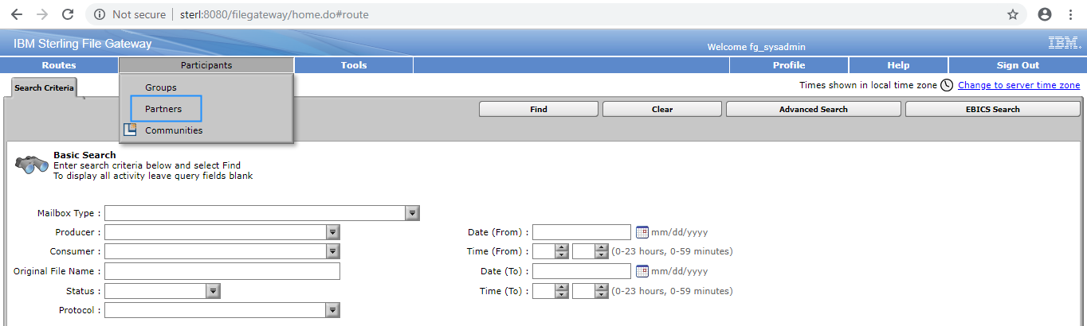

After click on the partners the following window will open and click on create button

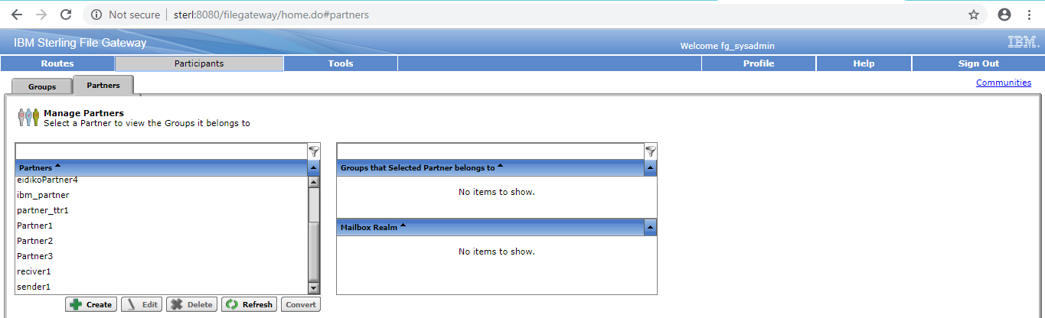

Then it will open the following window it will asks to select the "Community" and click on next button.

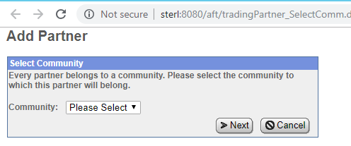

Then it will asks the Partner information as below and click on next

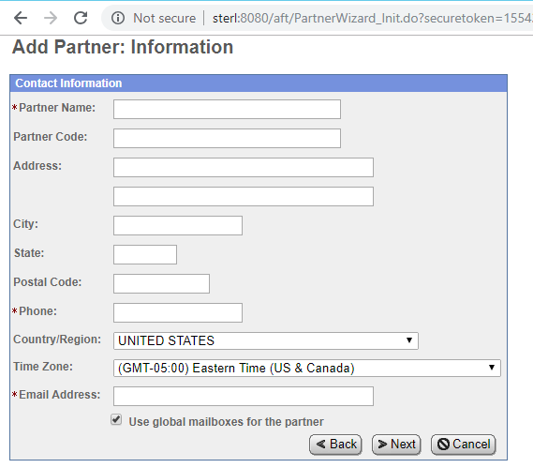

Then it will open the "User Account" window for authentication and click on next button

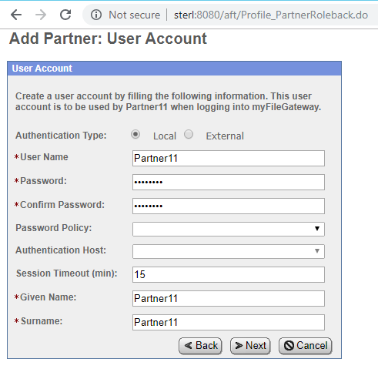

After that it will asks Partner Role as below

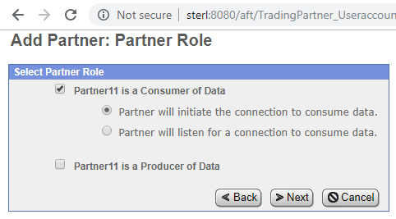

Then it will asks the Initiate Connection Settings as below. Select if you want then click next

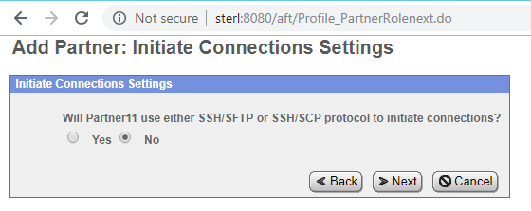

Then it will asks the PGP settings as below

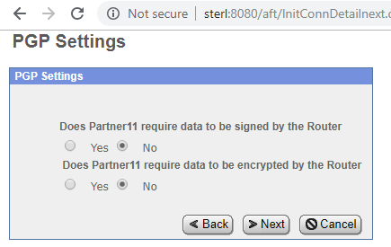

and click on next then it will open Summary of the partner and click on Finish to save the partner.

Create another partner as above who will listen for a connection to consume the data.

**Create Groups:**

After completion of creating the partners we need to add the partners to the groups.

For creating the Groups click on "Groups" in Participants tab as below

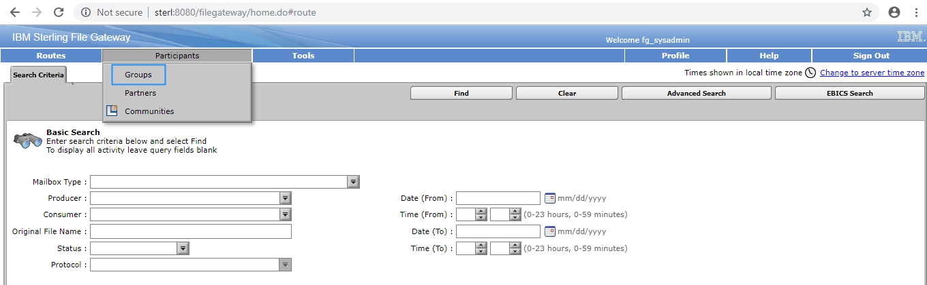

Then it will open the following window and click on the "Create" button or you can use the existed Groups.

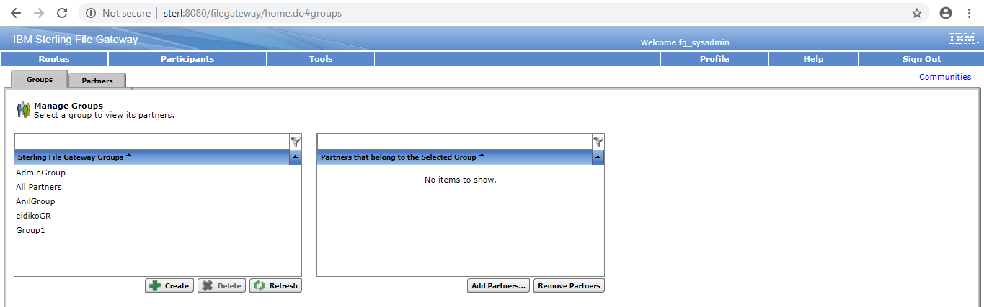

Then it will asks the Partner Group name as below

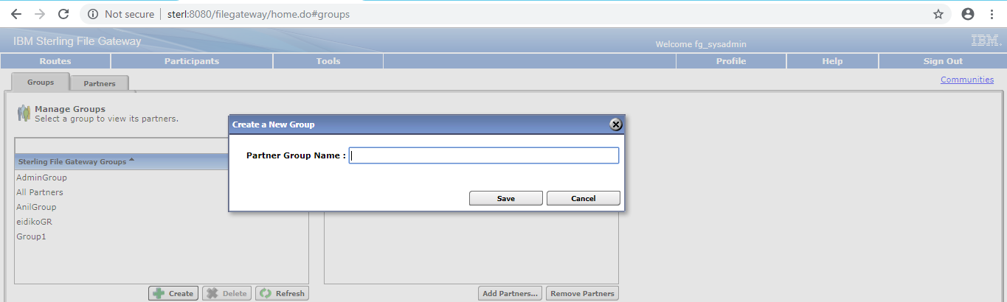

Give the name and click on Add Partners button

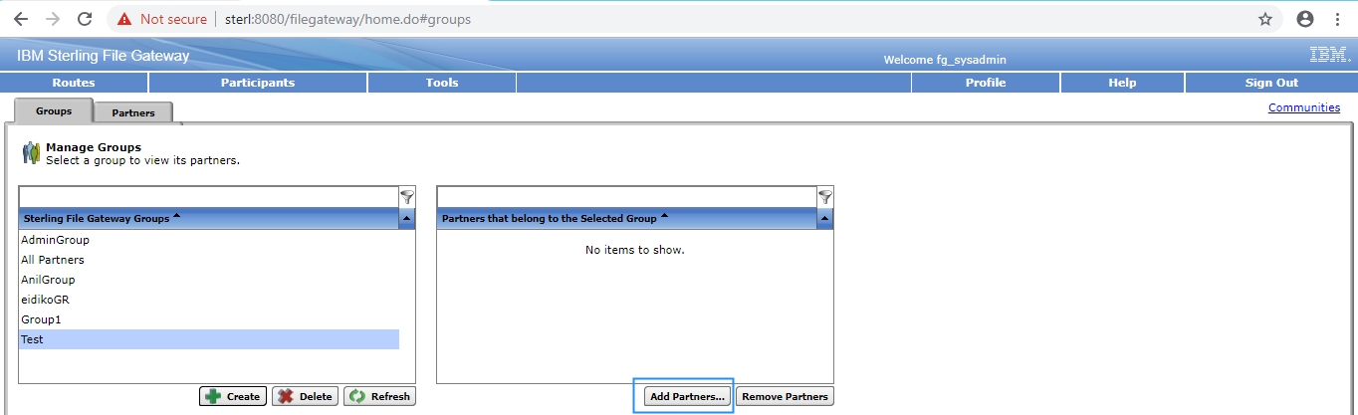

Then you need to select the group and partners and click on execute button as shown below

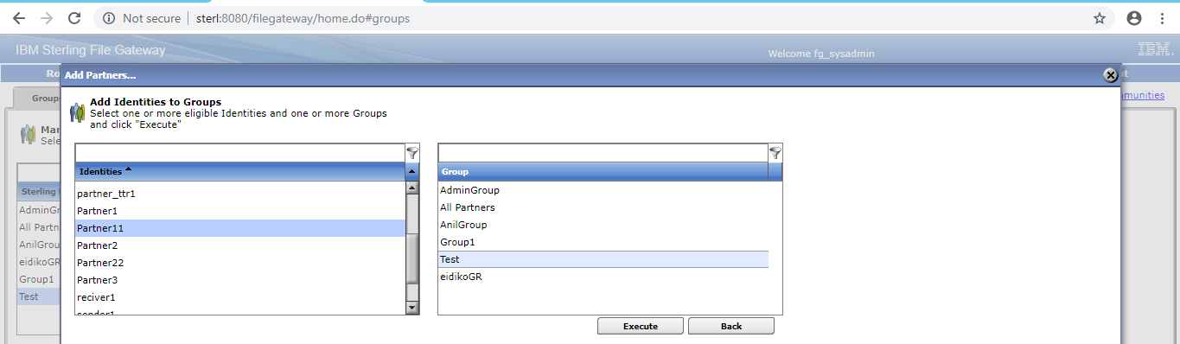

**Create Templates:**

you need to create the "Templates". For creating the Templates click on Templates in the Routes tab.

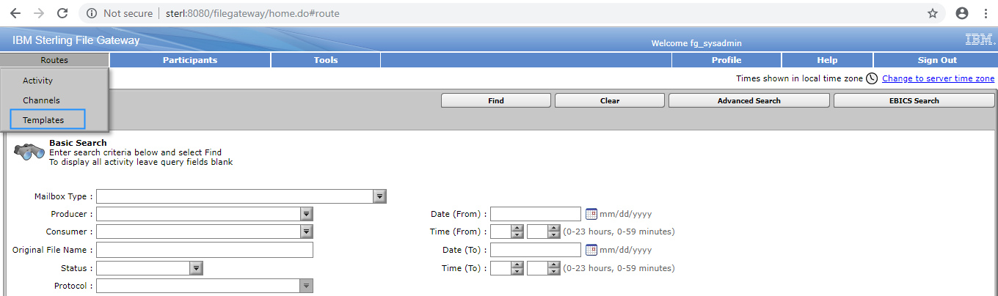

Then click on Create button for creating new Templates as below

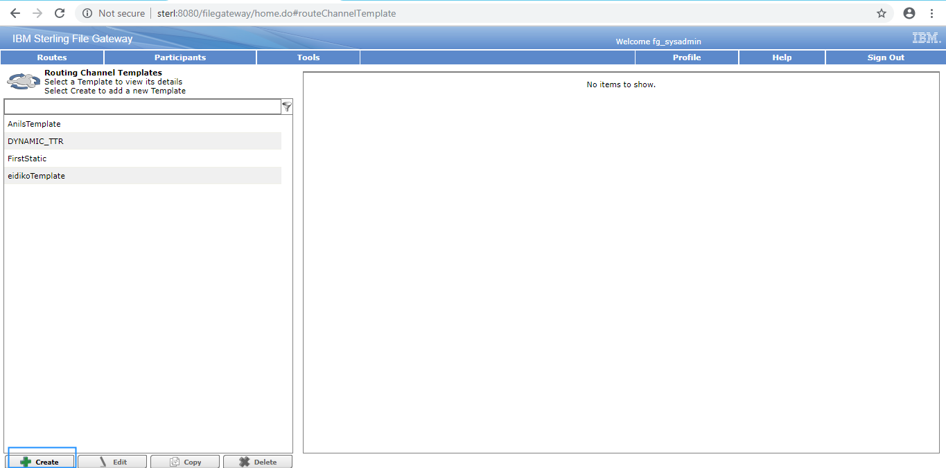

Then it will open the following window, Give the name and select the Template type and click on next

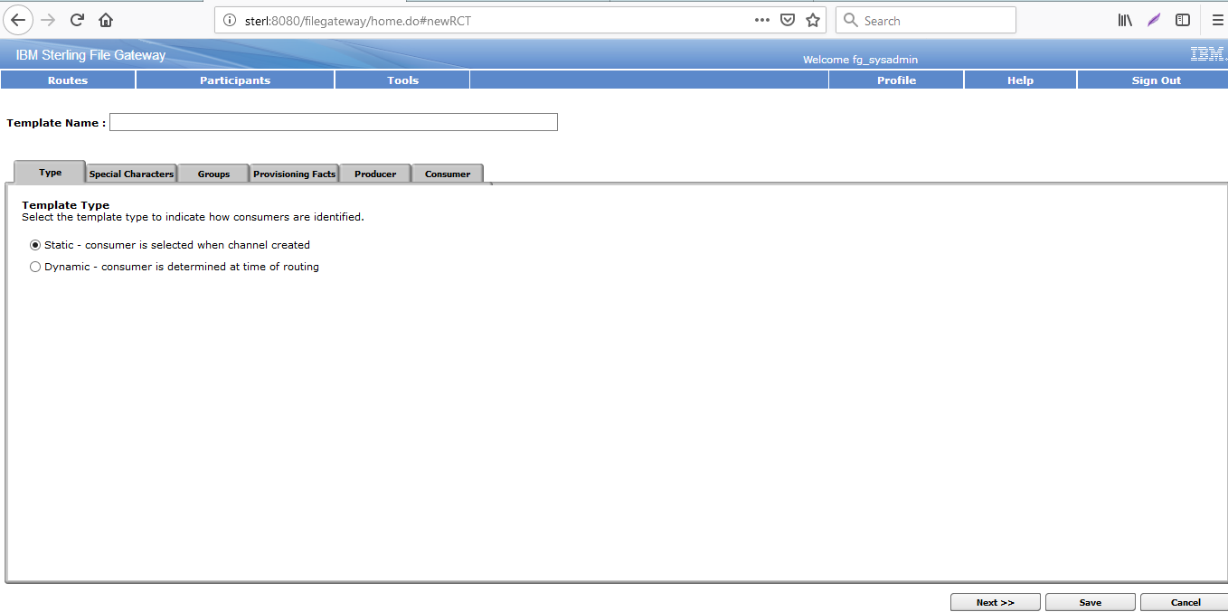

Mention the special characters in the producer file name and click on next

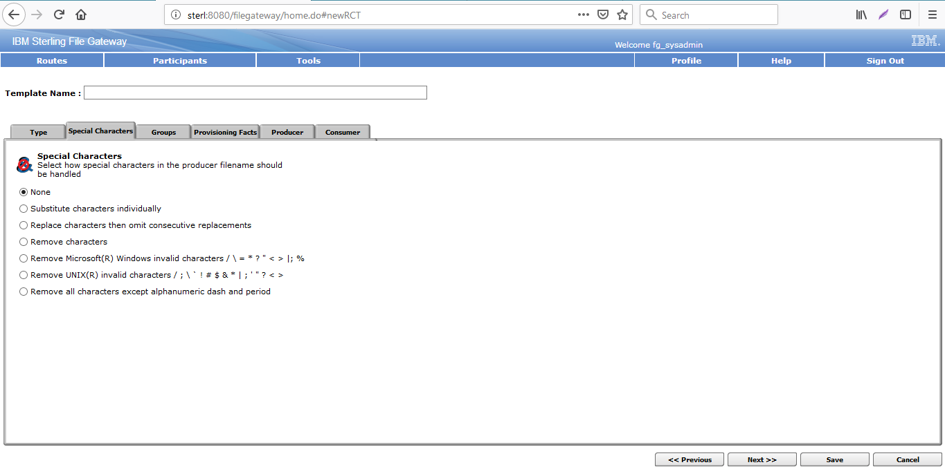

Then it will open the following window

Mention the Producer and Consumer groups which you want to use this Template and click on next

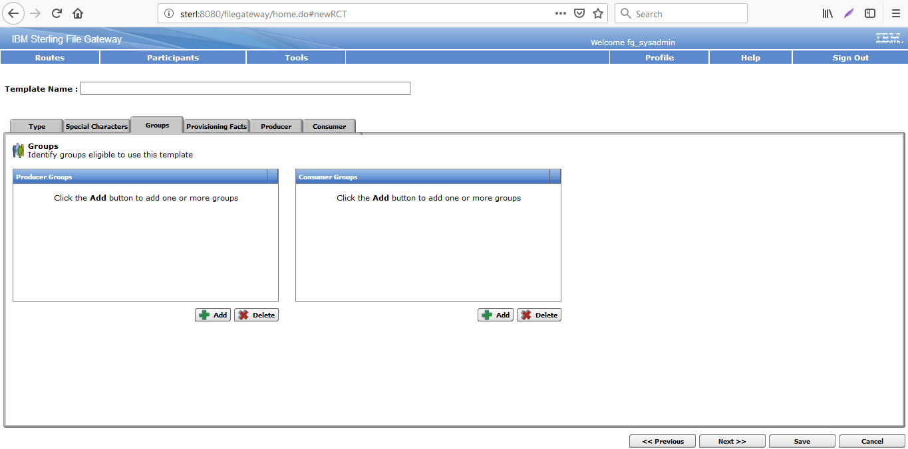

Provide the Provisioning Facts and click on next

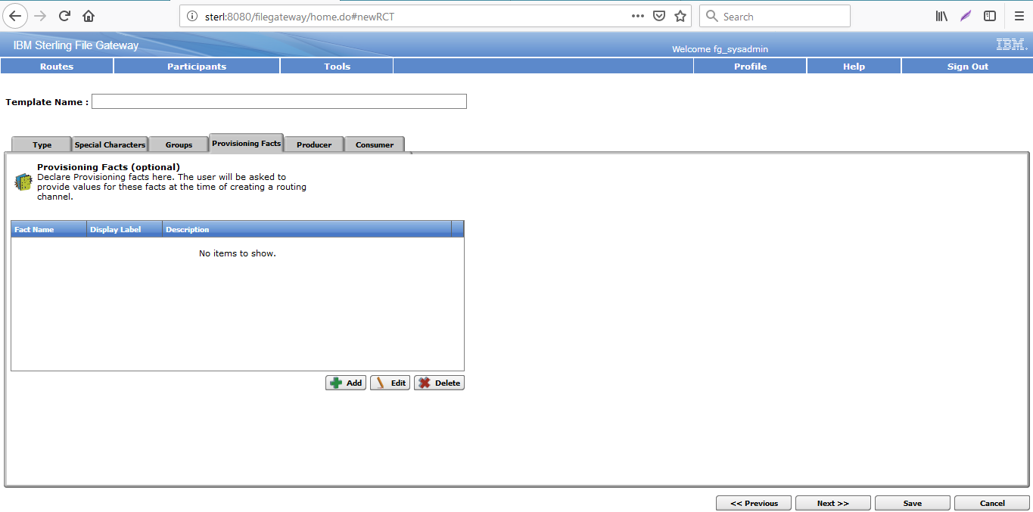

Then it will open the following window, Define the Producer mailbox pattern and click nect

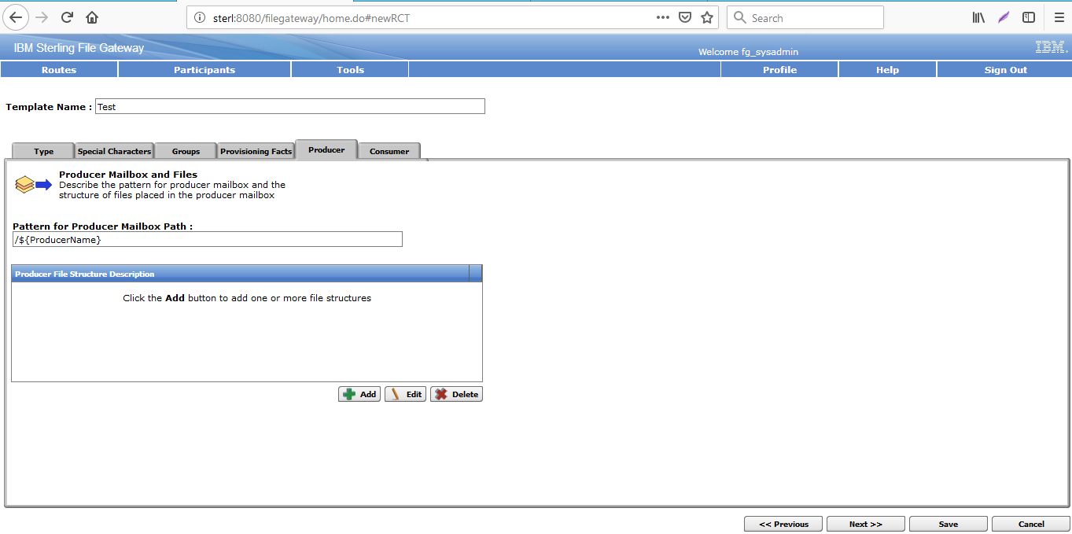

Describe the Consumer mailbox pattern and click on save for saving this Template.

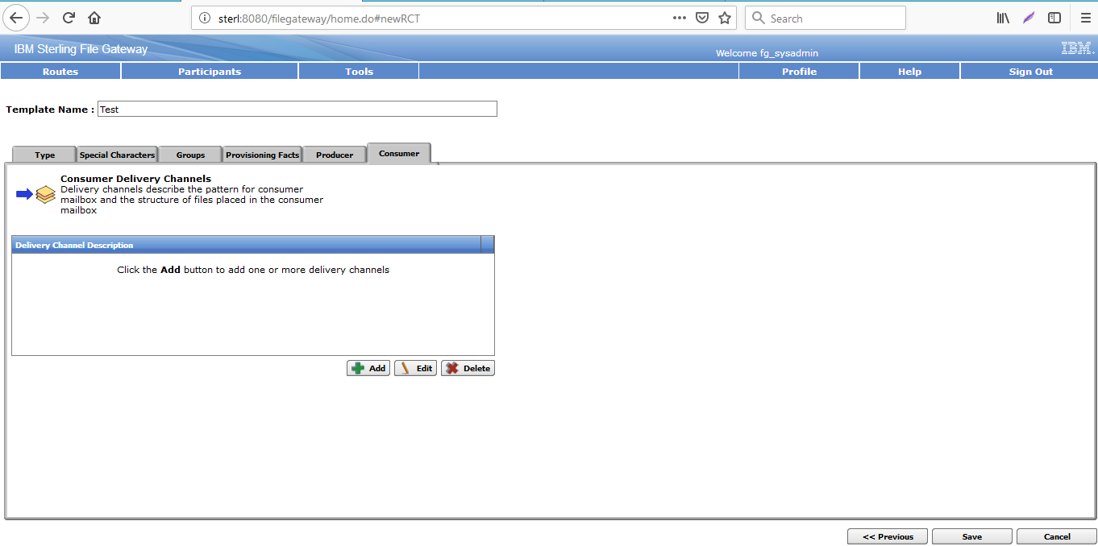

**Create Channels:**

Now we need to create the "Channel" for communication between the users

Click on the "Channels" in the Routes tab as shown below

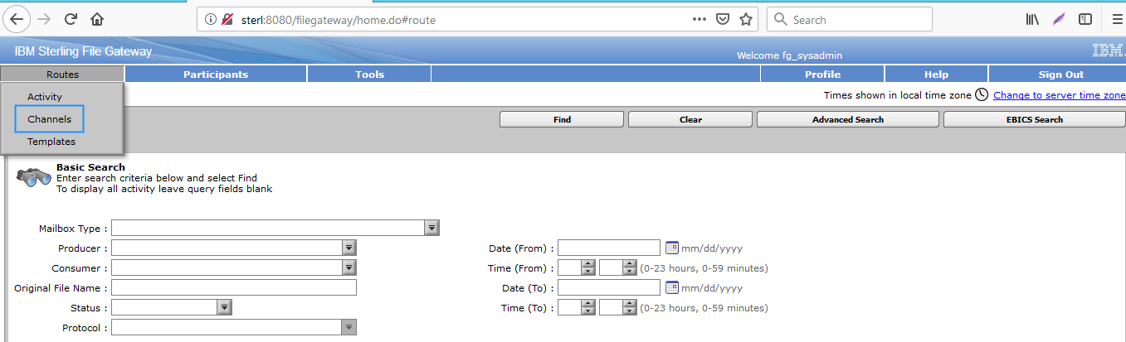

Then it will open the following window, click on create for creating the new "Channel"

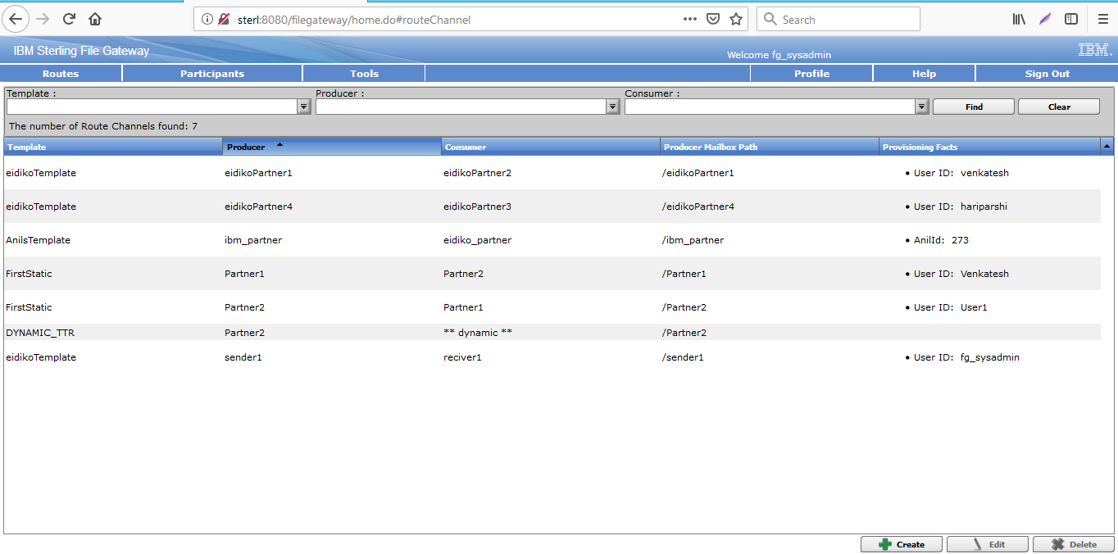

Then it will asks to select the Routing channel, Producer and consumer and click on save

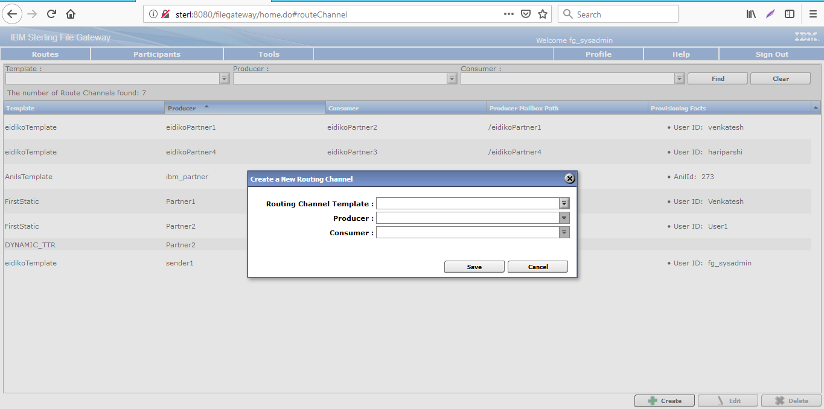

Now we need to login into the "Producer" and send the file as below.

Here we need to send the file to Consumer

Select the Mailbox path, browse the file and click on send

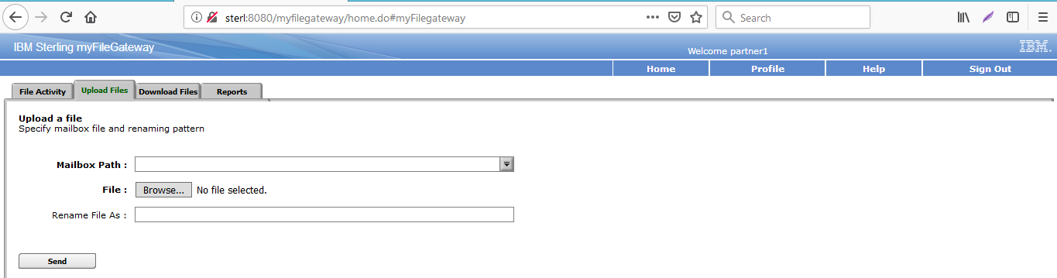

Then we need to login into Consumer and check file in Download files tab as below.

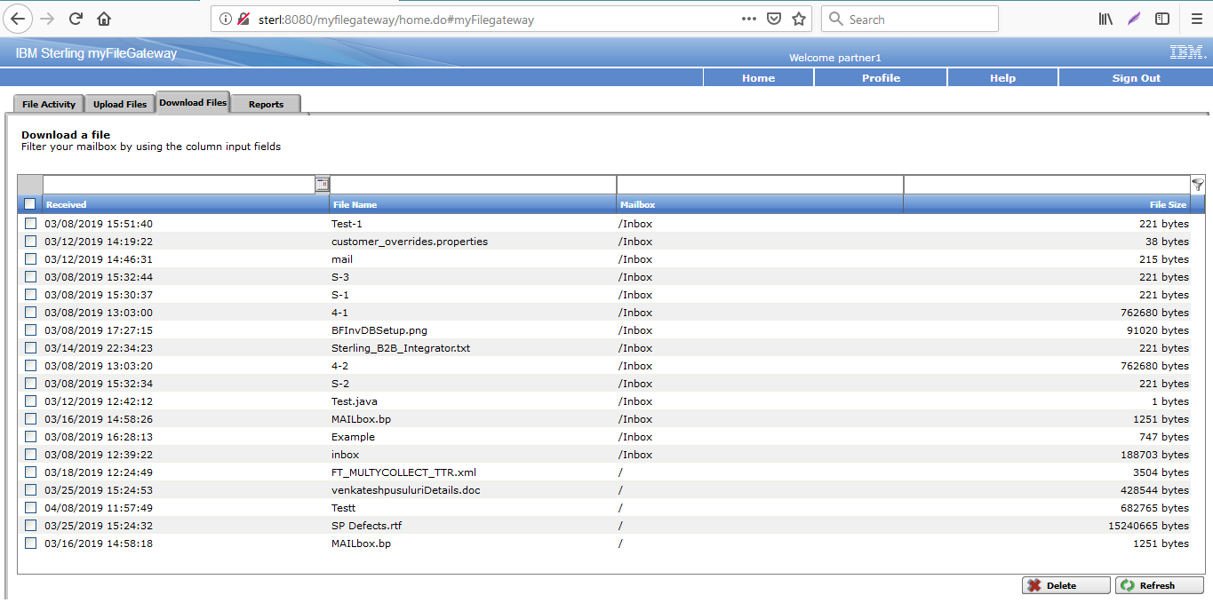

we can search the files from "File Activity" also by giving the following values as below.

