**File Transfer By Extension**

**Configuring File System Adapter Service**:

Create the "File System Adapter Service" of type "File System Adapter" under Deployment in Administration menu.

Use the File System adapter to collect (import) files from a file system into a business process and extract (export) files from a business process to a file system. You can configure the File System adapter to start a business process after files are collected from the file system or include the File System adapter in a business process flow. In addition, you can schedule the File System adapter to run at specific time intervals.

You can create multiple File System adapter configurations, one for each of several collection folders. Alternatively, you can use a single File System adapter configuration to point to different directories by specifying the directories for file collection and extraction explicitly in a business process.

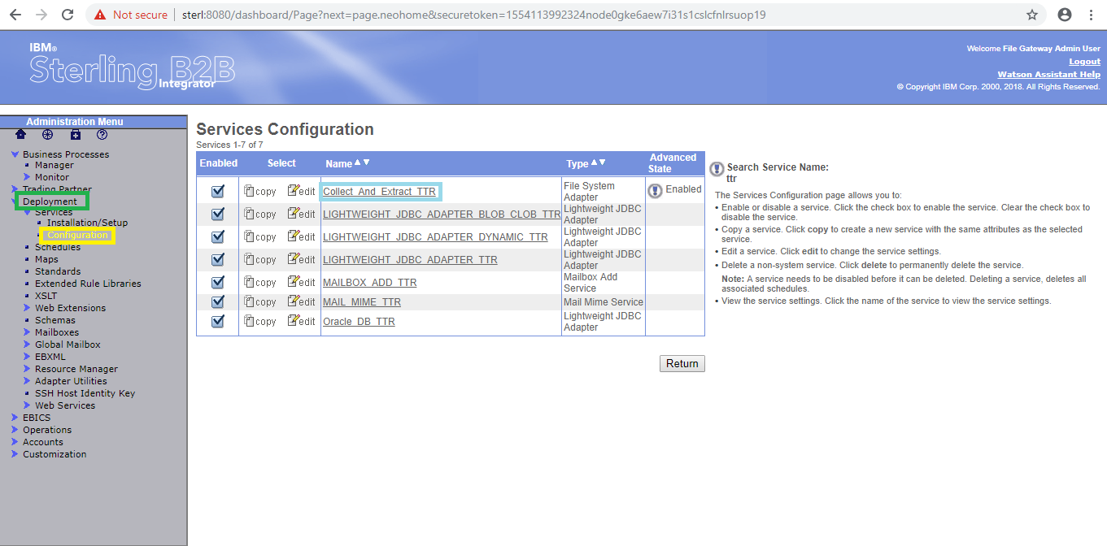

By using "edit" button we can edit the existed service and by using "copy" button we can copy the service.

Ensure that the adapter is enabled.

The following will illustrate the "File System Adapter Service" .

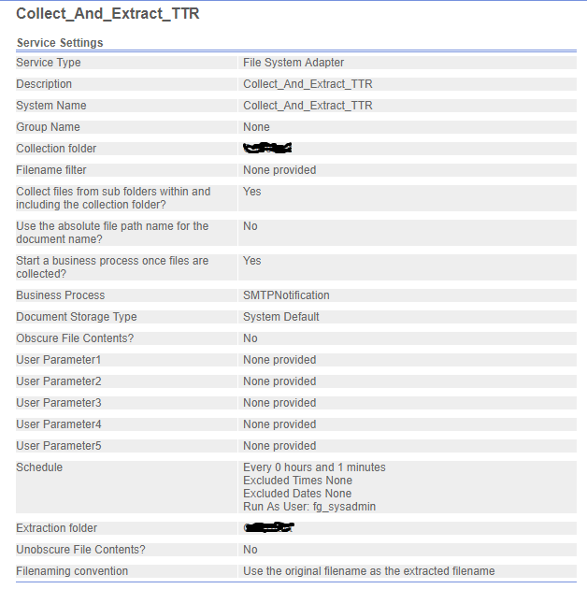

Create the Business Process under the Business Process in Administration menu

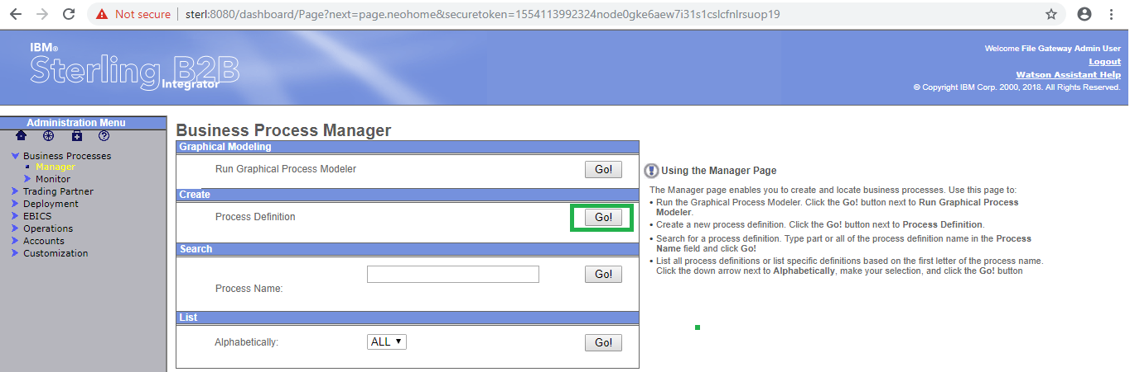

Click on "Go" button as shown above.

Select the Business Process Text Editor and click on next.

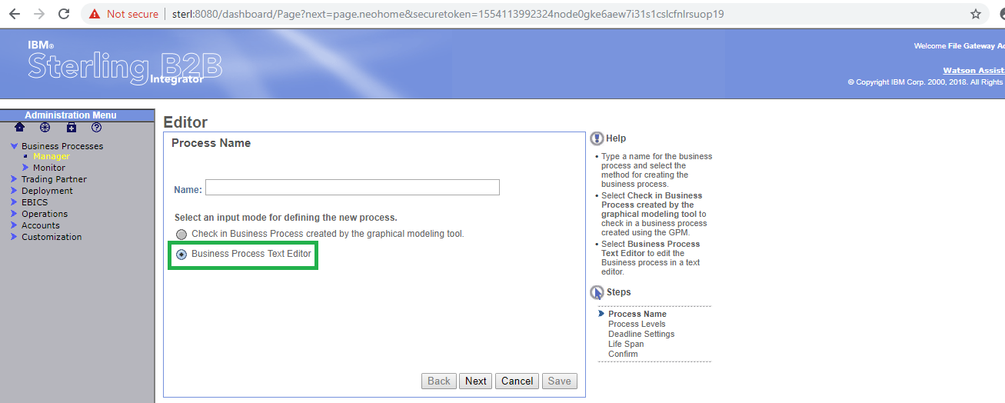

Copy the xml code in the Business Text Editor as below and click on next.

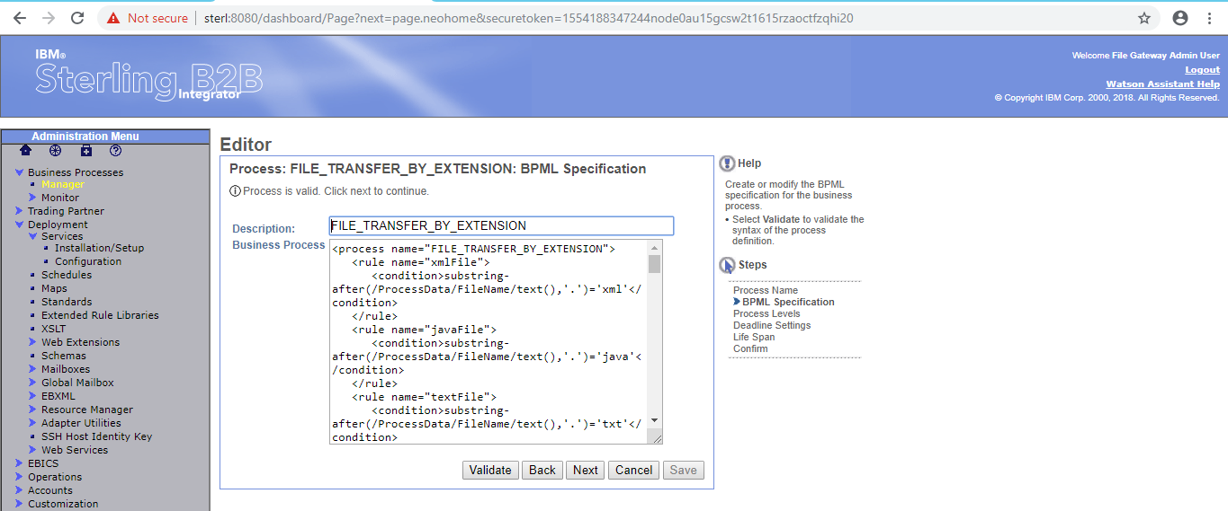

Click on "Validate" button for validating the process.

Business Process shown as below.

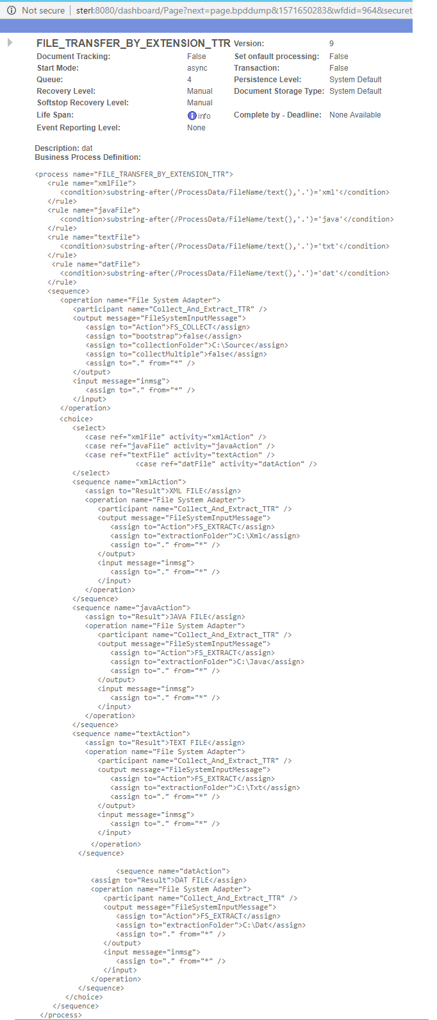

The "**rule**" element defines a rule, the conditions by which the rule is met, and dependency on other rules.

The condition element formulates an expression. The condition is met if the expression evaluates to true, or if the expression evaluates to false when the negative attribute is true.

Multiple conditions inside a rule are listed in logical order.

The "**rule**" element defines a rule that is referenced in a choice activity, used in an input element, or dependent on another rule. Dependencies are not affected by the order that rules are listed.

The contents of the "**condition**" element must correspond to an XPath expression.

Sterling B2B Integrator expects an XPath expression to evaluate a condition.

The following example describes the "**rule**" and "**condition**" activities.

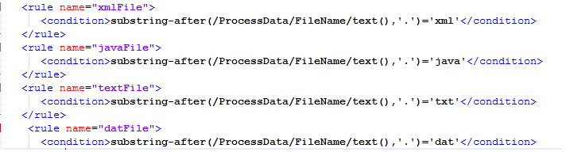

The below operation will the collect the files from the given "collectionFolder" i.e. "C:\Source" using the Action FS_COLLECT.

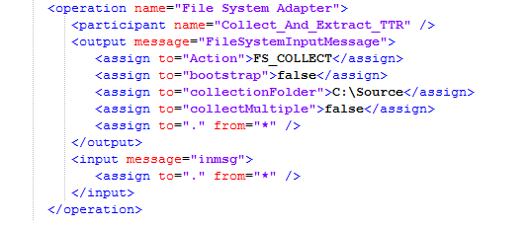

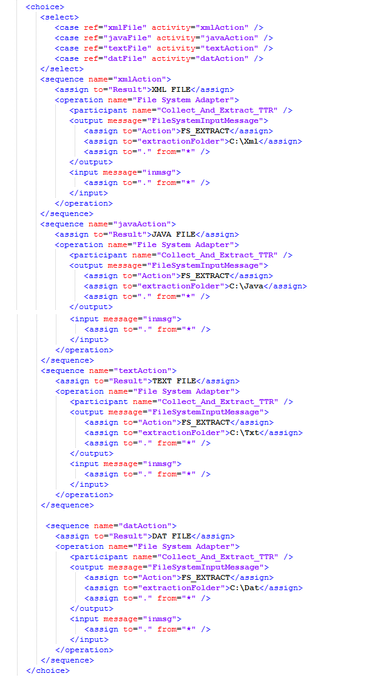

The above operations extract the files by using the action "FS_EXTRACT" and write it into destinations which are defined by using the "extractionFolder" attribute.

The above operations will extract the files based on the extensions. which are defined in the "**select**" activity. Here we are using "**sequence**"," **select**" and "**choice**"activities.

A "**sequence**" activity runs a series of child activities in the order in which it lists them. When a process runs, all of the child activities are run. The sequence activity finishes only after the last child activity is finished.

From the above example shows a "**sequence**" activity that contains child activities. When the process runs, Sterling B2B Integrator runs in the order in which the activities are listed in the sequence. The name attribute in the sequence element is optional.

The "**Choice**" activity makes decisions in the business process model and runs only one of the child activities it contains. Conditions determine which child activity runs.

You define the rules for the choice conditions. The only child activity to run is the one tied to the first case statement in the "**Choice**" activity that matches a rule. If none of the case statements in the Choice activity match a rule, the process continues to the next activity after the choice.

The "**select**" function enables information to be retrieved from Sterling B2B Integrator. Only the tables and fields available in the Select standard rule are available for the select extended rule.

Run the process by click on the "execution manager" .

Modify the process by click on "source manager" as shown as below.

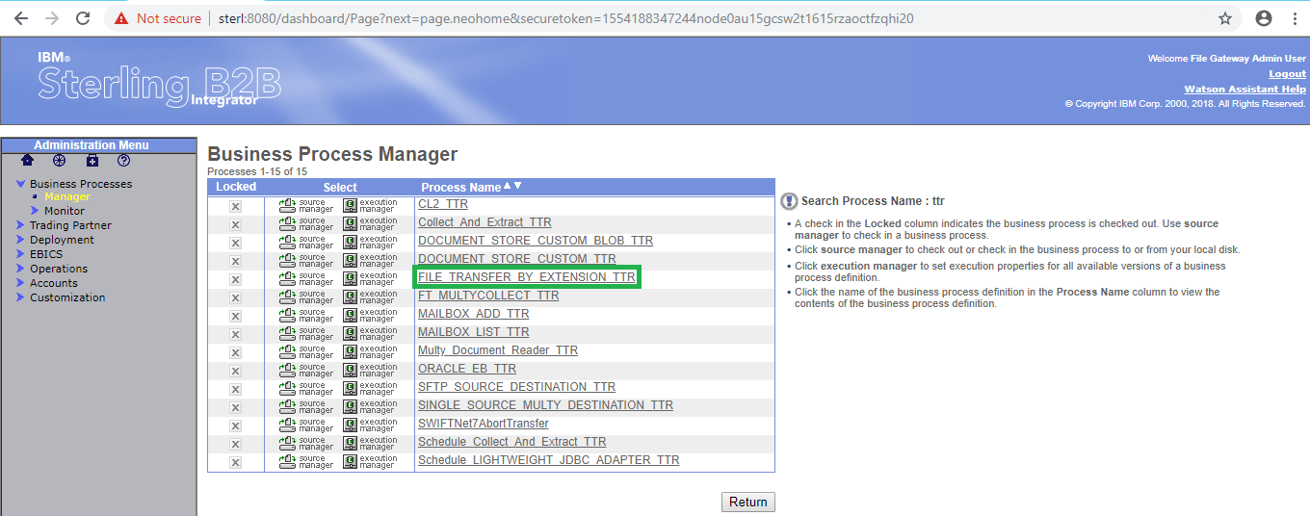

In the below shows the different version of process. first one is latest version of process and which is the last modified version.

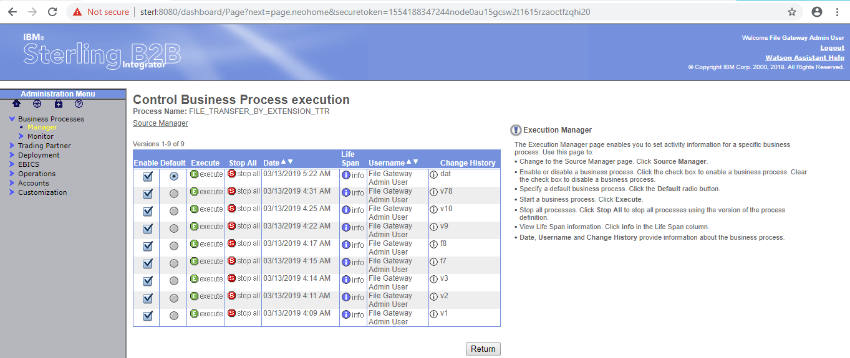

After click on the "execute" the following window will open

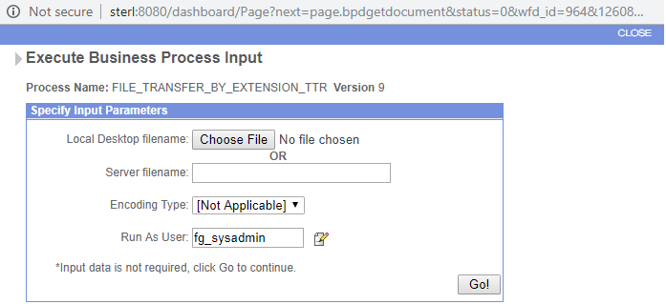

Click on the "Go" the following window will open

