**Single Source With Multiple Destinations**

**Configuring File System Adapter Service**:

Create the "File System Adapter Service" of type "File System Adapter" under Deployment in Administration menu.

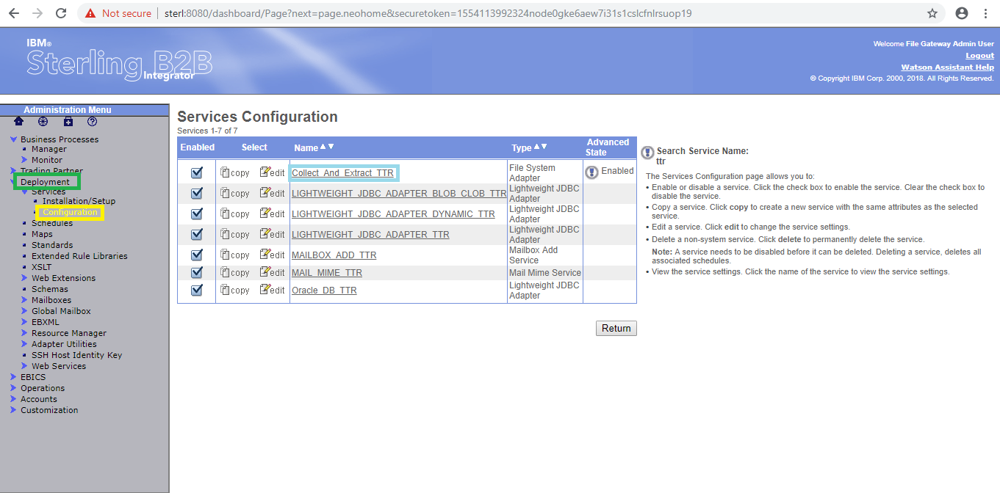

By using "edit" button we can edit the existed service and by using "copy" button we can copy the service.

Ensure that the adapter is enabled.

The following will illustrate the "File System Adapter Service" .

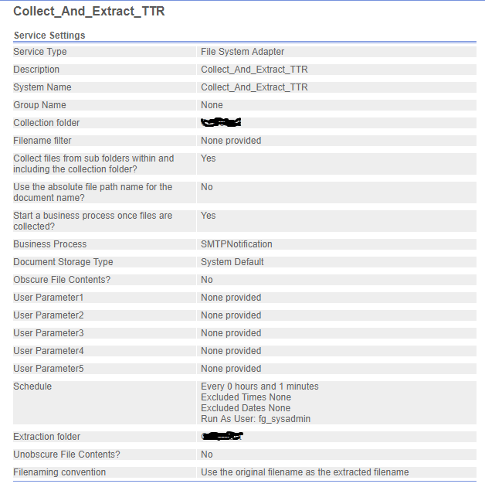

Create the Business Process under the Business Process in Administration menu

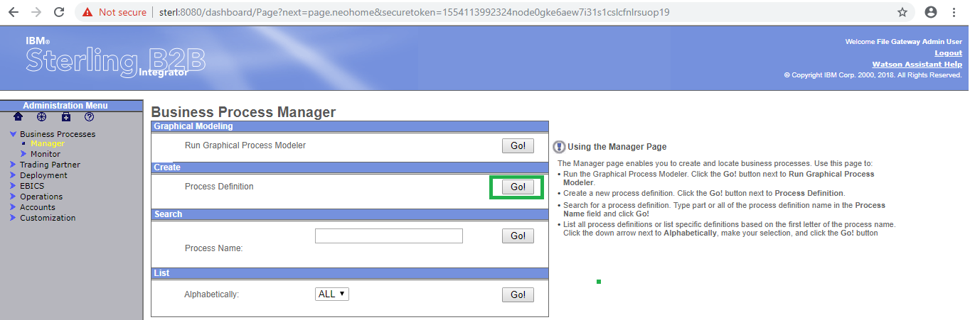

Click on "Go" button as shown above.

Select the Business Process Text Editor and click on next.

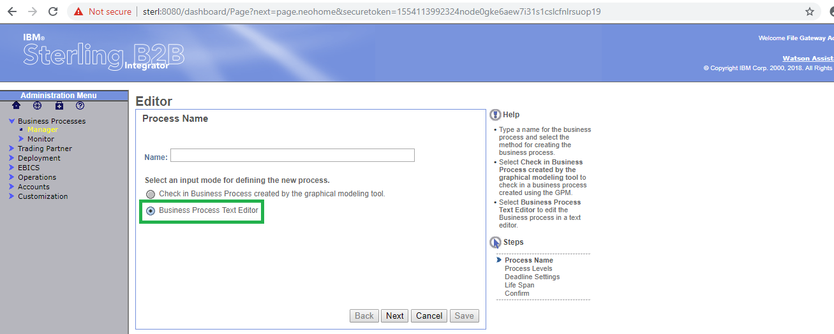

Copy the following xml code in the Business Text Editor as below and click on next.

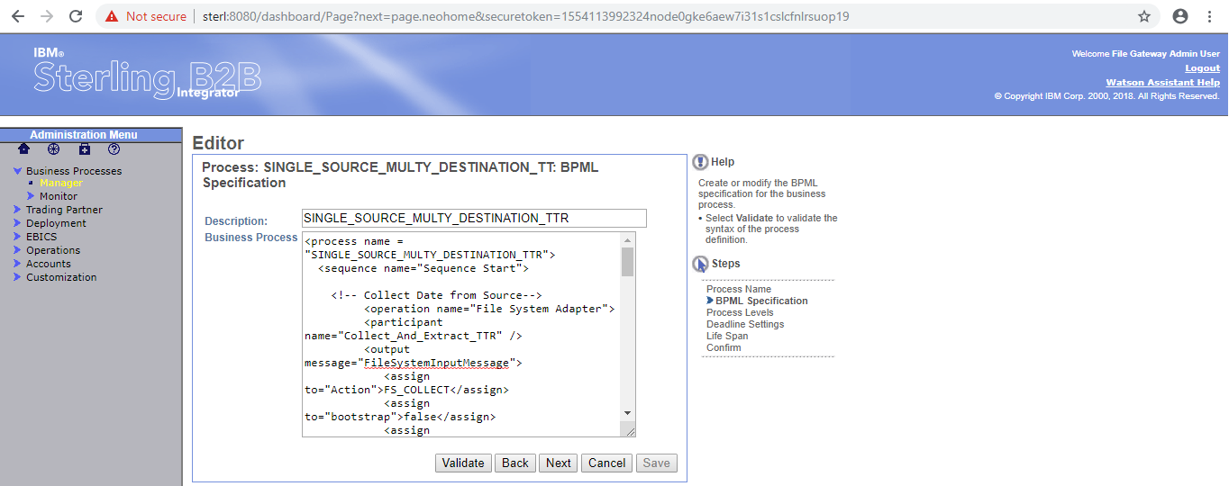

Click on "Validate" button for validating the process.

Business Process shown as below.

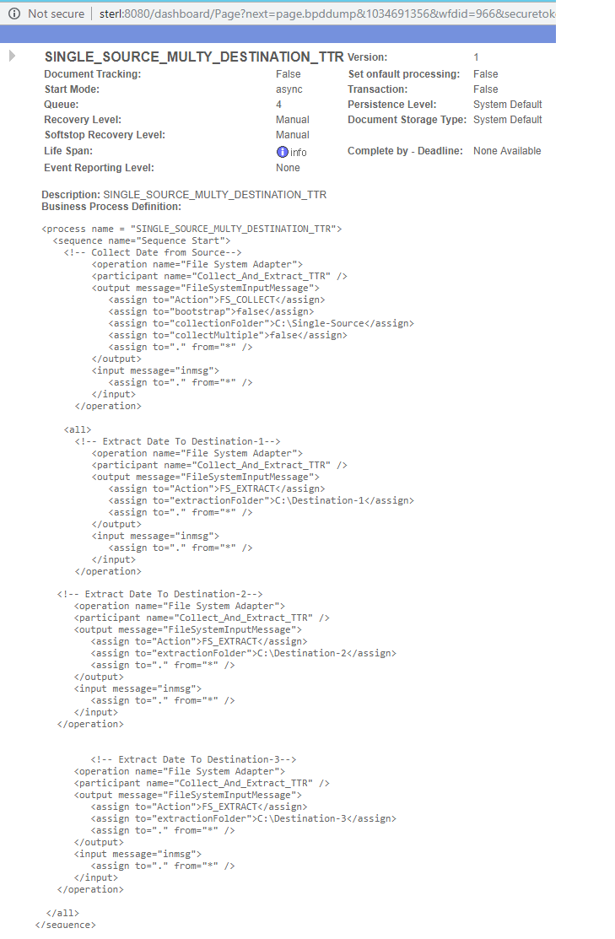

A "**sequence**" activity runs a series of child activities in the order in which it lists them. When a process runs, all of the child activities are run. The "**sequence**" activity finishes only after the last child activity is finished.

First "Sterling B2B Integrator" collect the file from the folder using "File System Adapter" service. you can see service implementation as below .

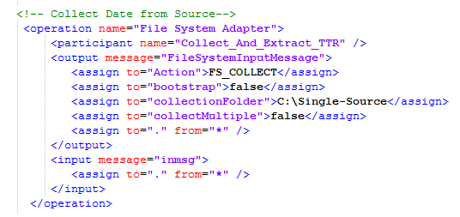

The above operation will the collect the file from the given "collectionFolder" i.e. "C:\Single-Source" using the Action FS_COLLECT. Here this operation is collecting only one file, for collecting multiple files need to set "collectMultiple" attribute as true.

The "**all**" activity contains two or more complex child activities and runs all of them simultaneously. The "**all**" activity finishes only after the child activities are finished.

The following example contains three child operations. Sterling B2B Integrator begins these sequences at the same time—that is, the three operations start simultaneously. The operations continue to run independently until the last operation in each is completed. The all activity finishes when all three child operations finished.

The below operations extract the file by using the action "FS_EXTRACT" and write it into destinations which are defined by using the "extractionFolder" attribute.

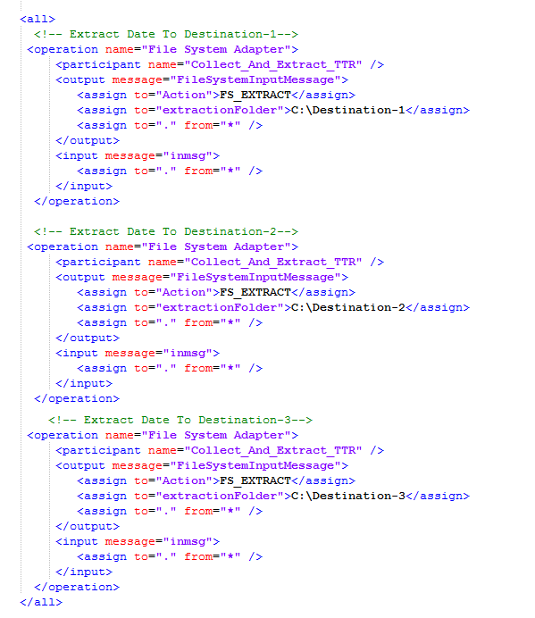

Run the process by click on the "execution manager" .

Modify the process by click on "source manager".

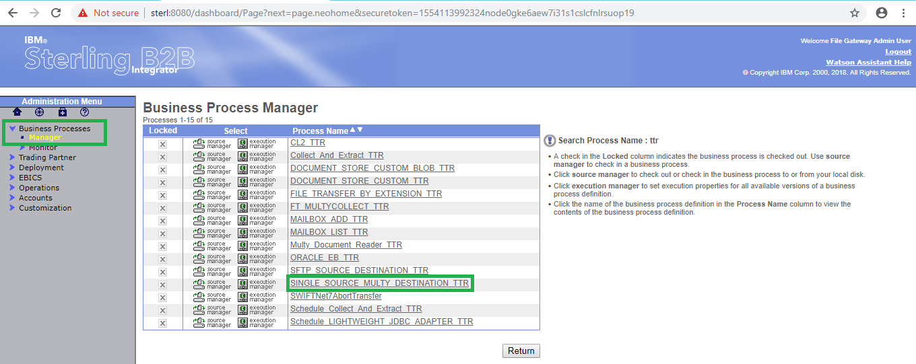

In the below shows the different version of process. first one is latest version of process and which is the last modified version.

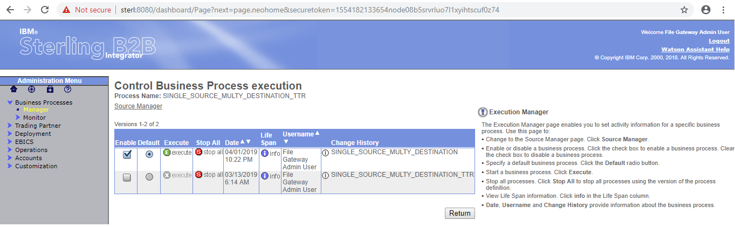

After click on the "execution manager" the following window will open

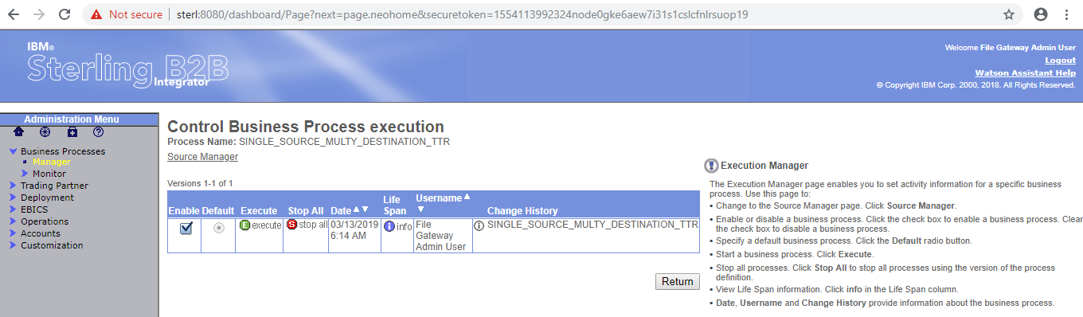

Click on the "execution manager" the following window will open

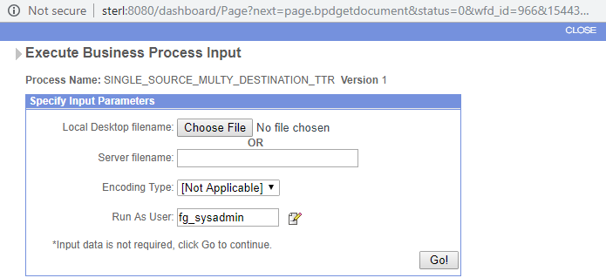

Click on Go button the following window will open

