PGP ENCRYPTION AND DECRYPTION IN MULSE SOFT

1 . Generate “PUBLIC KEY RING PGP FILE” and “SECRET KEY RING PGP FILE” using following command .
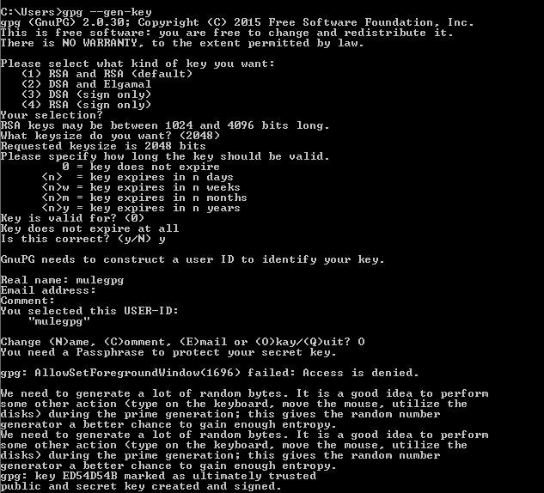
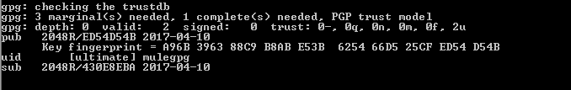
Then check the folder “C:\Users\bandaru\AppData\Roaming\gnupg” to get “pubring.gpg” for PUBLIC KEY RING FILE and “secring.gpg” for SECRET KEY RING PGP FILE .

And you can check your public key and private key in the asc file “secret-key-3A48720E” .

- Then we will use mule flow to do pgp encryption by using following steps .
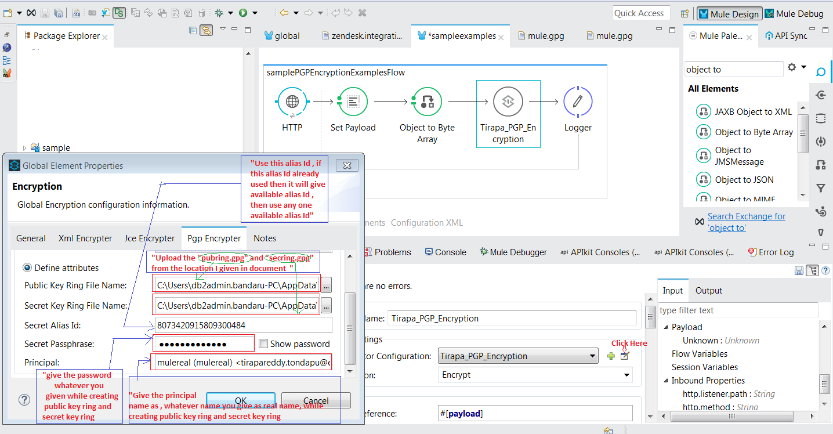

3. Then to do decryption see below mule flow .

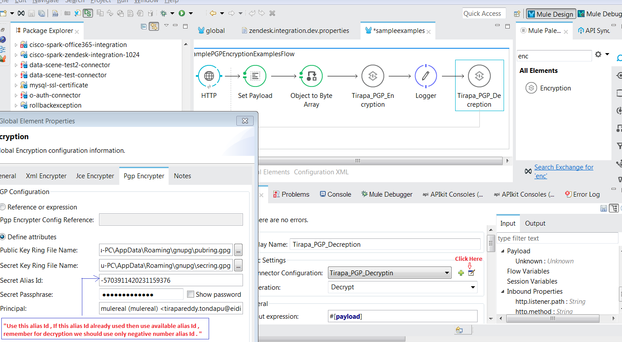
4. Deploy your application in mule server and run .

