PYSPARK DATA ENGINEERING

PySpark DataFrame Operations
Objective: Create an employee DataFrame, inspect its structure, filter records, add a calculated column, summarize data by department, and identify the five highest-paid employees.

What the code demonstrates
- SparkSession is the starting point for a PySpark application and provides access to Spark functionality.
- A DataFrame stores structured data in rows and named columns, similar to a table.
- printSchema() shows the column names and data types, while show(5) previews the first five records.
- filter() selects employees whose monthly salary is above ₹60,000.
- withColumn() creates AnnualSalary by multiplying monthly salary by 12.
- groupBy(), avg(), and count() produce department-level average salary and employee counts.
- Sorting salary in descending order makes it possible to inspect the five highest-paid employees.
Screenshot and output from the original assignment:
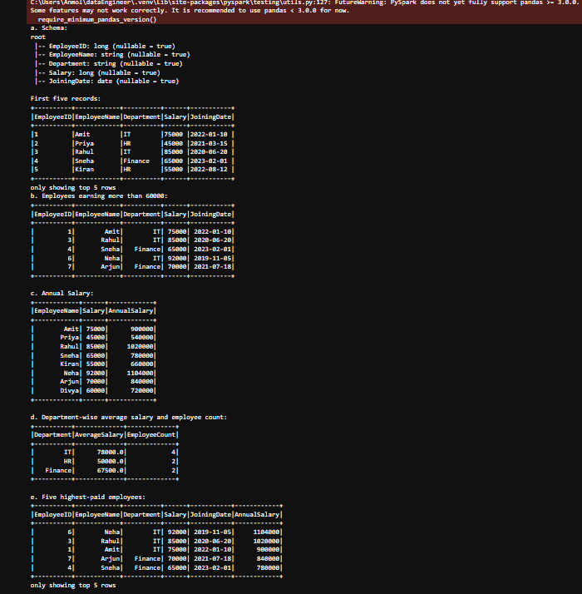

2. Question 8 – Data Cleaning and Aggregation
Objective: Clean transaction data by removing duplicate records, handling missing values, parsing dates, calculating revenue, and summarizing revenue by product.

What the code demonstrates
- A CSV file is loaded into a DataFrame using its header row and schema inference.
- dropDuplicates(["TransactionID"]) removes repeated transactions based on the transaction identifier.
- Missing values are handled with fill values for demonstration; in real projects, these choices should be based on business rules.
- Date parsing converts text into a date/time value. Invalid dates can become null so they can be reviewed rather than crashing the workflow.
- Revenue is calculated as Quantity × UnitPrice.
- groupBy("Product") and sum() calculate total revenue per product; descending sorting puts the highest revenue first.
Screenshots and output from the original assignment:
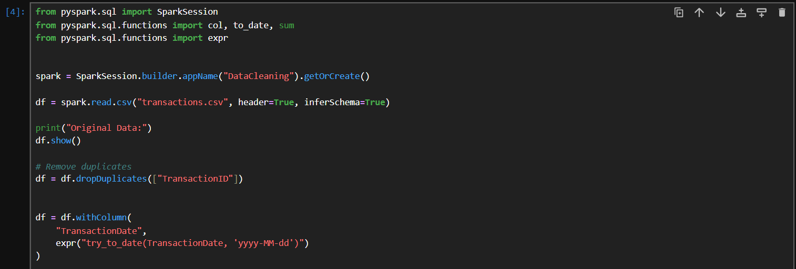
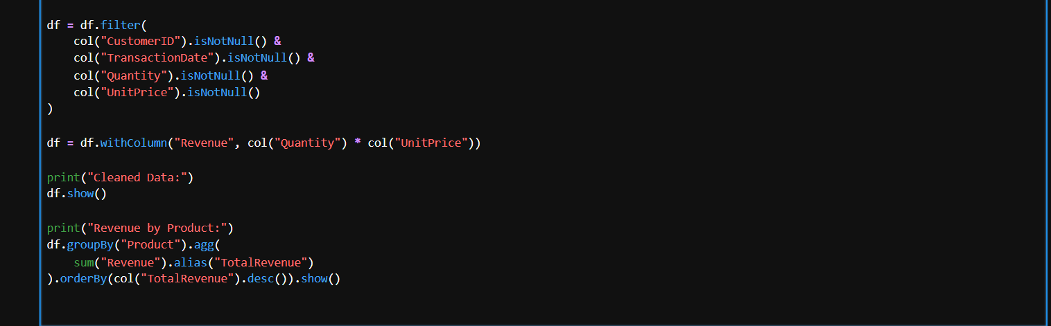
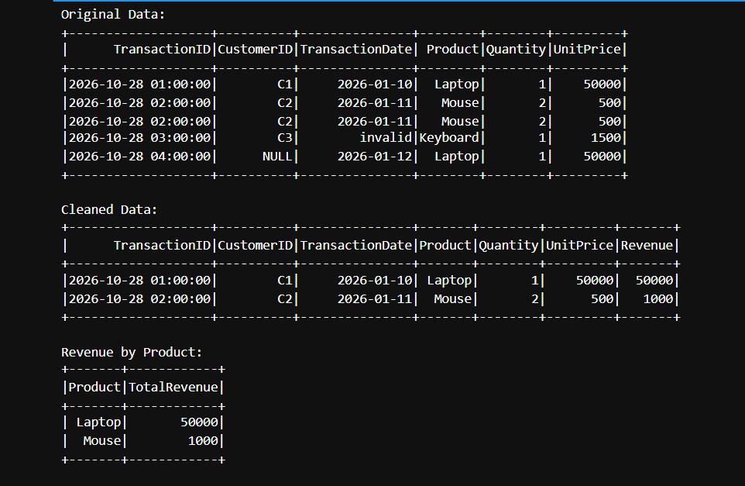

3. Question 9 – PySpark Joins and Performance
Objective: Combine customer and order datasets, find customers with no orders, calculate city-wise order totals, and understand how Spark executes operations.

What the code demonstrates
- An inner join on CustomerID combines order records with the matching customer details.
- A left-anti join returns customers whose IDs do not appear in the orders dataset; this identifies customers without orders.
- Grouping by City and summing OrderAmount produces city-wise order totals.
- A broadcast join can improve performance when one dataset is small enough to be copied to each executor, reducing the need to shuffle the larger dataset.
- Transformations such as filter() define work that Spark evaluates lazily.
- Actions such as show(), count(), and collect() trigger execution and return results.
Screenshots and output from the original assignment:
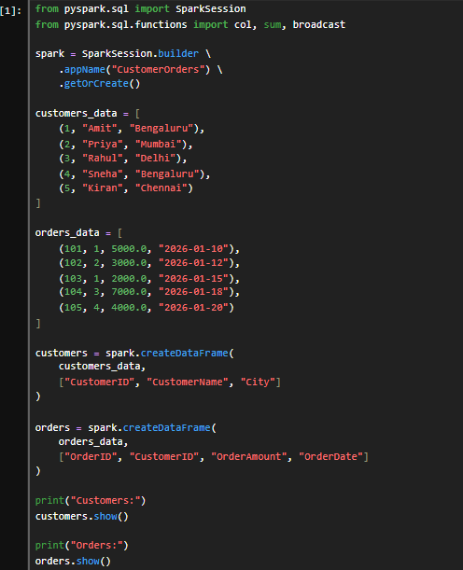
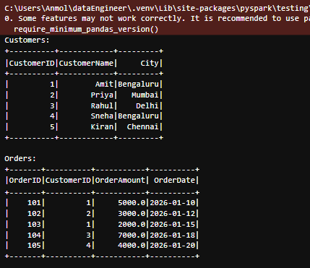
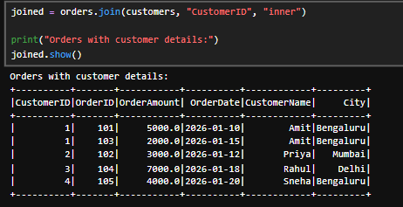
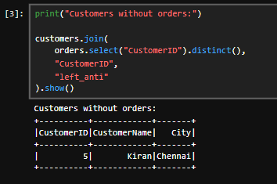
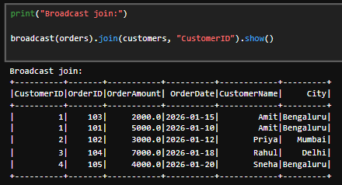

What I Learned
Through these PySpark exercises, I learned how Apache Spark can process structured data using DataFrames and familiar operations such as filtering, selecting, grouping, joining, and sorting. I understood how to inspect a DataFrame's schema and preview its records before applying transformations. I also learned how to create calculated columns, summarize information using aggregations, and use joins to combine related datasets or find records that do not have a match.
The data-cleaning exercise helped me understand why duplicate records, missing values, and incorrectly formatted dates must be handled before analysis. I practiced calculating revenue from quantity and unit price and creating product-wise summaries. The joins and performance exercise introduced me to Spark's lazy evaluation model: transformations describe the work, while actions trigger execution. I also learned that broadcast joins can be useful when one dataset is small enough to distribute efficiently.
Overall, this practical work strengthened my understanding of a basic data-engineering workflow: load data, inspect it, clean it, transform it, combine datasets, calculate summaries, and review the output. I gained confidence reading PySpark code and interpreting its results, while recognizing that choices such as filling missing values and using broadcast joins should be made according to the data and the needs of the application.

Key PySpark Functions Used
Function / Concept | Purpose
SparkSession | Starts and provides access to the Spark application.
printSchema(), show() | Inspect column types and preview rows.
filter() | Keep records that satisfy a condition.
withColumn() | Create or replace a DataFrame column.
groupBy(), avg(), count(), sum() | Aggregate records into summaries.
dropDuplicates() | Remove repeated records based on selected columns.
join(), left_anti | Combine matching data or find rows without a match.
Transformations and actions | Separate the definition of work from the operation that triggers execution.
Note: The screenshots and explanations are based on the PySpark section of the supplied HCL assignment. Any sample-value handling shown in the assignment is presented as a learning example, not a universal data-cleaning rule.

