☁ AWS | CLOUD | DATA
AWS CLOUD
& DATA ENGINEERING
PRACTICAL ASSIGNMENT REPORT
S3  RAW DATA | → | GLUE  DISCOVERY | → | S3  CURATED DATA
SQL • LINUX • AMAZON S3 • AWS GLUE • VISUAL ETL
SUBMITTED BY
NAME | C TRISHA
ROLL NUMBER | 23BTREC003
COLLEGE NAME | JAIN DEEMED TO BE UNIVERSITY
DEPARTMENT / BATCH | ECE/2023-2027
SUBMISSION DATE | 12 / 10 / 2026
LEARN • BUILD • TRANSFORM • DELIVER

ER DIAGRAM:
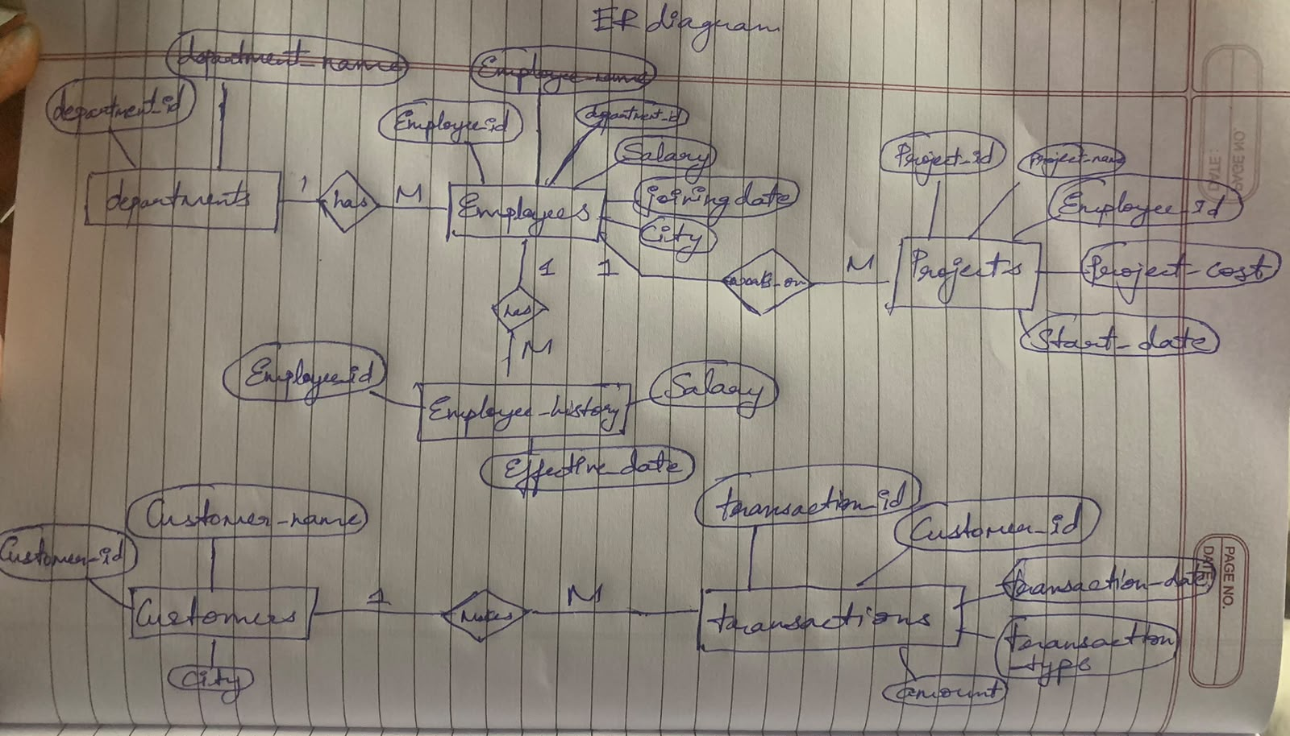

SQL PRACTICE(MY SQL WORKBENCH):
Query 1: Department-wise Employee Count and Average Salary
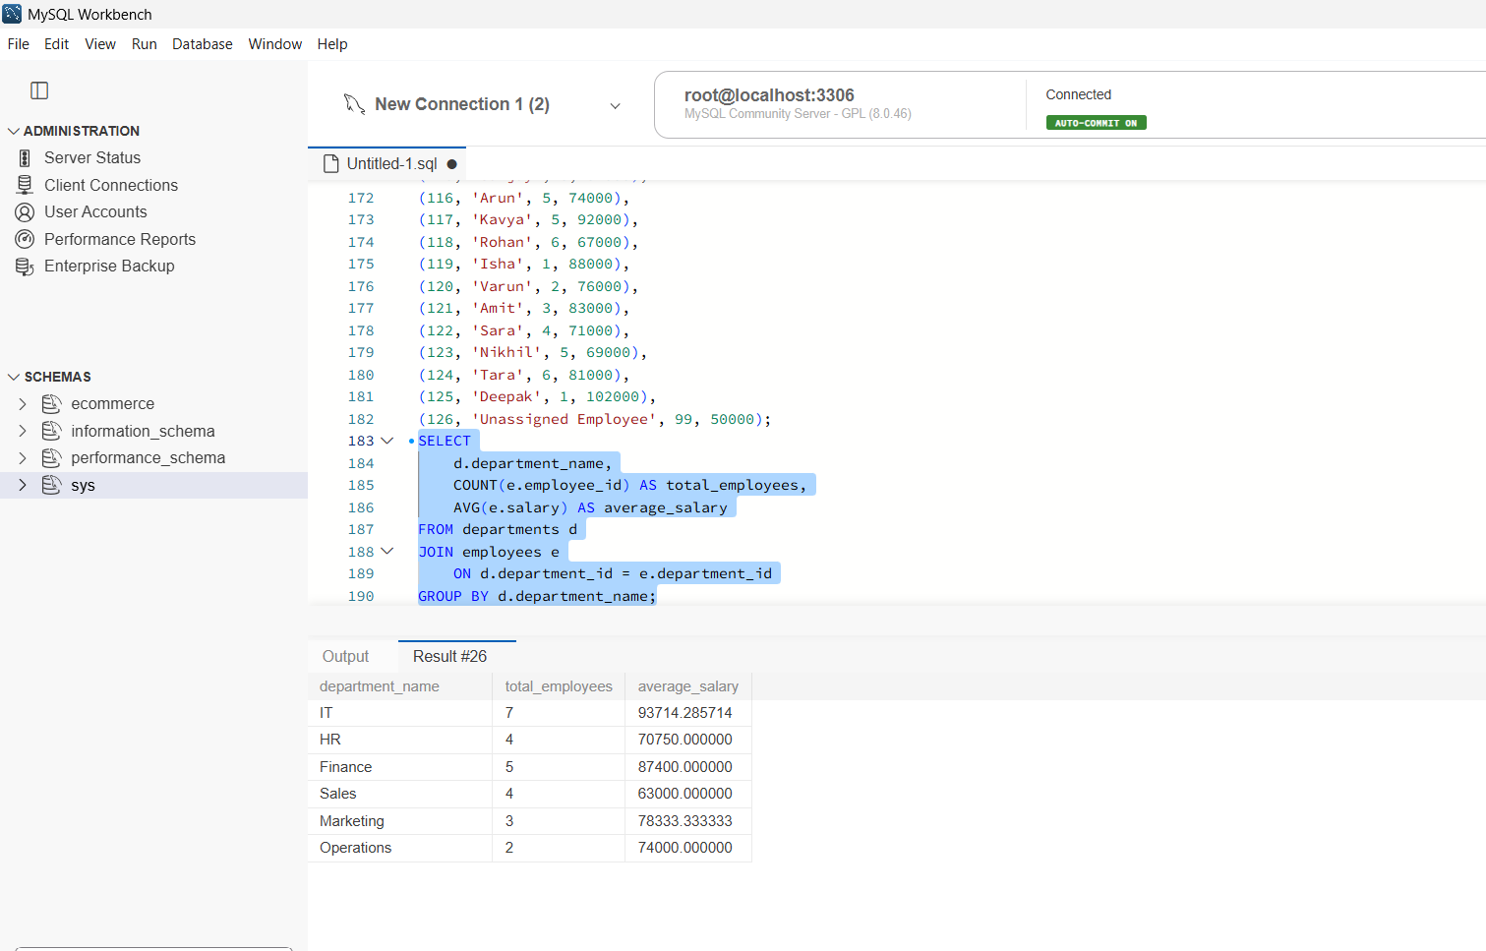
Query 2: Departments With Average Salary Above ₹70,000
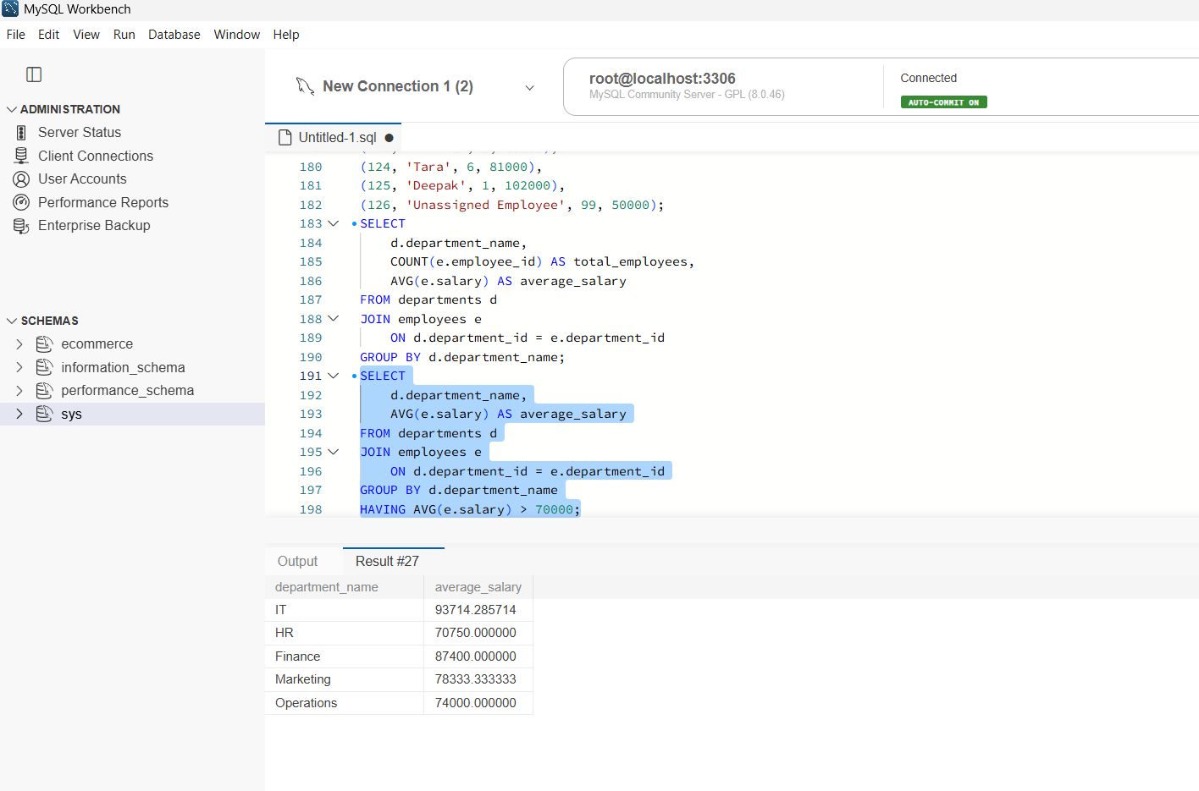

Query 3: Employee Names With Department Names and Salaries
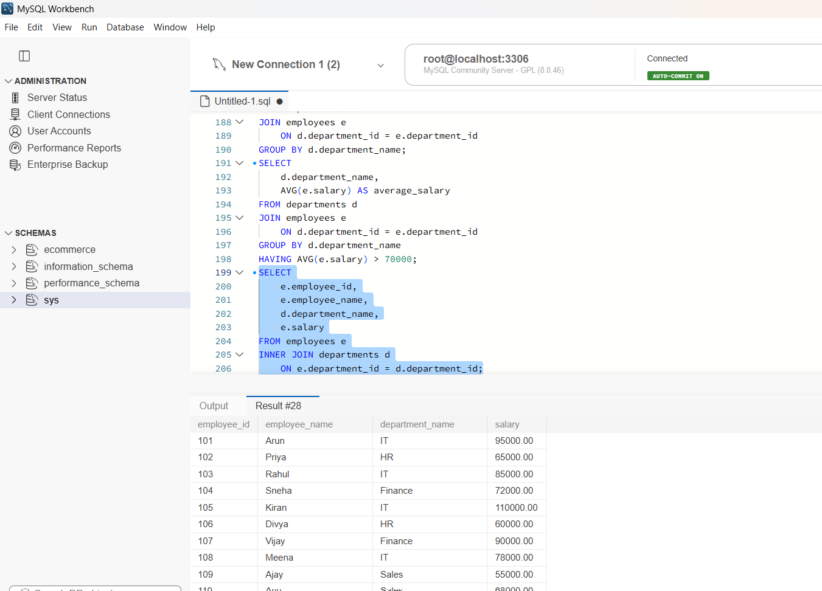
Query 4: Employees Without a Matching Department
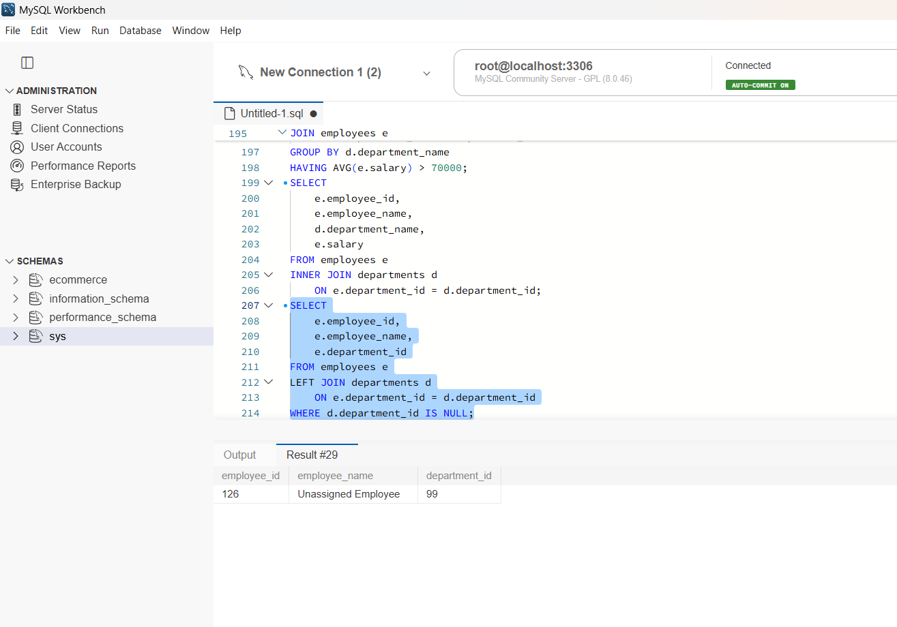

Query 5: Top Five Highest-Paid Employees
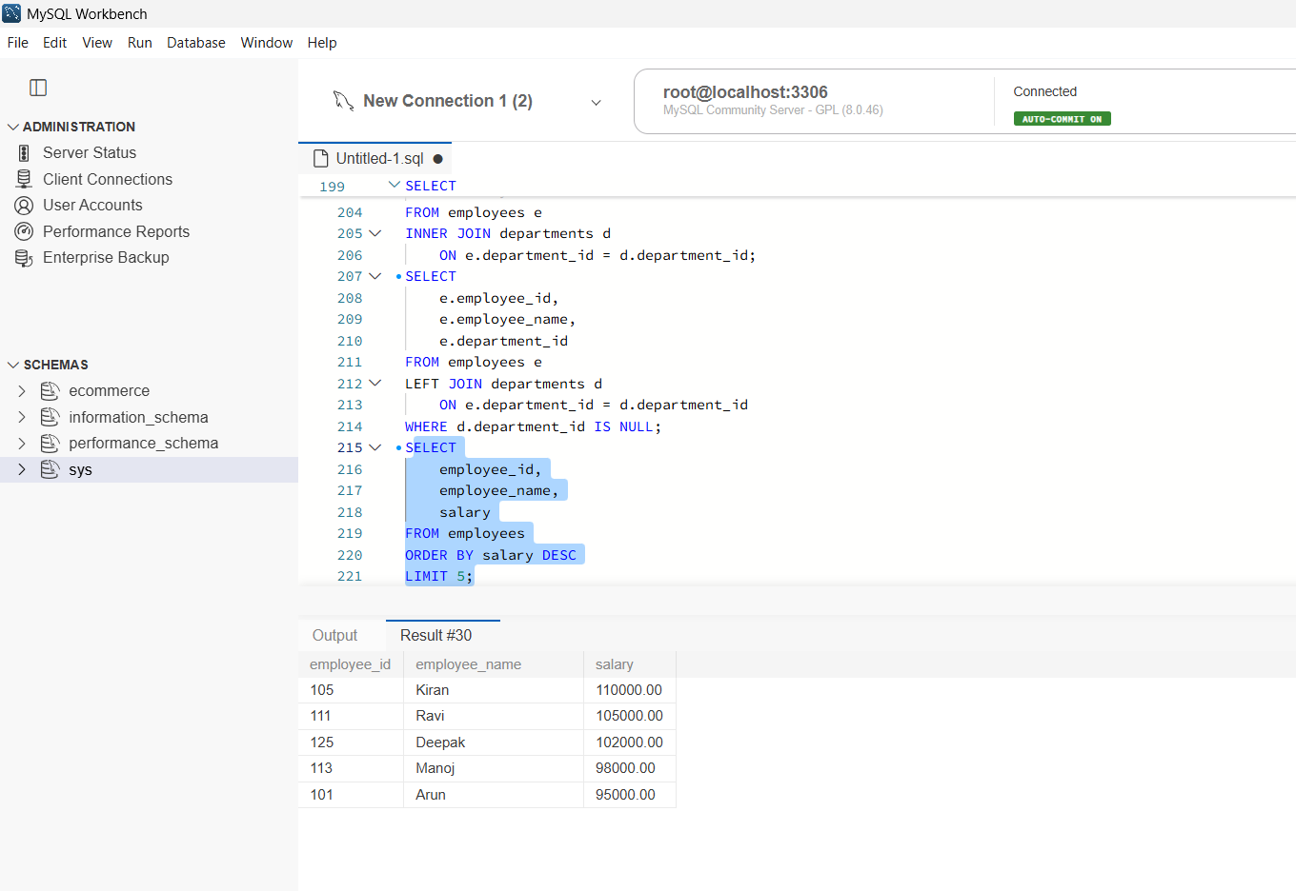
Query 6: Employees Assigned to Three or More Projects
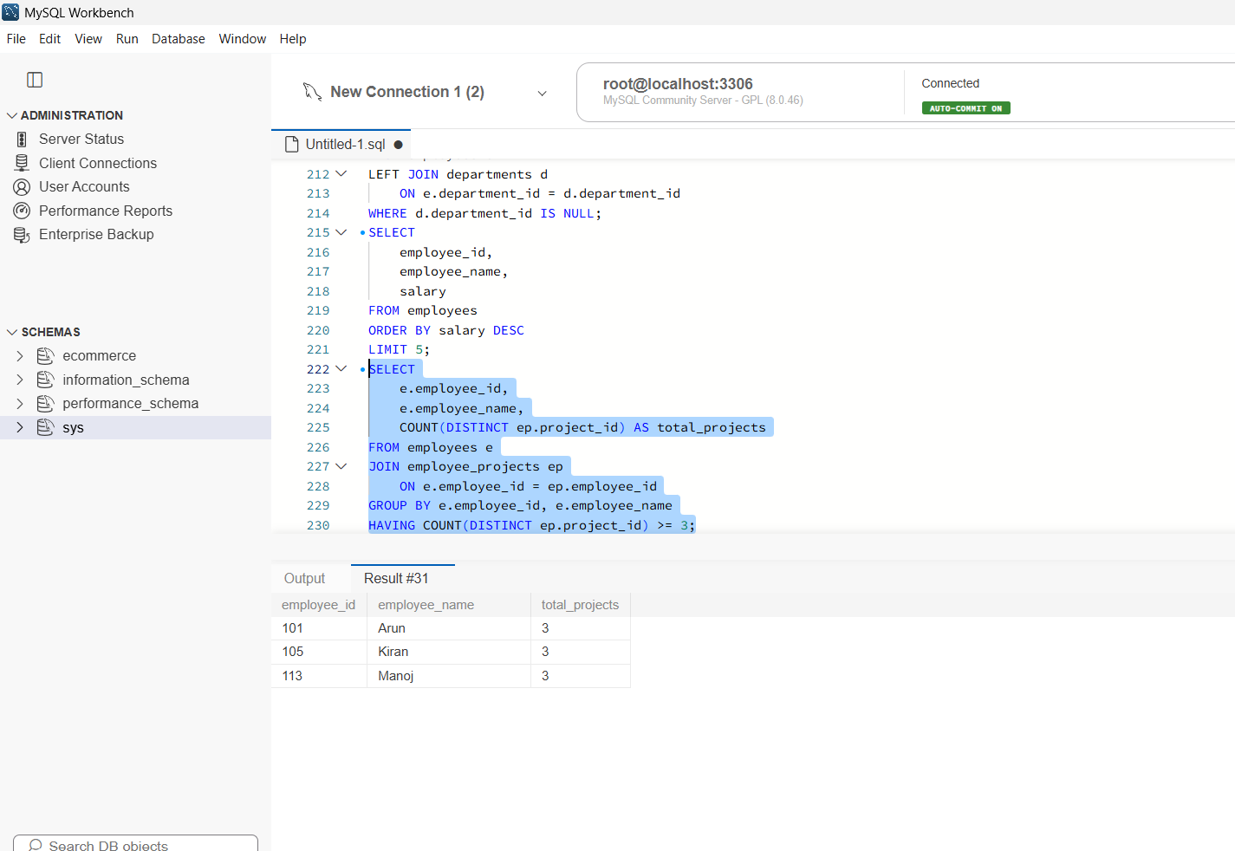
Query 7: Total Project Cost Per Employee
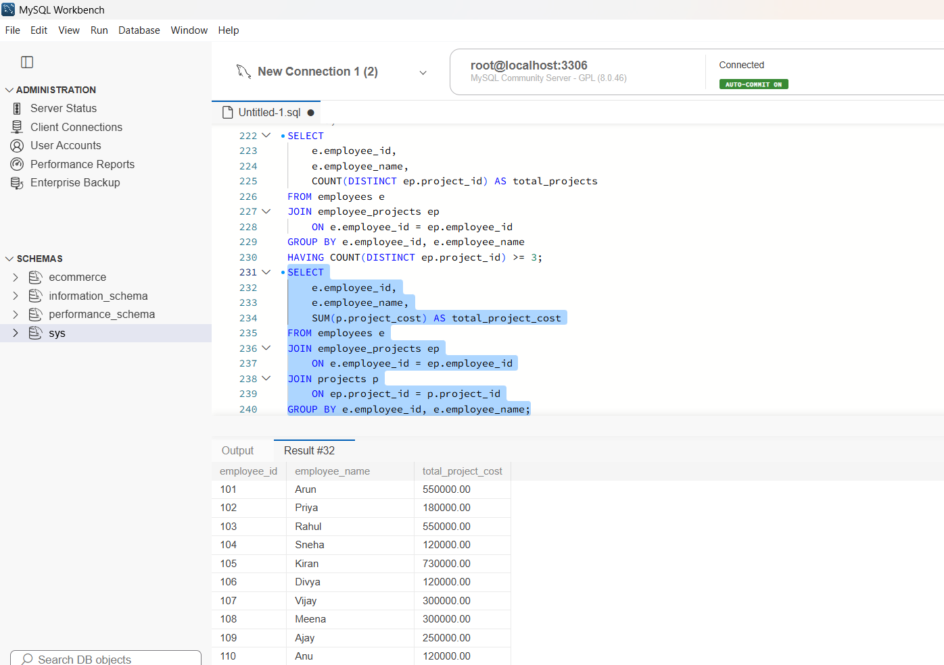
Query 8: Second-Highest Salary
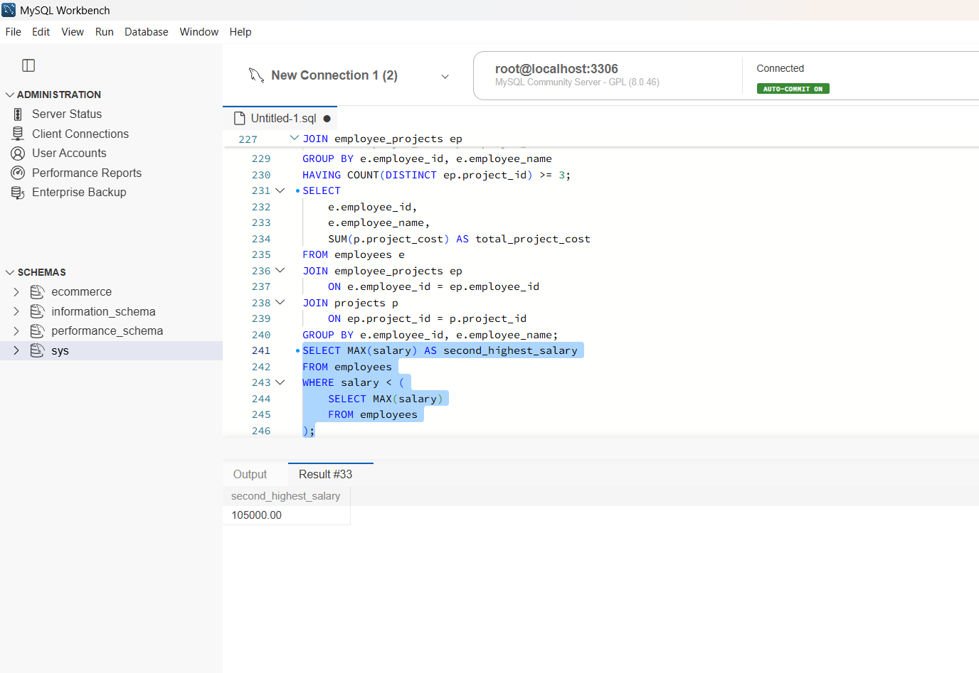
Query 9: Employees Earning Above Average Salary
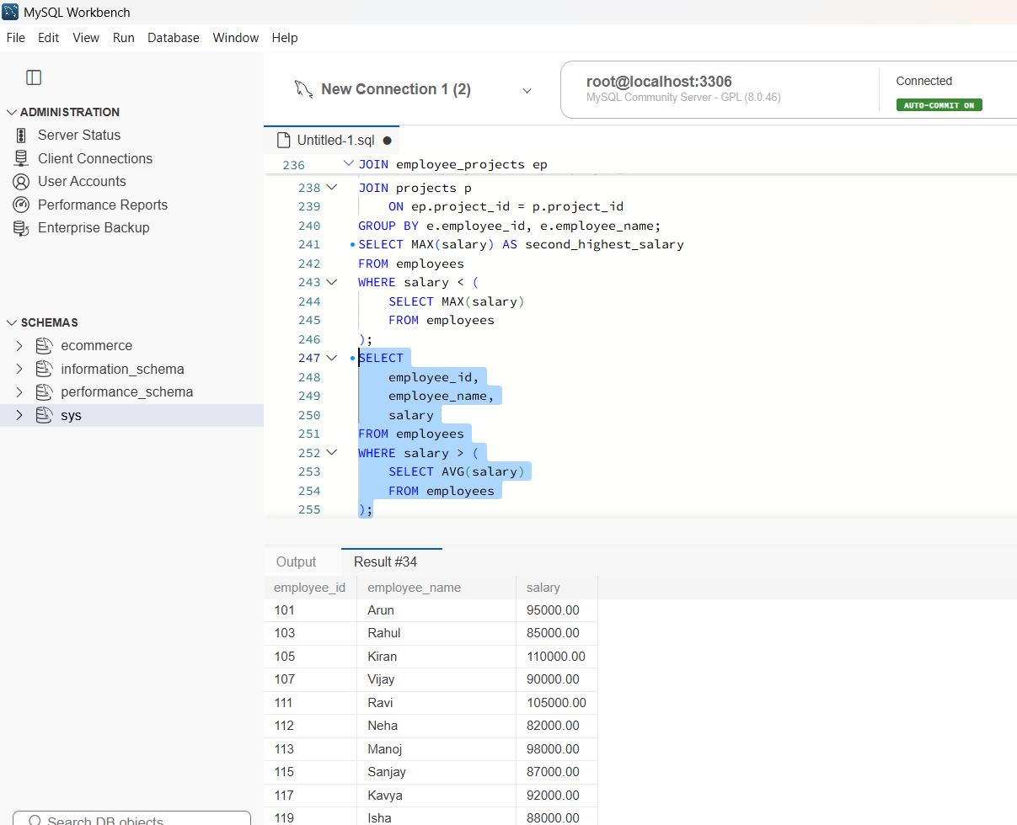
Query 10: Duplicate Employee Names
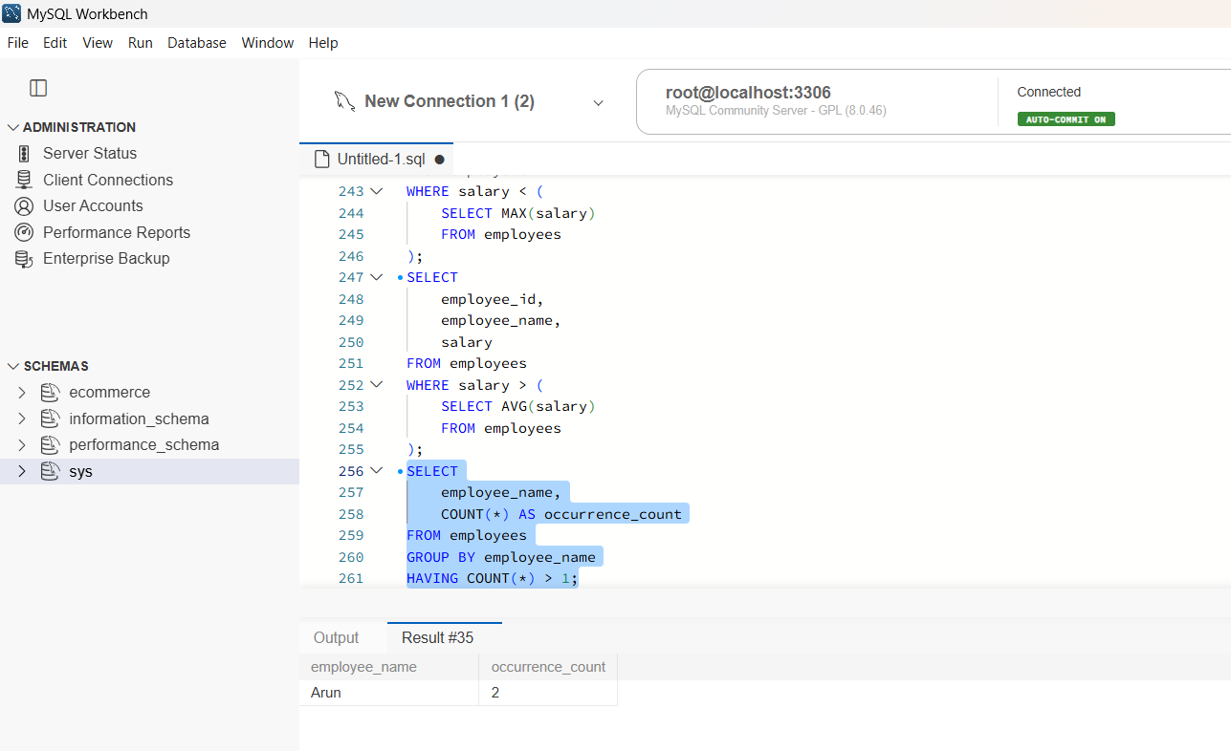
Query 11: Customers With Total Transactions Above ₹2,00,000
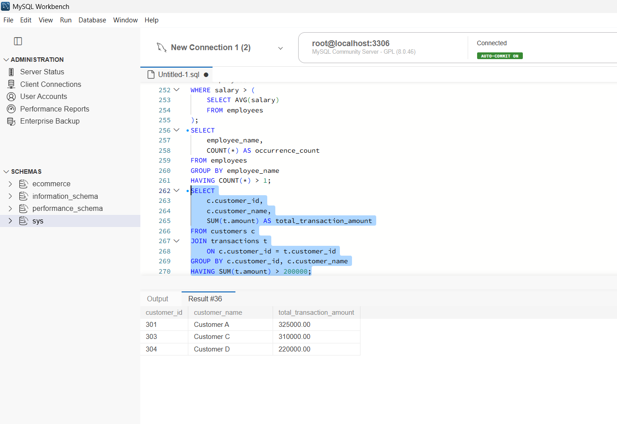
Query 12: Monthly Transaction Totals
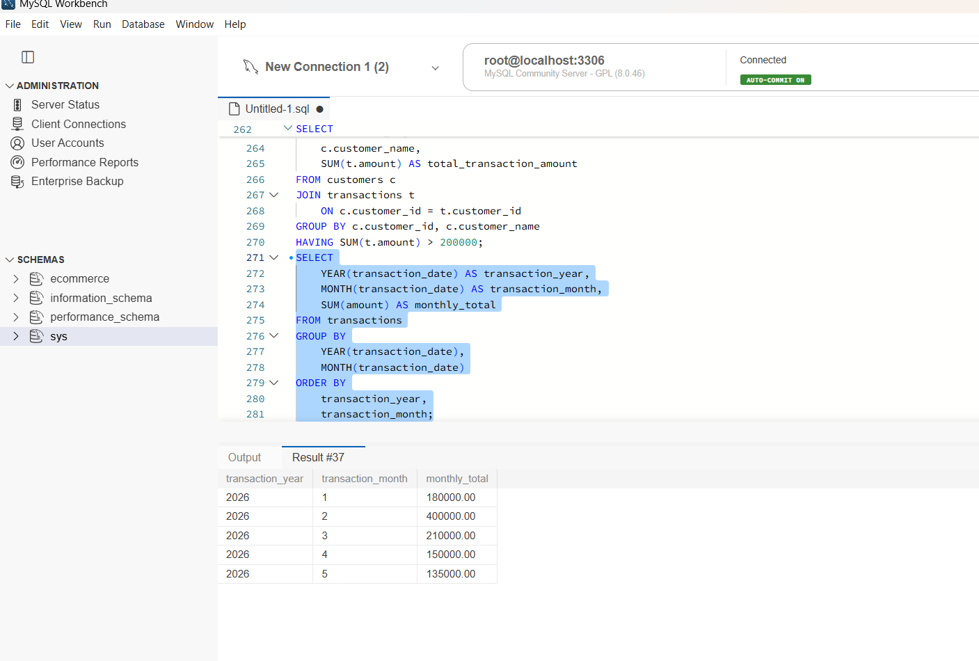
Query 13: Salary Ranking Within Each Department
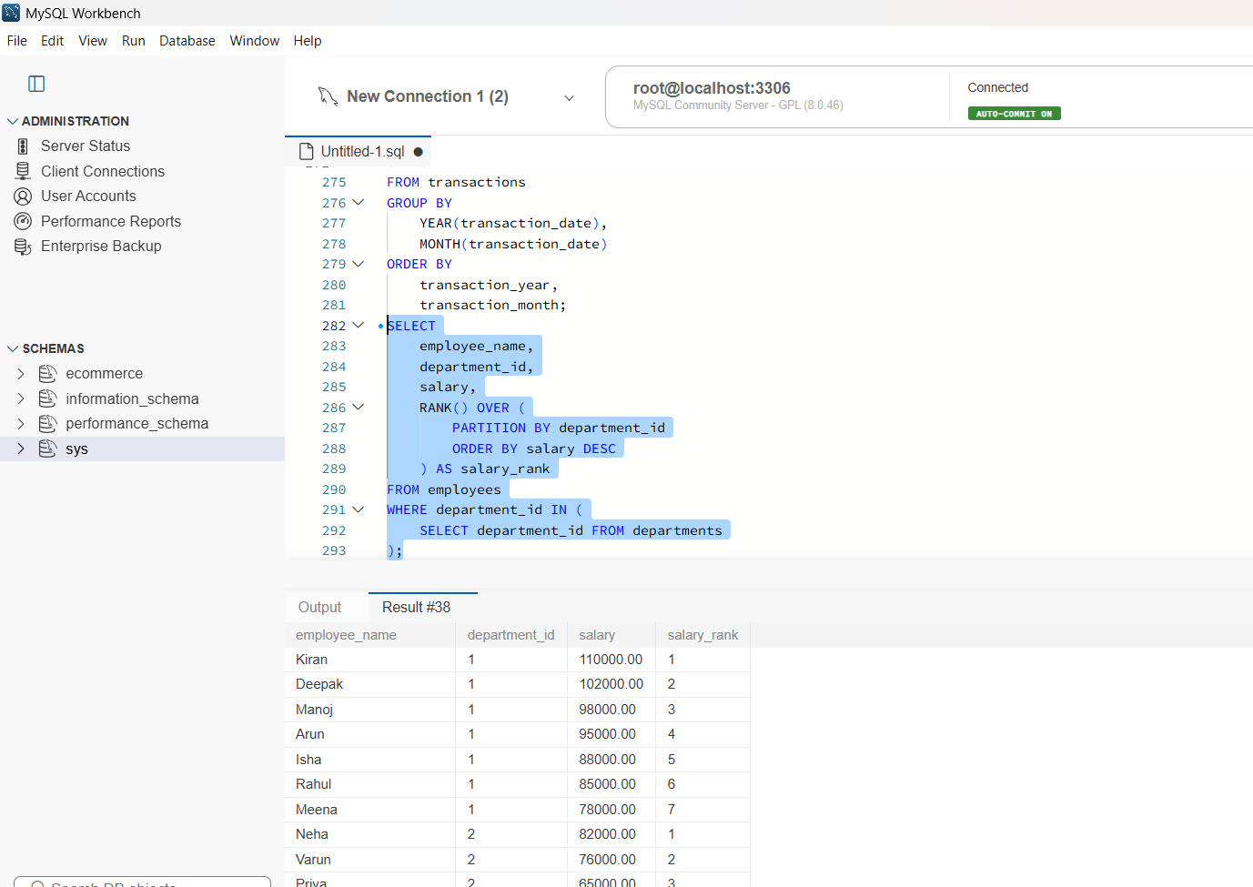

Query 14: High-Salary Employees Using a CTE
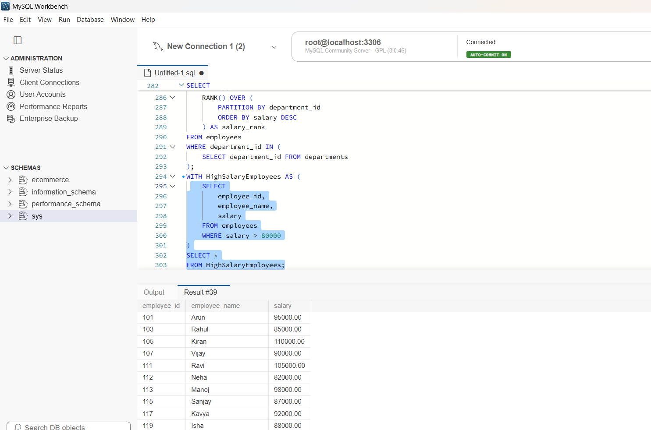

Query 15: Top Two Salary Ranks Per Department
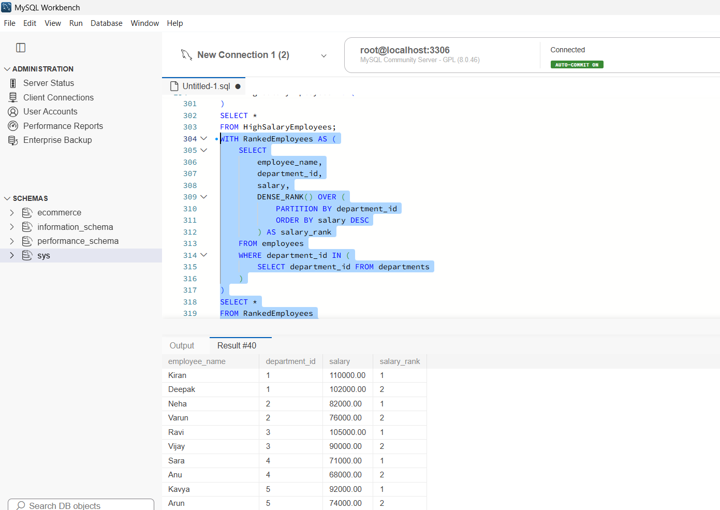

Query 16: Departments With More Than Three Employees
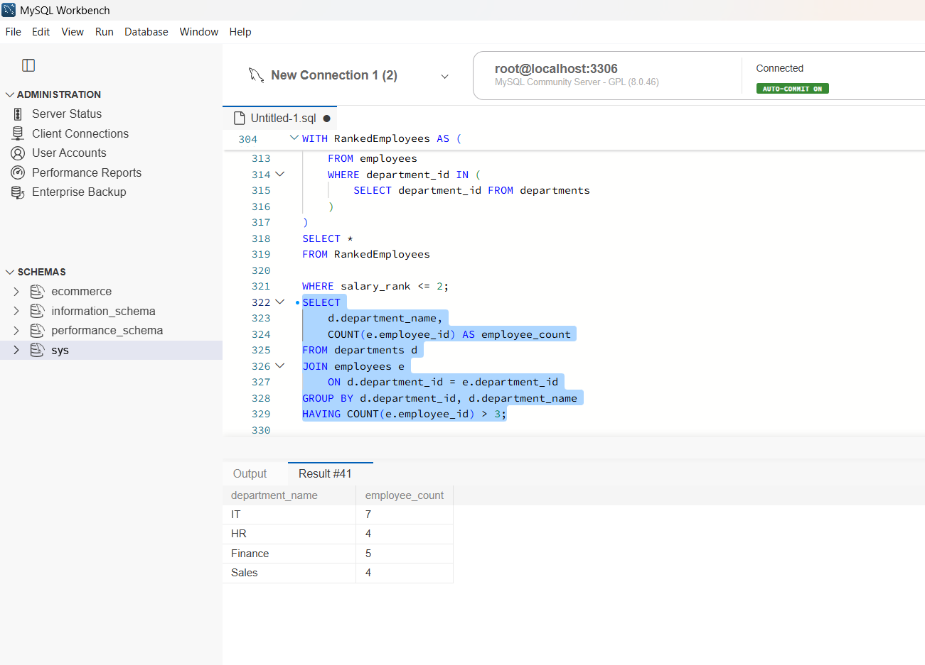
Query 17: Employees Not Assigned to Any Project
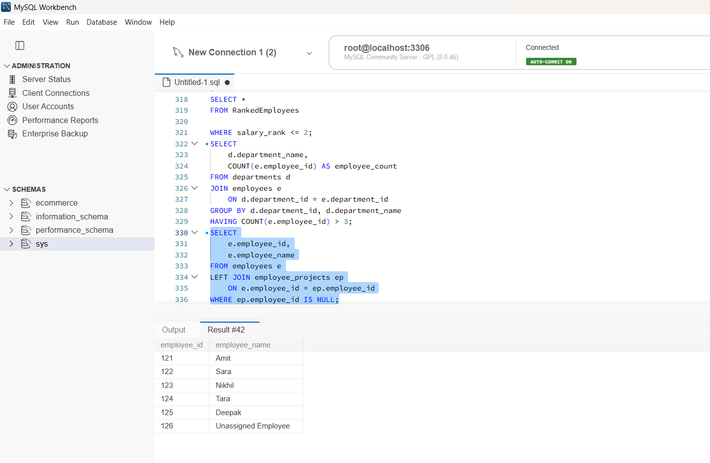

Query 18: Most Expensive Project
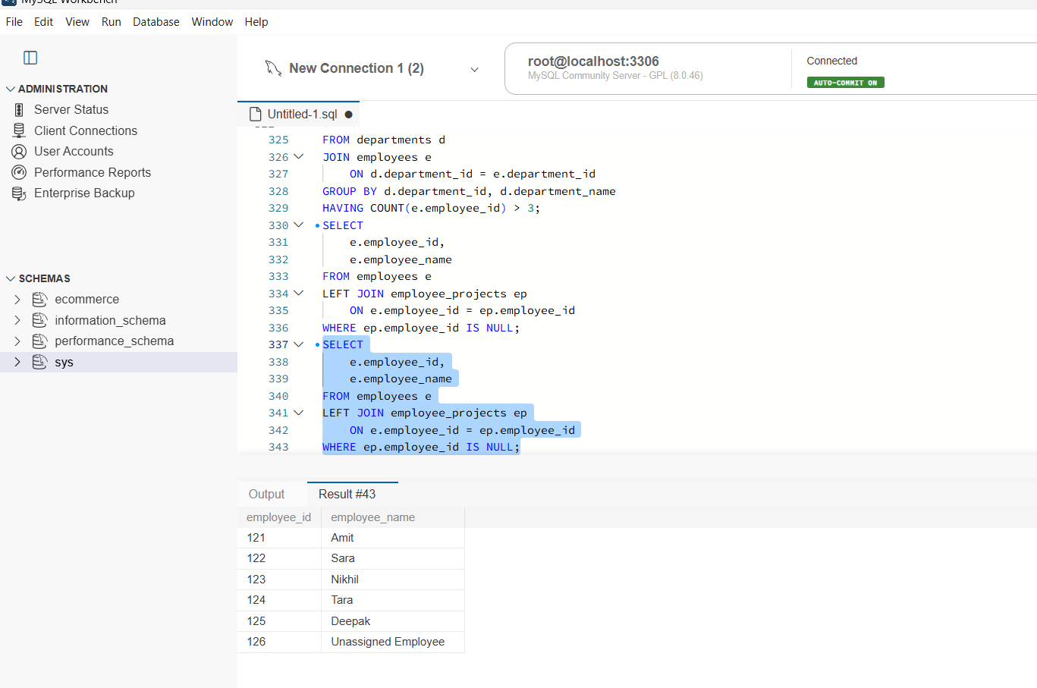

Query 19: Customers Who Have Never Made a Transaction
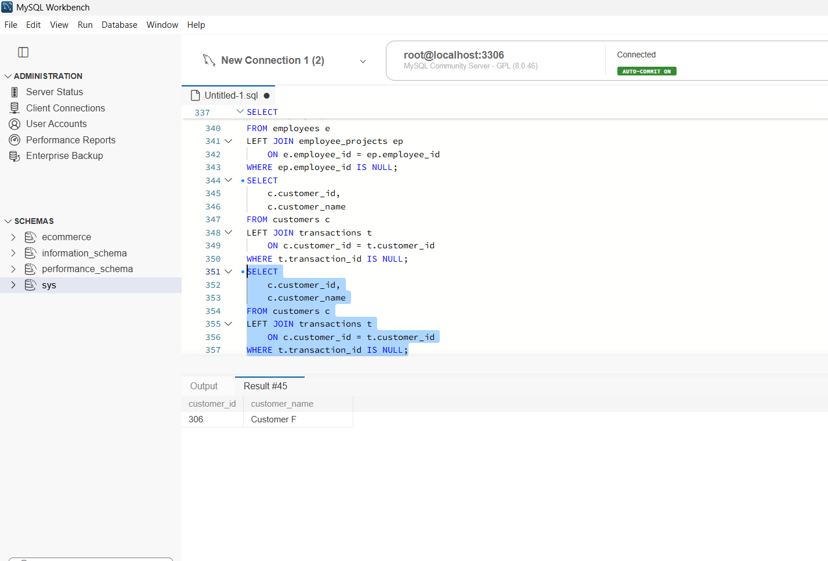
Query 20: Running Total of Transactions
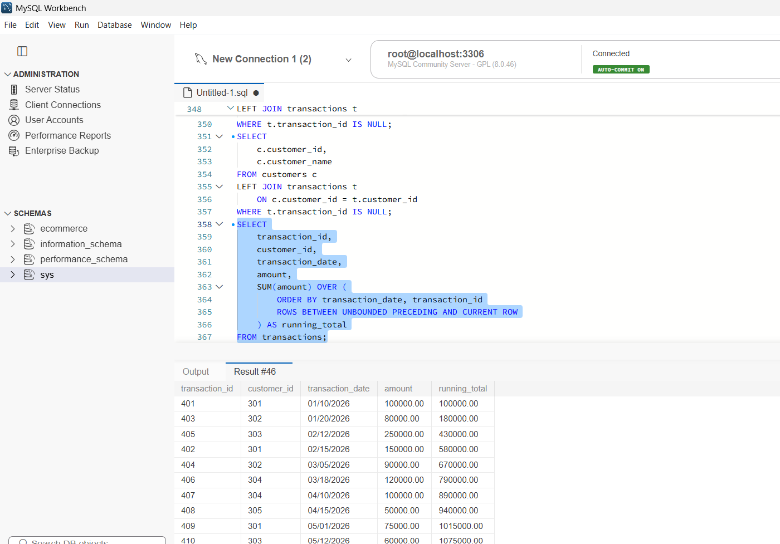

LINUX PRACTICE

Terminal output 1
(pwd,whoami,date,uname-a,hostname,ls-lah)
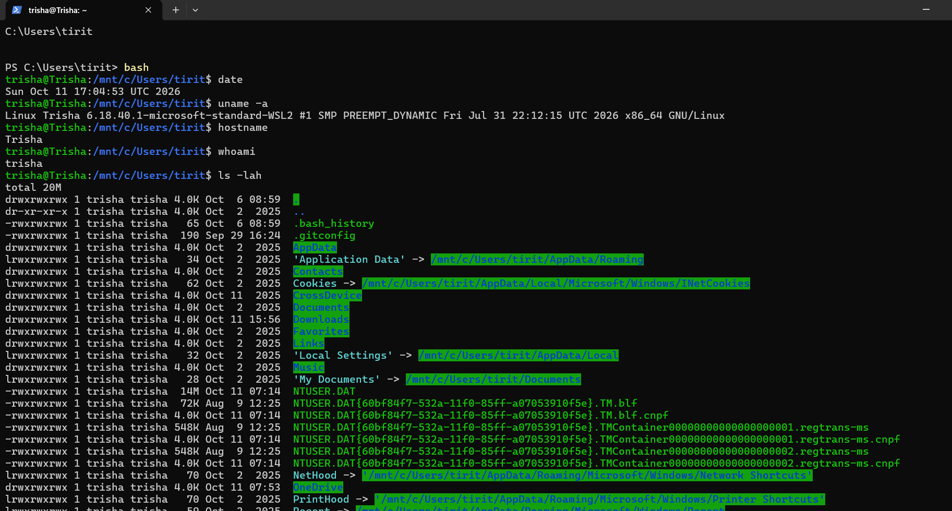

Terminal output 2
(mkdir,ls,cd,touch,echo,cat,cp,mv,rm)
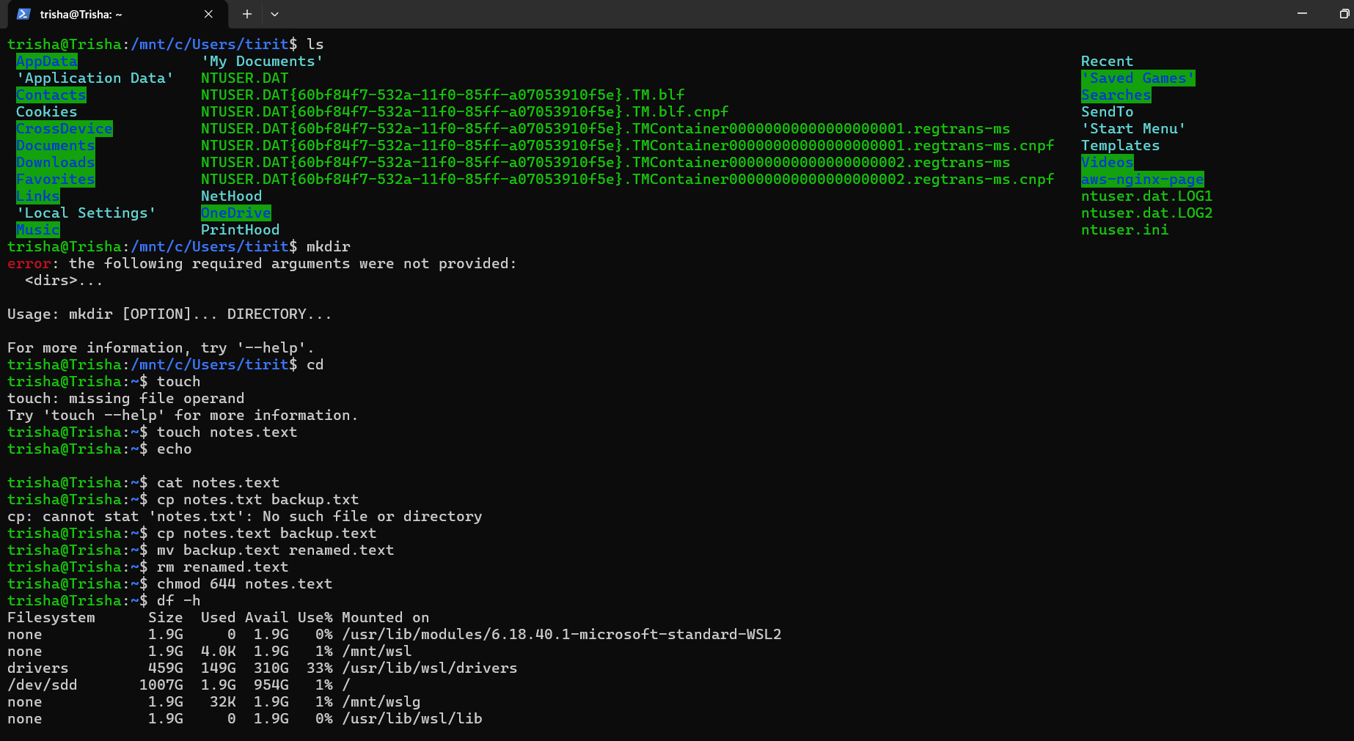

Terminal output 3
(chmod 644,df -h,du -h)
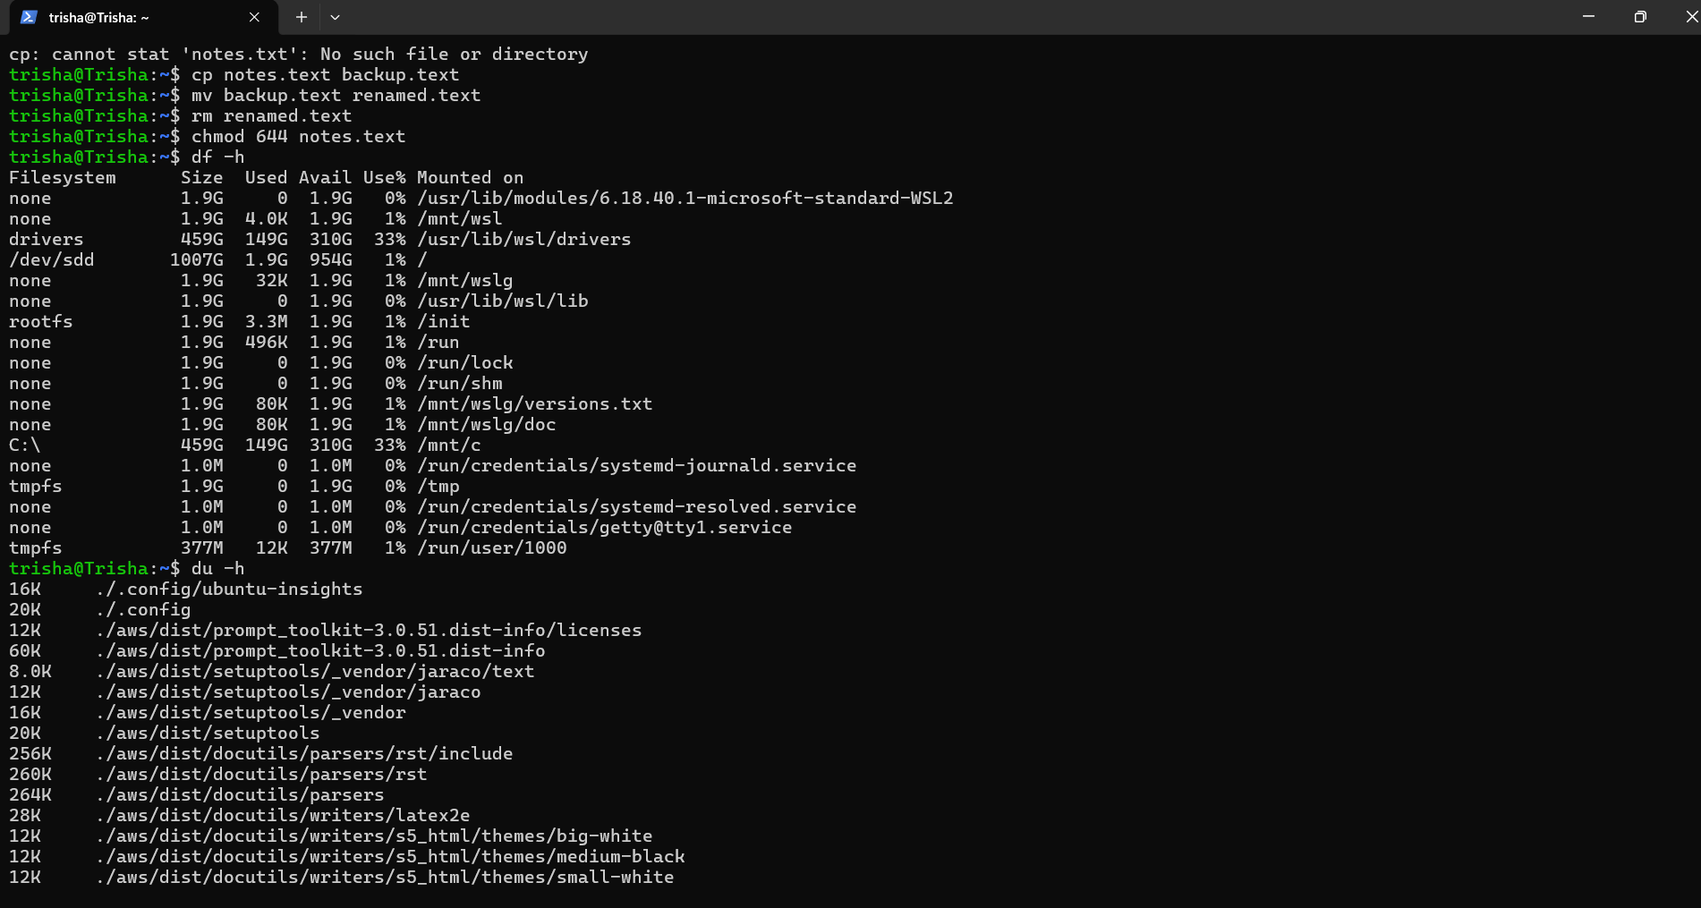

Account and region overview
Aws console home opened in the Europe(Stockholm) region
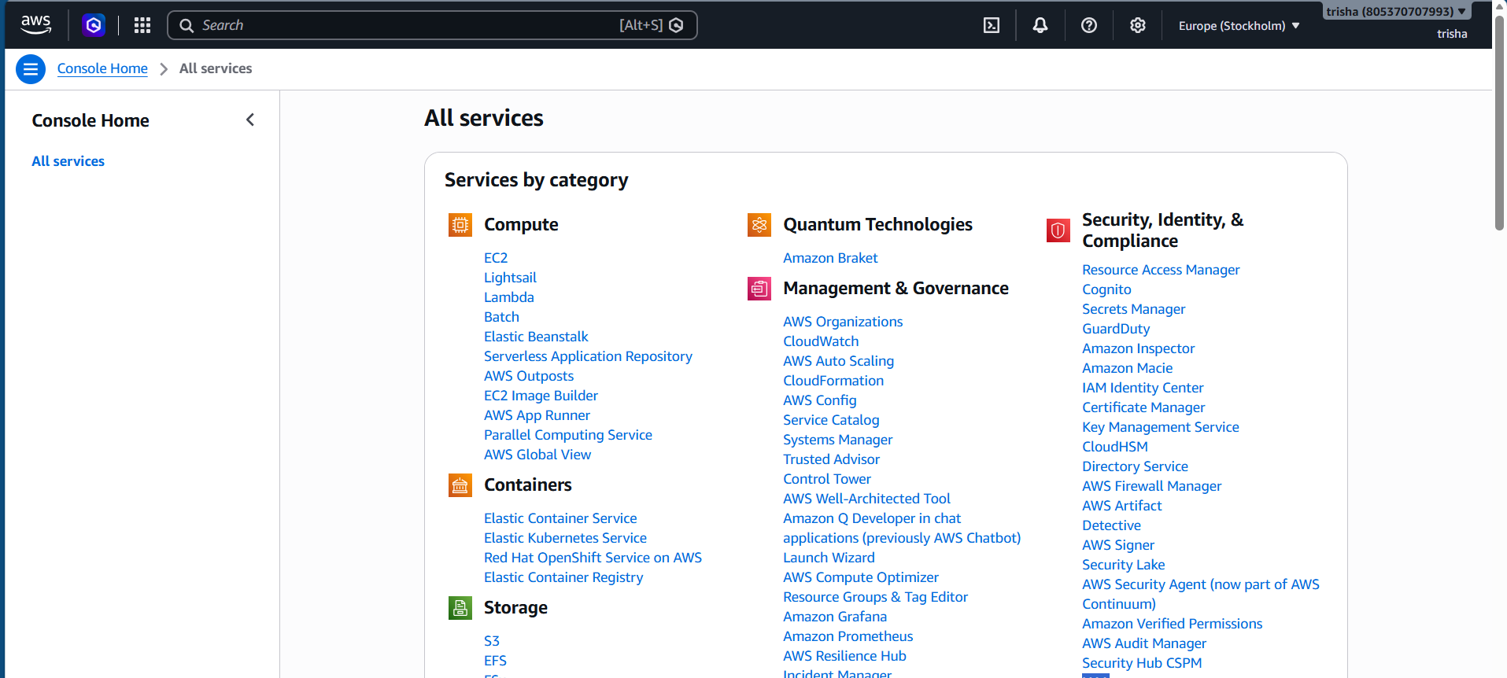

S3 storage setup
S3 page in the Europe (Stockholm) eu-north-1 region
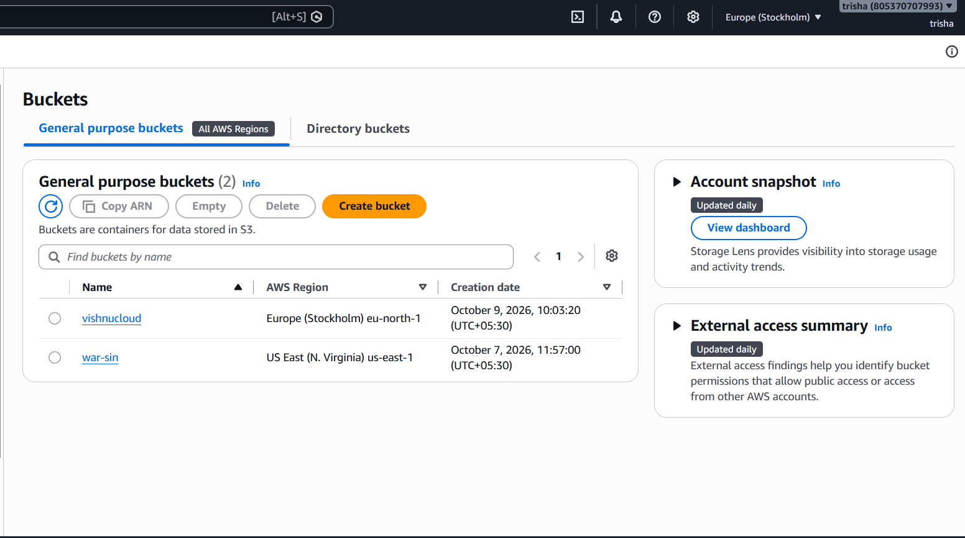
Creating a general purpose bucket in eu-north-1 named my-bucket345-805370707993-eu-north-1-an
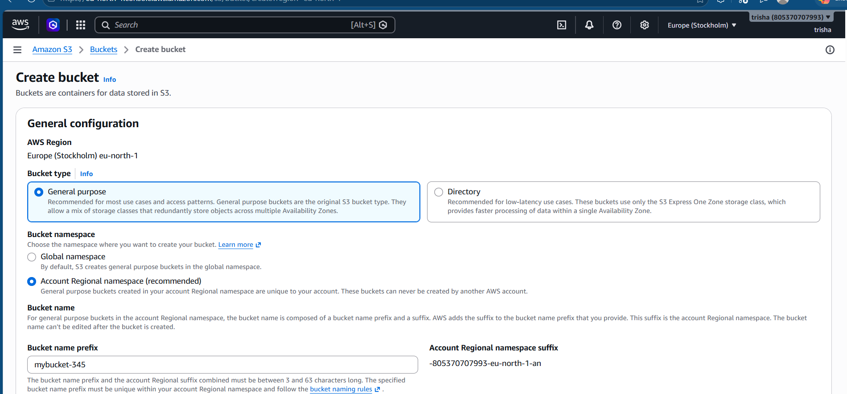

New bucket created successfully;it holds 0 objects so far
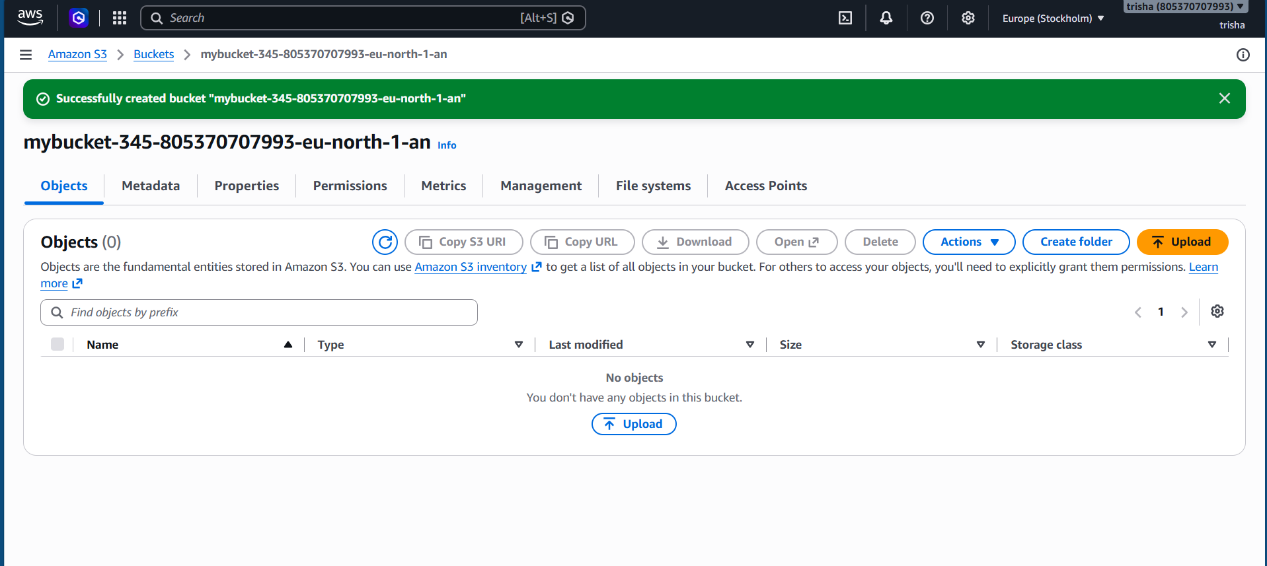
Iam role creation
Trusted entity type chosen: aws service
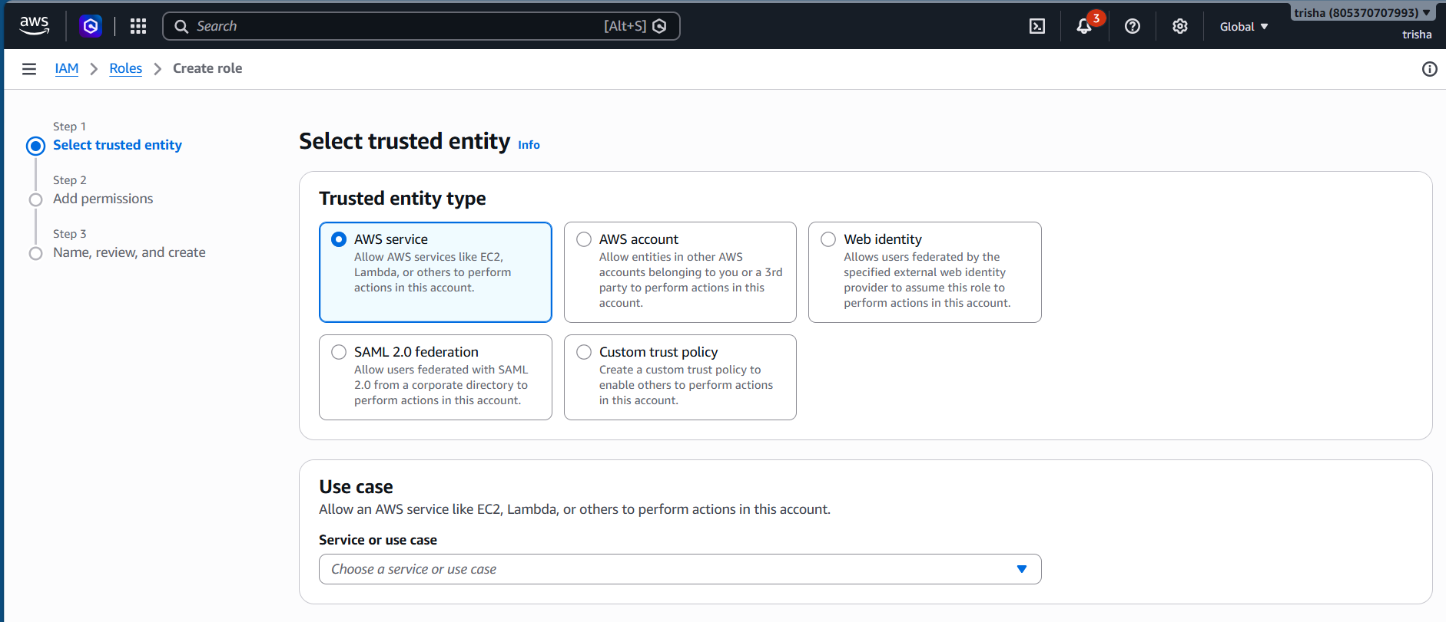

Glue chosen as the service use case
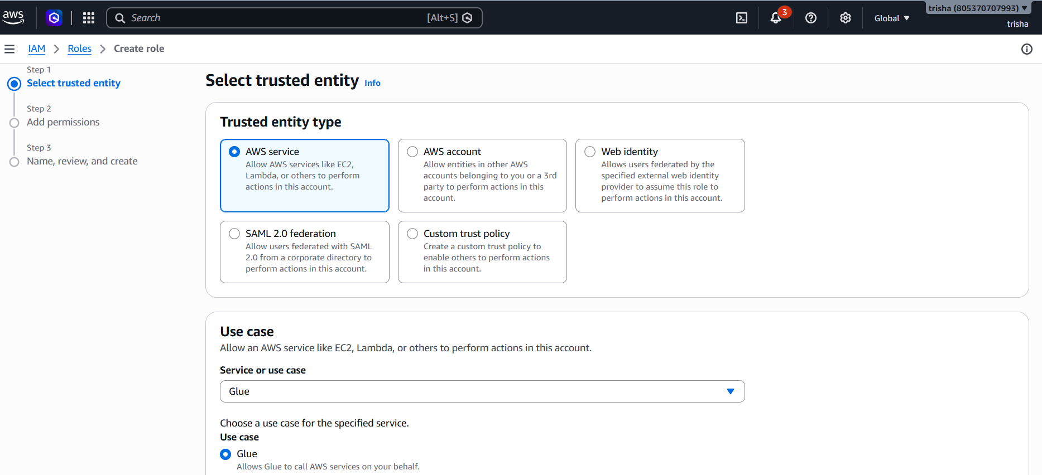
Permission step with the amazons3fullaccess policy ticked
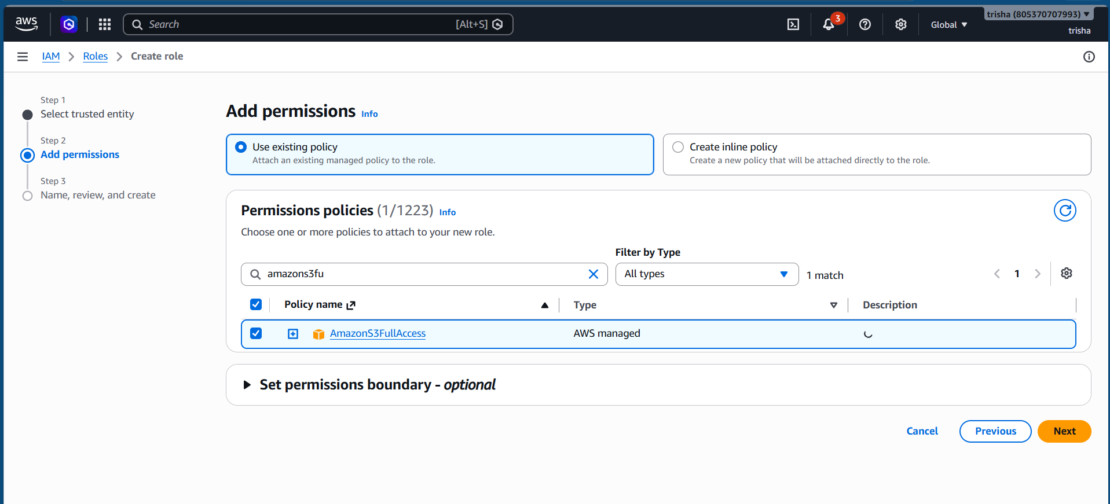

Confirmation message that the role trishagluerole was created
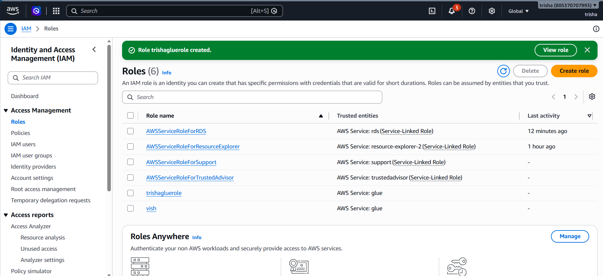

Role used by aws glue:awsglueemployeerole,carrying the amazons3full access and awsglueservicerole policies
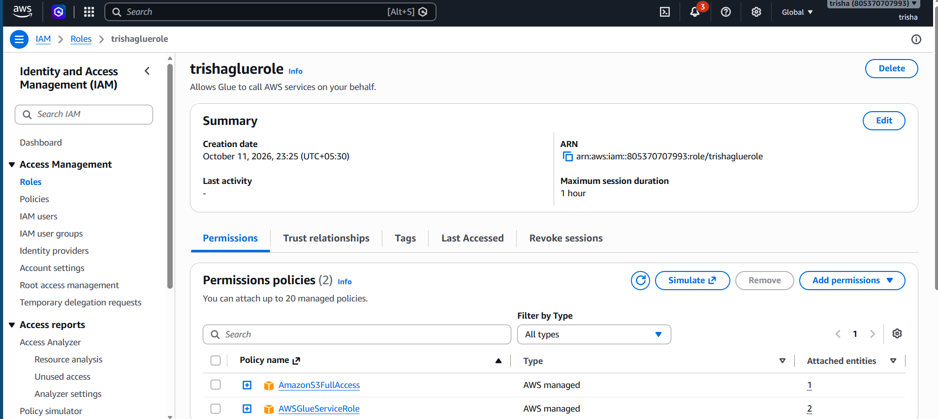
Glue desktop setup
Data catalog database glue_training_db showing its properties and table list
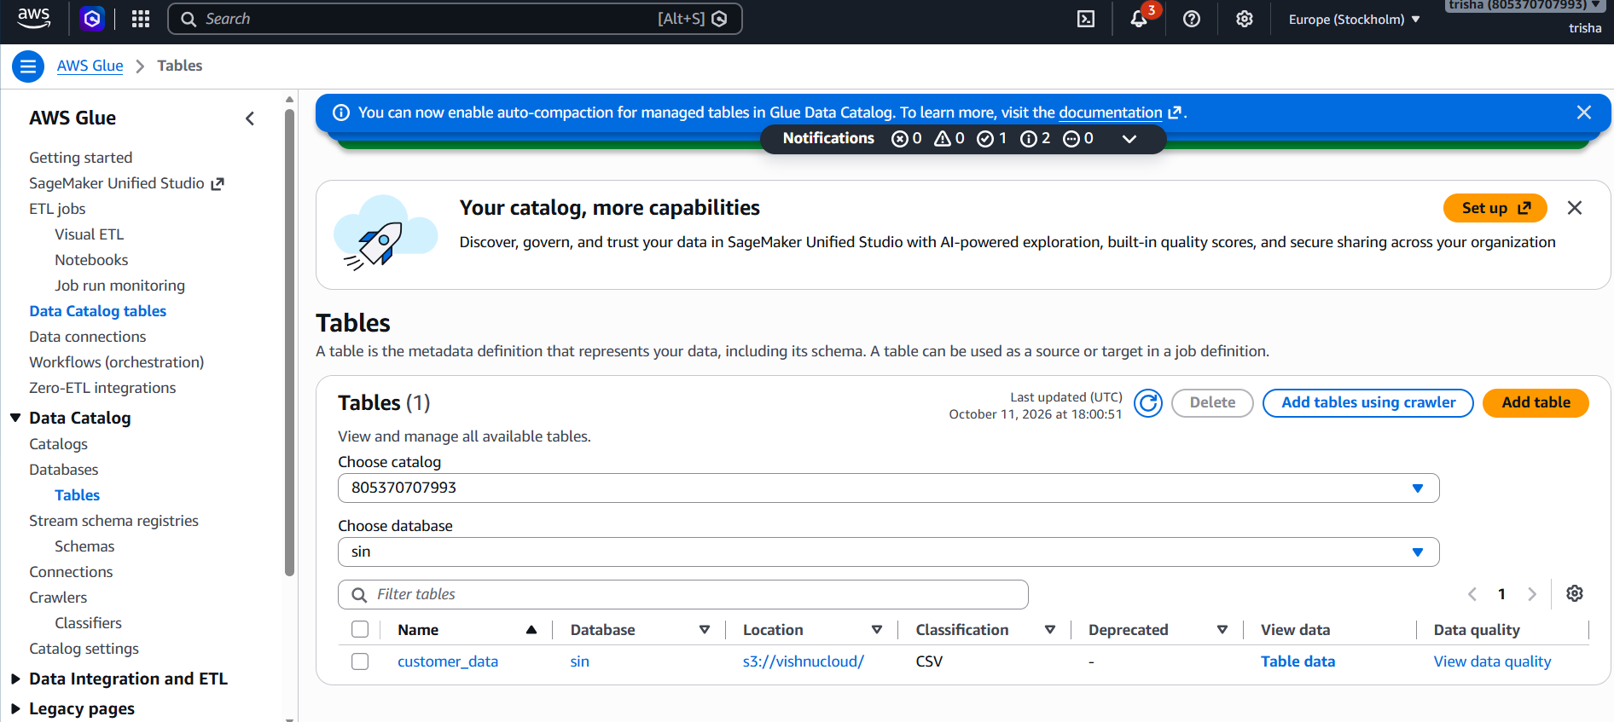

Crawler setup
Crawler employee_crawler with an s3 source,iam role awsglueemployeerole and target database glue_training_db
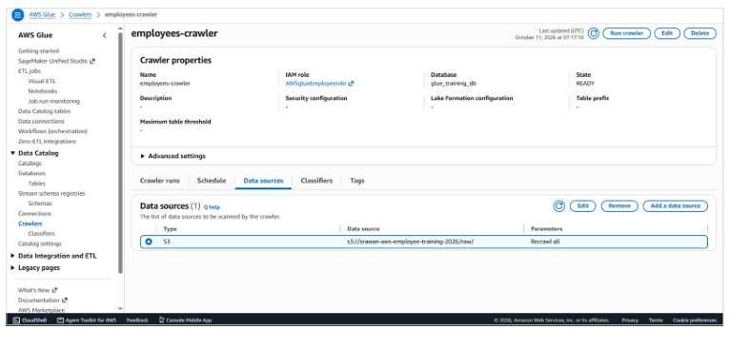

Review page of the crawler:properties, data source, security settings and out put, with an on demand schedule
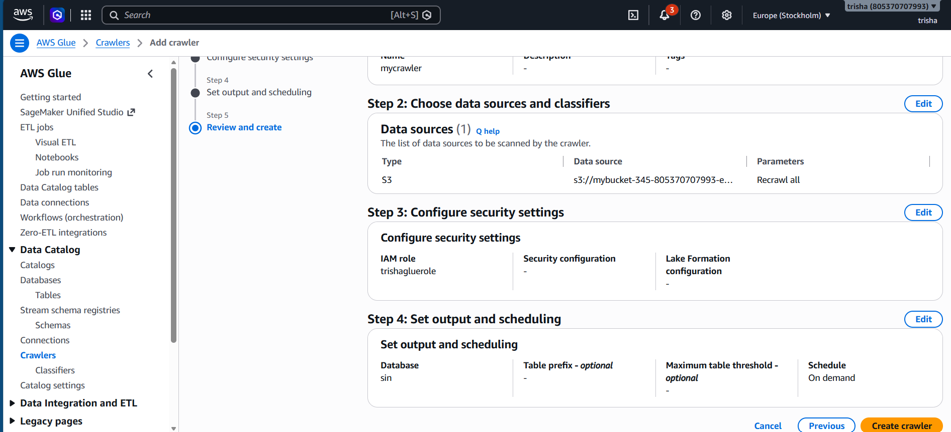
Running crawler
Crawler runs listed as completed, with the crawler state showing ready
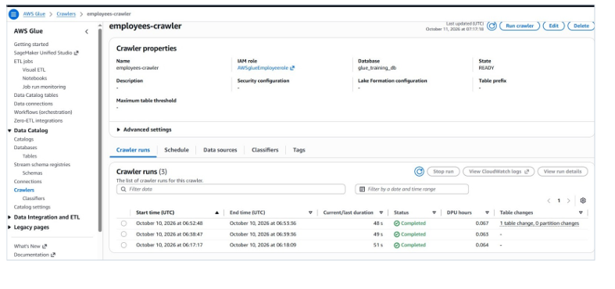
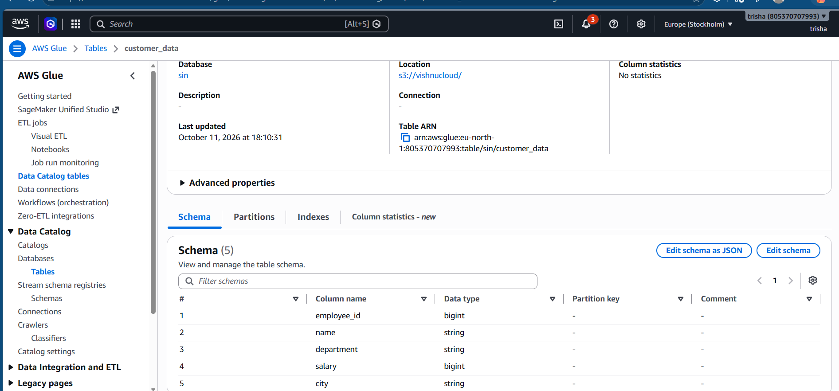

. Visual ETL Job Design

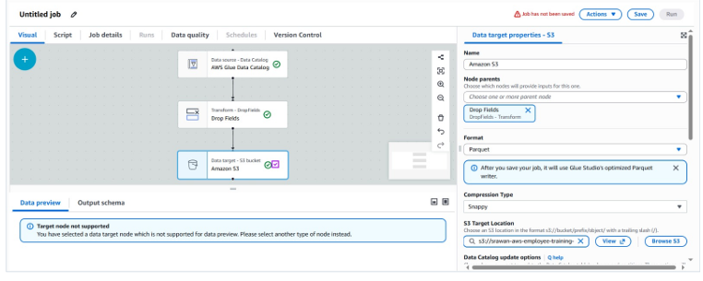

Data Transformation Step

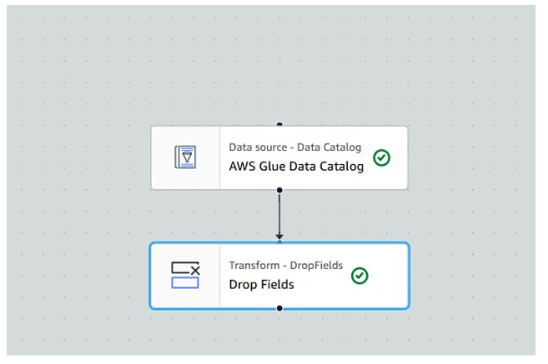

Output Target Settings

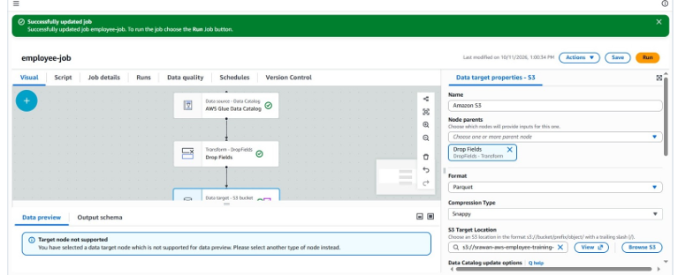

Running the ETL Job

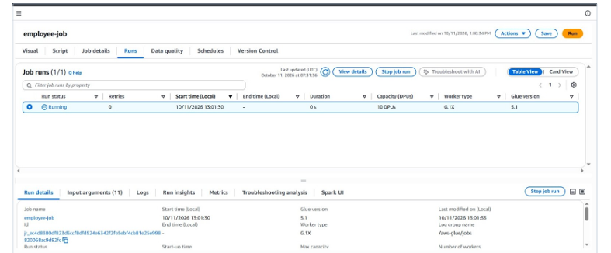

Catalog Table Details
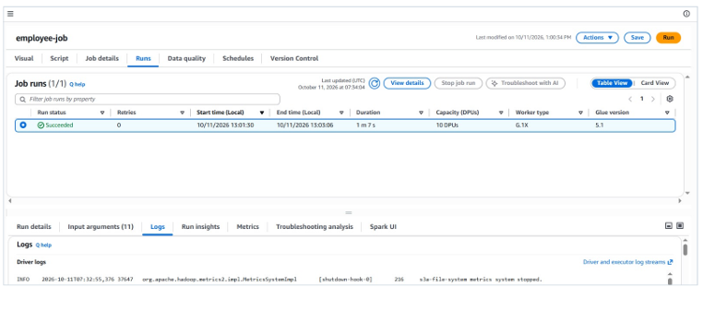

Curated Output in S3
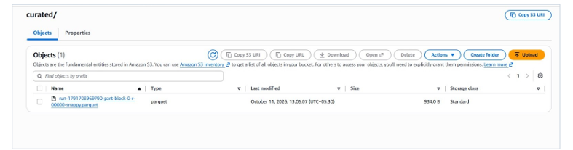

Final Explanation
Overall Idea
This assignment demonstrates how employee data can be stored, processed, and transformed using AWS cloud services, starting with a CSV file and producing structured Parquet output.
1. Amazon S3
I created an S3 bucket with two folders, raw and curated. The raw folder stores the original employee CSV file, while the curated folder is used to store the processed output.
2. IAM Role
I configured an IAM role to provide AWS Glue with the necessary permissions to access the S3 bucket and perform the required data processing operations.
3. AWS Glue Crawler
I configured a Glue crawler to scan the raw data folder. The crawler detected the structure of the CSV file and identified its columns and data types.
4. Glue Data Catalog
The crawler created a table in the glue_training_db database containing metadata about the employee dataset, including employee_id, name, department, salary, and city.
5. Visual ETL Job
I created a Visual ETL job in AWS Glue Studio by connecting the data source, transformation, and target nodes. This allowed me to design the data processing workflow visually without writing transformation code.
6. Data Transformation
I used the Drop Fields transformation to remove the city column from the employee dataset while retaining the remaining fields for further processing.
7. Output Generation
The transformed data was written to the curated S3 folder in Parquet format with Snappy compression. I verified the successful job execution and checked that the output files were generated.
Workflow: Amazon S3 (Raw CSV) → AWS Glue Crawler → Glue Data Catalog → Glue Visual ETL → Drop Fields → Amazon S3 (Curated Parquet)

