C TRISHA
23BTREC003
HCLTFP2264757
HCL assignment
QUESTION 1
SECTION A – ADVANCED SQL
Question 1: Database Design and Advanced Queries (8 Marks)
Question: Create a database named EnterpriseDB. Create Employees and Departments tables with appropriate data types, constraints, primary keys, and foreign keys. Insert at least 15 employees and 5 departments, including one department without employees. Write queries to display employee, department, and manager names; employees earning above their department average; the second-highest distinct salary; and the top three salary ranks per department, including ties.
Answer 1: Create the database and tables
Explanation:
- CREATE DATABASE creates the database.
- PRIMARY KEY uniquely identifies each record.
- VARCHAR stores text, INT stores integers, and DECIMAL stores salary values.
- FOREIGN KEY maintains relationships between tables.
- NOT NULL ensures that a required field cannot be empty.

Q1(a) Display employee names, department names, and manager names
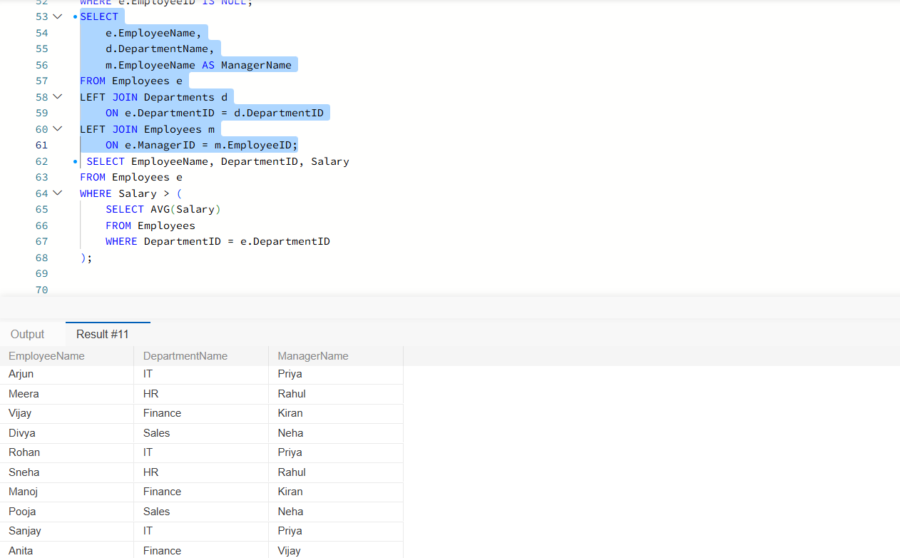
Explanation: Joins combine related information from tables. The first join finds the department, and the second join finds the manager. LEFT JOIN keeps employees even when they do not have a manager.

Q1(b) Find employees earning above their department average
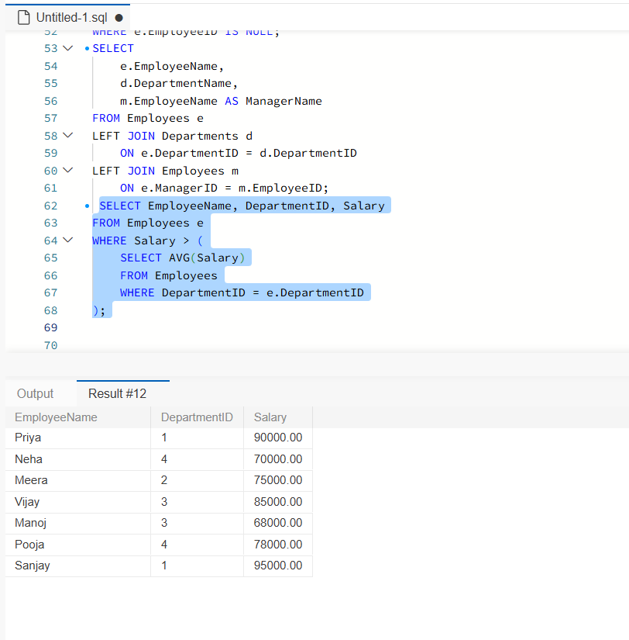
Explanation: The subquery calculates the average salary for each employee's department. The outer query displays employees earning more than that average.
Q1(c) Find the second-highest distinct salary
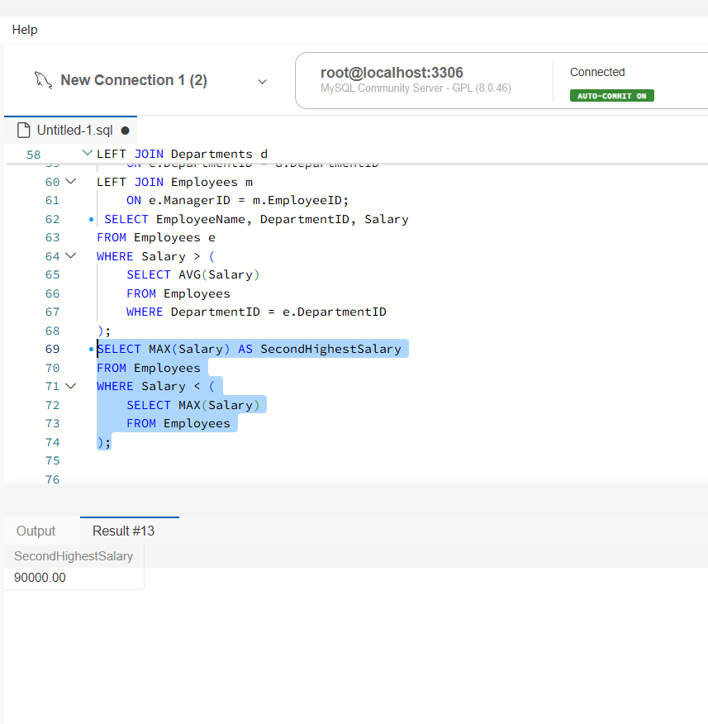
Explanation: The inner query finds the highest salary. The outer query finds the highest salary below it. This returns the second-highest distinct salary without using LIMIT, TOP, or FETCH FIRST.
Q1(d) Rank employees by salary within each department
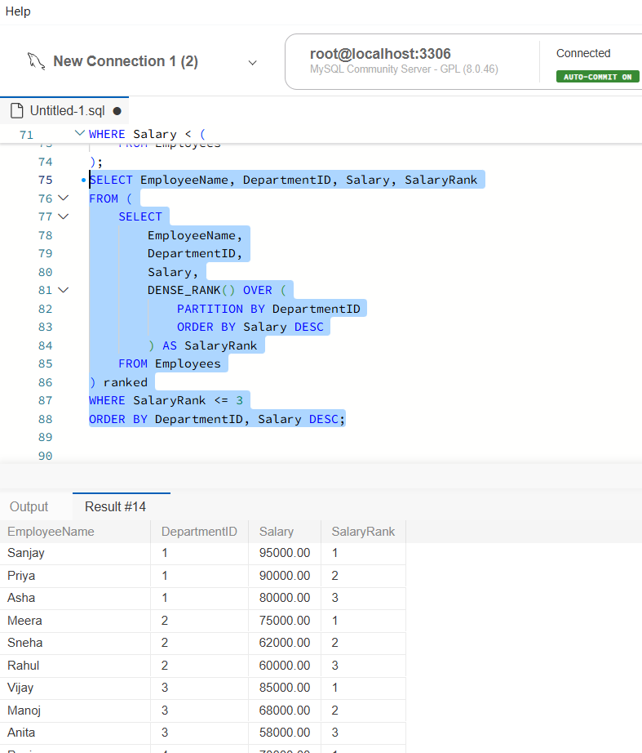
Explanation: DENSE_RANK() assigns ranks based on salary. PARTITION BY restarts the ranking for each department. Employees with equal salaries receive the same rank, so ties are retained.
Question 2: Sales Analytics and Query Optimization (6 Marks)
Question: Create a Sales table with SaleID, CustomerID, SaleDate, ProductName, Quantity, and UnitPrice. Insert 15 records. Calculate total revenue per product, monthly revenue and month-over-month change using a window function, and rewrite a date filter to improve potential index usage.
Q2(a) Calculate total revenue per product
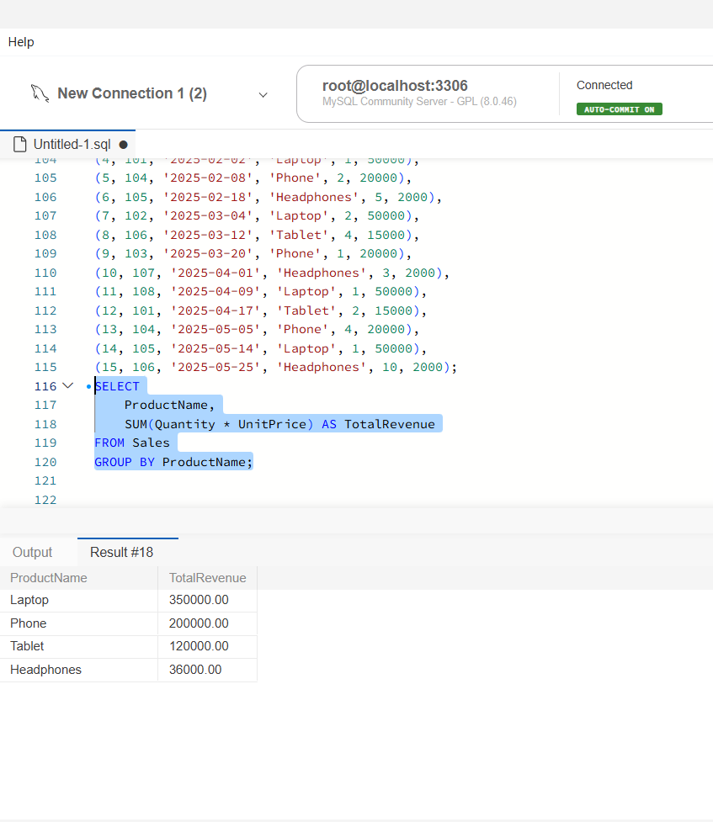
Explanation: SUM() calculates total revenue, while GROUP BY combines sales belonging to the same product.
Q2(b) Calculate monthly revenue and month-over-month change
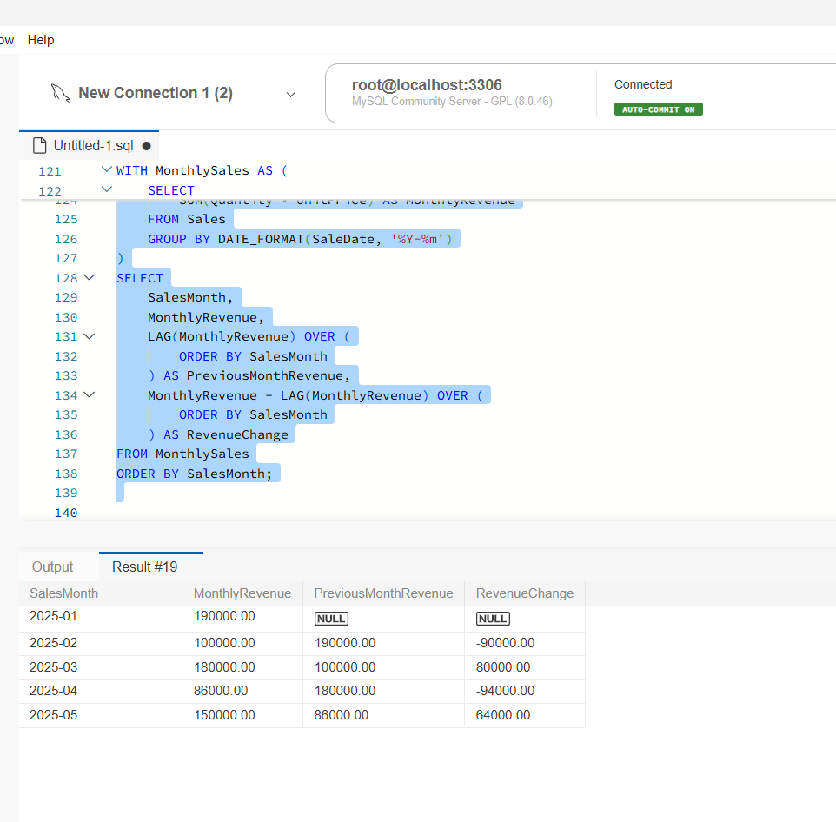
Explanation: The first query calculates revenue for each month. LAG() retrieves the previous month's revenue. Subtracting the previous month's revenue from the current month's revenue gives the change.
Q2(c) Rewrite the query for better index usage
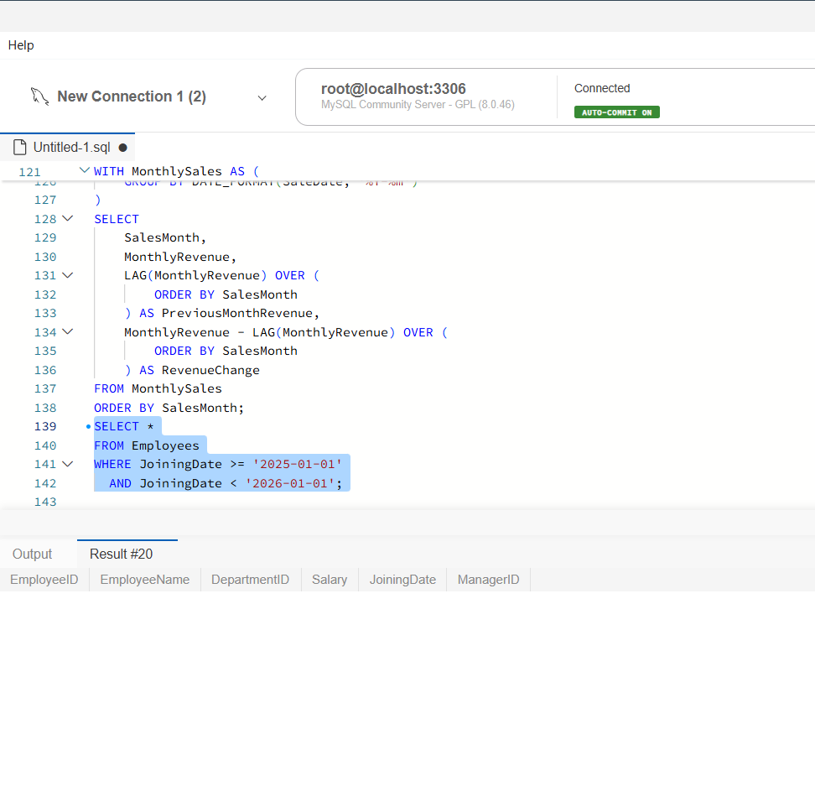
Explanation: Applying YEAR() to a column may prevent efficient use of a regular index on that column. A date range makes an index range scan more likely when an appropriate index exists.
Question 3: SQL Troubleshooting (6 Marks)
Question: Explain how an execution plan identifies expensive operations, recommend an index strategy for filtering by DepartmentID and Salary, and identify duplicate customer email addresses.
Q3(a) Explain execution plans
An execution plan shows how the database executes a query. It helps identify performance problems such as full table scans, inefficient joins, and expensive sorting operations.
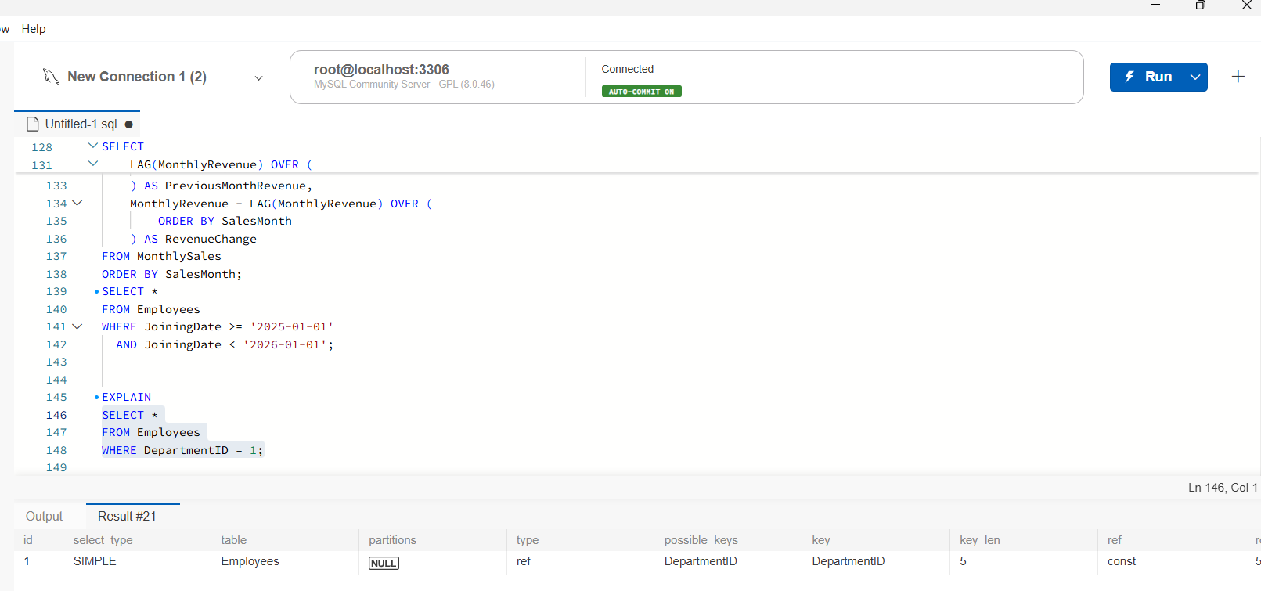
Explanation: EXPLAIN shows how MySQL plans to execute a query. It provides information about table scans, indexes, estimated rows, and join operations. This helps identify potentially inefficient queries and areas for optimization.
Q3(b) Recommend an index strategy
I would create a composite index on DepartmentID and Salary because queries frequently filter using these columns.
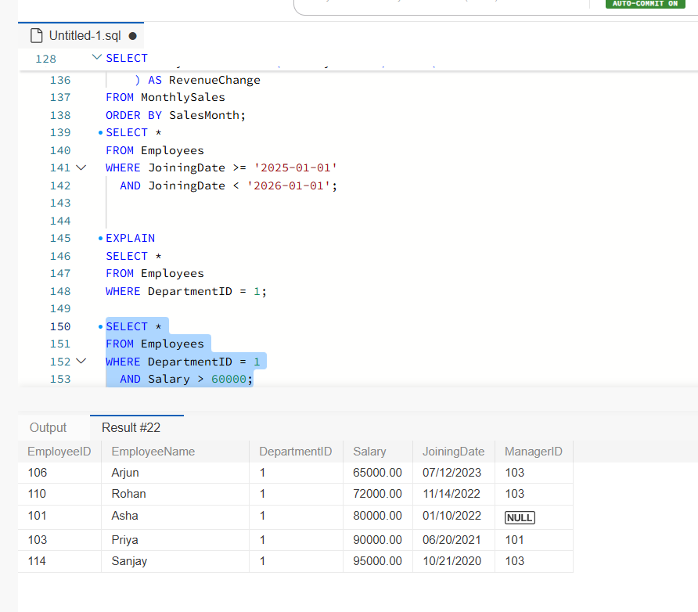
Explanation: A composite index on DepartmentID and Salary can help queries filtering by department and salary range. Index effectiveness should be checked using execution plans and actual query patterns.
Q3(c) Identify duplicate customer email addresses
I would use GROUP BY to group identical email addresses and HAVING COUNT(*) > 1 to display only duplicates.
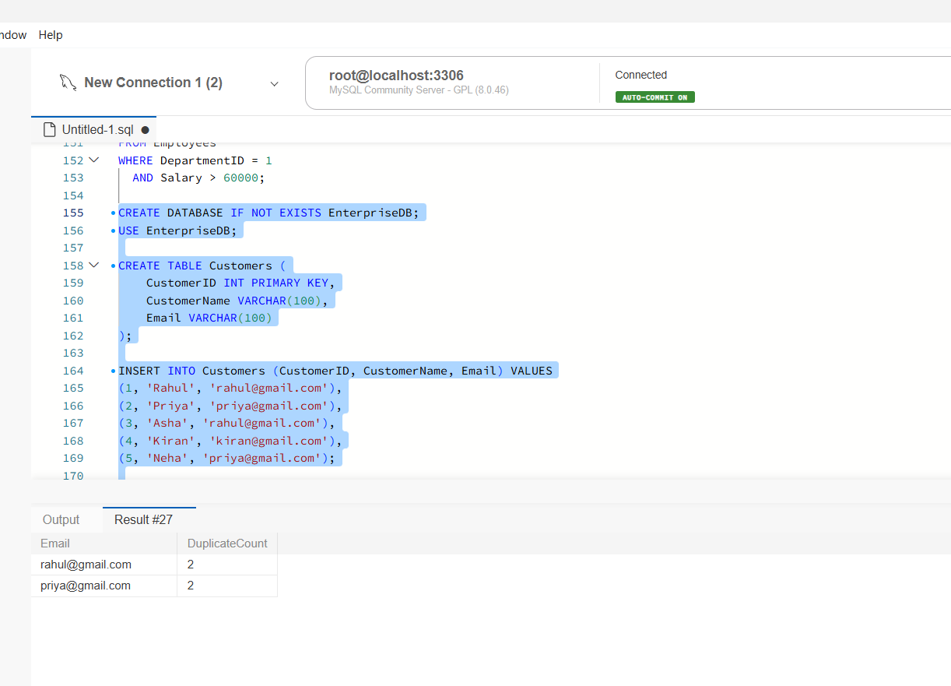
Explanation: GROUP BY groups identical email addresses. COUNT(*) counts the records in each group. HAVING COUNT(*) > 1 displays only email addresses that occur more than once.
Note: The sample code drops and recreates the Customers table each time, so its sample data can be inserted again safely.
SECTION B – LINUX
Question 4: Log Analysis (5 Marks)
Question: Use /var/log/application.log to find all ERROR entries, display the last 20 error entries, count errors, extract errors for a specified date into a separate file, and explain how to count errors for each hour.
Example log entry:
2026-10-28 10:15:23 ERROR payment-service Transaction failed
Q4(a) Find all ERROR lines
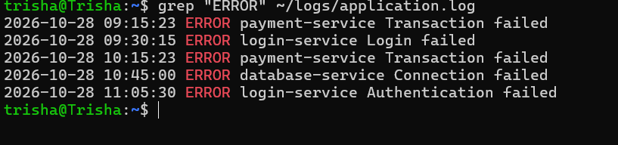
Linux command:
grep "ERROR" /var/log/application.log
Explanation: grep searches the log file and displays every line containing the word ERROR.
Q4(b) Display the last 20 error entries
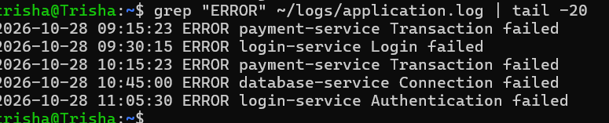
grep "ERROR" /var/log/application.log | tail -20
Explanation: grep selects error lines, and tail -20 displays the last 20 matching lines.
Q4(c) Count the total number of errors
grep -c "ERROR" /var/log/application.log
Explanation: The -c option counts the lines that match ERROR.
Q4(d) Extract errors for a specific date into a separate file
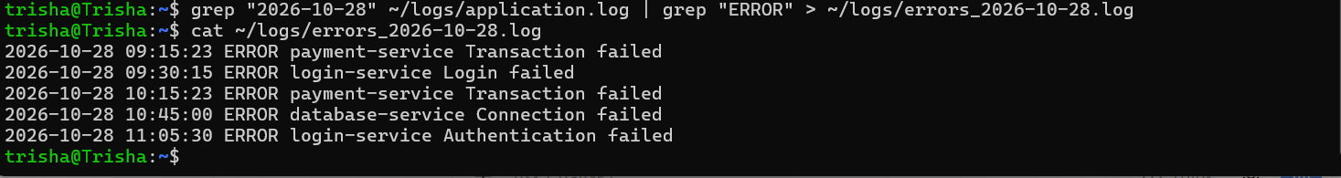
grep "2026-10-28" /var/log/application.log | grep "ERROR" > errors_2026-10-28.log
Explanation: The first grep filters by date, and the second filters by error status. The > operator saves the matching lines into a new file called errors_2026-10-28.log.
Replace 2026-10-28 with the required date.
Q4(e) Count errors for each hour
grep "ERROR" /var/log/application.log |
awk '{print substr($2,1,2)}' |
sort | uniq -c
Explanation:
- grep selects error entries.
- awk extracts the hour from the time field, such as 10 from 10:15:23.
- sort groups matching hours together.
- uniq -c counts the entries for each hour.
This command counts errors across all dates in the log. To count errors for only one date, filter by that date before extracting the hour.
Question 5: Linux Permissions and System Troubleshooting
Question: Create a group named finance, create a report file, set the required permissions, identify processes using the highest CPU, check memory and filesystem usage, and find files larger than 100 MB in an application directory.
Q5(a) Create a group named finance
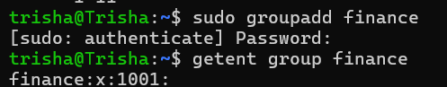
Command:
sudo groupadd finance
Explanation: The groupadd command creates a new group named finance. The sudo command provides administrator privileges.
To verify the group:
getent group finance
Q5(b) Create a report file
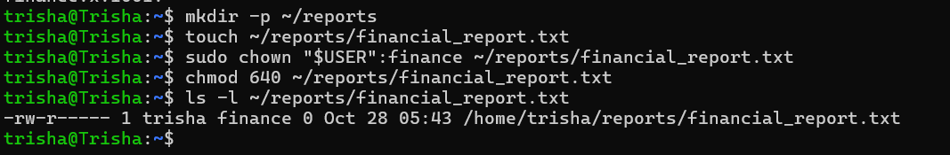
Commands:
mkdir -p ~/reports
touch ~/reports/financial_report.txt
Explanation:
- mkdir -p creates the reports directory.
- touch creates an empty file named financial_report.txt.
Q5(c) Set the owner and group
Command:
sudo chown "$USER":finance ~/reports/financial_report.txt
Explanation: The chown command sets the current user as the file owner and finance as the group.
Q5(d) Set the required permissions
Command:
chmod 640 ~/reports/financial_report.txt
Explanation: The permissions are set as follows:
Permission value | Access
6 | Owner can read and write
4 | Group can read only
0 | Others have no access
To verify the permissions:
ls -l ~/reports/financial_report.txt
Expected permission format:
-rw-r-----
Q5(e) Identify processes using the highest CPU
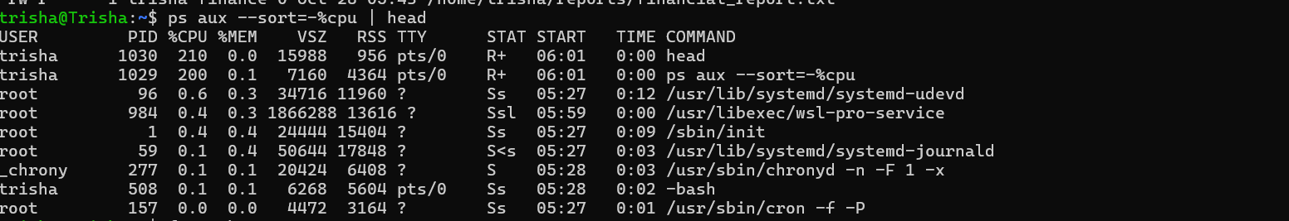
Command:
ps aux --sort=-%cpu | head
Explanation: ps aux lists running processes. The sorting option displays processes in descending CPU usage order, and head shows the first lines.
To monitor CPU usage live:
top
Press q to exit.
Q5(f) Check memory usage
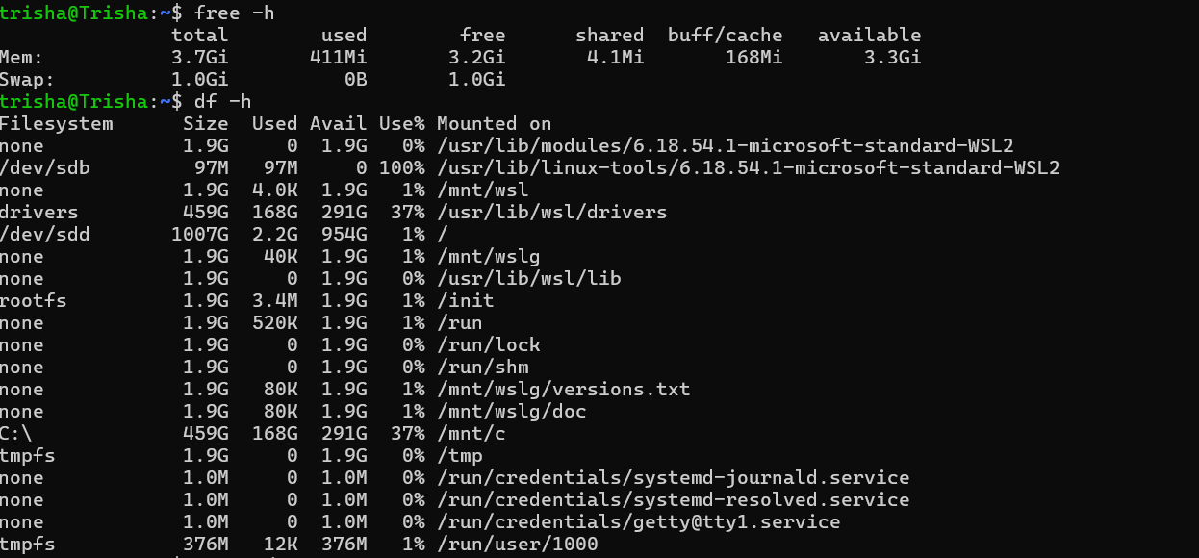
Command:
free -h
Explanation: Displays total, used, and available RAM in a human-readable format.
Q5(g) Check filesystem usage
Command:
df -h
Explanation: Displays filesystem capacity, used space, available space, and percentage of disk usage.
Q5(h) Find files larger than 100 MB
Command:
find ~/reports -type f -size +100M
Explanation:
- find searches for files.
- -type f selects regular files.
- -size +100M selects files larger than 100 MB.
For an actual application directory, replace ~/reports with the application directory path.
Conclusion for Question 5
Linux commands such as groupadd, chmod, chown, ps, free, df, and find help manage groups, file permissions, system resources, and large files.
Question 6: Bash Backup Script
Question: Write a Bash script named backup_check.sh that accepts source and destination directories, validates the arguments, checks whether the source directory exists, creates the destination directory if necessary, generates a timestamped compressed archive, displays success or failure messages, and demonstrates valid and invalid arguments.
Q6(a) Create the working directory and sample files
Commands:
mkdir -p ~/backup_practice
cd ~/backup_practice

mkdir -p ~/backup_practice/source
echo "This is my first file" > ~/backup_practice/source/file1.txt
echo "This is my second file" > ~/backup_practice/source/file2.txt
Explanation: These commands create a practice directory, a source directory, and two sample files to back up.
Q6(b) Create the backup script
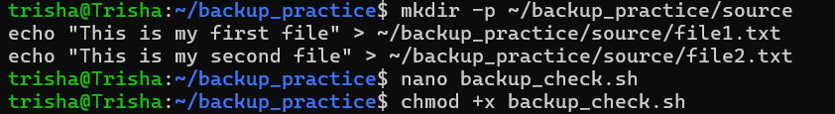
Command:
nano backup_check.sh
Explanation: The script checks the arguments and source directory, creates the destination directory when needed, and creates a compressed backup archive with a timestamp.
Save the script using Ctrl + O, press Enter, and exit using Ctrl + X.
Q6(c) Make the script executable
Command:

chmod +x backup_check.sh
Explanation: The chmod +x command gives the script execute permission.
Q6(d) Run the script with valid arguments
Command:
./backup_check.sh ~/backup_practice/source ~/backup_practice/backups
Expected output:
Backup successful: /home/youruser/backup_practice/backups/backup_20261028_111500.tar.gz
The timestamp and username will differ on your system.
Explanation: The script reads files from the source directory and creates a compressed backup in the destination directory.
Q6(e) Verify the backup archive
Command:
ls -lh ~/backup_practice/backups
Explanation: Lists the backup archive and displays its size.
To inspect the archive contents:
tar -tzf ~/backup_practice/backups/backup_*.tar.gz
You should see the sample files, including file1.txt and file2.txt.
Q6(f) Test invalid arguments
Test 1: Run without arguments
./backup_check.sh
Expected output:
Usage: ./backup_check.sh <source_directory> <destination_directory>
Explanation: The script displays a usage message because it requires two arguments.
Q6(g) Test an invalid source directory
Command:
./backup_check.sh ~/wrong_folder ~/backup_practice/backups
Expected output:
Error: Source directory does not exist.
Explanation: The script checks whether the source directory exists. If it does not exist, the script displays an error and stops.

SECTION C: PYSPARK DATA ENGINEERING
Question 7: PySpark DataFrame Operations
Objective
To create a PySpark DataFrame, perform filtering and column operations, calculate department-wise statistics, and identify the five highest-paid employees.
Procedure and Implementation
- Created a SparkSession to initialize the PySpark application.
- Created an employee DataFrame containing EmployeeID, EmployeeName, Department, Salary, and JoiningDate, with at least 15 records.
- Displayed the schema and the first five records using printSchema() and show(5).
- Filtered employees earning more than ₹60,000 per month using filter().
- Created an AnnualSalary column by multiplying monthly salary by 12 using withColumn().
- Grouped employees by department and calculated average salary and employee count using groupBy(), avg(), and count().
- Sorted employees by salary in descending order and displayed the five highest-paid employees.
Result
The PySpark program successfully demonstrated DataFrame creation, filtering, derived columns, aggregation, and sorting.

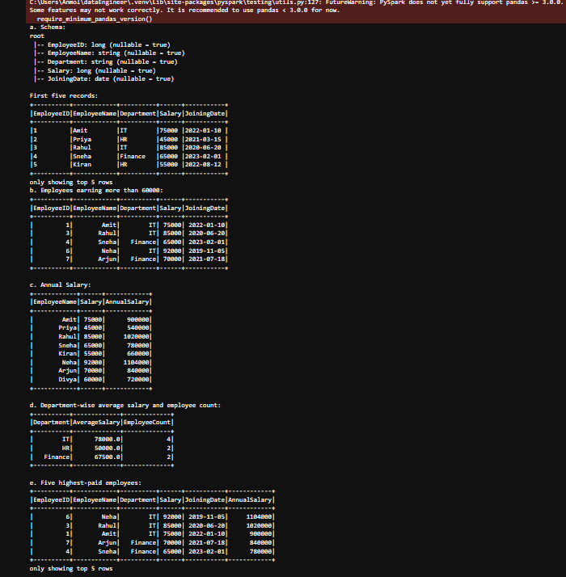
Question 8: Data Cleaning and Aggregation
Objective
To clean transaction data using PySpark by removing duplicates, handling missing values, correcting date formats, calculating revenue, and generating product-wise revenue summaries.
Procedure and Implementation
- Created a CSV file named transactions.csv with the columns TransactionID, CustomerID, TransactionDate, Product, Quantity, and UnitPrice.
- Included sample records containing a duplicate transaction, a missing quantity, a missing unit price, and an incorrectly formatted date.
- Loaded the CSV file into a DataFrame using the header option and schema inference.
- Removed duplicate transactions using dropDuplicates(["TransactionID"]).
- Handled missing values by replacing missing quantities with 1, missing unit prices with 0.0, and missing product names with "Unknown". These replacements are demonstration choices; in a real system, missing quantities or prices may need to be rejected or investigated.
- Converted TransactionDate into a date or timestamp type. Invalid dates were handled using a tolerant parsing function such as try_to_timestamp() so that malformed values become null rather than stopping the job.
- Calculated revenue using Quantity × UnitPrice.
- Grouped the cleaned records by Product, calculated total revenue, and sorted the results in descending order.
Result
The program demonstrated duplicate removal, missing-value handling, invalid-date detection, revenue calculation, and product-wise aggregation.
Screenshot 8.4: Attach the total revenue by product in descending order.
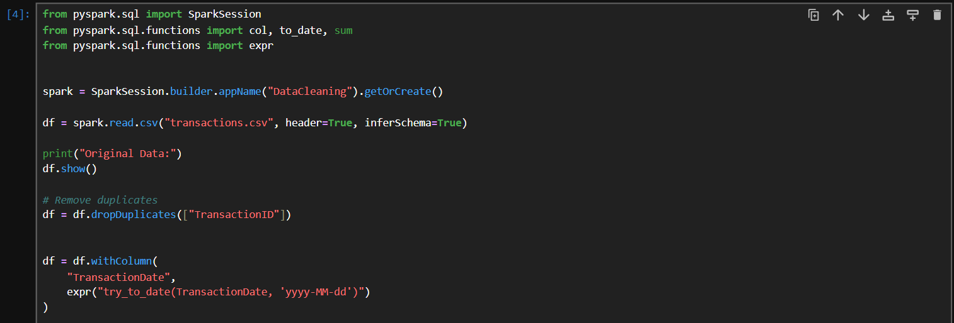
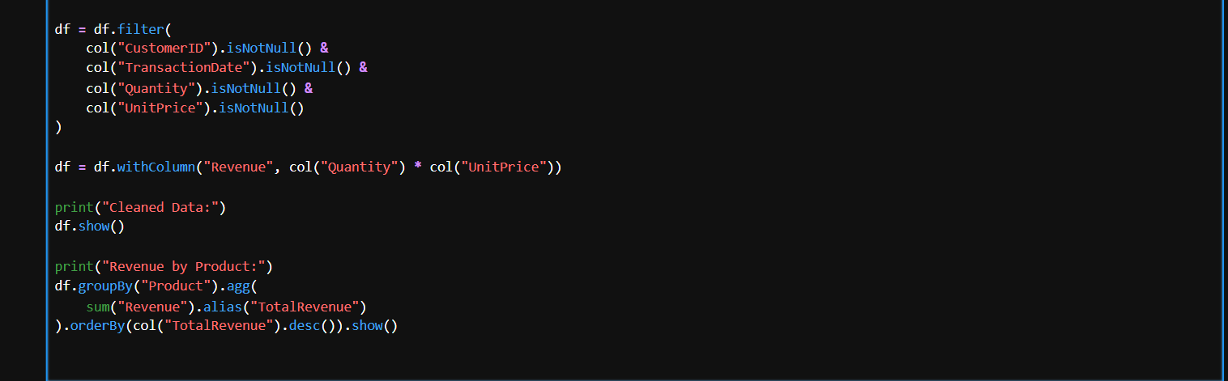
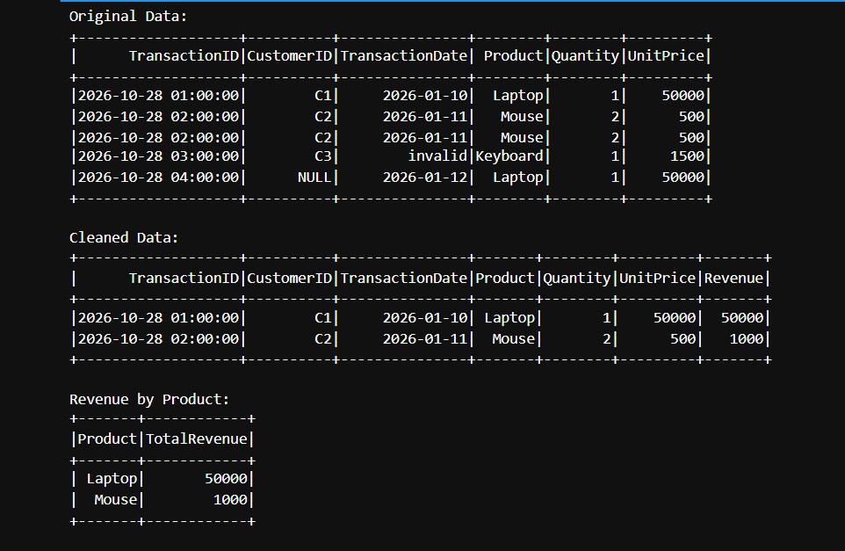

Question 9: PySpark Joins and Performance
Objective
To join customer and order datasets, identify customers without orders, calculate city-wise order totals, and understand PySpark transformations and actions.
Explanation
a. Loading datasets: Customer and order records are loaded into separate DataFrames.
b. Joining datasets: An inner join on CustomerID displays orders with the corresponding customer details.
c. Customers without orders: A left-anti join returns customers whose CustomerID does not appear in the Orders DataFrame.
d. Total order value by city: The joined DataFrame is grouped by City, and the sum of OrderAmount is calculated.
e. Broadcast join: A broadcast join is useful when one DataFrame is small enough to fit comfortably in the memory of each executor. Spark can distribute the smaller DataFrame to avoid shuffling the larger dataset. It should be used when the size of the smaller dataset and available memory make broadcasting appropriate.
f. Transformations and actions:
- Transformation: filter() or select() defines a new DataFrame and is evaluated lazily.
- Action: show(), count(), or collect() triggers execution and returns a result or output.
Result
The program demonstrates customer-order joins, identification of customers without orders, city-wise aggregation, and the use of broadcast joins.
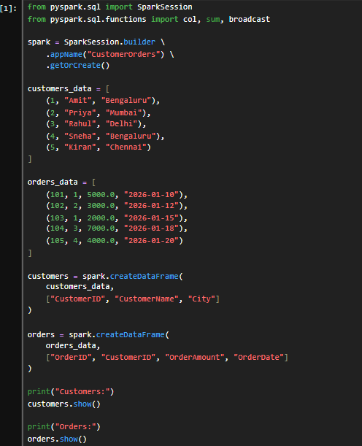
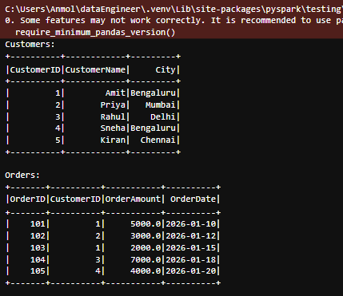
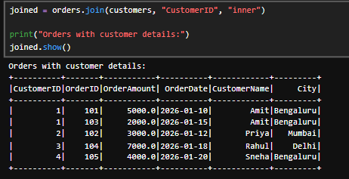
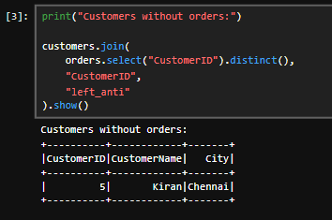
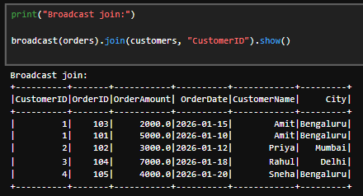
f. Transformations vs. Actions
- Transformations: Create a new DataFrame or execution plan. Example: filter().
- Actions: Execute computations and return results. Example: show().

SECTION D: AWS CLOUD SERVICES
Question 10: S3 and IAM Security
Objective
To securely store confidential employee reports in Amazon S3 and restrict access to authorized HR employees.
Procedure
- Create an S3 bucket with a globally unique name.
- Keep S3 Block Public Access enabled.
- Upload a sample employee report.
- Enable server-side encryption, preferably SSE-S3 or SSE-KMS according to organizational requirements.
- Create an IAM policy that permits authorized HR users to list the designated bucket and read objects in it.

Verification
- Confirm that Block Public Access is enabled.
- Test access using an authorized HR identity.
- Test access using an identity without permission and confirm that the read request is denied.
- Confirm that encryption is enabled for the uploaded object.
Explanation
Encryption at rest protects stored data by encrypting the object while it is stored. Access controls determine who can retrieve and decrypt the data. Both are important for protecting confidential reports.
Result
The proposed S3 configuration and IAM policy restrict report access to the intended authorized identities while keeping the bucket private.
a. Create an S3 bucket with Block Public Access enabled and upload a sample file. (1 mark)
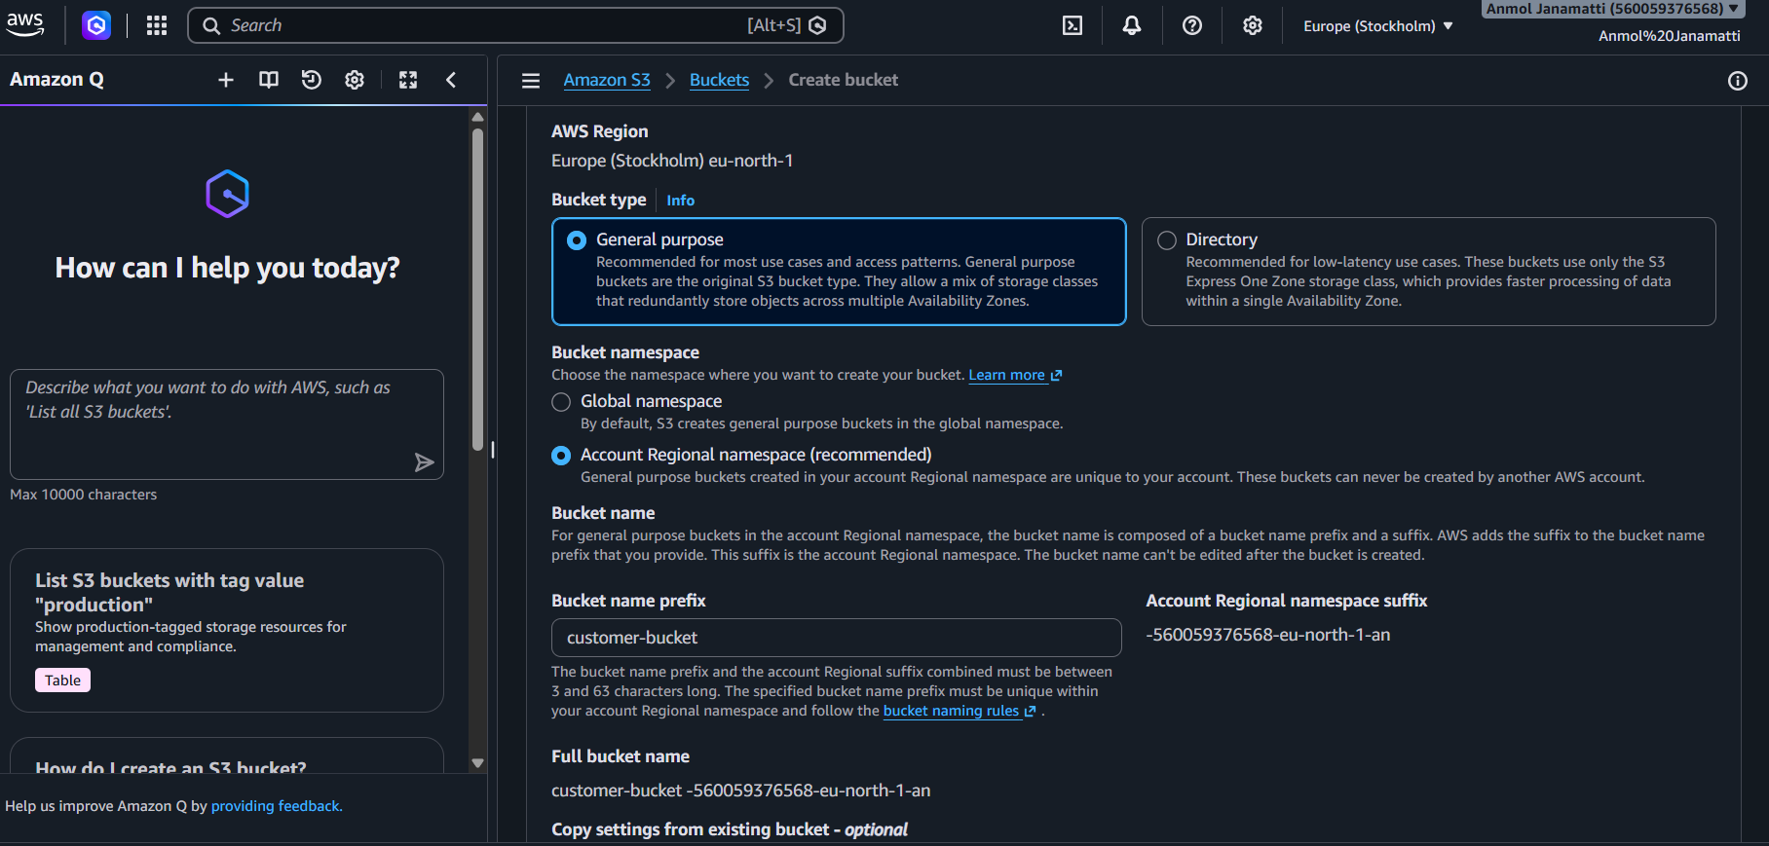

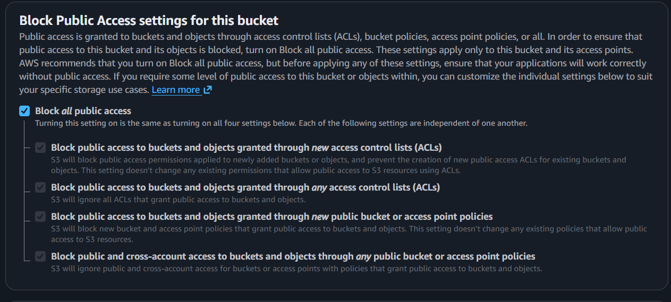
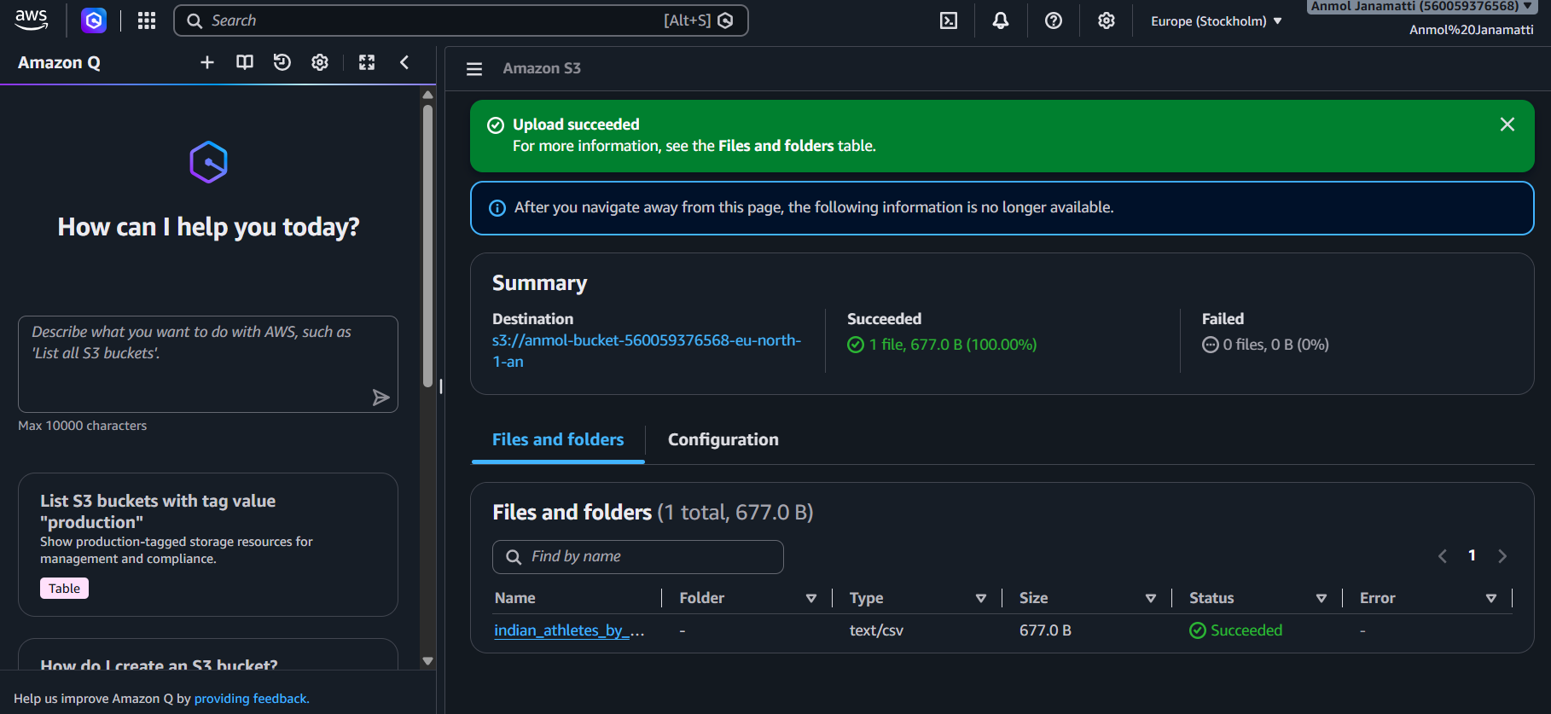

b. Design an IAM policy that grants read access to objects in the designated bucket without granting access to unrelated buckets. (2 marks)
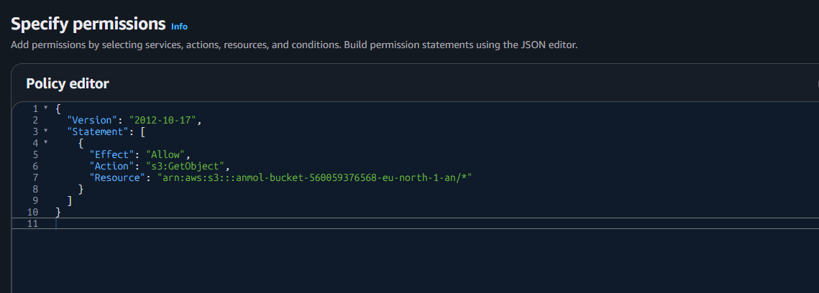
c. Explain how you would verify that an unauthorized user cannot read the file. (1 mark)
answer: If an unauthorized user tries to access the file, an Access Denied (403) error will occur. We can verify the failed access attempt using AWS CloudTrail logs (after enabling S3 data events).

d. Explain how encryption at rest protects the stored data. (1 mark)
answer: Encryption at rest protects stored data by encrypting it using encryption keys. Even if an unauthorized person gains access to the storage, they cannot read the data without the required decryption key. In AWS S3, this can be implemented using Server-Side Encryption (SSE).

Question 11: EC2 Troubleshooting and CloudWatch
Objective
To investigate EC2 application performance and connectivity issues and configure monitoring for high CPU utilization.
Procedure
a. Check instance status
- Open the Amazon EC2 console.
- Select the required instance.
- Check the instance state and system and instance status checks.
- Review the instance system log or console output if necessary.
b. Check connectivity
- Security groups act as virtual firewalls controlling inbound and outbound traffic.
- Missing inbound rules for the application port, such as TCP 80 or 443, can prevent connections.
- Route tables determine how traffic leaves or reaches a subnet.
- Network ACLs, DNS, operating-system firewalls, and application health should also be checked.
c. Configure a CloudWatch alarm
- Open Amazon CloudWatch and choose Alarms.
- Create an alarm using the EC2 CPUUtilization metric for the selected instance.
- Set the threshold to greater than 85%.
- Select the required evaluation period and number of periods.
- Configure an SNS notification if alerts are required.
- Review the alarm configuration and create it.
The exact alarm behavior depends on the selected metric period and evaluation settings.
d. Investigate high CPU
Use CloudWatch metrics to identify when CPU utilization increased. Review application logs, running processes, recent deployments, and operating-system monitoring data to identify the cause.
Result
EC2 status checks, network configuration, and CloudWatch alarms provide a systematic way to investigate connectivity and performance issues.
a. Check the EC2 instance state and status checks.
Open the AWS EC2 console and check whether the instance is in the Running state. Verify that both system status checks and instance status checks are passing.

b. Explain how security groups and route tables can affect application connectivity.
Security groups control incoming and outgoing traffic to the EC2 instance. Incorrect rules may block application traffic. Route tables determine where network traffic is sent, and incorrect routes can prevent users from connecting to the application.

c. Explain how to configure a CloudWatch alarm when CPU utilization exceeds 85% for a defined evaluation period.
Open Amazon CloudWatch and create an alarm for the EC2 instance's CPUUtilization metric. Set the threshold to greater than 85% and define the evaluation period. Configure an SNS notification to alert the administrator when the alarm is triggered.

d. Identify one method for investigating the root cause of high CPU utilization.
Use the EC2 instance's operating system tools, such as the top command in Linux, to identify processes consuming high CPU resources.

Question 12: Event-Driven Processing
Objective
To design an event-driven workflow that validates and processes CSV files uploaded to Amazon S3.
Proposed Architecture
Amazon S3 input bucket → S3 event notification → AWS Lambda → Process and validate CSV → Amazon S3 output location
Procedure
- Create an input S3 bucket for incoming CSV files.
- Create an AWS Lambda function containing the validation and processing logic.
- Configure an S3 event notification for object creation events, filtered to the required CSV files or input prefix.
- Grant the Lambda execution role permission to read input objects and write processed results to the output bucket or prefix.
- Configure CloudWatch Logs for the Lambda function.
- Handle exceptions and record failed processing attempts. For workloads requiring durable retries and failure isolation, configure an appropriate retry or dead-letter mechanism.
- Prevent duplicate processing by using an idempotency key based on the object key and version or event identifier.
- Avoid recursive triggering by writing output to a separate bucket or a prefix excluded from the trigger.
Explanation
Amazon S3 generates an event when a new object is uploaded. The event invokes Lambda, which reads and validates the file, processes its records, and stores the result. IAM permissions restrict access to the required locations. CloudWatch Logs support monitoring and troubleshooting.
Result
The design automates CSV processing through S3 events and Lambda while supporting logging, least-privilege permissions, and duplicate-processing protection.
a. Identify a suitable service for executing the processing code. (1 mark)
AWS Lambda is suitable for executing code to validate and process uploaded CSV files automatically.

b. Explain how an S3 upload can trigger processing. (1 mark)
Configure an S3 event notification to trigger the Lambda function whenever a new CSV file is uploaded to the input bucket.

c. Explain the IAM permissions needed to read the input file and write the results. (1 mark)
Assign an IAM execution role to Lambda with s3:GetObject permission for the input bucket and s3:PutObject permission for the output bucket.

d. Explain how errors and processing logs can be captured. (1 mark)
Use Amazon CloudWatch Logs to store Lambda execution logs and errors. CloudWatch can also be used to monitor failures.

e. Explain how to prevent duplicate processing or recursive triggering.
Use a separate S3 bucket for the processed results so that output uploads do not trigger the same Lambda function. To prevent duplicate processing, make the function idempotent by tracking processed files.

SECTION E: AWS STEP FUNCTIONS
Question 13: State Machine Design
Objective
To design an AWS Step Functions workflow that validates sales files, transforms data, calculates product-wise sales, stores results in S3, and sends a completion notification.
Proposed Workflow
Start → Validate File → Choice: Valid? → Transform Data → Calculate Sales → Store Results in S3 → Send Notification → Success
If validation fails, the workflow follows an invalid-file or failure path.
Suitable States
- Task: Executes a Lambda function or another supported service integration.
- Choice: Routes the execution according to validation results.
- Pass: Can prepare or transform simple state data without invoking a service.
- Succeed: Marks successful completion.
- Fail: Marks unsuccessful completion.
Error Handling
- Retry: Repeats a task when a retryable error occurs, using a configured interval and attempt limit.
- Catch: Routes an unhandled task failure to an error-handling state.
- Execution history: Shows state transitions, task inputs and outputs, timestamps, and error details useful for troubleshooting.
Example State Machine Definition
This is an illustrative Amazon States Language (ASL) definition. Replace the placeholder Lambda ARN with the deployed function ARN and adjust the payload structure to match the functions.
Result
The proposed state machine coordinates the processing stages, routes invalid files to a failure path, retries selected transient errors, and records execution history for troubleshooting.
a. Identify suitable states for validation, processing, storage, and notification. (2 marks)
Use AWS Step Functions with the following states: Task states for validation, data transformation, sales calculation, S3 storage, and sending the completion notification. Use Choice to check whether the input file is valid and Fail to handle invalid files.
b. Explain how a Choice state can route invalid files to a failure path and valid files to processing. (1 mark)
The Choice state checks the validation result. If the file is valid, it moves to processing. If the file is invalid, it routes the workflow to a Fail state.
c. Explain how Retry and Catch can handle transient failures and permanent errors. (2 marks)
Retry automatically retries temporary failures, such as service errors. Catch handles errors that cannot be recovered by retrying and routes the workflow to an error-handling state or Fail state.
d. Explain how the state machine can invoke Lambda functions or other supported AWS services. (1 mark)
Step Functions can invoke AWS Lambda functions using Task states to validate, transform, and calculate sales. It can also use supported AWS service integrations to store results in S3 and send notifications through Amazon SNS.
e. Explain how execution history helps troubleshoot a failed workflow. (1 mark)
Step Functions execution history shows each state's input, output, status, and error details. This helps identify the failed state and troubleshoot the problem.
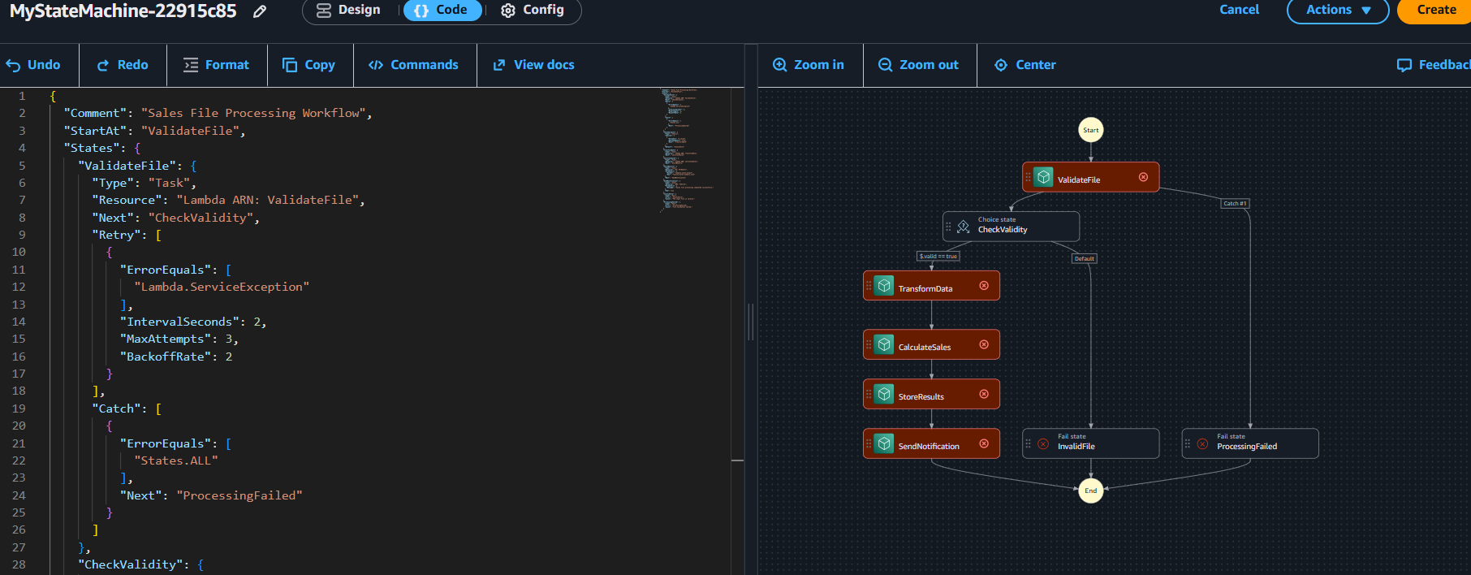

Question 14: Step Functions Implementation
Objective
To implement a sequential workflow consisting of ValidateFile, TransformData, and LoadResults, with validation failure handling, retries for temporary transformation errors, and a failure path for loading errors.
Explanation
a. Sequential execution: The Next field connects ValidateFile to TransformData and then LoadResults.
b. Retry policy: TransformData retries selected transient Lambda service errors up to three attempts, with a two-second interval and exponential backoff. Other error categories can be added according to the application.
c. Catch transition: If LoadResults fails, Catch stores the error under loadError and routes execution to RecordLoadFailure. This example records the error in Step Functions state; a production workflow should also persist it to a durable log or database if required.
d. Passing data: Step Functions passes task output to the next state by default. ResultPath, InputPath, OutputPath, or Parameters can be used to control the input and output structure.
e. Testing: Run a successful execution, then test invalid input, a temporary transformation error, and a permanent loading error. Review the execution graph and history to verify transitions, retries, and error details.
Result
The definition demonstrates sequential task execution, retry behavior, validation failure handling, and a loading-error route.
A data engineering team has developed three processing functions:
• ValidateFile
• TransformData
• LoadResults
The functions must execute in sequence. Requirements:
• If validation fails, the workflow must stop.
• If transformation fails temporarily, the workflow must retry.
• If loading fails permanently, the workflow must record the failure. Tasks:
a. Write an ASL JSON definition containing the three sequential tasks. Use placeholders for resource ARNs where necessary.
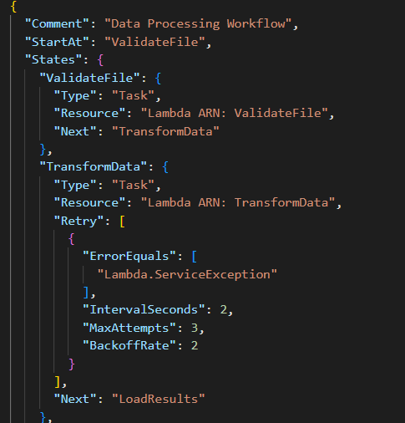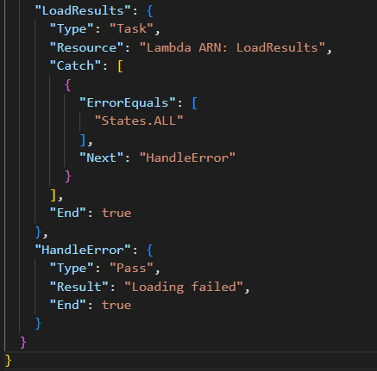
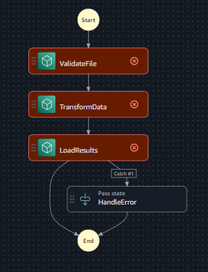
b. Configure a retry policy for the transformation task. (2 marks)
The Retry state retries temporary errors such as Lambda.ServiceException. It waits for 2 seconds, retries up to 3 times, and doubles the wait time after each retry using BackoffRate: 2.
c. Configure a Catch transition for the loading task. (1 mark)
The Catch block captures loading errors and transfers control to the HandleError state, where the failure is recorded.
d. Explain how data from one task is passed to the next task. (1 mark)
Step Functions passes the output of one task as the input to the next task by default. JSON data can be used to share processing results between functions.
e. Explain how you would test successful and failed executions. (1 mark)
Run the workflow with valid input to verify successful completion. Test with invalid input and simulated transformation or loading errors to verify that retries and error handling work correctly.

SECTION F: MICROSOFT AZURE
Question 15: Azure Data Lake Storage and Security
Objective
To configure Azure Data Lake Storage Gen2 for confidential business data and control access using Microsoft Entra ID and Azure role-based access control.
Procedure
- Create an Azure Storage account.
- Enable the hierarchical namespace option during account creation to support Azure Data Lake Storage Gen2.
- Create a filesystem in the storage account.
- Upload a sample dataset.
- Use Microsoft Entra ID identities and Azure RBAC roles to grant appropriate access to authorized users.
- Apply the principle of least privilege by granting only the required permissions at the narrowest suitable scope.
- Test access with an authorized identity and with an identity that has not been granted access.
Explanation
Azure Data Lake Storage Gen2 provides scalable data storage with filesystem-like organization. Microsoft Entra ID provides identity management, while Azure RBAC controls which users, groups, and applications can access resources. Filesystem and directory access-control lists may also be used where appropriate.
Verification
Confirm that the storage account has hierarchical namespace enabled, the dataset is present, and unauthorized access is denied. Verify that authorized users can access only the data permitted by their roles and access controls.
Result
The proposed configuration provides structured data storage and access control for confidential analytics datasets.
a. Configure a storage account with hierarchical namespace enabled. (1 mark)

Open the Azure Portal and create a Storage Account. Select the appropriate subscription and resource group, then enable the Hierarchical namespace option to use Azure Data Lake Storage Gen2.
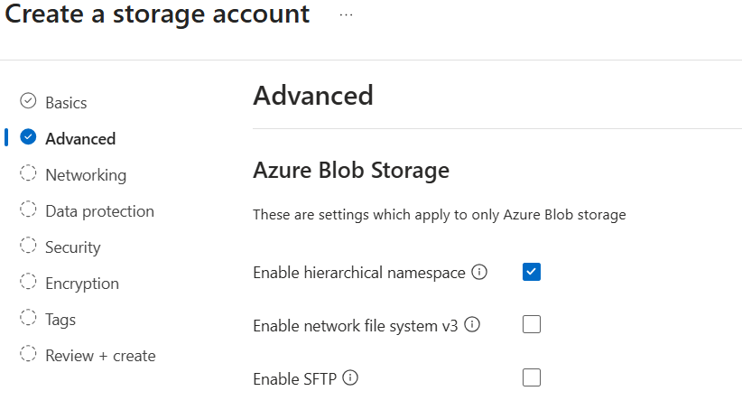

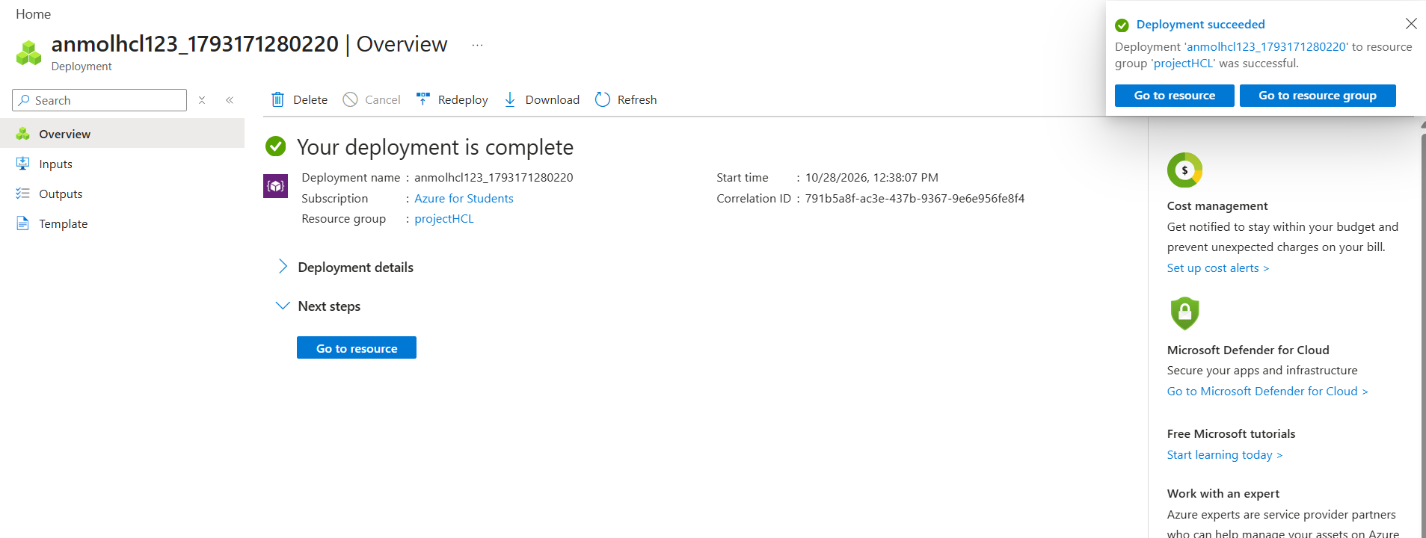

b. Create a filesystem or container and upload a sample dataset. (1 mark)
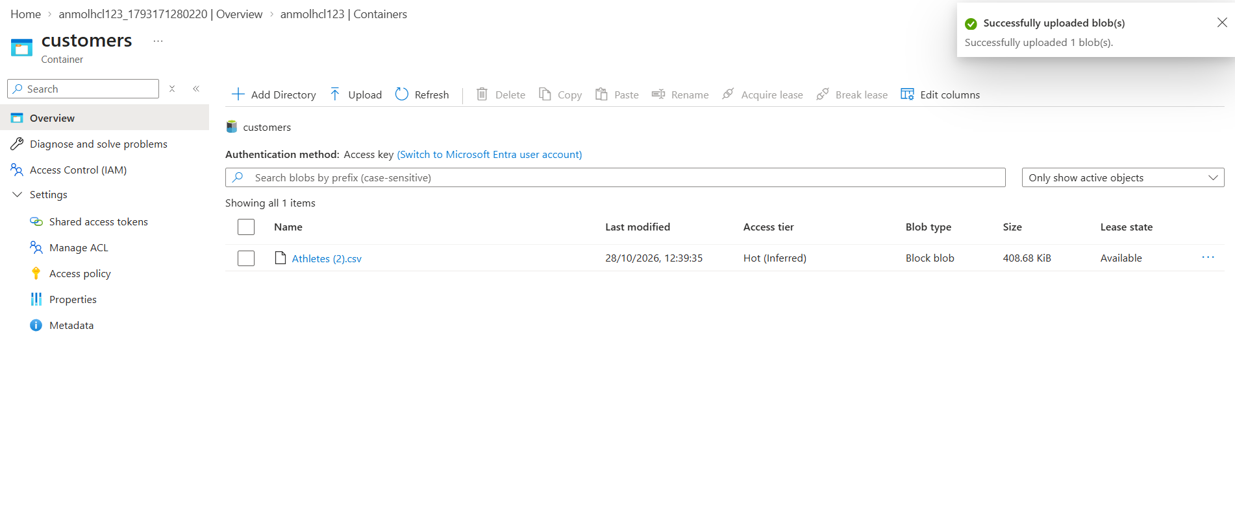
Open the storage account, go to Containers, create a container, and upload a sample CSV dataset for analytics.

c. Explain how Microsoft Entra ID and Azure RBAC manage access to the data. (2 marks)

Microsoft Entra ID manages user identities and authentication. Azure RBAC assigns permissions to users or groups based on their roles, such as Storage Blob Data Reader or Storage Blob Data Contributor, to control access to the data.

d. Explain how you would verify that unauthorized users cannot access the dataset. (1 mark)

Sign in as a user without the required permissions and attempt to access or download the dataset. Verify that access is denied, and check the Azure Monitor or diagnostic logs if configured

Question 16: Azure VM Troubleshooting
Objective
To investigate connectivity problems with an Azure virtual machine using secure network and access checks.
Procedure
a. Verify VM state
- Open the Azure portal.
- Navigate to Virtual Machines and select the required VM.
- Check the provisioning state and power state.
- Review boot diagnostics and activity logs if the VM is unavailable.
b. Check Network Security Group rules
Review inbound and outbound NSG rules. Confirm that the required traffic is allowed and that a higher-priority deny rule is not blocking the connection.
c. Check subnet and routing
Verify the subnet configuration, effective routes, route tables, network interface settings, and any required connectivity between the client and VM.
d. Use secure troubleshooting methods
- Use Azure Bastion to connect to supported VMs without exposing RDP or SSH directly to the public internet.
- Use just-in-time VM access where appropriate.
- Use Network Watcher connection troubleshooting and IP flow verification to identify connectivity blocks.
- Review boot diagnostics and VM logs before making changes.
Result
The procedure checks VM health, security rules, routing, and secure access options to identify connectivity problems while minimizing unnecessary public exposure.

Question 17: Azure Data Integration
Objective
To design a data integration pipeline that copies daily customer transaction CSV files into Azure Data Lake Storage Gen2 and prepares them for analysis.
Proposed Architecture
Source CSV → Azure Data Factory → Validation and transformation → Azure Data Lake Storage Gen2 → Monitoring and data-quality checks
Procedure
a. Select the orchestration service
Azure Data Factory is suitable for orchestrating data movement and transformation pipelines.
b. Copy the CSV file
- Create an Azure Data Factory instance.
- Configure a source linked service and dataset for the CSV file.
- Configure a destination linked service and dataset for Azure Data Lake Storage Gen2.
- Create a Copy Data activity to transfer the file to the destination filesystem.
- Configure managed identity or another approved authentication method with the necessary permissions.
c. Organize files by ingestion date
Store the files using date-based folders, for example:
transactions/ingestion_date=2026-10-28/transactions.csv
This organization supports traceability, partition pruning in suitable analytics systems, and easier identification of daily loads.
d. Handle malformed records and missing values
Validate column names, data types, required fields, and date formats. Depending on business rules, malformed records can be rejected or sent to a quarantine location. Missing values should be handled using approved defaults only when appropriate; otherwise, records should be flagged for investigation.
e. Monitor and validate completeness
Use Azure Data Factory Monitor to review pipeline runs, failures, durations, and activity details. Validate completeness by comparing source and destination record counts, checking required fields, and reconciling totals or other business-level metrics.
Result
Azure Data Factory provides an orchestrated approach to moving daily CSV files into Azure Data Lake Storage Gen2, organizing data by ingestion date, and monitoring data quality.
a. Select an appropriate service to orchestrate data movement.
Check the VM's status in the Azure portal under Virtual Machines. Verify that the provisioning state is Succeeded and the power state is Running.
b. Explain how to copy the CSV file into Azure Data Lake Storage Gen2. (1 mark)
Network Security Group (NSG) rules may block incoming connections if the required port, such as SSH (22) or RDP (3389), is denied. Verify that the inbound rules allow traffic from authorized sources.
c. Describe how to organize files by ingestion date. (1 mark)
Incorrect subnet configurations, route tables, or user-defined routes may prevent traffic from reaching the VM or returning to the client. Check the subnet association, route table, and network connectivity.
d. Explain how to handle malformed records and missing values. (1 mark) e. Explain how to monitor pipeline execution and validate data completeness. (1 mark)
Use Azure Bastion to connect securely to the VM through the Azure portal without assigning a public IP address to the VM. Alternatively, use Azure Serial Console to troubleshoot supported boot and connectivity issues. Restrict NSG rules to authorized sources and avoid opening ports to the entire internet.

