Great — since you asked “your Python/Docker/Git workflow setup”, I’ll build a complete, opinionated, modern workflow tailored to you, Tibor:
- Python dev (Pygame, FastAPI, Django, scripts)
- Docker (local dev + production)
- Git/GitHub (with Codespaces-friendly structure)
- WSL2 + Comfort Shell (your preferred environment)
I’ll give you one unified workflow that feels natural, fast, and predictable — something you can reuse across all your projects.

🚀 Your Unified Python + Docker + Git Workflow (WSL Comfort Shell Edition)
1) 🧱 Folder Structure (simple, scalable, Git-friendly)
project-name/
│
├── src/ # all Python code
│ └── app/ # your modules
│
├── tests/ # pytest tests
│
├── .venv/ # local virtual environment (ignored by Git)
├── requirements.txt # pinned versions
├── requirements-dev.txt # dev tools (pytest, black, mypy)
├── Dockerfile
├── docker-compose.yml
├── .gitignore
└── README.md
Why this works:
- clean separation of code/tests
- Docker can COPY only what it needs
- Git stays clean
- Works in VS Code, PyCharm, and GitHub Codespaces

2) 🐍 Python Workflow (fast, predictable, zero headaches)
Create project
mkdir project-name
cd project-name
python3 -m venv .venv
source .venv/bin/activate
Install dev tools
pip install -U pip
pip install black isort mypy pytest
pip install -r requirements.txt
Recommended dev tools
- black → formatting
- isort → import sorting
- mypy → type checking
- pytest → testing
- ruff (optional) → super-fast linter
Run tests
pytest -q
Format code
black .
isort .

3) 🐳 Docker Workflow (simple, fast, production-ready)
Dockerfile (Python slim + caching)
FROM python:3.12-slim

WORKDIR /app

COPY requirements.txt .
RUN pip install --no-cache-dir -r requirements.txt

COPY src ./src

CMD ["python", "src/app/main.py"]
docker-compose.yml (local dev)
services:
app:
build: .
volumes:
- ./src:/app/src
command: python src/app/main.py
Run locally
docker compose up --build
Run production
docker build -t myapp .
docker run -p 8000:8000 myapp

4) 🧬 Git Workflow (clean, safe, modern)
Initialize
git init
git add .
git commit -m "Initial commit"
Create new branch
git checkout -b feature/my-feature
Commit often
git add .
git commit -m "Add new logic"
Push
git push -u origin feature/my-feature
Merge via Pull Request
- clean history
- GitHub Actions can run tests
- safe for collaboration

5) 🧰 Comfort Shell Enhancements (your environment becomes a superpower)
Because you use WSL Comfort Shell, you get:
Aliases
alias gs="git status"
alias gc="git commit -m"
alias gp="git push"
alias gco="git checkout"
alias dcu="docker compose up"
alias dcd="docker compose down"
alias py="python3"
alias act="source .venv/bin/activate"
fzf-powered navigation
- Ctrl+R → fuzzy search through commands
- fzf + zoxide → jump to any project instantly
starship prompt
- shows Git branch
- shows Python venv
- shows Docker context

6) 🧪 Optional: Add Pre-commit Hooks (automatic formatting)
pip install pre-commit
pre-commit install
.pre-commit-config.yaml:
repos:
- repo: https://github.com/psf/black
rev: 24.3.0
hooks:
- id: black
- repo: https://github.com/pycqa/isort
rev: 5.13.2
hooks:
- id: isort
Now every commit is automatically formatted.

7) 🧠 Your workflow in practice (the real daily routine)
Start work
cd project-name
act
Run app
python src/app/main.py
Run tests
pytest
Run in Docker
docker compose up
Commit
git add .
git commit -m "Fix bug"
git push
Switch projects instantly
z project-name

🎁 Want me to generate this as a ready-to-run template for you?
I can produce:
- full folder structure
- Dockerfile
- docker-compose.yml
- .gitignore
- pre-commit config
- starship theme
- alias pack
- VS Code settings
- Python template (FastAPI, Django, Pygame, or plain scripts)
Just tell me which type of project you want the template for:
✔ FastAPI
✔ Django
✔ Flask
✔ Pygame
✔ General Python scripts
✔ Data science / Jupyter
✔ Microservices with Docker
Which one should I prepare for you next, Tibor?

Perfect — you want the Flask version of the Python/Docker/Git workflow.
Here is a complete, production-ready Flask project template designed for your WSL Comfort Shell environment, with clean structure, Docker support, and a modern Git workflow.
I’m giving you exact files, commands, and workflow steps — all optimized for your Python/Docker/Git setup.

🚀 FLASK PROJECT TEMPLATE (WSL Comfort Shell Edition)
🧱 1) Folder Structure (clean, scalable)
flask-app/
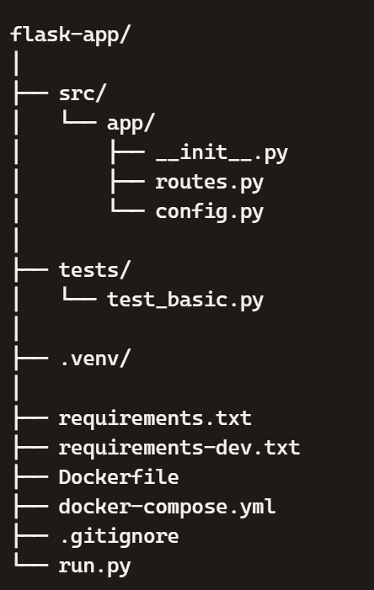

🧩 2) Flask Application Files
run.py
from src.app import create_app

app = create_app()

if __name__ == "__main__":
app.run(host="0.0.0.0", port=5000, debug=True)

src/app/init.py
from flask import Flask

def create_app():
app = Flask(__name__)
app.config.from_object("src.app.config.Config")

from .routes import bp as routes_bp
app.register_blueprint(routes_bp)

return app
src/app/routes.py
from flask import Blueprint, jsonify

bp = Blueprint("routes", __name__)

@bp.get("/")
def index():
return jsonify({"message": "Hello from Flask!"})
src/app/config.py
class Config:
DEBUG = True
SECRET_KEY = "change-me"

🧪 3) Tests (pytest)
tests/test_basic.py
def test_basic():
assert 1 + 1 == 2

📦 4) Python Requirements
requirements.txt
Flask==3.0.2
requirements-dev.txt
pytest
black
isort
mypy

🐳 5) Docker Setup
Dockerfile
FROM python:3.12-slim

WORKDIR /app

COPY requirements.txt .
RUN pip install --no-cache-dir -r requirements.txt

COPY src ./src
COPY run.py .

CMD ["python", "run.py"]
docker-compose.yml
services:
web:
build: .
ports:
- "5000:5000"
volumes:
- ./src:/app/src
command: python run.py
Run in Docker
docker compose up --build

🧬 6) Git Workflow (clean & modern)
Initialize
git init
git add .
git commit -m "Initial Flask project"
Create feature branch
git checkout -b feature/homepage
Push
git push -u origin feature/homepage

🧰 7) Comfort Shell Enhancements (your aliases)
Add to ~/.zshrc or ~/.bashrc:
alias gs="git status"
alias gc="git commit -m"
alias gp="git push"
alias gco="git checkout"

alias dcu="docker compose up"
alias dcd="docker compose down"

alias act="source .venv/bin/activate"
alias py="python3"

🧠 8) Your Daily Workflow (simple & fast)
Start work
cd flask-app
act
Run Flask locally
python run.py
Run tests
pytest
Run in Docker
docker compose up
Commit
git add .
gc "Add new route"
gp

🎁 Want me to generate a ZIP-ready project with all files filled in?
I can prepare:
- full folder structure
- all files with correct content
- ready-to-run Flask app
- Docker + Compose
- Git-ready structure
- VS Code settings (optional)
Just tell me yes, and I’ll generate the full project for you.

