Grade 6 • Unit 1 • Section D • Lesson 15
Alternative Assignment: Activity 1
Building Prisms and Pyramids with Nets
Name: ______________________________ Date: ________________
My goal today:
I can use a net to find the surface area of a prism and a pyramid.
The nets are already drawn for you. You will label them, find the area of every face, and add.

Tools: Word Bank and Reminders

Word | What it means
polyhedron | A solid shape with flat faces (prism, pyramid).
face | One flat side of the solid. Each polygon in the net is a face.
net | A flat pattern that folds up into the solid.
surface area | The total area of all the faces, in square units.

Area reminders
Rectangle: area = length × width
Triangle: area = ½ × base × height (the height meets the base at a right angle)
Surface area = add the areas of ALL the faces.

Part A: A Rectangular Prism (Card C)

Card C is a rectangular prism. It is 13 units long, 4 units wide, and 5 units tall. Here is its net. Each face has a number.
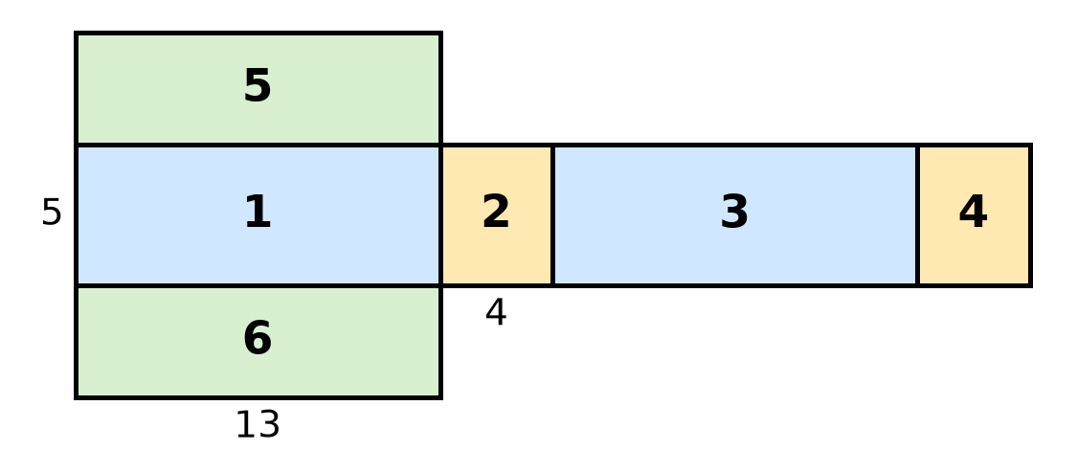
1. What polyhedron do you have? (circle one) rectangular prism triangular prism pyramid
2. How many faces does the net have? ______ What shape is every face? ______________________
3. Some faces are the same size. Color the matching faces the same color on the net. Which faces match?
Faces ____ and ____ Faces ____ and ____ Faces ____ and ____
4. Fill in the table. Multiply to find the area of each face.
Face | Shape | Length × Width | Area (square units)
1 | rectangle | 13 × 5
2 | rectangle | 4 × ____
3 | rectangle | ____ × ____
4
5
6

5. Add all six areas. ____ + ____ + ____ + ____ + ____ + ____ = ____
The surface area of Card C is ______________ square units.
Part B: A Square Pyramid (Card G)

Card G is a square pyramid. Its base is a 6 by 6 square. Each triangle has a base of 6 and a height of 10 (the dashed line). Here is its net.
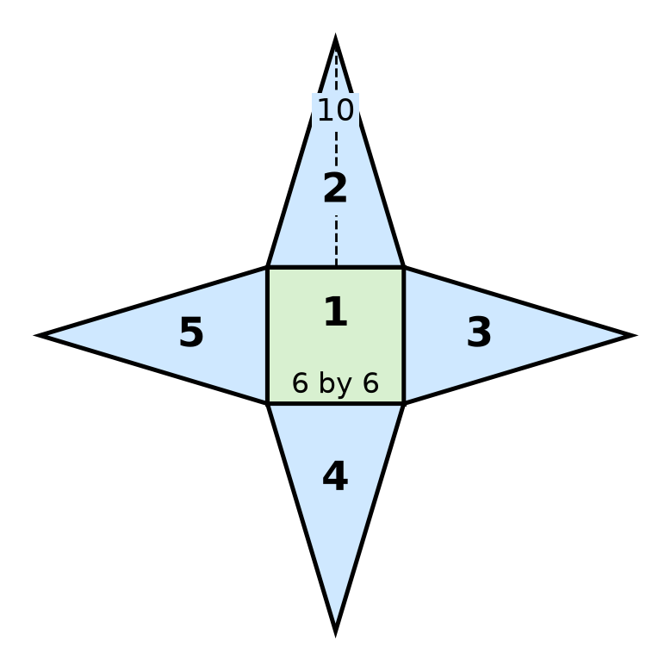
1. Fill in the table.
Face | Shape | How many? | Area of ONE face | Area of all of these faces
1 | square | 1 | 6 × 6 = ____
2, 3, 4, 5 | triangle | ____ | ½ × ____ × ____ = ____

2. Add the base and the triangles. ____ + ____ = ____
The surface area of Card G is ______________ square units.
3. Check yourself: A friend says, “There are 4 triangles, so I just find one triangle.” What else did your friend forget to include?
____________________________________________________________________
Part C: Show What You Know (choose ONE)

Pick a card from the lesson: B, D, E, or F. Use the same steps as Parts A and B.
Choice 1: Draw it.
Draw the net on graph paper (1 grid square = 1 unit). Label every face with a number or name. Make a table and find the surface area.
Choice 2: Fold it.
Your teacher gives you a net to cut and fold. Fold it into the solid. Write each face’s area on the face. Add them.
Choice 3: Explain it out loud.
Tell your teacher or partner each step while pointing to the faces. Your teacher will record your answers.

My card: ______ My surface area: ______________ square units
Reflect

Finish at least one sentence.
• A net helps me find surface area because ______________________________________________
• The hardest part was ______________________________ . I got through it by ____________________
• Surface area is measured in square units because ______________________________________

