HOT-WIRE C# SCRIPTS
Simple Rhino 8 + Grasshopper Implementation Guide
Five working geometric toolpath approaches, organized as verified design examples
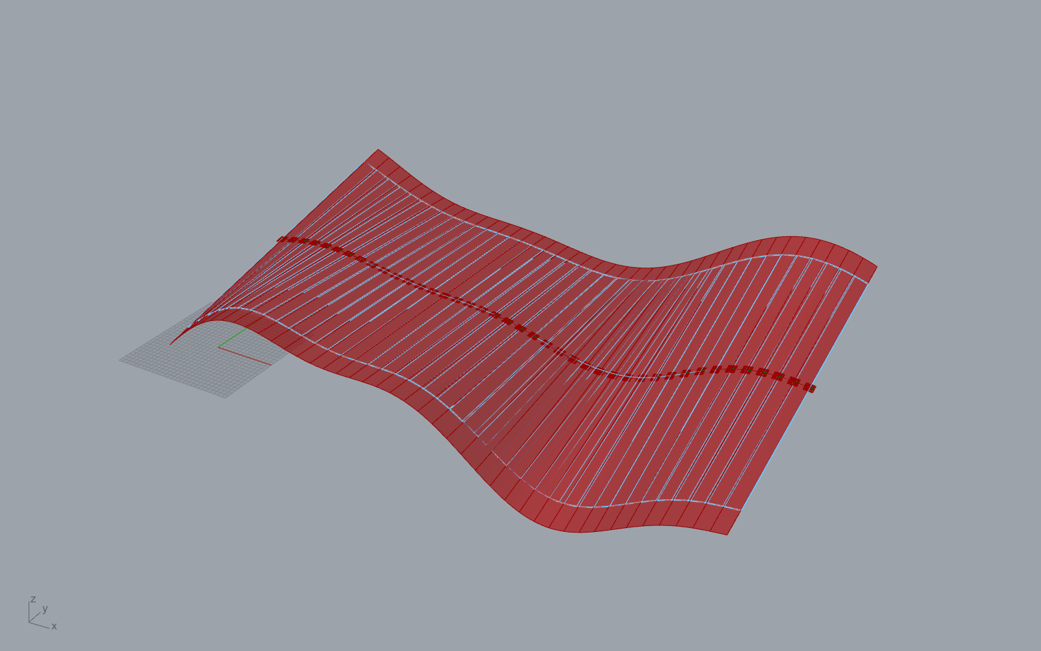
Existing fresh-open QA view of the general Geometry-to-Planes component.
READ THIS FIRST The files are verified as geometric Grasshopper examples. They are not a guarantee of safe robot motion. Real cutting still needs robot simulation, collision checking, calibration, kerf, feed-rate, and temperature tests.

Prepared for the project folder: Hotwire / Tirth Work

1. What was created
A separate folder named Verified_Design_Examples has been added inside Hotwire_CSharp_Implementation_Demo. It contains the tested C# source, Grasshopper definition, and matching Rhino design for each approach.
Folder | What it demonstrates
00_General_GeometryToPlanes | One reusable script in paired-rail mode and geometry-section mode.
01_Surface_UV | Wires generated between opposite UV sides of one surface.
02_Auto_Boundary_Pair | Automatic selection of opposite naked edges on a four-sided surface.
03_Centerline_Twist | A tapered, twisted ruled ribbon generated from a guide curve.
04_MultiAngle_Envelope | Several wire orientations tested against sectioned solid or mesh geometry.

OPENING RULE Open the .3dm design first in Rhino 8. Then open the matching .gh definition in Grasshopper. The .gh file already contains the C# script component and its test inputs.

2. The simplest mental model
- Grasshopper sends geometry and settings into the C# component.
- The script creates many ordered cutting stations.
- At every station it finds point A and point B.
- The straight hot wire is the line from A to B.
- All A points make Rail A. All B points make Rail B.
- The midpoint of every wire becomes a robot target position.
- A plane is placed at each midpoint to describe tool orientation.
- A straight loft between both rails previews the surface swept by the wire.
PLANE AXES X points along the wire from A to B. Y follows cutting travel. Z is X cross Y. Flip reverses A and B, so it reverses X.

3. General Geometry-to-Planes component
Purpose: Use one component either with two known boundary rails or with a Brep/Surface/SubD/Extrusion/Mesh that must be sectioned automatically.
Input | Plain meaning
G | The shape to section when paired rails are not supplied.
RailA + RailB | Two curves that directly control both ends of the hot wire.
PathDir | Direction in which the section planes move.
WireDir | Direction used to search for the widest part of a section.
Count | Number of wire positions.
Extension | Extra wire length beyond both selected endpoints.
Flip | Reverse A and B.
Tolerance | Rhino intersection tolerance.

Design 00A: paired rails
- Open Hotwire_GeometryToPlanes_Sample.3dm.
- Open Hotwire_GeometryToPlanes_Rails.gh.
- Confirm both RailA and RailB inputs contain curves.
- The script matches their directions so station 0 on one rail corresponds to station 0 on the other.
- It samples both curves by equal normalized arc length.
- It joins each pair with a wire line, extends it, and creates midpoint planes.
- Inspect WireLines, Planes, RailAOut, RailBOut, MidPath, Ruled, and Report.
BEST USE Choose paired rails when you already know the two boundaries of the ruled cutting surface. This is the most direct and predictable workflow.

Design 00B: automatic sections
- Keep the same Rhino sample open and open Hotwire_GeometryToPlanes_Sections.gh.
- Leave either rail input empty so the script selects geometry-section mode.
- PathDir controls where section planes advance.
- Each plane intersects G and produces one or more contours.
- The script measures every contour along WireDir and keeps the widest individual contour.
- Its two extreme points become A and B. All valid sections become the toolpath.
LIMIT This creates a ruled envelope. It is not an exact reconstruction of arbitrary double-curved or concave geometry.

4. Algorithm 01 - Surface UV
Purpose: Use the surface parameter directions themselves to decide how the wire moves.
- Open Hotwire_SurfaceUV_Sample.3dm and Hotwire_SurfaceUV.gh from folder 01_Surface_UV.
- The script accepts a Surface, or selects the largest face from a Brep.
- It reads the surface U and V domains.
- With WireAcrossU = true, the wire connects minimum U to maximum U while stations advance through V.
- With WireAcrossU = false, the wire connects minimum V to maximum V while stations advance through U.
- It extends and optionally flips the line, then builds rails, planes, midpoint path, and a straight loft.
- It samples nine points on each wire and measures their distance from the source surface. The maximum becomes Deviation.
Try this change | What you should see
Toggle WireAcrossU | The cutting direction swaps between the two surface directions.
Increase Count | More wire lines and closer path sampling.
Increase Extension | Longer wire lines; Deviation may also increase because extended ends are measured.
Toggle Flip | Same geometry, opposite wire X direction.

IMPORTANT Surface trims and holes are ignored because the code evaluates the underlying UV surface.

5. Algorithm 02 - Automatic boundary pair
Purpose: Let the script find the two possible opposite-edge pairs of a clean four-sided open surface.
- Open Hotwire_AutoBoundaryPair_Sample.3dm and Hotwire_AutoBoundaryPair.gh.
- The script duplicates the outer naked boundary curves and requires exactly four.
- It checks which curves do not share endpoints. Those are opposite edges.
- For each opposite pair, it aligns directions and samples both curves by normalized length.
- It calculates the average distance between synchronized points.
- PreferLong = false selects the smaller average span. PreferLong = true selects the other direction.
- The chosen pair becomes the endpoint rails and produces the usual lines, planes, midpoint path, and ruled loft.
COMMON FAILURE If Rhino shows a four-sided surface but the script reports more than four naked edges, rebuild or merge the fragmented edges/surface first.

6. Algorithm 03 - Centerline width and twist
Purpose: Generate a new blade or ribbon from a path without needing an existing surface.
- Open Hotwire_CenterlineTwist_Sample.3dm and Hotwire_CenterlineTwist.gh.
- The path is divided by normalized arc length, so stations are spaced by travel distance.
- At each station the script obtains a center point, tangent, and perpendicular frame.
- ReferencePlane gives the first lateral direction. Consecutive lateral vectors are sign-checked to reduce sudden flips.
- Twist grows gradually from zero to TwistDegrees along the path.
- Width changes linearly from WidthStart to WidthEnd.
- A and B are placed half the width on either side of the path, plus Extension.
- The result is the exact ruled ribbon implied by those generated wire lines.
Control | Effect
WidthStart / WidthEnd | Tapers or widens the ribbon.
TwistDegrees | Rotates the wire gradually around the path tangent.
ReferencePlane | Sets the starting side-to-side direction.
Count | Controls smoothness and the size of angle changes between stations.
Widths output | Reports total finite wire span, including both extensions.

BEST USE This is the clearest script for learning because every output comes from three ideas: centerline, width, and twist.

7. Algorithm 04 - Multi-angle envelope
Purpose: Compare several possible hot-wire orientations around a chosen travel direction and keep the most stable candidate.
- Open Hotwire_MultiAngleEnvelope_Sample.3dm and Hotwire_MultiAngleEnvelope.gh.
- The script normalizes PathDir and makes ReferenceWireDir perpendicular to it.
- It rotates that reference direction through AngleCount samples over 180 degrees.
- For each angle, it sections the geometry at every station.
- Within every section it selects the widest individual contour along the tested direction.
- It scores the candidate using valid-section coverage, wire-length variation, and adjacent direction change.
- The highest score becomes BestAngle and its lines become the output toolpath.
Score part | Meaning
Coverage x 1000 | Strong reward for producing a valid wire at most stations.
- length CV x 100 | Penalty for changing wire length.
- max direction change x 0.25 | Penalty for sudden changes between neighboring wires.

IMPORTANT The widest points can be on a concave contour, so the straight wire may pass through empty space. The result is a search heuristic, not proof of manufacturability.

8. What all outputs mean
Output | Meaning
Planes | Ordered midpoint frames for later robot-tool processing.
WireLines | The finite position of the hot wire at every valid station.
Ruled | Straight loft preview swept between the endpoint rails.
RailA / RailB | Paths followed by each end of the wire.
MidPath | Path followed by the center of the wire.
Report | Counts, settings, assumptions, and warnings.
Deviation / PairScores / Widths / Scores | Algorithm-specific diagnostic information.

9. How to inspect the C# inside Grasshopper
- Open the matching .gh file.
- Find the C# Script component in the labeled group.
- Double-click the component to open the script editor.
- Read RunScript first. It is the main execution sequence.
- Read helper methods below RunScript only when their names appear, such as BuildPlanes or StraightLoft.
- Compare the component input names with the RunScript arguments. They must match in spelling and order.
- Compare output names with the ref object outputs. A list output must remain list access in Grasshopper.
- After editing, compile the component and check the Report, runtime warnings, and output counts.
SOURCE FILES The separate .cs files are editable/versionable copies. The working .gh files contain embedded copies, so editing a .cs file alone does not automatically update the Grasshopper component.

10. Recommended learning exercises
- Change Count from 41 to 11, then to 81. Watch density and frame smoothness.
- Toggle Flip and inspect plane X axes. Geometry stays in place but orientation reverses.
- Increase Extension and compare physical clearance with wire-length output.
- On Surface UV, swap WireAcrossU and inspect which direction advances.
- On Auto Boundary Pair, toggle PreferLong and compare PairScores.
- On Centerline Twist, set twist to 0, 45, 90, and 180 degrees.
- On Multi-Angle Envelope, increase AngleCount and compare BestAngle and Scores.
- Deliberately use a poor PathDir to understand missing sections and coverage.

11. Geometric verification checklist
- The .3dm and matching .gh files open in Rhino 8 without missing references.
- The C# component shows zero Grasshopper errors.
- Planes count equals WireLines count.
- At least two valid stations exist.
- Rail A, Rail B, and MidPath are continuous in the intended order.
- Every wire line points consistently from A to B.
- No sudden frame reversal appears in plane previews.
- Ruled preview matches the intended straight-wire sweep.
- Wire length stays within the real bow/wire capacity.
- Report and algorithm-specific diagnostics have been read.
RECORDED TESTS The copied example definitions have existing fresh-open verification records showing embedded source, zero warnings/errors, and valid Planes/WireLines/Ruled outputs. Copies are hash-checked against those originals in the package manifest.

12. Robot fabrication checklist
Complete these checks separately before sending any motion to a robot:
- Use the exact robot model and controller configuration.
- Calibrate robot base, foam position, tool, and hot-wire TCP.
- Remap the generic plane axes to the real tool-axis convention.
- Check inverse kinematics, joint limits, robot configurations, and singularities.
- Run collision checking with robot, hot-wire bow, foam, fixtures, and cell equipment.
- Add approach, lead-in, lead-out, and retract motions.
- Test temperature, feed rate, kerf, foam type, and wire sag on scrap material.
- Run the first physical test at reduced speed under the workshop safety procedure.
ACCURACY STATEMENT The package can be verified for file integrity, Grasshopper solving, geometry counts, and output consistency. No one can truthfully promise 100% physical cutting accuracy without the actual robot, tool, calibration, stock, and process tests.

13. File-by-file opening order
Example | Open in Rhino first | Then open in Grasshopper
00A Paired rails | Hotwire_GeometryToPlanes_Sample.3dm | Hotwire_GeometryToPlanes_Rails.gh
00B Sections | Hotwire_GeometryToPlanes_Sample.3dm | Hotwire_GeometryToPlanes_Sections.gh
01 Surface UV | Hotwire_SurfaceUV_Sample.3dm | Hotwire_SurfaceUV.gh
02 Boundary pair | Hotwire_AutoBoundaryPair_Sample.3dm | Hotwire_AutoBoundaryPair.gh
03 Centerline twist | Hotwire_CenterlineTwist_Sample.3dm | Hotwire_CenterlineTwist.gh
04 Multi-angle | Hotwire_MultiAngleEnvelope_Sample.3dm | Hotwire_MultiAngleEnvelope.gh

All files are inside Hotwire_CSharp_Implementation_Demo / Verified_Design_Examples. Keep each .3dm and .gh pair together when moving the package.

