Name : Tirth Chavda
Roll no : 20BCE043
Subject : Microservice Architecture and programming

Practical 1:

Definition
1. Learn Git related commands about how to create project and manage it on Git environment
locally as well as on GitHub/Gitlab.
Capture necessary screens for the work you are doing for the submission with few lines of writeup in your own terms.
2. You are expected to learn basics of Docker and the commands to work with it, use the Docker
playground for the same.
For this you will need to create your account on Docker.com and follow the instructions on this
URL, and use (Alpine Image of Linux - primary experimentation).
https://training.play-with-docker.com/ops-s1-hello

- Play with Docker classroom
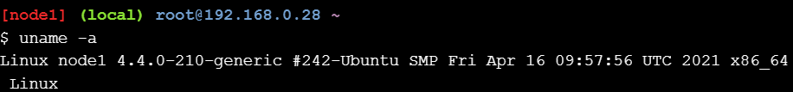

Steps: 1.Running the first Container
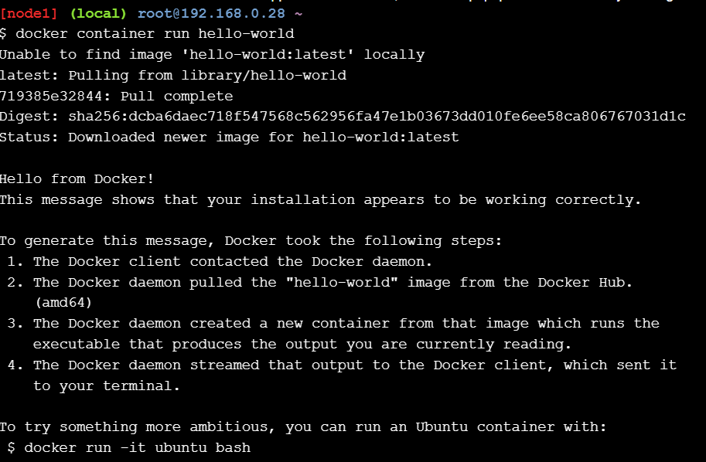

- Pull Alpine Test Container

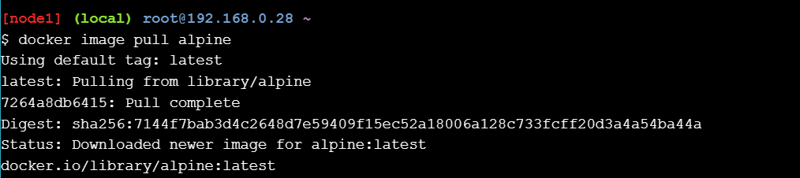

3.list down the all containers

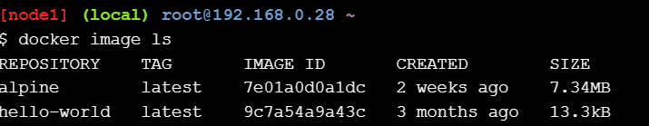

4.Run Alpine Container

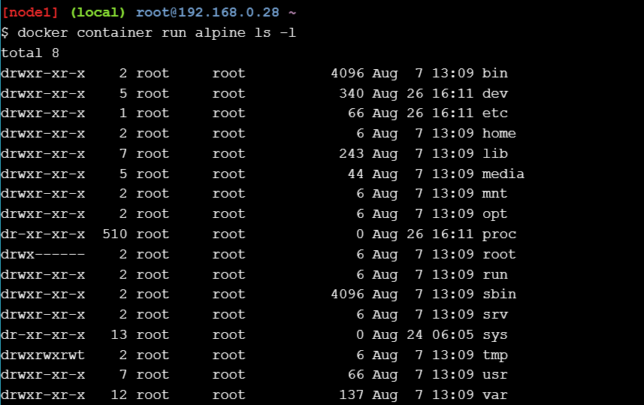

5.echo command

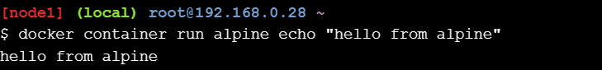

6.run command

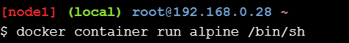

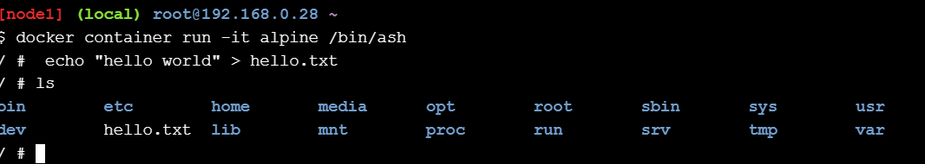

7.list all Containers

8.View Containers status

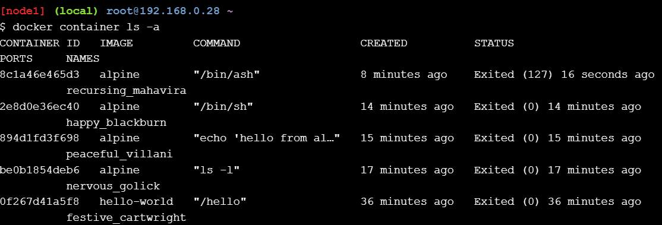

9.Container Isolation
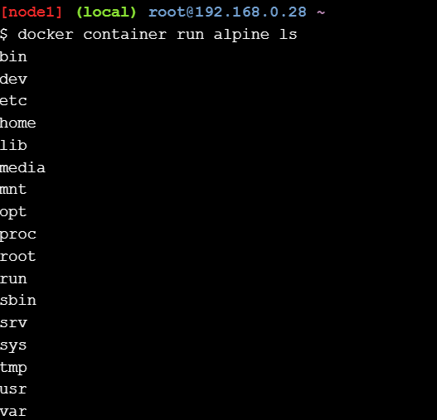
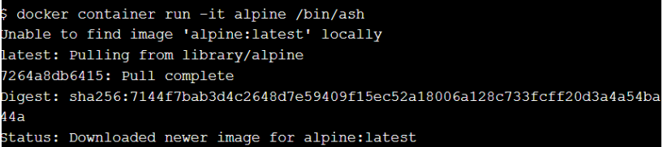

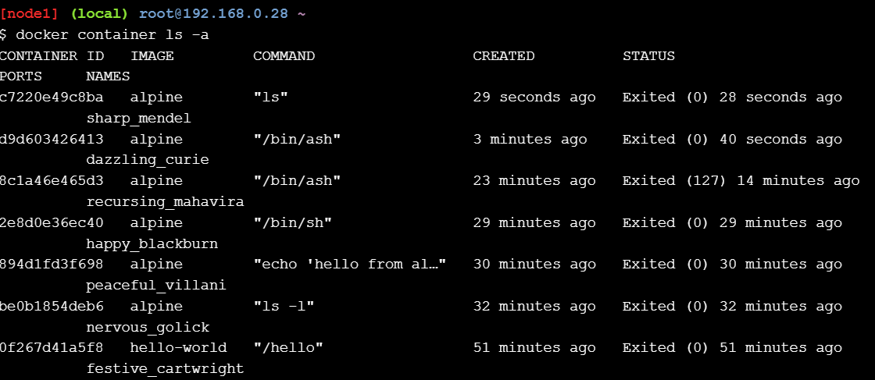

10.Start and Execute Container

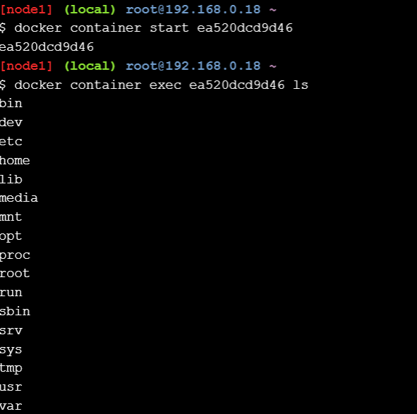

2.Git Related Commands

1.Initialize a new Git repository

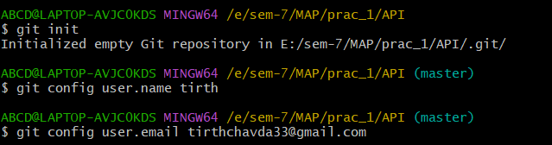

2. Create and Manage Files

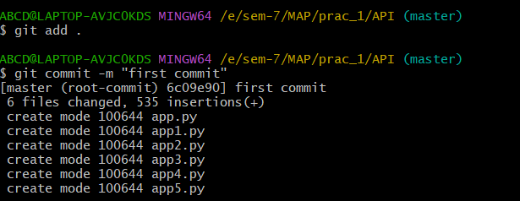

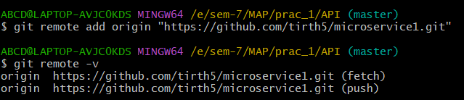
- Creating new Repository and connect local repository to remote

- Push Local Commits to Remote

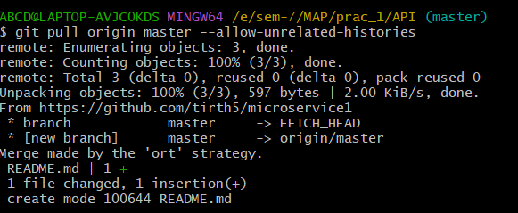

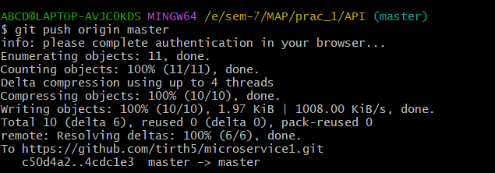

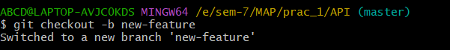
- Manage Branches

- Push the new branch to remote

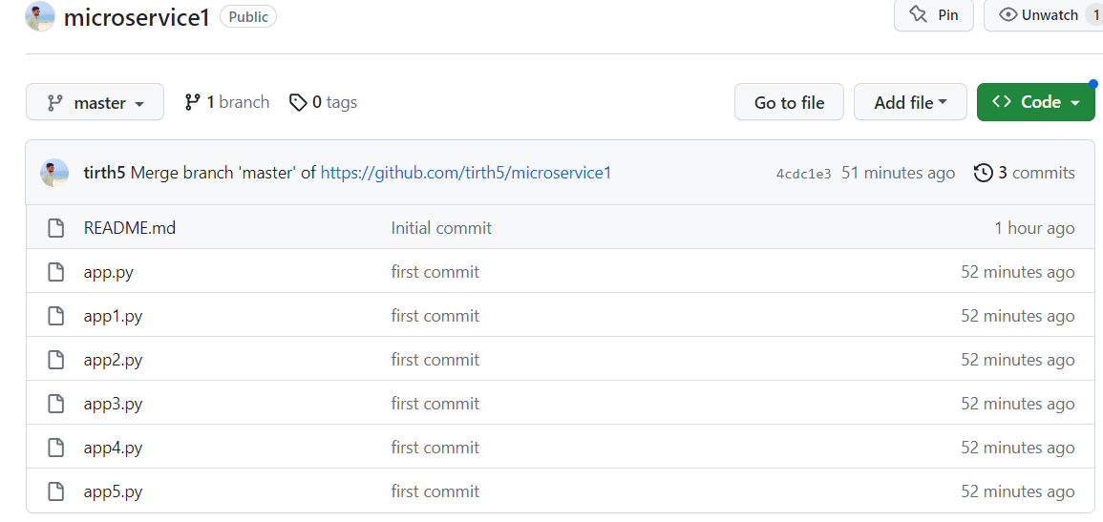

7. View the Status of git

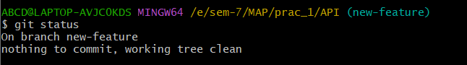

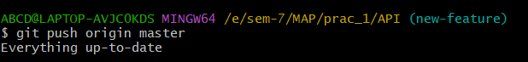
8. git pull

9. git clone

Git clone clones the remote repository

- Conclusion: After performing this practical, I learn about basics of docker and git commands.

