Name : Tirth Chavda
Roll no : 20BCE043
Subject : Microservice Architecture and programming

- Practical-2:
Aim: Submit here implementation of API calls with REST approach in any language, submit here code, commands and screen captures demonstrating API calls functionalities.

Code:
from flask import Flask, request, jsonify

app = Flask(__name__)

# Sample data - you can replace this with your own data or database integration
data = [
{'id': 1, 'name': 'John Doe', 'age': 30},
{'id': 2, 'name': 'Jane Smith', 'age': 25},
]

@app.route('/', methods=['GET'])
def home():
return jsonify({'message': 'Welcome to the API!'}), 200

@app.route('/hello', methods=['GET'])
def ho():
return jsonify({'message': 'hello from API'}), 200
# Route to get all items
@app.route('/api/items', methods=['GET'])
def get_items():
return jsonify(data)

# Route to get a specific item by ID
@app.route('/api/items/<int:item_id>', methods=['GET'])
def get_item(item_id):
item = next((item for item in data if item['id'] == item_id), None)
if item:
return jsonify(item)
else:
return jsonify({'message': 'Item not found'}), 404

# Route to create a new item
@app.route('/api/items', methods=['POST'])
def create_item():
new_item = request.json
new_item['id'] = len(data) + 1
data.append(new_item)
return jsonify(new_item), 201

# Route to update an existing item
@app.route('/api/items/<int:item_id>', methods=['PUT'])
def update_item(item_id):
item = next((item for item in data if item['id'] == item_id), None)
if item:
item.update(request.json)
return jsonify(item)
else:
return jsonify({'message': 'Item not found'}), 404

@app.errorhandler(404)
def not_found(error):
return jsonify({'message': 'Resource not found'}), 404

# Route to delete an item by ID
@app.route('/api/items/<int:item_id>', methods=['DELETE'])
def delete_item(item_id):
global data
data = [item for item in data if item['id'] != item_id]
return jsonify({'message': 'Item deleted successfully'}), 200

if __name__ == '__main__':
app.run(debug=True)

output:
- http://127.0.0.1:5000/

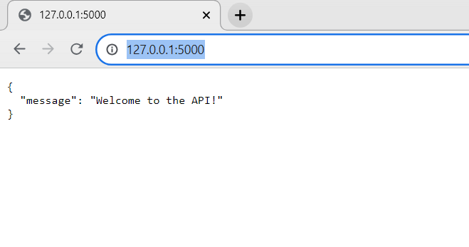

- http://127.0.0.1:5000/hello

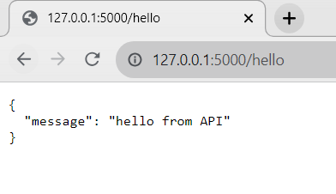

- http://127.0.0.1:5000/api/items
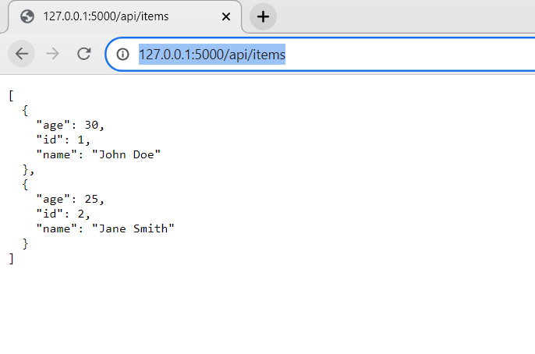
- API Testing on Postman for http://127.0.0.1:5000/api/items (GET Request)

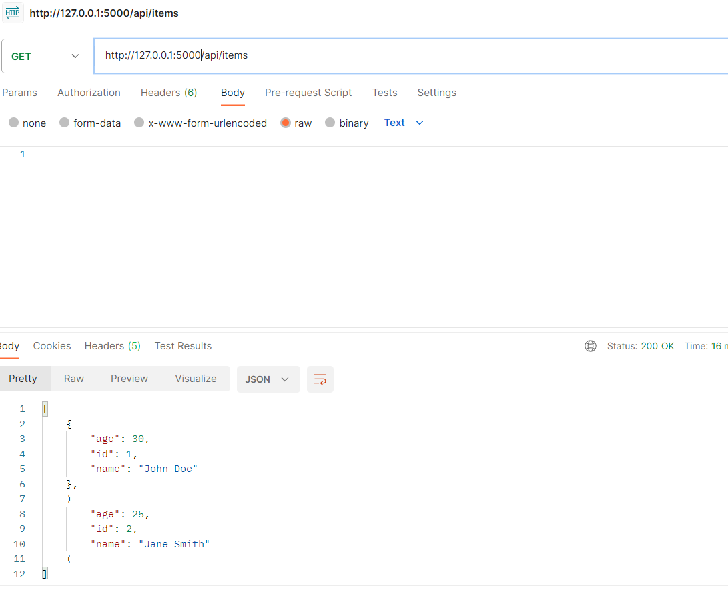

- Post Request for http://127.0.0.1:5000/api/items to add new member.

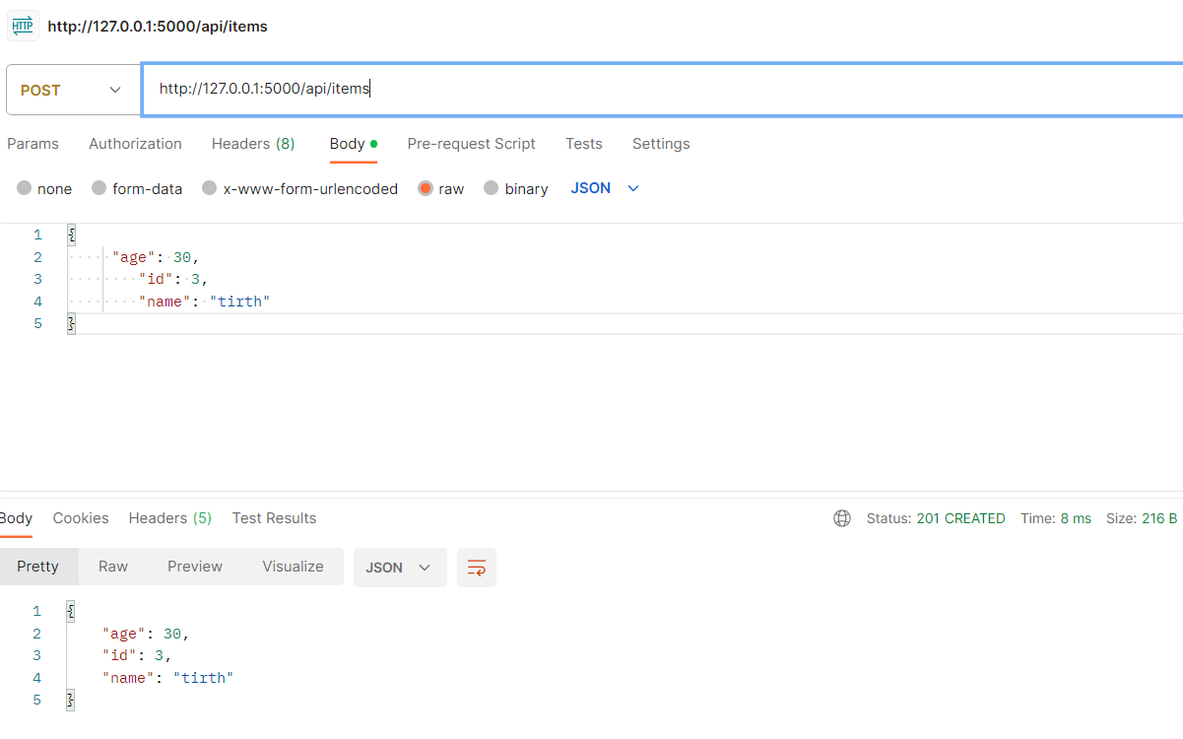
- Put Request for http://127.0.0.1:5000/api/items/2 to update details of any member

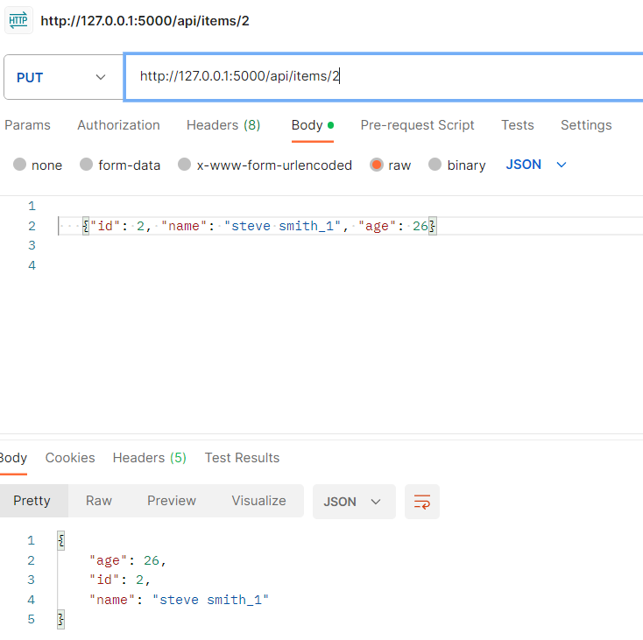

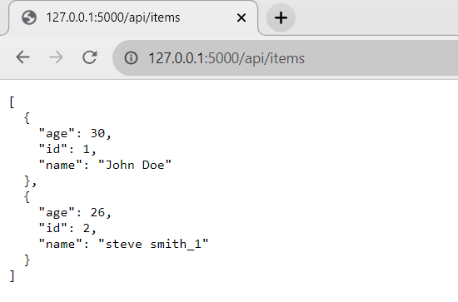

- Delete Request for http://127.0.0.1:5000/api/items/1 to delete any member.

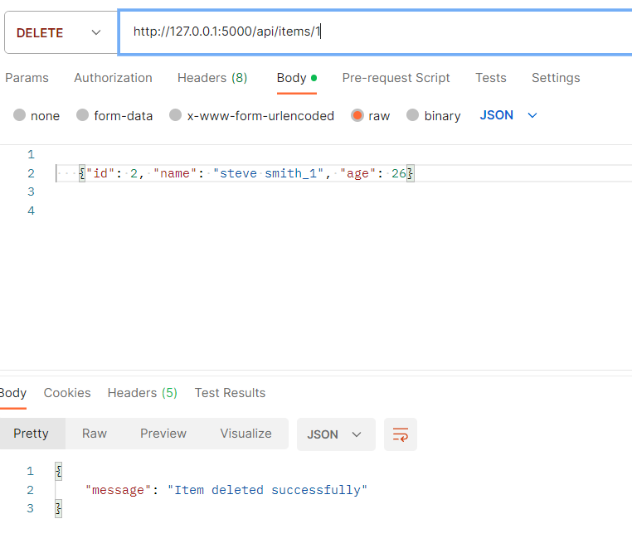

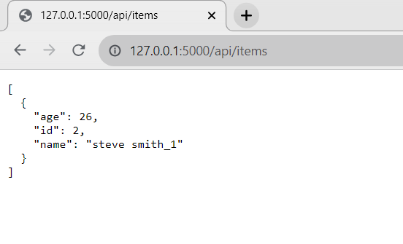

Conclusion: After performing this practical, I learn about how to do API testing on POSTMAN platform and how to write code for the same.

