# **Opens file01.txt in vim. Paste the text from above and save/exit.**$ vim file01.txt

# **Copy the file into the HDFS**$ hdfs dfs -put ./file01.txt /user/tirtha/

**WordCount.pig**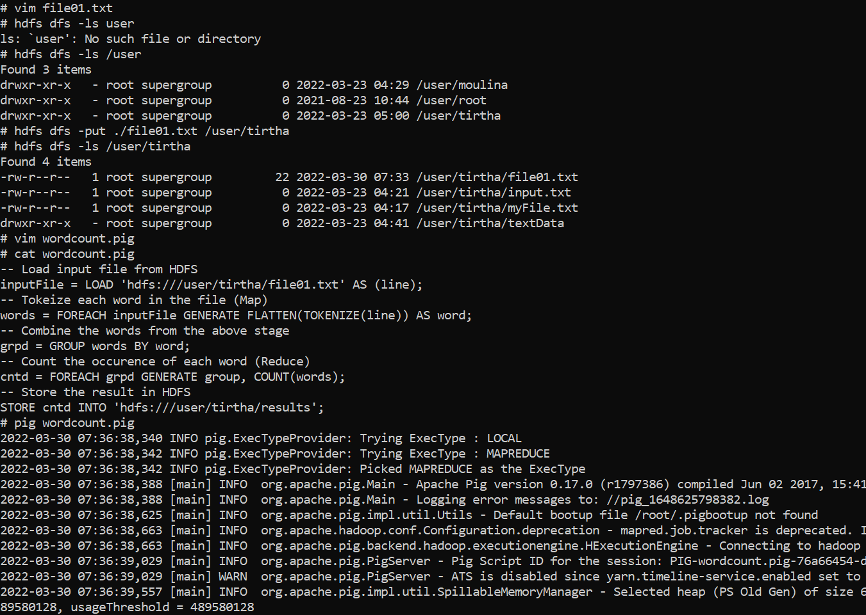

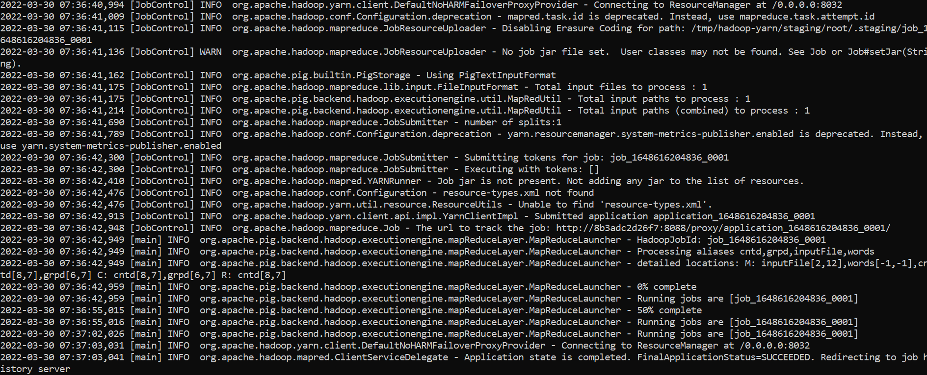

**To view the result, you can use the cat command in the HDFS:**

