**Step 1 -> Creating the sales.csv file and putting it in hdfs**

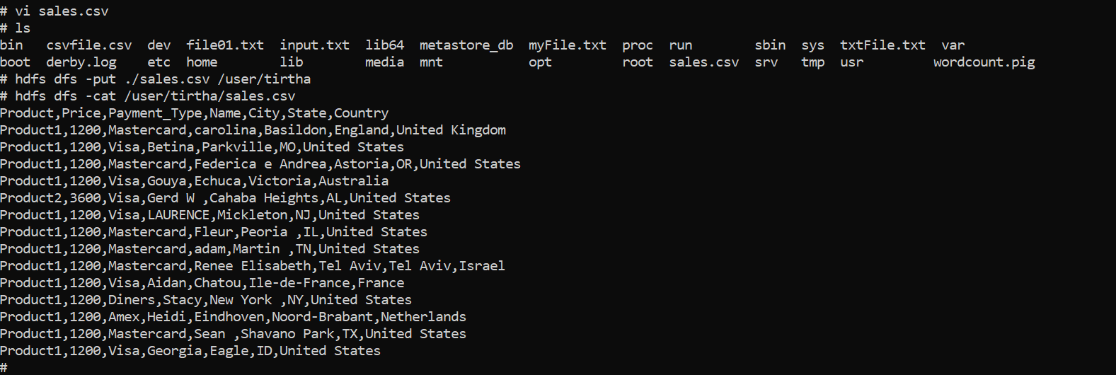

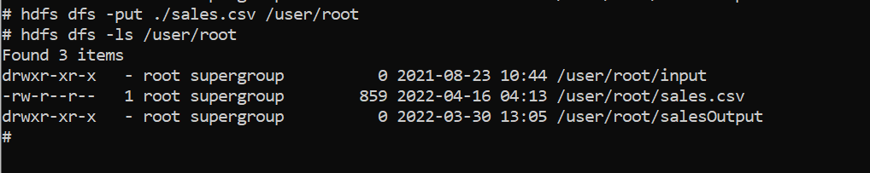

**Step 2 -> Create the SalesCSV.pig file**

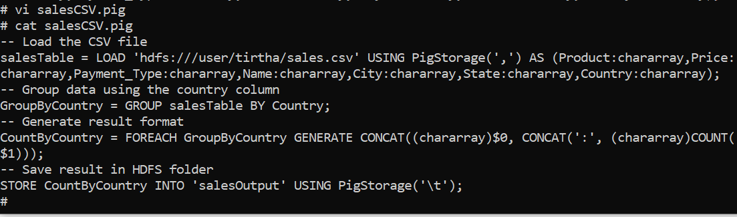

**Step 3 -> Run the pig file**

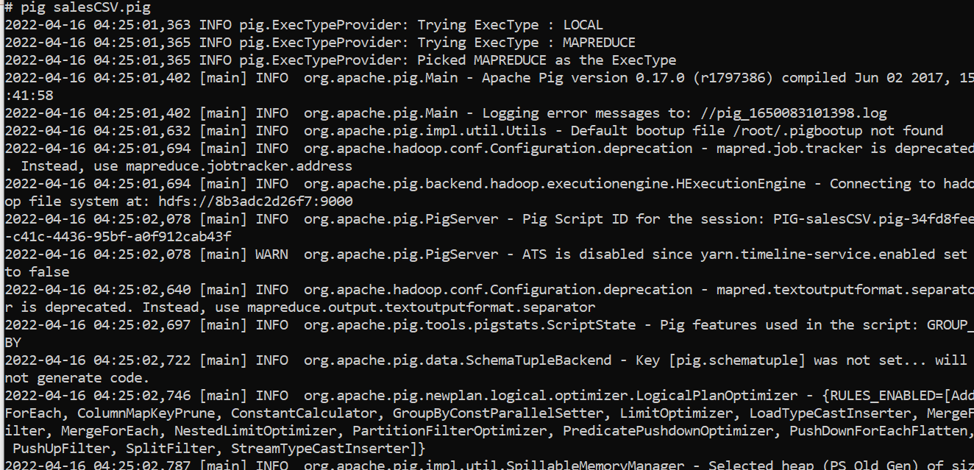

**Step 4 -> View the results**

