1. **Creating the CSV file:**

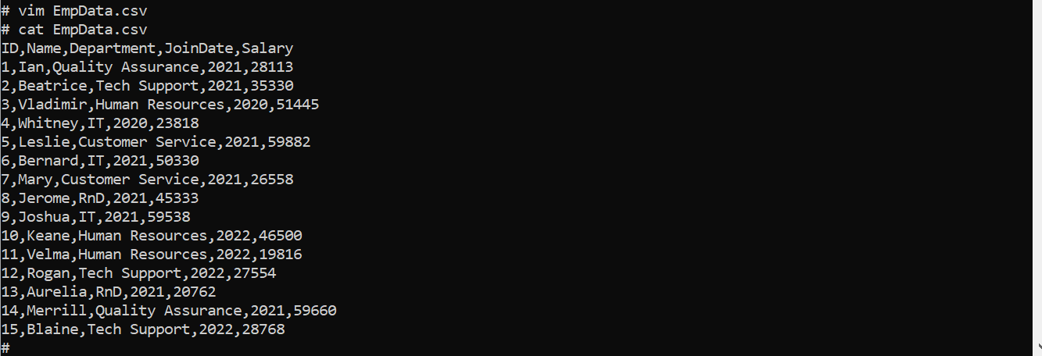

1. **Create and use “Office” database within Hive**

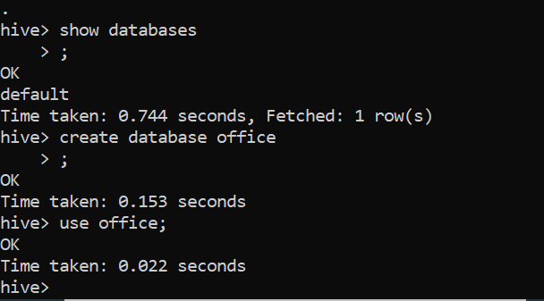

1. **Create and Describe “Employee” table**

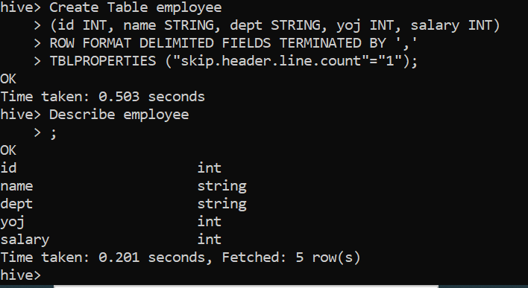

1. **Load local csv file into Employee table**

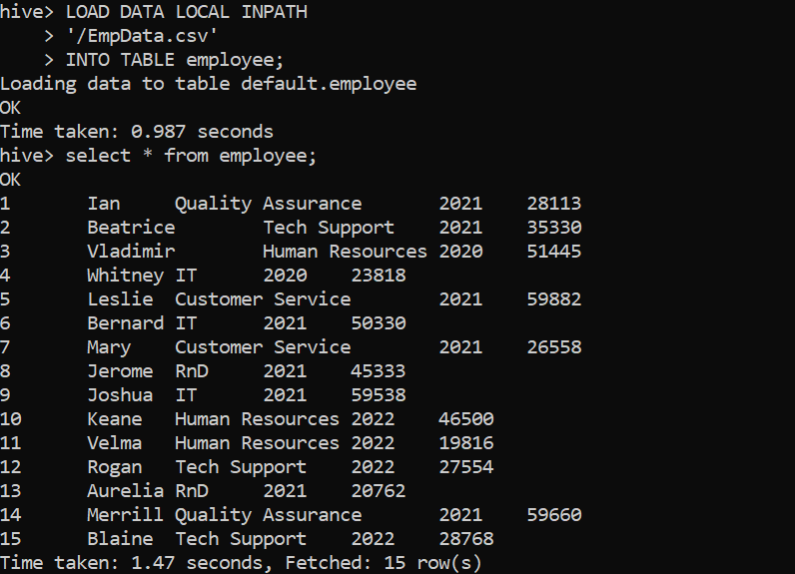

1. **To count the number of rows in the table**

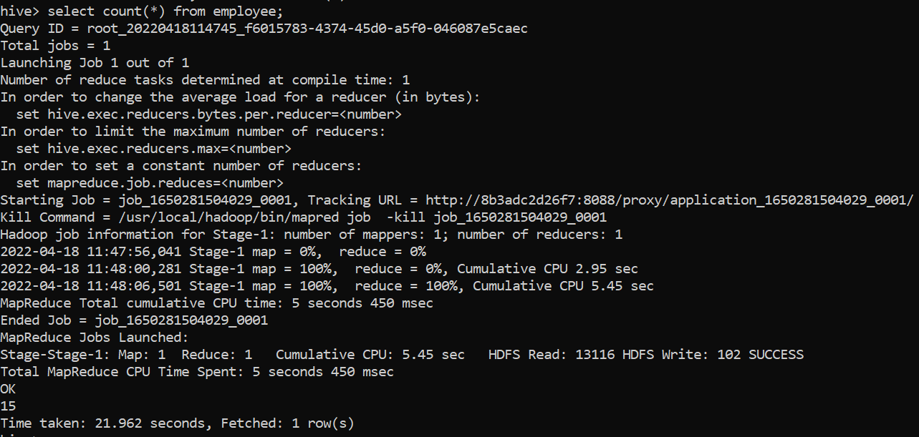

1. **Executing queries to trigger MAP only Jobs**

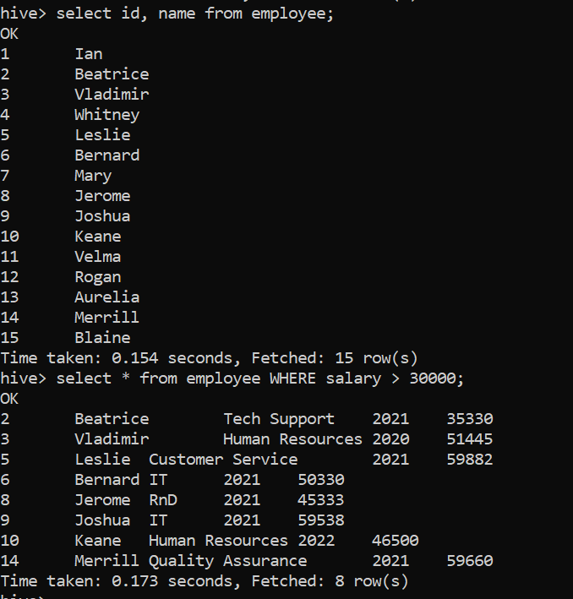

1. **Export results to HDFS and verify**

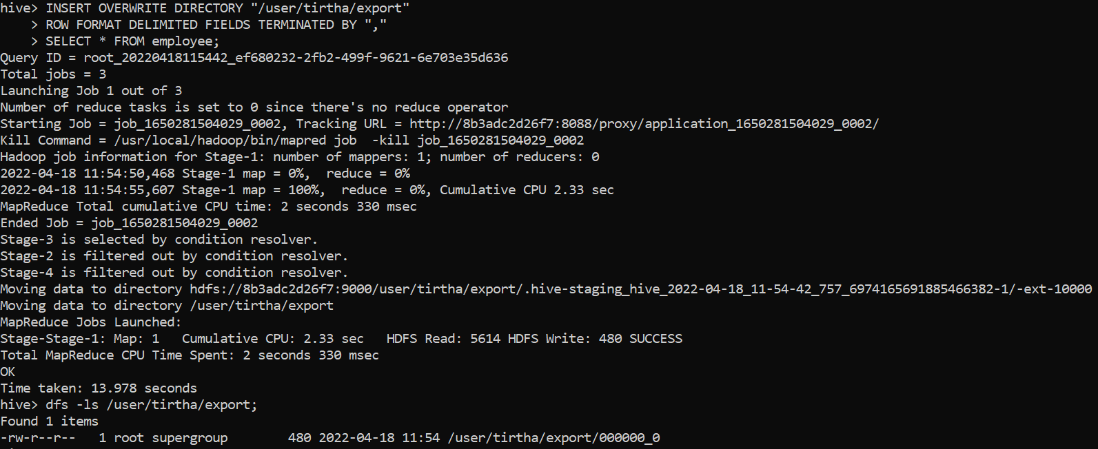

1. **Export results to Local directory:**

