NETWORK PHARMACOLOGY
AND COMPUTER-AIDED DRUG DESIGN
An in-silico study of Curcuma longa phytochemicals
against atherosclerosis

TIRTHA DAS | BIOTECHNOLOGY STUDENT

Selected compounds: Bisdemethoxycurcumin • Tetrahydrocurcumin • Germacrone

Research project report

Abstract
Atherosclerosis is a chronic disease in which lipids, inflammatory cells and other materials build up within the inner wall of arteries, forming plaques that can narrow or destabilise the vessels. This project uses an in-silico strategy combining network pharmacology and computer-aided drug design (CADD) to explore the possible relevance of phytochemicals from Curcuma longa (turmeric) to atherosclerosis-associated molecular targets. Phytochemical information and predicted compound-associated targets were assembled from the resources recorded in the project files. Atherosclerosis-associated genes were collected, and overlapping genes were identified. Protein–protein interaction analysis and pathway enrichment were then used to explore the biological network. IL6 was selected as the leading hub gene in the supplied CytoHubba result. Three compounds—bisdemethoxycurcumin, tetrahydrocurcumin and germacrone—were taken forward for molecular docking against the IL-6 protein. The supplied docking CSV reports top-pose binding affinities of −6.2, −6.1 and −6.3 kcal/mol, respectively. These findings provide a computational starting point for further study; experimental validation is required before drawing conclusions about biological activity or therapeutic benefit.

1. Background: Atherosclerosis
Atherosclerosis is a long-term inflammatory condition of the arteries. It begins when the normal function of the blood-vessel lining (the endothelium) is disturbed. Lipoproteins, especially low-density lipoprotein (LDL), can enter and become retained in the arterial wall. Modified LDL can trigger inflammation and attract immune cells such as monocytes. These cells can develop into macrophages and take up lipids, forming foam cells. Over time, lipid deposits, inflammatory cells, smooth-muscle cells and extracellular material can form an atherosclerotic plaque.
Plaques may gradually restrict blood flow. If a plaque becomes unstable and ruptures or erodes, a blood clot may form and block the artery. Depending on the affected vessel, atherosclerosis can contribute to coronary artery disease, heart attack, stroke and peripheral artery disease.
Atherosclerosis is not controlled by a single gene or pathway. Lipid handling, inflammation, oxidative stress, endothelial function, immune-cell movement and plaque remodelling all contribute. This complex biology makes it useful to study groups of related genes and pathways rather than focusing on only one molecular target.

2. Why Network Pharmacology and CADD?

2.1 Network pharmacology
Network pharmacology studies how multiple compounds may be connected to multiple genes, proteins and biological pathways. It is useful for complex diseases such as atherosclerosis because a plant extract or a group of phytochemicals may be associated with several molecular targets. By comparing compound-related targets with disease-associated genes, researchers can identify shared targets and explore how they connect in a protein–protein interaction (PPI) network.
- It helps organise large lists of compound targets and disease-associated genes.
- It can highlight shared genes and highly connected hub proteins for further study.
- Pathway enrichment can suggest biological processes that may link the shared genes to disease.

2.2 Computer-aided drug design (CADD)
CADD uses computational tools to study how a small molecule may interact with a biological target. In this project, molecular docking was used to estimate possible binding poses and binding-affinity scores for the selected turmeric compounds in relation to the IL-6 protein structure. Docking can help prioritise compounds for further investigation, but a docking score does not prove that a compound binds in a living system, blocks the target, or improves disease outcomes.
- It supports early screening and comparison of candidate molecules.
- It provides predicted ligand poses and interaction patterns for structural inspection.
- It can help guide later laboratory experiments and target-validation studies.
Together, network pharmacology and CADD provide complementary views: network pharmacology helps select biologically relevant targets, while CADD explores possible compound–protein interactions at the structural level. Neither method alone demonstrates a cure or clinical effect.

3. Aim and Objectives
Aim: To investigate, using computational methods, the potential links between selected Curcuma longa phytochemicals and molecular targets associated with atherosclerosis.
- To identify phytochemicals reported for Curcuma longa and screen selected compounds using molecular and toxicity-related properties.
- To collect compound-associated target genes and atherosclerosis-associated genes from the databases used in the project.
- To identify overlapping genes and explore their protein–protein interaction network.
- To identify hub genes and relevant KEGG pathways.
- To perform molecular docking of three selected phytochemicals against the IL-6 protein.
- To interpret the computational results and identify suitable directions for future experimental validation.

4. Materials and Computational Resources
Purpose | Resources recorded in the project
Phytochemical information | Dr. Duke’s Phytochemical and Ethnobotanical Databases; IMPPAT
Compound/disease target information | IMPPAT and GeneCards, as recorded in the project workflow
Overlap analysis | Venny 2.0
PPI network and hub analysis | STRING, Cytoscape and CytoHubba
Pathway enrichment | ShinyGO; KEGG pathway information
Molecular property/toxicity screening | ProTox, Molsoft and SwissADME
Molecular preparation and docking | PyRx, BIOVIA tools and AutoDock Vina

5. Methodology

5.1 Phytochemical selection and preliminary screening
The project began with phytochemicals reported for Curcuma longa. The supplied screening table contains five named compounds, although the project notes state that six compounds were initially considered. The table records molecular weight, SMILES, predicted toxicity class, hydrogen-bond donor count (HBD), hydrogen-bond acceptor count (HBA) and logP. ProTox, Molsoft and SwissADME were used for the screening work described in the project.
Compound | Molecular weight | Reported toxicity class | HBD | HBA | logP
Bisdemethoxycurcumin | 308.3 g/mol | Class 5 | 2 | 4 | 3.35
(+)-(S)-ar-turmerone | 216.32 g/mol | Class 4 | 1 | 0 | 4.02
(+)-ar-turmerone | 219.34 g/mol | Class 4 | 0 | 1 | 4.02
Tetrahydrocurcumin | 372.4 g/mol | Class 5 | 2 | 6 | 3.21
Germacrone | 218.33 g/mol | Class 5 | 0 | 1 | 4.65

The three compounds carried forward to target/network analysis and docking were bisdemethoxycurcumin, tetrahydrocurcumin and germacrone. The original project notes state that two compounds were excluded due to toxicity class 5; however, the supplied screening table lists class 5 for all three selected compounds. This selection rationale must be checked against the original ProTox outputs before publication. The current report therefore records the values as shown in the table and does not claim that class 5 was the reason for exclusion.

5.2 Target-gene collection and overlap analysis
Compound-associated target genes for the three selected phytochemicals were collected using the resources recorded in the workbook, including IMPPAT. Atherosclerosis-associated genes were collected from GeneCards. The combined compound-target list was compared with the disease-associated gene list using Venny 2.0.
Recalculation from the supplied workbook gives 212 unique compound-associated target genes across the three compound lists, 249 disease-associated gene entries, and 21 overlapping genes. The overlap represents candidate shared genes for further analysis; it does not mean that every overlapping gene is experimentally confirmed as a direct target of each compound.
The 21 overlapping genes identified from the supplied workbook are:
ALOX15, ALOX5, CBS, CTNNB1, ESR1, F10, F13A1, F2, FABP4, IL6, KDR, MAPK14, MMP2, MMP9, NFE2L2, PLAU, PPARA, PPARG, SRC, TLR4, TNF

5.3 PPI network and hub-gene analysis
The overlapping genes were analysed using STRING to explore known and predicted protein–protein associations. The network was visualised in Cytoscape, and CytoHubba was used to rank nodes and identify highly connected candidate hub genes. In the supplied CytoHubba screenshot, IL6 is shown as the leading hub gene, with MMP9, PPARG, TNF and CTNNB1 also appearing among the prominent nodes.
IL6 is the gene symbol for interleukin-6 (IL-6), a cytokine involved in inflammatory signalling. Its appearance as a hub makes it a biologically relevant candidate for follow-up. A hub ranking alone does not establish that IL-6 is the best drug target or that inhibiting it will treat atherosclerosis.

5.4 KEGG pathway enrichment
Pathway enrichment was carried out using ShinyGO and KEGG pathway information. The supplied enrichment_all.csv contains 140 pathway records. The following pathways are particularly relevant to the atherosclerosis focus of this project:
KEGG pathway | Genes listed in supplied enrichment CSV
Lipid and atherosclerosis (hsa05417) | MAPK14, IL6, MMP9, NFE2L2, PPARG, SRC, TLR4
Fluid shear stress and atherosclerosis (hsa05418) | MAPK14, CTNNB1, KDR, MMP2, MMP9, NFE2L2, SRC
PPAR signalling pathway (hsa03320) | FABP4, PPARA, PPARG

These pathway results connect the shared-gene network to lipid regulation, vascular responses, inflammation and metabolic signalling. The pathway table in the Excel workbook contains inconsistent gene labels in some rows; the pathway–gene pairs in this report were therefore taken from the separate enrichment_all.csv file supplied with the project.

5.5 Molecular docking with IL-6
IL6 was selected as the hub-gene candidate, and its protein product, interleukin-6 (IL-6), was used as the docking target. The three selected ligands were prepared and docked using the workflow described in the project: PyRx, BIOVIA tools and AutoDock Vina. The ligand identifiers in the docking CSV were mapped to compound names using the mapping supplied by the researcher.
Ligand identifier in docking CSV | Compound | UFF energy label (not docking score) | Top-pose Vina affinity
IL6345_124072_uff_E=204.81 | Tetrahydrocurcumin | 204.81 | −6.1 kcal/mol
IL6345_5315472_uff_E=218.21 | Bisdemethoxycurcumin | 218.21 | −6.2 kcal/mol
IL6345_6436348_uff_E=402.80 | Germacrone | 402.80 | −6.3 kcal/mol

The CSV’s first listed pose for each ligand has RMSD upper-bound and lower-bound values of 0.000. The binding-affinity values above are the AutoDock Vina scores reported in the CSV. The UFF_E values embedded in the ligand filenames refer to force-field energy labels from ligand preparation/optimisation; they are not Vina binding-affinity scores and should not be compared with the values in kcal/mol.
Among the three top poses, germacrone has the most negative score (−6.3 kcal/mol), followed closely by bisdemethoxycurcumin (−6.2 kcal/mol) and tetrahydrocurcumin (−6.1 kcal/mol). The score differences are small and should be treated as preliminary docking predictions, not as evidence of stronger biological activity or clinical superiority.

6. Results Summary
Analysis stage | Result from supplied project files
Selected plant | Curcuma longa (turmeric)
Compounds advanced | Bisdemethoxycurcumin, tetrahydrocurcumin and germacrone
Unique compound-associated targets | 212
Atherosclerosis-associated gene entries | 249
Overlapping genes | 21
Top hub gene shown in CytoHubba screenshot | IL6
Pathway enrichment file | 140 pathway records
Docking target | IL-6 protein
Top-pose docking scores | −6.1; bisdemethoxycurcumin: −6.2; germacrone: −6.3 kcal/mol

7. Figures from the Original Project File
The following screenshots have been retained from the supplied project document. They are included as supporting visual records of the network, pathway and docking workflow. Before public posting, confirm that each docking screenshot is labelled with the correct ligand name and that the displayed protein structure matches the target used for the reported docking scores.
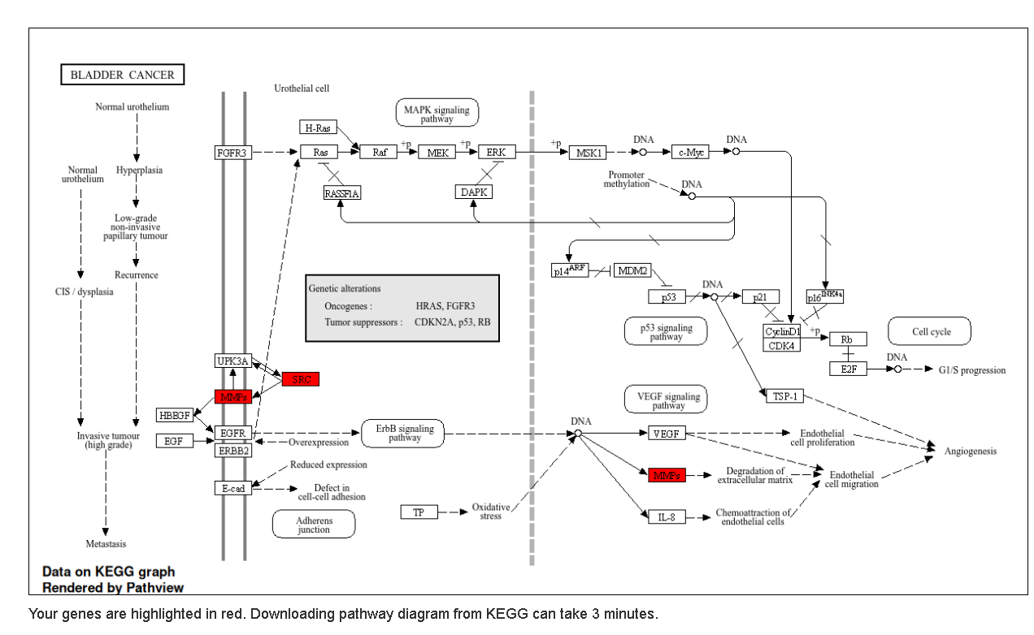
Figure 1. KEGG pathway visualisation supplied with the project.
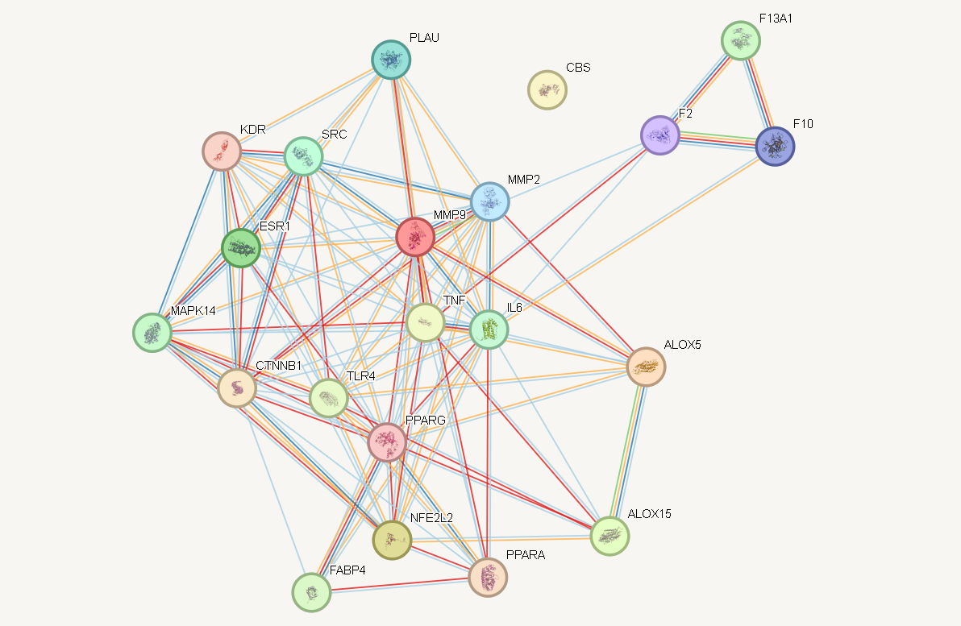
Figure 2. STRING protein–protein interaction network of the overlapping genes.
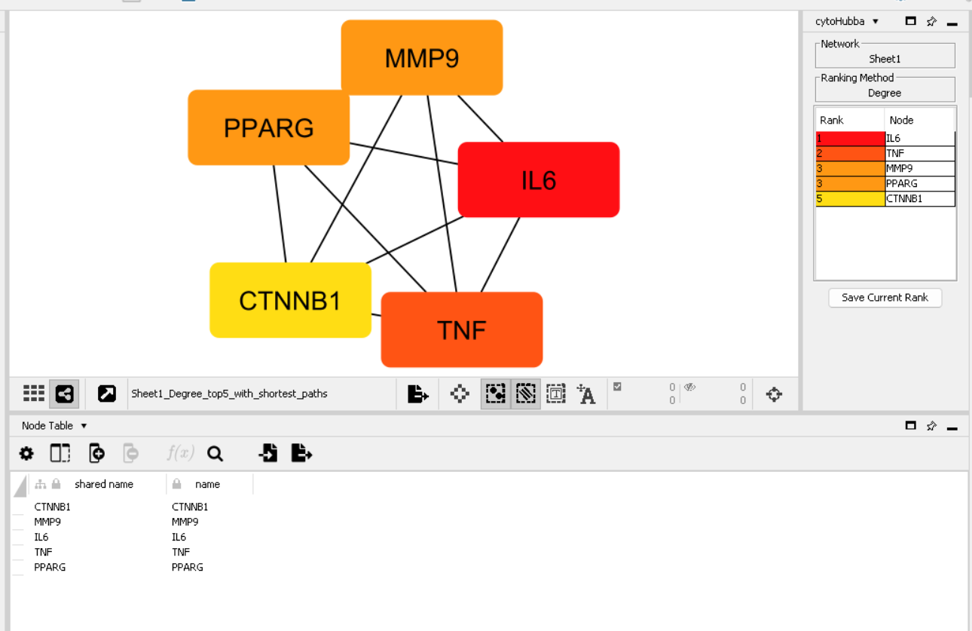
Figure 3. CytoHubba hub-gene ranking screenshot; IL6 is highlighted as the leading hub in the supplied view.
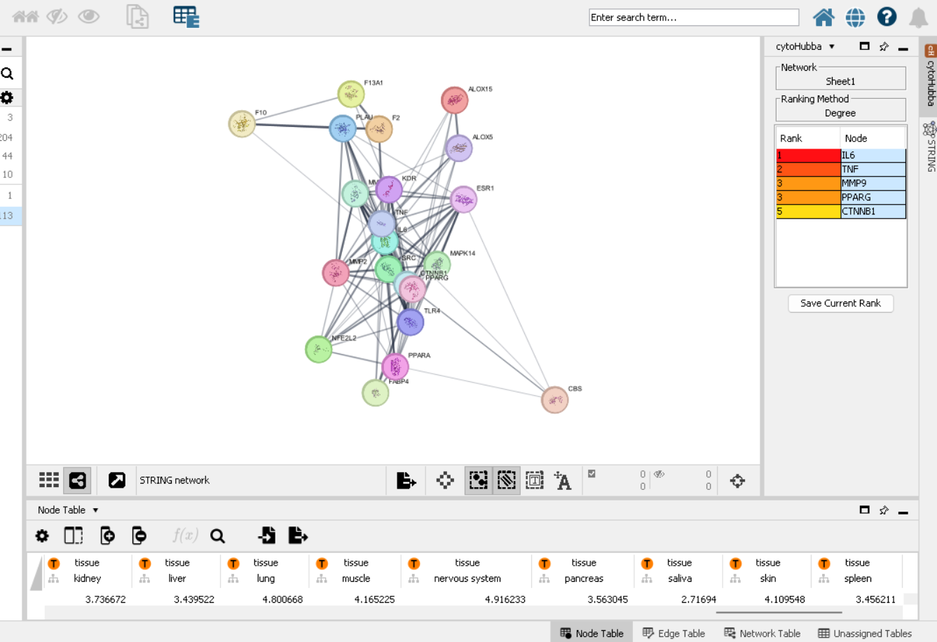
Figure 4. Cytoscape visualisation of the protein–protein interaction network.
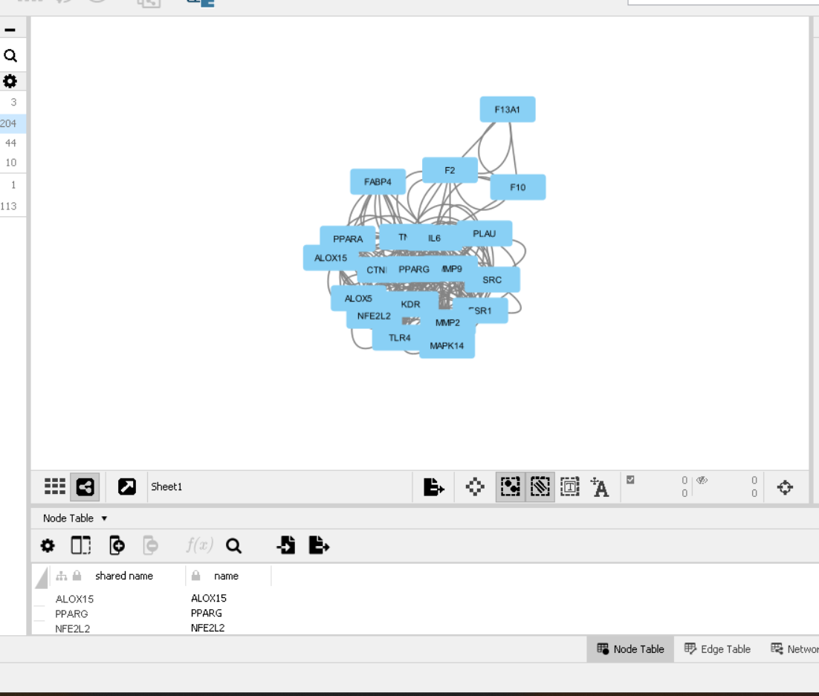
Figure 5. Additional network visualisation
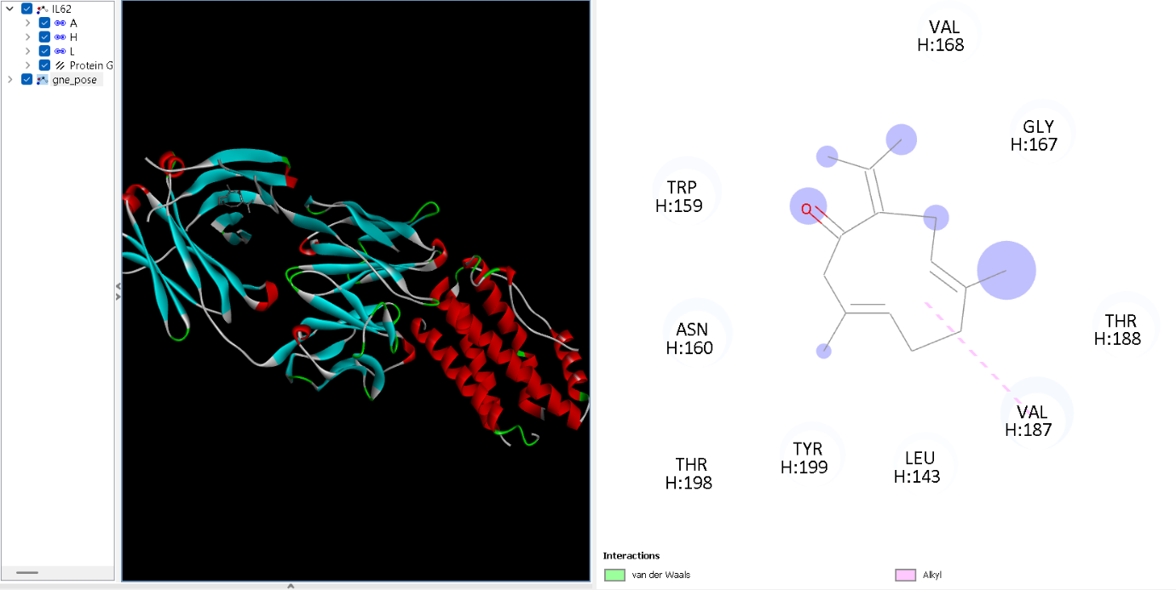
Figure 6. Docking/ligand-interaction visualisation of IL6 protein with Germacrone

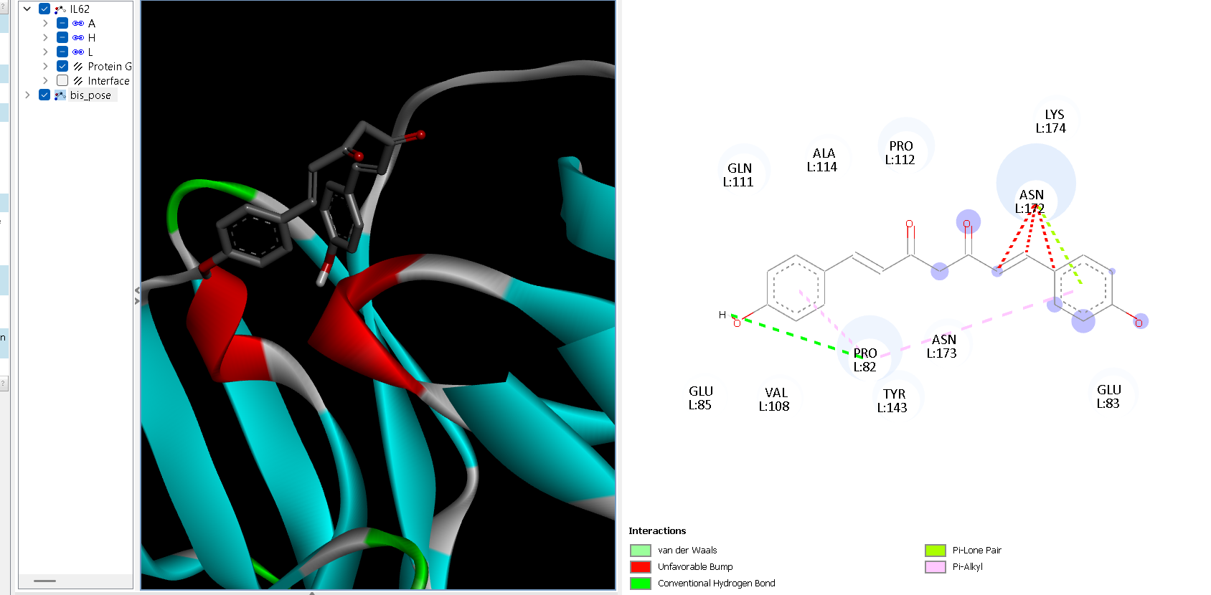
Figure 7. Docking/ligand-interaction visualisation of IL6 PROTEIN WITH BIS-DEMETHOXYCURCUMIN

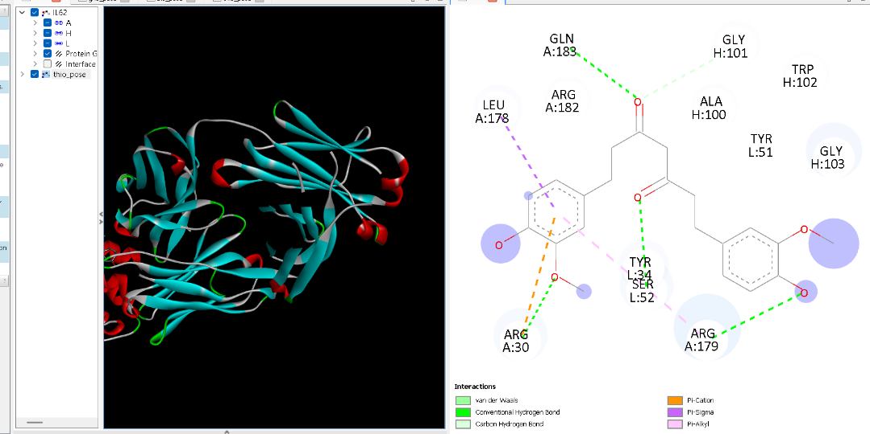
Figure 8. Docking/ligand-interaction visualisation of IL6 PROTEIN WITH TETRAHYDROCURCUMIN

8. Discussion
The workflow combines target-based and network-based approaches to explore the possible relevance of turmeric phytochemicals to atherosclerosis. The 21 shared genes provide a shortlist of candidate links between the selected compounds and the disease-associated gene set. The PPI analysis places IL6 among the leading network nodes, while pathway enrichment highlights lipid/atherosclerosis, fluid-shear-stress and PPAR-related signalling.
Docking was then used as a structural follow-up step for the three selected phytochemicals against IL-6. All three reported scores are negative and close in value. These scores suggest that the docking software found poses with predicted favourable scoring values under the chosen setup. However, IL-6 is a cytokine rather than a conventional enzyme with a well-defined catalytic pocket. Protein flexibility, the selected structure, binding-site definition, protonation, ligand preparation and docking settings can all affect the result. The docking output should therefore be interpreted cautiously and supported by inspection of the binding site and interactions.

9. Limitations and Future Work
- Compound–target associations from databases are predictions or curated associations and need independent validation.
- Gene overlap and PPI centrality do not prove direct compound binding, target modulation or disease benefit.
- Docking scores are approximate scoring-function outputs; they are not experimental binding constants.
- The toxicity-class selection statement in the notes conflicts with the screening table and must be checked against the original ProTox reports.
- The screening table lists five compounds, while the notes say six were initially considered; the missing compound should be identified if the full screening process is reported.
- The exact mapping of the three docking screenshots to ligand names should be confirmed before using them in a public portfolio.
- Further work could include checking the IL-6 structure and binding site, comparing with a suitable reference ligand, repeating docking with validated settings, analysing protein–ligand contacts, and performing molecular dynamics or laboratory validation where resources allow.
- Experimental studies such as cell-based inflammatory assays, target-binding studies and appropriate safety testing would be needed before making claims about biological or therapeutic effects.

10. Conclusion
This project used network pharmacology and CADD to investigate three Curcuma longa phytochemicals—bisdemethoxycurcumin, tetrahydrocurcumin and germacrone—in the context of atherosclerosis. Analysis of the supplied target and disease-gene datasets identified 21 overlapping genes. STRING/Cytoscape and CytoHubba analysis highlighted IL6 as the leading hub gene in the supplied result, and pathway enrichment identified lipid and atherosclerosis, fluid shear stress and atherosclerosis, and PPAR signalling among the relevant pathways. Docking against IL-6 produced top-pose Vina scores between −6.1 and −6.3 kcal/mol. The findings are hypothesis-generating and provide a basis for further computational and experimental investigation; they do not establish that the compounds prevent, treat or cure atherosclerosis.

