WEEK 2 PROJECT
Advanced Data Visualization
and Storytelling with Python
Breast Cancer Wisconsin (Diagnostic) Dataset
Biomedical Data Visualization and Exploratory Analysis

Submitted by | Tirtha Das
Program | B.Tech Biotechnology
Tools | Python, Pandas, NumPy, Matplotlib, Seaborn, Scikit-learn
Project type | Data Visualization and Data Storytelling
2026

Contents
1. Introduction
2. Dataset Description
3. Project Objectives
4. Tools and Methods
5. Data Preparation and Quality Checks
6. Visualization 1 – Class Distribution
7. Visualization 2 – Mean Radius by Diagnosis
8. Visualization 3 – Mean Tumor Radius Distribution
9. Visualization 4 – Correlation Heatmap
10. Visualization 5 – Mean Radius vs Mean Texture
11. Visualization 6 – Multivariate Feature Relationships
12. Numerical Analysis
13. Overall Data Story
14. Scientific and Potential Business Implications
15. Limitations
16. Conclusion
17. Reproducibility and Main Python Workflow
18. References

1. Introduction
Data visualization is an important part of scientific data analysis because it converts large tables of numbers into patterns that can be understood more easily. In biomedical research, visualization can help researchers compare groups, identify relationships among measurements, detect unusual observations, and communicate findings to people who may not have a strong technical background.
This project applies Python-based data visualization to the Breast Cancer Wisconsin (Diagnostic) dataset. The analysis focuses on measurements describing characteristics of cell nuclei and explores how these measurements differ between benign and malignant samples.
The central data-story question is: Can quantitative measurements of cell-nucleus characteristics show clear patterns that distinguish the benign and malignant groups in this dataset?

2. Dataset Description
The analysis uses the Breast Cancer Wisconsin (Diagnostic) dataset loaded through the scikit-learn dataset interface. The dataset contains 569 observations and 30 numerical features, together with a target variable representing the diagnostic class.
The measurements include mean, standard-error, and worst-value characteristics related to nuclear morphology, including radius, texture, perimeter, area, smoothness, compactness, concavity, concave points, symmetry, and fractal dimension.
For easier interpretation, the numerical target was mapped to two readable labels: 0 = Malignant and 1 = Benign. The resulting analysis contains 357 benign observations and 212 malignant observations.
Dataset characteristic | Result
Number of observations | 569
Numerical features | 30
Total columns before label creation | 31
Benign samples | 357
Malignant samples | 212
Missing values | 0
Duplicate rows | 0

3. Project Objectives
- Explore a publicly accessible biomedical dataset using Python.
- Check the structure and quality of the data before visualization.
- Compare benign and malignant samples using multiple visualization types.
- Identify relationships and strong correlations among tumor features.
- Build a coherent visual narrative rather than presenting isolated charts.
- Explain the scientific meaning and potential practical value of the observed patterns.

4. Tools and Methods
The submitted notebook uses Python with Pandas, NumPy, Matplotlib, Seaborn, and Scikit-learn. Scikit-learn provides the dataset, Pandas handles tabular data, NumPy supports numerical operations, and Matplotlib/Seaborn are used for statistical and graphical analysis.
Tool | Use in the project
Python | Overall analysis workflow
Pandas | Data manipulation, grouping, and inspection
NumPy | Numerical and matrix operations
Matplotlib | Figure creation and formatting
Seaborn | Statistical and multivariate visualization in the notebook
Scikit-learn | Loading the Breast Cancer Wisconsin dataset

5. Data Preparation and Quality Checks
The notebook first loaded the dataset and inspected its structure. The dataframe contained 569 rows and 31 columns. Column names were reviewed to understand the available measurements.
The data types were checked. The measured features are numerical floating-point variables, while the target is an integer class label. A readable diagnosis column was created by mapping 0 to Malignant and 1 to Benign.
The missing-value check returned zero missing values for every column. The duplicate-row check also returned zero. Therefore, no missing-value imputation or duplicate-removal step was required before visualization.

Visualization 1 – Class Distribution
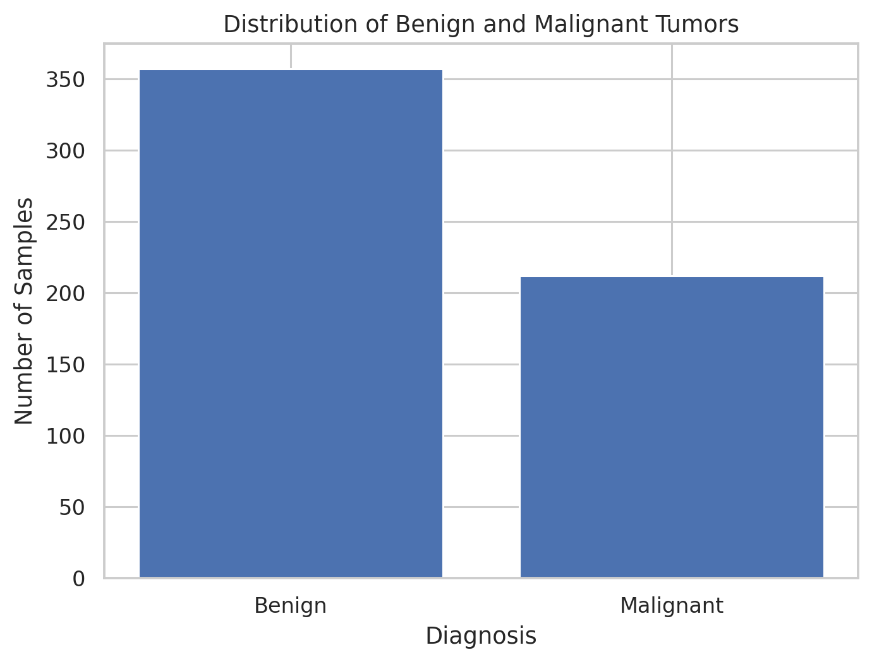
Figure 1. The count plot shows the number of observations in each diagnostic group.

Why this visualization was selected
A count plot establishes the composition of the dataset before any biological comparison. It gives a simple answer to the first question: how many samples belong to each group?

What the visualization shows
The dataset contains 357 benign samples and 212 malignant samples. The benign group is larger, so later comparisons should be read with this class imbalance in mind.

Contribution to the data story
This chart establishes the starting point of the story by showing the population represented in the analysis.

Visualization 2 – Mean Radius by Diagnosis
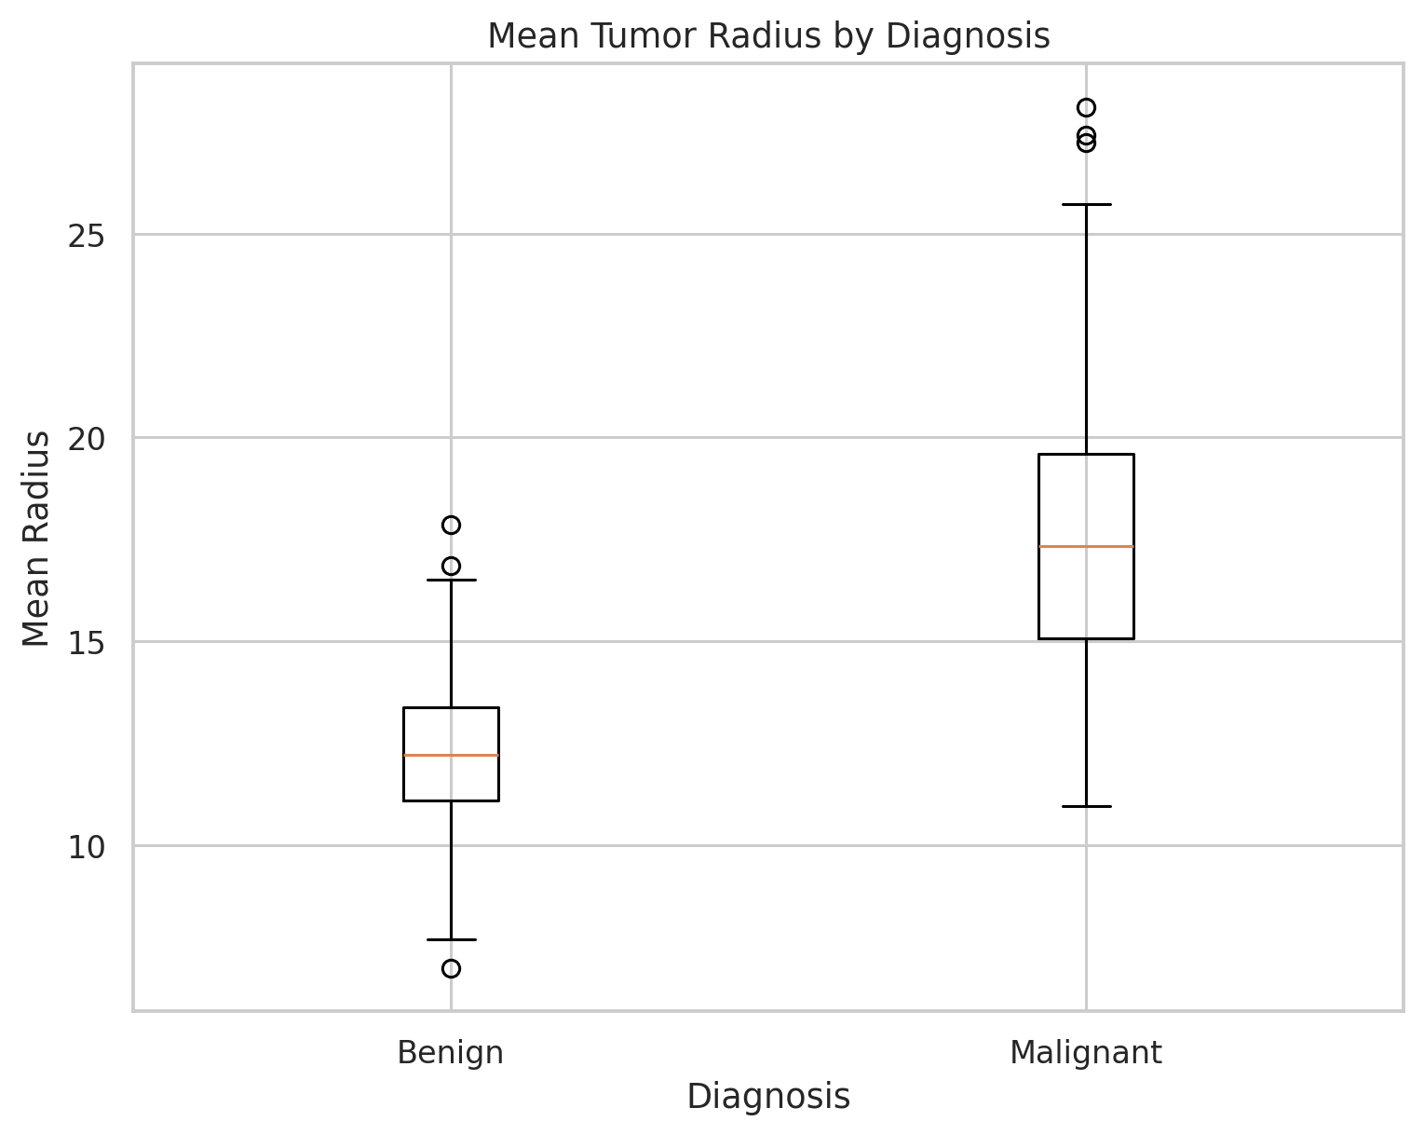
Figure 2. The box plot compares the distribution of mean tumor radius between benign and malignant observations.

Why this visualization was selected
A box plot was added as a stronger group-comparison visualization. It summarizes the center and spread of each group and makes the difference in the distributions easy to compare.

What the visualization shows
The malignant group has a mean mean-radius value of 17.46, compared with 12.15 for the benign group. The malignant distribution is shifted toward larger radius values.

Contribution to the data story
This visualization moves the narrative from 'who is in the dataset?' to 'what measurable characteristic differs between the groups?'

Visualization 3 – Mean Tumor Radius Distribution
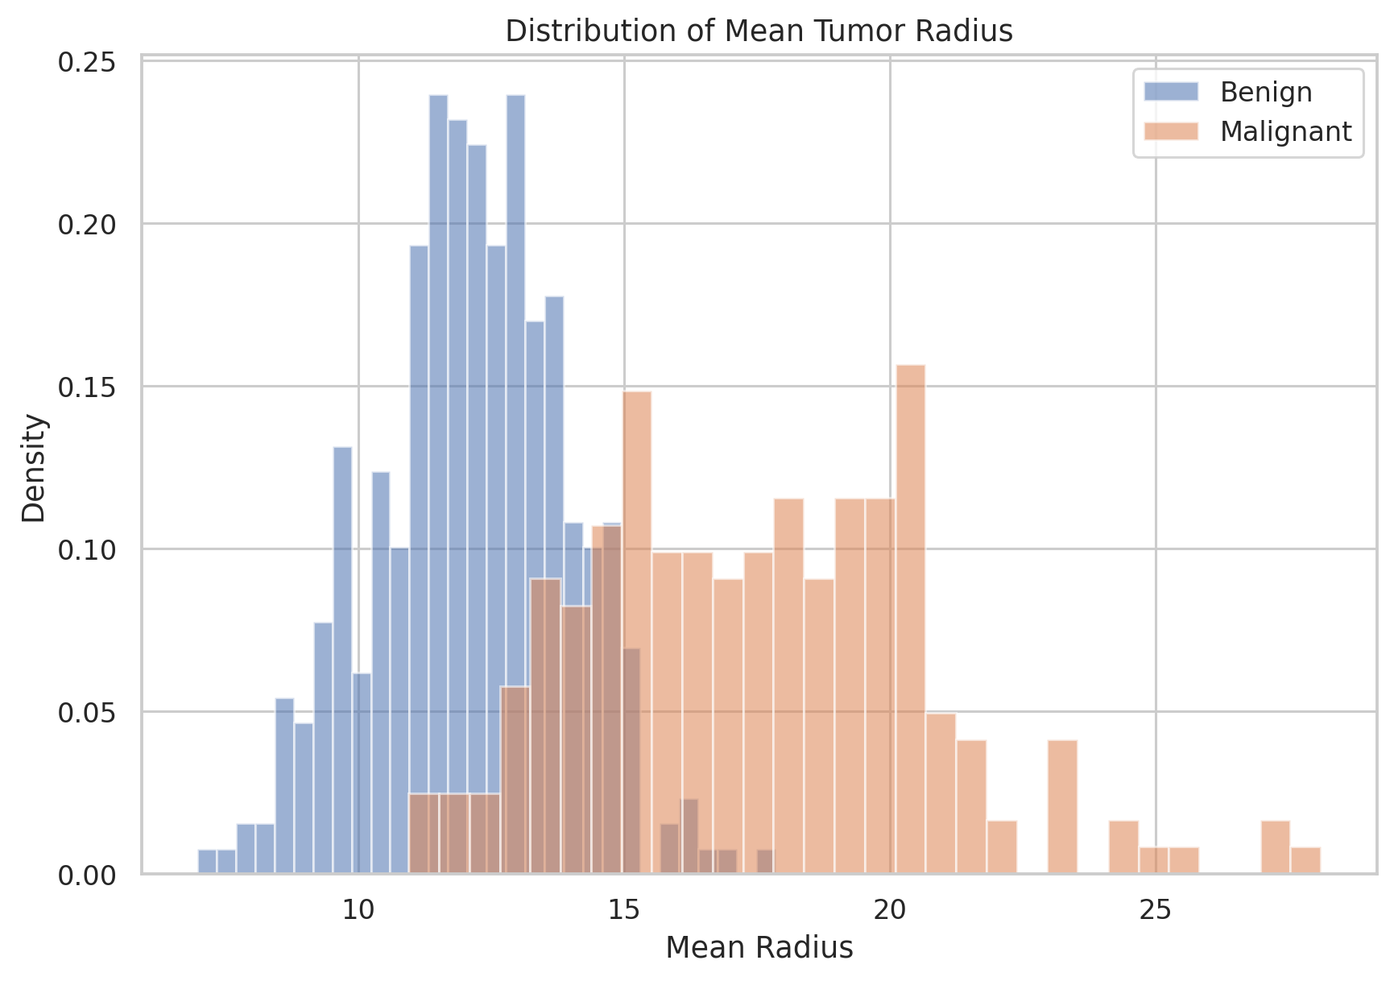
Figure 3. The histogram shows the distribution of mean radius for benign and malignant observations.

Why this visualization was selected
A histogram was selected to show where observations are concentrated rather than only reporting a mean. The overlapping distributions also make it possible to see that the groups are not perfectly separated.

What the visualization shows
Malignant observations are more concentrated at higher mean-radius values, while benign observations are more concentrated at lower values. Some overlap remains between the groups.

Contribution to the data story
This visualization adds distribution-level detail to the box plot and shows both separation and overlap.

Visualization 4 – Correlation Heatmap
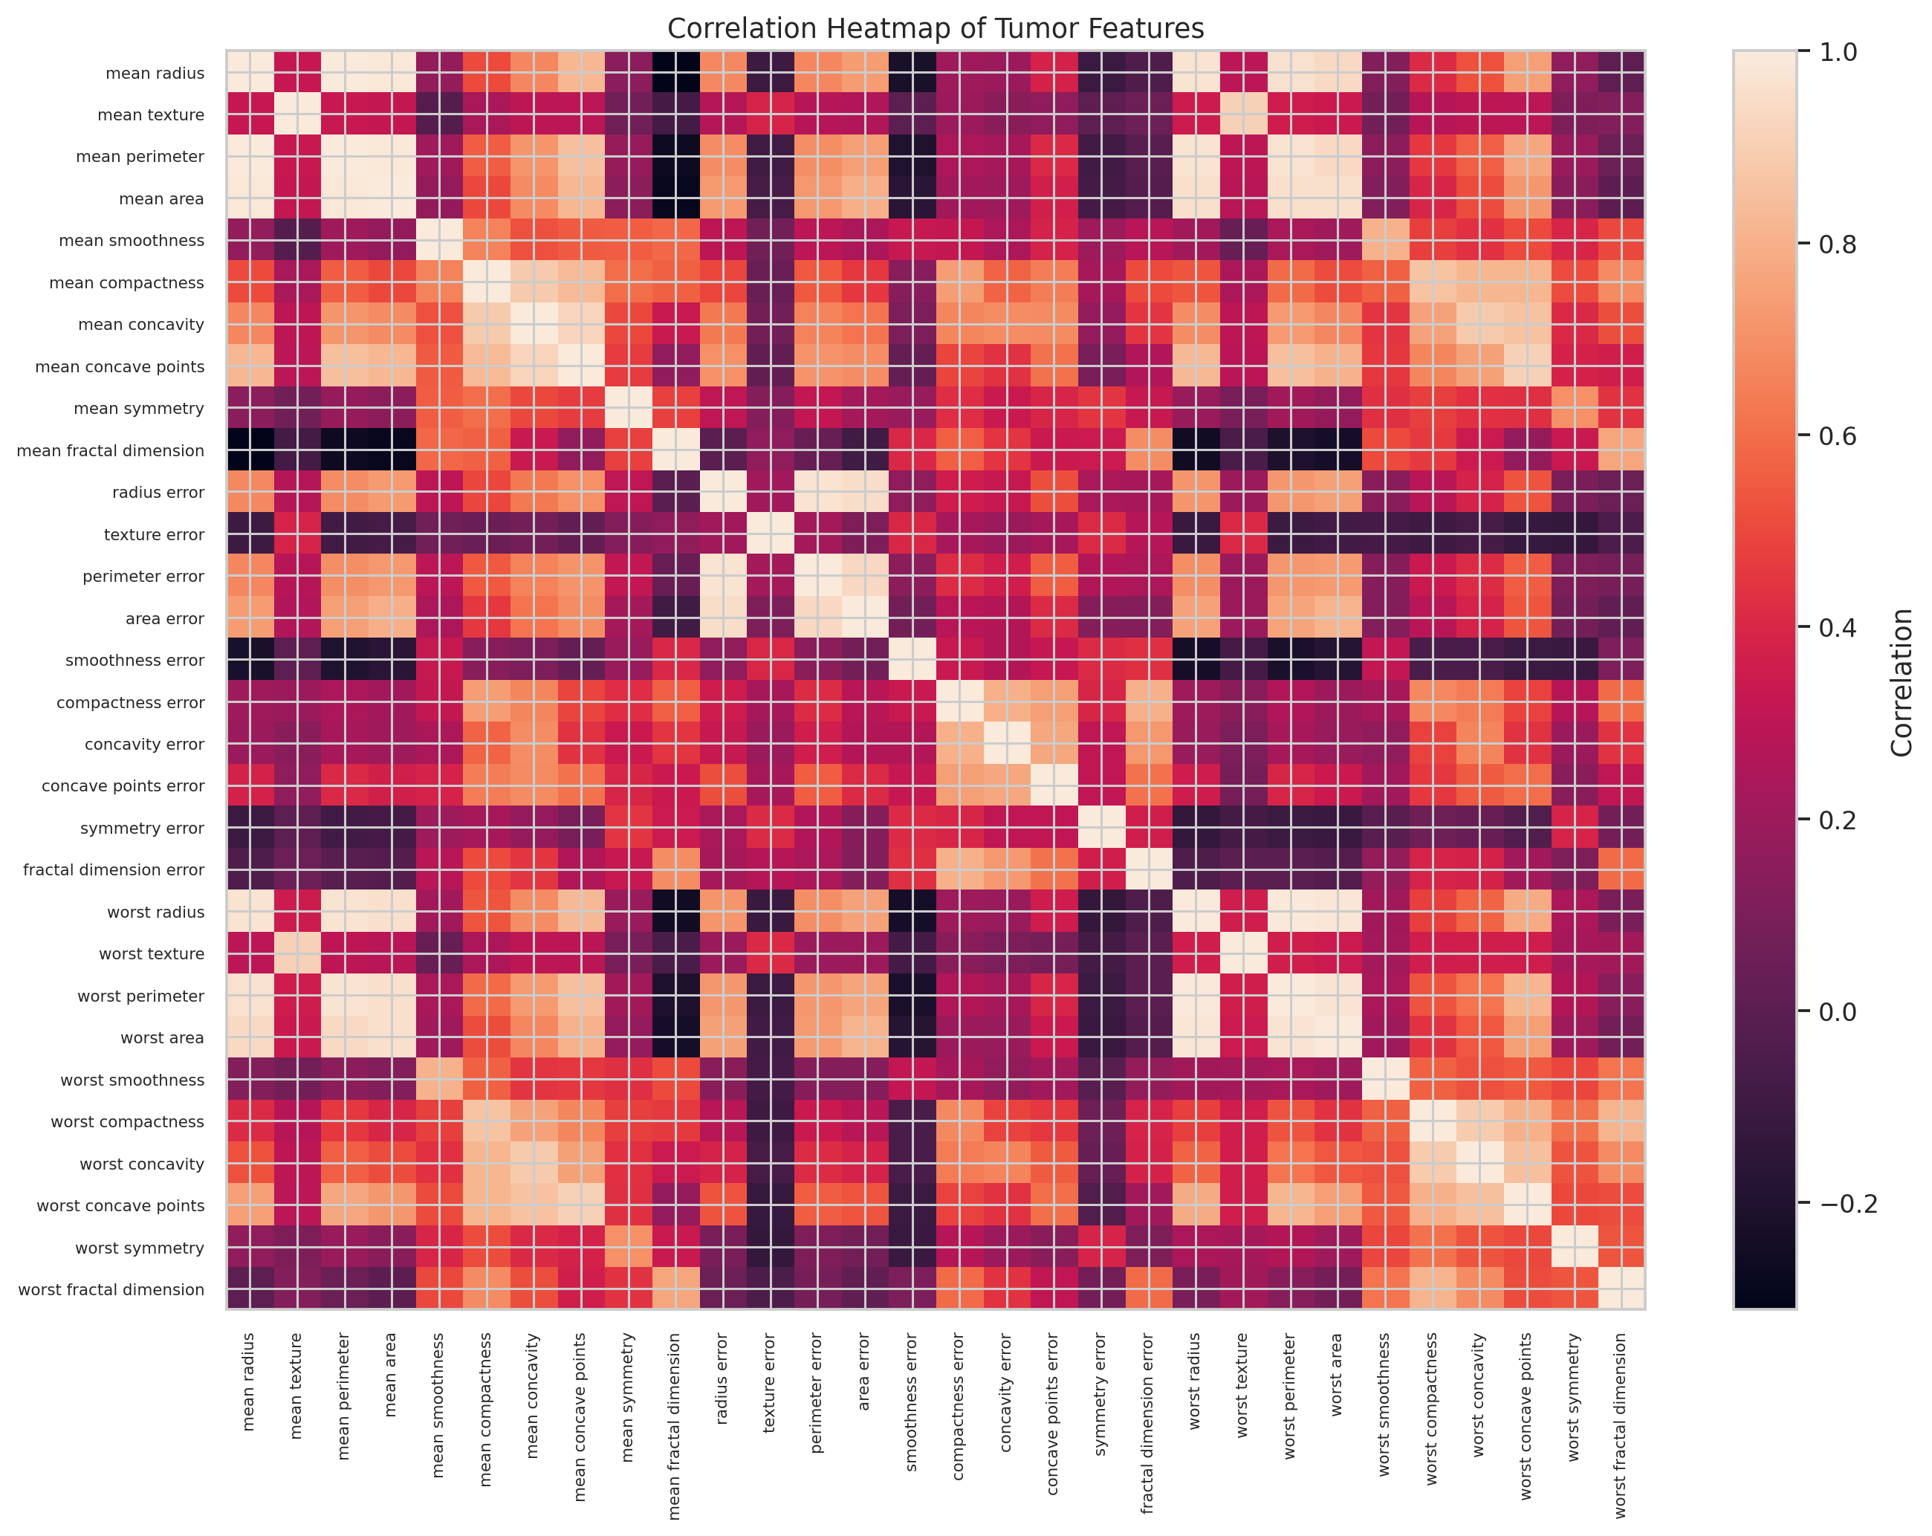
Figure 4. The heatmap displays pairwise correlations among the 30 numerical tumor features.

Why this visualization was selected
A heatmap is useful for a dataset with many variables because it compresses hundreds of pairwise relationships into one visual matrix.

What the visualization shows
The strongest positive relationship found was between mean radius and mean perimeter (r = 0.997855). Mean radius and mean area were also highly correlated (r = 0.987357).

Contribution to the data story
The story now shifts from differences between diagnostic groups to relationships within the feature set.

Visualization 5 – Mean Radius vs Mean Texture
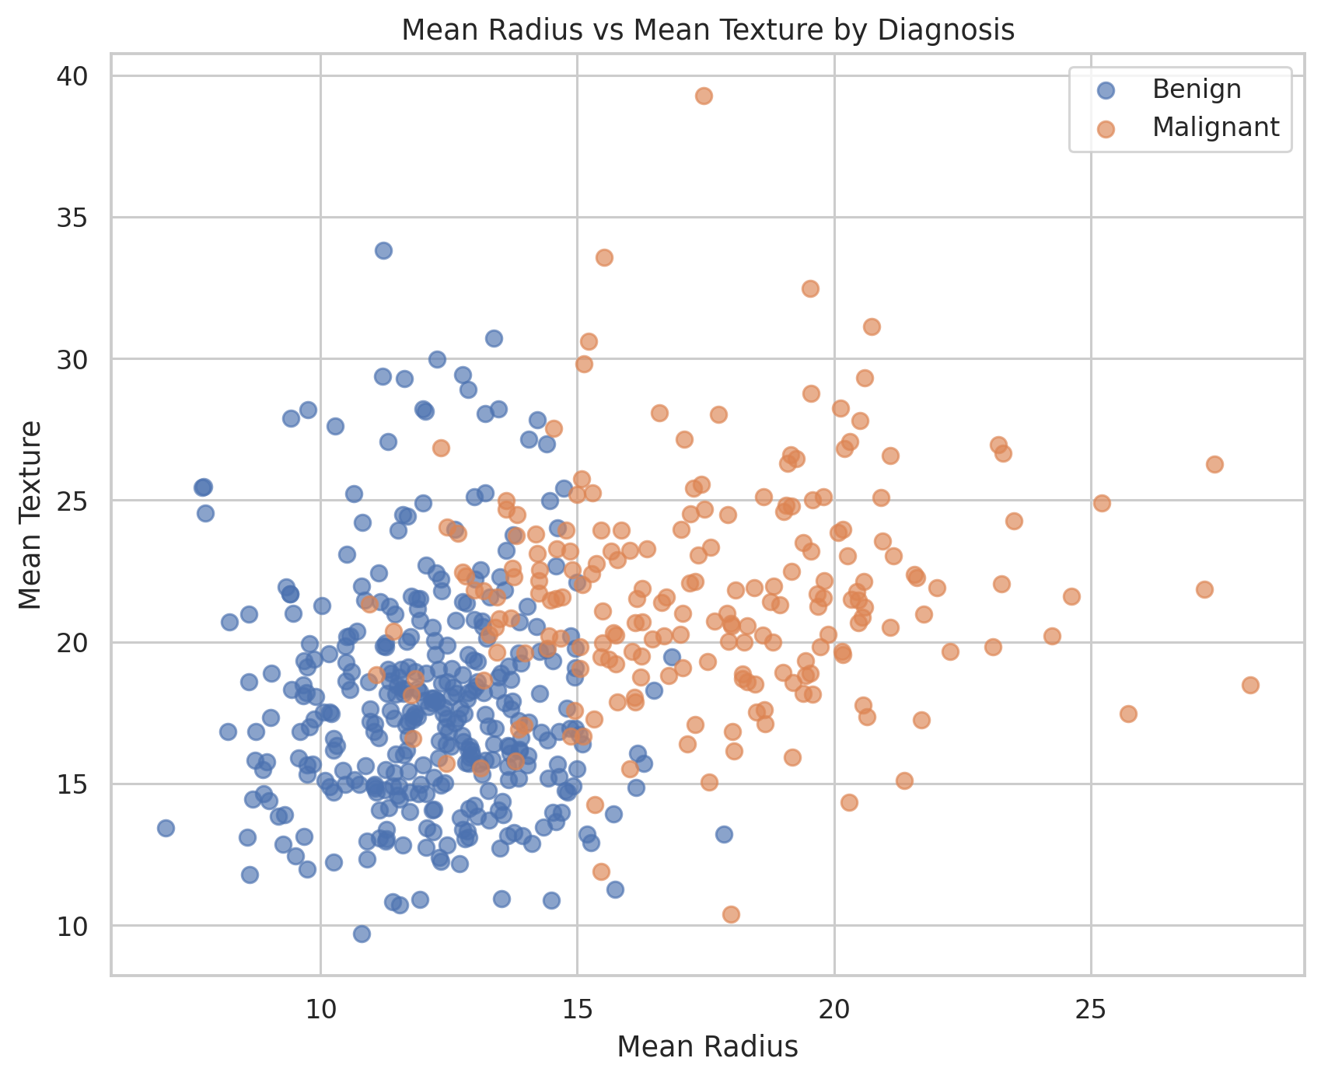
Figure 5. The scatter plot shows mean radius against mean texture while separating observations by diagnosis.

Why this visualization was selected
A scatter plot allows individual observations to be examined and shows whether the two groups occupy different regions of the feature space.

What the visualization shows
The malignant observations occur more frequently at higher mean-radius values. The groups still overlap, showing that two variables alone do not provide a perfect separation.

Contribution to the data story
This supports a multivariable view of the problem: several characteristics can contribute to the observed diagnostic pattern.

Visualization 6 – Multivariate Feature Relationships
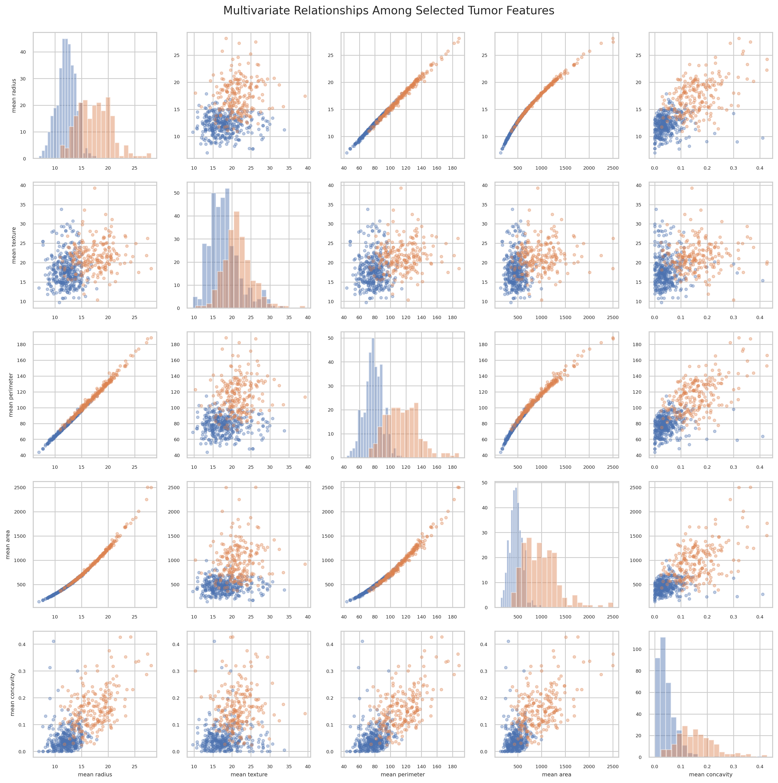
Figure 6. The pair-plot-style figure compares mean radius, mean texture, mean perimeter, mean area, and mean concavity across the two diagnosis groups.

Why this visualization was selected
A multivariate view was selected to examine several relationships together. This is useful because biological measurements often change together rather than independently.

What the visualization shows
Size-related features such as radius, perimeter, and area show strong relationships, while mean concavity also shows visible differences between the groups.

Contribution to the data story
The final visualization brings the narrative together by showing that the dataset contains a multidimensional pattern rather than a single decisive variable.

12. Numerical Analysis
The notebook calculated group-wise means for five important features. These numerical values support the visual comparisons.
Feature | Benign mean | Malignant mean
mean radius | 12.146524 | 17.462830
mean texture | 17.914762 | 21.604906
mean perimeter | 78.075406 | 115.365377
mean area | 462.790196 | 978.376415
mean concavity | 0.046058 | 0.160775
The numerical comparison shows clear differences in several measurements. Mean radius is 12.15 for benign observations and 17.46 for malignant observations. Mean perimeter is 78.08 versus 115.37, while mean area is 462.79 versus 978.38.

Strongest Positive Correlations
Feature 1 | Feature 2 | Correlation
mean radius | mean perimeter | 0.997855
worst radius | worst perimeter | 0.993708
mean radius | mean area | 0.987357
mean perimeter | mean area | 0.986507
worst radius | worst area | 0.984015
worst perimeter | worst area | 0.977578
radius error | perimeter error | 0.972794
mean perimeter | worst perimeter | 0.970387
mean radius | worst radius | 0.969539
mean perimeter | worst radius | 0.969476

13. Overall Data Story
The story begins with dataset composition: benign observations are more numerous than malignant observations. The analysis then moves to the question of whether measurable morphological characteristics differ between the groups.
The box plot and radius distribution show a clear shift toward larger mean-radius values in malignant observations. The numerical analysis supports this pattern, with an average mean radius of about 17.46 in malignant samples and 12.15 in benign samples.
The correlation heatmap shows that several size-related measurements are strongly connected. Mean radius and mean perimeter have an especially strong positive correlation, while mean radius and mean area are also strongly related.
The scatter plot and multivariate figure show that the diagnostic groups tend to occupy different regions of feature space, but they are not perfectly separated. Therefore, the main message is not that one measurement can diagnose a sample. Instead, several quantitative morphological measurements show patterns associated with the diagnostic groups.

14. Scientific and Potential Business Implications

Scientific implications
- Quantitative morphological measurements can reveal useful patterns in biomedical datasets.
- Visualization can help researchers identify candidate variables for later statistical modelling or machine-learning studies.
- Strong correlations among size-related measurements indicate that some variables may contain overlapping information.
- Multivariate visualization supports a more realistic view of biological systems, where several characteristics can vary together.

Potential business and healthcare-data implications
- Biomedical analytics teams can use clear visual dashboards to help researchers inspect large diagnostic datasets.
- Visualization can support early-stage research decisions by highlighting important variables before more detailed modelling or validation.
- Clear visual summaries can improve communication between data scientists, laboratory researchers, clinicians, and project managers.
- Any real-world clinical use would require independent validation, statistical testing, and clinical evaluation before supporting patient-level decisions.

15. Limitations
- This is an exploratory analysis of an existing dataset, not a clinical diagnostic study.
- The two diagnostic groups are not equal in size.
- The visualizations show associations and patterns; they do not prove causation.
- Several features are highly correlated and therefore may contain overlapping information.
- The analysis does not include external validation, hypothesis testing, or a predictive model.
- The findings should not be used to diagnose an individual patient.

16. Conclusion
This project demonstrates how Python-based visualization can transform a biomedical dataset into an understandable visual narrative. Multiple visualization techniques were used to examine class composition, feature distributions, group differences, correlations, two-variable relationships, and multivariate patterns.
The analysis found clear differences between benign and malignant observations across several cellular morphology measurements. Malignant samples had higher average values for important size-related variables such as radius, perimeter, and area, and also showed a higher average mean concavity. At the same time, overlap between the groups shows why these measurements should not be treated as a stand-alone diagnostic rule.
The project demonstrates that good data storytelling is not only about producing charts. It requires selecting a visual form that answers a clear question, explaining the pattern in simple language, and connecting each result to the next step of the scientific story.

17. Reproducibility and Main Python Workflow
The uploaded notebook contains the complete working analysis. The main workflow is summarized below for reproducibility.
import pandas as pd
import numpy as np
import matplotlib.pyplot as plt
import seaborn as sns
from sklearn.datasets import load_breast_cancer
data = load_breast_cancer(as_frame=True)
df = data.frame
df["diagnosis"] = df["target"].map({
0: "Malignant",
1: "Benign"
})
# Quality checks
df.shape
df.isnull().sum()
df.duplicated().sum()
# Visualization
sns.histplot(
data=df,
x="mean radius",
hue="diagnosis",
kde=True,
bins=30,
element="step"
)
plt.show()
# Group-wise numerical analysis
df.groupby("diagnosis")[
["mean radius", "mean texture",
"mean perimeter", "mean area",
"mean concavity"]
].mean()
# Correlation analysis
correlation = df.drop(
columns=["target", "diagnosis"]
).corr()

18. References
1. Scikit-learn documentation: Breast Cancer Wisconsin (Diagnostic) dataset, accessed through sklearn.datasets.load_breast_cancer.
2. UCI Machine Learning Repository: Breast Cancer Wisconsin (Diagnostic) Dataset.
3. Seaborn documentation: statistical data visualization in Python.
4. Matplotlib documentation: visualization and plotting in Python.
End of Report

