WEEK 3 TASK
Statistical Analysis and Hypothesis Testing in Python
Scientific Statistical Analysis Using the Iris Flower Dataset
Prepared using Python, Pandas, SciPy, Pingouin and Matplotlib
Student: Tirtha Das
Project: Week 3 Statistical Analysis and Hypothesis Testing
Analysis focus: Petal length across three Iris species
Submission Report

Table of Contents
1. Executive Summary
2. Introduction and Scientific Problem
3. Research Question and Hypotheses
4. Dataset Description
5. Methodology and Analytical Design
6. Data Cleaning and Quality Checks
7. Descriptive Statistics
8. Visual Exploratory Analysis
9. Assumption Testing
10. Welch's ANOVA
11. Games–Howell Post-hoc Analysis
12. Confidence Intervals and Effect Sizes
13. Integrated Results and Interpretation
14. Discussion
15. Limitations
16. Conclusion
17. Planned Workload Allocation
18. Reproducible Python Code Appendix

1. Executive Summary
This report presents a statistical analysis of petal length in three Iris species: Iris-setosa, Iris-versicolor, and Iris-virginica. The objective was to test whether mean petal length differs among the three species using a rigorous hypothesis-testing workflow.
The original dataset contained 150 observations and five variables. One missing value was found in petal_length and was removed. After this step, 149 observations remained. One exact duplicate row was then identified and removed, giving a final analytical dataset of 148 observations.
The Shapiro–Wilk tests did not provide evidence of non-normality within any species (all p-values > 0.05). Levene's test, however, showed that the group variances were not equal (Levene statistic = 18.4691, p < 0.001). Because the equal-variance assumption was not met, Welch's ANOVA was used instead of ordinary one-way ANOVA.
Welch's ANOVA showed an extremely strong difference in mean petal length among the three species (F = 1793.4542, p = 1.2875 × 10⁻⁶⁵). Games–Howell post-hoc tests showed that all three species pairs differed significantly (p < 0.001 for each comparison). The pairwise confidence intervals did not include zero, and the Hedges' g values indicated very large effects.
Overall, the null hypothesis of equal mean petal length is rejected. The analysis supports the conclusion that petal length differs substantially among the three Iris species.

2. Introduction and Scientific Problem
Statistical analysis is useful in scientific work because observed differences between groups can be tested rather than judged only by visual inspection. In biological data, measurements often vary within the same group, so a statistical test is needed to decide whether differences between group means are larger than would be expected from random variation.
The present analysis uses petal length as a continuous biological measurement and Iris species as the grouping variable. The scientific problem is to determine whether the average petal length is the same across Iris-setosa, Iris-versicolor, and Iris-virginica.
This problem is suitable for one-way group comparison because there is one numerical outcome (petal length) and one categorical factor with three independent species groups.

3. Research Question and Hypotheses

Research question:
Does mean petal length differ significantly among Iris-setosa, Iris-versicolor, and Iris-virginica?
Null hypothesis (H₀):
The mean petal length is equal across the three species: μsetosa = μversicolor = μvirginica.
Alternative hypothesis (H₁):
At least one species has a different mean petal length.
Significance level:
α = 0.05.
Decision rule: when p < 0.05, reject H₀. When p ≥ 0.05, fail to reject H₀.

4. Dataset Description
The analysis was performed on the Iris flower dataset supplied for the project and loaded into Python from the CSV file used in the notebook. The notebook contains 150 observations and five columns.
Variable | Type | Role
sepal_length | Numeric | Descriptive feature
sepal_width | Numeric | Descriptive feature
petal_length | Numeric | Primary outcome variable
petal_width | Numeric | Descriptive feature
species | Categorical | Grouping variable

The three species were initially balanced at 50 observations each. Cleaning changed the final species counts because the missing petal-length observation belonged to one group and one duplicate was removed.

5. Methodology and Analytical Design

Study design
This was an observational comparison of three independent species groups. Petal length was treated as the continuous response variable and species as the categorical explanatory variable.

Analytical workflow
- Inspect dataset dimensions, variables, data types, and missing values.
- Remove the observation with missing petal length.
- Identify and investigate exact duplicate rows, then remove the duplicate.
- Calculate descriptive statistics by species.
- Check normality using the Shapiro–Wilk test.
- Check equality of variances using Levene's test.
- Because equal variances were not supported, use Welch's ANOVA.
- If Welch's ANOVA is significant, use Games–Howell pairwise comparisons.
- Calculate 95% confidence intervals for pairwise mean differences.
- Report Hedges' g effect sizes and visualizations.

Software and Python libraries
Python was used for the analysis. Pandas was used for data handling, SciPy for statistical tests and confidence-interval calculations, Pingouin for Games–Howell post-hoc analysis, and Matplotlib for visualizations.

6. Data Cleaning and Quality Checks
The notebook first checked the structure of the dataset. The original dataset contained 150 rows and 5 columns. There was one missing value in petal_length; the other variables had no missing values.
Cleaning stage | Rows remaining | Finding
Original dataset | 150 | 1 missing petal_length value
After removing missing value | 149 | No missing values remained
After duplicate removal | 148 | No duplicate rows remained

The duplicate check identified two identical records for Iris-virginica (petal length 5.1 cm, petal width 1.9 cm, sepal length 5.8 cm, and sepal width 2.7 cm). One of the two identical rows was removed. The final dataset contained 148 observations.
Species | Final count
Iris-setosa | 49
Iris-versicolor | 50
Iris-virginica | 49
Total | 148

7. Descriptive Statistics
The final descriptive statistics for petal length are shown below. The means are clearly separated, with Iris-setosa having the shortest mean petal length and Iris-virginica the longest.
Species | n | Mean (cm) | SD (cm) | Min (cm) | Max (cm)
Iris-setosa | 49 | 1.463 | 0.175 | 1.0 | 1.9
Iris-versicolor | 50 | 4.260 | 0.470 | 3.0 | 5.1
Iris-virginica | 49 | 5.561 | 0.554 | 4.5 | 6.9

The difference between the smallest and largest group means is approximately 4.10 cm (5.561 − 1.463). However, descriptive differences alone are not enough to establish statistical significance, so formal hypothesis testing was performed.

8. Visual Exploratory Analysis
Three visualizations were produced in the notebook. The boxplot compares the distribution and spread of petal length across species. The histogram shows the distribution and degree of separation between species. The mean-and-confidence-interval plot summarizes the group means with approximate 95% confidence intervals.
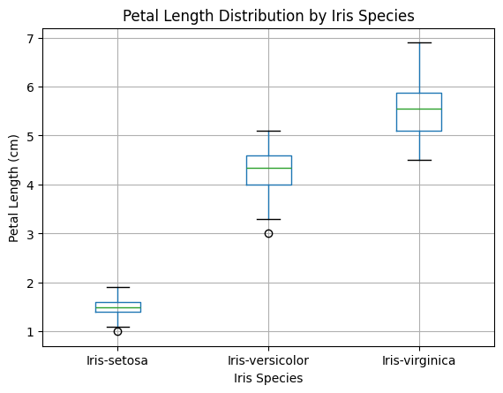
Figure 1. Petal length distribution by Iris species (boxplot).
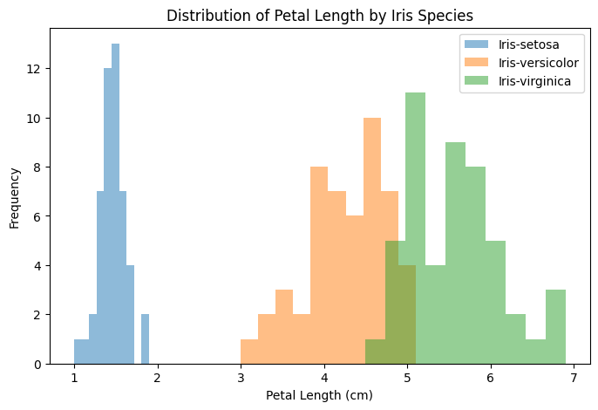
Figure 2. Distribution of petal length by Iris species (overlaid histograms).
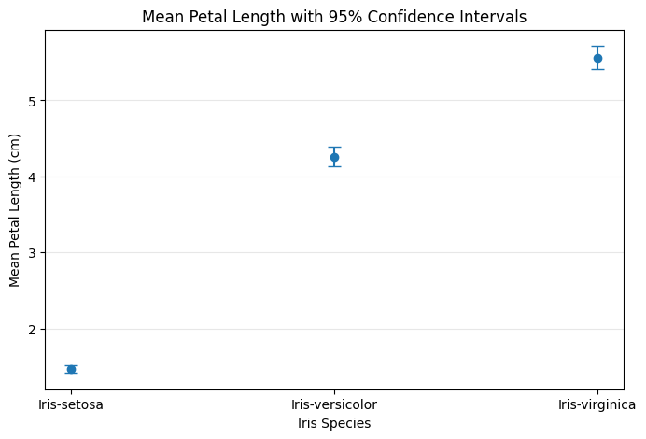
Figure 3. Mean petal length with approximate 95% confidence intervals. The plotted interval uses 1.96 × SEM, as implemented in the notebook.

9. Assumption Testing

9.1 Shapiro–Wilk normality test
The Shapiro–Wilk test was applied separately to the petal-length values in each species. The null hypothesis of this test is that the data are consistent with a normal distribution.
Species | Shapiro–Wilk statistic | p-value | Interpretation
Iris-setosa | 0.9569 | 0.0706 | No evidence against normality
Iris-versicolor | 0.9660 | 0.1585 | No evidence against normality
Iris-virginica | 0.9655 | 0.1597 | No evidence against normality

All three p-values are greater than 0.05. Therefore, the analysis did not find sufficient evidence to reject normality within any species. The normality assumption is reasonably supported.

9.2 Levene's test for equal variances
Levene's test was used to examine whether the three groups had equal variances. The test produced a statistic of 18.4691 with p < 0.001.
Because p < 0.05, the equal-variance null hypothesis is rejected. The species groups therefore show unequal variances. This is important because ordinary one-way ANOVA relies on a common-variance assumption.
To address this issue, Welch's ANOVA was selected because it is designed for comparisons of group means when variances are unequal.

10. Welch's ANOVA
Welch's ANOVA was used to test whether the three species have the same mean petal length while allowing the group variances to differ.
Statistic | Value
Welch F-statistic | 1793.4542
p-value | 1.2875 × 10⁻⁶⁵
Significance level | 0.05
Decision | Reject H₀

The p-value is vastly smaller than 0.05. Therefore, the null hypothesis of equal mean petal length across the three Iris species is rejected. There is extremely strong statistical evidence that mean petal length differs among the species.
Welch's ANOVA establishes that a difference exists somewhere among the groups, but it does not identify which pairs differ. Therefore, a Games–Howell post-hoc test was performed.

11. Games–Howell Post-hoc Analysis
Because Levene's test indicated unequal variances, Games–Howell was used for pairwise comparisons. This method is suitable for comparing independent group means without requiring equal variances.
Comparison | Mean A | Mean B | Difference (A−B) | 95% CI | p-value | Hedges' g
Setosa vs Versicolor | 1.4633 | 4.2600 | −2.7967 | −2.9387 to −2.6548 | p < 0.001 | −7.7949
Setosa vs Virginica | 1.4633 | 5.5612 | −4.0980 | −4.2641 to −3.9319 | p < 0.001 | −9.9006
Versicolor vs Virginica | 4.2600 | 5.5612 | −1.3012 | −1.5064 to −1.0961 | p < 0.001 | −2.5164

All three pairwise comparisons were statistically significant. The negative sign in the mean difference and Hedges' g indicates the direction of subtraction (A minus B); it does not indicate a negative biological effect.
For the Setosa-versicolor comparison, the mean difference was −2.7967 cm. For Setosa-versus-Virginica, it was −4.0980 cm, the largest pairwise difference. For Versicolor-versus-Virginica, the mean difference was −1.3012 cm. Every 95% confidence interval excludes zero, supporting the statistical significance of each pairwise difference.

12. Confidence Intervals and Effect Sizes

12.1 Confidence intervals
The Games–Howell confidence intervals describe plausible ranges for the pairwise mean differences. None of the intervals contains zero. This is consistent with the p-values below 0.05 and supports the conclusion that each species pair has a statistically meaningful difference in mean petal length.

12.2 Effect sizes
Hedges' g was included to describe the magnitude of the pairwise differences. The absolute values of the reported effect sizes are very large: 7.7949, 9.9006, and 2.5164. Therefore, the differences are not only statistically significant but also large relative to the within-group variation.
The largest effect size was observed for Setosa versus Virginica, matching the largest difference in group means.

13. Integrated Results and Interpretation
The complete statistical workflow gives a consistent result. Descriptive statistics and plots showed strong separation in petal length among the three species. Normality was reasonably supported, while equal variances were not. The variance problem was addressed by using Welch's ANOVA rather than a standard equal-variance ANOVA.
Welch's ANOVA produced F = 1793.4542 and p = 1.2875 × 10⁻⁶⁵, leading to rejection of H₀. Games–Howell post-hoc analysis then showed significant differences in all three pairwise comparisons, with p < 0.001 for each comparison. The confidence intervals excluded zero and the effect sizes were very large.
Thus, the statistical evidence strongly supports the alternative hypothesis: mean petal length is not the same across the three Iris species.

14. Discussion
The results show a clear species-related difference in petal length in the analyzed dataset. Iris-setosa has a much smaller mean petal length than both Iris-versicolor and Iris-virginica. Iris-virginica also has a larger mean petal length than Iris-versicolor.
The analysis demonstrates why assumption testing matters. If ordinary one-way ANOVA had been used without checking variance equality, the unequal variances would have been ignored. The use of Welch's ANOVA and Games–Howell provides a more appropriate approach for the observed data structure.
The findings are statistically strong, but the analysis is observational. Therefore, the results should be described as differences or associations between species and petal length rather than as proof that species membership causes a change in petal length.

15. Limitations
- The analysis is based on the dataset supplied for the project; the notebook does not document additional sampling conditions or collection metadata.
- One missing petal-length observation was removed rather than imputed.
- One exact duplicate record was removed. The reason the duplicate occurred is not known from the notebook.
- The analysis focuses on petal length and does not test whether other flower measurements show the same pattern.
- Statistical significance does not by itself establish biological causation.
- The mean-and-error-bar figure uses an approximate 95% interval based on 1.96 × SEM, while the pairwise Games–Howell confidence intervals use the Games–Howell standard error and t distribution.

16. Conclusion
The hypothesis-testing analysis provides strong evidence that mean petal length differs among Iris-setosa, Iris-versicolor, and Iris-virginica. After data cleaning, 148 observations were analyzed. Normality was reasonably supported, but equal variances were not, so Welch's ANOVA was selected.
Welch's ANOVA was highly significant (F = 1793.4542, p = 1.2875 × 10⁻⁶⁵). Games–Howell post-hoc testing found significant differences between every pair of species (p < 0.001), with 95% confidence intervals that excluded zero and very large Hedges' g values.
Therefore, the null hypothesis is rejected and the research hypothesis is supported. The analysis shows that petal length is strongly different across the three Iris species in this dataset.

17. Planned Workload Allocation
The assignment specifies an expected workload of approximately 30–35 hours. The following allocation provides a realistic project plan for documenting the work. It is a planned workload rather than a claim that every hour was independently timed.
Activity | Planned time
Dataset selection, download and inspection | 3 hours
Data cleaning and quality checks | 4 hours
Exploratory statistics and visualization | 5 hours
Statistical assumption testing | 4 hours
Welch's ANOVA and post-hoc testing | 4 hours
Confidence intervals and effect-size interpretation | 3 hours
Report writing and figure preparation | 5 hours
Code review, formatting and final checks | 2 hours
Total | 30 hours

18. Reproducible Python Code Appendix
The following code is an organized version of the analysis performed in the notebook. It preserves the main analytical steps and outputs used in this report.

A. Load and inspect data
import pandas as pd
df = pd.read_csv("iris_.csv")
print(df.shape)
print(df.columns)
print(df.dtypes)
print(df.isnull().sum())
print(df["species"].value_counts())

B. Remove missing petal length
df = df.dropna(subset=["petal_length"])
print(df.shape)
print(df.isnull().sum())

C. Investigate and remove duplicate
print(df[df.duplicated(keep=False)])
print("Duplicate rows:", df.duplicated().sum())
df = df.drop_duplicates()
print(df.shape)
print(df["species"].value_counts())
print(df.duplicated().sum())

D. Descriptive statistics
df.groupby("species")["petal_length"].agg(
["count", "mean", "std", "min", "max"]
).round(3)

E. Boxplot
import matplotlib.pyplot as plt
df.boxplot(column="petal_length", by="species")
plt.title("Petal Length Distribution by Iris Species")
plt.suptitle("")
plt.xlabel("Iris Species")
plt.ylabel("Petal Length (cm)")
plt.show()

F. Normality tests
from scipy.stats import shapiro
groups = [
df[df["species"] == "Iris-setosa"]["petal_length"],
df[df["species"] == "Iris-versicolor"]["petal_length"],
df[df["species"] == "Iris-virginica"]["petal_length"]
]
for name, group in zip(
["Iris-setosa", "Iris-versicolor", "Iris-virginica"],
groups
):
statistic, p_value = shapiro(group)
print(name)
print("Shapiro-Wilk statistic:", round(statistic, 4))
print("p-value:", round(p_value, 4))

G. Levene's test
from scipy.stats import levene
statistic, p_value = levene(
groups[0], groups[1], groups[2]
)
print("Levene's test statistic:", round(statistic, 4))
print("p-value:", p_value)

H. Welch's ANOVA
from scipy.stats import f_oneway
welch_result = f_oneway(
groups[0],
groups[1],
groups[2],
equal_var=False
)
print("F-statistic:", round(welch_result.statistic, 4))
print("p-value:", welch_result.pvalue)

I. Games–Howell post-hoc test
!pip install pingouin -q
import pingouin as pg
games_howell = pg.pairwise_gameshowell(
data=df,
dv="petal_length",
between="species"
)
print(games_howell)

J. 95% confidence intervals and effect sizes
from scipy.stats import t
games_howell["CI_lower"] = (
games_howell["diff"]
- t.ppf(0.975, games_howell["df"]) * games_howell["se"]
)
games_howell["CI_upper"] = (
games_howell["diff"]
+ t.ppf(0.975, games_howell["df"]) * games_howell["se"]
)
final_results = games_howell[
["A", "B", "mean_A", "mean_B",
"diff", "CI_lower", "CI_upper",
"pval", "hedges"]
].round(4)
final_results

K. Mean and approximate 95% CI plot
import numpy as np
import matplotlib.pyplot as plt
summary = df.groupby("species")["petal_length"].agg(
["mean", "count", "std"]
)
summary["sem"] = summary["std"] / np.sqrt(summary["count"])
summary["ci"] = 1.96 * summary["sem"]
plt.figure(figsize=(8, 5))
plt.errorbar(
summary.index,
summary["mean"],
yerr=summary["ci"],
fmt="o",
capsize=5
)
plt.xlabel("Iris Species")
plt.ylabel("Mean Petal Length (cm)")
plt.title("Mean Petal Length with 95% Confidence Intervals")
plt.grid(axis="y", alpha=0.3)
plt.show()

Final Submission Note
This document covers the required hypothesis, methodology, data preparation, statistical tests, visualizations, p-value and confidence-interval interpretation, effect sizes, conclusions, and Python code. The analysis is based on the supplied iris_flower.ipynb notebook and its recorded outputs.

