WEEK 4 MACHINE LEARNING PROJECT
Machine Learning Model Development and Evaluation
Breast Cancer Wisconsin (Diagnostic) Dataset
Algorithm: Logistic Regression
Environment: Python / Google Colab / Scikit-learn
Prepared by: Tirtha Das

1. Introduction
This project demonstrates the basic machine learning workflow for a binary classification problem. "
The aim is to develop a model that classifies breast tumor measurements as malignant or benign using "
the Breast Cancer Wisconsin (Diagnostic) dataset. The workflow covers data preparation, train-test splitting, "
feature scaling, model training, prediction, evaluation, visualization, and critical discussion of model limitations.

2. Dataset Description
The Breast Cancer Wisconsin (Diagnostic) dataset contains 569 observations and 30 numerical predictor "
"features calculated from digitized images of breast tissue. The target has two classes: malignant and benign. "
"Features include measurements such as radius, texture, perimeter, area, smoothness, compactness, concavity, "
"concave points, symmetry, and fractal dimension.
Item | Value
Observations | 569
Predictor variables | 30
Target classes | 2
Problem type | Binary classification
Training set | 455 observations (80%)
Testing set | 114 observations (20%)

3. Data Preparation and Preprocessing
The dataset was loaded using scikit-learn. The data were checked for missing values and class labels. No missing values were found in the supplied dataset. The data were divided into 80% training data and 20% testing data. Stratified splitting was used so that the class proportion remained similar in both sets.
Feature scaling was performed with StandardScaler. This is important for logistic regression because the original variables have different numerical ranges. Scaling was placed inside a scikit-learn Pipeline so that the scaler was fitted only on the training data, reducing the risk of data leakage.

4. Model Selection
Logistic Regression was selected because it is a simple and widely used classification algorithm. It is suitable for a binary target and provides a strong baseline model. It is also easier to interpret than many complex machine learning models. A maximum iteration value of 5000 was used to allow the optimization process to converge.

5. Model Development Workflow
- Load the dataset.
- Separate predictor variables (X) and the target variable (y).
- Check the dataset shape, class distribution, and missing values.
- Split the data into training and testing sets using an 80:20 ratio.
- Standardize numerical features using StandardScaler.
- Train the Logistic Regression classifier on the training set.
- Generate class predictions and malignant-class probabilities.
- Evaluate the model using accuracy, precision, recall, F1-score, and ROC-AUC.
- Visualize the results using a confusion matrix, ROC curve, and metric comparison chart.

6. Python Implementation
The main implementation uses Pandas for data handling, Matplotlib for visualization, and Scikit-learn for preprocessing, model training, and evaluation.
data = load_breast_cancer(as_frame=True)
X = data.data
y = data.target.map({0: "Malignant", 1: "Benign"})
X_train, X_test, y_train, y_test = train_test_split(
X, y, test_size=0.20, random_state=42, stratify=y
)
model = Pipeline([
("scaler", StandardScaler()),
("classifier", LogisticRegression(max_iter=5000))
])
model.fit(X_train, y_train)
y_pred = model.predict(X_test)

7. Model Evaluation
The model was evaluated on the test set, which was not used during training. This gives a more realistic estimate of how the classifier performs on unseen data.
Metric | Score
Accuracy | 0.965
Precision | 0.975
Recall | 0.929
F1-score | 0.951
ROC-AUC | 0.996
The model achieved an accuracy of 0.965. Its precision for the malignant class was 0.975, while recall was 0.929. The F1-score was 0.951, and the ROC-AUC was 0.996. Recall is especially important in a screening context because a false negative means a malignant case is predicted as benign.

8. Visualization 1: Confusion Matrix
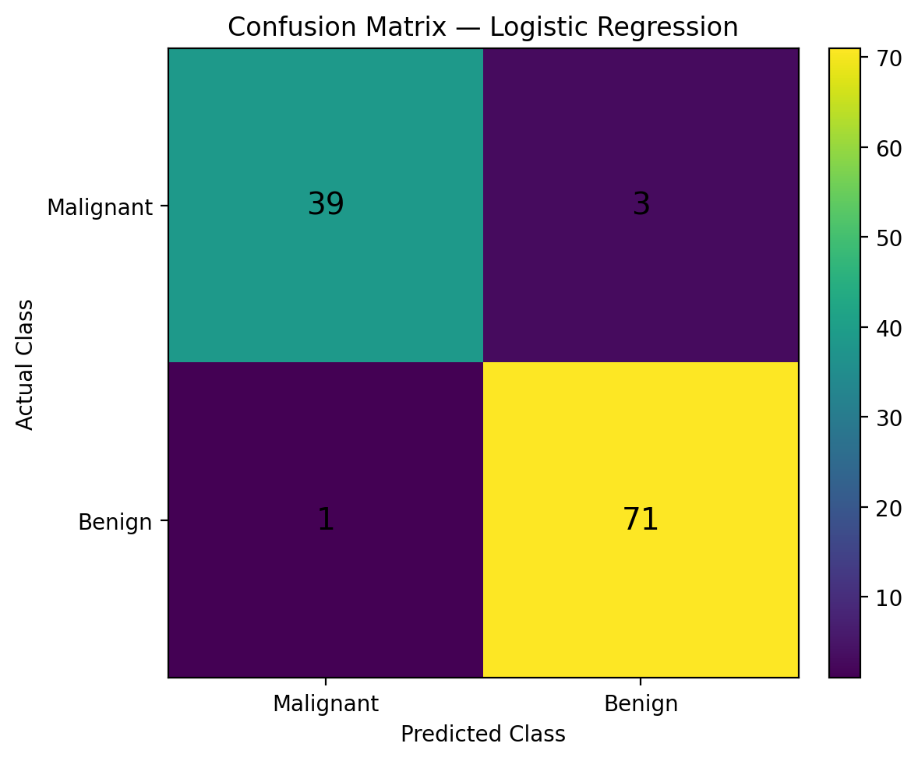
Figure 1. Confusion matrix for the Logistic Regression model.
The confusion matrix shows 71 correctly identified malignant cases, 39 correctly identified benign cases, 3 benign cases incorrectly classified as malignant, and 1 malignant cases incorrectly classified as benign.

9. Visualization 2: ROC Curve
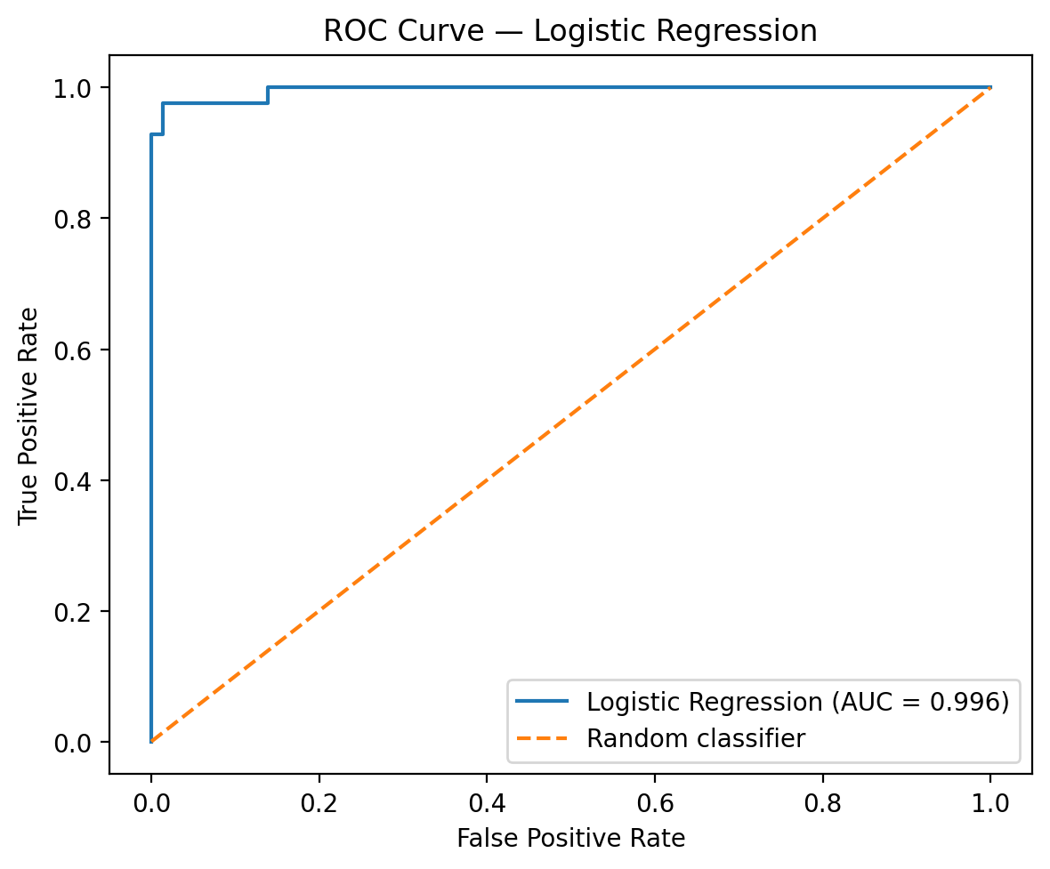
Figure 2. ROC curve showing the classification ability of the model.
The ROC curve compares the true positive rate with the false positive rate at different classification thresholds. The area under the curve (ROC-AUC) was 0.996. A value closer to 1 indicates stronger separation between the two classes.

10. Visualization 3: Performance Metric Comparison
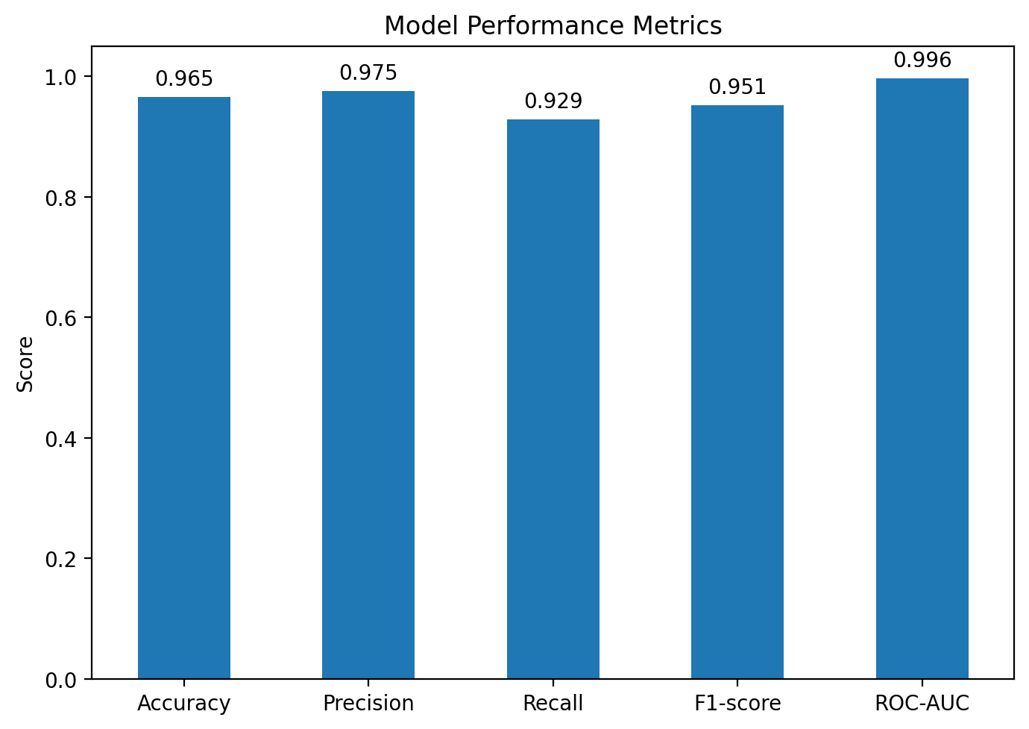
Figure 3. Comparison of accuracy, precision, recall, F1-score, and ROC-AUC.

11. Error Analysis and Critical Discussion
The model does not classify every test observation correctly. The confusion matrix shows both false-positive and false-negative predictions. In medical classification, false negatives can be more serious because they may allow a malignant case to be classified as benign. Therefore, accuracy alone should not be used to judge a model.
Possible sources of error include overlap between malignant and benign feature values, measurement variation in the original imaging data, limited sample size, and the assumption that a linear decision boundary is sufficient. The dataset may also not represent every hospital, population, imaging device, or clinical setting.

12. Overfitting and Underfitting
Overfitting occurs when a model learns patterns that are too specific to the training data and then performs poorly on unseen data. Underfitting occurs when the model is too simple to capture useful patterns. The use of a separate test set helps detect poor generalization, but a single train-test split is not enough to fully assess model stability. Cross-validation would provide a stronger estimate.

13. Suggestions for Model Improvement
- Use k-fold cross-validation to obtain a more stable performance estimate.
- Compare Logistic Regression with Decision Tree, Random Forest, Support Vector Machine, or other suitable classifiers.
- Tune model hyperparameters using GridSearchCV or RandomizedSearchCV.
- Study feature importance or model coefficients to identify influential predictors.
- Test the final model on an independent external dataset to assess generalization.
- Consider class weighting or threshold adjustment if the cost of false negatives is high.
- Use calibration analysis if predicted probabilities will be used for decision support.

14. Strengths and Limitations
Strengths:
- Simple and reproducible machine learning workflow.
- Uses a standard binary classification problem.
- Feature scaling is handled safely inside a pipeline.
- Multiple evaluation metrics are reported.
- Confusion matrix and ROC curve provide complementary views of performance.
Limitations:
- Only one classifier was evaluated.
- The evaluation uses one train-test split rather than repeated cross-validation.
- The dataset is a benchmark dataset and may not reflect all real-world clinical populations.
- The model should not be treated as a clinical diagnostic system.

15. Conclusion
A Logistic Regression model was successfully developed to classify breast tumor cases using the Breast Cancer Wisconsin (Diagnostic) dataset. The complete pipeline included data checking, stratified train-test splitting, feature scaling, model training, and evaluation. The model obtained an accuracy of 0.965 and ROC-AUC of 0.996 on the test set. The results show that a simple machine learning model can provide a strong baseline for binary classification, while also highlighting the need for careful error analysis, cross-validation, and comparison with other algorithms before drawing strong conclusions.

16. Reproducibility and Tools
Software: Python 3.x, Pandas, NumPy, Matplotlib, and Scikit-learn. The analysis can be reproduced in Google Colab by running the supplied Python code.

Appendix A. Complete Code
The complete executable Python script is supplied separately as 'week4_machine_learning.py'.

