WEEK 5 · FINAL PROJECT REPORT
Comprehensive Data Science Project Report and Strategic Recommendations
From raw data to decisions: an end-to-end synthesis of four biomedical data-science projects
Prepared by: Tirtha Das
Program: B.Tech Biotechnology
Datasets: Diabetes clinical data · Breast Cancer Wisconsin (Diagnostic) · Iris flowers
Tools: Python · Pandas · NumPy · Matplotlib · Seaborn · SciPy · Pingouin · Scikit-learn
Year: 2026

Contents
1. Executive Summary
2. Introduction and Objectives
3. Methodology and Project Overview
4. Detailed Analysis
4.1 Week 1 – Data Acquisition, Cleaning and EDA (Diabetes)
4.2 Week 2 – Data Visualization and Storytelling (Breast Cancer)
4.3 Week 3 – Statistical Analysis and Hypothesis Testing (Iris)
4.4 Week 4 – Machine Learning Model (Breast Cancer)
5. Key Findings and Cross-Project Patterns
6. Strategic Recommendations
7. Potential Business and Research Impact
8. Discussion
9. Limitations
10. Future Improvements and Roadmap
11. Conclusion
12. Workload Allocation
Appendix A. Consolidated Code
Appendix B. Plain-Language Glossary
References

1. Executive Summary
This report brings together four weeks of hands-on data-science work into one connected story. Each week used a real, publicly available biomedical or biological dataset and added one new skill: data cleaning and exploration (Week 1), visual storytelling (Week 2), statistical hypothesis testing (Week 3) and machine-learning (Week 4). Week 5 combines these results, finds the patterns that repeat across them, and turns them into practical recommendations.
The bottom line
Good decisions from data depend on three things done in order: clean and trustworthy data first, clear evidence second (visuals and statistics), and a carefully validated model last. Where this order was followed, results were strong and easy to explain. Where data quality was weak, as with the diabetes dataset, the weakness was the main risk.

Headline results
Table 1. Summary of results from each week
Week | Question asked | Key result | What it means
1 | Is the diabetes data ready to use? | 768 rows, 9 columns. Insulin was 48.7% missing and SkinThickness 29.6% missing. The diabetes-positive group had higher mean glucose (142.2 vs 110.7), BMI (35.4 vs 30.9) and age (37.1 vs 31.2). | Data quality, not model choice, is the biggest risk.
2 | Do benign and malignant tumors look different? | Malignant mean radius 17.46 vs 12.15 benign. Size features are almost perfectly correlated (r up to 0.998). Groups overlap. | Clear pattern, but no single measurement is enough.
3 | Does petal length differ across Iris species? | Welch's ANOVA F = 1793.45, p = 1.29 × 10⁻⁶⁵. All three species pairs differ (p < 0.001), with very large effect sizes. | Right test choice (unequal variances) gave a trustworthy answer.
4 | Can a model classify tumors? | Logistic Regression: accuracy 0.965, precision 0.975, recall 0.929, F1 0.951, ROC-AUC 0.996 on 114 test cases. | Strong baseline; 3 malignant cases were still missed.

Top recommendations
- Make data quality the first gate. Standardize how missing values are recorded and document every cleaning step before any analysis starts.
- Treat heavily missing variables with care. Do not use Insulin or SkinThickness without a documented, tested imputation strategy.
- Choose methods that match the data. Check assumptions before testing, and report effect sizes as well as p-values.
- Judge models by the cost of errors. In screening, a missed malignant case matters more than a false alarm, so recall must be tracked alongside accuracy.
- Validate before any real use. Use cross-validation, an independent dataset and calibration checks; keep any model as decision support for a human expert, not a replacement.

2. Introduction and Objectives

2.1 Background
Data science is not one skill but a chain of connected steps. Data must first be collected and cleaned. It must then be explored and visualized so that patterns can be seen. Claims must be tested with statistics so that they are not just impressions. Finally, a model can be built to make predictions, and its limits must be understood. A weakness at any link weakens everything that follows.
During this internship, each week covered one link in that chain using biomedical or biological data. This final report joins the links into one project and answers a practical question: what should a decision-maker do differently because of what these analyses found?

2.2 Objectives of this report
- Bring together the findings, figures and code from Weeks 1 to 4 into one coherent document.
- Identify the key findings and patterns that appeared across the datasets.
- Develop clear, evidence-based strategic recommendations and explain how they can improve decisions.
- Describe potential business and research impact, and be honest about limitations.
- Propose realistic next steps for improving the work.

2.3 Intended audience
The report is written for three kinds of readers: a research or analytics lead who must decide where to invest effort, a clinical or laboratory team who may use the results, and a project manager who needs a plain-language view of risks and next steps. Each analysis section therefore ends with an “In simple words” summary.

3. Methodology and Project Overview
The work followed one repeatable workflow across all four weeks. Figure 1 shows how the weeks connect.
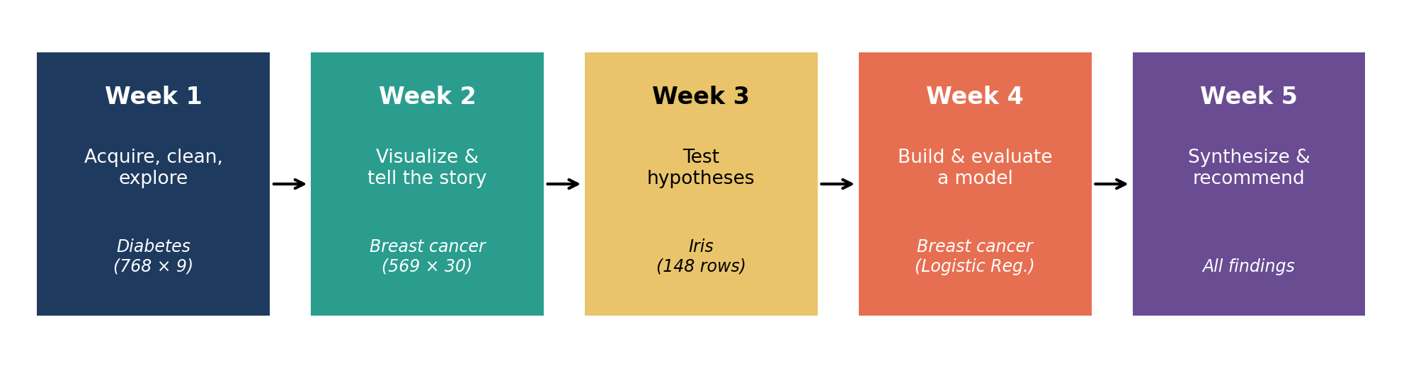
Figure 1. The five-week workflow: each week adds one stage and Week 5 combines them.

3.1 Datasets used
Table 2. The three datasets used in the internship
Dataset | Size | Used in | Content
Diabetes (diabetes1.csv) | 768 rows × 9 columns | Week 1 | Pregnancies, glucose, blood pressure, skin thickness, insulin, BMI, pedigree function, age and a 0/1 diabetes outcome.
Breast Cancer Wisconsin (Diagnostic) | 569 rows × 30 features | Weeks 2 and 4 | Measurements of cell nuclei from digitized images; 357 benign and 212 malignant samples.
Iris flowers | 150 rows → 148 after cleaning | Week 3 | Sepal and petal measurements for three species.

3.2 Analytical workflow
- Acquire and inspect. Load the data, check shape, data types and summary statistics.
- Clean. Find missing values, zeros that mean “not measured”, duplicates and impossible values.
- Explore and visualize. Use charts to see distributions, group differences and correlations.
- Test. State hypotheses, check test assumptions, run the correct test and measure effect size.
- Model. Split data into training and test sets, scale features inside a pipeline, train, and evaluate on unseen data.
- Synthesize and recommend. Combine findings and turn them into actions (this report).

3.3 Tools and techniques
Table 3. Tools and where they were used
Tool | Use in the project
Python, Google Colab | Main environment for all analyses.
Pandas, NumPy | Loading, cleaning, grouping and numerical operations.
Matplotlib, Seaborn | Histograms, box plots, count plots, scatter plots and correlation heatmaps.
SciPy, Pingouin | Shapiro–Wilk, Levene, Welch's ANOVA, Games–Howell post-hoc test and effect sizes.
Scikit-learn | Dataset loading, train-test split, StandardScaler, Pipeline, Logistic Regression and metrics.

How the figures in this report were produced
Figures 4 to 8 and 10 to 12 and 14 to 16 are the original plots from Weeks 2, 3 and 4. The Week 1 notebook did not store its plot images, so Figures 2 and 3 were redrawn using the exact numbers from the Week 1 tables. Figures 9, 13 and 17 are new summary charts drawn from numbers already reported in Weeks 2, 3 and 4. No new data was introduced.

4. Detailed Analysis

4.1 Week 1 – Data Acquisition, Cleaning and Exploratory Analysis

Purpose
To take raw clinical data and prepare it for analysis. The diabetes dataset has 768 observations and 9 variables. The goal was to understand its quality before using it for anything else.

What was done
- Loaded the CSV file and inspected it with head(), shape, info() and describe().
- Checked missing values, zero values, duplicates and the range of Age, BMI and Glucose.
- Converted zeros in Glucose, BloodPressure, SkinThickness, Insulin and BMI to missing values, because a true zero is not possible for these measurements. Zeros in Pregnancies and Outcome were kept because they are meaningful.
Table 4. Missing values found in the diabetes dataset
Variable | Missing values | Missing percentage
Insulin | 374 | 48.70%
SkinThickness | 227 | 29.56%
BloodPressure | 35 | 4.56%
BMI | 11 | 1.43%
All other variables | 0 | 0.00%

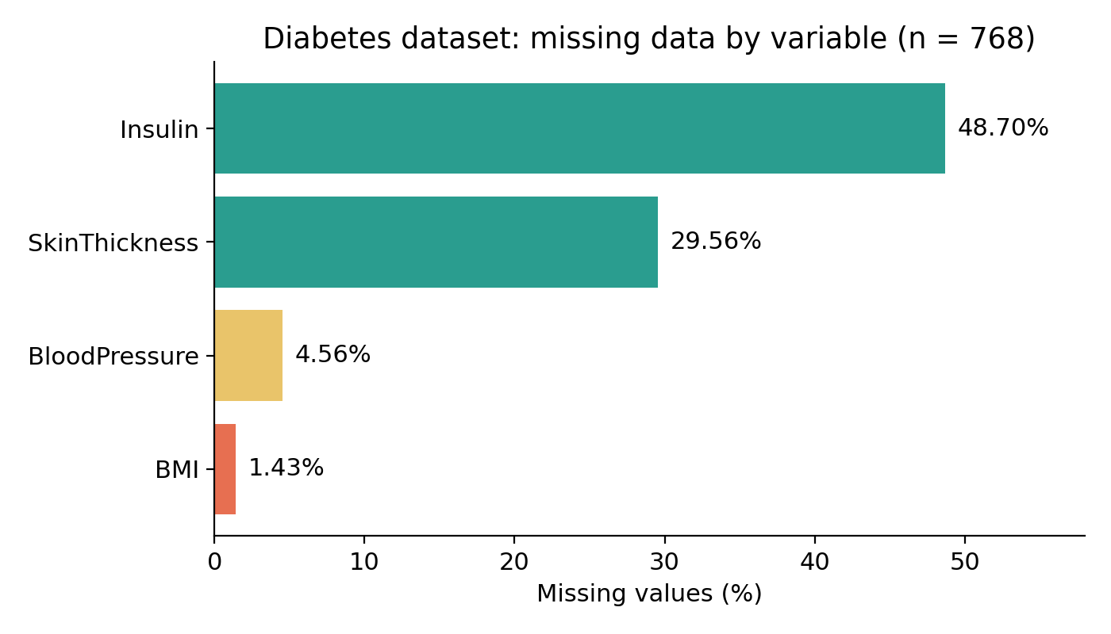
Figure 2. Missing data by variable. Insulin and SkinThickness have the largest gaps.
The chart shows why this dataset needs careful handling: nearly half of all Insulin values and almost a third of SkinThickness values are missing. Simply deleting these rows would remove most of the data, so a deliberate strategy is needed.
Code excerpt: cleaning and group statistics (Week 1)
# Treat zeros as missing for measurements where zero is impossible
cols = ['Glucose','BloodPressure','SkinThickness','Insulin','BMI']
df[cols] = df[cols].replace(0, np.nan)

df.isnull().sum() # count missing values
df.duplicated().sum() # 0 duplicate rows found
df.groupby('Outcome')[['Glucose','BMI','Age']].mean()

The code replaces impossible zeros with missing-value markers so they do not distort averages. The last line compares the two outcome groups.
Table 5. Mean values by diabetes outcome
Outcome group | Mean glucose | Mean BMI | Mean age (years)
0 (no diabetes) | 110.71 | 30.86 | 31.19
1 (diabetes) | 142.17 | 35.41 | 37.07
Difference | +31.46 | +4.55 | +5.88

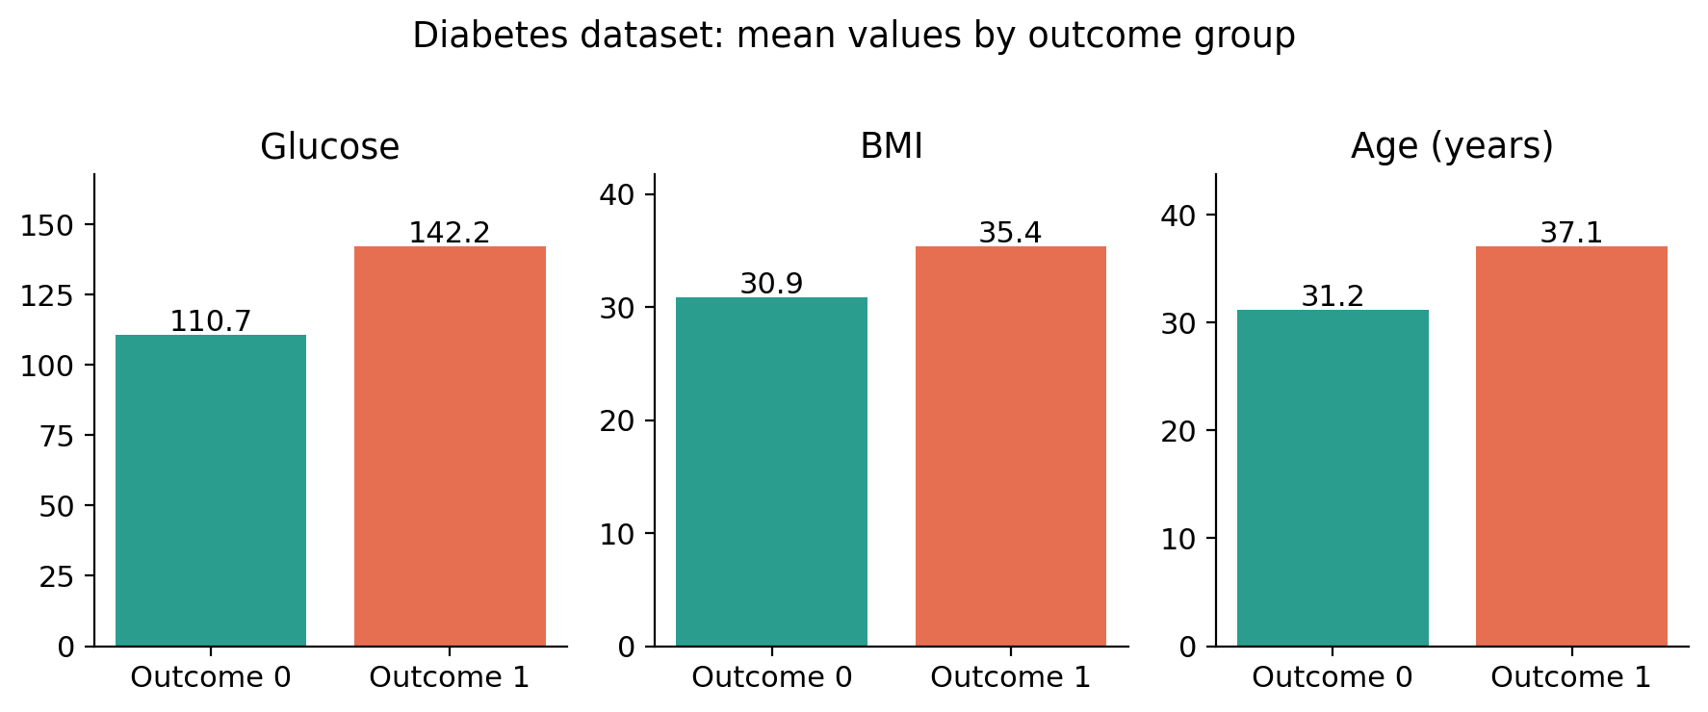
Figure 3. Mean glucose, BMI and age for the two outcome groups.
The diabetes-positive group had a mean glucose about 28% higher than the other group, and also higher BMI and age. These are descriptive differences within this dataset and do not prove cause and effect.
In simple words
Before analysis, the data had to be repaired. A large share of insulin and skin-thickness values were missing. Even so, the data already hinted at a pattern: people with diabetes in this dataset tended to have higher glucose, higher BMI and higher age.

4.2 Week 2 – Data Visualization and Storytelling

Purpose
To use charts to answer one question: can measurements of cell nuclei show clear patterns that separate benign from malignant samples? The Breast Cancer Wisconsin (Diagnostic) dataset has 569 samples (357 benign, 212 malignant), 30 numerical features, no missing values and no duplicates.
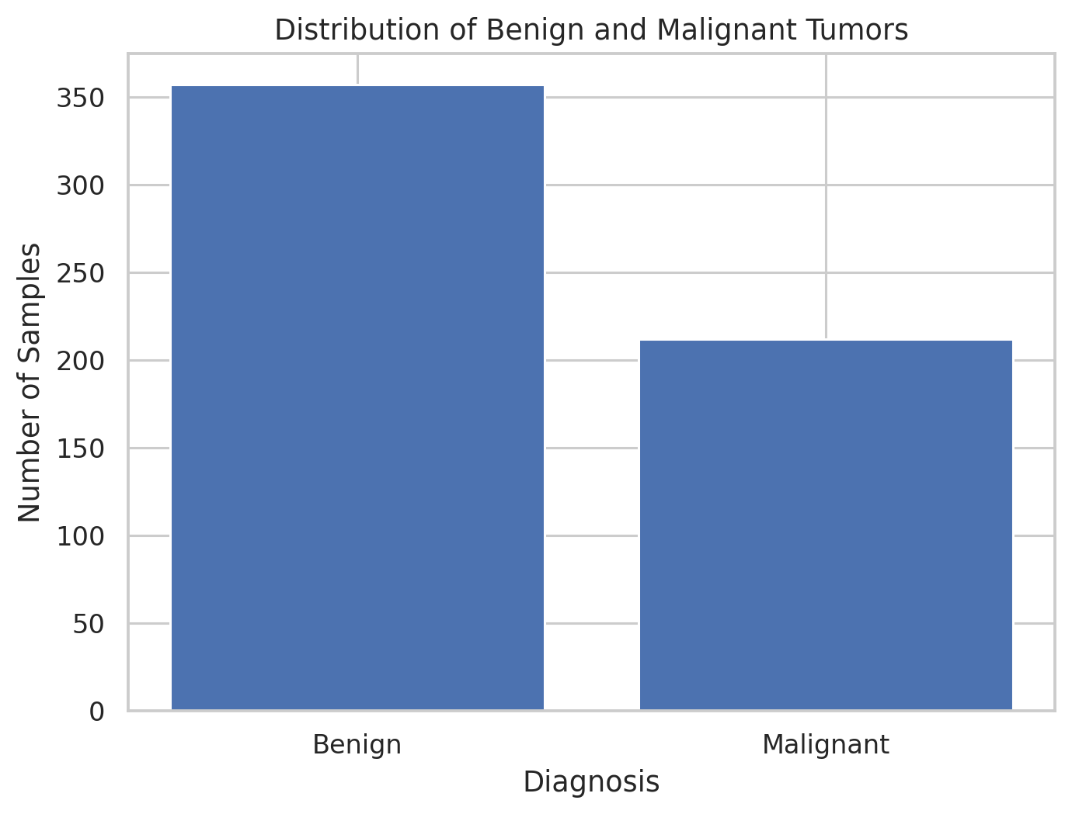
Figure 4. Class distribution: 357 benign and 212 malignant samples.
Benign samples outnumber malignant ones, so later comparisons must keep this imbalance in mind.
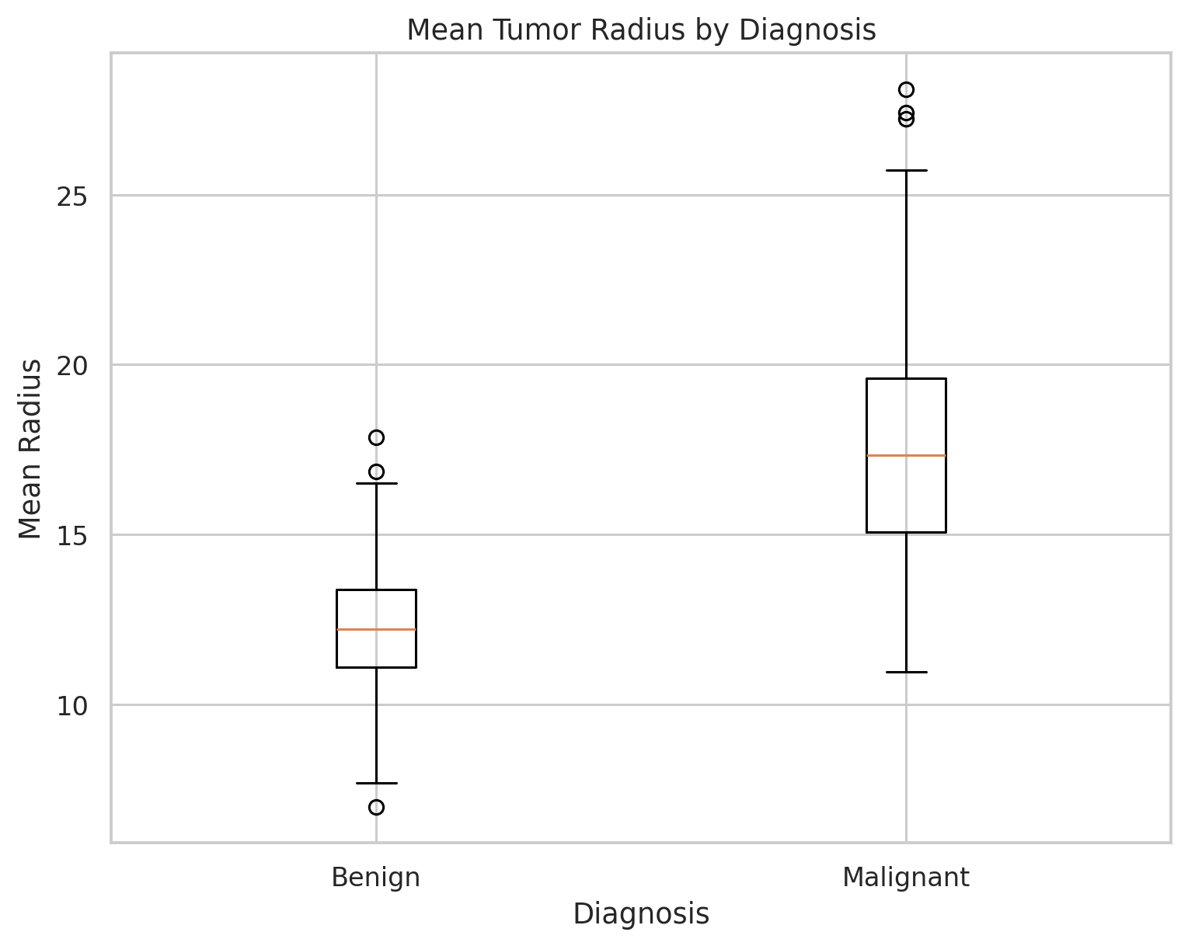
Figure 5. Box plot of mean radius by diagnosis; malignant samples are shifted to larger values.
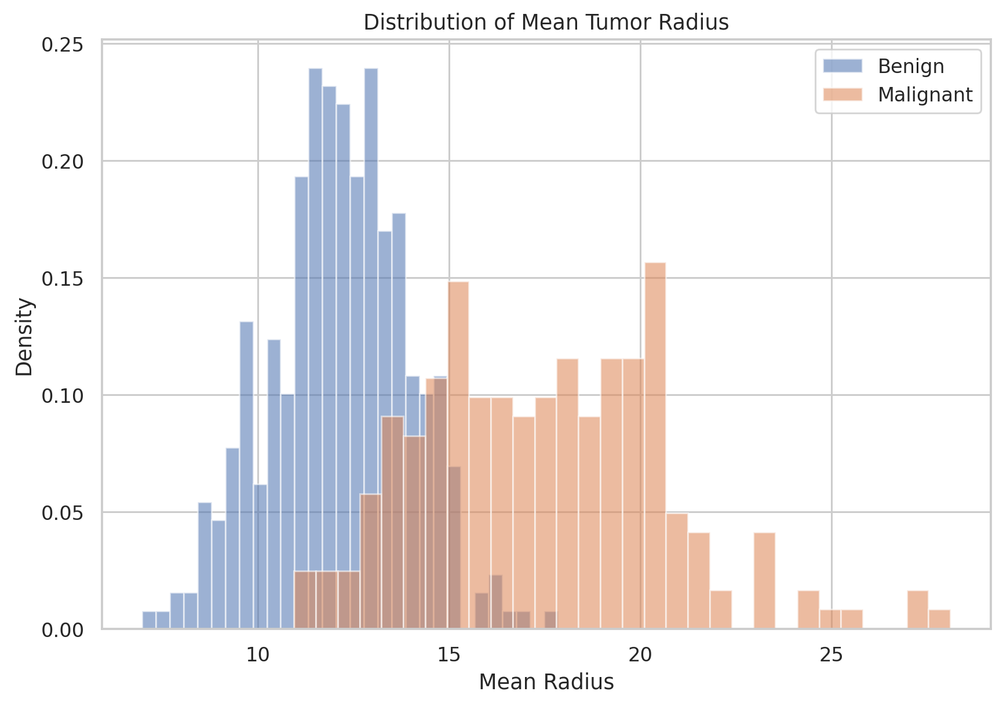
Figure 6. Histogram of mean radius. The groups are mostly separate but overlap in the middle.
The malignant group has a higher average radius (17.46) than the benign group (12.15). The histogram shows the same story with more detail: the groups are shifted apart, but there is an overlap zone where a single measurement cannot decide.
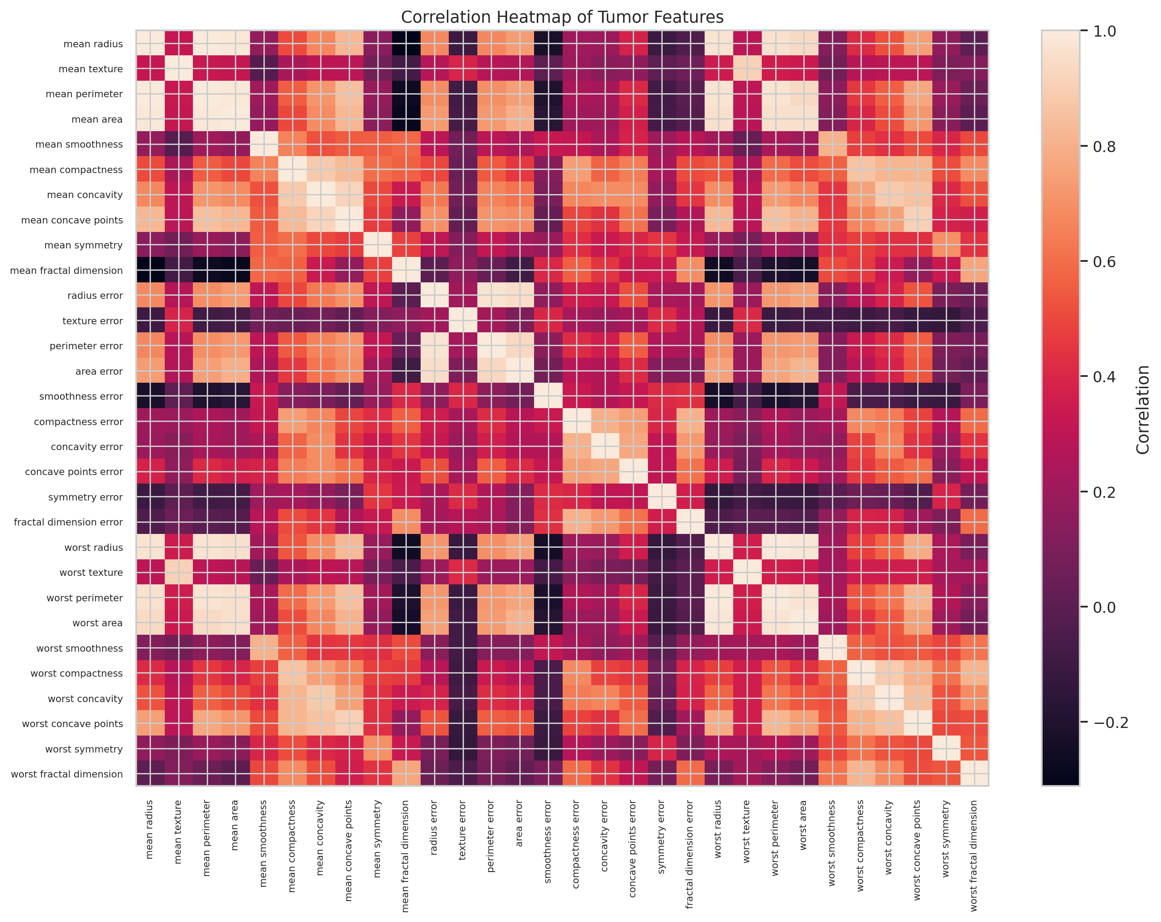
Figure 7. Correlation heatmap of the 30 features; size-related features are very strongly correlated.
Many features carry almost the same information. Mean radius and mean perimeter have a correlation of 0.998, and mean radius and mean area 0.987. Models and analyses should be aware of this redundancy.
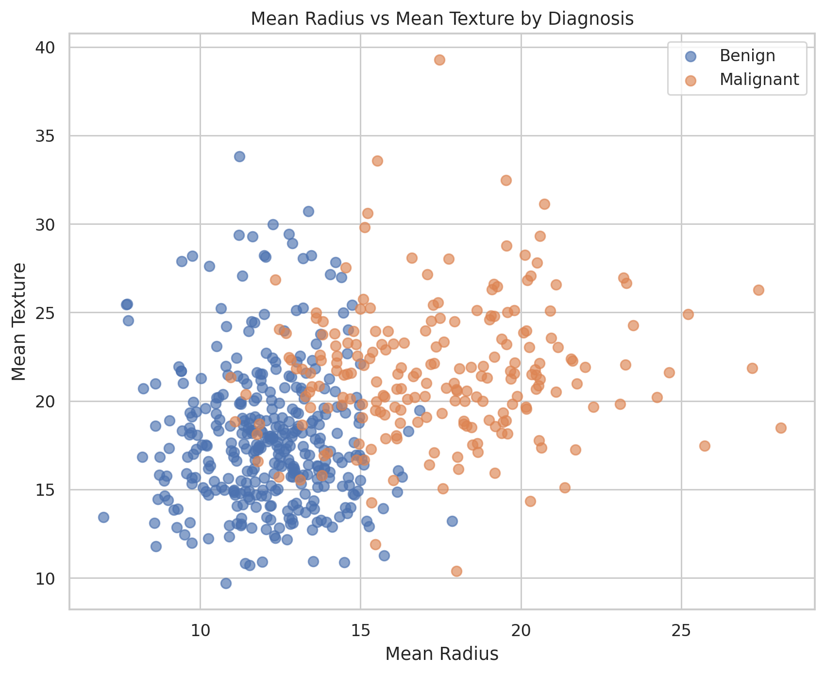
Figure 8. Mean radius against mean texture, coloured by diagnosis.
In two dimensions the groups occupy different regions but still overlap. This supports using several features together instead of relying on one.
Table 6. Group means for five key features
Feature | Benign mean | Malignant mean | Malignant ÷ benign
Mean radius | 12.15 | 17.46 | 1.44×
Mean texture | 17.91 | 21.60 | 1.21×
Mean perimeter | 78.08 | 115.37 | 1.48×
Mean area | 462.79 | 978.38 | 2.11×
Mean concavity | 0.046 | 0.161 | 3.49×

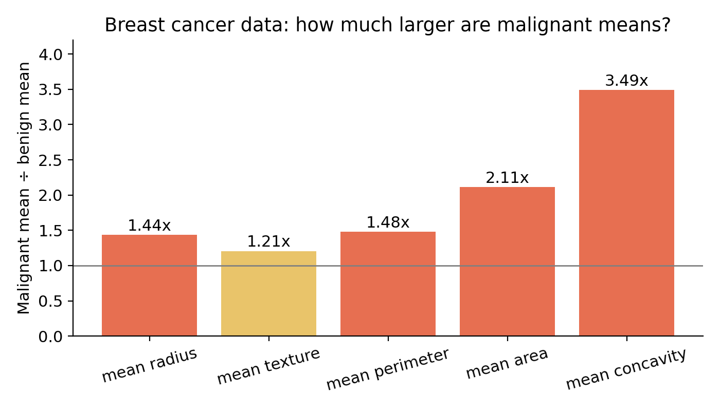
Figure 9. How much larger the malignant average is than the benign average for five features.
The ratio chart shows that the biggest relative difference is in concavity (about 3.5 times higher), followed by area (about 2.1 times). Size features differ strongly and shape irregularity (concavity) differs even more in relative terms.
Code excerpt: visualization workflow (Week 2)
data = load_breast_cancer(as_frame=True)
df = data.frame
df['diagnosis'] = df['target'].map({0: 'Malignant', 1: 'Benign'})

sns.countplot(data=df, x='diagnosis')
sns.boxplot(data=df, x='diagnosis', y='mean radius')
sns.heatmap(df.drop(columns=['target','diagnosis']).corr(), cmap='coolwarm')
df.groupby('diagnosis')[['mean radius','mean area','mean concavity']].mean()

In simple words
Malignant samples tend to be bigger and more irregular than benign ones. But the two groups overlap, so no single number can sort them perfectly. This is why a combined, multi-feature approach is needed.

4.3 Week 3 – Statistical Analysis and Hypothesis Testing

Purpose
To move from “the chart looks different” to “the difference is statistically proven”. The question was whether mean petal length differs among Iris-setosa, Iris-versicolor and Iris-virginica.
- Null hypothesis (H₀): mean petal length is the same in all three species.
- Alternative (H₁): at least one species has a different mean. Significance level α = 0.05.
- Cleaning: 150 rows → 149 after removing one missing petal length → 148 after removing one exact duplicate.
Table 7. Petal length by species after cleaning
Species | n | Mean (cm) | SD (cm) | Min (cm) | Max (cm)
Iris-setosa | 49 | 1.463 | 0.175 | 1.0 | 1.9
Iris-versicolor | 50 | 4.260 | 0.470 | 3.0 | 5.1
Iris-virginica | 49 | 5.561 | 0.554 | 4.5 | 6.9

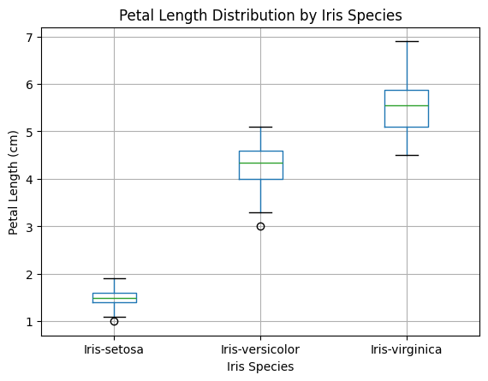
Figure 10. Box plot of petal length by species.
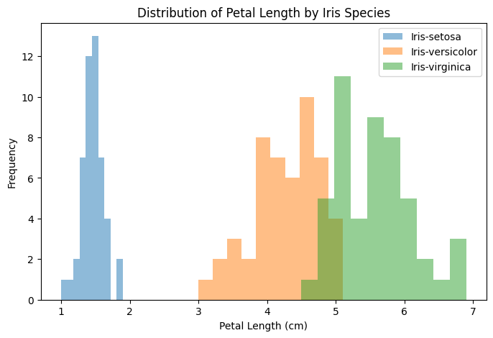
Figure 11. Overlaid histograms of petal length; setosa is clearly separate.
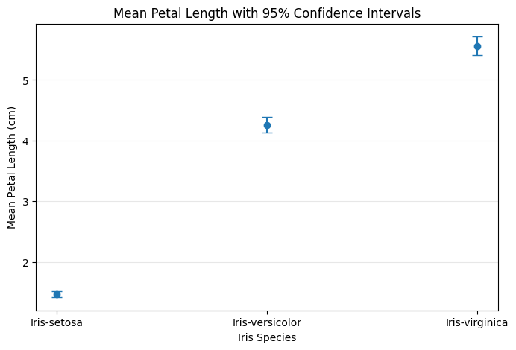
Figure 12. Mean petal length with approximate 95% confidence intervals.

Choosing the right test
Shapiro–Wilk tests found no evidence against normality in any species (p = 0.0706, 0.1585 and 0.1597). Levene's test, however, showed unequal variances (statistic 18.47, p < 0.001). Because ordinary ANOVA assumes equal variances, Welch's ANOVA was used instead, followed by the Games–Howell post-hoc test.
Table 8. Welch's ANOVA and Games–Howell results
Comparison | Mean difference | p-value | Hedges' g | 95% CI
Setosa vs Versicolor | −2.797 | < 0.001 | −7.79 | −2.939 to −2.655
Setosa vs Virginica | −4.098 | < 0.001 | −9.90 | −4.264 to −3.932
Versicolor vs Virginica | −1.301 | < 0.001 | −2.52 | −1.506 to −1.096

Overall test: Welch F = 1793.45, p = 1.29 × 10⁻⁶⁵, so H₀ is rejected. The negative signs only show the direction of subtraction (A minus B).
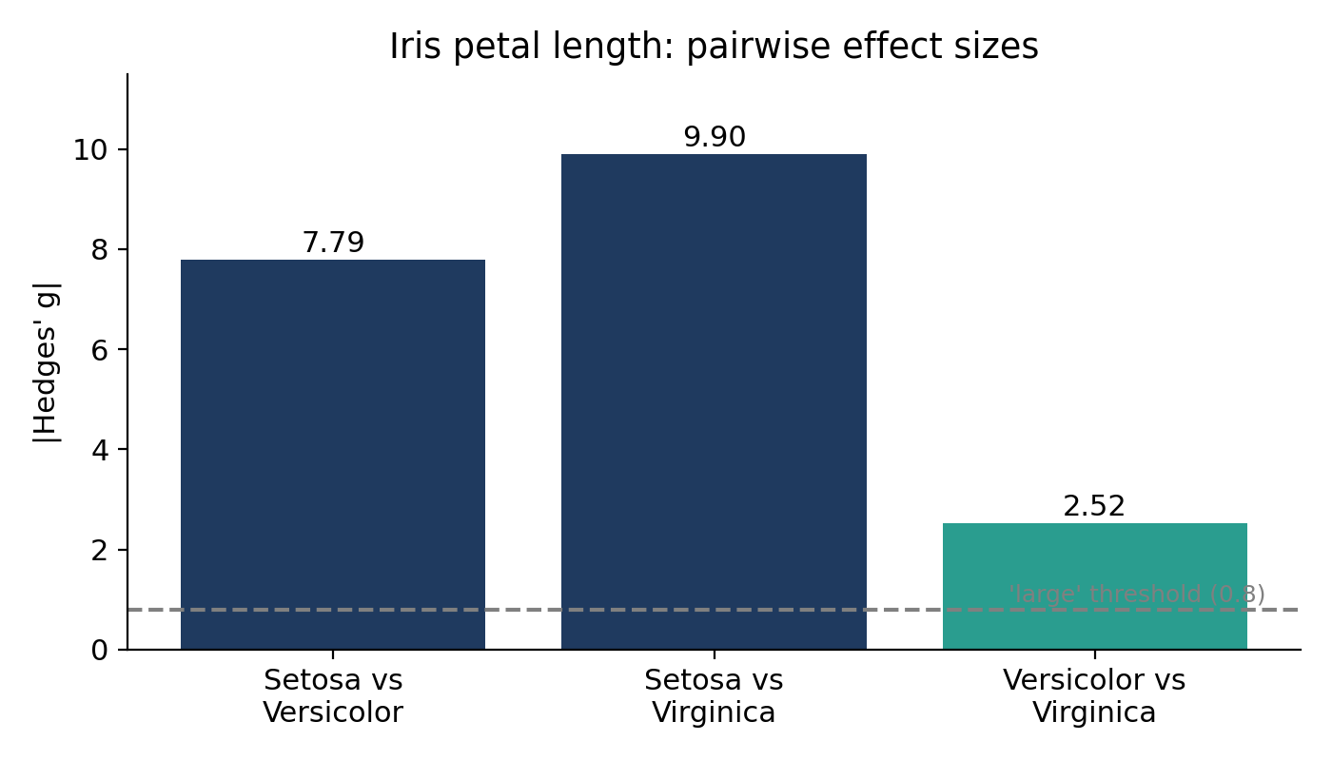
Figure 13. Size of the difference (Hedges' g) for each species pair. All are far above the “large” threshold of 0.8.
Code excerpt: assumption tests and Welch's ANOVA (Week 3, representative)
from scipy import stats
import pingouin as pg

groups = [g['petal_length'].values for _, g in df.groupby('species')]

for name, g in df.groupby('species'):
print(name, stats.shapiro(g['petal_length'])) # normality

print(stats.levene(*groups)) # equal variances?
print(pg.welch_anova(data=df, dv='petal_length', between='species'))
print(pg.pairwise_gameshowell(data=df, dv='petal_length', between='species'))

In simple words
The three species clearly differ in petal length, and this is not chance. Because the spread was different between species, a test built for unequal spread was chosen. Choosing the right test is what makes the answer trustworthy.

4.4 Week 4 – Machine Learning Model Development and Evaluation

Purpose
To build a model that classifies a tumor as malignant or benign from the 30 measurements, and to judge honestly how well it works on data it has never seen.

Approach
- Split the 569 samples into 455 for training and 114 for testing (80:20), keeping class proportions the same (stratified).
- Placed StandardScaler and Logistic Regression in one Pipeline so scaling is learned from the training data only. This prevents data leakage.
- Used Logistic Regression as a simple, interpretable baseline model.
Code excerpt: model pipeline (Week 4)
X_train, X_test, y_train, y_test = train_test_split(
X, y, test_size=0.20, random_state=42, stratify=y)

model = Pipeline([
('scaler', StandardScaler()),
('classifier', LogisticRegression(max_iter=5000))
])

model.fit(X_train, y_train)
y_pred = model.predict(X_test)

Table 9. Test-set performance
Metric | Score | Plain meaning
Accuracy | 0.965 | 110 of 114 test cases were classified correctly.
Precision (malignant) | 0.975 | When the model says “malignant”, it is right 97.5% of the time.
Recall (malignant) | 0.929 | It finds 92.9% of the truly malignant cases.
F1-score | 0.951 | A balance of precision and recall.
ROC-AUC | 0.996 | Almost perfect ability to rank malignant above benign.

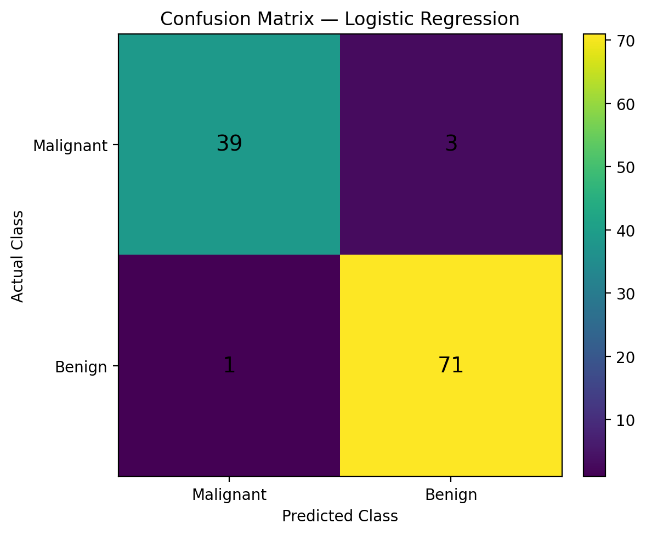
Figure 14. Confusion matrix: 39 malignant caught, 3 missed, 1 benign flagged, 71 benign cleared.
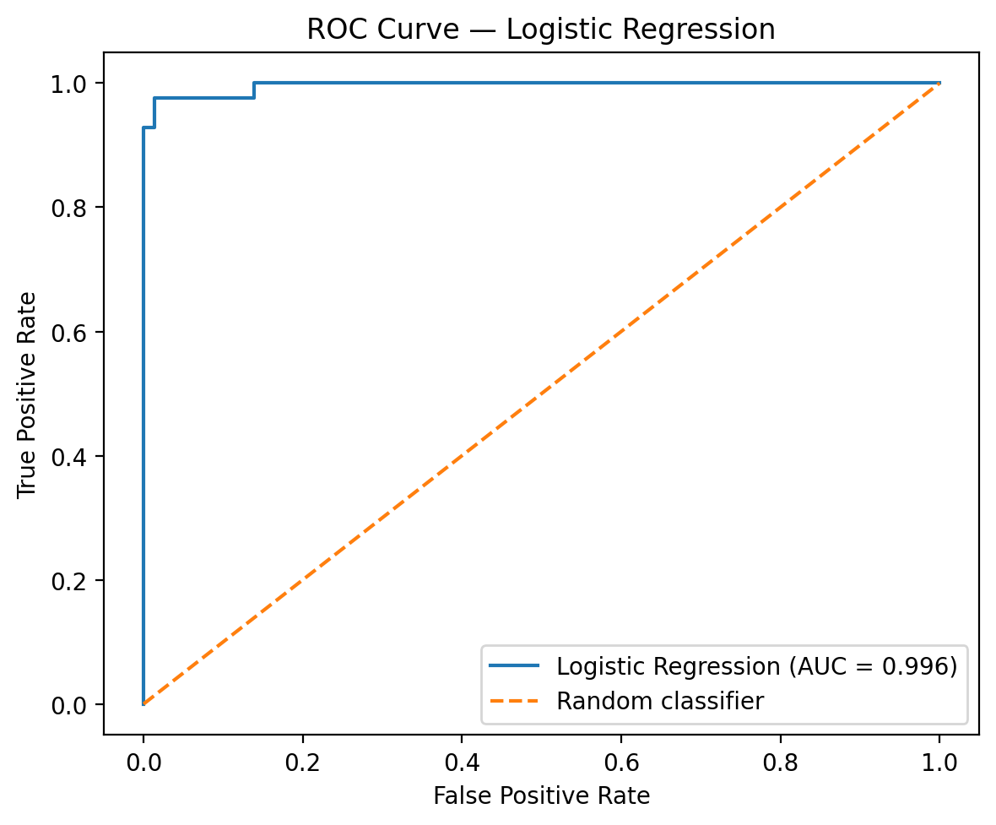
Figure 15. ROC curve with an AUC of 0.996.
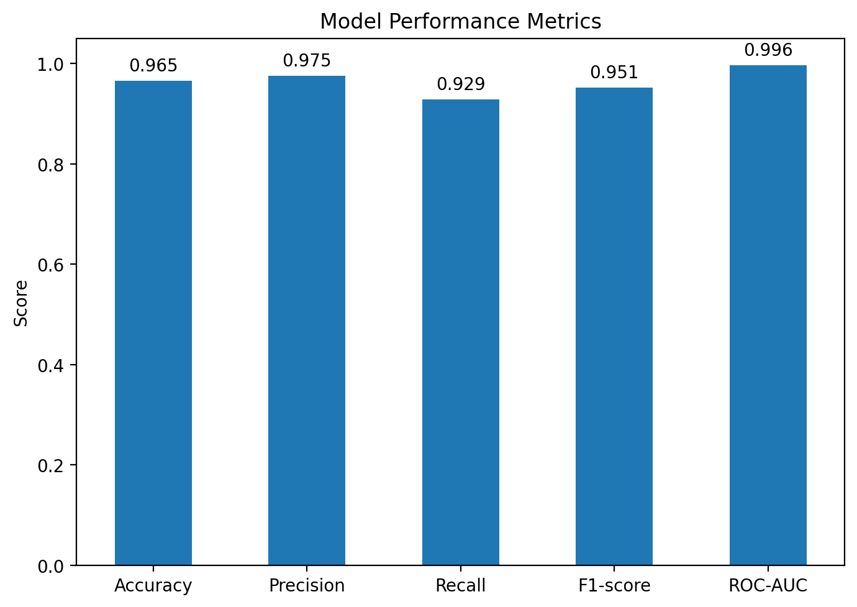
Figure 16. Comparison of accuracy, precision, recall, F1-score and ROC-AUC.
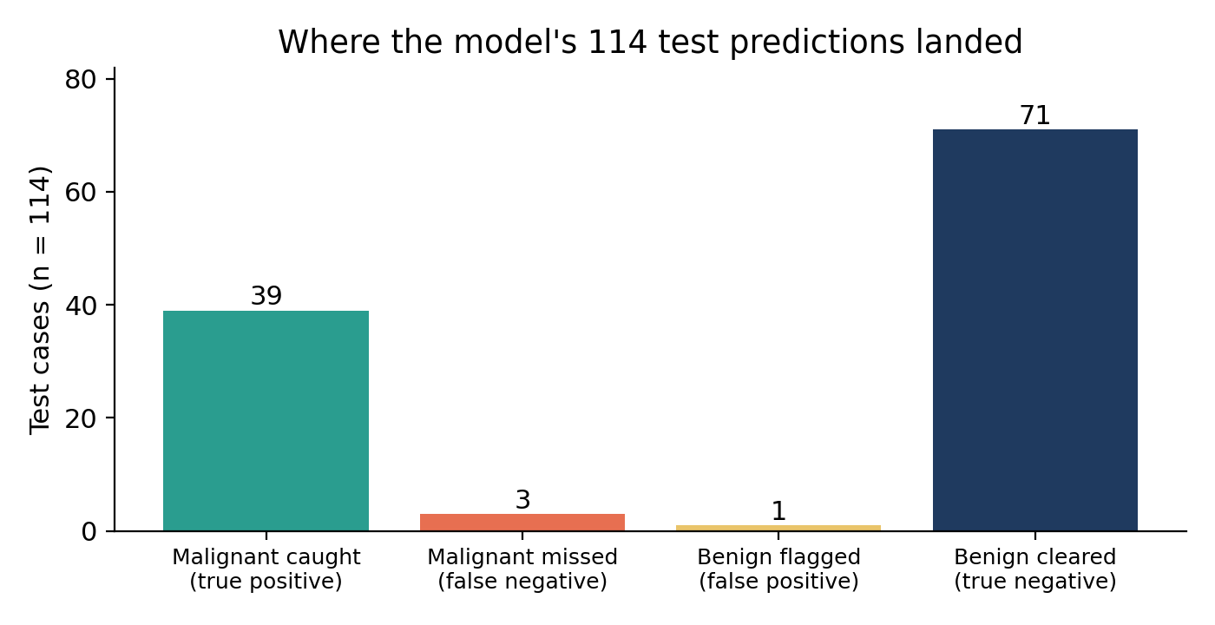
Figure 17. What happened to each of the 114 test predictions, in plain terms.
Note on interpretation
The confusion matrix (Figure 14) and the recall and precision values together show that the 3 errors in the top-right cell are malignant cases predicted as benign (false negatives), and the 1 error in the bottom-left cell is a benign case predicted as malignant (false positive). The Week 4 text described these two groups the other way round; the matrix and metrics confirm the orientation used here.
Baseline check: the test set has 72 benign and 42 malignant cases, so a model that always answered “benign” would be right 63.2% of the time. The model's 96.5% accuracy is a large improvement over this, which is a useful sanity check that the model learned real structure.
In simple words
The model is very good, but not perfect. Out of 42 truly malignant cases, it missed 3. In medical screening this kind of error is the most serious, so accuracy alone should never be the only number reported.

5. Key Findings and Cross-Project Patterns
Looking across the four weeks, six patterns appear again and again. These patterns are the basis for the recommendations in the next section.
Table 10. Cross-project patterns and the evidence for each
# | Pattern | Evidence from the project
1 | Data quality sets the ceiling. | Week 1: 48.7% of Insulin and 29.6% of SkinThickness missing, and zeros disguised as real values. Week 3: one missing value and one hidden duplicate.
2 | Disease-related groups differ clearly, but overlap. | Week 1: higher glucose, BMI and age in the diabetes group. Week 2: malignant radius 17.46 vs 12.15, yet overlap in histogram and scatter plot.
3 | Many features are redundant. | Week 2: size features correlate up to r = 0.998. Feature overlap means fewer, well-chosen features may do almost as well.
4 | Method must match the data. | Week 3: unequal variances (Levene p < 0.001) meant Welch's ANOVA, not ordinary ANOVA. Effect sizes confirmed the differences are large, not only “significant”.
5 | Combining many features beats any single feature. | Weeks 2 and 4: no single measure separated the groups, but a model using all 30 reached accuracy 0.965 and ROC-AUC 0.996.
6 | Headline accuracy hides the cost of errors. | Week 4: 96.5% accuracy still contained 3 missed malignant cases (recall 0.929). Error type matters more than the overall score.

5.1 How the weeks reinforce each other
- Week 2 predicted Week 4. The visual overlap between groups in Week 2 warned that perfect classification would be unlikely, and the Week 4 model did make a small number of errors (4 out of 114 test cases).
- Week 1 warns about the risks any diabetes model would face. The missingness found in Week 1 would directly harm a diabetes model if it were not handled first.
- Week 3 provides the standard of proof. The same assumption-first, effect-size-aware approach should be applied to the Week 1 and Week 2 group differences, which were only described and not formally tested.

6. Strategic Recommendations
Each recommendation below is tied to evidence from the project, states a concrete action, and explains how it improves decisions.
Table 11. Recommendation summary
# | Recommendation | Evidence | Action | Benefit | Priority
R1 | Adopt a data-quality gate before every analysis | Week 1 (hidden zeros, 48.7% missing); Week 3 (missing value, duplicate) | Standardize missing-value codes; run a fixed checklist: missing, zeros, duplicates, ranges; log all changes. | Prevents wrong conclusions from bad inputs. | High
R2 | Do not use heavily missing variables without a tested strategy | Week 1 (Insulin 48.7%, SkinThickness 29.6%) | Compare options (drop variable, median imputation, model-based imputation, missing-indicator) and check how results change. | Avoids silently biased models. | High
R3 | Test assumptions and report effect sizes | Week 3 (Levene p < 0.001; Hedges' g up to 9.9) | Use a standard template: normality, variance, test choice, post-hoc, confidence intervals, effect size. | Makes claims defensible and comparable. | High
R4 | Use several features together and manage redundancy | Week 2 (r up to 0.998, overlap); Week 4 (AUC 0.996) | Use multivariable models; reduce correlated features with regularization, feature selection or PCA. | Simpler, more stable models. | Medium
R5 | Select models by the cost of errors | Week 4 (3 missed malignant cases, recall 0.929) | Set a minimum recall target for screening use; tune the decision threshold; report the confusion matrix every time. | Fewer missed serious cases. | High
R6 | Validate before any real-world use | Week 4 (single split, one model, benchmark data) | Add k-fold cross-validation, compare other models, test on an external dataset, check probability calibration. | Confidence that results hold outside this dataset. | High
R7 | Keep a human expert in the loop | Weeks 2 and 4 (overlap and errors) | Position the model as decision support; flag borderline probabilities for expert review. | Safer, more accountable decisions. | High
R8 | Standardize visual communication | Week 2 (six-step visual story) | Create a reusable visual set: class balance, group comparison, distribution, correlation, scatter. | Clearer, faster reporting to non-technical teams. | Medium
R9 | Make every analysis reproducible | Week 1 (missing source citation) | Record dataset source and version, fix random seeds, use pipelines, keep code in version control. | Results can be repeated and audited. | Medium

6.1 How these recommendations improve decisions
- They reduce risk early. R1, R2 and R9 stop problems at the start of a project, where fixing them is cheapest.
- They make evidence trustworthy. R3 and R4 ensure that when a team says “group A differs from group B”, the claim is backed by the right test and a measure of how big the difference is.
- They protect people. R5, R6 and R7 make sure a predictive model is judged by the harm of its mistakes and is checked independently before it influences a real person.
- They save time. R8 and R9 turn one-off work into reusable templates, so future projects start from a tested standard.

6.2 Suggested implementation order
Table 12. Phased implementation plan
Phase | Actions | Expected outcome
Phase 1: Foundations (weeks 1–2) | R1, R2, R9: data checklist, missing-value policy, reproducibility template. | Clean, documented data for every new project.
Phase 2: Evidence (weeks 3–4) | R3, R4, R8: statistical template, redundancy handling, visual toolkit. | Consistent, defensible analysis and communication.
Phase 3: Safe modelling (weeks 5–8) | R5, R6, R7: cost-based metrics, cross-validation, external test, human review. | A validated model fit for decision support.

7. Potential Business and Research Impact

7.1 Research impact
- Visualization and statistics can shortlist the most informative variables (for example size and concavity measures) before expensive laboratory or clinical studies.
- A documented, reproducible workflow lets other researchers repeat and extend the results, which strengthens scientific credibility.
- The Week 3 approach (assumption checks plus effect sizes) can be reused for any group comparison, such as treatment versus control.

7.2 Business and healthcare-analytics impact
- Efficiency. A strong baseline model and a reusable pipeline reduce the time to build a first working model.
- Risk control. Early data-quality checks lower the chance of expensive rework or incorrect decisions later.
- Better communication. Clear visual stories help scientists, clinicians and managers agree on what the data shows.
- Prioritization. Recall-focused evaluation helps teams decide how much human review is needed on borderline cases.

7.3 What the model's performance could mean at scale
The figures below are an illustrative extrapolation of the Week 4 test results and are not guaranteed outcomes. They show why recall and precision need to be discussed with stakeholders in concrete terms.
Table 13. Illustrative effect of recall 0.929 and precision 0.975
If the model screened… | Approximate result (assuming similar performance)
1,000 truly malignant cases | About 929 caught and about 71 missed.
1,000 cases predicted malignant | About 975 truly malignant and about 25 false alarms.
Same model with a lower decision threshold | Fewer missed cases, but more false alarms. The trade-off must be chosen by clinicians and managers.

Important caution
These datasets are benchmark data. Any real clinical use would require independent validation, regulatory review and clinical evaluation. This work must not be used to diagnose individual patients.

8. Discussion
The most important lesson across the four weeks is that strong results are the product of a strong process. The Iris analysis gave a very clear answer because the data was cleaned, the assumptions were checked and the right test was selected. The breast-cancer model performed very well because features were scaled safely inside a pipeline and judged on unseen test data. The diabetes dataset, in contrast, shows what happens at the start of a project when data is incomplete: before any modelling, nearly half of one variable was unusable.
A second lesson is about overlap. Both the visualizations in Week 2 and the errors in Week 4 show that biological groups are not cleanly separated. A model with 0.996 ROC-AUC still made four mistakes. Good practice therefore means reporting uncertainty, examining errors and keeping experts involved.
A third lesson concerns the difference between statistical and practical importance. In Week 3, p-values were extremely small, but it was the effect sizes (g from 2.5 to 9.9) that showed how large the differences really were. Reporting both gives decision-makers a more complete picture.
Finally, the differences found in Weeks 1 and 2 are associations. They show that variables move together with the outcome; they do not show that one causes the other. Causal claims would need a different study design.

9. Limitations
- Benchmark datasets. All three datasets are public teaching datasets and may not represent every hospital, population or instrument.
- Unresolved missing data. In Week 1, missing values were identified and zeros converted, but no imputation strategy was completed, and the original dataset source was not documented.
- Single split and single model. The Week 4 results come from one train-test split with Logistic Regression only. The numbers could change with a different split.
- Small test set. With 114 test cases, one extra error changes recall noticeably (3 missed out of 42 malignant cases).
- Class imbalance. The breast-cancer data has 357 benign and 212 malignant samples, which can favour the larger class.
- Descriptive findings in Weeks 1 and 2. Group differences there were not formally hypothesis-tested.
- Association, not causation. All findings describe patterns in observational data.
- Small cleaning decisions. Removing one missing and one duplicate Iris record is reasonable but changes sample counts slightly, and the reason for the duplicate is unknown.
- Week 1 figures were redrawn. The original plots were not saved, so Figures 2 and 3 are re-creations from the reported numbers.

10. Future Improvements and Roadmap
Table 14. Planned improvements
Area | Improvement | Linked to
Data quality | Document the diabetes data source; test median, KNN and model-based imputation; compare results. | R1, R2, R9
Statistics | Add formal tests (for example t-tests or Mann–Whitney) for the Week 1 and Week 2 group differences, with effect sizes. | R3
Feature handling | Apply PCA or regularized models to deal with correlated size features; study logistic regression coefficients. | R4
Modelling | Add k-fold cross-validation; compare Random Forest, SVM and Decision Tree; tune with GridSearchCV. | R5, R6
Diabetes model | Build a classifier for the diabetes outcome after proper imputation. | R2, R6
Safety | Tune the threshold for high recall; check probability calibration; test on an external dataset. | R5, R6, R7
Communication | Build an interactive dashboard from the Week 2 visual set. | R8
Reproducibility | Package the workflow as a documented script with fixed seeds and version control. | R9

11. Conclusion
This report combined four weeks of work into a single end-to-end story. The diabetes project showed that data must be inspected and repaired before it can be trusted. The breast-cancer visualizations showed clear but overlapping differences between benign and malignant samples. The Iris analysis showed how assumption-checked statistics give reliable proof of group differences. The Logistic Regression model showed that a simple, well-built pipeline can reach an accuracy of 0.965 and ROC-AUC of 0.996, while still missing 3 of 42 malignant cases.
From these results, nine recommendations were developed, covering data quality, statistical practice, model selection, validation and reproducibility. Following them would make future projects faster, safer and easier to explain. The most important message for stakeholders is simple: trust the data first, trust the evidence second, and trust a model only after it has been tested against the cost of its mistakes.

12. Workload Allocation
The assignment expects about 30 to 35 hours of work. The table below is a planned allocation for this Week 5 task. It is a realistic plan for documenting the work, not a claim that every hour was timed.
Table 15. Planned workload for the Week 5 task
Activity | Planned time
Reviewing and synthesizing Weeks 1 to 4 | 5 hours
Re-checking numbers and results against the original reports | 4 hours
Preparing new summary figures and redrawing Week 1 charts | 4 hours
Cross-project analysis and strategic recommendations | 6 hours
Writing the report sections | 8 hours
Consolidating code and writing the appendices | 3 hours
Review, formatting and final checks | 2 hours
Total | 32 hours

Appendix A. Consolidated Code
The main code from each week is shown here in one place. The complete notebooks and scripts from each week contain the full versions.
A.1 Week 1: data acquisition, cleaning and EDA
import pandas as pd, numpy as np
import matplotlib.pyplot as plt, seaborn as sns

df = pd.read_csv('diabetes1.csv')
df.head(); df.shape; df.info(); df.describe()
df.isnull().sum()
(df == 0).sum()
df.duplicated().sum()
df = df.drop_duplicates()

cols = ['Glucose','BloodPressure','SkinThickness','Insulin','BMI']
df[cols] = df[cols].replace(0, np.nan)

sns.histplot(df['Glucose'], bins=30, kde=True)
sns.heatmap(df.isnull(), cbar=False)
sns.countplot(data=df, x='Outcome')
sns.boxplot(data=df, x='Outcome', y='Glucose')
sns.heatmap(df.corr(numeric_only=True), annot=True, cmap='coolwarm', fmt='.2f')
df.groupby('Outcome')[['Glucose','BMI','Age']].mean()

A.2 Week 2: visualization (main steps)
from sklearn.datasets import load_breast_cancer
data = load_breast_cancer(as_frame=True)
df = data.frame
df['diagnosis'] = df['target'].map({0: 'Malignant', 1: 'Benign'})
df.isnull().sum().sum(); df.duplicated().sum()

sns.countplot(data=df, x='diagnosis')
sns.boxplot(data=df, x='diagnosis', y='mean radius')
sns.histplot(data=df, x='mean radius', hue='diagnosis', kde=True)
sns.heatmap(df.drop(columns=['target','diagnosis']).corr(), cmap='coolwarm')
sns.scatterplot(data=df, x='mean radius', y='mean texture', hue='diagnosis')
df.groupby('diagnosis')[['mean radius','mean texture','mean perimeter',
'mean area','mean concavity']].mean()

A.3 Week 3: statistical analysis (representative)
import pandas as pd
from scipy import stats
import pingouin as pg

df = pd.read_csv('iris_.csv')
df = df.dropna(subset=['petal_length'])
df = df.drop_duplicates()

df.groupby('species')['petal_length'].agg(['count','mean','std','min','max']).round(3)

groups = [g['petal_length'].values for _, g in df.groupby('species')]
for name, g in df.groupby('species'):
print(name, stats.shapiro(g['petal_length']))
print(stats.levene(*groups))
print(pg.welch_anova(data=df, dv='petal_length', between='species'))
print(pg.pairwise_gameshowell(data=df, dv='petal_length', between='species'))

A.4 Week 4: machine-learning pipeline
from sklearn.model_selection import train_test_split
from sklearn.pipeline import Pipeline
from sklearn.preprocessing import StandardScaler
from sklearn.linear_model import LogisticRegression
from sklearn.metrics import (accuracy_score, precision_score, recall_score,
f1_score, roc_auc_score, confusion_matrix)

data = load_breast_cancer(as_frame=True)
X = data.data
y = data.target.map({0: 'Malignant', 1: 'Benign'})

X_train, X_test, y_train, y_test = train_test_split(
X, y, test_size=0.20, random_state=42, stratify=y)

model = Pipeline([('scaler', StandardScaler()),
('classifier', LogisticRegression(max_iter=5000))])
model.fit(X_train, y_train)
y_pred = model.predict(X_test)

print(accuracy_score(y_test, y_pred))
print(precision_score(y_test, y_pred, pos_label='Malignant'))
print(recall_score(y_test, y_pred, pos_label='Malignant'))
print(f1_score(y_test, y_pred, pos_label='Malignant'))
print(confusion_matrix(y_test, y_pred, labels=['Malignant','Benign']))

A.5 Suggested extension (not yet run in the project)
# Recommended next step (R6): cross-validation for a more stable estimate
from sklearn.model_selection import cross_val_score, StratifiedKFold
cv = StratifiedKFold(n_splits=5, shuffle=True, random_state=42)
scores = cross_val_score(model, X, y, cv=cv, scoring='recall_macro')
print(scores.mean(), scores.std())

Appendix B. Plain-Language Glossary
Table 16. Key terms in simple words
Term | Simple meaning
Imputation | Filling in missing values with sensible estimates, such as the median.
Correlation (r) | How strongly two measurements move together, from −1 to +1.
Hypothesis test | A formal way to check whether a difference is real or could be chance.
p-value | How surprising the data would be if there were truly no difference. Small values (below 0.05) suggest a real difference.
Welch's ANOVA | A test comparing group averages that still works when groups have unequal spread.
Games–Howell test | A follow-up test that shows which specific pairs of groups differ.
Effect size (Hedges' g) | How big a difference is, not only whether it exists. Above 0.8 is considered large.
Train-test split | Keeping some data hidden during training so the model can be tested fairly.
Data leakage | When information from test data accidentally influences training, making results look better than they are.
Pipeline | A fixed chain of steps (for example scale then classify) applied the same way every time.
Precision | Of the cases the model flags, how many are truly positive.
Recall | Of all truly positive cases, how many the model finds.
ROC-AUC | How well the model ranks positive cases above negative ones; 1.0 is perfect, 0.5 is guessing.
Cross-validation | Repeating the train-test process on several splits to get a steadier performance estimate.

References
- Wolberg, W. H., Street, W. N., & Mangasarian, O. L. Breast Cancer Wisconsin (Diagnostic) Data Set. UCI Machine Learning Repository; also distributed with scikit-learn.
- Fisher, R. A. (1936). The use of multiple measurements in taxonomic problems. Annals of Eugenics, 7(2), 179–188.
- Smith, J. W., Everhart, J. E., Dickson, W. C., Knowler, W. C., & Johannes, R. S. (1988). Using the ADAP learning algorithm to forecast the onset of diabetes mellitus. Proceedings of the Symposium on Computer Applications and Medical Care, 261–265. (The diabetes data structure matches the Pima Indians Diabetes Database; the exact download source used in Week 1 should be confirmed and cited.)
- Welch, B. L. (1951). On the comparison of several mean values: an alternative approach. Biometrika, 38(3/4), 330–336.
- Games, P. A., & Howell, J. F. (1976). Pairwise multiple comparison procedures with unequal n's and/or variances. Journal of Educational Statistics, 1(2), 113–125.
- Pedregosa, F., et al. (2011). Scikit-learn: Machine learning in Python. Journal of Machine Learning Research, 12, 2825–2830.
- Vallat, R. (2018). Pingouin: statistics in Python. Journal of Open Source Software, 3(31), 1026.

