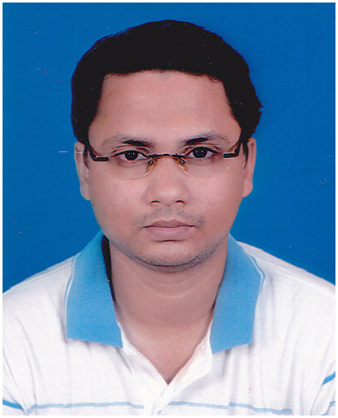
Resume
Tirtha Pratim Purakayastha
Nandankanan, Dankuni Ward no. 17
Dist: Hooghly, Pin: 712311
Contact: 8900188963 / 8777828475
Email : tirtha_big@yahoo.com / tirthabig0@gmail.com
Profile:

To secure a challenging position where I can effectively contribute my skills.

Educational Qualification

- Madhyamik from WBBSE, in all subjects in 2000.
- Higher Secondary from WBCHSE, in Commerce in 2002.
- Graduation from Calcutta University in Commerce in 2006.

Other Certification

Diploma in Desk top Publishing from Moulali Youth Computer Training Center.
Experience
Certificate course on HTML & CSS from Braintech Solution, Dankuni.

Worked in Techno Exponent as a “Sr. HTML Developer” For 2 years (From 10/05/2023 to 27/05/2025).

♦Job Profile: Making HTML pages from Figma file, Solving design issues after programming, creating sites in WIX from Figma file
Worked in Bargad Software Solutions Pvt. Ltd. as a “Team Lead (UI)” For 5 years (From 1/06/2018 to 9/05/2023).

♦Job Profile: Making WordPress page from PSD layout, solving design issues after programming, Wire-framing, theming of login panel and admin panel, theming of live sites, making responsive design (Media Query / Bootstrap), WordPress conversion of HTML ready sites, making WordPress sites using Elementor / Avada theme, speed optimization of websites, team management.

Worked in Tata Interactive Systems (TIS) as a “Senior UI Developer” For 1 year 8 months (From 16/08/2016 to 30/04/2018).

♦Job Profile: Making HTML page from PSD layout, solving of design issues after programming, worked on Blackboard LMS and Canvas LMS.

Worked in Simayaa Technologies Pvt. Ltd. as a “Web Designer” For 11 Months (From 20/07/2015 to 30/06/2016).

♦Job Profile: PSD to HTML conversion, maintenance of web sites, Image Editing, solving of design issues after programming, making responsive design (Media Query / Bootstrap), Work on table less div based design, theming of login panel and admin panel, theming of live sites.

Worked in Xentric Technologies Pvt. Ltd. as a “Web Designer” For 2 years 1 Month (From 01/07/2013 to 10/07/2015).

♦Job Profile: Web Site Development and Designing according to client’s requirements, Web pages layout & designing, maintenance of web sites, Image Editing, solving of design issues after programming, making responsive design (Media Query / Bootstrap), Work on table less div based design, theming of login panel and admin panel.

Worked in Millennium Infra Projects Ltd as “Data Entry Operator” for 1 year 11 months (From 6/06/2011 to 23/05/2013).

♦Job Profile: Making ID cards for the company arrangers, Create Banner, Leaflet, Invitation cards of the company.

Worked in “Infinity Realcon Ltd.” as “DTP Operator & Web Page Developer” for 1 year and 4 months (From 1/02/2010 to 5/06/2011).

♦Job Profile: Making ID cards for the company arrangers, Updation of company website

Worked as “Office Assistant” in “Moulali Youth Computer Training centre (Ground Floor)” for 7 months (From 1/04/2009 to 8/11/2009).

♦Job Profile: Look after seven youth computer training centers, P.F & E.S.I calculation of the staffs, giving staff salary, maintaining staffs attendance register, payment of royalty etc.

Work Samples

https://jhilltravel.com/
https://soccerpath.us/
https://trevligastunder.se/
https://www.easeaccounting.co.uk/
https://kidmoto.taxi/
https://finbridge.twebexponent.in/
https://www.pointtechllp.com/
https://pegasus.triviio.com/

Software Skills

- Photoshop CC
- Dreamweaver CC / Notepad++ / Visual Studio Code
- HTML 4.01, HTML5
- CSS3
- Bootstrap v3 / v4 / v5
- Media Query
- Tailwind CSS

- WordPress (Custom / Elementor / Avada / WPBakery)
- WIX
- Blackboard (LMS)
- Canvas (LMS)
- React JS (Basic Knowledge)
- Version Control (GIT)
Other skills

- English Typing speed up to 30WPM.
Personal Information

NAME - Tirtha Pratim Purakayastha.
FATHER’S NAME - Late Chitta Ranjan Purakayastha.
DATE OF BIRTH - 23/06/1983.
LANGUAGES KNOWN - English, Hindi, Bengali.

