Titanic Dataset
About the Dataset
The dataset contains the details of the people boarded on Titanic for the unfortunate day. There are two dataset - Train.csv and Test.csv
- train.csv: This dataset is only for building the model. For training set the outcome ("Ground truth") is provided. The model will be based on features like passengers’ gender and class.
- test.csv: This dataset is only for testing purposes of our model. For test set the outcome ("Ground truth") is not provided. For each passenger in the test set, it is the model's job to predict whether or not they survived the sinking of the Titanic.
Data Dictionary
- Survived: Survival [0=no, 1=yes]
- Pclass: Ticket class [1=1st, 2=2nd, 3=3rd]
- Sex: Gender [male, female]
- Age: Age in years
- SibSp: No. of siblings/spouses aboard the Titanic
- Parch: No. of parents aboard the Titanic
- Ticket: Ticket number
- Fare: Ticket fare
- Cabin: Cabin number
- Embarked: Port of Embarktion [C=Cherbourg, Q=Queentown, S=Southampton]

Variable Notes
- Pclass: A proxy for socio-economic status (SES)
1st= Upper
2nd= Middle
3rd= Lower
- Age: Age is fractional if less than 1. If age is estimated, it is in the form of xx.5
- SibSp: The dataset defines family relations in this way...
Sibling = brother, sister, stepbrother, stepsister
Spouse = husband, wife (mistresses and fiancés were ignored)
- Parch: The dataset defines family relations in this way...
Parent = mother, father
Child = daughter, son, stepdaughter, stepson
Some children travelled only with a nanny, therefore parch=0 for them.

Report
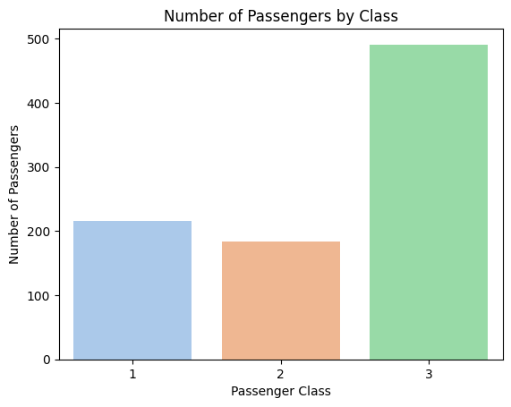
The majority of passengers belonged to 3rd class, with 2nd class having the fewest passengers. This distribution likely reflects affordability, as 3rd class tickets were the most economical.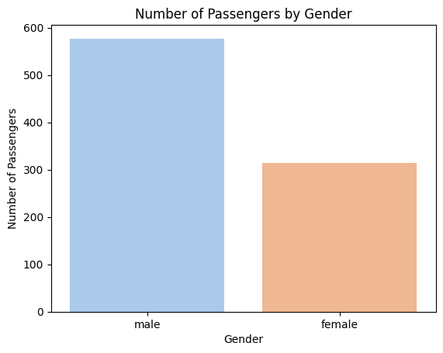
A higher number of male passengers were on board compared to females.
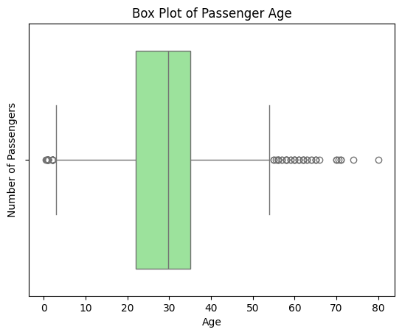
Most passengers were between 20 and 40 years with 30 years being the most common age.
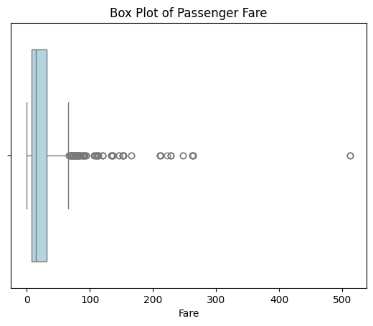
The majority of passengers paid between $20 and $50, which aligns with the high number of 3rd class travellers.
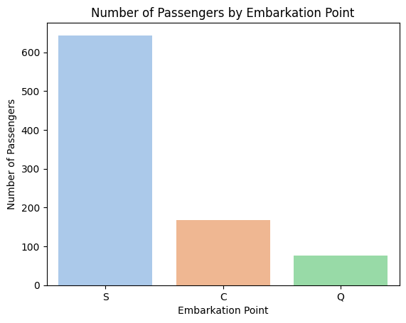
Most passengers boarded from Southampton, while the fewest boarded from Queenstown. This could be due to better accessibility or popularity of Southampton.
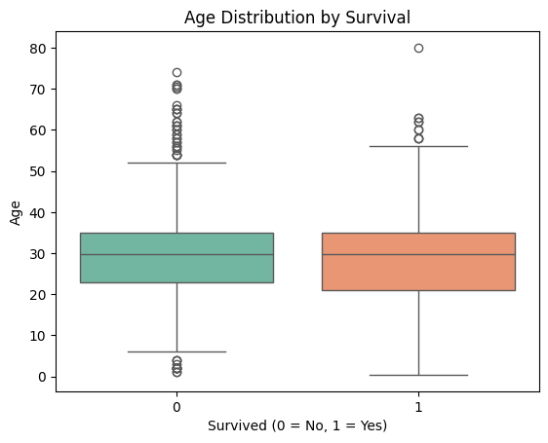
There was no major difference in age between those who survived and those who did not. However, younger passengers (especially children) had a slightly higher survival rate.
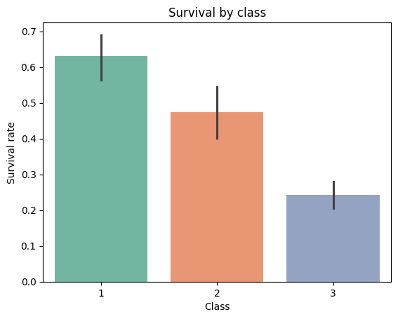
Passengers from 1st and 2nd class had higher survival rates than those in 3rd class, suggesting that premium passengers were given rescue priority.
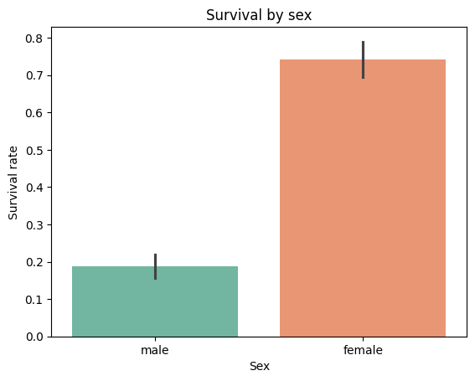
Female passengers had a significantly higher survival rate than males. This could be due to:
- Females possibly receiving priority during evacuation
- The fact that they made up a smaller proportion, making rescue efforts more effective.

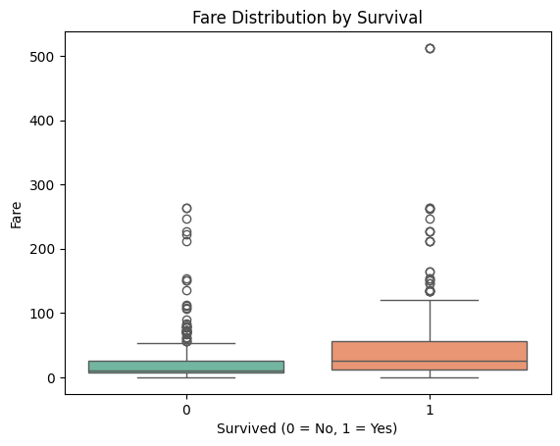
Again, people who paid more tend to survive more.
Conclusion
- Higher ticket class increased survival probability, likely due to better cabin locations and rescue priority.
- Younger passengers, especially in their 20s and 30s, were slightly more likely to survive.
- Females had a much higher survival rate, suggesting gender-based rescue preference ("women and children first").

