**LeakGAN**

Difference b/w syntax and semantics

**1. Syntax**

**Definition**: Syntax refers to the set of rules, principles, and processes that govern the structure of sentences in a language. It focuses on the arrangement of words and phrases to create well-formed sentences.

**Key Points**:

* **Rules of Structure**: Syntax deals with how words combine to form phrases and sentences. For example, in English, a basic syntactic rule is that a typical sentence structure is Subject-Verb-Object (SVO), as in "The cat (Subject) chased (Verb) the mouse (Object)."
* **Grammar**: Syntax is a major component of grammar, determining the correct order and arrangement of words. It helps in parsing sentences to understand their grammatical correctness.
* **Tree Structures**: Syntax can be represented through tree structures that show hierarchical relationships between words and phrases.

**2. Semantics**

**Definition**: Semantics refers to the meaning of words, phrases, and sentences. It is concerned with the interpretation and understanding of the meaning conveyed by linguistic expressions.

**Key Points**:

* **Meaning**: Semantics focuses on what the words and sentences actually mean. It involves understanding concepts like synonyms, antonyms, and the implications of word choices.
* **Contextual Interpretation**: Semantics takes into account context and the way meaning can change based on the situation or the nuances of language. For example, "She is feeling blue" uses "blue" metaphorically to mean "sad," rather than referring to the color.
* **Ambiguity**: Semantics addresses issues of ambiguity and how the same syntactic structure can convey different meanings depending on the context.

The BLEU (Bilingual Evaluation Understudy) score is a widely used metric for evaluating the quality of machine-generated text, particularly in tasks like machine translation. It measures how well the output of a model matches reference translations or target texts. Here’s a detailed look at what the BLEU score is and how it works:

### ****What is BLEU Score?****

* **Purpose**: The BLEU score evaluates the quality of text by comparing it to one or more reference texts (ground truth). It is particularly useful for assessing machine translation systems, but it can also be applied to other text generation tasks like summarization.
* **Scale**: BLEU score ranges from 0 to 1, where 1 represents a perfect match between the generated text and the reference texts. In practice, scores are often presented as percentages (0% to 100%).

Let’s say you have a reference sentence: “The cat is on the mat.” and a generated sentence: “The cat is on the rug.”

1. **1-gram Precision**:
   * Generated sentence: [The, cat, is, on, the, rug]
   * Reference sentence: [The, cat, is, on, the, mat]
   * Common 1-grams: [The, cat, is, on]
   * Precision: 4/6 = 0.67
2. **2-gram Precision**:
   * Generated sentence 2-grams: [(The, cat), (cat, is), (is, on), (on, rug)]
   * Reference sentence 2-grams: [(The, cat), (cat, is), (is, on), (on, the)]
   * Common 2-grams: [(The, cat), (cat, is), (is, on)]
   * Precision: 3/4 = 0.75
3. **Brevity Penalty**:
   * If the length of the generated text is shorter than the reference text, a penalty is applied.

The final BLEU score would combine these n-gram precisions and apply the brevity penalty to give a final score.

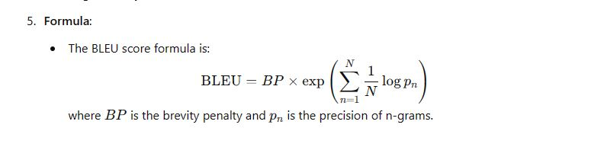

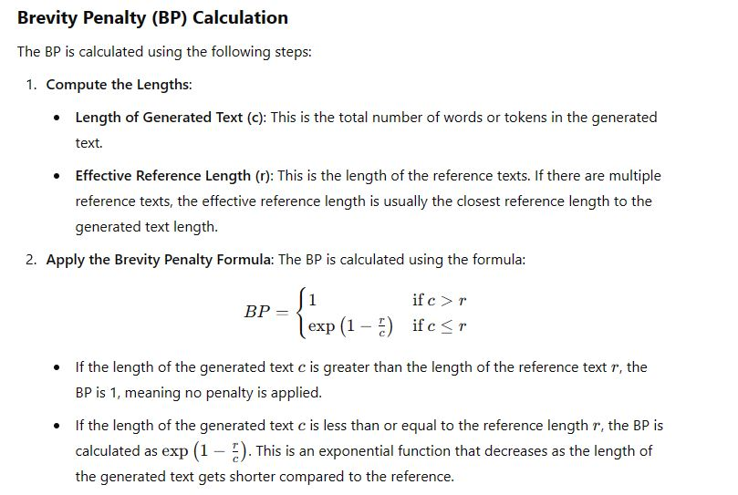

1. Discriminator leaks information
2. The formation of the problem has been in the context of RL.

Where state is the text produced till time t. In traditional GAN producing text

the reward signal is produced at the end.

1. In LeakGAN, a hierarchical RL architecture is used as a promising mechanism to effectively incorporate such leaked information ft into the generation procedure of Gθ (also see Figure 1)

Hierarchical Reinforcement Learning (HRL) is a framework in reinforcement learning (RL) that addresses complex decision-making problems by breaking them down into simpler, more manageable sub-problems. The main idea is to create a hierarchy of goals or tasks that simplify the learning and decision-making process.

In traditional RL, an agent learns to perform tasks by directly interacting with the environment and receiving rewards. However, when tasks are very complex, this approach can become inefficient and challenging because the agent has to learn everything from scratch and handle all aspects of the problem simultaneously.

HRL helps by introducing multiple levels of abstraction:

1. **High-Level (Meta) Controller:** This level is responsible for deciding which sub-task or goal the agent should focus on. It operates at a higher level of abstraction and makes decisions based on the overall progress toward achieving the main objective.
2. **Low-Level (Sub-task) Controllers:** These controllers are responsible for executing specific sub-tasks or actions required to achieve the goals set by the high-level controller. They operate at a lower level of abstraction and focus on more detailed aspects of the task.