Automatic Hand Sanitizer Dispenser using Arduino

Trithankar Saha Dibbya  
Computer Science and Engineering (C.S.E)  
BRAC UniversityDhaka, Bangladesh  
tirthankar.saha.dibbya@g.bracu.ac.bd

Tanjim Islam Riju  
Computer Science and Engineering (C.S.E)  
BRAC UniversityDhaka, Bangladesh  
tanjim.islam.riju@g.bracu.ac.bd

Sajid Muntasir  
Computer Science and Engineering (C.S.E)  
BRAC UniversityDhaka, Bangladesh  
sajid.muntasir@g.bracu.ac.bd Tasfia Ayesha Maliha  
Computer Science and Engineering (C.S.E)  
BRAC UniversityDhaka, Bangladesh  
tasfia.ayesha.maliha@g.bracu.ac.bd

*Abstract*— In the wake of global health crises, maintaining hand hygiene has become paramount. The Automatic Hand Sanitizer Dispenser project harnesses the versatility of the Arduino Uno platform to provide a reliable, automated solution for hand sanitation. Integrated with an ultrasonic sensor, the device detects a user's hand and dispenses the right amount of sanitizer, ensuring consistent application each time. A distinguishing feature of our dispenser is its incorporation of the DS18B20 temperature sensor, which concurrently measures and displays the user's temperature on a 16x2 I2C LCD display. This dual-functionality not only encourages hand hygiene but also monitors potential health anomalies. A servo motor, controlled by the Arduino, facilitates the precise dispensing mechanism. Owing to its compact design, achieved using a small breadboard and minimal components like a 100-ohm resistor, the system is portable and versatile, making it suitable for diverse settings - from homes and offices to hospitals and public spaces. This project not only addresses immediate health concerns but also showcases the potential of microprocessor-based designs in creating efficient, multifunctional devices.

Keywords— Automatic Hand Sanitizer Dispenser, Arduino Uno, Ultrasonic sensor, DS18B20 temperature sensor, Hand hygiene

# Introduction

Hand hygiene, while always important, has gained newfound prominence in the context of global health challenges. The rapid spread of infectious diseases has made regular hand sanitization an indispensable practice in daily life. While manual dispensers are prevalent, they often lead to wasted product and do not guarantee uniform application. Moreover, the manual interaction with such dispensers in high-traffic areas increases the risk of cross-contamination. Recognizing these challenges, our team set out to design an automated solution that would not only address the need for consistent sanitization but also offer additional health monitoring features.

The Automatic Hand Sanitizer Dispenser, built around the Arduino Uno microcontroller, is our innovative answer to this pressing need. By leveraging the capabilities of the ultrasonic sensor, our dispenser detects the presence of a user's hand and promptly delivers a predetermined amount of sanitizer. A standout feature of our design is the integration of the DS18B20 temperature sensor, enabling the device to measure and display the user's temperature in real-time. This added functionality serves as a proactive measure in health monitoring, especially in spaces where large numbers of people congregate.

In this report, we will delve into the technical aspects of our design, the challenges faced during its development, and its potential applications in various settings. We aim to showcase how microprocessor technology, combined with ingenuity, can lead to practical and multifunctional solutions that address contemporary health and safety concerns.

# Methodology

## System Architecture

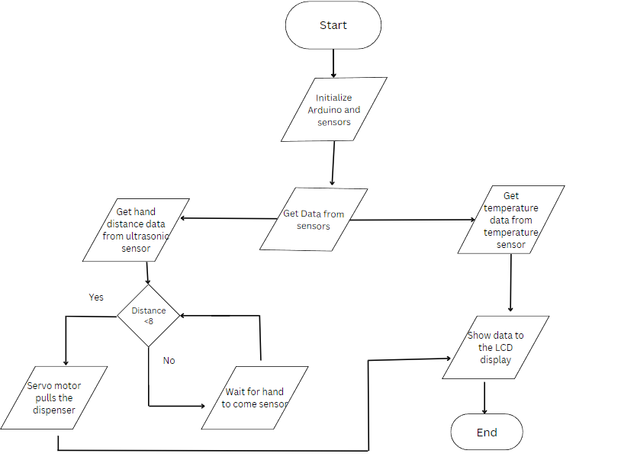

Fig: Flowchart

## Technical Specifications

|  |  |  |
| --- | --- | --- |
| **Component** | **Manufacturer Name** | **Use** |
| Arduino UNO R3 | Not mentioned  ARD-50328 | Primary microcontroller |
| HCSRO4 Ultrasonic Sonar Sensor | Not mentioned  SEN-10004 | To detect the hand near the dispenser |
| Micro servo motor | Not mentioned  SG90 | To pull the dispenser down |
| 16*2 standard LCD with I2C adapter board soldered | Not mentioned  LCD 1602 | To display the distance of hand from the dispenser and body temperature |
| DS18B20 waterproof digital temperature sensor | Dallas Semiconductor  SEN-31820 | To measure the body temperature |
| Jumper wires Male-Male  Male-Female | Not mentioned | To connect all the components together |
| Breadboard |  |  |
| Resistor 100 ohm |  | A pull-up resistor weakly ‘pulls’ the voltage of the wire it is connected to towards its voltage source level when the other components on the line are inactive. It helps to give more reliable readings from inputs by avoiding ‘floating’ among other things |

The primary objective of this project is to ensure efficient and automated hand sanitization coupled with body temperature monitoring. To achieve this, we've integrated a set of sensors and components that work seamlessly together.

The core of our system is the Arduino UNO R3, serving as the primary microcontroller. It's responsible for processing data from sensors, controlling the dispenser mechanism, and displaying relevant information to the user.

The HCSRO4 Ultrasonic Sonar Sensor plays a pivotal role in user interaction. It detects the proximity of the user's hand, triggering the dispensing process. Its accuracy ensures that the sanitizer is released only when a hand is detected, minimizing wastage.

Complementing the ultrasonic sensor is the Micro servo motor. Its main function is to pull the dispenser down, releasing the sanitizer. Its continuous motion ensures an adequate amount of sanitizer is dispensed for effective hand hygiene.

For real-time feedback to users, the 16x2 standard LCD with an I2C adapter board is integrated. It dynamically displays the distance of the user's hand from the dispenser and, crucially, the body temperature, giving users a comprehensive health-check experience with every interaction.

The DS18B20 waterproof digital temperature sensor, a crucial component, measures the user's body temperature. Its precision ensures that temperature readings are accurate, assisting in health monitoring during these crucial times.

Finally, to ensure the components communicate effectively and the system remains modular, Jumper wires of various types are used. They form the backbone of the device's connectivity. The breadboard facilitates easy assembly and potential modifications, while the 100-ohm resistor ensures stable and reliable readings by avoiding 'floating' and other electronic discrepancies.

Together, these components form a holistic system, ensuring both hygiene and health monitoring are seamlessly integrated into a singular user experience.

## Design and Implementation

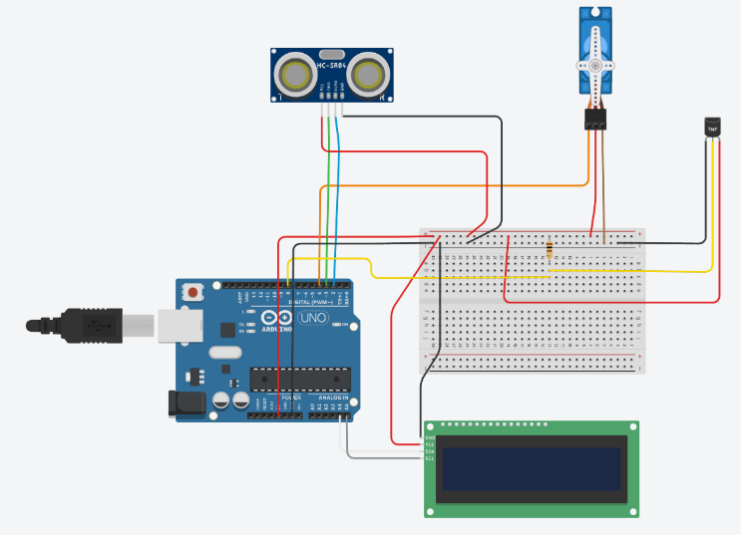

Fig 1: Circuit View

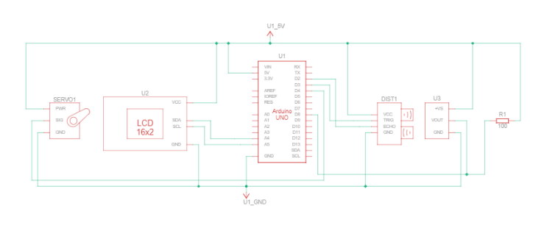

Fig 2: Schematic View

## Pseudocode

Step 1: Initialize the necessary libraries for the servo motor, LCD display, temperature sensor, and ultrasonic sensor.

Step 2: Define the connections of the temperature sensor, ultrasonic sensor, and servo motor to the Arduino pins.

Step 3: Set up the Arduino with the following configurations:

Begin serial communication for debugging and data output.

Initiate the temperature sensors.

Define pin modes for ultrasonic sensor's trigger and echo pins.

Initialize the LCD display and display the message "Hand Sanitizer".

Attach the servo motor and set its initial position.

Step 4: In the main loop:

a. Request the current temperature from the temperature sensor. If the temperature is successfully retrieved, display the body temperature in Fahrenheit on the LCD.

b. Using the ultrasonic sensor, measure the distance to detect the proximity of a user's hand. If the distance is less than 7 cm, activate the servo motor to dispense sanitizer and display the message "Dispensing :D" on the LCD.

c. If the distance is greater than 30 cm or an invalid reading is obtained, display the message "KeepUrHandsClose".

d. Otherwise, display the measured distance in centimeters on the LCD.

Step 5: Wait for a short delay, then repeat the main loop.

The Arduino IDE was used to write and upload the program to the Arduino board.

# Ease of use

## Intuitive Interaction

The use of an ultrasonic sensor ensures that users don't need to touch the device, minimizing the risk of contamination. When a user places their hand under the dispenser, the device immediately detects it and dispenses the sanitizer, eliminating any need for manual intervention or pressing buttons.

## Informative Display

Our 16x2 I2C LCD display provides real-time feedback to the user. Not only does it indicate when the sanitizer is being dispensed, but it also displays the user's temperature, taken via the DS18B20 temperature sensor. This immediate feedback ensures users are informed and can take necessary precautions if an abnormal temperature is detected.

## Portability and Versatility

The compact design, achieved using a small breadboard and minimalistic component layout, ensures that the dispenser can be placed in a variety of settings, from homes to public places. Its versatility means that it can be used almost anywhere, making it a convenient tool for promoting hand hygiene.

##### Conclusion

In this project, we developed an Automatic Hand Sanitizer Dispenser using Arduino, aimed at promoting hand hygiene and monitoring body temperature. Hand hygiene is a paramount practice, especially in the current global health landscape, and ensuring its consistent application is crucial. With the integration of the ultrasonic sensor, our system ensures touchless and precise dispensing of sanitizer, minimizing wastage and maximizing efficiency. The addition of the DS18B20 temperature sensor adds a layer of health monitoring, offering users a quick check of their body temperature. As public health and safety become increasingly intertwined with technology, innovations like ours can play a pivotal role in ensuring communities remain safe. Given the widespread need for such solutions in numerous public and private settings, we believe that refining and expanding the capabilities of our design can greatly benefit society at large.

##### References