SeatFlow Microservices Design and Development
  - Scalable Services SEZG583 | Assignment 1
  - Workshop seat booking with concurrency control idempotency and resilience
22 October 2026

Purpose and result
SeatFlow demonstrates how four independently runnable services preserve booking integrity when requests compete for seats, arrive repeatedly or encounter downstream failures. The implementation uses REST over HTTP, four separately owned PostgreSQL databases and a durable booking workflow. Payment and notification are local mocks.
The executed evidence suite passed seven scenario groups and fourteen unit tests. Twenty five simultaneous reservations for five seats produced five successes and twenty SOLD_OUT rejections. Duplicate booking and payment calls produced one logical effect. A lost payment response and real service restarts recovered without a duplicate charge.
Team member | Proposed service ownership | Share
SHAH BHAGYESH . | Booking and architecture | 25%
SUDHARSHAN M N . | Inventory and concurrency | 25%
CHINCHALKAR AJINKYA SANJAY . | Payment and idempotency | 25%
TIRTHARAJ SINHA . | Notification and resilience | 25%

This is the proposed equal responsibility and presentation allocation. The team must confirm actual contributions and individual reflections before submission. AI assistance is disclosed in Appendix C.

Report map
Pages 2 to 6 explain the problem, boundaries, architecture, data and APIs. Pages 7 to 10 document the challenges and failure recovery. Pages 11 to 13 cover tests, operation, decisions and limitations. Appendices contain contribution allocation, reflection drafts, AI use and submission links.

1 Problem scope and business rules
A learner books one seat in a paid workshop. The scarce resource is the remaining seat count. Booking is unsafe to repeat because it can allocate inventory and create a charge. The main transaction spans Booking, Inventory, Payment and Notification. This narrow domain exposes distributed consistency problems without unrelated features.

Assumptions and scope
Each booking reserves one seat. Prices use positive integer cents. APIs run in a trusted local demonstration environment. Customer is a display label rather than an authenticated identity. The Payment mock can charge, decline, fail or delay a response; Notification stores a mock delivery.
Authentication, a customer UI, real payments, time bound holds and broker messaging are outside scope. The chosen additional challenge is 3A Resilience. Decline release and an outbox strengthen integrity without claiming another challenge option.
Rule | Required behavior | Code and test trace
BR1 | Allocated seats never exceed capacity. | Inventory reserve and SQL CHECK; inventory unit test; concurrency scenario.
BR2 | Same key and payload return the original result with one effect. Changed payload conflicts. | Common idempotent and fingerprint; common unit test; idempotency scenario.
BR3 | Amounts are positive integer cents. Booking obtains price from Inventory. | Payment chargeInput and Booking input schema; payment and booking tests; main scenario.
BR4 | Confirm only after a known successful payment. | Booking assertPaid and transitions; booking unit test; resilience scenario.
BR5 | Release at most once and never release confirmed inventory. | Inventory reservationTransition and row lock; inventory test; main and resilience scenarios.
BR6 | One logical confirmation message per booking. | Notification unique booking ID and stable key; notification test; recovery scenario.

README.md gives the complete file mapping. Business rules live in each service domain module; database constraints provide a second line of enforcement where appropriate.

2 Service decomposition and architecture
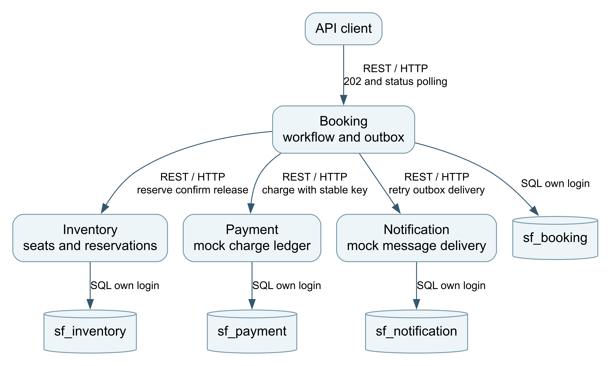
Figure 1 Four capabilities use REST and access only their own databases
Service | Responsibility | Owned data
Booking | Accept requests and coordinate durable progress. | Bookings, states, correlation IDs, outbox and replay records.
Inventory | Allocate capacity and protect reservation state. | Workshops, availability, quoted reservations and replay records.
Payment | Record a mock charge or decline once per booking. | Payment ledger, fault mode and replay records.
Notification | Record one mock confirmation delivery. | Delivery records and replay records.

Boundaries follow business capabilities. Inventory protects capacity without payment knowledge; Payment can change its mock behavior independently; Notification has a separate failure lifecycle. Booking owns coordination rather than making each capability orchestrate the next.
A service per table would fragment local invariants. A shared schema would simplify transactions but violate ownership and couple deployments. A monolith is simpler for a domain this small; the four service design is justified by the assignment learning goals, with its operational cost made explicit.

3 Main flow and explicit states
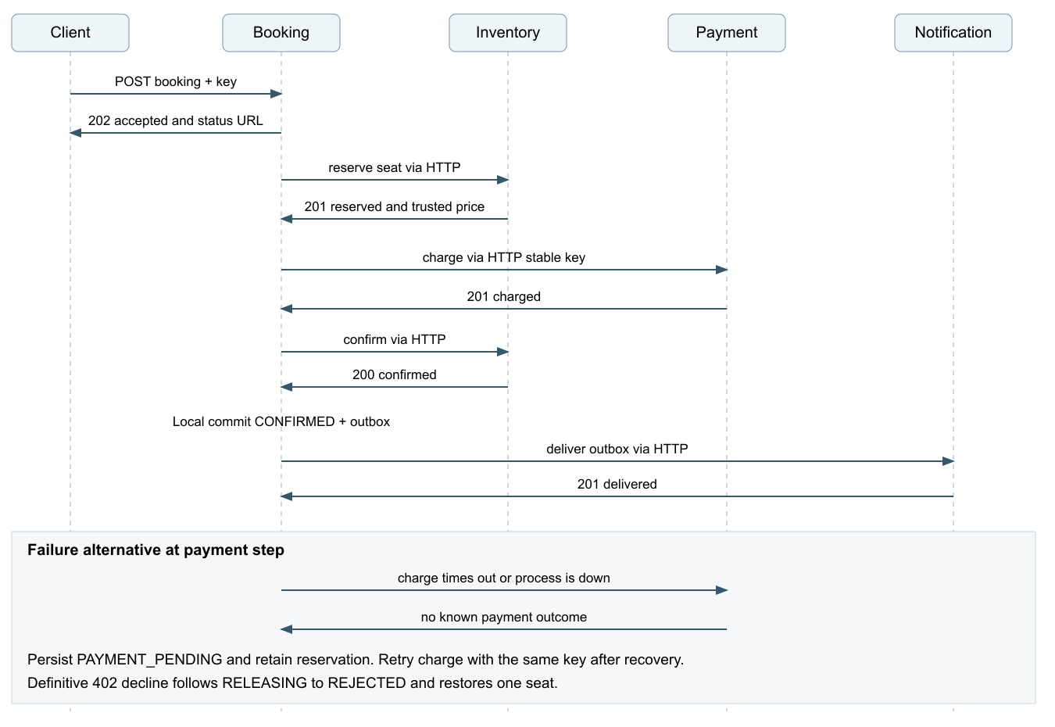
Figure 2 Happy path and payment failure alternative All service calls use REST over HTTP
POST booking saves the request and cached 202 response in one local transaction. The client receives a resource ID and polls current status. A worker persists each step before moving on. The synchronous call depth is one downstream hop from Booking; capabilities do not call one another in a long chain.
States are PENDING, RESERVED, PAYMENT_PENDING, PAID, CONFIRMED, RELEASING and REJECTED. Domain code enforces allowed transitions. A timeout leaves PAYMENT_PENDING with a held seat. A definitive 402 decline moves through RELEASING to REJECTED. PAID reaches CONFIRMED only after Inventory confirmation.
Reserve, charge and notice keys derive from the booking ID. Replaying a step after a crash is safe. PostgreSQL session advisory locks serialize workers per booking and are released when the session closes.

4 Data ownership and integrity
The local launcher uses one PostgreSQL cluster with four databases and different logins. PUBLIC access is revoked. This is logical database isolation, not four independent database servers or operating system isolation. Credential tests require SQLSTATE 42501 for representative cross database connection attempts.
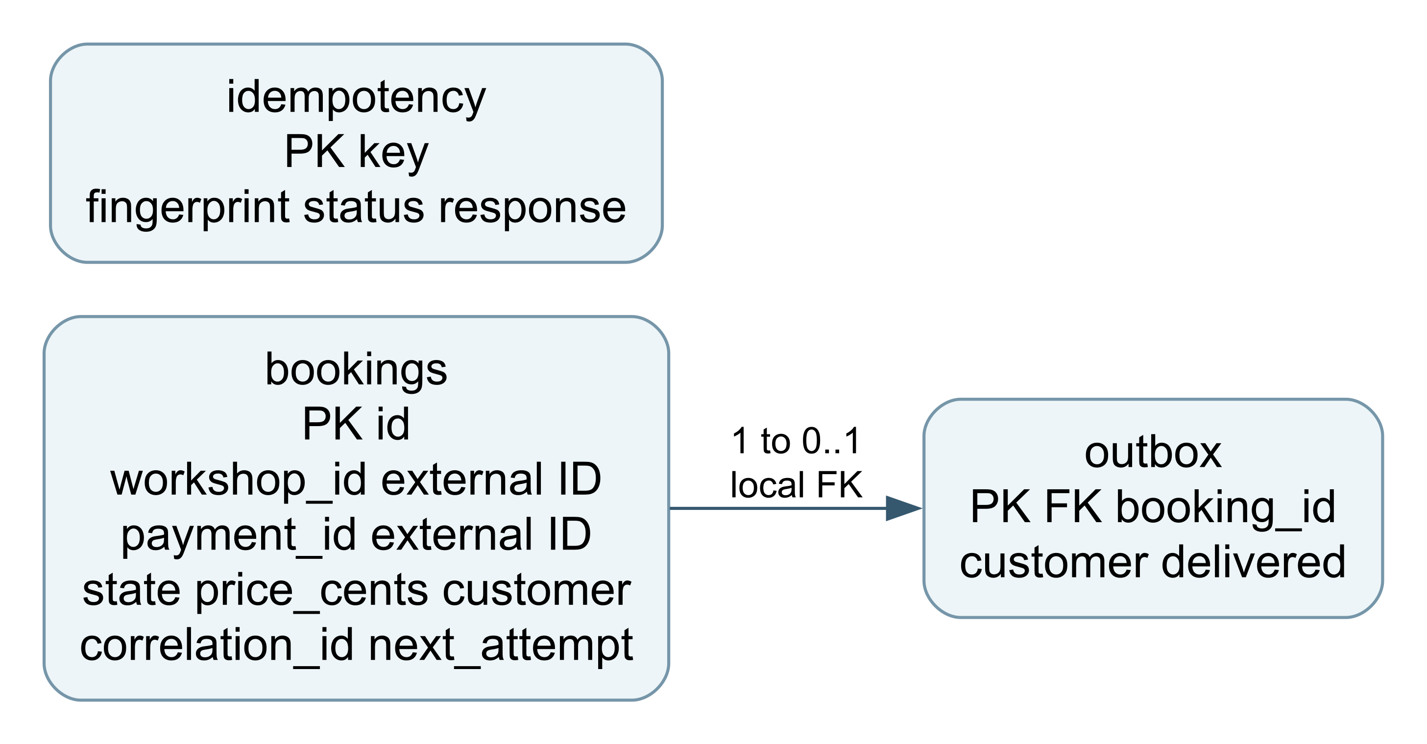
Figure 3 Booking data Local outbox foreign key and external references
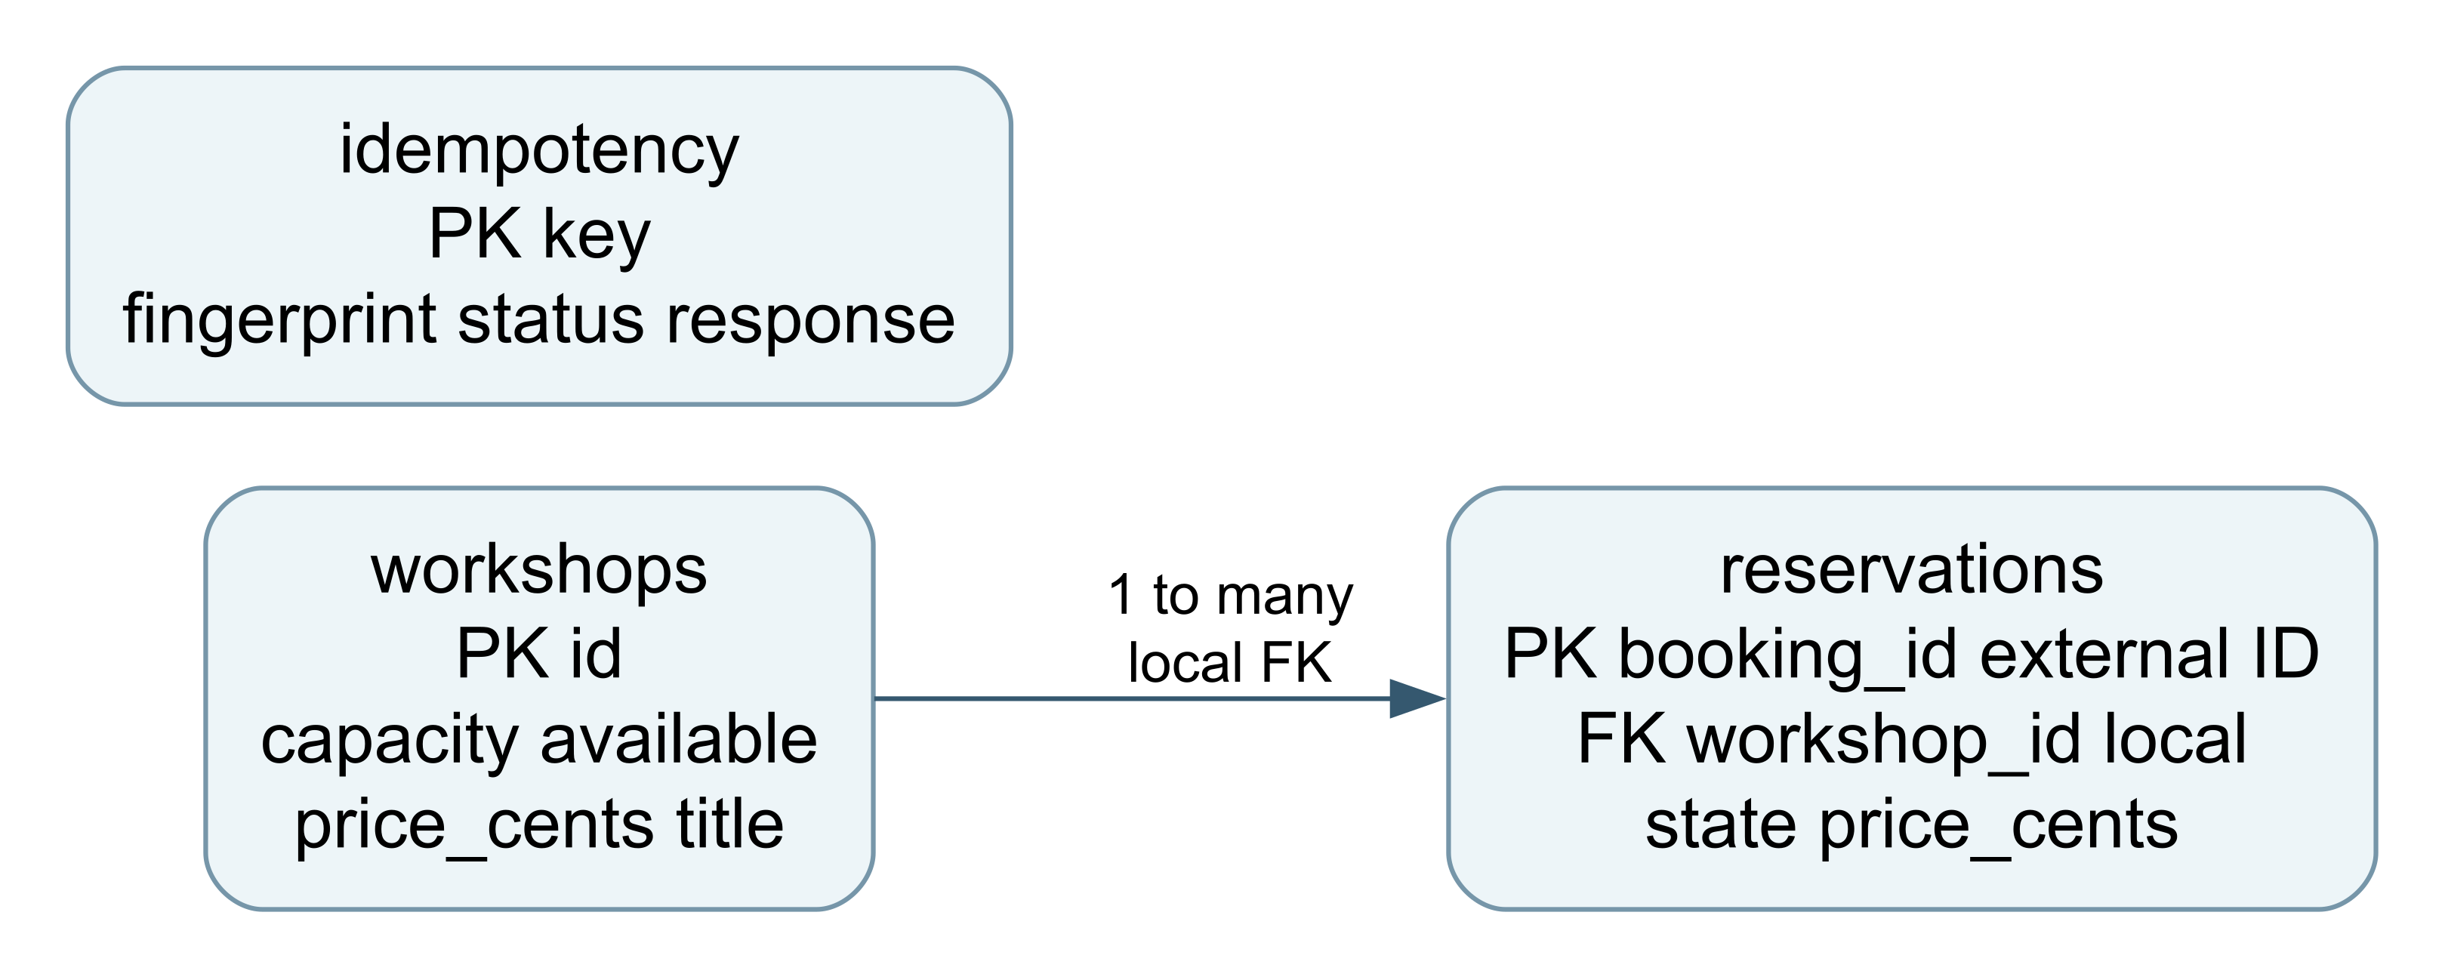
Figure 4 Inventory data Local workshop and reservation relationship
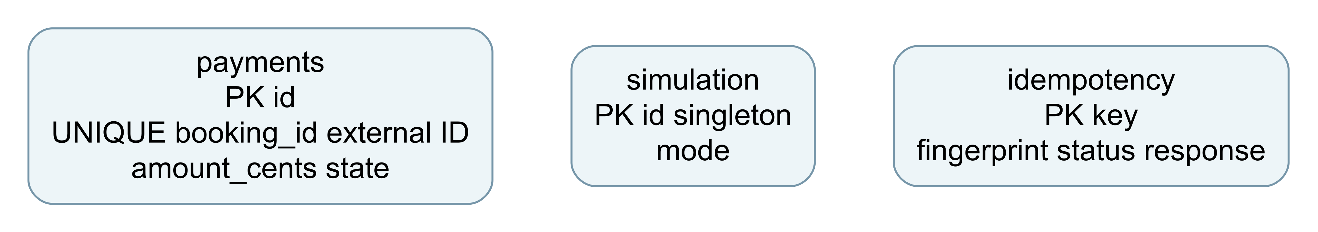
Figure 5 Payment data Ledger fault mode and replay storage
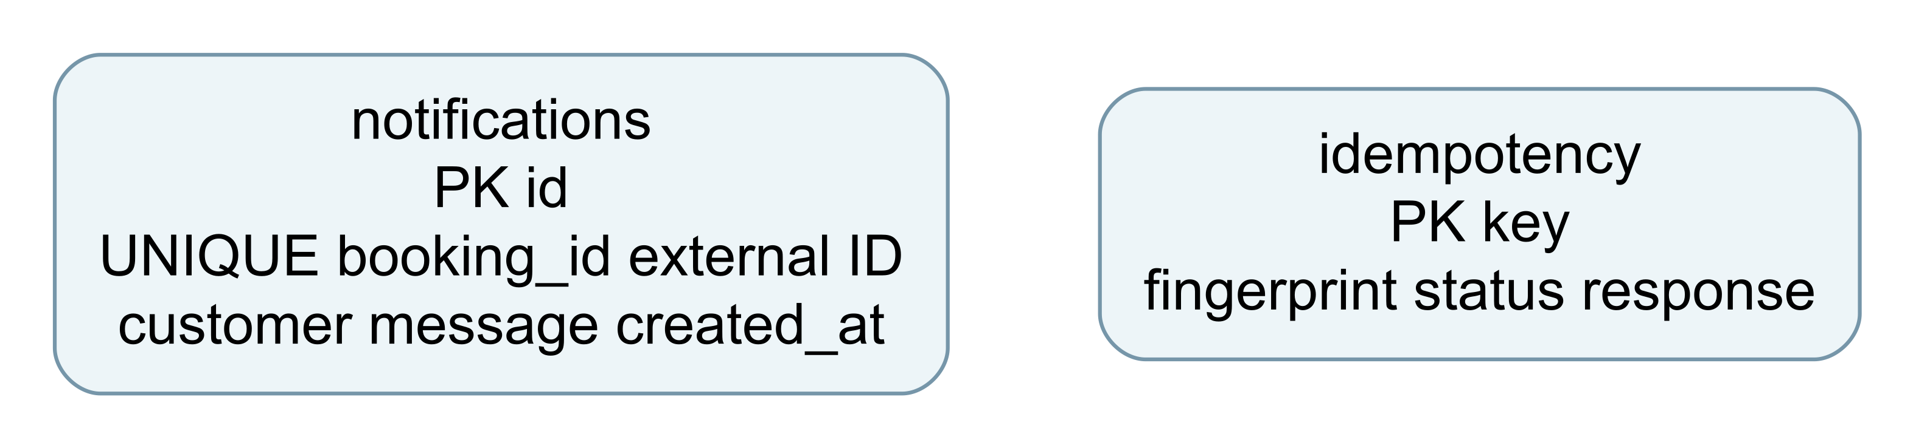
Figure 6 Notification data Unique booking delivery and replay storage
Only local relationships have foreign keys: Inventory reservation to workshop and Booking outbox to booking. Booking workshop_id and payment_id and downstream booking_id fields are external IDs without cross database constraints. Cross service facts are resolved only through APIs.
Every service stores its own idempotency key, fingerprint, HTTP status, JSON response and creation time. Integer cents avoid floating point arithmetic. Reservations retain the authoritative price used for payment.

5 REST API design
Service | Versioned endpoint | Result
Booking | POST /api/v1/bookings | 202 and Location
Booking | GET /api/v1/bookings/{id} | 200 current state
Inventory | POST or GET /api/v1/workshops | 201 create or 200 list
Inventory | POST /api/v1/reservations | 201 or 409 SOLD_OUT
Inventory | GET /api/v1/reservations/{id} | 200 reservation
Inventory | POST /api/v1/reservations/{id}/confirm | 200 or 409 conflict
Inventory | POST /api/v1/reservations/{id}/release | 200 safe repeat
Payment | POST /api/v1/charges | 201 or 402 decline
Payment | GET /api/v1/charges/{bookingId} | 200 ledger record
Payment | POST /api/v1/simulation | 200 when enabled
Notification | POST /api/v1/notifications | 201 mock delivery
Notification | GET /api/v1/notifications/{bookingId} | 200 delivery record

Every service exposes GET /health and GET /openapi.json. The OpenAPI 3.1 files in docs/openapi specify methods, request fields, idempotency headers and errors for Booking, Inventory, Payment and Notification.

Sample booking request and response
POST /api/v1/bookings
Idempotency-Key: learner-001
X-Correlation-ID: demo-001
{"workshopId":"distributed-systems","customer":"Demo learner"}
202 Accepted
{"id":"<booking UUID>","status":"ACCEPTED",
"statusUrl":"/api/v1/bookings/<booking UUID>"}
Inputs reject unknown fields and enforce UUID, integer and bounded string constraints. Missing keys return 400; invalid input returns 422; missing resources return 404; conflicting state or payload returns 409. Direct transient mock failures return 503.
{"error":{"code":"IDEMPOTENCY_CONFLICT",
"message":"Key was already used with a different request",
"correlationId":"demo-001"}}

6 Challenge 1 Concurrency control
Twenty five HTTP requests compete concurrently for five seats. The script checks every response and the final database state. A second experiment races twenty complete booking workflows for another five seat workshop. scripts/scenarios.mjs contains the assertions and scripts/evidence.mjs runs the isolated stack.
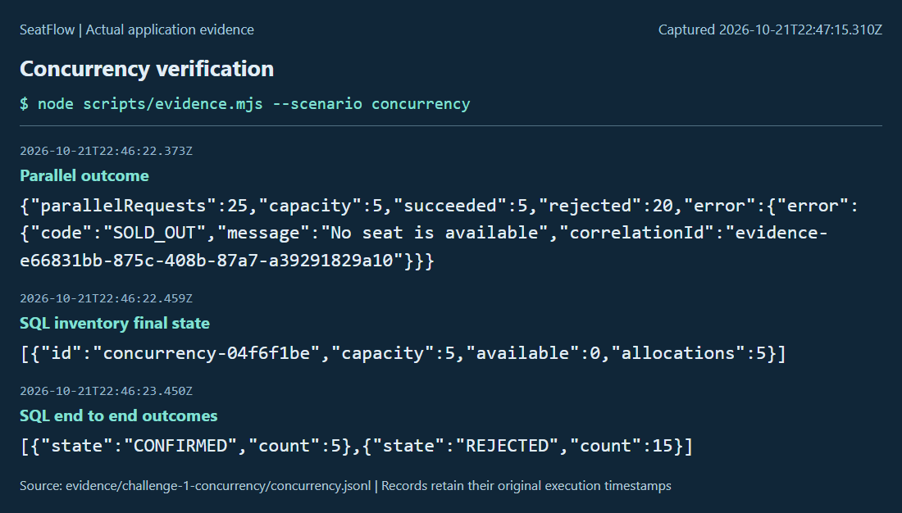
Figure 7 Actual command output and final SQL state Original execution timestamps are preserved

Mechanism and reasoning
UPDATE workshops SET available = available - 1
WHERE id = $1 AND available > 0 RETURNING price_cents;
PostgreSQL locks an updated row; a competing updater waits and rechecks its condition against the updated version [1]. The decrement and reservation insert share one transaction. A failed business effect rolls back its changes. CHECK constraints prevent availability below zero or above capacity.
A separate application read lets callers observe the same last seat. A process mutex protects only one process. Serializable transactions need retry handling; a conditional update is narrower and sufficient for this invariant. Hot rows still serialize, so the evidence establishes correctness rather than throughput.

7 Challenge 2 Idempotency
The first call claims a unique key, executes the local business effect and stores its original status and JSON result in one transaction. A simultaneous competing claim waits and then reads the committed saved result. All statements use the same PostgreSQL client [2]. A SHA 256 fingerprint covers the canonical validated payload.
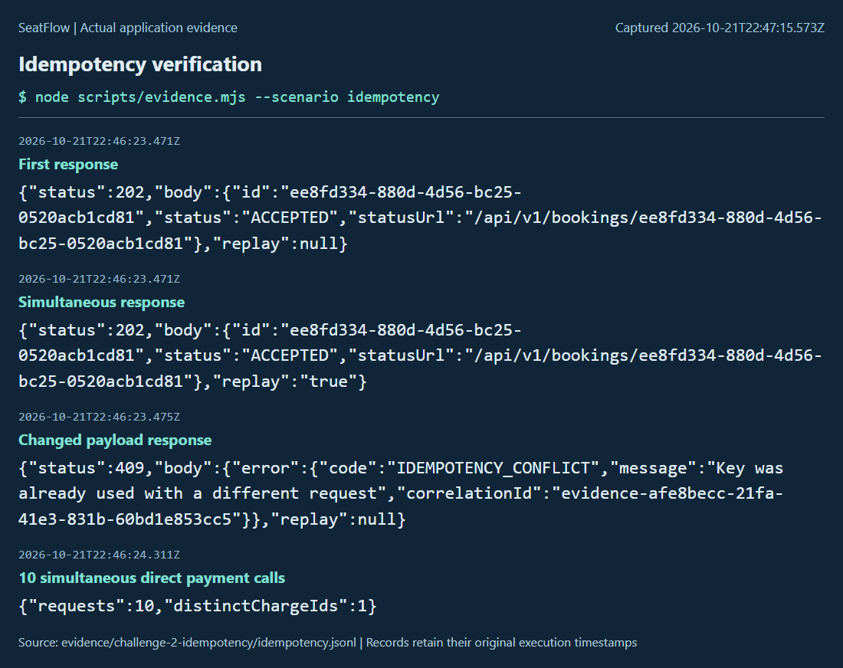
Figure 8 Simultaneous calls share one booking Changed payload conflicts and ten payment calls produce one charge ID
The script also performs three sequential replays and queries the key, fingerprint and saved response, plus one booking, charge and notification. A replay stays the original 202 acceptance result; GET status supplies the eventual outcome. The Idempotency Replayed header marks a replay and logs record idempotency_replay with its correlation ID.
A response cache written after a separate business commit leaves a crash window. A memory cache loses protection on restart. Transactional storage avoids both. Keys are scoped per service and retained for this demo; production requires an explicit retention policy and stable operation identity contract.

8 Challenge 3A Resilience
The Payment mock first commits a charge and delays only the initial response by 1200 ms. The caller times out after 300 ms and retries with the same key. That retry replays the committed charge, exercising a timeout that hides an already successful effect.
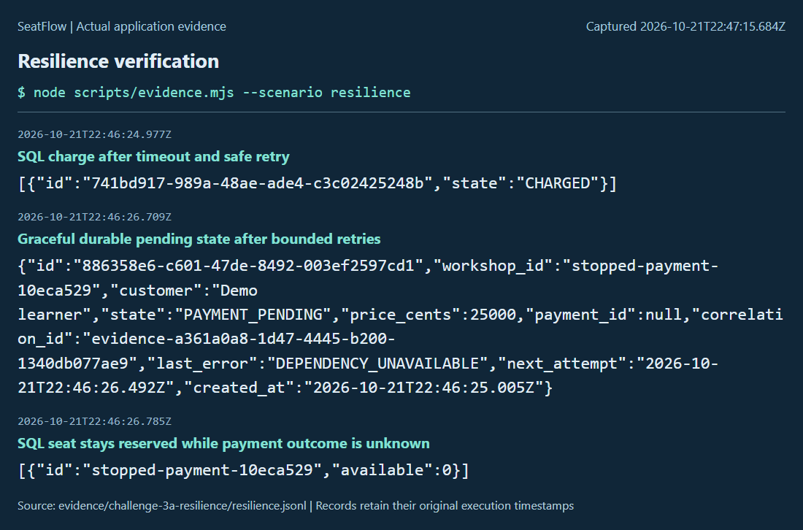
Figure 9 Lost response leaves one charge Stopped Payment yields durable pending state and reserved inventory
The next experiment stops the actual Payment process, submits a booking and observes PAYMENT_PENDING with DEPENDENCY_UNAVAILABLE. Three attempts bound each worker round; later rounds resume pending work. Restarting Payment completes the booking and SQL still shows one charge.
delayMs = floor(baseMs * 2 ** attempt + random() * baseMs)
Defaults: baseMs 80 attempts 3 timeoutMs 300
Transient HTTP failures and connection or timeout errors are retried. A definitive 402 decline is a business result: Booking releases the reservation and rejects the booking. No circuit breaker is claimed. A long outage can leave seats reserved; retaining inventory under uncertain payment outcome is an explicit integrity tradeoff.

9 Failure recovery and notification outbox
Notification can fail after payment and confirmation. Booking writes CONFIRMED and an outbox row in one local transaction, sends a stable notice key and marks delivered only after a successful response. Notification has a unique booking ID as well as its own replay table.
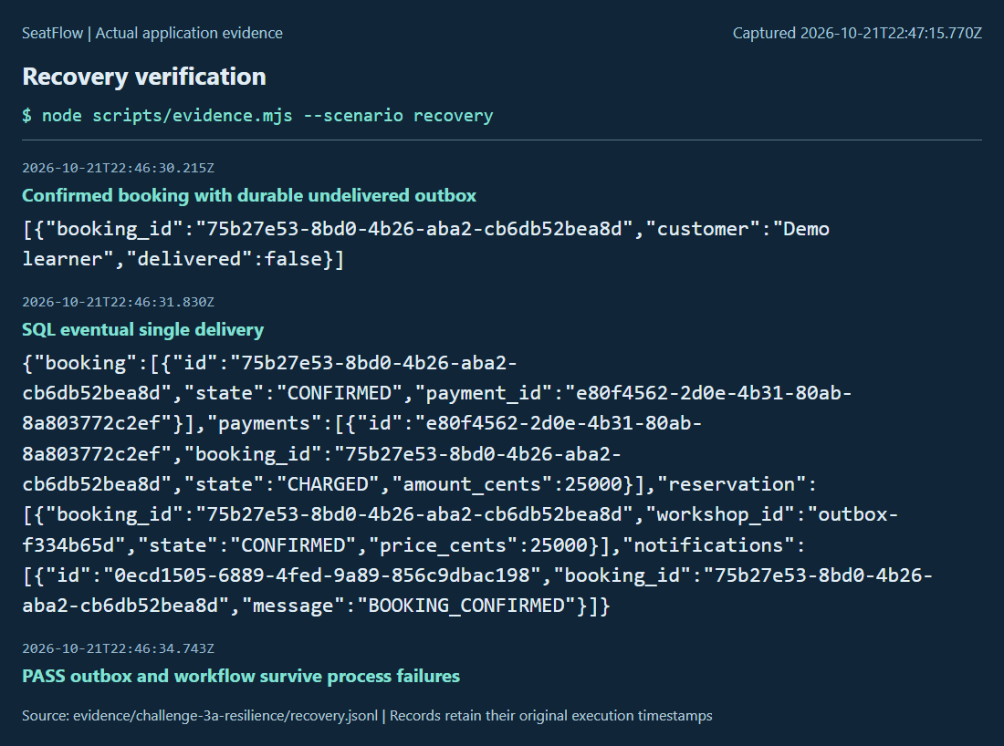
Figure 10 Notification downtime preserves an outbox Restart produces one logical delivery and Booking also resumes
The recovery script stops Notification, confirms a booking, observes delivered=false, restarts Notification and verifies one message. It also restarts Booking during an uncertain payment outcome and checks a single eventual charge. Data survives each process restart.
A crash after downstream success but before saving progress repeats a call. Downstream idempotency makes that repeat safe. Delivery followed by a crash before marking the outbox repeats the same notice key. This is at least once delivery with one logical effect in the mock database, not exactly once transport.
The tests cover process failure and response loss. They do not cover disk corruption, database failover or every instruction level crash. Production APIs must authorize state transitions and verify provider receipts; this local demonstration assumes trusted callers.

10 Testing strategy and observed results
Scenario group | Observed outcome
Health and main | Four healthy services; one confirmed reservation, charge and notice.
Concurrency | 25 reservations give 5 successes and 20 rejections; 20 full bookings give 5 confirmed and 15 rejected.
Idempotency | Simultaneous and sequential replays match; changed payload is 409; 10 charge calls yield one ID.
Resilience | Response loss and Payment restart retain one charge; decline releases once.
Recovery | Notification catches up and Booking resumes persisted work.
Contracts and credentials | Four OpenAPI endpoints; 422 and 400 errors; four wrong database connections denied.

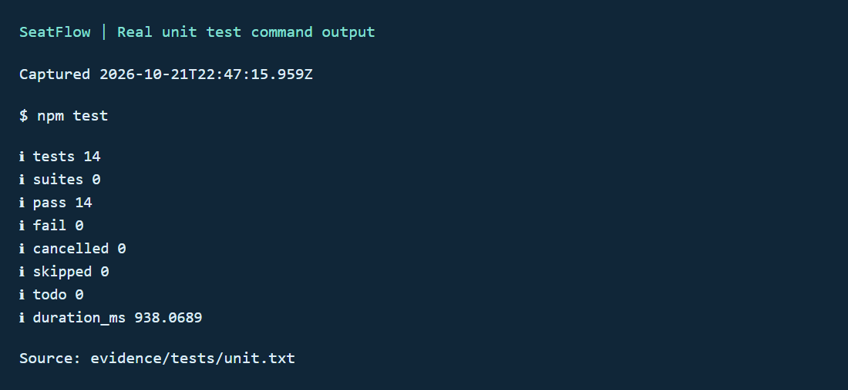
Figure 11 Fourteen unit tests pass Raw output remains in evidence/tests/unit.txt
Unit tests isolate core domain rules and retry policy. Integration scripts use real HTTP and PostgreSQL and assert final state. Raw evidence is retained per challenge; full-run.txt records all seven groups. Screenshots are presentation views of actual output and retain original source timestamps.
A clean dependency installation and isolated stack were exercised on this Windows host. A fresh clone on another member machine remains a pre submission check. The suite is evidence of tested invariants and scenarios, not a performance benchmark or a full distributed failure proof.

11 Running and operating the project

Reproduce from a clean copy
npm ci
npm test
npm start
# Another terminal
node scripts/client.mjs
# Isolated test services and databases
npm run evidence
Node.js 22 or later and npm are required; validation used Node 24.13.1. First installation downloads native PostgreSQL binaries. Run PostgreSQL in a normal user account. The launcher creates different random service passwords and four owned databases. Generated files stay in the ignored .runtime directory; no administrator credential reaches a service.
Configuration | Purpose
PORT HOST DATABASE_URL | Own listener and own database connection.
DB_POOL_SIZE | Own pool size, default 12.
INVENTORY_URL PAYMENT_URL NOTIFICATION_URL | Booking downstream API locations.
HTTP_TIMEOUT_MS RETRY_ATTEMPTS RETRY_BASE_MS | Bounded calls and backoff with jitter.
WORKER_INTERVAL_MS | Booking polling interval.
ENABLE_SIMULATION MOCK_DELAY_MS | Local mock fault controls and post commit response delay.

Development ports are 8081 to 8084 with PostgreSQL 15432; evidence uses 18081 to 18084 with PostgreSQL 15433. Run one evidence suite at a time. Each service has its own manifest, source, tests, .env.example and Dockerfile. The root lockfile makes dependency installation repeatable.

Operational visibility
GET /health checks each service own database. JSON logs contain timestamp, service, event and correlationId. Booking persists the request ID so background work retains the trace. Retry and replay events show operation details; application logs exclude database URLs and credentials.
Data persists after launcher shutdown. Windows uses pg_ctl fast stop. Dockerfiles prepare image builds for Assignment 2; containers and Minikube have not been validated. The shared library provides infrastructure plumbing without shared entities or cross database access.

12 Decisions limitations and references
Decision | Options and rationale
Durable asynchronous acceptance | Chosen over a long blocking request. 202 and polling retain a stable client operation while dependencies recover; a worker adds operational complexity.
Booking orchestration | Chosen over choreography for an explicit state machine with four services. A broker adds infrastructure outside the chosen challenge.
Conditional inventory update | Chosen over a process lock or global serializable isolation. Local SQL protects capacity with limited lock scope.
Transactional replay storage | Chosen over memory caching or separate effect and cache commits. Business effect and saved result commit together.
Retain uncertain reservations | Chosen over timeout release to protect potentially paid inventory, at the cost of availability during prolonged outages.
Local durable outbox | Chosen over making confirmation depend on message delivery. Notification can recover independently.

Limits and next steps
The educational system has trusted callers and mock providers. There is no authentication, expiry, operator reconciliation, production key retention or real payment settlement. Startup DDL is adequate for the demonstration; production needs versioned migrations, migration roles, authorization, monitoring and workflow repair tools.
Next tests should include database restarts, partitions, cancellation races, larger workloads and multiple worker instances. Advisory locks serialize work per booking, but horizontal scale has not been measured. Assignment 2 can add container and Minikube deployment after reviewing these operational assumptions.

Technical references
[1] PostgreSQL Transaction Isolation, Read Committed UPDATE condition rechecking. https://www.postgresql.org/docs/18/transaction-iso.html
[2] node postgres Transactions, one client per transaction. https://node-postgres.com/features/transactions
[3] Express Error handling, async errors and middleware. https://expressjs.com/en/guide/error-handling/
[4] Embedded PostgreSQL native development lifecycle. https://github.com/leinelissen/embedded-postgres

Appendix A Contribution and review allocation
The proposed allocation assigns each member 25 percent of service review, documentation and presentation responsibility. It must be confirmed by the team and is not a fabricated record of completed student work or commit authorship.
Member | Assigned area and cross review | Video
SHAH BHAGYESH . | Booking, public API, architecture and report integration; review Notification. | 00:00 to 02:15
SUDHARSHAN M N . | Inventory, capacity invariants, reservation lifecycle and concurrency; review Booking. | 02:15 to 04:30
CHINCHALKAR AJINKYA SANJAY . | Payment, transactional idempotency and duplicate evidence; review Inventory. | 04:30 to 06:45
TIRTHARAJ SINHA . | Notification outbox, retries, recovery and tests; review Payment. | 06:45 to 09:00

Member confirmation
Each member should understand the assigned code, run the scenarios, make genuine review or implementation commits and revise their reflection. Confirm actual percentage after that work. Faculty evaluation also considers commit history and each member speaking in the demo.
The silent recording has four named sections. Speaking_Script.txt provides timed lines for the students to record themselves. Keep the narrated version between eight and ten minutes.
Member | Institute student ID | Actual share
SHAH BHAGYESH . | Member to complete | 25% proposed
SUDHARSHAN M N . | Member to complete | 25% proposed
CHINCHALKAR AJINKYA SANJAY . | Member to complete | 25% proposed
TIRTHARAJ SINHA . | Member to complete | 25% proposed

The supplied Taxila profile numbers are not treated as institute student IDs.

Appendix B Individual reflection drafts
These drafts explain the assigned technical areas. Each student must rewrite the reflection to describe personal completed work, the hardest problem actually solved and the intended improvement. They are not signed personal experience statements.

SHAH BHAGYESH
Assigned area: Booking workflow and architecture. The central design problem is distinguishing accepted work from completed work. HTTP 202 supplies a durable operation identity while status polling shows progress. Persisting each state and the correlation ID allows a worker to resume after a process restart.
The difficult failure window is downstream success followed by a crash before local progress is saved. Repeating a stable operation key avoids repeating its effect. A payment timeout must remain uncertain rather than becoming an unconditional rejection. An operator view of old pending workflows and explicit reconciliation would be useful improvements.
Member completion: Describe your actual changes or review, the issue you personally reproduced, evidence you checked and the next improvement. Add genuine commit references.

SUDHARSHAN M N
Assigned area: Inventory and concurrency. Available seats must stay between zero and total capacity while reservation records agree with allocations. An application read is insufficient because two callers can see the same last seat. Conditional UPDATE checks capacity at the database serialization point, and the reservation insert belongs to that transaction.
A thread safe process is not the same as a safe distributed resource. A local mutex does not protect another service instance. Release also needs state protection so stock cannot increase twice. Future work should test multi instance operation, larger workloads and capacity changes while reservations exist.
Member completion: Explain the race you personally investigated, your interpretation of the twenty five request result and changes or test reviews you actually performed. Add genuine commit references.

Appendix B Individual reflection drafts continued

CHINCHALKAR AJINKYA SANJAY
Assigned area: Payment and idempotency. The key claim, business effect and cached response commit together. A unique key serializes simultaneous arrivals; a fingerprint rejects changed payloads. Canonicalization prevents JSON object property order from changing the semantic request identity.
Response loss after commit is the difficult concept. A charge may exist even though the caller times out. The mock delays its first response after recording the charge; repeating the same payment key retrieves that result. Improvements include an explicit key retention window and provider receipt verification for a real integration.
Member completion: Explain the tests you personally ran, the failure window you investigated, your actual changes or findings and your next improvement. Include genuine commit references.

TIRTHARAJ SINHA
Assigned area: Notification, retry policy and recovery. Message delivery can fail after a reservation is paid and confirmed. A durable outbox keeps that intent while letting the booking finish. Confirmation and outbox creation commit together; the receiver records one logical delivery for each stable booking ID.
A crash after delivery but before saving delivered=true can repeat a send. Receiver idempotency makes the repeat safe. Timeouts and bounded retries limit each round, while durable state permits later recovery. Improvements include alerts for old outbox entries, operator repair tools and database failure tests.
Member completion: Describe your personal role in stop and restart experiments, retry log interpretation and message verification. State the hardest issue you actually solved and add genuine commit references.

Appendix C AI use and submission links

AI use declaration
OpenAI Codex assisted with design, original application code, tests, local execution, evidence capture, diagrams, the technical report and silent demo recording. No generated audio is included. The team records its own narration. Payment and notification are local mocks using demonstration data.
Students must understand the implementation and confirm statements about their own work. The equal allocation represents proposed responsibility ownership, not student authorship of generated code. Reflection drafts require personal revision. No fictional commit history or hosting URL has been created.

Appendix D Submission links
Complete these fields after publishing the source and recording the four voice tracks. Verify faculty viewing access.
Item | Team to complete
GitHub repository URL
Final narrated video URL
Google Drive folder with video and documents
Final report PDF location

Final team checks
- Run a clean copy on another member machine using README.md.
- Confirm real contributions and replace the personal reflection drafts.
- Record the four members and mix their audio with the silent video.
- Update submission links and export this editable document to PDF.
- Submit repository link, PDF report and narrated video link.

Evidence integrity
The report uses actual command and PostgreSQL results. Readable screenshot views select relevant output while raw JSONL and service logs remain available. Original execution timestamps are retained. Video generation helpers are removed after verification.

