**2CS503 Design and Analysis of Algorithms**

**Tutorial 5: Heaps**

Q.1 Answer the following MCQs:

1. What is the time complexity of Build Heap operation. Build Heap is used to build a max(or min) binary heap from a given array. Build Heap is used in Heap Sort as a first step for sorting.

A. O(nLogn)

B. O(n2)

C. O(logn)

D. O(n)

1. Suppose we are sorting an array of eight integers using heapsort, and we have just finished some heapify (either maxheapify or minheapify) operations. The array now looks like this: 16 14 15 10 12 27 28 How many heapify operations have been performed on root of heap?

A. 1

B. 2

C. 3 or 4

D. 5 or 6

1. A max-heap is a heap where the value of each parent is greater than or equal to the values of its children. Which of the following is a max-heap?

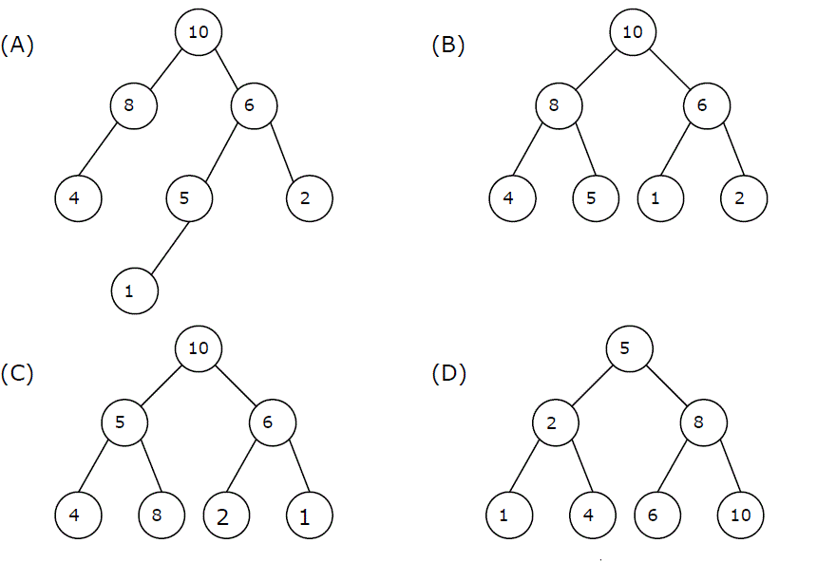

A. A

B. B

C. C

D. D

1. Consider a binary max-heap implemented using an array. Which one of the following array represents a binary max-heap?

A. 25,12,16,13,10,8,14

B. 25,12,16,13,10,14,8

C. 25,14,16,13,10,8,12

D. 25,14,12,13,10,8,16

1. In a binary max heap containing n numbers, the smallest element can be found in time. Is an array of a sorted elements producing a min heap tree? Justify with an example.

A. O(n)

B. O(logn)

C. O(loglogn)

D. O(1)

1. The elements 32, 15, 20, 30, 12, 25, 16 are inserted one by one in the given order into a Max Heap. The resultant Max Heap is.

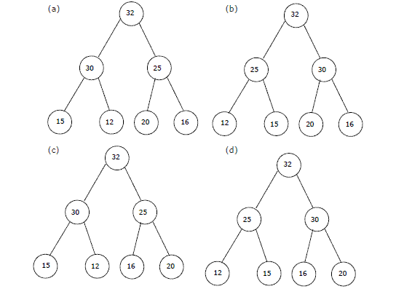

1. a
2. b
3. c
4. d
5. A priority queue is implemented as a Max-Heap. Initially, it has 5 elements. The level-order traversal of the heap is: 10, 8, 5, 3, 2. Two new elements 1 and 7 are inserted into the heap in that order. The level-order traversal of the heap after the insertion of the elements is:
6. 10, 8, 7, 3, 2, 1, 5
7. 10, 8, 7, 2, 3, 1, 5
8. 10, 8, 7, 1, 2, 3, 5
9. 10, 8, 7, 5, 3, 2, 1

Q.2 Answer the following questions:

1. Explain the terms Binary Heap and Binomial Heap.
2. Given the two heaps H and H’ find the union of these two heaps.



