Mission CHANDRA competition

TRS BVM Students Excel in Mission CHANDRA Competition
Two teams from the TRS Student Chapter, BVM Engineering College successfully cleared the preliminary round of the Mission CHANDRA Competition, held at Science City, Ahmedabad, on 19 August 2023.
Under the guidance of Prof. (Dr.) Vinay J. Patel, Prof. Ashish M. Thakkar, and Prof. (Dr.) Mehfuza S. Holia, both teams demonstrated exceptional creativity and technical skills in designing innovative concepts for future space missions.

Team 1
Sr. No. | Team Member | Year & Branch
1 | Honey Rathod | 4th Year, EC
2 | Viren Modiyani | 4th Year, EC
3 | Paavan Shah | 2nd Year, EL
4 | Dhruv Patel | 2nd Year, EL

Team 2 – Winning Team
Sr. No. | Team Member | Year & Branch
1 | Twisha Shah | 2nd Year, EL
2 | Dhanraj Zaveri | 2nd Year, EL
3 | Yash Roghelia | 2nd Year, EL
4 | Diya Jasani | 1st Year, EL

Both teams received trophies, certificates, and a cash prize of ₹5,000 for their performance in the preliminary round.
In the final competition held on 14 October 2023, Team 2 emerged as the winner, securing a ₹25,000 cash prize, trophy, and certificates, along with the prestigious opportunity for an internship at ISRO Ahmedabad.
The achievement showcases the students’ excellence in space technology, innovation, engineering design, and teamwork, bringing pride and recognition to BVM Engineering College and the TRS Student Chapter.

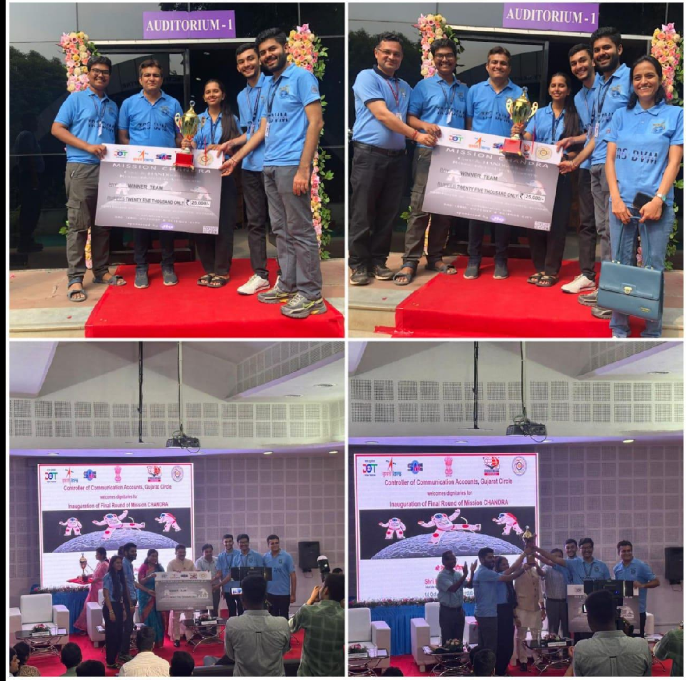

ROBOFEST 3.0

ROBOFEST 3.0
No. | Category | Name Of Student | Final Stage
1. | Underwater Robot | Mentor: Prof. G.B.Rathod  Students Team: Nirbhay Tejani (ME) Siddharth Darji (ME) Rugnesh Vora (EL) Tirth Soni (EL) Prince Sharma (EL) | Rs. 10,00,000/- for  winning first position
2. | Rover Robot | Mentor: Dr. D. M. Patel Students Team: Mahummad Ali Sheikh (ME) | Rs. 5,00,00/- for winning third position.
Karan Shah (ME)
Dhruv Patel (EL)
Jeet Rathod (EE)
Ishan Upadhye (EE)
3. | Home Cleaning Robot | Mentor: Dr. Mehfuza Holia  Students Team:  Amisha Shyam Sakhare(EC)  Dhan Prajapati(EC)  Nirbhay Tejani(ME) Siddharth Darji(ME)  Yash Panchal(ME) | Rs. 2,50,000/- for consolation prize
4. | Swarm Robot | Mentor: Prof. Ashish Thakkar  Students Team: Nirmay Gajjar (EL)  Rohit Jasoliya (ME) Tushar Galaiya (EL)  Kartavi Desai (CP)  Akshay Singh (EL) | Rs. 10,00,000/- for  winning first position
5. | Rover Robot | Mentor: Prof. Vijaypratap Singh  Students Team: Thakkar Parth (ME)  Shukla Pranjal (ME) Kunal Engineer(ME)  Vahora Samrej Firozbhai(ME)  Devansh Dave (EC) | Rs. 2,50,000/- for consolation prize

No. | Category | Name of Student | Ideation  Stage | Proof of  concept Stage
6. | Hexapod robot | Mentor: Dr. Haresh Patoliya  Students Team:  Swayam Vijay Jathar (ME) Mansuri Mo.Rayyan (ME) Jay I. Rathod((ME) Darshil J. Gohil (ME)  Yash Mehta (EC) | Rs. 50,000  for winning position | Rs. 2,00,000 for  winning position
7 | Maze Solving Robot | Mentor: Prof. Ashish Thakkar  Students Team: Keivalya Pandya(ME) Jay Goswami (EL) Honey Rathod(EC)  Jayati Raval (IT) | Rs. 50,000  for winning position | Rs. 1,00,000 for  winning position
8 | Self-Balancing Robot | Mentor: Dr. Vinay J Patel  Students Team:  Jay Goswami (EL) Keivalya Pandya(ME) Rohit Jasoliya (ME)  Jayati Raval (IT) | Rs. 50,000  for winning position | Rs. 2,00,000 for  winning position
9 | Hexapod robot | Mentor: Dr. M.M. Solanki  Students Team: Harsh Sonaiya (ME) Yash Sangale (EL) Yash Roghelia(EL)  Mahesh Rathwa (ME)  Vivek Chauhan(EL) | Rs. 50,000  for winning position | Rs. 2,00,000 for  winning position
10 | Underwater robot | Mentor: Prof. Jayesh Koisha  Students Team:  Dev Bhanderi(ME)  Dushyant Singh Rathore(ME) Shoobham Parikh(ME)  Om Patel (ME)  Tushar Galaiya (EL) | Rs. 50,000  for winning position | Rs. 2,00,000 for  winning position
11 | Swarm Robots | Mentor: Dr. R.B.Gandhi  Students Team:  Harsh Sonaiya (ME)  Viren Modiyani (ME)  Divyang Goswami (EC) Jenish Pansheriya (EE)  Nirmay Gajjar (EL) | Rs. 50,000  for winning position | Rs. 1,00,000 for  winning position
12 | Maze Solving Robot | Mentor: Dr. Mehfuza Holia  Students Team: Dipesh Shobhraj Vadhwani(EL) Harshil Soni(EL)  Raviraj Shah(ME)  Paavan Hiren Shah (EC) | Rs. 50,000  for winning position | Rs. 1,00,000 for  winning position
13 | Self-Balancing Robot | Mentor: Dr. Aakar Rogheliya  Students Team:  Zaid Shaikh (ME)  Bhushan Patole (ME)  Aditya Shah (EL)  Priya Bhavsar (EL) | Rs. 50,000  for winning position | Rs. 2,00,000 for  winning position
14 | Swarm Robots | Mentor: Dr. Vinay J Patel  Students Team:  Darshit Darji (EL)  Raunak Abhani(ME)  Hunaid Barodawala (ME)  Nirbhay Thakkar (EL) Amisha Shyam Sakhare (EC) | Rs. 50,000  for winning position | Rs. 1,00,000 for  winning position

