DD Robocon’24
AIR Rank 4
Mentors | Students Team
Dr. Vinay Patel, Dr. Haresh Patolia | Shoobham Parikh  Dushyant Singh Rathod  Dev Bhandari  Yash Roghelia  Tarun Kataria  Utsav Maradia  Ruchit Soni  Smit Talaviya  Daksh Mandera  Yash Sojitra  Anshul Majmudar  Krish Vaghela  Nihar Trivedi
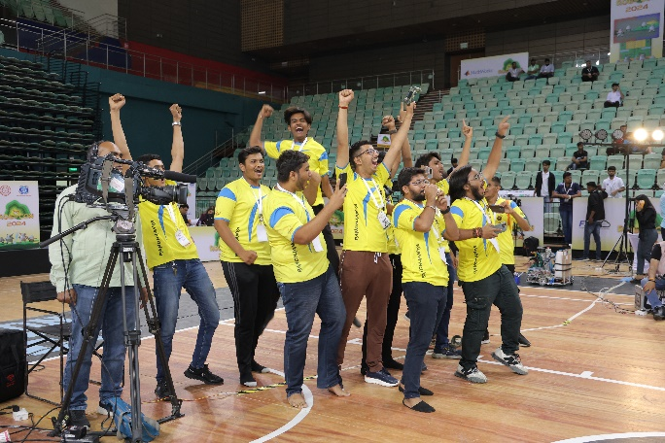
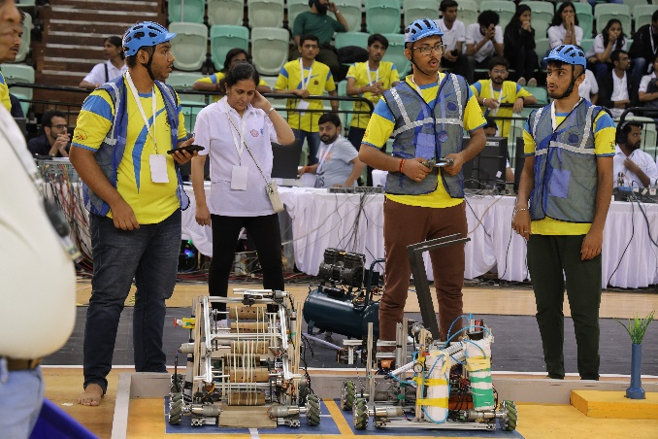

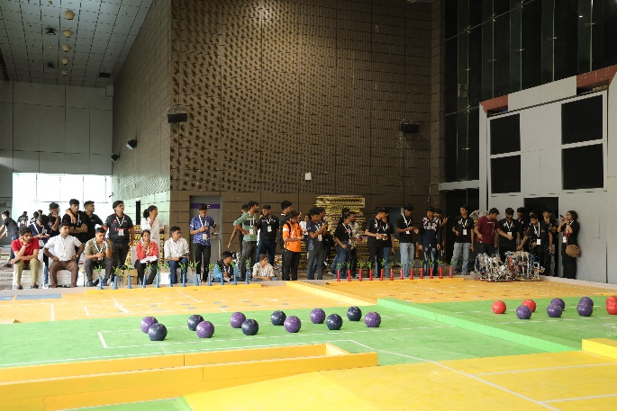
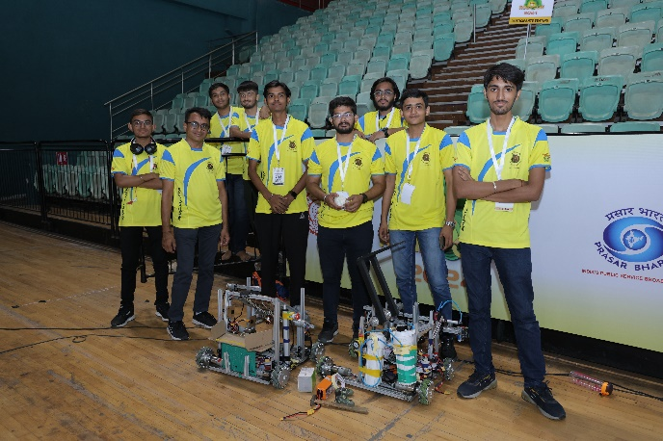

GUJCOST ROBOFEST 4.0
No. | Name of Faculty | Award Title | Event Name
 | Dr. Mehfuza Holia-Mentor  Student team:  - Bambhaniya Anil Nathabhai (21EE017)  - Machhi Shubham Santoshbhai (21EL006)  - Rana Sujal Rajeshkumar(22ME325)  - Darji Hiteshbhai Nagjibhai(22ME068)  - Paghadar Akshaykumar Narsinhbhai(22EL044) | Won the cash prize of 7,50,000/- and secure runner up position in Grand Finale stage of GUJCOST Robofest 4.0 (India’s biggest National level Robot making competition) in Underwater Robotics Category. | Robofest 4.0 (India’s biggest National level Robot making competition) in Underwater Robotics Category.
 | Prof. Vijaypratap Sing- Mentor  Student team:  - Jenish Prnsheriya (22EE039)  - Paavan Shah (22EC411)  - Dhruv Shah (22ME087)  - Rohit Gupta (21EL044)  - Deep Maheshwari (22EL072) | Won the cash prize of 10,00,000/- and secure First position in Grand Finale stage of GUJCOST Robofest 4.0 | Robofest 4.0 (India’s biggest National level Robot making competition) in Underwater Robotics Category.
 | Aakar Roghelia- Mentor  Students team:  - Yuvraj Sinh( 22EL056)  - Smit Tamboli (23EC432)  - Divyaraj Sinh (22ME041)  - Donal Dangariya (22EL068) | Won the cash prize of 7,50,000/- and secure runner up position in Grand Finale stage of GUJCOST Robofest 4.0 | Robofest 4.0 (India’s biggest National level Robot making competition) in Underwater Robotics Category.
 | Dr. D.M.Patel- Mentor  - Dhruvi Shah (23EC426)  - Nihar Trivedi (23EL001)  - Roshan Mali (23EC421)  - Dhruv Shah (22ME087)  - Meet Prajapati (23EL047) | Won the cash prize of 7,50,000/- and secure runner up position in Grand Finale stage of GUJCOST Robofest 4.0 (India’s biggest National level Robot making competition) in Swarm Robotics Category. | Robofest 4.0 (India’s biggest National level Robot making competition) in Swarm Robotics Category.
 | Dr. Vinay J Patel- Mentor  Student team:  - Heet Vashi  - Kushal Vaghasiya  - Poojan Mehta  - Suraj Verma | Won the cash prize of 7,50,000/- and secure runner up position in Grand Finale stage of GUJCOST Robofest 4.0 | Robofest 4.0 ((India’s biggest National level Robot making competition) in ship hulls cleaning robot- Application Based Category
 | Prof. Ashish M Thakar- Mentor  Student team:  - Nirmay Gajjar (21EL076)  - Tushar Galaiya (21EL054)  - Akshay Singh (21EL083)  4.Utsav Maradia (23ME042) | Won the cash prize of 10,00,000/- and secure First position in Grand Finale stage of GUJCOST Robofest 4.0 | (India’s biggest National level Robot making competition) in category of Agriculture robot- Application based Solving Robot..

SAUVC- IEEE

Team Brahmaputra from the TRS Student Chapter, BVM Engineering College has successfully cleared the qualifying round of the SAUVC–IEEE Underwater Competition at Singapore Polytechnic, Singapore, securing a place among the Top 20 teams advancing to the finals.
The team members are:
Sr. No. | Team Member
1 | Rugnesh Vora
2 | Akshay Paghadar
3 | Anil Bambhaniya
4 | Sujal Rana
5 | Hitesh Darji
6 | Tushar Galaiya
The team is guided by Prof. (Dr.) Vinay J. Patel, Dr. Ashish Thakkar (Mechanical Engineering) and Dr. Mehfuza Holia (Electronics Engineering).

