DD Robocon’25
AIR Rank 10
Mentors | Students Team
Dr. Vinay Patel, Dr. Haresh Patolia, Vijay Pratap Singh | Student Names  - Smit Talaviya Smit Rajeshbhai  - Soni Ruchit Niravkumar  - Prajapati Rishabh  - Mori Kishankumar  - Vinit Udai Pratap Yadav  - Javya Rushik Vasanikumar  - Bhagat Ankushkumar Shankar  - Karan Paresh Vakharia  - Kansara Prem  - Parmar Mohitsinh Pravinsinh  - Satheesh Nadar  - Tank Nikhil Vrajlalbhai  - Utsav Atulbhai Maradia  - Gujarati Jeel Sureshbhai  - Patil Ganesh Vasudev  - Rathod Jaykumar Dipakbhai  - Chauhan Bhumil Chandrakanthbhai  - Meghani Mehul Pravinbhai  - Sojitra Yashkumar Alpesh  - Rathod Keval Rajnikant  - Chauhan Riya Nirlepkumar  - Yash Roghelia  - Jadav Bhavya Rameshbhai  - Rajeshbhai

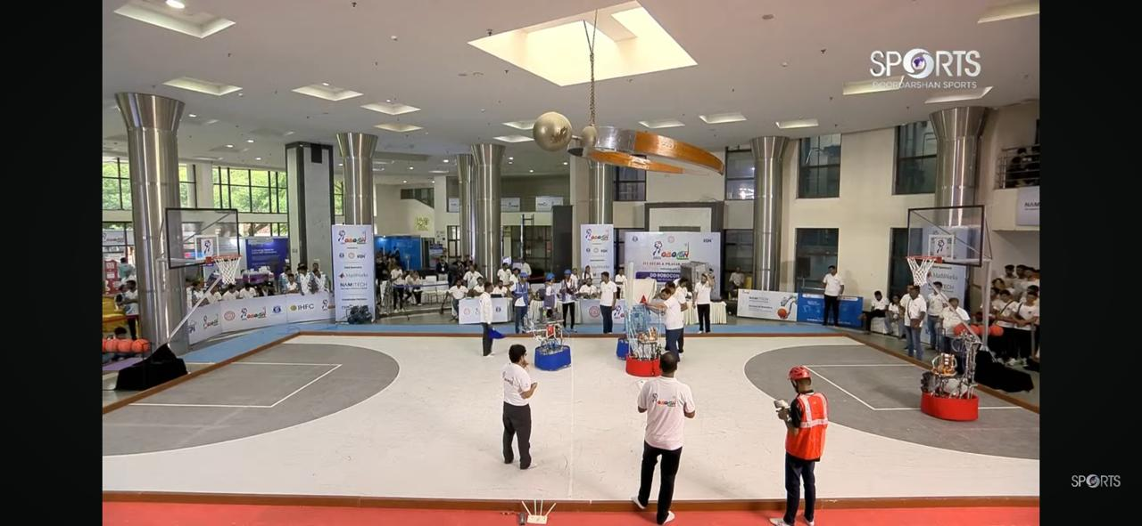

Gujcost Robofest 5.0

Sr.No. | Name of Mentor & Student Team | Cash Prize | Award
1 | Mentor: Prof.(Dr.) Vinay J Patel  Students Team:  Nikhil Tank  Shiyani Meet  Mokana Navya  Bhavya Jadav | 7,50,000/- | First runner up position at Grand Finale Robofest 5.0 India’s biggest robotics competition under the category of ‘’Underwater Robot”.
2. | Mentor: Prof.(Dr.) Mehfuza S Holia  Students Team:  Parsana Shyam  Pambhar Vishrut  Kanzariya Kishan  Chaudhari Harsh | 5,00,000/- | Second runner up position at Grand Finale Robofest 5.0 India’s biggest robotics competition under the category of ‘’Underwater Robot”.

