PRACTICAL - 5
- PROBLEM – I
  - AIM : Shape areas: an abstract Shape with abstract area(); subclasses Circle, Rectangle,
  - Triangle. Put a mix in a Shape[] and loop once to print each area and the running total,
  - tracking the largest — one loop handling every shape through polymorphism.
CODE :
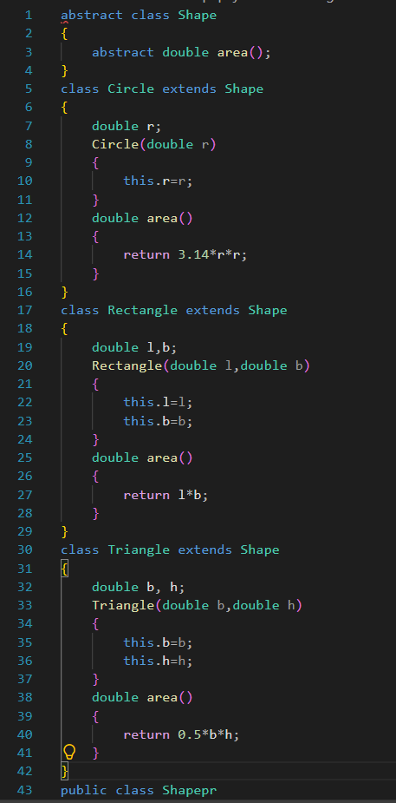
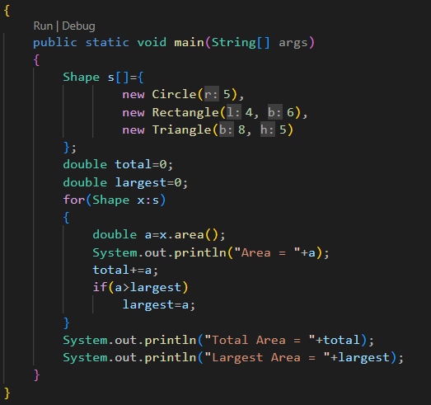
OUTPUT SCREENSHOT :
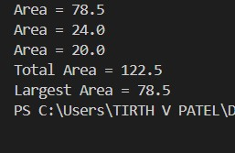
LEARNING OUTCOMES :
- Understand and implement abstract classes and abstract methods.
- Apply inheritance using Circle, Rectangle, and Triangle.
- Demonstrate runtime polymorphism using a Shape[] array.
- Implement method overriding through the area() method.
- Calculate individual areas, total area, and largest area using a single loop.

- PROBLEM – II
  - AIM : Payroll: an abstract Employee with abstract monthlySalary(); FullTime (fixed), PartTime (hours × rate) and Intern (stipend), each calling super for the shared name/id. Loop a mixed array to print each salary and the total; use instanceof to add a note only for interns.
CODE :
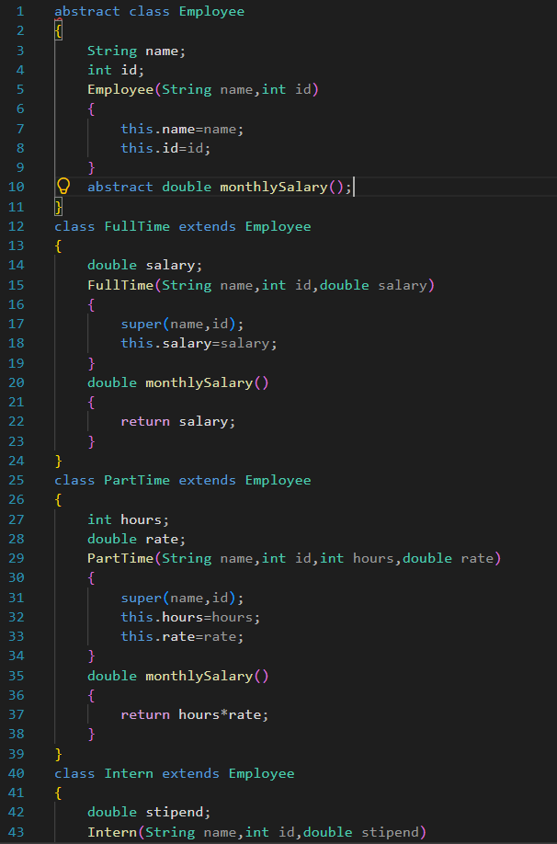
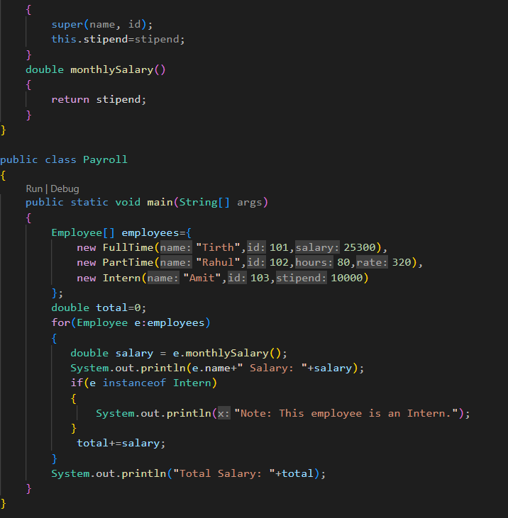
OUTPUT SCREENSHOT :
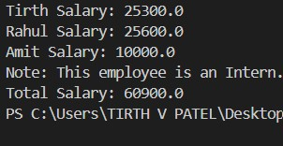
LEARNING OUTCOMES :
- Understand abstract classes and inheritance in a payroll system.
- Implement different salary calculations using method overriding.
- Apply polymorphism to process FullTime, PartTime, and Intern objects.
- Use constructor and super calls for common employee information.
- Calculate and display individual salaries and total payroll efficiently.

- PROBLEM – III
AIM : (For Advanced Learners – home) Model a few media types that each compute a late fee differently and total the fees for a returned batch. Design the hierarchy and rules yourself.
CODE :
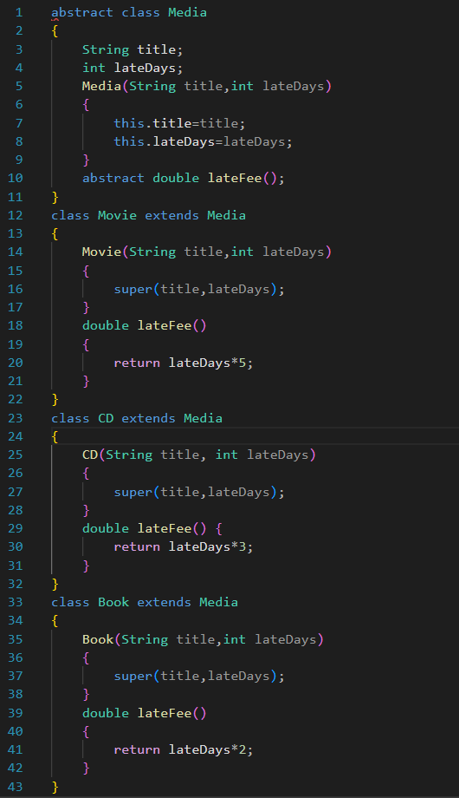
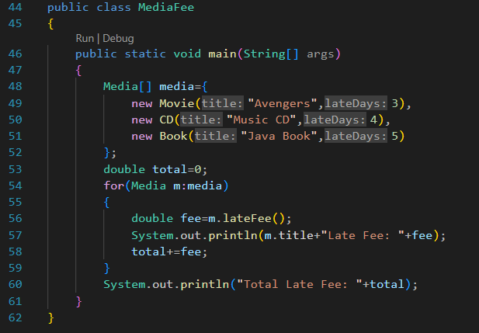
OUTPUT :
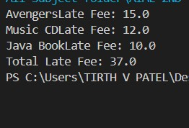
LEARNING OUTCOME :
- Design a class hierarchy for different types of media.
- Apply abstraction, inheritance, and polymorphism to real-world problems.
- Implement different fee calculation rules for different media types.
- Use method overriding to provide type-specific behavior.
- Calculate the total fee for a batch of returned media using object-oriented programming principles.

