**1. What is Security? Explain security goals in detail?**

**Security:**

Security refers to the protection of data, systems, and networks from unauthorized access, modification, or destruction. It ensures the confidentiality, integrity, and availability of information.

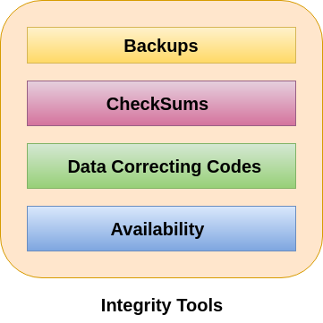 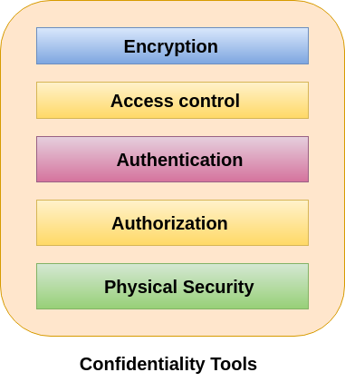

**Security Goals:**

The main goals of security are often referred to as the **CIA Triad**:

1. **Confidentiality**
   * Ensures that data is accessible only to authorized users.
   * Prevents unauthorized access or disclosure of sensitive information.
   * Techniques: Encryption, access controls, authentication mechanisms.
2. **Integrity**
   * Ensures that data is accurate, complete, and not altered by unauthorized entities.
   * Prevents malicious modifications and corruption of data.
   * Techniques: Checksums, hashing, digital signatures.
3. **Availability**
   * Ensures that data and resources are available to authorized users whenever needed.
   * Protects against attacks like Denial-of-Service (DoS).
   * Techniques: Redundant systems, backup strategies, load balancing.

**Additional Security Goals:**

1. **Authentication**
   * Verifies the identity of users before granting access.
   * Techniques: Passwords, biometrics, multi-factor authentication (MFA).
2. **Authorization**
   * Determines user permissions and access rights.
   * Ensures that users only access resources they are allowed to.
3. **Non-Repudiation**
   * Prevents users from denying their actions.
   * Techniques: Digital signatures, transaction logs.

**2. What is an Attack? Explain the Different Attacks in Cryptography.**

**Answer:**

An **attack** in cryptography refers to an attempt to break the security of a cryptographic system by exploiting its weaknesses. The aim is to decrypt ciphertext, bypass encryption, forge signatures, or gain unauthorized access.

**Types of Cryptographic Attacks:**

1. **Brute Force Attack**: Attempts to decrypt by trying all possible keys. Effective against weak encryption systems.
2. **Ciphertext-only Attack**: Attacker has only ciphertext and tries to deduce plaintext or key.
3. **Known-plaintext Attack**: Attacker has both ciphertext and plaintext, using this to deduce the key.
4. **Chosen-plaintext Attack**: Attacker selects plaintexts and studies corresponding ciphertexts to analyze the encryption.
5. **Chosen-ciphertext Attack**: Attacker sends manipulated ciphertexts and studies decrypted plaintexts to extract information.
6. **Man-in-the-Middle Attack**: The attacker intercepts and alters communication between two parties.
7. **Birthday Attack**: Exploits hash collisions to find two different inputs producing the same hash.
8. **Side-channel Attack**: Analyzes physical information (timing, power usage) from the system to extract keys.
9. **Replay Attack**: Captures and replays valid messages or transactions to gain unauthorized access.
10. **Collision Attack**: Finds two different inputs generating the same hash, undermining the reliability of hash functions.

Cryptographic attacks exploit various vulnerabilities, necessitating robust encryption, key management, and secure protocols for data protection.

**Question: Explain the concept of Steganography. (7 Marks)**

**Answer:**

Steganography is the technique of hiding secret information within a carrier file (like image, audio, or video) in such a way that it remains undetectable to anyone except the intended recipient. Unlike encryption, which focuses on making data unreadable, steganography hides the very existence of the message.

**Key Points:**

1. **Types**:
   * **Text**: Conceals data in text through subtle letter or space manipulation.
   * **Image**: Hides data in the least significant bits (LSB) of image pixels.
   * **Audio/Video**: Embeds data by modifying sound or visual elements.
2. **Techniques**:
   * **LSB (Least Significant Bit)**: Common method for hiding data in image or audio.
   * **Masking and Filtering**: Hides data in prominent image or audio parts.
   * **Transform Domain**: Uses frequency domains to hide information (e.g., Discrete Cosine Transform).
3. **Applications**: Used for data protection, digital watermarking, and covert communication.
4. **Security Concerns**: While effective, steganography is vulnerable to detection through steganalysis, which uses statistical methods or machine learning.

**Question 4: Explain security services and mechanisms. (7 marks)**

**Answer:**

**Security Services** ensure the protection of data in computer systems and networks. Key services include:

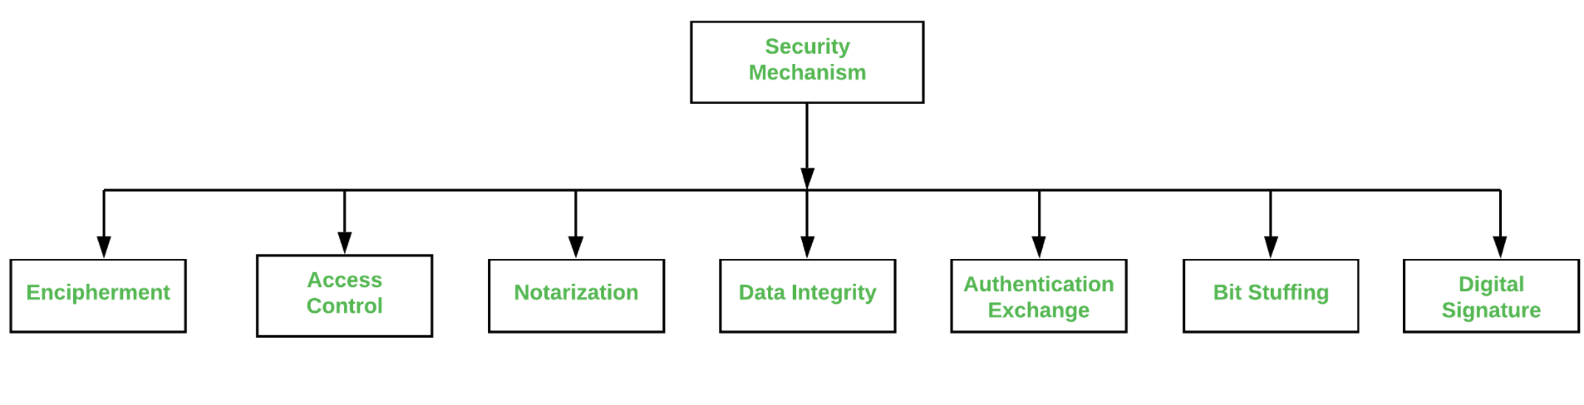

1. **Confidentiality**: Protects data from unauthorized access, achieved through encryption.
2. **Integrity**: Ensures data remains accurate, achieved using hashing.
3. **Authentication**: Verifies the identity of users or systems.
4. **Authorization**: Restricts access to resources, typically using access control methods.
5. **Non-repudiation**: Prevents the sender from denying actions, using digital signatures.
6. **Availability**: Ensures resources are accessible when needed, through redundancy and fault tolerance.

**Security Mechanisms** are the tools that implement these services, such as:

1. **Encryption**: Ensures confidentiality.
2. **Hashing**: Provides data integrity.
3. **Access Control**: Manages authorization with methods like ACLs and RBAC.
4. **Firewalls**: Prevent unauthorized network access.
5. **Digital Signatures**: Ensure non-repudiation.
6. **IDS**: Detects network threats.
7. **VPNs**: Secure communications by encrypting data.

**Conclusion**: Security services protect data, while mechanisms enforce these protections, ensuring systems are secure from threats.

**Question 5:Explain the Extended Euclidean Algorithm with Example (7 Marks)**

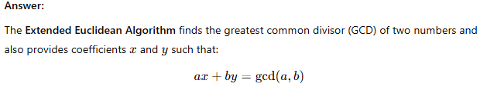

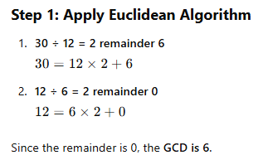

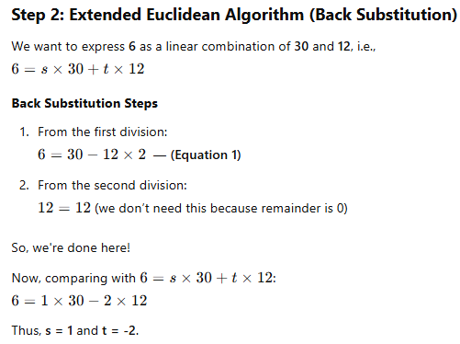

**Question:**

**How to find the multiple inverse using the extended Euclidean algorithm with an example? (7 Marks)**

**Answer:**

To find the modular multiplicative inverse of a number a modulo m, we can use the **Extended Euclidean Algorithm**. The modular inverse of a modulo m is the number x such that:



**Steps to find the Modular Inverse:**

1. **Apply the Euclidean Algorithm** to find the greatest common divisor (GCD) of a and m.
2. **Reverse the Euclidean steps** to express the GCD as a linear combination of a and m.
3. The coefficient of a in this linear combination will give the modular inverse, modulo m.

If gcd(a, m) = 1, then an inverse exists. If gcd(a, m) ≠ 1, the inverse does not exist.

**Example:**

**Find the modular inverse of a = 3 modulo m = 11.**

**Step 1: Use the Euclidean Algorithm to find gcd(3, 11).**

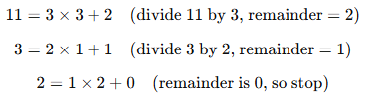

The gcd is 1, which means 3 and 11 are coprime, and an inverse exists.

**Step 2: Reverse the Euclidean steps to express 1 as a linear combination of 3 and 11.**

From the second equation:



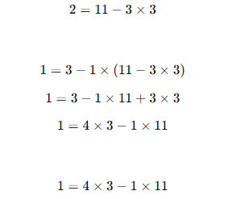

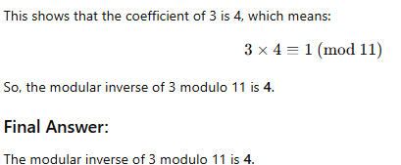

**7. What is Cryptography? Explain Types of Cryptography.**

**Cryptography** is the practice of securing communication and information through the use of codes and ciphers. It ensures that data remains confidential, authentic, and integral while being transmitted or stored. The primary goal is to protect the information from unauthorized access, modification, or tampering.

**Types of Cryptography:**

1. **Symmetric Key Cryptography**:
   * Involves a single key for both encryption and decryption.
   * The same key is shared between the sender and receiver.
   * Example: AES (Advanced Encryption Standard), DES (Data Encryption Standard).
2. **Asymmetric Key Cryptography**:
   * Uses two different keys: a public key for encryption and a private key for decryption.
   * The public key is distributed to everyone, but the private key is kept secret.
   * Example: RSA (Rivest-Shamir-Adleman), ECC (Elliptic Curve Cryptography).
3. **Hash Functions**:
   * A one-way cryptographic function that converts data into a fixed-length hash value (digest).
   * It is used for data integrity and authentication, but cannot be decrypted back into the original data.
   * Example: SHA (Secure Hash Algorithm), MD5 (Message Digest Algorithm 5).
4. **Hybrid Cryptography**:
   * Combines both symmetric and asymmetric encryption methods to leverage the strengths of both.
   * The symmetric key is used for data encryption, while the asymmetric key is used for secure key exchange.
   * Example: TLS (Transport Layer Security).

**8. What is a Modern Block Cipher? List Its Components in Detail.**

**Modern Block Cipher** is a symmetric key encryption algorithm that encrypts data in fixed-size blocks, typically 64 or 128 bits, using the same key for both encryption and decryption. It processes a block of plaintext to produce ciphertext through a series of transformation steps

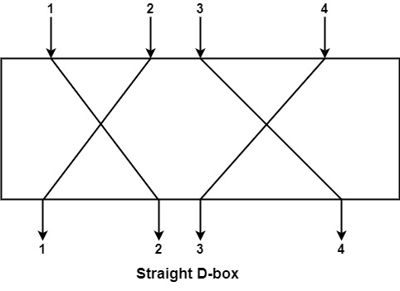.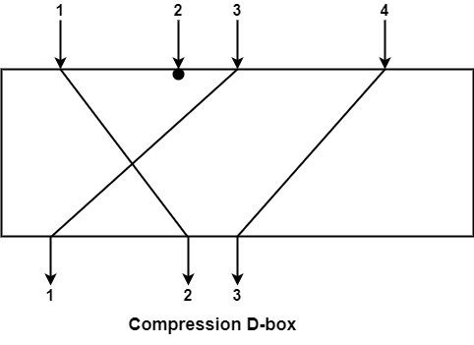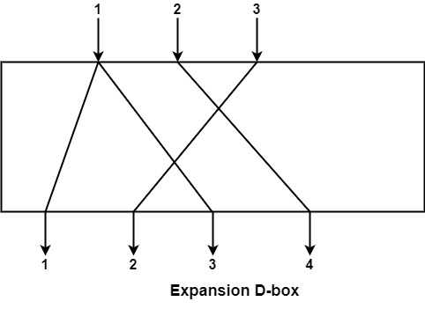

**Components of a Block Cipher:**

1. **Plaintext**:
   * The original message or data that needs to be encrypted.
2. **Key**:
   * A secret value used in the encryption process. In symmetric block ciphers, both the sender and receiver use the same key.
3. **Rounds**:
   * The block cipher applies several rounds of transformation to the plaintext to increase security.
   * Each round involves operations such as substitution and permutation.
   * Example: AES uses 10, 12, or 14 rounds, depending on the key length (128, 192, or 256 bits).
4. **Substitution (S-Box)**:
   * Involves replacing the input bits with output bits using a predefined table (substitution box).
   * It helps in achieving confusion, making it hard to decipher the ciphertext without the key.
5. **Permutation (P-Box)**:
   * Reorders the bits in the data block to achieve diffusion, spreading out the plaintext’s influence across the ciphertext.
6. **Feistel Network**:
   * A type of structure used in some block ciphers (e.g., DES) where the data is split into two halves, and rounds apply operations to each half.
   * This structure makes encryption reversible, allowing decryption using the same steps in reverse.

Examples of Modern Block Ciphers:

* AES (Advanced Encryption Standard)
* DES (Data Encryption Standard)
* Blowfish
* Twofish

Here are the answers to your questions, formatted for easy reading and understanding:

**9. What is Feistel Cipher? Draw the Feistel Cipher structure and explain it.**

**Feistel Cipher:**

The **Feistel cipher** is a symmetric encryption algorithm that applies a series of operations to transform plaintext into ciphertext. It operates on the principle of dividing the data into two halves, applying a round function, and then swapping the halves. The key feature of Feistel ciphers is that the encryption and decryption operations are structurally identical, making it efficient and easy to implement.

**Feistel Cipher Structure:**

A Feistel cipher typically uses multiple rounds of encryption. In each round, the data is split into two halves: the left half (L) and the right half (R). The round function (F) is applied to the right half, and the result is XORed with the left half. Then, the two halves are swapped before moving to the next round.

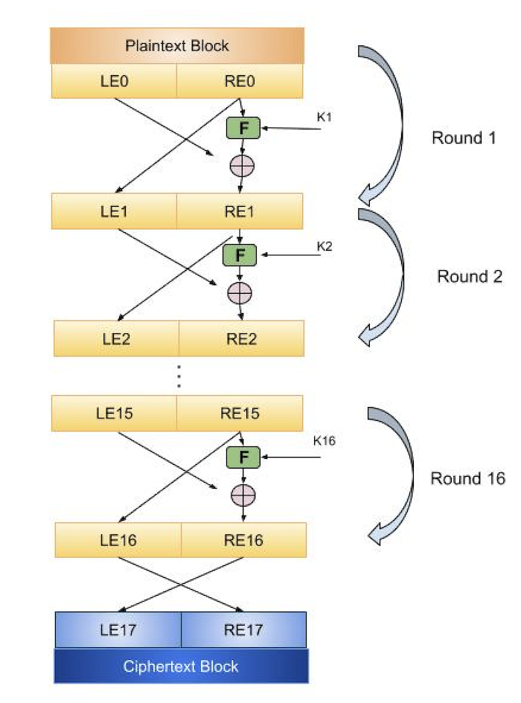

**Working of Feistel Cipher:**

1. **Split**: The plaintext is divided into two halves: Left (L) and Right (R).
2. **Round Function**: In each round, a round function (F) is applied to the right half (R) using a round key (K_i), and the result is XORed with the left half (L).
3. **Swap**: After each round, the left and right halves are swapped.
4. **Repetition**: This process is repeated for several rounds (n rounds) until the final ciphertext is obtained.

**Decryption:**

The decryption process follows the same steps as encryption, with the round keys applied in reverse order. Since the Feistel structure uses identical steps for both encryption and decryption, it simplifies the implementation of both processes.

**10. What is Stream Cipher? Explain Synchronous Stream Ciphers.**

**Stream Cipher:**

A **stream cipher** is a type of symmetric encryption algorithm that encrypts plaintext one bit or byte at a time. Stream ciphers generate a **keystream** that is combined with the plaintext to produce ciphertext. The keystream is typically generated using a key and a random initialization vector (IV).

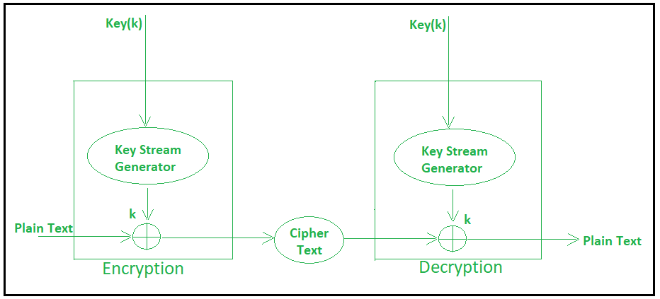

**Synchronous Stream Ciphers:**

In a **synchronous stream cipher**, the keystream is generated independently of the plaintext and is combined with the plaintext at each bit or byte position. The key used to generate the keystream remains constant for each corresponding ciphertext bit or byte.

**How Synchronous Stream Ciphers Work:**

1. A **key** and an **initialization vector (IV)** are used to generate a keystream.
2. The keystream is combined (usually by XORing) with the plaintext to produce ciphertext.
3. Since the keystream is independent of the plaintext, encryption and decryption are fast.

**Example of Synchronous Stream Cipher**: RC4 is one of the most widely used synchronous stream ciphers.

**Advantages of Synchronous Stream Ciphers:**

* **Efficiency**: Synchronous stream ciphers are fast and can be easily implemented.
* **Low Error Propagation**: Any error in the ciphertext affects only the corresponding bit or byte, minimizing the impact.

**Disadvantages of Synchronous Stream Ciphers:**

* **Synchronization**: Both the sender and receiver must remain synchronized, i.e., they must generate the same keystream at the same time. If they fall out of sync, decryption will fail.

**11. What is DES, explain DES Structure in details? And explain DES weaknesses?**

**Answer:**

**DES (Data Encryption Standard):**  
DES is a symmetric-key algorithm for encryption. It was developed by IBM and adopted by the U.S. National Institute of Standards and Technology (NIST) in 1977. DES uses a 56-bit key to encrypt 64-bit blocks of data.

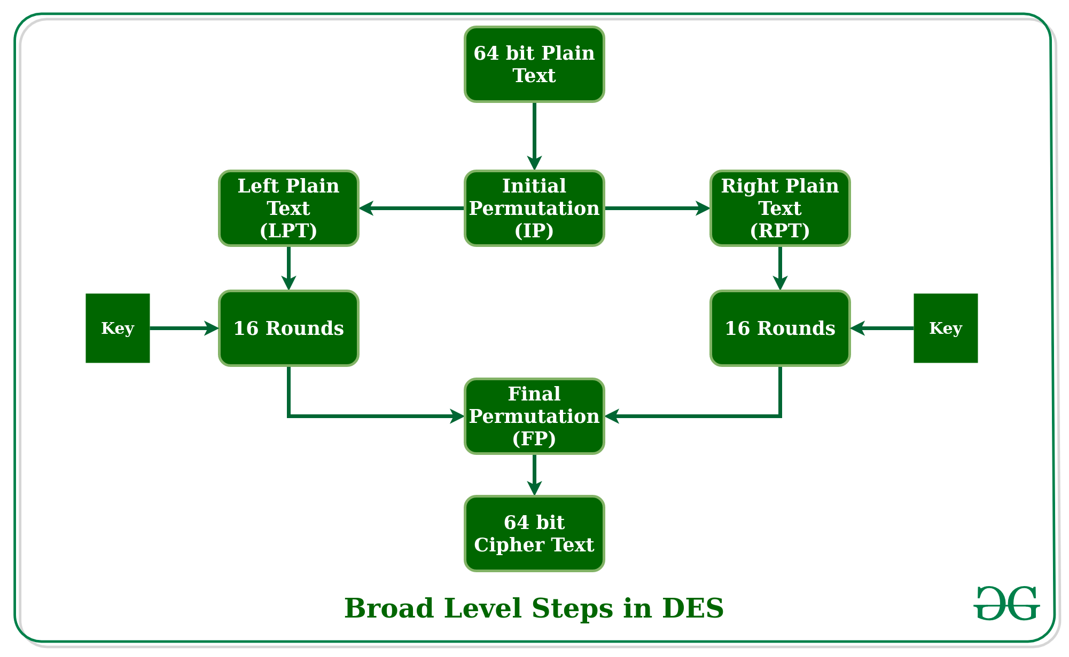

**DES Structure:**

* **Initial Permutation (IP):** The input block of 64 bits is rearranged according to a fixed permutation, producing two 32-bit halves (L0 and R0).
* **Rounds (16 Rounds):** The encryption process involves 16 rounds of complex transformations. In each round:
  + **Expansion:** The 32-bit right half (R) is expanded to 48 bits.
  + **Key Mixing:** The expanded R is XORed with a round key (48-bit).
  + **Substitution:** The XORed value is passed through 8 S-boxes, each producing a 4-bit output.
  + **Permutation (P4):** The output of the S-boxes is permuted.
  + **Final XOR with Left Half (L):** The result is XORed with the left half (L).
* **Swap:** The left and right halves are swapped after each round except the last one.
* **Final Permutation (FP):** The 64-bit output after the 16th round is passed through a final permutation, reversing the initial permutation.

**DES Weaknesses:**

* **Key Length:** The 56-bit key length is too short by modern standards, making it susceptible to brute force attacks.
* **Vulnerability to Differential and Linear Cryptanalysis:** DES is vulnerable to these advanced cryptanalytic attacks, allowing attackers to break the cipher more efficiently.
* **Slow Speed:** DES encryption is relatively slow compared to modern encryption algorithms.
* **Security Margins:** With the increasing computational power, DES's security margins have weakened, leading to the development of more secure algorithms like AES.

**12. What is AES, explain transformations in AES?**

**Answer:**

**AES (Advanced Encryption Standard):**  
AES is a symmetric encryption algorithm established as the standard by NIST in 2001. AES can use keys of 128, 192, or 256 bits and operates on 128-bit blocks of data.

**AES Transformations:** AES involves several rounds of transformations depending on the key size:

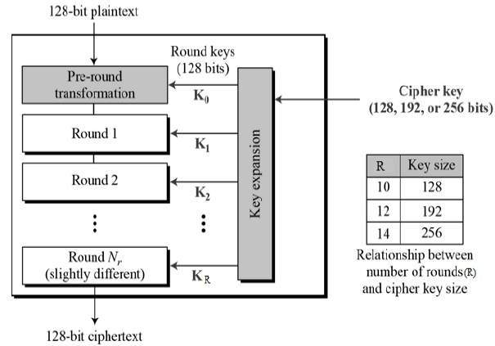

* **SubBytes:** A non-linear substitution step where each byte in the block is replaced with a corresponding byte from the S-box.
* **ShiftRows:** A transposition step where each row of the state is shifted by an offset. The first row is unchanged, the second row is shifted by one byte, the third row by two bytes, and the fourth row by three bytes.
* **MixColumns:** A mixing operation that combines the bytes in each column of the state. It provides diffusion by mixing the input data across the entire block.
* **AddRoundKey:** Each byte of the state is XORed with a round key derived from the original encryption key.

**AES Rounds:**

* **10 rounds for 128-bit key**
* **12 rounds for 192-bit key**
* **14 rounds for 256-bit key**

Here is a concise, easy-to-understand answer for the given questions:

**13. Explain Meet-in-the-Middle Attack, Brute Force Attack, and DOS Attack**

**Meet-in-the-Middle Attack:**

* It is a cryptographic attack used mainly against block ciphers.
* The attacker tries to break a cipher by exploiting the fact that some ciphers use multiple encryption rounds.
* The idea is to attack both the encryption and decryption process by searching for possible keys from both sides simultaneously.
* It works in cases like 2-round DES (Data Encryption Standard) where the cipher undergoes encryption and decryption at the same time to find a match.
* **Efficiently reduces the complexity** of a brute-force attack by searching through half of the possible keys.
* 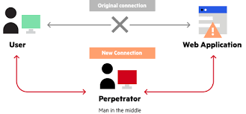

**Brute Force Attack:**

* A brute force attack is the most straightforward and exhaustive cryptographic attack.
* The attacker tries every possible key to decrypt the encrypted message.
* It works for any encryption, but the time taken is **proportional to the size of the key**.
* The method becomes infeasible for strong encryption methods with long keys due to the massive number of possibilities.
* 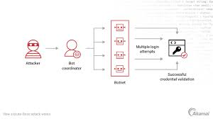

**Denial of Service (DOS) Attack:**

* A DOS attack is a cyberattack where the attacker floods the target system or network with traffic or requests.
* **Goal**: Overwhelm the system and prevent legitimate users from accessing the services.
* It can be done by exploiting vulnerabilities in the system to cause it to crash, hang, or become unavailable.
* **DDoS (Distributed DOS)** is a more advanced version, where the attack is launched from multiple sources to evade detection.
* 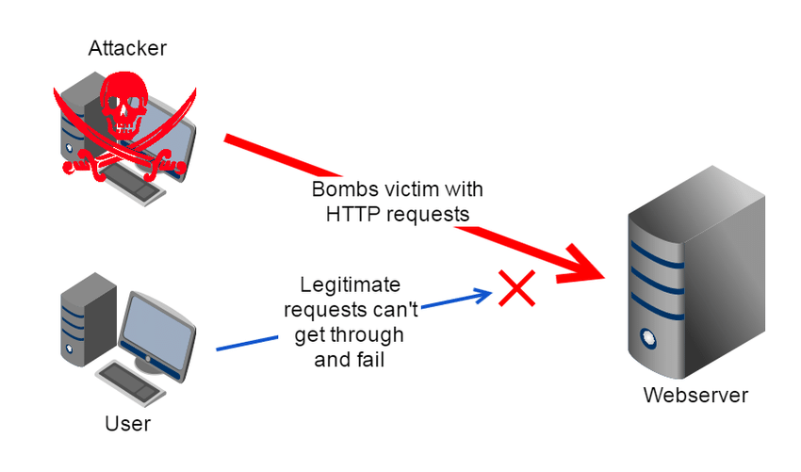

**14. Explain Multiple DES and its Weaknesses**

**Multiple DES (Triple DES or 3DES):**

* Triple DES is an extension of the original DES algorithm and uses **three rounds of encryption** with **three different keys** (K1, K2, K3).
* It is designed to increase the security of DES by applying it three times:
  1. Encrypt with K1.
  2. Decrypt with K2.
  3. Encrypt with K3.
* Triple DES is more secure than regular DES but is still susceptible to certain attacks.
* 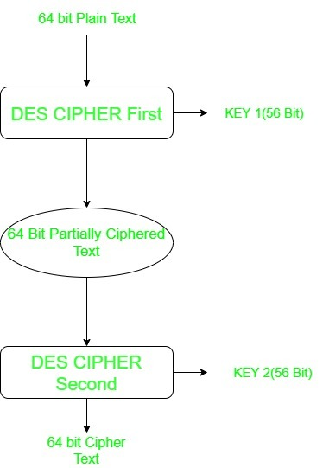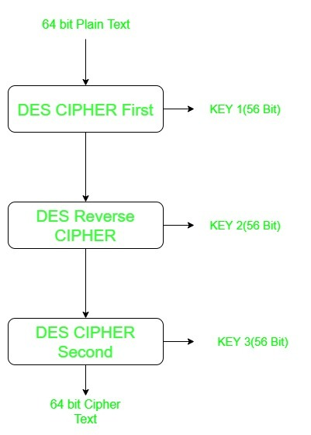

**Weaknesses of Multiple DES:**

* **Brute-force vulnerability**: Although stronger than DES, Triple DES can still be broken by a brute force attack due to its relatively small key space (even with 3 keys, it is **only 112 bits** of security).
* **Slow performance**: Triple DES is slower than other modern encryption methods like AES (Advanced Encryption Standard) because of the multiple rounds of encryption.
* **Meet-in-the-middle attack**: This attack can be effective against 2-key 3DES where one key is reused for encryption and decryption, reducing the complexity significantly.

**15. What is a Product Cipher? Draw the Two Round Product Cipher?**

**Answer:**

* **Product Cipher:**  
  A product cipher is a cryptographic technique that combines multiple simple ciphers (such as substitution and transposition ciphers) to create a more secure encryption scheme. It applies two or more ciphers to the plaintext in succession.
* **Two-Round Product Cipher:** In the two-round product cipher, we apply two different encryption operations (such as a substitution and transposition) in two rounds. The first round uses one cipher, and the second round applies another cipher to the intermediate ciphertext. Here’s how it works:
  1. **First Round: Substitution Cipher** (e.g., Shift Cipher or Affine Cipher).
  2. **Second Round: Transposition Cipher** (e.g., Columnar Transposition or Rail Fence Cipher).

**Diagram for Two-Round Product Cipher:**

Plaintext → Substitution (First Round) → Transposition (Second Round) → Ciphertext

**16. What is AES? Explain Structure of AES?**

**Answer:**

* **AES (Advanced Encryption Standard):** AES is a symmetric-key encryption algorithm used worldwide to secure data. It operates on fixed-size blocks of data (128 bits) and supports key sizes of 128, 192, and 256 bits. It is widely used in securing sensitive information.
* **Structure of AES:** AES is based on the **Rijndael** algorithm and consists of the following steps:
  1. **Key Expansion:**
     + The 128-bit key is expanded into an array of key schedule words.
  2. **Initial Round:**
     + **AddRoundKey:** The plaintext is XORed with the key (first round key).
  3. **Main Rounds (9 Rounds for 128-bit key, 11 for 192-bit key, 13 for 256-bit key):**
     + **SubBytes:** Non-linear substitution step where each byte is replaced with a corresponding byte from a lookup table.
     + **ShiftRows:** Rows of the state are shifted cyclically.
     + **MixColumns:** Each column of the state is mixed to provide diffusion.
     + **AddRoundKey:** The round key is added (XORed) to the state.
  4. **Final Round (without MixColumns):**
     + **SubBytes**
     + **ShiftRows**
     + **AddRoundKey**

**Diagram of AES Structure:**

