Step1: Register the user details and getting the encrypted password as response
http://localhost:8080/register

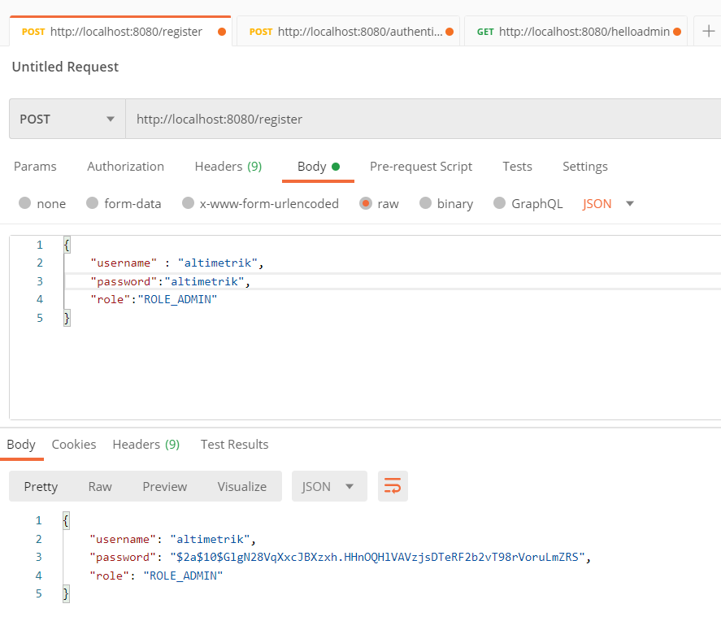

Step2: authenticate the user as request and generating the token
http://localhost:8080/authenticate
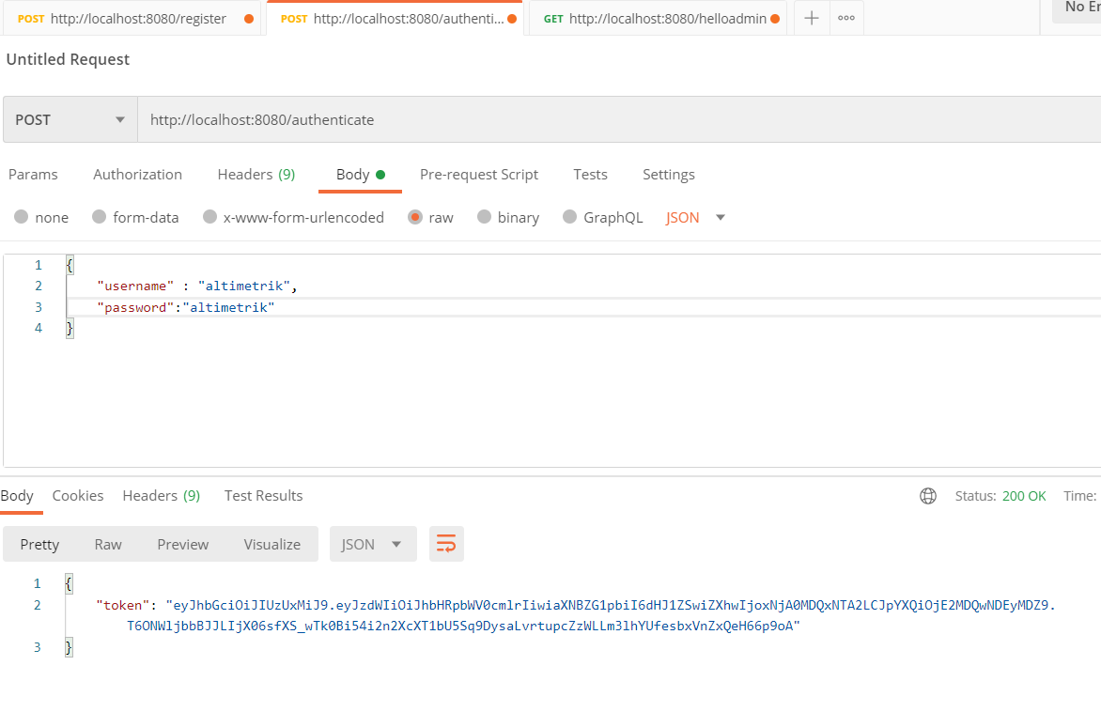

Step3: passing the token and calling the sample rest api
http://localhost:8080/helloadmin

