Rice Type Identification AI Model - Final Report

# 1. INTRODUCTION

## 1.1 Project Overview

The Rice Type Identification AI model assists in classifying different types of rice grains using image recognition, allowing users to make informed agricultural decisions.

## 1.2 Purpose

To provide a quick, accurate, and accessible way for farmers, scientists, and enthusiasts to identify rice grain types using AI and deep learning techniques.

# 2. IDEATION PHASE

## 2.1 Problem Statement

Identifying rice varieties manually is time-consuming and prone to errors, affecting crop management and research accuracy.

## 2.2 Empathy Map Canvas

Includes identifying user needs—farmers, researchers, home growers.

## 2.3 Brainstorming

Explored AI-based image classification, selected CNN with MobileNetv4 for lightweight, high-accuracy modeling.

# 3. REQUIREMENT ANALYSIS

## 3.1 Customer Journey Map

User uploads rice grain image → System processes image → Prediction of rice type → User receives guidance.

## 3.2 Solution Requirement

- Image input interface  
- AI model backend (CNN + MobileNetv4)  
- Output display with rice type

## 3.3 Data Flow Diagram

Below is the data flow diagram of the rice type identification system:

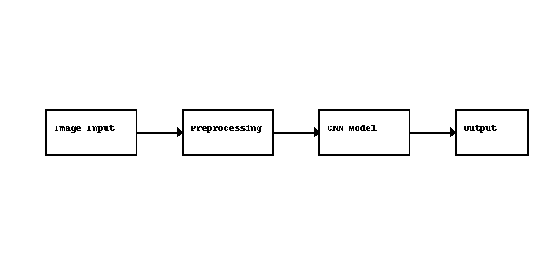

## 3.4 Technology Stack

- Python, TensorFlow/Keras  
- MobileNetv4  
- Flask (for web interface, if applicable)

# 4. PROJECT DESIGN

## 4.1 Problem Solution Fit

Ensures precise, accessible rice identification without needing expert knowledge.

## 4.2 Proposed Solution

AI-driven image classification model for rice identification.

## 4.3 Solution Architecture

- Frontend: Image upload UI  
- Backend: CNN model hosted on server  
- Output: Rice type label

# 5. PROJECT PLANNING & SCHEDULING

## 5.1 Project Planning

List development stages: data collection, model training, UI design, testing

# 6. FUNCTIONAL AND PERFORMANCE TESTING

## 6.1 Performance Testing

Model accuracy, confusion matrix, latency for predictions.

# 7. RESULTS

## 7.1 Output Screenshots

Add screenshots of image input and prediction results.

# 8. ADVANTAGES & DISADVANTAGES

Advantages:  
- Fast and accurate rice identification  
- Useful for farmers, researchers, and hobbyists  
- Easy-to-use interface

Disadvantages:  
- Dependent on image quality  
- May misclassify visually similar grains

# 9. CONCLUSION

The Rice Type Identification AI model effectively classifies rice varieties, aiding in agricultural planning and education through a simple, intelligent tool.

# 10. FUTURE SCOPE

- Expand to more rice varieties  
- Integrate with mobile apps  
- Improve accuracy with larger datasets

# 11. APPENDIX

Source Code: (Add GitHub link)  
Dataset Link: (e.g., Kaggle or collected dataset)  
GitHub & Project Demo Link: (Add links here)