AI RESEARCH PAPER ASSISTANT
ResearchForge

Course | BIT4543 Artificial Intelligence
Project area | AI Topic: Document Intelligence
Group members | [GROUP MEMBER 1 - FULL NAME & STUDENT ID]  [GROUP MEMBER 2 - FULL NAME & STUDENT ID]  [GROUP MEMBER 3 - FULL NAME & STUDENT ID]
Lecturer | Encik Azuan Nazeer
Submission date | [SUBMISSION DATE]
Live system | https://researchforge.rukon.dev
Repository | https://github.com/tirukon015/researchforge

Declaration
We declare that this report is our own work and that all sources of information have been acknowledged. The system was designed, implemented, deployed and tested by the project group. All results in Chapter 5 were produced by running the deployed system against real research papers; no result, test count or evaluation figure has been estimated or invented. Where a planned capability was not built, or an evaluation could not be completed, this is stated explicitly.
Where a planned capability was not built, or where an evaluation could not be completed, this is stated explicitly rather than omitted.

Acknowledgement
We thank our lecturer, Encik Azuan Nazeer, for guidance throughout the BIT4543 Artificial Intelligence group project. We also acknowledge the authors of the five open-access arXiv papers used as evaluation input, and the maintainers of the open-source libraries on which the system is built.

Abstract
Researchers spend a substantial part of their time reading academic papers in order to decide which papers are worth reading closely. This project developed ResearchForge, a deployed web application that assists this first pass by accepting an uploaded research paper in PDF form and generating a structured summary with key findings, an analysis of research gaps, and literature review content, all saved into a private per-user research library.
The system performs inference against hosted large language models rather than training a model of its own. Two providers operate behind a single interface: Groq running qwen/qwen3.6-27b as the configured primary, and Anthropic claude-opus-5 as the automatic fallback. Model output is constrained to a declared schema and validated before storage, and output that fails validation is discarded rather than repaired. The production pipeline supplies the whole extracted document as context; the retrieval infrastructure in the repository is prepared scaffolding and is not called during analysis.
Testing combined 522 automated backend tests and 16 frontend tests, all passing, with live verification against the deployed system. Per-user isolation enforced by PostgreSQL Row Level Security passed 26 live checks with no failures, including a direct database query that bypassed the application and returned zero rows. A content-addressed cache reduced a repeated analysis of the same paper from 32.4 seconds and three model calls to 3.2 seconds and none. Evaluation also produced a significant negative finding: at its free service tier the configured primary provider could not process any paper in the evaluation corpus, and every analysis was completed by the fallback provider.

TABLE OF CONTENTS
Right-click and choose Update Field to build the contents.

LIST OF FIGURES
Figure 2.1: Conceptual framework of the ResearchForge analysis pipeline 1
Figure 4.4: ResearchForge public landing page 1
Figure 4.5: Empty dashboard for a newly created user account 1
Figure 4.6: Generated research paper summary and key findings 1
Figure 4.7: Generated research gaps and limitations 1
Figure 4.8: Cross-paper literature review interface 1
Figure 4.9: User research paper library 1
Figure 4.10: Owner AI configuration and provider availability controls 1
Figure 4.11: ResearchForge responsive dashboard on a mobile viewport 1
Figure 4.1: ResearchForge system architecture 1
Figure 4.2: Use case diagram 1
Figure 4.3: Activity flow for analysing an uploaded paper 1
Figure 4.12: Entity relationship diagram 1
Figure D.1: ResearchForge account creation screen 1
Figure D.2: Research paper upload and analysis progress 1
Figure D.4: Account settings for an authenticated user 1

LIST OF TABLES
Table 2.1: Comparison of related systems and approaches 1
Table 3.1: Evaluation corpus of open-access research papers 1
Table 3.2: Development tools and technologies 1
Table 4.1: Functional requirements and implementation status 1
Table 4.2: Non-functional requirements and supporting evidence 1
Table 5.1: Automated backend test distribution by module 1
Table 5.2: Measured acceptance of a revoked session token after sign-out 1
Table 5.3: Live data isolation test cases and results 1
Table 5.4: Live provider configurations and completion results 1
Table 5.5: Controlled production cache test results 1
Table 5.6: Observed processing performance 1
Table 5.7: Text extraction results for the evaluation corpus 1
Table 5.8: Input token requirement of each corpus paper against the free-tier limit 1
Table 5.9: Output produced across ten completed analyses 1
Table 6.1: Achievement of project objectives with supporting evidence 1
Table A.1: Project milestones and completion status 1
Table C.1: Evaluation corpus with source and licence information 1
Table D.1: Common problems and their resolution 1

CHAPTER 1: INTRODUCTION

1.1 Background
Academic research depends on reading. Before contributing to a field, a researcher must establish what the field already claims, which questions remain open, and how studies relate to one another. A search on a narrow topic returns dozens of candidates, and each must be assessed for what it claims, what evidence supports it, and whether it justifies reading in full.
Recent progress in large language models has made document-level understanding practical for small teams, since hosted models are reached through an interface and need no training or labelled corpus. This shifts the engineering problem from model training to system design: how the document is supplied, how output is constrained and validated, how provider failures are handled, and how user data is kept private.
ResearchForge was built to address that problem for the specific task of research paper analysis. It is a deployed, publicly reachable web application in which a researcher uploads a paper and receives structured analysis saved into a private library.

1.2 Problem Statement
The obvious approach is to paste a question into a general-purpose chatbot. This fails in a way that is damaging for research: such a system will answer confidently about a paper it has not read, drawing on prior knowledge of similar work, and may produce a plausible summary or a citation that does not correspond to the document.
For a researcher an unreliable summary is worse than none. A fabricated claim costs more time to detect than the summary saved, and if undetected it propagates into the researcher own writing. Any system assisting genuine research must therefore treat groundedness as a design requirement rather than as a hoped-for property of the model.

1.3 Objectives
The project set the following objectives.
- To allow authenticated users to upload research papers in PDF form.
- To extract text reliably from uploaded PDF documents, and to reject documents from which no text can be extracted.
- To generate structured summaries and key findings grounded in the uploaded document.
- To identify research gaps supported by the document.
- To generate literature review content from an analysed paper.
- To support cross-paper literature review across several analysed papers.
- To provide a usable research assistant interface.
- To provide secure user accounts with per-user ownership of the research library, enforced at the database level.
- To reduce duplicate AI processing through same-paper analysis caching.
- To provide owner-controlled AI provider configuration.

1.4 Scope
Included. The system covers account creation and sign-in by email or Google, PDF upload and text extraction, generation of summary, key findings, research gaps and literature review content, cross-paper review, a private per-user library, account settings, owner-controlled provider selection and availability, and a same-paper analysis cache. It is deployed and publicly accessible.
Excluded. The system does not train or fine-tune any model; it performs inference against hosted foundation models. It has no optical character recognition, so scanned papers cannot be analysed. It does not implement an active vector retrieval pipeline: the embedding provider, chunks table and pgvector column in the repository are prepared infrastructure the production path does not call. It provides no grounded question-and-answer chat, document export or citation extraction, and the evaluation includes no labelled benchmark or expert grading, for the reasons in Section 5.14.

1.5 Significance of the Project
For the user, the system reduces the effort of the first reading pass while keeping output checkable: every section is constrained to the uploaded document, and where the document does not support a section the system reports insufficient evidence rather than generating text to fill the gap.

CHAPTER 2: LITERATURE REVIEW

2.1 Introduction
This chapter reviews the AI technologies relevant to document intelligence, examines existing systems addressing parts of the same problem, identifies the gap this project addresses, and presents the conceptual framework.

2.2 Artificial Intelligence Technologies Relevant to the Project
Artificial intelligence builds systems that perform tasks normally requiring human intelligence. This project sits within applied AI: it composes an application from existing components rather than advancing model capability.
Natural language processing concerns human language. Devlin et al. (2018) showed with BERT that bidirectional pre-training followed by fine-tuning produces strong results across language tasks. Beltagy et al. (2019) showed with SciBERT that pre-training on scientific text improves performance on scientific tasks, which is evidence that academic writing has distinctive characteristics.
Large language models and inference. Contemporary models are accessed as hosted services: an application supplies a prompt and receives generated text, with model parameters fixed. This is inference, not training, and the distinction matters for how this project is described and assessed.
Grounding and retrieval. A model asked about a document it has not been given will answer from prior knowledge. Retrieval-augmented generation (Lewis et al., 2020) retrieves relevant passages and supplies them as context. Alternatively, a document small enough to fit the context window can be supplied whole. ResearchForge uses the second approach, for reasons in Section 3.8.
Evaluating generated text. Wang et al. (2020) proposed generating questions from a summary and answering them against the source as an automatic, reference-free measure of factual consistency. This is directly relevant to ungrounded summaries, though it requires a question-answering pipeline this project did not build.

2.3 Related Works
General-purpose conversational assistants can summarise a pasted document. They are flexible and need no setup, but offer no guarantee the answer derives from the supplied text, no persistent library, and no structured output an application can validate.
Reference managers such as Zotero and Mendeley organise papers and generate citations. They solve storage and bibliography, which this project does not attempt, but do not analyse paper content.
Academic search services such as Semantic Scholar provide search, citation graphs and short generated summaries over an indexed corpus rather than over a document the user supplies, and do not produce a gap analysis for a specific paper.
Retrieval-augmented question answering systems follow Lewis et al. (2020): a corpus is chunked, embedded and indexed, and relevant passages are retrieved to answer a query. This scales beyond a context window but introduces failure modes, since a retrieval step returning the wrong passage silently degrades the answer.
Research on factual consistency, including Wang et al. (2020), addresses measurement rather than system construction: it scores whether a summary is consistent with its source but does not prevent unsupported generation.
Table 2.1: Comparison of related systems and approaches
Study or system | Method used | Strengths | Limitations
Conversational assistants | Prompt a hosted model directly | Flexible; no setup | No guarantee output derives from the document; no library
Zotero, Mendeley | Reference storage and citation | Reliable organisation | No content analysis or summarisation
Semantic Scholar | Indexed corpus, citation graph | Large coverage; discovery | Not user-supplied documents; no per-paper gap analysis
Lewis et al. (2020) | Retrieve passages, then generate | Scales beyond a context window | Retrieval errors silently degrade output
Wang et al. (2020) | Question generation and answering | Reference-free consistency signal | Measures consistency; does not prevent it
ResearchForge | Whole-document grounded generation, schema-constrained | Validated output; database-level isolation; fallback; caching | Bounded by context window; no retrieval; no labelled benchmark

2.4 Comparison of Related Systems
Two design consequences follow. If output is to be trustworthy the constraint must be enforced by the system rather than requested of the model, which led to schema-constrained generation with discard-on-mismatch. Retrieval, meanwhile, is a means to an end: where a document fits in the context window, supplying it whole avoids retrieval error entirely.

2.5 Research Gap
The reviewed work leaves a gap: systems that analyse a user-supplied paper generally do not enforce that their output derives from it; systems that enforce grounding through retrieval add a layer whose failures are hard to observe; and systems that organise literature do not analyse it. Multi-user research tools also rarely make explicit how one user documents are kept from another.
ResearchForge addresses this by combining whole-document grounded generation with structural enforcement of output validity, database-level isolation, and recorded provenance. It does not close the gap entirely: without a labelled benchmark it cannot show that the gaps it identifies are those a domain expert would identify, as stated in Section 5.14.

2.6 Conceptual Framework
The conceptual framework in Figure 2.1 shows how an input paper becomes research insight. An uploaded PDF is extracted, normalised and hashed, and the hash is used to look up a previous analysis. On a miss the document is submitted in three grounded passes, with one fallback attempt for retryable failures, and validated before storage; on a hit the stored analysis is reused with no model call. The framework contains no vector retrieval stage, because the production pipeline performs none.
The framework deliberately does not include a vector retrieval stage, because the production pipeline does not perform retrieval.
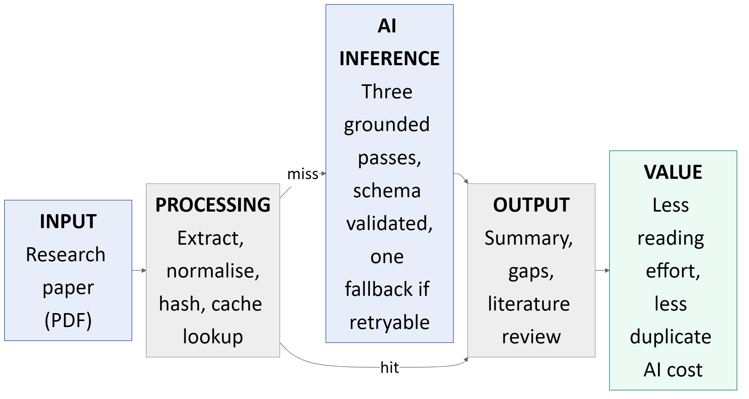
Figure 2.1: Conceptual framework of the ResearchForge analysis pipeline

2.7 Chapter Summary
The conclusions carried into the methodology are that grounding must be enforced structurally rather than requested, that retrieval is unnecessary when a document fits in context, and that per-user isolation must be enforced below the application layer.

CHAPTER 3: METHODOLOGY

3.1 Introduction
This chapter describes the development methodology and process, how input documents were collected and prepared, how text is extracted and preprocessed, how the AI component was designed, the provider architecture, the structured generation approach, the cache, the database design and the tools used.

3.2 Development Methodology
The project used an incremental, milestone-based methodology: work was divided into small milestones, each ending with a test and a review before the next began. This suited a project in which several design questions could only be answered by measurement. The decision not to build vector retrieval was made only after measuring that real papers fit within the context window, and the decision to move isolation into the database followed a defect showing that application-level filtering had failed silently.

3.3 System Development Process
Each milestone followed the same process: inspect existing code, make a small additive change, run the automated suite, verify behaviour against the deployed system where relevant, and record the outcome. Database changes were made through numbered migration files containing only CREATE and additive ALTER statements; no migration contains DROP, TRUNCATE or DELETE, so applying one cannot destroy existing data. Six migrations were applied in sequence: initial schema; analyses and reviews; authentication and ownership; owner and AI configuration; the analysis cache; and provider availability.

3.4 Data Collection
Operational data is whatever papers users choose to upload. There is no fixed operational dataset; the system processes documents supplied at runtime.
Evaluation data is a fixed corpus assembled specifically to measure the system. It consists of five open-access research papers from arXiv.

3.5 Dataset and Research Paper Preparation
Five real, openly available arXiv papers were selected as the evaluation corpus. Metadata was retrieved from the arXiv application programming interface rather than transcribed by hand, and is recorded in the dataset manifest alongside the source URLs and licence information. The PDFs are stored unmodified in the project repository.
Table 3.1: Evaluation corpus of open-access research papers
arXiv ID | Title | Year | Authors | Pages
1706.03762 | Attention Is All You Need | 2017 | 8 | 15
1810.04805 | BERT: Pre-training of Deep Bidirectional Transformers for Language Understanding | 2018 | 4 | 16
1903.10676 | SciBERT: A Pretrained Language Model for Scientific Text | 2019 | 3 | 6
2004.04228 | Asking and Answering Questions to Evaluate the Factual Consistency of Summaries | 2020 | 3 | 13
2005.11401 | Retrieval-Augmented Generation for Knowledge-Intensive NLP Tasks | 2020 | 12 | 19

Papers were chosen to vary in length, publication year and author count. The selection is acknowledged as narrow: all five are English-language computational linguistics papers from one arXiv category, all born-digital with a text layer. Nothing here establishes behaviour on scanned documents, other disciplines or other languages. The project has no labelled machine-learning training dataset, because no model is trained.

3.6 PDF Text Extraction
Text extraction uses the pypdf library, chosen because it is pure Python and introduces no system-level dependency, which suits deployment to a serverless platform.
Extraction is deliberately strict: a PDF yielding no usable text is rejected with HTTP 422 and no model is called. A language model given empty input still produces fluent, confident output, which would be entirely ungrounded, so rejecting the document is correct even though scanned papers cannot be processed.

3.7 Text Preprocessing
Extracted text is normalised before use: Unicode is normalised using NFKC and runs of whitespace collapsed. Two PDF renderings of the same paper can differ invisibly in ligatures, non-breaking spaces or line endings, and without normalisation the same paper would hash differently and be analysed twice. The normalised text is then hashed with SHA-256 together with an analysis version constant, giving the document identity used for caching in Section 3.11.
The normalised text is then hashed with SHA-256 together with an analysis version constant. The resulting hash is the document identity used for caching, described in Section 3.11.

3.8 AI Model Development
The AI component performs inference against hosted foundation models. No model is trained, fine-tuned or otherwise fitted by this project, and no proprietary labelled dataset exists.
Model and provider selection. Two providers sit behind one interface. Groq, running qwen/qwen3.6-27b, is the configured primary and was selected for speed and for independence from a single supplier. Anthropic claude-opus-5 is the automatic fallback, selected because its interface parses directly into a declared schema, strengthening the validation guarantee in Section 3.10.
How the document becomes model input. The whole normalised paper is placed in the prompt as context: full-document grounded generation. The repository contains an embedding provider, a chunks table and a pgvector column, but the production path does not call them; they are prepared scaffolding. The system must therefore not be described as implementing retrieval-augmented generation.
The decision was empirical: every corpus paper fitted a single context window with no truncation or chunking (Section 5.13). Retrieval would have added a failure mode, in which an incorrect retrieval silently degrades the answer, without solving a problem the system had. A map-reduce digest exists as a size guard above 400,000 characters and was never invoked.
Inference process. Analysis makes three separate structured calls: summary and key findings, research gaps, and literature review content. They are separate because a single combined prompt produced a noticeably weaker gap analysis, with attention dominated by the summary.

3.9 AI Provider Architecture
The owner selects one provider as the global primary. The other enabled provider automatically acts as the fallback; there is no separate automatic setting, and normal users cannot select or switch providers.
Two rules govern routing. One switch per analysis: an analysis makes at least three calls, and a per-call switch would let different parts be written by different models, making the recorded model identity meaningless. Fallback only for retryable failures: the check is a whitelist, so a new error type does not become retryable by default. A rate limit is worth a second attempt; a malformed PDF, a validation failure or a missing key is not.
Only one fallback attempt is made. The system does not retry indefinitely, and not all errors trigger fallback.
Provider availability is enforced when the router is constructed rather than checked at call time, so a provider the owner has switched off is never constructed and no code path can call it. Routing applies globally; existing analyses are not reprocessed when configuration changes.
An earlier version of the project used Google Gemini. Gemini is a historical provider only: it is not part of the current architecture, and current analyses are not produced by it.

3.10 Prompt and Structured Generation Approach
Grounding is enforced through four layers rather than requested in the prompt alone.
The prompt requires every claim to be traceable to the supplied text and requires the model to report insufficient evidence rather than fill a gap. The prompts are stored in version-controlled files rather than scattered through the code.
The schema constrains the output. Each of the three passes declares a Pydantic model describing the expected structure, including explicit insufficient-evidence fields that give the model a way to decline that is as easy as complying.
Validation checks the returned data against that schema. The Anthropic provider parses directly into the declared model; the Groq provider requests JSON and validates it against the same model.
Discard on mismatch is the rule that makes the previous layers meaningful. Output that fails validation is rejected, not repaired. A partially valid analysis that the system patched up would be an invented analysis, which is precisely what the grounding claim forbids.

3.11 Same-Paper Analysis Cache
Analysing the same paper twice costs two sets of tokens and produces two answers to one question. The cache prevents this.
The cache is keyed by the content hash together with the analysis version. Because the key derives from normalised content, a paper is recognised regardless of filename, and the version component allows deliberate invalidation when the analysis method changes.
The cache is global internal infrastructure, not a user library. If one user uploads a paper another has already analysed, the stored analysis is reused instead of making duplicate model calls, while each user still receives their own private paper, analysis and library records. The cache does not reveal who first uploaded a document, and it does not replace Row Level Security: the cache table has Row Level Security enabled with no policy at all, so it is unreachable by user requests and accessible only to the backend.
Only successful, schema-validated analyses are cached; failed, rate-limited, malformed or incomplete results are never written. A uniqueness constraint on the key prevents duplicate rows and makes concurrent writes safe. Because the key excludes the provider, changing provider configuration does not invalidate a valid cached analysis.

3.12 Database Design and Data Management
The database is Supabase PostgreSQL. PostgreSQL was selected specifically for Row Level Security, which is the mechanism behind the per-user ownership objective.
Ownership columns default to the authenticated identity supplied by the database, so a row cannot be inserted without an owner even if application code omits it. Records created before authentication remain unowned: they were neither deleted nor assigned to a user whose ownership could not be established, and are unreachable because a null owner never matches an authenticated identity.

3.13 Development Tools and Technologies
Table 3.2: Development tools and technologies
Layer | Technology | Reason
Frontend | Next.js 16, React 19, TypeScript | Server-rendered pages, typed API client
Styling | Hand-written CSS custom properties | One token set drives both themes
Backend | Python 3.14, FastAPI, Pydantic | Validates API input and model output alike
PDF extraction | pypdf | Pure Python, no system dependency
Database | Supabase PostgreSQL | Row Level Security for per-user isolation
Authentication | Supabase Auth | Email and Google; no password stored here
AI providers | Groq qwen3.6-27b; Anthropic claude-opus-5 | Schema-constrained generation, second vendor
Testing | pytest, Vitest | Offline suites running against fakes
Linting | Ruff | Lint and format in one tool
Hosting | Vercel | Both services in one project, one origin

Neither TensorFlow nor PyTorch is used, because no model is trained. Neither MySQL nor MongoDB is used, because PostgreSQL was chosen specifically for Row Level Security.

3.14 Chapter Summary
The methodology combined incremental development with measurement-driven decisions. The AI component performs inference with output constrained by a declared schema, and the cache is keyed by normalised content so duplicate inference is avoided without compromising isolation.

CHAPTER 4: SYSTEM DESIGN AND IMPLEMENTATION

4.1 Introduction
This chapter describes the requirements the system was built against, its interface, architecture, use cases, process flow and database design, and the implementation of each major module.

4.2 System Requirements
Requirements were derived from the objectives in Section 1.3 and refined during development as defects revealed unstated expectations.

4.3 Functional Requirements
Table 4.1: Functional requirements and implementation status
ID | Requirement | Implemented in | Status
F1 | Create an account and sign in by email or Google | Supabase Auth | Implemented
F2 | Upload a research paper in PDF form | Analyse endpoint | Implemented
F3 | Generate a structured summary with key findings | Analysis service | Implemented
F4 | Identify research gaps supported by the paper | Analysis prompts | Implemented
F5 | Generate literature review content | Analysis service | Implemented
F6 | Review across several saved papers | Cross-review service | Implemented
F7 | Papers, analyses and reviews private to their owner | RLS, migration 003 | Implemented
F8 | Owner selects primary provider and switches one off | Owner API | Implemented
F9 | An analysed paper is not analysed again | Analysis cache | Implemented
F10 | A PDF without extractable text is rejected | Ingestion module | Implemented
F11 | Change display name and password, and sign out | Settings page | Implemented

4.4 Non-Functional Requirements
Table 4.2: Non-functional requirements and supporting evidence
ID | Category | Requirement | Evidence
N1 | Performance | New analysis within about two minutes | 32.4 s, Section 5.10
N2 | Performance | Repeated analysis in a few seconds | 3.2 s and 2.7 s, Section 5.10
N3 | Security | No cross-user access even if application code is wrong | 26 checks passed, Section 5.7
N4 | Security | No secret reaches the browser or version control | Environment variables; key-type guard
N5 | Security | A revoked session stops working | Refused at 6.1 s, Section 5.6
N6 | Reliability | A retryable provider failure does not fail the request | 5 of 5 fallbacks, Section 5.9
N7 | Scalability | Repeated uploads cost one analysis | Content-addressed cache
N8 | Portability | Runs on Windows, macOS and Linux | pathlib; no platform-specific commands

4.5 User Interface Design and Implementation
The interface consists of fifteen routes built with Next.js and hand-written CSS using custom properties, so a single set of design tokens drives light and dark themes.
Figure 4.4 shows the public landing page, which introduces the product to visitors who are not signed in and provides the entry points to sign in and create an account. No application data is reachable from it.

Figure 4.4: ResearchForge public landing page
Figure 4.5 shows the dashboard for a newly created account: the library is empty and the counters read zero, the visible consequence of requirement F7, since a new user sees nothing belonging to any other user. The upload area is the entry point for analysis.
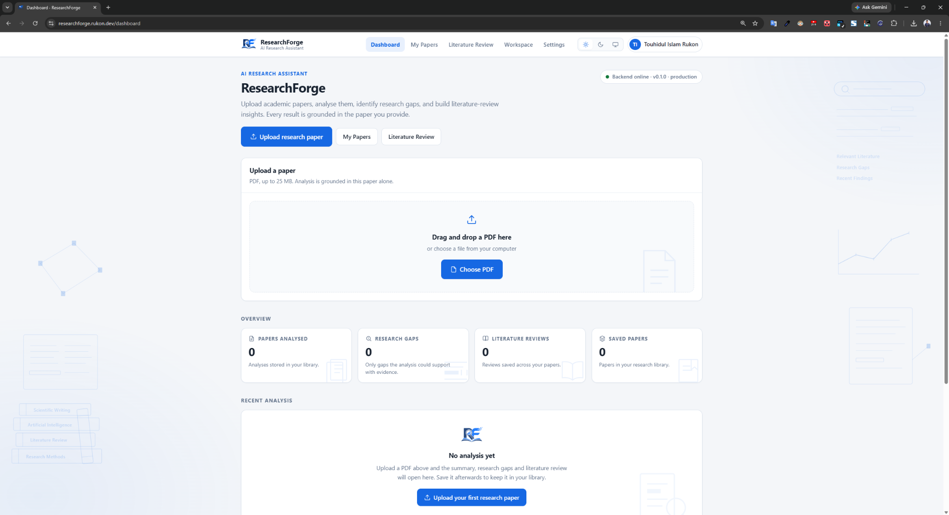
Figure 4.5: Empty dashboard for a newly created user account
Figure 4.6 shows the summary and key findings generated for an uploaded paper, satisfying requirement F3.
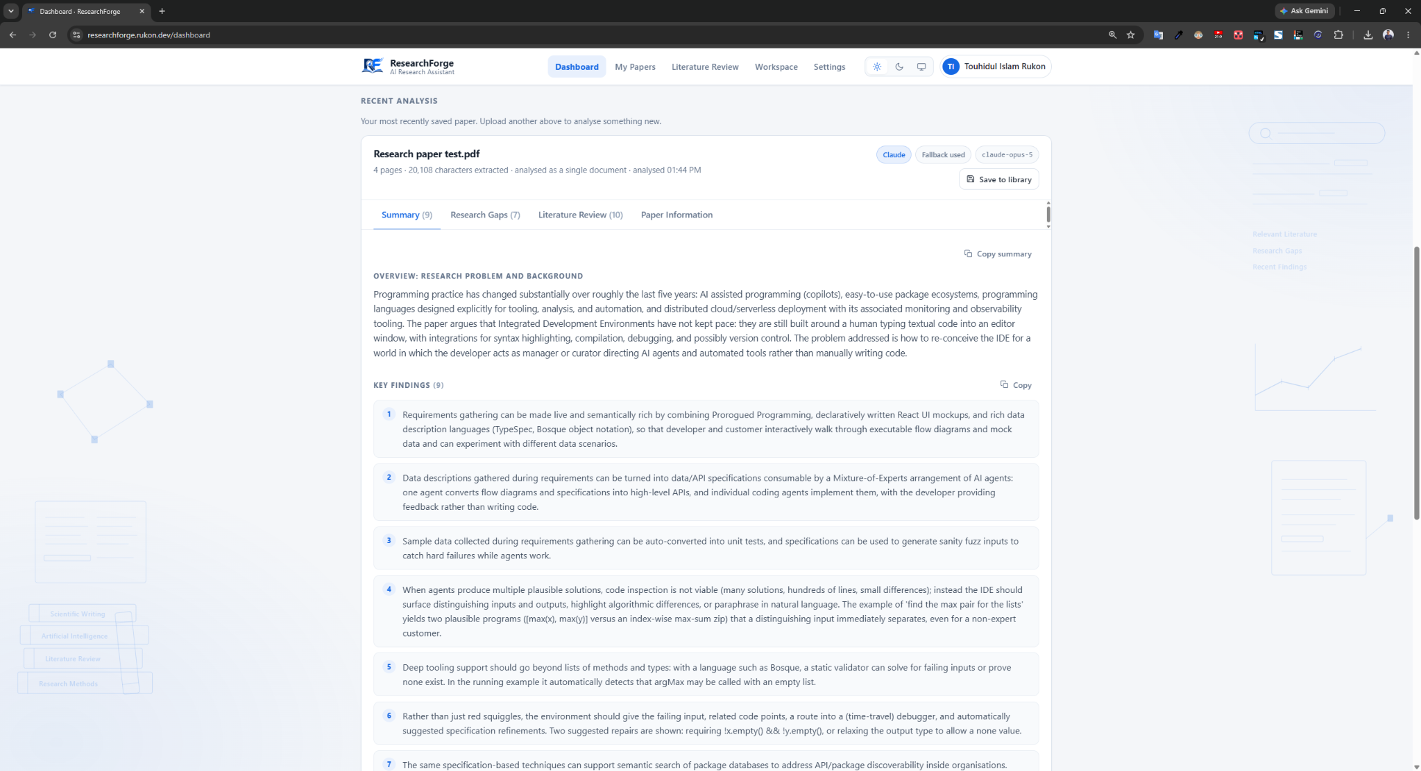
Figure 4.6: Generated research paper summary and key findings
Figure 4.7 shows the identified research gaps and the limitations stated by the authors, the output of the second structured pass described in Section 3.8.
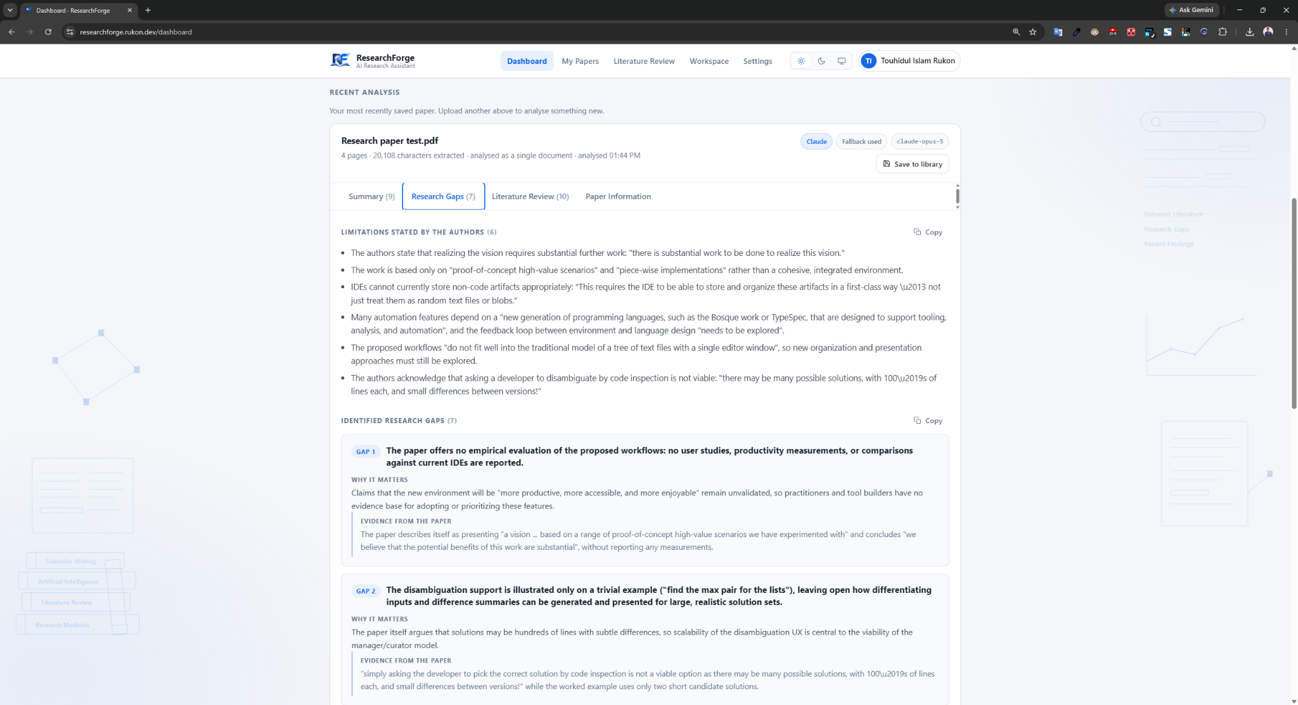
Figure 4.7: Generated research gaps and limitations
Figure 4.8 shows the cross-paper literature review interface, in which the user selects several analysed papers and generates a review across them. The example is a review generated from two papers; the feature requires more than one paper by design.
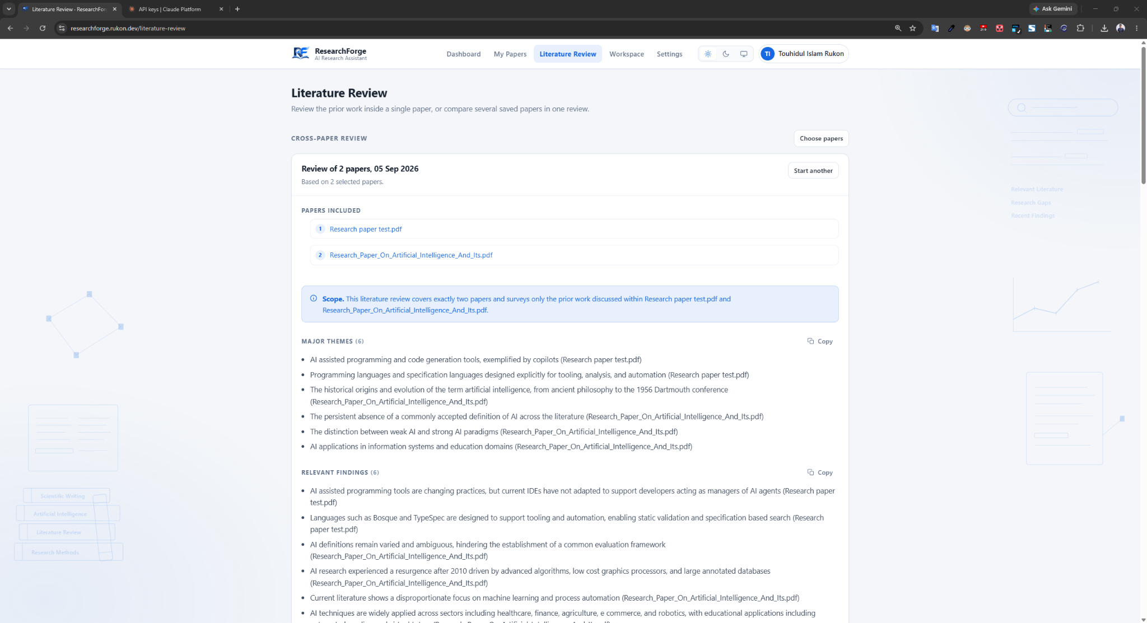
Figure 4.8: Cross-paper literature review interface
Figure 4.9 shows the private research library, containing only the signed-in user papers.
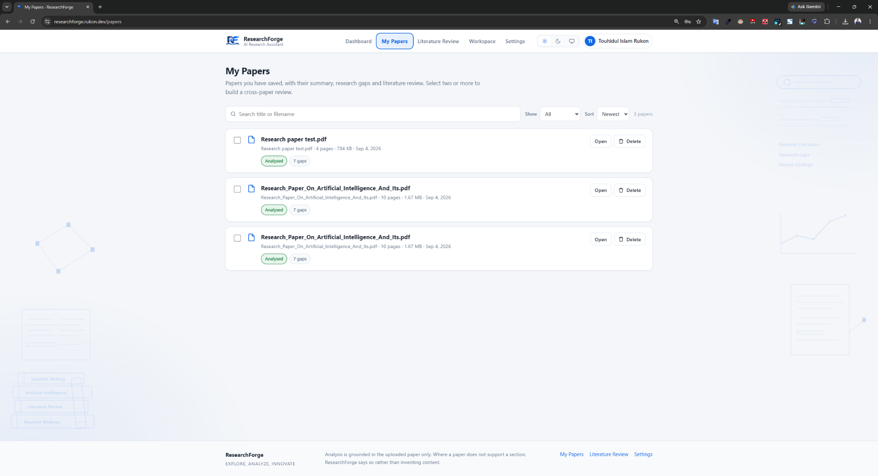
Figure 4.9: User research paper library
Figure 4.10 shows the Owner AI Configuration panel, visible only to an account registered as an application owner. It provides selection of the global primary provider and per-provider availability. Normal users have no equivalent control and the panel does not appear in their settings.
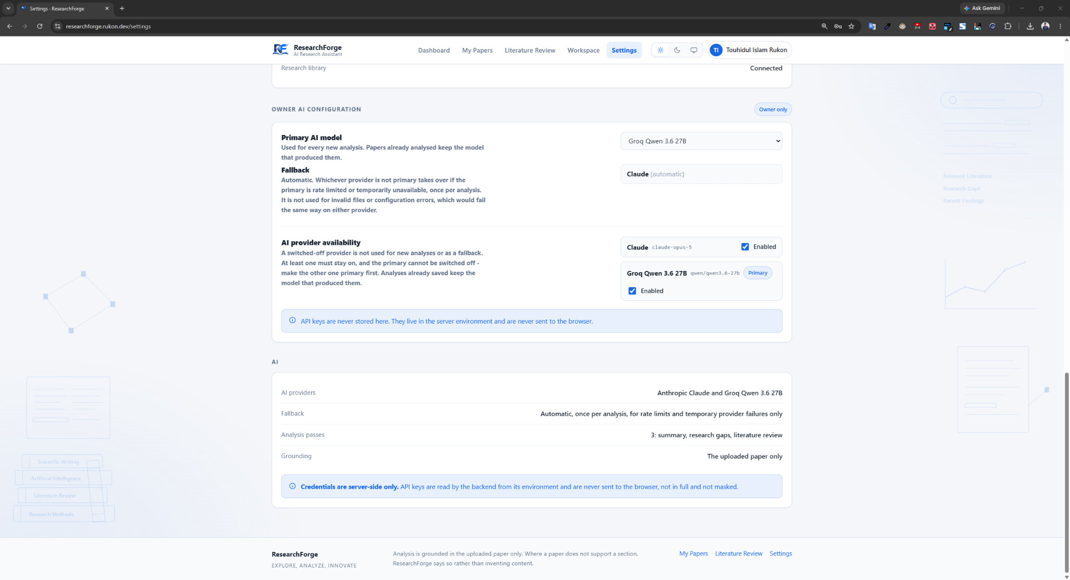
Figure 4.10: Owner AI configuration and provider availability controls
Figure 4.11 shows the dashboard at a mobile viewport. The layout reflows to a single column, the account name is hidden below 900 pixels to prevent header overflow, and card content is not clipped. Both behaviours were corrections made after testing on a real handset.

Figure 4.11: ResearchForge responsive dashboard on a mobile viewport

4.6 System Architecture
The system is deployed as a single Vercel project running two services that share one origin: a Next.js frontend and a FastAPI backend. Because they share an origin, the frontend calls the backend using a relative path.
Figure 4.1 shows the architecture. A request carries the bearer token and PDF to the backend, which verifies the token, extracts and normalises the text, computes the hash and consults the cache. On a miss the router calls the primary provider, with one fallback attempt for retryable failures, and the response is validated before being written to PostgreSQL. Results return filtered by the authenticated identity.
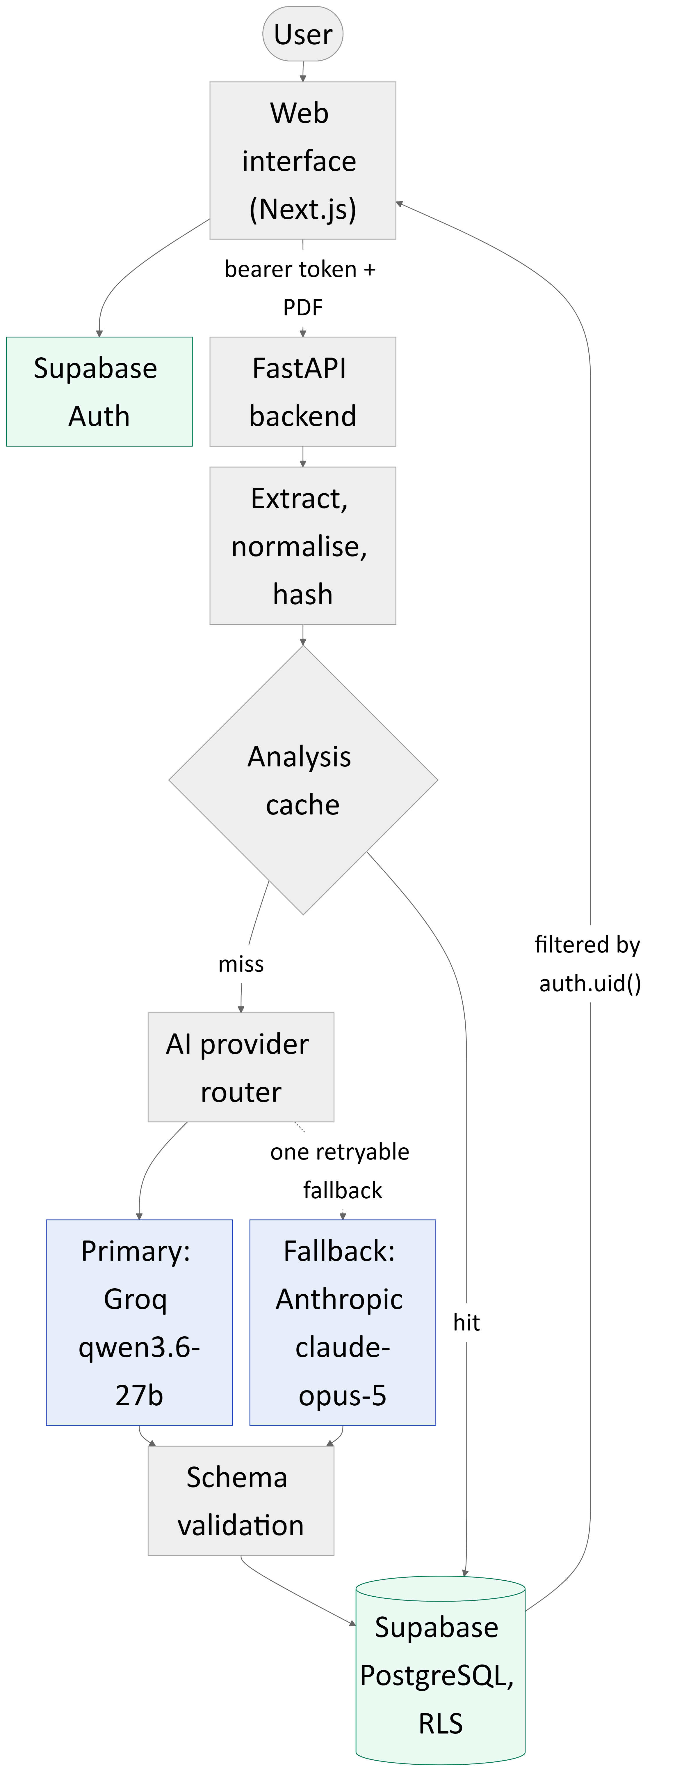
Figure 4.1: ResearchForge system architecture
The retrieval infrastructure present in the repository is not shown as part of the production flow because the analysis path does not call it.

4.7 Use Case Design
Figure 4.2 shows the use cases and two actors. A User manages their account, uploads and analyses papers, views the generated output, performs cross-paper review and manages their library. An Owner additionally reaches the AI configuration. Owner privileges are determined on the server from the authenticated identity and the owner register; there is no separate owner login page.
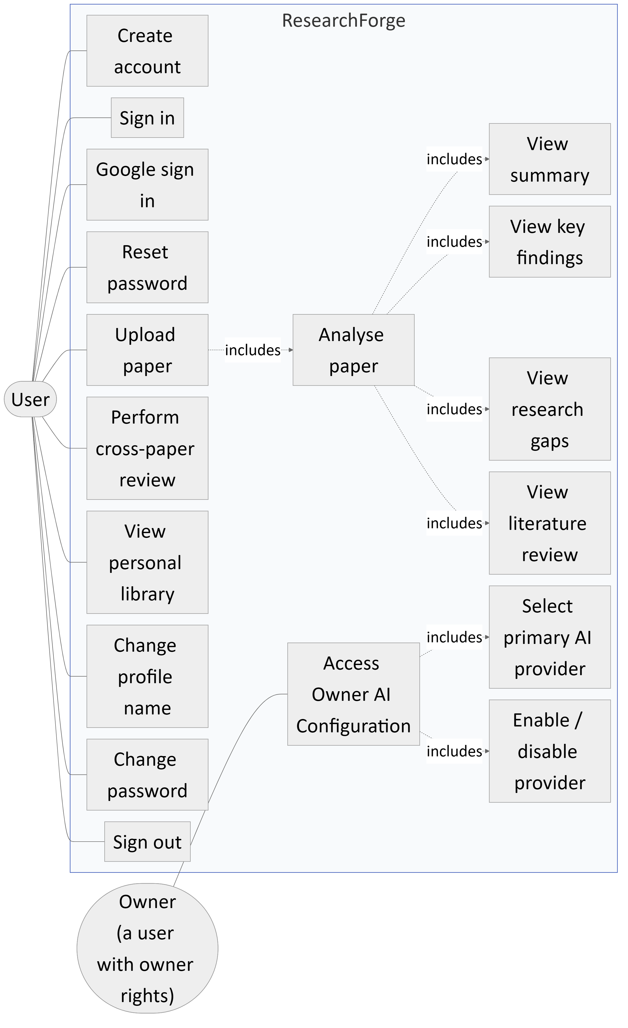
Figure 4.2: Use case diagram

4.8 Activity Flow
Figure 4.3 shows the activity flow, making the cache path explicit: a hit reuses the stored, previously validated analysis with no model call while still creating that user own records. On a miss the request goes to the primary provider, one fallback attempt is permitted for a retryable failure, and the response must pass schema validation before the analysis and cache entry are stored.
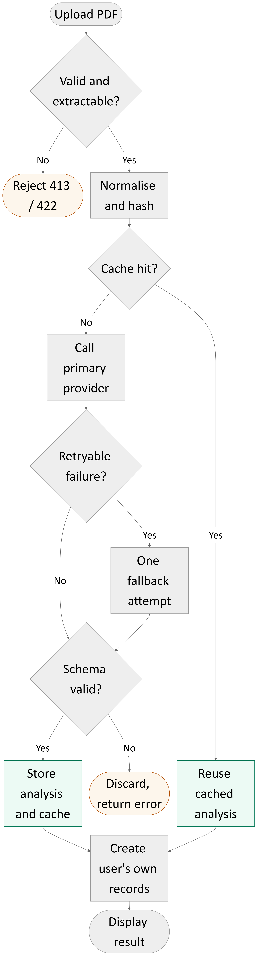
Figure 4.3: Activity flow for analysing an uploaded paper

4.9 Database and ERD Design
Figure 4.12 shows the entity relationship design. The authentication users entity represents identity managed by Supabase Auth and is shown for context; it is not an application table. Papers, analyses and reviews each carry an owning user. Reviews relate to papers through a join table, which allows one review to cover several papers.
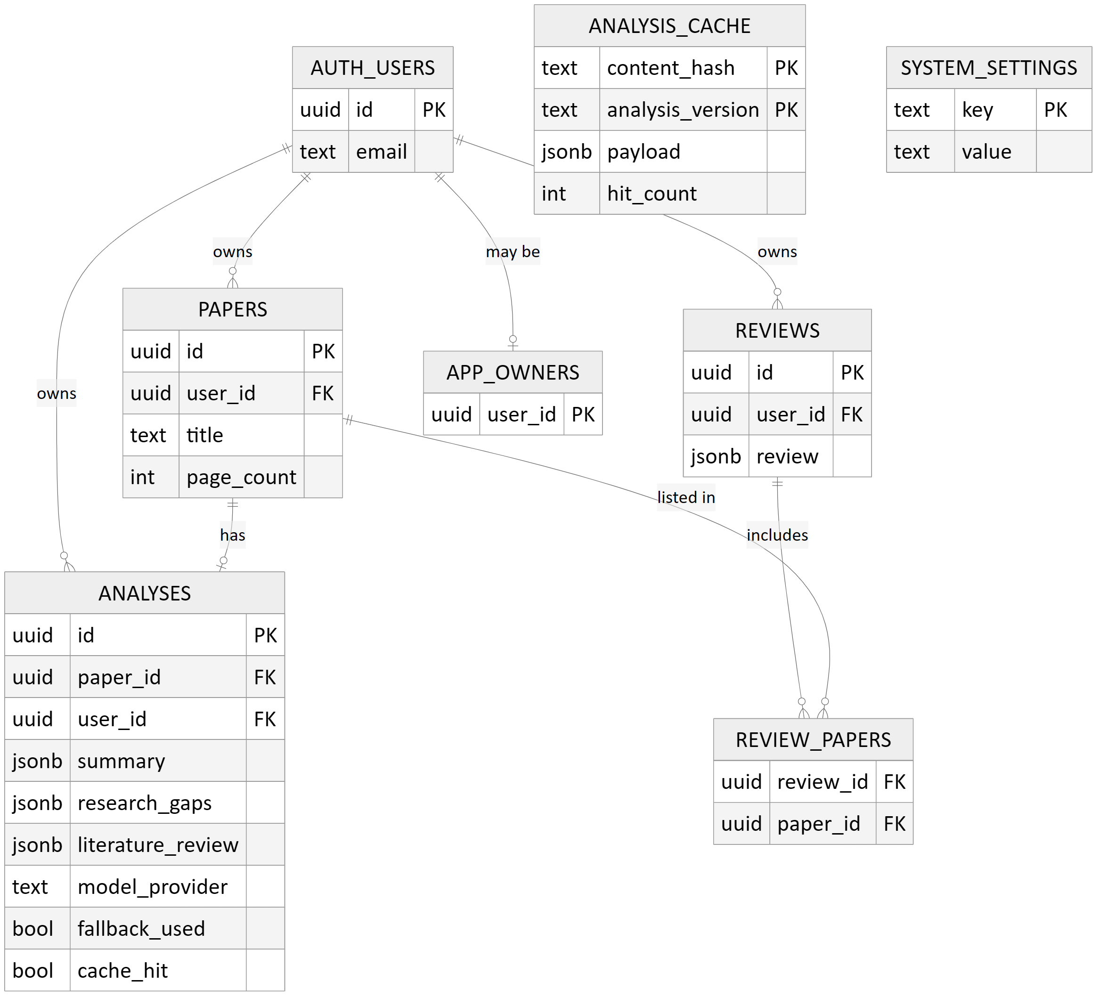
Figure 4.12: Entity relationship diagram
Three aspects deserve comment. Ownership columns default to the authenticated identity, so a row cannot be created without an owner. The analyses table records provenance: the provider that actually produced the result, the model, whether the fallback was used, whether the response came from cache, and the processing time. The analysis cache table has no user column, being keyed by content.

4.10 Authentication and User Ownership
Authentication uses Supabase Auth with email and password and Google sign-in; no password is stored by this project. Every route except the public landing page and the health endpoint requires a valid bearer token.
The isolation guarantee is not the token check. It rests on which credential the backend uses to reach the database: requests are made as the signed-in user, so PostgreSQL resolves the authenticated identity and applies every Row Level Security policy automatically. A forgotten ownership filter therefore returns nothing rather than everything. Section 6.7 describes the defect that made this change necessary.
The property this produces is that a forgotten ownership filter returns nothing rather than everything. Isolation stops being something every query must remember and becomes a property the database enforces. Section 6.7 describes the defect that made this change necessary.

4.11 Research Paper Processing Module
The processing module checks the uploaded file against the size limit, rejecting oversized uploads with HTTP 413, then extracts text with pypdf. A document yielding no usable text is rejected with HTTP 422 and never reaches a model. The extracted text is normalised and hashed as described in Section 3.7, producing the identity used for caching.

4.12 AI Analysis Module
The analysis module orchestrates the three structured passes described in Section 3.8. It is deliberately unaware of provider routing: it calls a provider interface and the routing happens beneath it, which meant that adding a second provider and a fallback changed no business logic. Each pass supplies the whole normalised document together with the pass-specific prompt and declared output schema, and the response is validated before it is accepted.

4.13 Research Gap Detection
Gap detection is the second structured pass. The prompt directs the model to identify gaps the paper itself supports, drawing on the limitations the authors state and the future work they propose, rather than speculating about the field. The schema separates identified gaps from author-stated limitations and carries an explicit insufficient-evidence flag.

4.14 Literature Review Module
The third pass produces review content for a single paper: the major themes it engages with, the comparisons it draws with prior work, and the future directions it identifies. As with the other passes, content is constrained to the uploaded document.

4.15 Cross-Paper Literature Review
Cross-paper review operates over papers the user has already analysed. The user selects papers from their own library and the system generates a review across them. It requires more than one paper, since a review across a single paper is that paper own review content. Only the requesting user papers can be selected; an attempt to include another user paper fails, as verified in Section 5.7.

4.16 Same-Paper Cache
The cache is implemented as described in Section 3.11, keyed by content hash and analysis version. On a hit the stored payload is returned and the hit counter incremented; the response reports the cache hit flag as true and preserves the original run processing time rather than the time taken to serve the cached copy. That preserved value is what distinguishes a genuine cache hit from a merely fast analysis.

4.17 AI Provider Routing and Fallback
Routing is implemented in a component that itself satisfies the provider interface, so the analysis module needs no knowledge of it. It holds the primary provider and, when a second is enabled, the fallback, and applies the two rules from Section 3.9. Each analysis records the provider that actually produced it, the model used, and whether the fallback was involved.

4.18 Owner AI Configuration
Owner configuration is stored as two values: the active primary provider, and the set of providers enabled at all. The set is stored as one value rather than a boolean per provider, so the state in which no provider is enabled cannot be represented; a database check constraint permits only the three valid combinations. Write access is restricted to accounts in the owner register.

4.19 Error Handling
Errors are translated into meaningful HTTP responses rather than generic failures: 413 for an oversized upload, 422 for a document without extractable text, 429 for a provider rate limit with retry information where supplied and an exhausted quota distinguished from temporary throttling, 503 for credential problems, and 502 with the reason when a response fails validation.

4.20 Responsive Interface
The interface adapts to small viewports, as shown in Figure 4.11. Two corrections were required: decorative artwork inside cards is clipped only at widths of 561 pixels and above, because clipping unconditionally cut off real content on small screens, and the account name is hidden below 900 pixels because it caused the header to overflow. Both defects were found only by opening the deployed site on a physical device.

4.21 Chapter Summary
The system is a Next.js interface and a FastAPI backend sharing one deployment, with Supabase providing authentication and a PostgreSQL database whose Row Level Security enforces ownership. Analysis is three schema-constrained passes over the whole document, routed to a primary provider with a single retryable fallback.

CHAPTER 5: TESTING AND EVALUATION

5.1 Introduction
This chapter reports how the system was tested and what testing found. All results were produced by running the tests described; no figure has been estimated or adjusted.

5.2 Testing Strategy
Testing operates at three levels, kept separate because each can pass while another fails. The isolation defect described in Section 6.7 passed every automated test while being wrong in production, which demonstrates why one level is insufficient.
No test in the automated suite calls a paid interface. Every provider is replaced by a fake, so the suite runs offline, costs nothing and is deterministic. A small number of live-provider tests exist but are skipped unless explicitly enabled.

5.3 Unit Testing
The backend suite was executed with pytest and the frontend suite with Vitest. The verified result is 522 backend tests passing with 5 skipped, and 16 frontend tests passing: 538 passing tests with no failures. The 5 skipped are the opt-in live provider tests, skipped by design rather than by failure.
Table 5.1: Automated backend test distribution by module
Test module | Tests | What it protects
Authentication | 61 | Token verification, expiry, bad credentials
LLM providers | 49 | Provider behaviour, error translation, validation
Repository | 48 | Every database access path
Rate limiting | 42 | Rate-limit recognition and retry discipline
Provider router | 36 | Primary and fallback routing, retryable whitelist
Library | 35 | Library reads and writes
Analysis | 31 | The three-pass pipeline
Provider availability | 30 | A disabled provider is never constructed
Groq provider | 30 | Client behaviour and JSON validation
Content hash | 30 | Normalisation and cache identity
Embeddings | 29 | The unused embedding scaffolding
Owner configuration | 28 | Owner-only endpoints
Key type guard | 22 | A publishable key in a private slot
Analysis cache | 22 | Cache correctness and versioning
Ownership | 20 | Caller identity carried faithfully
Application wiring | 9 | Startup, health, route registration
Live provider smoke tests | 5 | Live calls, opt-in and skipped

The largest single module is authentication, which reflects a deliberate judgement that this is where a silent failure is most costly.
Static quality checks were also run. Ruff reported no issues and no formatting differences across the application source and tests, the TypeScript compiler reported no type errors, and the production build completed successfully, producing 15 routes.

5.4 Integration Testing
Integration testing exercised the complete path from browser to database against the deployed system. Because the isolation guarantee is enforced by the database rather than by application code, it cannot be verified with a fake: the ownership unit tests prove the application carries each caller identity faithfully, but they model Row Level Security with a stub. The live scripts create throwaway accounts, run a scenario as two different people, and then delete only what they created using the product own endpoints.

5.5 API Testing
The API was tested for error semantics as well as success paths: 401 for unauthenticated requests, 413 for oversized uploads, 422 for PDFs without extractable text, 429 for provider rate limiting rather than a generic server error, and 502 with an explanatory message when a response fails validation.

5.6 Authentication and Security Testing
Authentication testing covered account creation, sign-in, sign-out, password change and session behaviour, and is the largest module in the automated suite.
One finding initially appeared to be a security defect. A live test asserted that a token was refused immediately after sign-out, and it failed. The assertion, not the system, was wrong: token verifications are cached for five seconds so that one page load does not generate a burst of authentication requests, and the test re-checked after two seconds.
What matters is whether the acceptance window is bounded, which was measured by sampling after sign-out.
Table 5.2: Measured acceptance of a revoked session token after sign-out
Time after sign-out | Result
1.6 seconds | Still accepted
3.9 seconds | Still accepted
6.1 seconds | Refused with 401
8.0 to 20.7 seconds | Refused with 401

The window is bounded and consistent with the documented five-second verification cache. The test now asserts the real contract, which is that sign-out takes effect once the cache expires. The residual behaviour is recorded as a limitation in Section 6.9.

5.7 User Ownership and Row Level Security Testing
This is the test the automated suite cannot perform. Two throwaway accounts were created against the production system and a full scenario executed as two different people. The run passed 26 checks with no failures.
Table 5.3: Live data isolation test cases and results
Test case | Expected | Actual | Status
Protected route with no token | 401 | 401 | Pass
New account opens its library | Empty | 0 papers | Pass
User A uploads a paper | In User A library only | 1 paper, correct title | Pass
User B lists papers | User A paper absent | Absent | Pass
User B opens User A paper by id | 404, not 403 | 404 | Pass
User B deletes User A paper | 404, paper intact | 404 | Pass
User B searches User A title | No results | No results | Pass
Dashboard counters | Own work only | Own work only | Pass
User B adds User A paper to a review | 404 | 404 | Pass
User A reviews own two papers | 201, both named | 201, both named | Pass
Direct database query with browser key | Zero rows | Zero rows | Pass
Token used after sign-out, past cache | 401 | 401 at 6.1 s | Pass

Two results deserve emphasis. Requests for another user resource return 404 rather than 403, so the system does not confirm that a resource exists. More importantly, querying the database directly with the key that ships inside the browser, bypassing the application entirely, returns zero rows: isolation does not depend on the application being correct.

5.8 AI Provider Testing
Provider behaviour was unit-tested for both providers: request construction, translation of provider errors, rate-limit handling, rejection of an unknown model, and validation of structured output. The router was tested for correct primary and fallback selection with either provider configured as primary, and for the rule that a disabled provider is never constructed.
Live testing against the deployed system used the five-paper evaluation corpus described in Section 3.5, analysed under three configurations.

5.9 AI Fallback Testing
The fallback mechanism was verified live. With Groq configured as primary and Anthropic enabled, all five papers completed, and in every case the analysis was produced by the fallback, with the fallback flag recorded as true.
Table 5.4: Live provider configurations and completion results
Configuration | Papers completed | Completed by the configured primary
Anthropic primary, both enabled | 5 of 5 | 5 of 5
Groq primary, both enabled | 5 of 5 | 0 of 5
Groq only, Anthropic switched off | 0 of 5 | 0 of 5

The third configuration was added during evaluation because every run in the second had fallen back, which meant it measured the fallback rather than Groq. Switching Anthropic off removed the safety net and confirmed that a disabled provider is unreachable. Only one fallback attempt is made per analysis, and only for whitelisted retryable failures. Unit tests verify selection in both directions; the live evidence covers the Groq to Anthropic direction.

5.10 Same-Paper Cache Testing
Cache behaviour was verified against the deployed system using one document uploaded three times: by a first user, again by the same user, then by a second user. Four independent signals were checked, because a cache hit must not merely be faster, it must demonstrably make no model call.
Table 5.5: Controlled production cache test results
Request | Latency | Cache hit flag | Model called
First upload, User A | 32.4 seconds | False | Yes, three structured calls
Same document, User A | 3.2 seconds | True | No
Same document, User B | 2.7 seconds | True | No

The four signals were the cache hit flag in the response; the collapse in latency; the preserved processing time, which remained the original figure of 29,823 milliseconds on both hits rather than the time taken to serve the cached copy; and the increment of the hit counter. The third is the signal a merely fast response could not fake.
The test also verified that one shared cache row was reused while the two users retained separate private library records, and that nothing identifying the first user appeared in the second user response. An earlier run during development produced 24.7 seconds for the miss and about 2.3 and 2.0 seconds for the hits; Table 5.5 reports the most recent verified run.
An earlier run of the same test, conducted during development, produced 24.7 seconds for the miss and approximately 2.3 and 2.0 seconds for the two hits. The values reported in Table 5.5 are from the most recent verified run.

5.11 User Interface Testing
Interface behaviour was verified by performing each required capability through the browser as a user would: creating an account, uploading a paper, reading the summary and gaps, building a cross-paper review, and confirming a second account could see none of it. Fifteen live uploads were performed across the three evaluation configurations, and the frontend unit suite contributed 16 automated tests.

5.12 Responsive and Mobile Testing
The interface was opened on a physical handset and at reduced viewport widths. This found two defects desktop testing had not: decorative artwork clipping real content on narrow screens, and the account name causing header overflow. Both were fixed as described in Section 4.20, and the corrected layout is shown in Figure 4.11.

5.13 System Performance
Performance was measured on the deployed system. The values below are what was observed in the tests described; they are not guarantees, and processing time varies with document length and provider load.
Table 5.6: Observed processing performance
Measurement | Observed value
New analysis, controlled cache test | 32.4 seconds
Cache hit, same user | 3.2 seconds
Cache hit, different user | 2.7 seconds
New analysis of corpus papers, median | 98.8 seconds
New analysis of corpus papers, range | 72.6 to 115.2 seconds

The difference between the controlled test and the corpus papers reflects document size: the controlled test uses a short fixture, whereas corpus papers are complete research papers of 6 to 19 pages. A new analysis of a full paper therefore takes on the order of one and a half minutes, because three separate passes are made over the entire document.
Text extraction was measured across the corpus and is identical for both providers, since it happens before any model call.
Table 5.7: Text extraction results for the evaluation corpus
Paper | Pages | Characters extracted | Characters per page | Chunks | Truncated
1706.03762 | 15 | 39,489 | 2,632 | 1 | No
1810.04805 | 16 | 63,578 | 3,973 | 1 | No
1903.10676 | 6 | 23,767 | 3,961 | 1 | No
2004.04228 | 13 | 46,601 | 3,584 | 1 | No
2005.11401 | 19 | 69,097 | 3,636 | 1 | No

Extraction yield is consistent across the corpus, indicating that the extractor handled two-column academic layout without dropping content. No paper required chunking or truncation, which is the empirical basis for the decision in Section 3.8 not to build a retrieval pipeline.

5.14 Evaluation Results
Why standard accuracy metrics do not apply. Accuracy, precision, recall and F1 require labelled ground truth. Generating a literature review has no single correct output, and no labelled corpus of correct research gaps exists within the project, so reporting classification metrics would be fabrication presented as rigour and none are reported. The evaluation instead measures properties observable without ground truth: completion rate, fallback behaviour, provenance accuracy, latency, output completeness, rejection of invalid output, and cost avoidance.
The evaluation instead measures properties that can be observed without ground truth: completion rate, fallback behaviour, provenance accuracy, latency, output completeness, whether invalid output is rejected, and cost avoidance through caching.
The principal finding. The intended comparison between the two providers could not be completed. With the fallback removed, Groq refused every request, and its own error message gives the reason: the free service tier permits 7,000 input tokens per minute, and each paper required more than that in a single request.
Table 5.8: Input token requirement of each corpus paper against the free-tier limit
Paper | Pages | Input tokens requested | Tier limit | Ratio
1903.10676 | 6 | 7,920 | 7,000 | 1.1 times over
1706.03762 | 15 | 11,745 | 7,000 | 1.7 times over
2004.04228 | 13 | 12,661 | 7,000 | 1.8 times over
1810.04805 | 16 | 18,498 | 7,000 | 2.6 times over
2005.11401 | 19 | 20,362 | 7,000 | 2.9 times over

This is not a pacing problem. A per-minute allowance can normally be satisfied by waiting, but a single request of 7,920 tokens can never fit within a 7,000-token-per-minute allowance however long the system waits. Even the shortest paper exceeds the limit, so at this service tier the configured primary provider cannot analyse a research paper of realistic length.
Output characteristics. Ten analyses completed successfully across the first two configurations, and all ten were produced by Anthropic.
Table 5.9: Output produced across ten completed analyses
Measure | Median | Range
Key findings per summary | 8 | 6 to 11
Research gaps identified | 9 | 7 to 10
Limitations extracted | 11.5 | 7 to 12
Literature review themes | 8 | 5 to 9
Comparisons with prior work | 7.5 | 5 to 12
Future directions identified | 5 | 3 to 7

No analysis reported insufficient evidence in any of the ten runs, which is expected for complete, well-structured papers but means the corpus did not exercise that path at all. The safeguard is verified by the automated suite rather than by this evaluation.

5.15 Discussion of Results
The three configurations in Table 5.4 say something together that none says alone. The system completed every paper it was given, yet under the configuration the owner had selected it never once used the provider selected as primary. The fallback worked exactly as designed, and in working perfectly it made a completely non-functional provider invisible: every analysis succeeded, the interface reported no error, and a user would have noticed nothing.
The failure was detectable only because each analysis records which provider actually produced it, and because results were grouped by that record rather than by configuration. Grouping by configuration would have reported that both providers performed comparably while measuring the same provider twice. The system is therefore single-provider in effect though dual-provider in architecture.
Two measurement errors occurred and were corrected, described in Section 6.8; both produced plausible but wrong numbers, and both arose because the cache is keyed by content.
Threats to validity. The corpus is small and narrow: five English-language computational linguistics papers. There is no ground truth, so Table 5.9 measures how much was produced rather than whether it was correct. The provider comparison could not be completed, the insufficient-evidence path was never triggered, each paper was analysed once per configuration, and the evaluation was performed by the project team rather than independently.

5.16 Chapter Summary
The system passes 538 automated tests with no failures, and static analysis, type checking and the production build are clean. Live testing verified per-user isolation across 26 checks, including direct database access that bypassed the application. The cache reduces a repeat analysis from 32.4 seconds and three model calls to about 3 seconds and none. The provider evaluation produced a negative finding: the configured primary cannot process papers at its free tier, and the fallback concealed this.

CHAPTER 6: DISCUSSION

6.1 Introduction
This chapter interprets the results of Chapter 5 against the project objectives, identifies the strengths of the delivered system, records the challenges encountered, and states the limitations and mitigations.

6.2 Achievement of Project Objectives
Table 6.1: Achievement of project objectives with supporting evidence
Objective | Evidence | Result
1. Upload research papers | 15 live uploads across three configurations | Achieved
2. Extract text from PDFs | Table 5.7; documents without text rejected | Achieved
3. Structured summaries and key findings | 10 summaries, median 8 findings | Achieved
4. Identify research gaps | 10 gap analyses, median 9 gaps | Achieved
5. Literature review content | 10 reviews, median 8 themes | Achieved
6. Cross-paper literature review | Verified live over two papers; Figure 4.8 | Achieved
7. Usable research assistant interface | Figures 4.4 to 4.11; clean build | Achieved
8. Secure accounts and per-user ownership | 26 live checks, no failures | Achieved
9. Reduce duplicate AI processing | 32.4 s to 3.2 s, no model call | Achieved
10. Owner-controlled provider configuration | Figure 4.10; disabled provider unreachable | Mechanism achieved

6.3 System Strengths
Four strengths are worth stating. Isolation is a database property, so a forgotten ownership filter returns nothing rather than everything. Grounding is enforced structurally, since output is constrained to a schema and discarded when it does not conform. Provenance is recorded for every analysis, which is what made the central evaluation finding detectable. Duplicate inference is avoided without compromising privacy, because the cache is keyed by content while each user retains a separate private record.

6.4 Challenges Encountered
The most significant challenges were a data isolation defect that no test detected, provider rate limiting that initially presented as generic server errors, an infrastructure layer that concealed provider error messages, and a fallback mechanism so effective that it hid a non-functional provider. Each is described in the sections that follow.

6.5 Technical Challenges
A database change broke every library read. Queries were updated to select new provenance and cache columns before the corresponding migration had been applied. The database rejected the entire request rather than the missing columns, so all reads failed. The fix retries and degrades one migration level at a time, returning the columns that do exist rather than failing completely.
An external service concealed provider error messages. The custom domain is served through a content delivery network that replaces an origin error body with a short generic message, so every failed analysis looked identical and carried no explanation. Addressing requests directly to the application origin returned the real provider message, which is how the token limit in Section 5.14 was identified. Without this step the central finding of the evaluation would have remained invisible.

6.6 AI Provider and Rate-Limit Challenges
Provider rate limiting was encountered repeatedly and shaped several design decisions.
During earlier development the project used a different provider whose free tier returned frequent rate-limit responses, initially surfaced as generic server errors. Handling was rewritten to be vendor-neutral: rate limits are recognised, retry information is passed through, an exhausted quota is distinguished from temporary throttling, and hidden retries inside client libraries were disabled because they multiply cost without informing the caller.

6.7 Authentication and Data Ownership Challenges
The most instructive defect in the project was in data isolation. An earlier version of the backend connected to the database using a privileged key that is designed to bypass Row Level Security. Every policy was present and correctly written, and every policy was inert. The application worked, every feature behaved correctly and the automated tests passed, because at the unit level nothing was wrong.
The defect was found by signing in as a second real account and checking whether the first account papers were visible. The fix, described in Section 4.10, was to connect as the signed-in user so that the database resolves the caller identity and applies the policies itself.
Records created before authentication existed remain unowned. They were deliberately neither deleted nor assigned to an owner who could not be established, and they are unreachable because a null owner never matches an authenticated identity.

6.8 Same-Paper Cache Challenges
Because the cache is keyed by content rather than by user or provider, a cached result can be returned where a fresh analysis was expected. This affected measurement twice during evaluation, as described in Section 5.15: once when two papers returned successful responses under a configuration intended to exercise a different provider, and once when the cache test own fixture was still cached from a previous run.
Neither was a defect in the cache, which behaved as designed. Both were defects in measurement, resolved by clearing the relevant cache rows before measuring. The episode is recorded because it demonstrates a general risk: a correctness-preserving optimisation can invalidate an experiment silently.

6.9 Limitations
Effectively single-provider. The architecture supports two providers and the fallback is verified, but the configured primary cannot process papers at its free tier, so genuine redundancy is not currently achieved.
No verification of truth. The system is grounded, which is weaker and more precise than accurate: output is constrained to the supplied document and non-conforming output is discarded, but nothing establishes that a summary is correct. Generated content requires researcher verification before it is relied upon or cited.
No labelled benchmark dataset, so no accuracy figure can be reported.
Full-document context rather than active retrieval. This is appropriate for papers that fit a context window, and every paper tested did, but it bounds document size.
Extraction quality varies with document structure, and scanned documents are rejected because there is no optical character recognition.
A bounded window after sign-out, in which a revoked token is accepted for up to about five seconds, as a deliberate trade against contacting the authentication service on every request.
Cache depends on identical normalised content and on versioning: a document differing after normalisation is treated as different, and the analysis version must change when the analysis method changes.
Narrow evaluation: five papers from one discipline, analysed once per configuration, evaluated by the project team.

6.10 Mitigation Strategies
Provider dependence is mitigated by the two-provider architecture itself, which would deliver genuine redundancy as soon as a second provider capable of accepting a full paper is configured; the routing, availability control and provenance recording required already exist and are tested. Rate limiting is mitigated by accurate error reporting and by the cache.
The absence of truth verification is mitigated by design decisions that make output checkable, and the user manual states that generated content should be checked against the paper before being cited. The absence of a labelled benchmark is mitigated by reporting only observable properties, and in the longer term by the evaluation proposed in Section 7.5.

6.11 Chapter Summary
Nine objectives are fully achieved and verified; the tenth is achieved in mechanism but limited by an external service tier. The challenges encountered were mostly failures invisible until deliberately checked, which is the main methodological lesson of the project.

CHAPTER 7: CONCLUSION AND FUTURE WORK

7.1 Conclusion
This project set out to build an AI research paper assistant that accepts uploaded research papers and produces structured summaries, research gap analyses and literature review content, delivered as a usable application with secure per-user accounts. That system was built, deployed and tested, and it is publicly reachable.
The work that proved most consequential was not the generation itself. The substantial engineering lay around the model call: constraining output to a schema and discarding what does not conform, enforcing isolation in the database rather than in application code, recording which provider actually produced each result, and avoiding duplicate inference through caching.
The evaluation produced a finding of wider interest. The configured primary provider could not process any corpus paper at its free tier, yet every analysis completed because the fallback handled all of them. A redundancy mechanism conceals the failure it compensates for, and this was detectable only because the system records the provider that actually served each request.

7.2 Achievement of Objectives
All ten objectives were addressed. Nine are fully achieved and supported by evidence in Chapter 5: upload, extraction, summarisation, gap identification, literature review generation, cross-paper review, a usable interface, secure per-user ownership, and reduced duplicate processing. The tenth, owner-controlled provider configuration, is implemented and verified as a mechanism, but its practical effect is constrained by the service tier described in Section 6.6.

7.3 Contributions of the Project
The project contributes a working, deployed application performing grounded document analysis with per-user isolation, provider fallback and content-addressed caching; a demonstration that grounding can be enforced structurally, since schema validation with discard-on-mismatch makes output validity a property of the system rather than a request to the model; and a methodological observation, that automatic fallback hides the failure it compensates for, so such a system must record which path was taken and be evaluated by that record rather than by configuration.

7.4 Limitations
The limitations detailed in Section 6.9 are summarised here. The system is effectively single-provider at present. It does not verify the truth of what it generates, only that the output derives from the supplied document and is structurally valid. It has no labelled benchmark and therefore reports no accuracy figure. It processes documents that fit within a model context window rather than retrieving from a corpus, and it cannot process scanned documents. A revoked session remains valid for a few seconds. The evaluation covers five papers from a single discipline, assessed by the project team.

7.5 Future Improvements
The following are proposed as future work and are not implemented.
- Ground-truth evaluation. Assemble papers annotated by domain experts with the gaps a human reader identifies, and score system output against them. This is the highest-value next step, because it is the only way to show that the right gaps were found.
- Restore genuine provider redundancy with a second provider able to accept a full paper, on a paid tier or by adding a provider.
- Deliberately exercise the insufficient-evidence path with documents that lack the requested content.
- Production vector retrieval, using the prepared embedding and pgvector infrastructure, for documents larger than a context window.
- Citation-aware evidence linking, so each statement points to its supporting passage.
- Streamed partial results, so the summary can be read while gap analysis continues.
- Optical character recognition, evaluation beyond one discipline, and a human evaluation study of usefulness.
- Additional features: document versioning, reference extraction, a research knowledge graph, multilingual support and usage analytics.

7.6 Final Summary
ResearchForge is a deployed AI research paper assistant that analyses uploaded papers, generating summaries, research gaps and literature review content grounded in the document, with per-user isolation enforced by the database, owner-controlled provider configuration, automatic fallback and content-addressed caching. It passes 538 automated tests with no failures and has been verified live against the deployed system.
Its most valuable results came from checking what the system actually did rather than trusting what the code implied: policies that were correct but inert, a fallback that concealed a dead provider, and a cached result that would have been recorded as another provider success.

REFERENCES
Beltagy, I., Lo, K., & Cohan, A. (2019). SciBERT: A pretrained language model for scientific text (arXiv:1903.10676). arXiv. https://arxiv.org/abs/1903.10676
Devlin, J., Chang, M.-W., Lee, K., & Toutanova, K. (2018). BERT: Pre-training of deep bidirectional transformers for language understanding (arXiv:1810.04805). arXiv. https://arxiv.org/abs/1810.04805
Lewis, P., Perez, E., Piktus, A., Petroni, F., Karpukhin, V., Goyal, N., Kuttler, H., Lewis, M., Yih, W.-t., Rocktaschel, T., Riedel, S., & Kiela, D. (2020). Retrieval-augmented generation for knowledge-intensive NLP tasks (arXiv:2005.11401). arXiv. https://arxiv.org/abs/2005.11401
Vaswani, A., Shazeer, N., Parmar, N., Uszkoreit, J., Jones, L., Gomez, A. N., Kaiser, L., & Polosukhin, I. (2017). Attention is all you need (arXiv:1706.03762). arXiv. https://arxiv.org/abs/1706.03762
Wang, A., Cho, K., & Lewis, M. (2020). Asking and answering questions to evaluate the factual consistency of summaries (arXiv:2004.04228). arXiv. https://arxiv.org/abs/2004.04228

APPENDIX A: PROJECT SCHEDULE
The project followed a thirteen-milestone roadmap recorded in the project plan, in which each milestone ended with a test and a review before the next began. The observed development period was 1 to 4 September 2026, taken from the repository file history rather than estimated.
Table A.1: Project milestones and completion status
Milestone | Deliverable | Status
0. Setup and planning | Repository structure, project plan, coding rules | Complete
1. Environment and foundations | Environment, dependencies, health endpoint, tests | Complete
2. Database foundation | Supabase project, initial migrations, verified connection | Complete
3. PDF ingestion | Upload endpoint and extraction verified on real papers | Complete
4. Chunking and embedding | Chunking with metadata, embeddings stored | Not built, see note
5. Retrieval and question answering | Grounded answers from retrieved passages | Not built, see note
6. Summarisation | Structured summaries with key findings | Complete
7. Research gaps | Evidence-backed gap analysis | Complete
8. Literature review | Literature review content generation | Complete
9. Frontend foundation | Layout, API client, upload and library pages | Complete
10. Frontend features | Summary, gaps and review pages with error states | Complete
11. Deployment | Live deployment with a working public URL | Complete
12. Evaluation and documentation | Evaluation against real papers, results recorded | Complete

Work added after the original roadmap comprised authentication and per-user isolation, owner AI configuration, the analysis cache, and provider availability control, corresponding to migrations 003 to 006.
Note on milestones 4 and 5. These were planned but deliberately not built. Measurement during milestone 3 established that every corpus paper fits within a single context window without chunking (Table 5.7), so retrieval would have introduced a failure mode without addressing a problem the system had. The infrastructure remains as prepared scaffolding and is not called in production.

APPENDIX B: SOURCE CODE
This appendix reproduces representative extracts that implement the claims made in the report. The complete source is in the project repository. No credential, key or environment value appears in any extract.

B.1 Data isolation
The single change that converted isolation from an application responsibility into a database guarantee. The anonymous key identifies the project and the user own access token identifies the person, so PostgreSQL resolves the caller identity and applies every Row Level Security policy.
self._headers = {
"apikey": settings.supabase_anon_key.strip(), # identifies the PROJECT
"Authorization": f"Bearer {token}", # identifies the PERSON
"Content-Type": "application/json",
}
An earlier version used a privileged key here, which is designed to bypass Row Level Security and therefore made every policy inert while every feature continued to work.

B.2 Provider routing and the retryable whitelist
Fallback is permitted only for failures on an explicit whitelist, so that a newly introduced error type does not silently become retryable.
PROVIDERS = ("anthropic", "groq")
OPPOSITE = {"anthropic": "groq", "groq": "anthropic"}
def is_retryable(error: LLMError) -> bool:
A rate limit or a temporary outage is worth a second vendor. A bad PDF, a
validation failure, a missing key or an unknown model is not: retrying
those spends a second quota to produce the same error.
return isinstance(error, (LLMRateLimitError, LLMTransientError))

B.3 Provider availability
A provider that the owner has disabled is never constructed, so no code path can call it. Availability is applied when the router is built rather than checked when it is used.
def build_routed_provider(primary, settings, enabled=None):
allowed = tuple(enabled) if enabled else PROVIDERS
fallback_name = OPPOSITE[primary]
fallback = (_construct(fallback_name, settings)
if fallback_name in allowed else None)
return RoutedLLMProvider(primary=_construct(primary, settings),
fallback=fallback)

B.4 Document identity and caching
Normalisation before hashing means two renderings of the same paper produce the same identity. The analysis version is part of the key so that the cache can be invalidated deliberately when the analysis method changes.
ANALYSIS_VERSION = "v1" # declared once; a test asserts this
def normalise_text(text: str) -> str:
Two PDFs of the same paper can differ in invisible ways - ligatures,
non-breaking spaces, line-ending style - and would otherwise hash
differently and be analysed twice.
return re.sub(r"\s+", " ", unicodedata.normalize("NFKC", text)).strip()
def content_hash(text: str) -> str:
payload = f"{ANALYSIS_VERSION}\n{normalise_text(text)}"
return hashlib.sha256(payload.encode("utf-8")).hexdigest()

B.5 Structured output validation
Output that does not match the declared schema is discarded rather than repaired, which is the mechanism behind the grounding claim.
try:
return output_model.model_validate(parsed)
except ValidationError as exc:
raise LLMResponseError(
"The provider returned an analysis that did not match the expected "
"structure, so it was discarded rather than partially used."
) from exc

B.6 Row Level Security policy
Ownership is defaulted by the database and enforced by policy, so a row cannot be created without an owner and cannot be read by another user.
ALTER TABLE papers ALTER COLUMN user_id SET DEFAULT auth.uid();
CREATE POLICY papers_select_own ON papers
FOR SELECT USING (user_id = auth.uid());
CREATE POLICY lrp_owner_only ON literature_review_papers AS RESTRICTIVE
USING (EXISTS (SELECT 1 FROM literature_reviews r
WHERE r.id = review_id AND r.user_id = auth.uid()));

APPENDIX C: DATASET SAMPLES

C.1 Evaluation corpus
Five real, openly available arXiv papers form the evaluation corpus. No paper was written for this project and no PDF was modified. Metadata was retrieved from the arXiv application programming interface rather than transcribed.
Table C.1: Evaluation corpus with source and licence information
arXiv ID | Title | Year | Source | Licence
1706.03762 | Attention Is All You Need | 2017 | arxiv.org/abs/1706.03762 | arXiv open access
1810.04805 | BERT: Pre-training of Deep Bidirectional Transformers | 2018 | arxiv.org/abs/1810.04805 | arXiv open access
1903.10676 | SciBERT: A Pretrained Language Model for Scientific Text | 2019 | arxiv.org/abs/1903.10676 | arXiv open access
2004.04228 | Asking and Answering Questions to Evaluate Factual Consistency | 2020 | arxiv.org/abs/2004.04228 | arXiv open access
2005.11401 | Retrieval-Augmented Generation for Knowledge-Intensive NLP Tasks | 2020 | arxiv.org/abs/2005.11401 | arXiv open access

C.2 Manifest record format
Each corpus entry is recorded with the following fields.
paper_id, title, authors, author_count, year, published,
venue_or_source, primary_category, doi, url, pdf_url,
licence, file, file_size_bytes

C.3 Sample of extracted input
The opening of paper 1903.10676 after extraction and normalisation, as the model receives it.
SciBERT: A Pretrained Language Model for Scientific Text
Iz Beltagy Kyle Lo Arman Cohan
Allen Institute for Artificial Intelligence, Seattle, WA, USA
Abstract
Obtaining large-scale annotated data for NLP tasks in the scientific
domain is expensive and time consuming. [...]

C.4 Sample of stored output
An abridged extract from the stored analysis of the same paper. The provenance fields record which provider actually produced the analysis.
{
"document": { "page_count": 6, "extracted_characters": 23767,
"chunk_count": 1, "truncated": false },
"model_provider": "anthropic",
"model_used": "claude-opus-5",
"fallback_used": false,
"cache_hit": false,
"processing_time_ms": 72564,
"summary": { "key_findings": [ "..." ] },
"research_gaps": { "identified_gaps": [ "..." ],
"insufficient_evidence": false }
}
No user identifier, email address or credential appears in stored analysis records reproduced here.

APPENDIX D: USER MANUAL

D.1 Creating an account
Open the ResearchForge web address and choose Sign up, then either enter an email address and password or choose Continue with Google. If you register by email, confirm the address using the message sent to you.
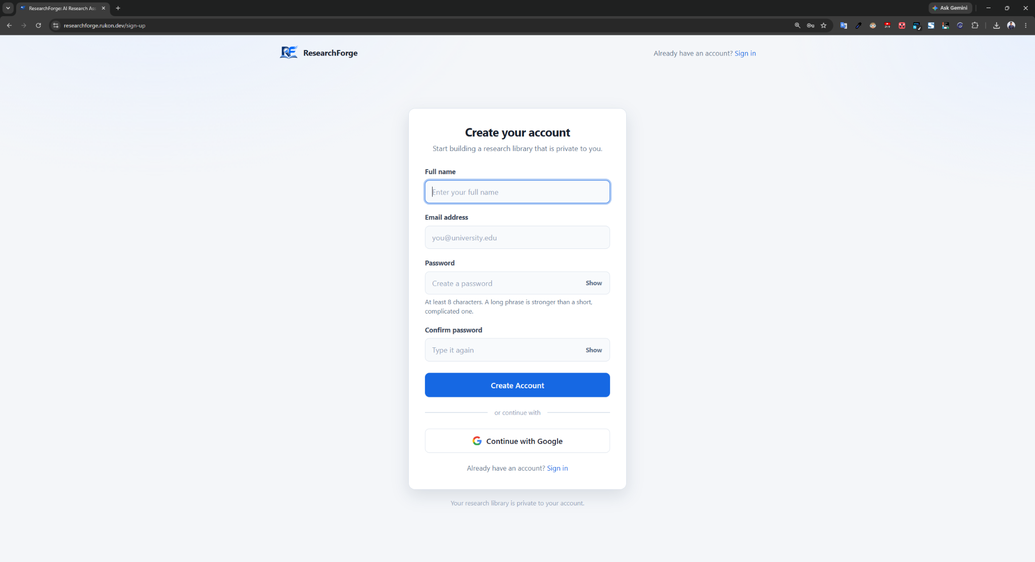
Figure D.1: ResearchForge account creation screen
After signing in you arrive at the dashboard. Your library is empty, and no other user papers are ever visible to you.

D.2 Uploading and analysing a paper
On the dashboard, drag a PDF onto the upload area or use the file chooser.
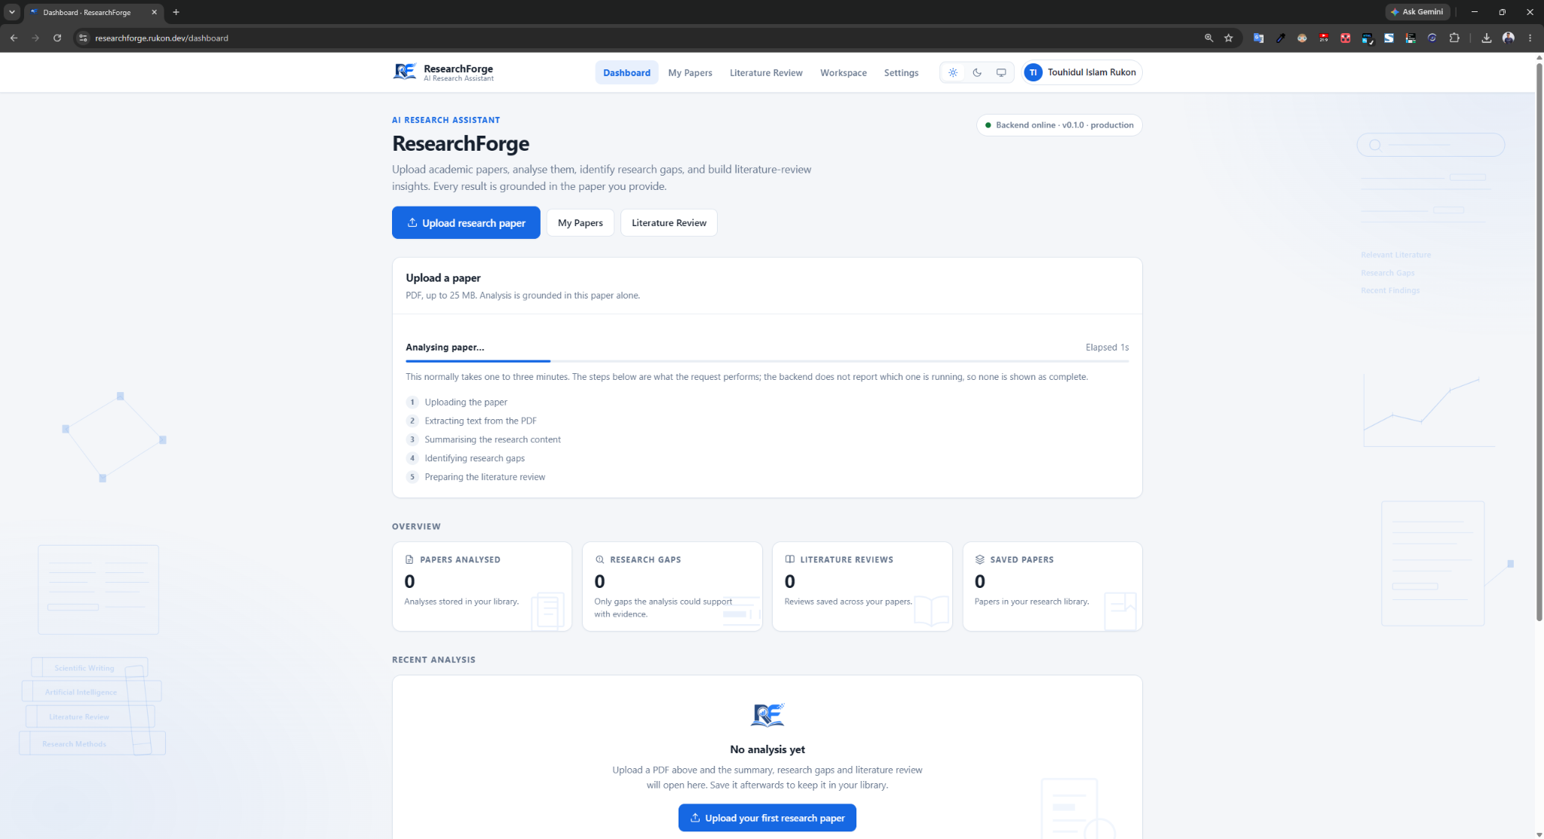
Figure D.2: Research paper upload and analysis progress
A new paper takes roughly one and a half minutes, because three separate grounded passes are made over the whole document. If the same paper has already been analysed the result returns in about three seconds, and nothing about the other person is shown to you.
If your PDF is rejected it is almost certainly a scanned document. The system requires extractable text and refuses documents without it rather than producing confident output about a document it cannot read.

D.3 Viewing analysis results
When analysis completes you are shown the summary and key findings, the identified research gaps and stated limitations, and literature review content. Where the paper does not support a section, the system reports insufficient evidence instead of generating text. Treat the output as a guide to reading rather than a substitute for it, and check any claim against the paper before citing it.

D.4 Managing account settings
Open Settings to change your display name, change your password, or sign out. Changing your password requires your current password.
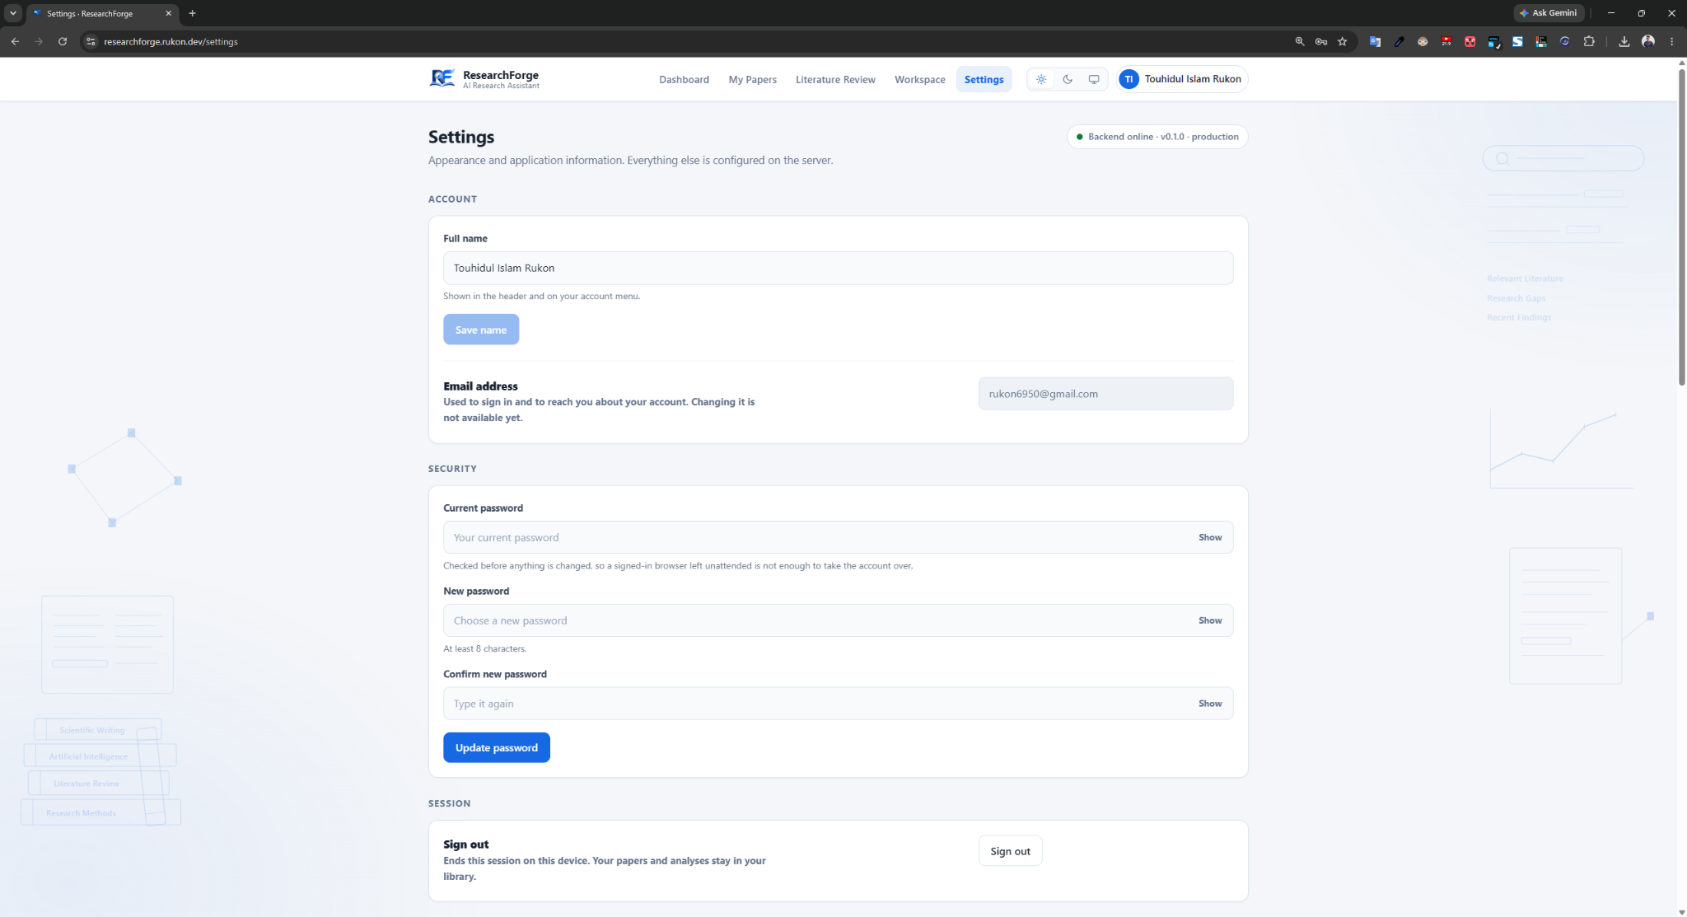
Figure D.4: Account settings for an authenticated user
Signing out takes effect within about five seconds.

D.5 Owner AI configuration
If your account is registered as an application owner, Settings additionally shows AI Configuration, illustrated in Figure 4.10. The primary provider setting selects which provider leads, and the other enabled provider automatically becomes the fallback. The availability controls switch a provider off entirely, and a provider that is off is never called. The configuration in which no provider is enabled cannot be saved. Normal users do not see this panel.

D.6 Viewing your research library
Open My Papers to see everything you have analysed, and select any paper to reopen its summary, key findings and research gaps. Only you can see, open or delete your papers, and this is enforced by the database rather than the application.

D.7 Generating literature reviews
Literature review content for a single paper is produced as part of that paper analysis and appears with its results. No separate action is required.

D.8 Cross-paper literature review
Open Literature Review to build a review across several of your saved papers. Select the papers to include and generate the review. The feature requires more than one paper, and only papers in your own library can be selected.

D.9 Signing out and password recovery
Use Sign out in Settings to end your session. If you have forgotten your password, choose Forgot password on the sign-in page and follow the link sent to your email address.

D.10 Troubleshooting
Table D.1: Common problems and their resolution
Symptom | Cause | What to do
PDF rejected as having no extractable text | The file is a scanned image | Use a text-based PDF; the system has no optical character recognition
Upload rejected as too large | The file exceeds the size limit | Use the published version rather than a large preprint bundle
Analysis seems slow | Normal; three passes are made over the whole paper | Allow about one and a half minutes for a new paper
Still signed in immediately after signing out | Sessions are verified with a short cache | Wait about five seconds
An analysis fails with a rate-limit message | The AI provider has throttled requests | Wait and try again; the message states the provider guidance

