Scheduled Folder Cleanup for a Windows Service — MySQL Walkthrough
Audience: Windows admins or developers who need to automate folder cleanup for a running service. Goal: stop the MySQL80 Windows service safely, delete two folders recursively, and start the service back up — all automatically on a schedule. Why this matters: a running service holds file handles on its folders. Deleting those folders while the service runs leaves locked files behind or fails outright. This guide shows the safe, repeatable pattern.
Note on scope: this guide uses MySQL 8 as the example service because it is commonly installed locally and easy to test against. The same script works for any Windows service (Tomcat, Jenkins, Apache, etc.) — you only change four variables at the top.

Table of Contents
# | Section | What it covers
1 | Introduction | What the script does and why each step exists.
2 | Requirements | What you need on your machine before you start.
3 | The Six Conditions the Script Handles | Every state the service can be in, and what the script does about it.
4 | Step 1 — Verify the Service Exists | Check that MySQL80 is installed and its state.
5 | Step 2 — Create Dummy Test Folders | Why we never point the script at real MySQL data.
6 | Step 3 — Create the Script File | Save the .bat file to disk.
7 | Step 4 — Understand the Script | Walkthrough of each block before you run it.
8 | Step 5 — Run the Script as Administrator | Execute and watch the output.
9 | Step 6 — Verify the Results | Confirm the service came back, folders are empty, log is saved.
10 | Step 7 — Schedule It (Optional) | Two ways to schedule: Task Scheduler GUI or schtasks one-liner.
11 | Full Script | Ready-to-copy code block.
12 | Troubleshooting | Common failure modes and fixes.

1. Introduction

What the script does
- Stops the MySQL80 Windows service gracefully (net stop).
- Waits up to 60 seconds for the service to reach the STOPPED state.
- If it doesn’t stop, force-kills the mysqld.exe process as a last resort.
- Checks for any orphan mysqld.exe still in the task list and kills it.
- Recursively deletes two folders (rmdir /S /Q) and recreates them empty.
- Starts the service again (net start) and waits up to 60 seconds for it to reach RUNNING.
- Writes the full output to a timestamped log file, kept for 7 days.

Why it exists
MySQL (and services like it) locks its data folders while running. If you just schedule rmdir /S /Q on those folders without stopping the service first, you’ll get “file in use” errors and leave partial junk behind. This script handles the whole lifecycle — stop, verify, clean, restart — and logs everything so unattended failures can be debugged later.

Who runs it
The script must run as Administrator because net stop, taskkill /F, and sc query on services all require elevated privileges. Under Task Scheduler, configure the task with “Run with highest privileges” checked.

2. Requirements
Requirement | Why
Windows 10 / 11 / Server | The script uses sc, net, taskkill, forfiles, powershell — all Windows-native.
MySQL Community Server 8.x installed as a Windows service | Provides the MySQL80 service to test against.
Administrator account | Needed to stop/start services.
CMD or Task Scheduler | The script is a .bat file. No PowerShell required except for date formatting.
A folder you can write to | For example C:\scripts\ to hold the .bat and its log folder.

Before you start — check MySQL is there
Open CMD (normal) and run:
sc query | findstr /i mysql
You should see something like:
SERVICE_NAME: MySQL80
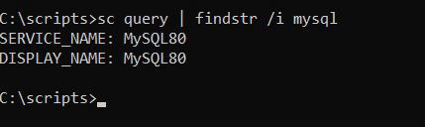
If you don’t see a MySQL service listed, install MySQL Community Server from dev.mysql.com/downloads/installer first. Pick the Server only setup type. The installer registers MySQL80 as a Windows service automatically.

3. The Six Conditions the Script Handles
A robust cleanup script has to handle every realistic state the service can be in. Here is each condition and how the script reacts.
# | Condition | What the script does
1 | Service already stopped | Skip the stop step, go straight to cleanup.
2 | Service running, stops gracefully in time | Send net stop, poll every 5s until STOPPED.
3 | Service running but won’t stop in the timeout | Force-kill with taskkill /F /IM mysqld.exe /T.
4 | Service reports STOPPED but process is orphaned | Detect lingering mysqld.exe in tasklist and kill it.
5 | Path passed to :clean is dangerous (empty / drive root / system folder) | Abort with exit code 3 before any deletion.
6 | Service does not come back up after cleanup | Exit with code 2 so Task Scheduler flags failure.
Conditions 1–3 are the core service-state branches. Conditions 4–6 are safety guards that catch real-world edge cases: crashed processes that didn’t clean up, typos in the folder path, and a failed restart that would otherwise go unnoticed.

4. Step 1 — Verify the Service Exists

What to do
Open a normal CMD window and run three commands:
sc query | findstr /i mysql
sc query MySQL80
tasklist | findstr /i mysql

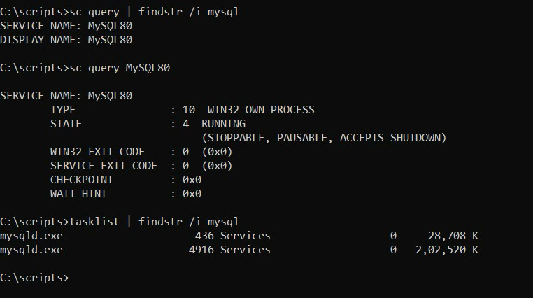

Why each one
Command | Purpose
sc query \| findstr /i mysql | Lists every service with “mysql” in the name. Confirms MySQL80 exists.
sc query MySQL80 | Shows the current state (RUNNING, STOPPED, etc.) of that specific service.
tasklist \| findstr /i mysql | Shows the actual process(es). Confirms the executable name is mysqld.exe.

What you should see
sc query MySQL80 should include:
STATE : 4 RUNNING
and tasklist should include at least one mysqld.exe row. 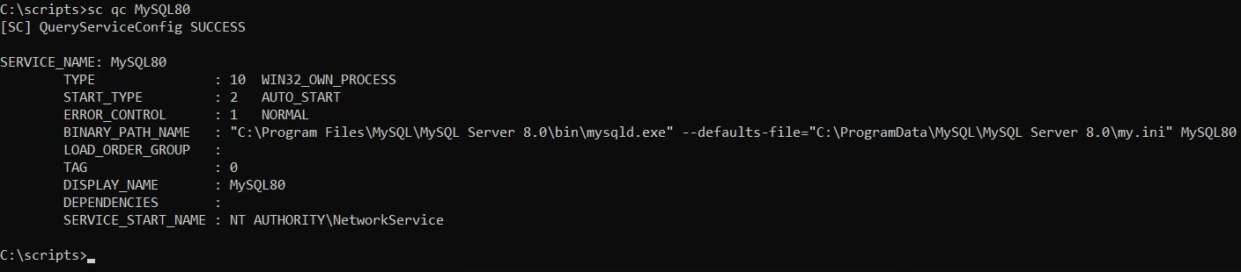

5. Step 2 — Create Dummy Test Folders

Why dummies?
MySQL’s real data lives in C:\ProgramData\MySQL\MySQL Server 8.0\Data. Never point the cleanup script at that folder — it deletes every database you have. For testing, create two throwaway folders instead so the service-stop/start logic can be verified without risking data.

What to run
In any CMD window:
mkdir C:\mysql-test-1
mkdir C:\mysql-test-2
echo hello > C:\mysql-test-1\a.txt
echo world > C:\mysql-test-2\b.txt
mkdir C:\mysql-test-1\sub
echo nested > C:\mysql-test-1\sub\c.txt
This creates two folders with a mix of files and a subfolder, so the recursive delete (rmdir /S /Q) actually has something to do.
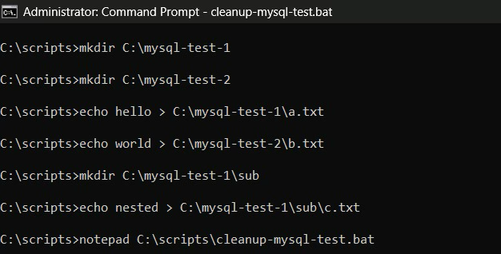

6. Step 3 — Create the Script File

Create the folder
If you don’t have C:\scripts yet:
mkdir C:\scripts

Open Notepad
notepad C:\scripts\cleanup-mysql.bat
When Notepad asks “Do you want to create a new file?”, click Yes.

Paste the script
Copy the full script from Section 11 (Full Script) at the bottom of this document into Notepad, then File → Save.

Verify the file exists
dir C:\scripts\cleanup-mysql.bat
You should see the file with a size around 3 KB.
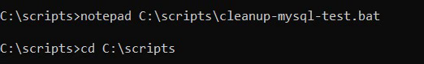
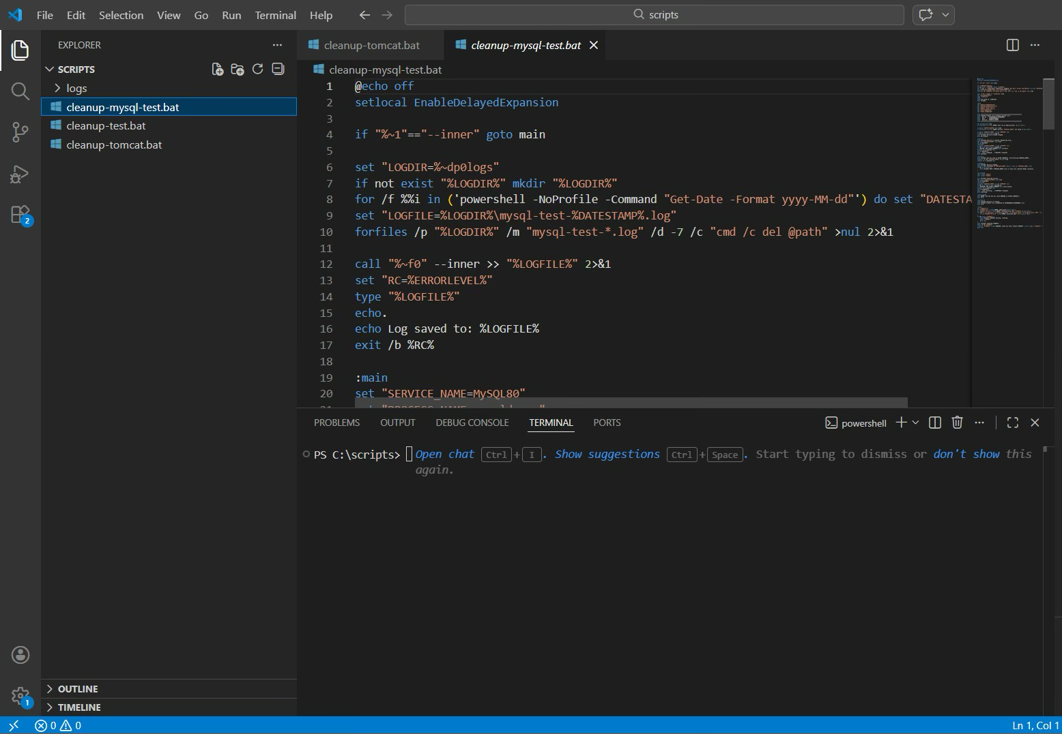

7. Step 4 — Understand the Script
Before running any script as Administrator, you should know what each part does. The script has five logical sections.

Section A: Logging wrapper (top of file)
if "%~1"=="--inner" goto main
set "LOGDIR=%~dp0logs"
if not exist "%LOGDIR%" mkdir "%LOGDIR%"
for /f %%i in ('powershell -NoProfile -Command "Get-Date -Format yyyy-MM-dd"') do set "DATESTAMP=%%i"
set "LOGFILE=%LOGDIR%\cleanup-%DATESTAMP%.log"
forfiles /p "%LOGDIR%" /m "cleanup-*.log" /d -7 /c "cmd /c del @path" >nul 2>&1
call "%~f0" --inner >> "%LOGFILE%" 2>&1
set "RC=%ERRORLEVEL%"
type "%LOGFILE%"
exit /b %RC%
What it does: when the script is first launched, it re-invokes itself with a hidden --inner flag and redirects all output (stdout + stderr) to a dated log file. The first copy of the script just waits, then prints the log to the console at the end. The forfiles line deletes log files older than 7 days automatically.

Section B: Configuration
set "SERVICE_NAME=MySQL80"
set "PROCESS_NAME=mysqld.exe"
set "DIR1=C:\mysql-test-1"
set "DIR2=C:\mysql-test-2"
set "STOP_TIMEOUT=60"
set "START_TIMEOUT=60"
What it does: these are the only six values you should ever need to change. Swap them to match any other service/folder pair.

Section C: Pre-flight checks
net session >nul 2>&1
if errorlevel 1 ( echo ERROR: Must run as Administrator. & exit /b 1 )
sc query "%SERVICE_NAME%" >nul 2>&1
if errorlevel 1 ( echo ERROR: Service not found. & exit /b 1 )
What it does: refuses to continue if you forgot “Run as Administrator” or if the service name is wrong. Fails fast with a clear error instead of a confusing failure later.

Section D: Stop → clean → start (the main work)
The core flow: check running state → net stop → poll for STOPPED → fallback to taskkill /F → orphan check → delete both folders → net start → poll for RUNNING.
This is where the six conditions from Section 3 are implemented.

Section E: The :clean subroutine
:clean
set "TARGET=%~1"
if "%TARGET%"=="" ( echo ERROR: empty path & exit /b 3 )
if "%TARGET:~3%"=="" ( echo ERROR: refusing drive root "%TARGET%" & exit /b 3 )
for %%P in ("C:\Windows" "C:\Windows\System32" "C:\Program Files" ...) do (
if /i "%TARGET%"=="%%~P" ( echo ERROR: protected path & exit /b 3 )
)
rmdir /S /Q "%TARGET%"
mkdir "%TARGET%"
goto :eof
What it does: before deleting, checks that the path isn’t empty, isn’t a drive root (C:\), and isn’t a system directory. If any of those fail, it aborts with exit code 3. This prevents a typo like DIR1=C:\ from wiping the whole disk.

8. Step 5 — Run the Script as Administrator

Open an elevated CMD
- Click Start.
- Type cmd.
- Right-click “Command Prompt” → Run as administrator.
- Click Yes on the UAC prompt.
The title bar should now say Administrator: Command Prompt.

Execute the script
cd C:\scripts
cleanup-mysql.bat

What you should see
Execution takes roughly 15–30 seconds. Expected sequence:
============================================================
[<date> <time>] ===== Cleanup started =====
Run by : <YOUR_DOMAIN>\<YOUR_USERNAME>
Host : <YOUR_MACHINE>
Service : MySQL80
============================================================
[<time>] Service is running. Requesting stop...
still stopping... (5s elapsed)
[<time>] Service stopped.
[<time>] Cleaning C:\mysql-test-1 ...
[<time>] Cleaning C:\mysql-test-2 ...
[<time>] Starting service...
still starting... (5s elapsed)
[<time>] Service is running.
[<date> <time>] ===== Completed by <DOMAIN>\<USER> =====
Log saved to: C:\scripts\logs\cleanup-<YYYY-MM-DD>.log
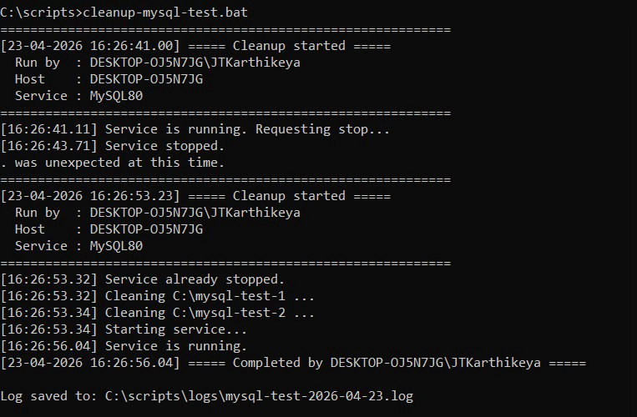

9. Step 6 — Verify the Results
After the script finishes, run these three verification commands in the same CMD window:
sc query MySQL80
dir C:\mysql-test-1
dir C:\mysql-test-2
type C:\scripts\logs\cleanup-*.log

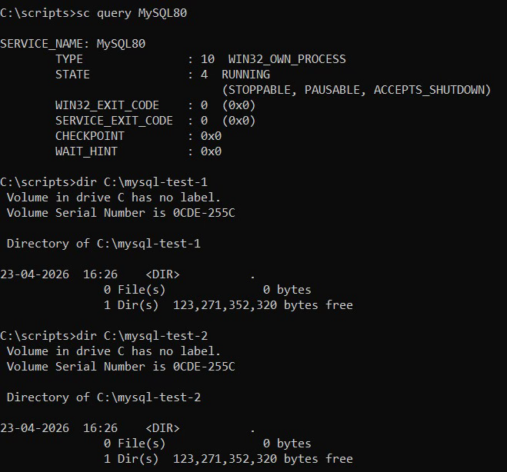

What to confirm
Check | Expected result
sc query MySQL80 | State is 4 RUNNING. MySQL is back up.
dir C:\mysql-test-1 | Folder exists but is empty (0 files).
dir C:\mysql-test-2 | Folder exists but is empty (0 files).
Log file | Contains the same timestamped output you saw in the terminal.

Sanity check your databases (if you had any)
Because the script only touched C:\mysql-test-1 and C:\mysql-test-2, your real MySQL databases under C:\ProgramData\MySQL\...\Data are untouched. To confirm:
mysql -u root -p -e "SHOW DATABASES;"
All your existing schemas should still be listed.

10. Step 7 — Schedule It (Optional)
There are two ways to schedule the script to run automatically every night at 10 PM: a GUI walkthrough using Task Scheduler, or a single command-line call using schtasks. Both create the same scheduled task — pick whichever you prefer.

10a. GUI method — Task Scheduler
- Start → Task Scheduler → Create Task (not “Create Basic Task” — the basic version doesn’t let you tick “highest privileges”).
- General tab:
  - Name: MySQL Nightly Cleanup
  - Select Run whether user is logged on or not.
  - Tick Run with highest privileges ✅.
- Triggers tab → New:
  - Daily, start time 22:00:00.
- Actions tab → New:
  - Action: Start a program.
  - Program/script: C:\scripts\cleanup-mysql.bat.
- Settings tab:
  - Tick If the task fails, restart every 5 minutes (up to 3 times).
  - Tick Stop the task if it runs longer than 30 minutes.
- Click OK. Enter your Windows password when prompted.

10b. CLI method — schtasks one-liner
If you’d rather skip the clicks, open CMD as Administrator and run:
schtasks /Create /TN "MySQL Nightly Cleanup" /TR "C:\scripts\cleanup-mysql.bat" /SC DAILY /ST 22:00 /RL HIGHEST /RU SYSTEM /F
This creates the exact same task in one shot.

What each flag means
Flag | Meaning
/TN "MySQL Nightly Cleanup" | Task name (shown in Task Scheduler).
/TR "C:\scripts\cleanup-mysql.bat" | The program to run.
/SC DAILY | Schedule: once per day.
/ST 22:00 | Start time: 10:00 PM.
/RL HIGHEST | Run with highest privileges (required for net stop).
/RU SYSTEM | Run as the built-in SYSTEM account — no password needed, runs even when no user is logged in.
/F | Force overwrite if a task with this name already exists.

Verify the task is scheduled
Either method produces the same task. Confirm it’s there:
schtasks /Query /TN "MySQL Nightly Cleanup" /V /FO LIST
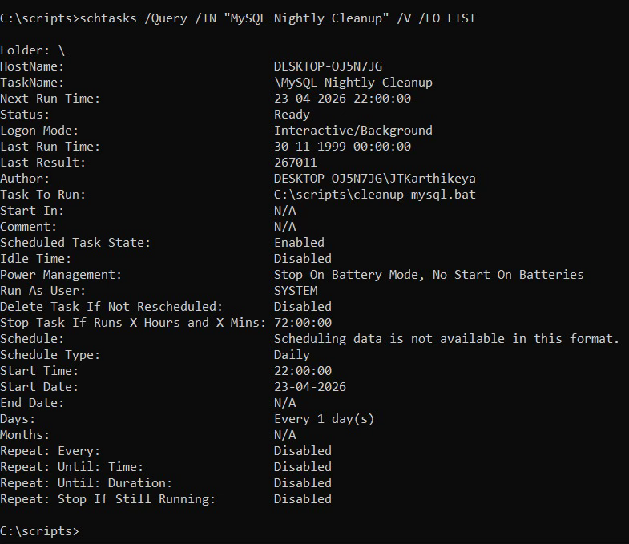
This shows the next run time, account it runs as, and current status.

Test the schedule immediately
Don’t wait until 10 PM — trigger the task manually to make sure the whole scheduled run works:
schtasks /Run /TN "MySQL Nightly Cleanup"
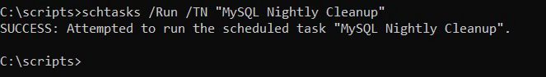
Wait ~30 seconds, then check the log:
type C:\scripts\logs\cleanup-*.log
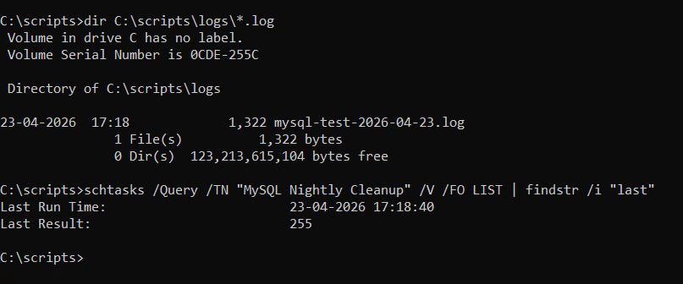
The latest log entry should show the scheduled run, including the Run by line showing NT AUTHORITY\SYSTEM (if you used the CLI method with /RU SYSTEM) or your user account (if you used the GUI).

Remove the schedule later
schtasks /Delete /TN "MySQL Nightly Cleanup" /F
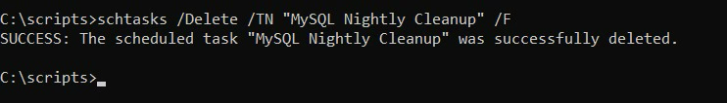

11. Full Script
Save this as C:\scripts\cleanup-mysql.bat.
@echo off
setlocal EnableDelayedExpansion
REM ============================================================
REM MySQL cleanup script
REM 1. Stops the MySQL80 service (waits up to STOP_TIMEOUT sec)
REM 2. Force-kills the process if it will not stop
REM 3. Recursively wipes two folders and recreates them
REM 4. Starts the service again (waits up to START_TIMEOUT sec)
REM Output is written to .\logs\cleanup-YYYY-MM-DD.log
REM Logs older than 7 days are purged automatically.
REM ============================================================
REM --- Logging wrapper: re-invoke self with output redirected ---
if "%~1"=="--inner" goto main
set "LOGDIR=%~dp0logs"
if not exist "%LOGDIR%" mkdir "%LOGDIR%"
for /f %%i in ('powershell -NoProfile -Command "Get-Date -Format yyyy-MM-dd"') do set "DATESTAMP=%%i"
set "LOGFILE=%LOGDIR%\cleanup-%DATESTAMP%.log"
forfiles /p "%LOGDIR%" /m "cleanup-*.log" /d -7 /c "cmd /c del @path" >nul 2>&1
call "%~f0" --inner >> "%LOGFILE%" 2>&1
set "RC=%ERRORLEVEL%"
type "%LOGFILE%"
echo.
echo Log saved to: %LOGFILE%
exit /b %RC%
:main
REM ----- EDIT THESE FOR YOUR MACHINE --------------------------
set "SERVICE_NAME=MySQL80"
set "PROCESS_NAME=mysqld.exe"
set "DIR1=C:\mysql-test-1"
set "DIR2=C:\mysql-test-2"
set "STOP_TIMEOUT=60"
set "START_TIMEOUT=60"
REM ------------------------------------------------------------
echo ============================================================
echo [%date% %time%] ===== Cleanup started =====
echo Run by : %USERDOMAIN%\%USERNAME%
echo Host : %COMPUTERNAME%
echo Script : %~f0
echo Service : %SERVICE_NAME%
echo Process : %PROCESS_NAME%
echo Folders : %DIR1%
echo %DIR2%
echo ============================================================
REM --- Must run elevated ---
net session >nul 2>&1
if errorlevel 1 (
echo ERROR: This script must be run as Administrator.
exit /b 1
)
REM --- Does the service exist? ---
sc query "%SERVICE_NAME%" >nul 2>&1
if errorlevel 1 (
echo ERROR: Service "%SERVICE_NAME%" not found.
exit /b 1
)
REM --- Stop the service if running ---
sc query "%SERVICE_NAME%" | find "RUNNING" >nul
if not errorlevel 1 goto stop_it
echo [%time%] Service already stopped.
goto do_cleanup
:stop_it
echo [%time%] Service is running. Requesting stop...
net stop "%SERVICE_NAME%" >nul 2>&1
set /a WAITED=0
:waitloop
sc query "%SERVICE_NAME%" | find "STOPPED" >nul
if not errorlevel 1 goto stopped_ok
if !WAITED! GEQ %STOP_TIMEOUT% goto forcekill
timeout /t 5 /nobreak >nul
set /a WAITED+=5
echo still stopping... (!WAITED!s elapsed)
goto waitloop
:forcekill
echo [%time%] Service did not stop within %STOP_TIMEOUT%s. Force-killing %PROCESS_NAME%...
taskkill /F /IM "%PROCESS_NAME%" /T >nul 2>&1
timeout /t 3 /nobreak >nul
:stopped_ok
echo [%time%] Service stopped.
REM --- Condition: orphan process after service reports STOPPED ---
tasklist /FI "IMAGENAME eq %PROCESS_NAME%" 2>nul | find /i "%PROCESS_NAME%" >nul
if not errorlevel 1 (
echo [%time%] WARNING: Orphan %PROCESS_NAME% still running. Killing it.
taskkill /F /IM "%PROCESS_NAME%" /T >nul 2>&1
timeout /t 3 /nobreak >nul
)
:do_cleanup
REM --- Clean folders ---
call :clean "%DIR1%"
call :clean "%DIR2%"
REM --- Start the service (with start timeout) ---
echo [%time%] Starting service...
net start "%SERVICE_NAME%" >nul 2>&1
set /a STARTED=0
:startloop
sc query "%SERVICE_NAME%" | find "RUNNING" >nul
if not errorlevel 1 goto started_ok
if !STARTED! GEQ %START_TIMEOUT% goto start_failed
timeout /t 5 /nobreak >nul
set /a STARTED+=5
echo still starting... (!STARTED!s elapsed)
goto startloop
:start_failed
echo ERROR: Service did not reach RUNNING within %START_TIMEOUT%s. Check Event Viewer.
exit /b 2
:started_ok
echo [%time%] Service is running.
echo [%date% %time%] ===== Cleanup completed by %USERDOMAIN%\%USERNAME% =====
exit /b 0
REM ------------------------------------------------------------
:clean
set "TARGET=%~1"
REM --- Path safety guard ---
if "%TARGET%"=="" (
echo ERROR: empty path passed to :clean. Aborting.
exit /b 3
)
if "%TARGET:~3%"=="" (
echo ERROR: refusing to clean drive root "%TARGET%". Aborting.
exit /b 3
)
for %%P in (
"C:\Windows"
"C:\Windows\System32"
"C:\Program Files"
"C:\Program Files (x86)"
"C:\Users"
"C:\ProgramData"
) do (
if /i "%TARGET%"=="%%~P" (
echo ERROR: refusing to clean protected path "%%~P". Aborting.
exit /b 3
)
)
if not exist "%TARGET%" (
echo [%time%] %TARGET% does not exist, creating.
mkdir "%TARGET%"
goto :eof
)
echo [%time%] Cleaning %TARGET% ...
rmdir /S /Q "%TARGET%"
if exist "%TARGET%" (
echo WARNING: Could not fully remove %TARGET% (files may still be locked).
) else (
mkdir "%TARGET%"
)
goto :eof

12. Troubleshooting
Symptom | Likely cause | Fix
'cleanup-mysql.bat' is not recognized | You’re not in C:\scripts\ or the file wasn’t saved. | dir C:\scripts\cleanup-mysql.bat — if missing, re-save from Notepad.
ERROR: This script must be run as Administrator. | CMD wasn’t opened with “Run as administrator”. | Close CMD, right-click → Run as administrator, re-run.
ERROR: Service "MySQL80" not found. | MySQL service is named differently on your machine. | Run sc query \| findstr /i mysql — update SERVICE_NAME= to match the name shown.
Script says Service did not stop within 60s | MySQL is busy with a long-running query. | Either raise STOP_TIMEOUT or accept the force-kill. For production, increase to 300.
ERROR: refusing to clean protected path | You accidentally set DIR1 or DIR2 to a system folder. | Edit the script, use a test-only path like C:\mysql-test-1.
Service did not start back up | Something the script deleted was required by MySQL. | Not the case with test folders. If you ever swap DIR1/DIR2 to real MySQL paths, stop — do not delete Data\.
Empty log file | powershell couldn’t resolve the date. | Check PowerShell is on PATH: where powershell.

Change log
Date | Author | Change
 |  | Initial version.

