Heart Failure Prediction System

- Background/ Problem Statement

According to the World Health Organization, 12 million deaths occur yearly due to heart disease. Load of cardiovascular disease is rapidly increasing all over the world in the past few years. Early detection of cardiac diseases can decrease the mortality rate and overall complications. However, it is not possible to monitor patients every day in all cases accurately and consultation with a patient for 24 hours by a doctor is not available since it requires more patience, time and expertise.
Our Heart Failure Prediction System is intended to assist patients in recognizing their heart state early and receiving treatment at an earlier stage, allowing them to avoid any serious conditions. We have designed this system using the Machine Learning model to predict the future possibility of heart disease by implementing the Logistic Regression algorithm.
The framework used in this project is Django. The Front End involves Html, CSS and JavaScript. The Back End involves MySQL Database. The Back End Language is Python.

- Working of the Project

Our Python-based Heart Failure Prediction System consists of 2 modules: User and Admin.

The user would need to register first to log into the system. For the system to predict if there is heart failure or not, the user would require to give inputs. The parameters include Age, Sex, Chest Pain Type, Resting BP, Cholesterol, Fasting BS, Resting ECG, Maximum Heart Rate, Exercise-induced Agina, Oldpeak, and the slope of the peak exercise ST segment. After the user provides all these inputs, the system will detect if there is any heart disease. The chatbot in the system will inform the user about the causes of heart failure, and the diagnosis test required. It will also provide links to nearby hospitals/clinics that specializes in heart disease. The user can also check out some free checkup camps.

The admin can log in using their credentials. They can view the users using the system. They can also add free checkup camp details.

We have used Logistic Regression to develop this system. It is a significant machine learning algorithm because it can provide probabilities and classify new data using continuous and discrete datasets.

- Advantages

- The system is easy to maintain.
- It is user-friendly.
- Users can search for a doctor’s help at any point in time.
- Very useful in case of emergency.
- They can also look for free check-up camps.

- System Description

The system comprises 2 major modules with their sub-modules as follows:
- User:
● Register:
- The user would need to register first to log in.
● Login:
- The user can log in using their credentials.
● Prediction:
The users have to provide the below inputs for the system to predict if there is any heart failure or not.
- Age: [years]
- Sex: [M: Male, F: Female]
- Chest Pain Type: [TA: Typical Angina, ATA: Atypical Angina, NAP: Non-Anginal Pain, ASY: Asymptomatic]
- Resting Blood Pressure: [mm Hg]
- Serum Cholesterol: [mm/dl]
- Fasting Blood Sugar: [1: if FastingBS > 120 mg/dl, 0: otherwise]
- Resting Electrocardiogram Results: [Normal: Normal, ST: having ST-T wave abnormality (T wave inversions and/or ST elevation or depression of > 0.05 mV), LVH: showing probable or definite left ventricular hypertrophy by Estes' criteria]
- Maximum Heart Rate Achieved: [Numeric value between 60 and 202]
- Exercise-Induced angina: [Y: Yes, N: No]
- Oldpeak: = ST [Numeric value measured in depression]
- ST Slope: The slope of the peak exercise ST segment [Up: upsloping, Flat: flat, Down: downsloping]
The system will predict if there is any heart disease. The output class will be [1: heart disease, 0: Normal]
● Chatbot:
- The user can get to know the causes of heart failure and the diagnosis test required through the chatbot.
- It can also provide links to nearby hospitals/clinics that specialize in heart disease.
● View Free Checkup Camps:
- The user can look for Free Check-up Camps.

- Admin:
● Login:
- The admin can log in using their credentials.
● View Users:
- The admin can view the list of users.
● Add free checkup camps details:
- The admin can add free checkup camp details.

- Project Life Cycle

The waterfall model is a classical model used in the system development life cycle to create a system with a linear and sequential approach. It is termed a waterfall because the model develops systematically from one phase to another in a downward fashion. The waterfall approach does not define the process to go back to the previous phase to handle changes in requirements. The waterfall approach is the earliest approach that was used for software development.

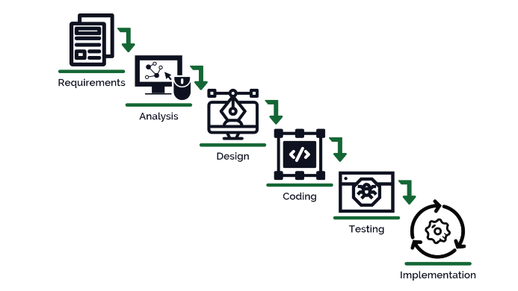

- System Requirements

- Hardware Requirement

- Laptop or PC
- Windows 7 or higher
- I3 processor system or higher
- 4 GB RAM or higher
- 100 GB ROM or higher

- Software Requirement

- Laptop or PC
- Python
- Sublime Text Editor
- XAMP Server

- Limitations/Disadvantages

- The system is not fully automated, it needs data from the user for a full diagnosis.
- If a user enters any wrong input, the system will produce inaccurate results.

- Application

- This application can be used by all patients or their family members who need help in an emergency.

- Reference

- https://www.academia.edu/42249626/Mini_Project_Report_On_Heart_Disease_Prediction_
- https://www.researchgate.net/publication/331589020_Heart_Disease_Prediction_System
- https://cse.anits.edu.in/projects/projects2021C3.pdf
- http://www.smkfomra.net/announcement-files/CSE-1643970050.pdf
- https://www.irjet.net/archives/V7/i4/IRJET-V7I4993.pdf

