ASSIGNMENT 1

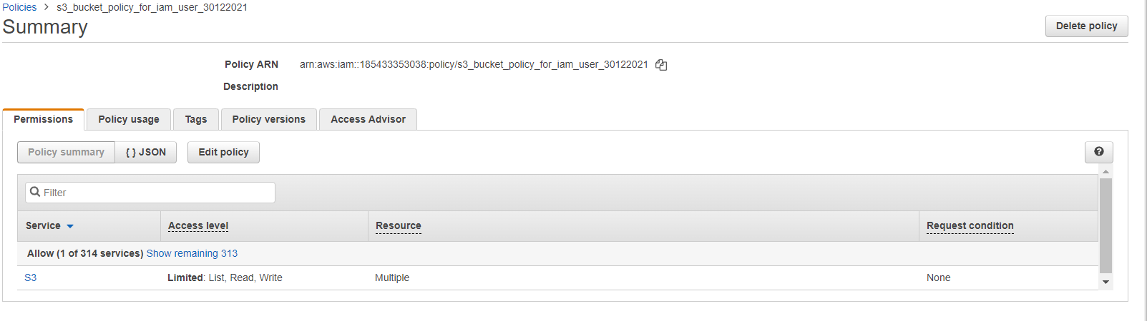

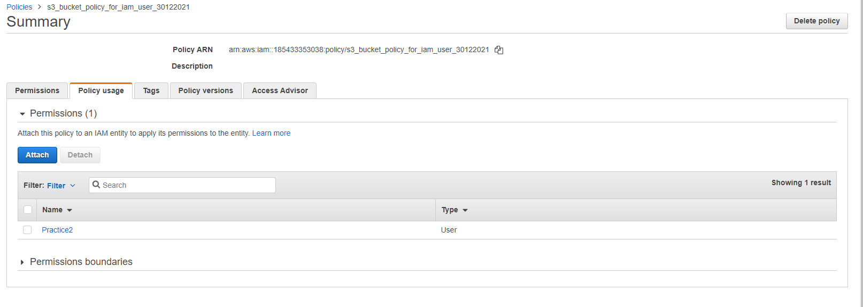

ASSIGNMENT 2

EC2 INSTANCE

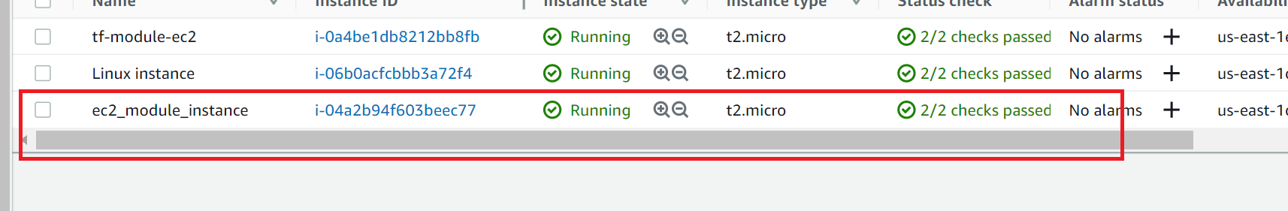

VPC



SUBNET



INTERNET GATEWAY



NAT GATEWAY



SECURITY GROUP

