Phishing Detection & Awareness Report
Name : TIRUMANI DIVYA SRI
Task : Phishing Email Analysis.

1.Introduction
Phishing is a cyber attack where attackers send fake emails pretending to be trusted companies. The goal is to trick users into revealing sensitive information such as usernames, passwords, or financial details.
2. Phishing Email Sample
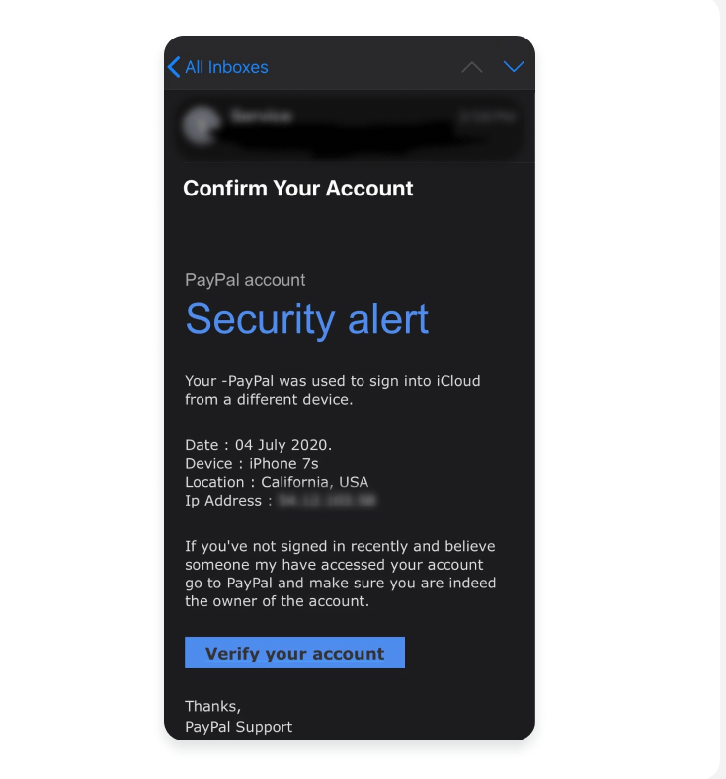
Example phishing email pretending to be from PayPal asking the user to verify their account.
3. Email Header Analysis
Email headers contain technical information about the sender and mail servers used to deliver the email. Security analysts examine headers to detect spoofed or suspicious email sources.
4. Sender Domain and Link Inspection
Phishing emails often include links that lead to fake websites designed to steal login credentials. Attackers use domain names that look similar to legitimate company domains to trick users.
5. Phishing Indicators
• Urgent language like Security Alert
• Suspicious login notification
• Fake device and IP information
• Request to verify account
• Possible malicious link
6. Evidence and Screenshots
1.
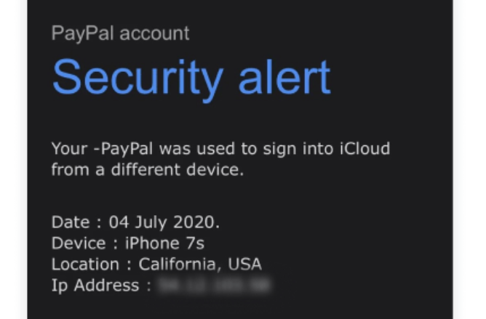
2.


3.


4.

These screenshots highlight suspicious elements present in the phishing email.
7. Email Risk Classification
Risk Level: PHISHING
This email contains multiple phishing indicators and attempts to trick users into verifying account information through a suspicious link.
8. Prevention Guidelines
• Always verify sender email address
• Avoid clicking suspicious links
• Enable two-factor authentication
• Report suspicious emails
9. Conclusion
This analysis identified several phishing indicators within the email. Users should remain cautious when receiving security alerts and always verify email authenticity before taking action.

