**MCQs and Descriptive Questions Generation for PDFs and MCQs generation for videos**

**Introduction:**

This project is for generating MCQs and descriptive questions out of a PDF. The user selects the number of MCQs and descriptive questions for each chapter, and based on that the number of MCQs and descriptive questions are generated for each chapter. The user also gets options to whether to choose all the chapters of the PDF or for only specified chapter.

Similarly, the other project is to generate MCQs out of a video. The user uploads a video, and a summary is generated out of the given video, and then the user selects the number of MCQs to be generated. Those number of MCQs are generated for that particular video.

**Content Types:**

|  |  |
| --- | --- |
| **Contents** | **Page** |
| Title | 1 |
| Introduction: | 1 |
| Technology: | 2 |
| Key features: | 2 |
| User Manual | 2-10 |

**Technology:**

|  |  |
| --- | --- |
| **Layer** | **Technology** |
| Backend | Python, Llama 3 |
| Frontend | HTML, CSS, and JavaScript |
| Database | MySQL |
| Authentication | Session based login |
| Server | Localhost (development environment) |

**Key Features:**

* To generate MCQs and descriptive questions for a PDF and MCQs for a video.
* To generate descriptive answers as well as answer for a n MCQ.
* Generated questions are level based from 1-5
* There are options to download the questions as a document, excel and a csv file.
* The user can generate a question paper out of the questions generated by giving the number of questions to be generated for each level.

**Main Page:**

This is the main page. Generate Questions from PDFs icon is for generating MCQs and descriptive questions from PDFs. Generate questions from video is for generating MCQS from the video. View saved questions is for viewing the database entries and generating question paper out of those entries for each level. Multilingual video generator and text summarizer are different projects which lead to different pages.

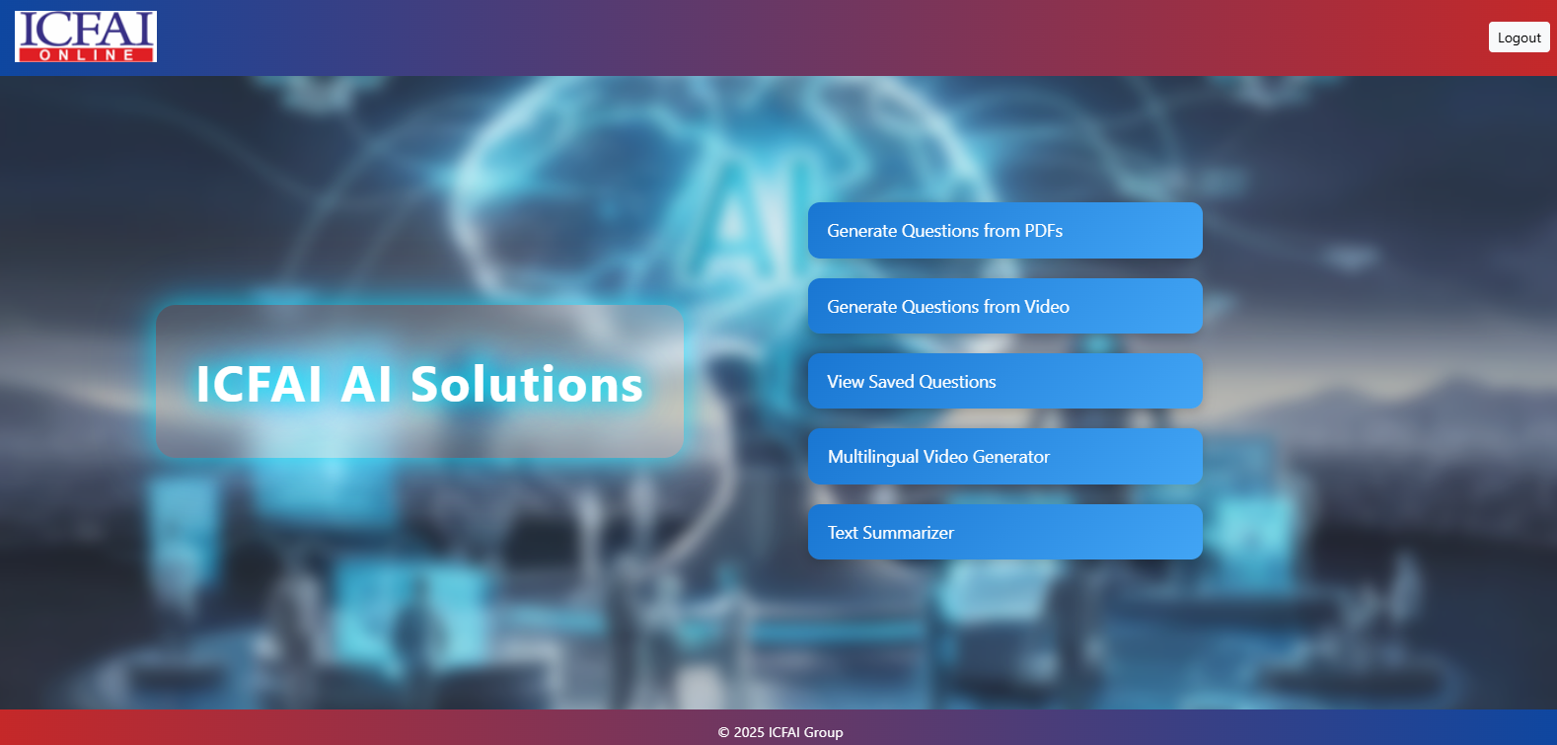

**Generate Questions From a PDF:**

The user uploads a PDF and gets to choose whether to generate the number of MCQs or Descriptive questions or both. He also gets to choose whether to generate questions using AI model or using content from the text book. After choosing all the required options the user clicks on generate MCQS button to generate the questions and answers too.

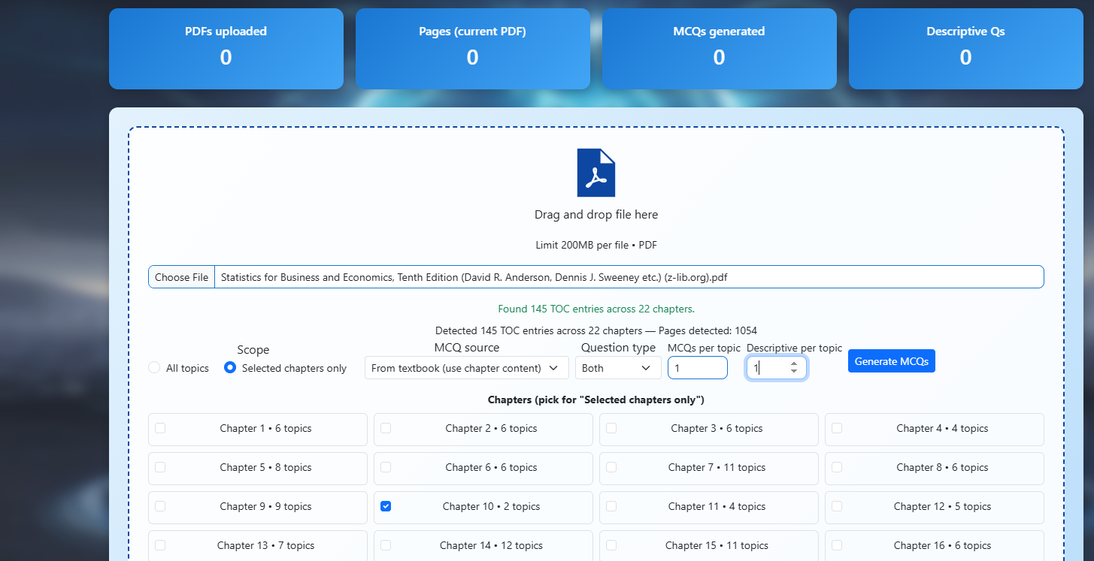

**Generated Output From a PDF:**

This is how the output comes in the page based on the selected questions for each topic of that particular chapter. The user can download the generated questions and answers as a PDF or an Excel or a CSV.   
  
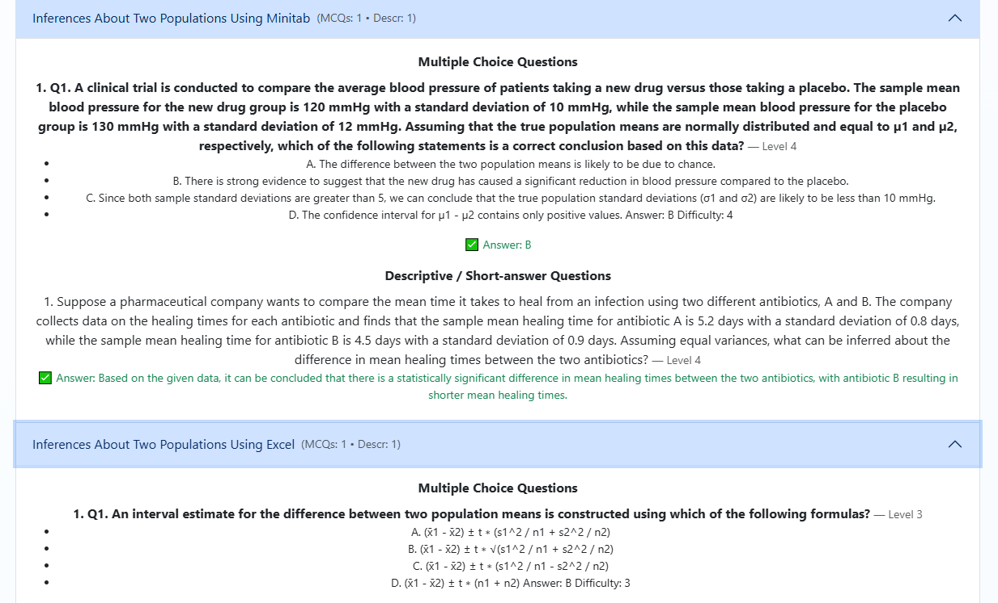



**Generate Questions From a Video:**

The user uploads a video and selects the transcribe button to get the text from the video and generate a summary from the transcription. Once the transcript is generated a summary is generated from it and the output looks like how it is given in the below image.

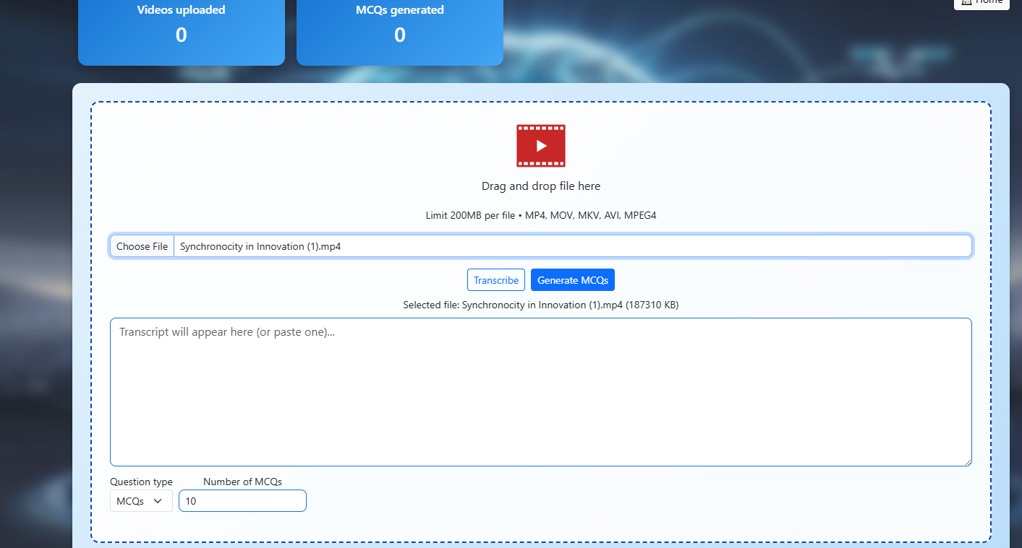

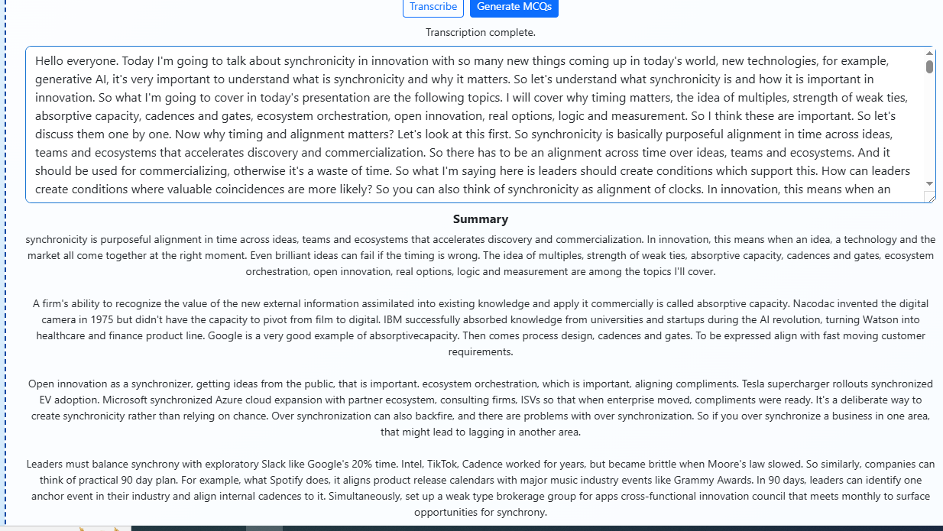

**Generated Output From a Video:**This is the output for the MCQs generated for the video after the summary is generated from the video.

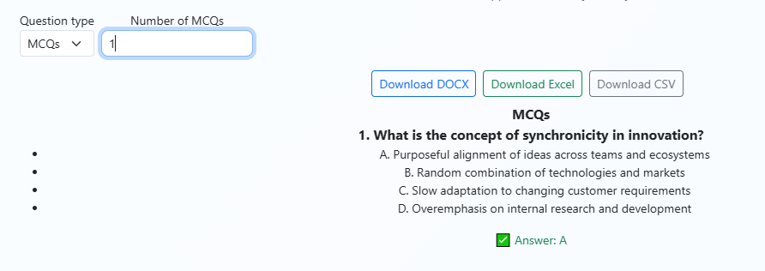

**View Saved Questions:**

When the user clicks this icon, it shows the database entries in it and provides the option for the user to generate a question paper by giving the number of questions for each level.

