**Create or update your LinkedIn profile. Provide a screenshot of your profile page in a PDF submission.**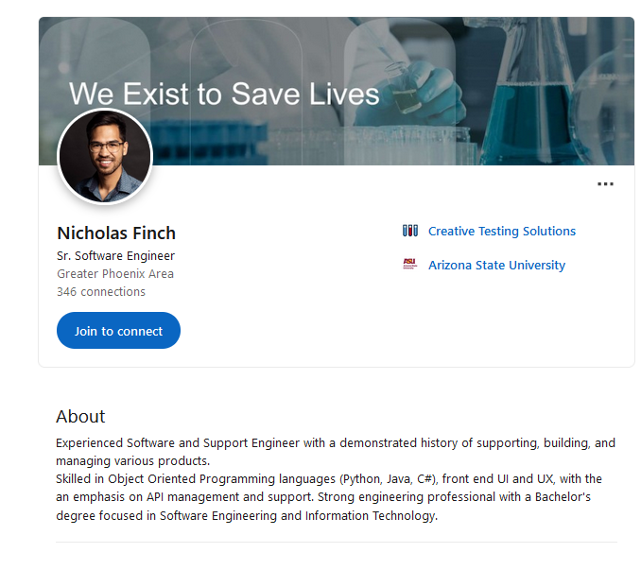  
  
**URL to GitHub Repository:**<https://github.com/tisaconundrum2/promineotech/tree/main/Week-01-CLI_Source_Control_and_Variables>

**URL to Your Coding Assignment Video:**<https://youtu.be/Q3JI2Sa5F5Y>

**Instructions:**

* In Visual Studio Code, write the code that accomplishes the objectives listed below and ensures that the code compiles and runs as directed.
* Create a new repository on GitHub for this week’s assignments and push this document, with your project code, to the repository.
* Include the URLs for this week’s repository and video where instructed.
* Submit this document as a .PDF file in the LMS.

**Assignment Steps:**

* ­­The link below has a zipped file that contains an empty directory (folder) for yourassignments.
* Download the file to your computer and unzip it.
* This directory (folder) should be used to organize each week’s projects in the course.

<https://drive.google.com/file/d/1WDc_WJ8I0MfwbrbmtMsxHdTpupZsPjXT/view>

* Following the Git/GitHub tutorial in your week 0 video:
  + Create a directory (folder) inside **Week 01 - CLI, Source Control, and Variables**
  + Create a repository on the GitHub website.
  + **Push** your directory of files to GitHub as instructed in the video.
  + After your first push, please ensure that you make some changes to your directory (folder), such as adding a new file or changing your code.
  + **Push** those changes to your repository a second time (as shown in the video).

<https://www.youtube.com/watch?v=NGeksLUB1e8>

* When complete, paste a screenshot of your terminal or command prompt that shows.

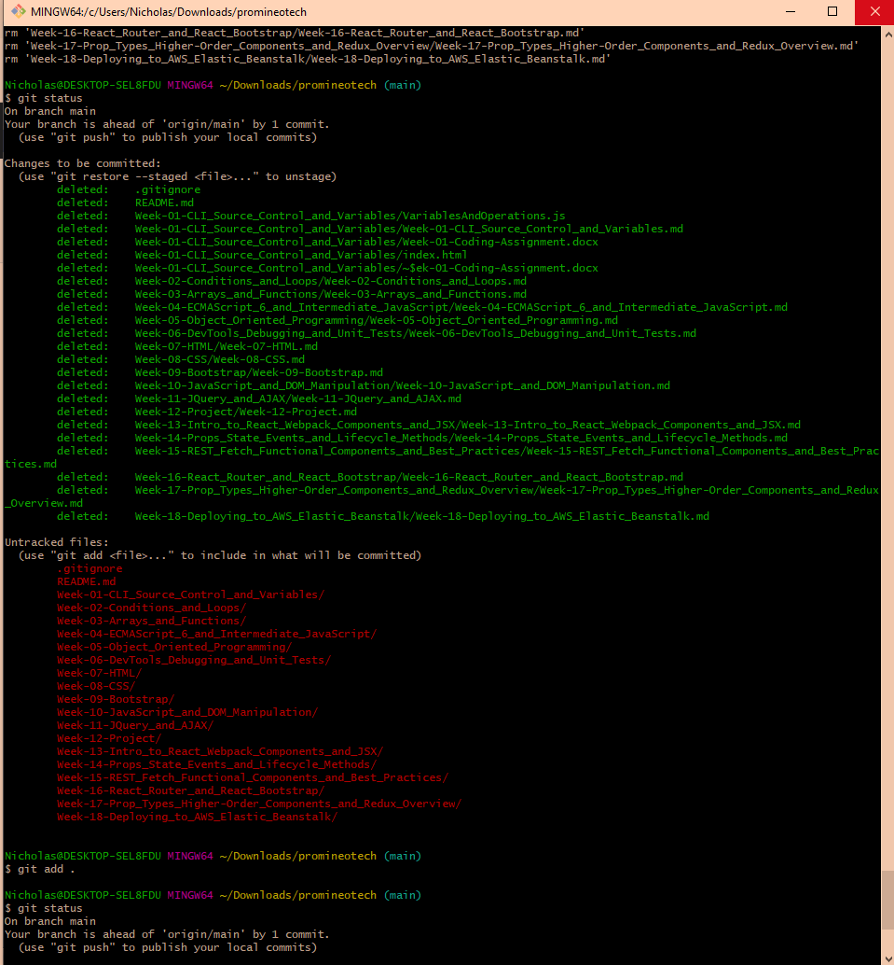

**Video Steps:**

* Create a video, up to five minutes max, showing and explaining how your project works with an emphasis on the portions you contributed.
* This video should be done using screen share and voice over.
* This can easily be done using Zoom, although you don't have to use Zoom, it's just what we recommend.
  + You can create a new meeting, start screen sharing, and start recording.
  + This will create a video recording on your computer.
* This should then be uploaded to a publicly accessible site, such as YouTube.
  + Ensure the link you share is**PUBLIC** or **UNLISTED**!
  + If it is not accessible by your grader, your project will be graded based on what they can access.