Token & Positional Embeddings in the Transformer
A ground-up study note
Table of Contents

Token & Positional Embeddings in the Transformer
A ground-up study note — L2 norms, the 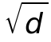 scaling, sinusoidal vs. learned encodings
Built from a working session that started with one suspicious line of code and unwound every assumption behind it: what an L2 norm is, why a random vector’s length lands near , why 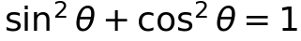, how positional encodings store position, and whether the token embedding and the positional encoding are magnitude-compatible. Revisit this whenever the concepts need rebuilding from scratch.

1. The starting point: two modules and one worry
A transformer turns a sequence of token IDs into vectors in two steps that are then added together:
Because the two are added, a single principle governs everything in this note: their magnitudes must be comparable, or the larger one drowns out the other. “Magnitude” here means the L2 norm of each vector. The whole session was an attempt to make that one sentence precise.
The two modules under study:
- TokenEmbedding — a learned lookup table, scaled by .
- LearnedPositionalEncoding — a learned lookup table indexed by position.
The thread of the whole note. Token embedding norm 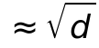, positional encoding norm  (learned) or exactly 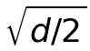 (sinusoidal). Same order of magnitude 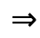 neither signal erases the other when they are summed.

2. What an L2 norm is
The L2 norm (Euclidean norm), written  or 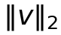, is the length of a vector — the straight-line distance from the origin to the point it represents. For 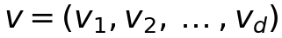:
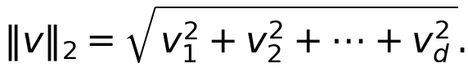
The “2” is the 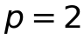 case of the general 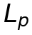 norm 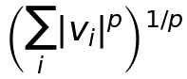. It is just the Pythagorean theorem generalized from two dimensions to 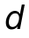: square each coordinate, add, take the square root.
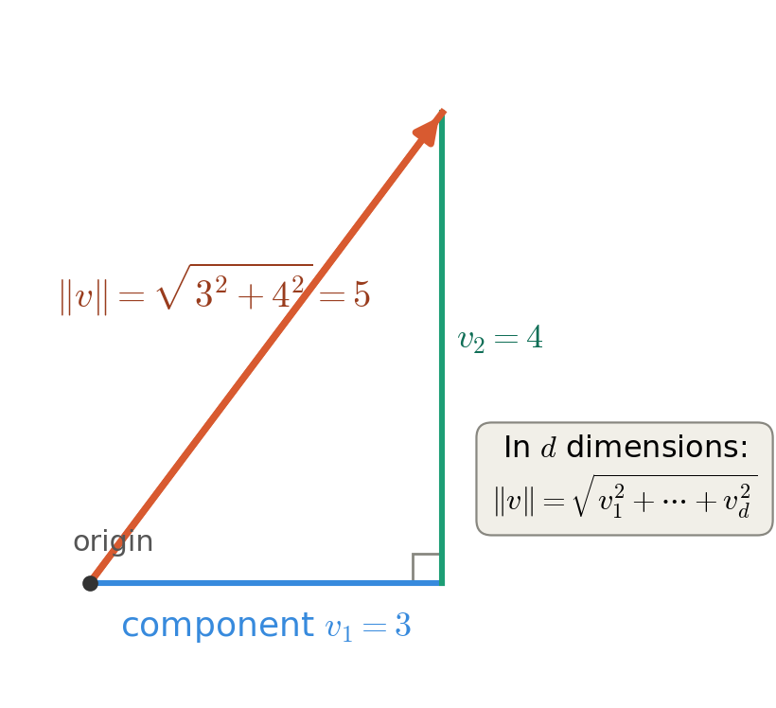
The L2 norm is the length of the vector. In two dimensions it is the hypotenuse of a right triangle with legs equal to the components; in  dimensions it is the same recipe with more terms under the root.

3. Why a random vector’s norm lands near 
This single fact is used everywhere below, so it is worth deriving carefully.

3.1 The hidden identity: 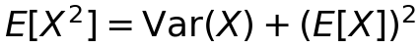
The step people skip is that the expected value of the square is not the square of the expected value. The exact gap between them is the variance. Starting from the definition of variance and expanding:
Rearranging gives the master identity:
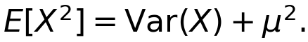

3.2 Applying it to an embedding row
PyTorch’s default nn.Embedding init draws each entry from 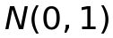, so 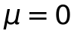 and 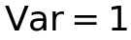, hence 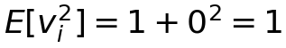. By linearity of expectation (no independence needed),
If instead each entry is drawn from 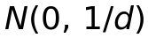, then 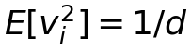, so 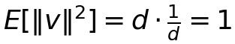 and 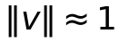.
One-line intuition. 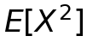 is the average squared distance from zero; 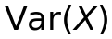 is the average squared distance from the mean. When the mean is zero, they coincide — which is why a zero-mean variable has 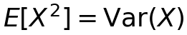.

3.3 Why  specifically: norm follows dimensionality
The deeper reason the answer is  rather than any other number: the norm of a vector grows as 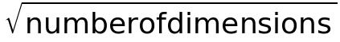 whenever each dimension contributes a roughly fixed amount of “energy.” It is the Pythagorean theorem at scale — doubling the dimensions multiplies the norm by only 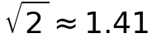, not by .
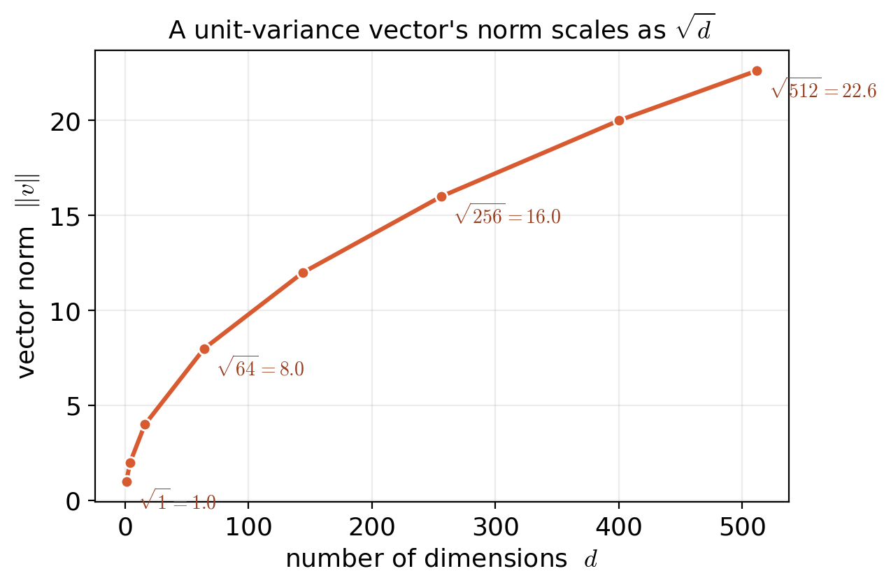
Norm versus dimension count for unit-variance components. The sub-linear  growth is why the scaling factor used later is , not .

4. The  scaling of the token embedding
The original transformer (Attention Is All You Need, §3.4) multiplies the token embeddings by . A faithful implementation pairs this with an initialization at variance 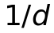:
- Initialize weights with standard deviation 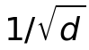, i.e.   row norm 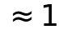.
- Multiply the output by   row norm .

4.1 The bug this avoids
With PyTorch’s default  init, the rows already have norm . Multiplying by  then overshoots to norm 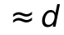 — a factor of  too large. At 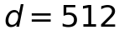 that is a norm of 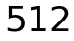 against a sinusoidal PE’s 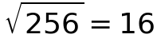: the token signal buries the positional one by a factor of 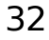.
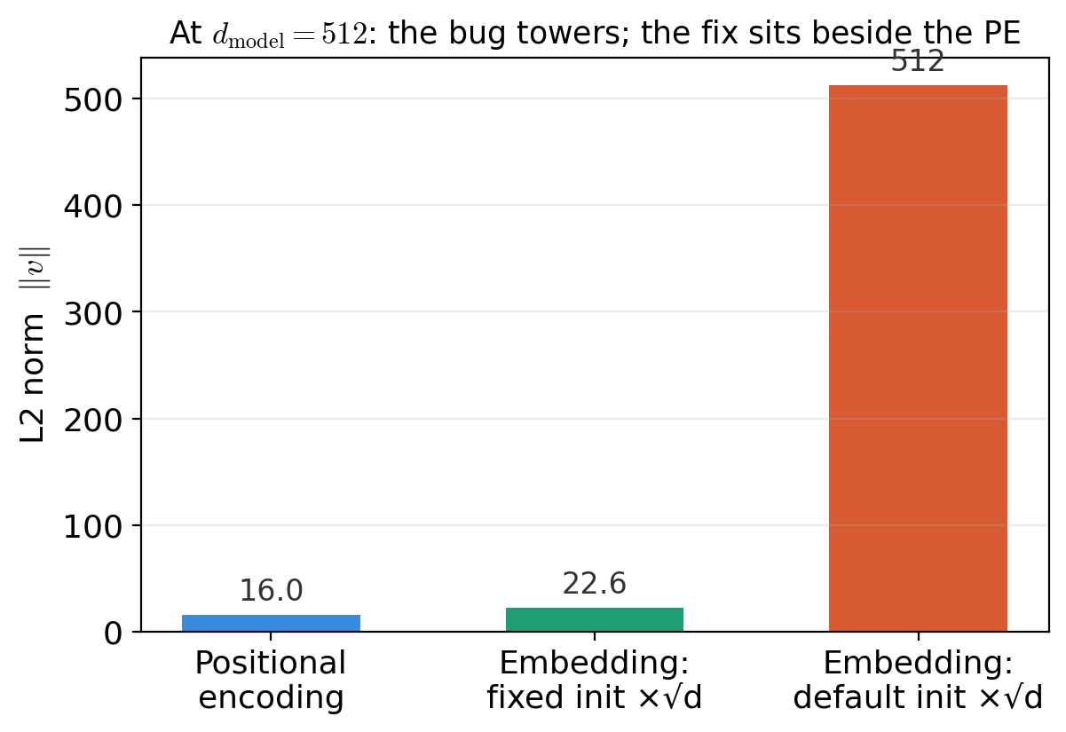
Three regimes at . The bug (default init 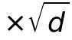) reaches norm  and dwarfs the positional encoding; the fix (variance- init ) lands at 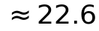, right beside the PE.
Documentation caveat. A stale inline comment claimed the overshoot drowns the PE “~12×.” The true factor is , which is  at  (the “12” only fits 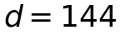, since 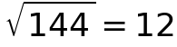). The factor varies with the model dimension and should be written 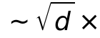.

4.2 “Scale down then scale up” — is it a pointless round trip?
A natural objection: the init scales the rows down to norm , and the forward pass scales them back up to . For this module’s output alone, the two exactly cancel. The reason it is not redundant is weight tying: the same stored matrix is reused as the output projection that produces logits,
and the output path does not multiply by .
- As the output projection, the matrix should sit at the small scale (norm ); otherwise the logit dot-products are  times too large and saturate the softmax at initialization.
- As the input embedding, it should sit at norm  to match the positional encoding.
The resolution: store the matrix at the small scale (good for the output side) and apply the  correction only on the input path. The down-scale is the resting state of the shared parameter; the up-scale is a local fix-up the output path skips. A second, subtler non-cancellation: the multiply also rescales the gradients reaching the embedding, changing its effective learning rate — so even untied, “the output is identical” is not quite the whole story once training begins.
Verdict. The recipe is meaningful exactly when the embedding weight is tied to the output head. If the weights are not tied, the down-then-up scaling is a genuine no-op for this module, and you should either tie them or drop the recipe.

5. Sinusoidal positional encoding from the ground up

5.1 What it is
Attention is order-agnostic — to it, “the cat sat” and “sat cat the” are the same bag of words. So we inject position by adding a position-dependent vector to each token. For position 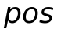, the sinusoidal encoding builds a -long vector whose entries alternate sine and cosine, each pair at its own frequency:
Dimensions 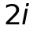 and 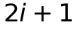 share the same frequency 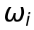 — one sine, one cosine. They are a matched pair. Early pairs wiggle fast; later pairs wiggle slowly.
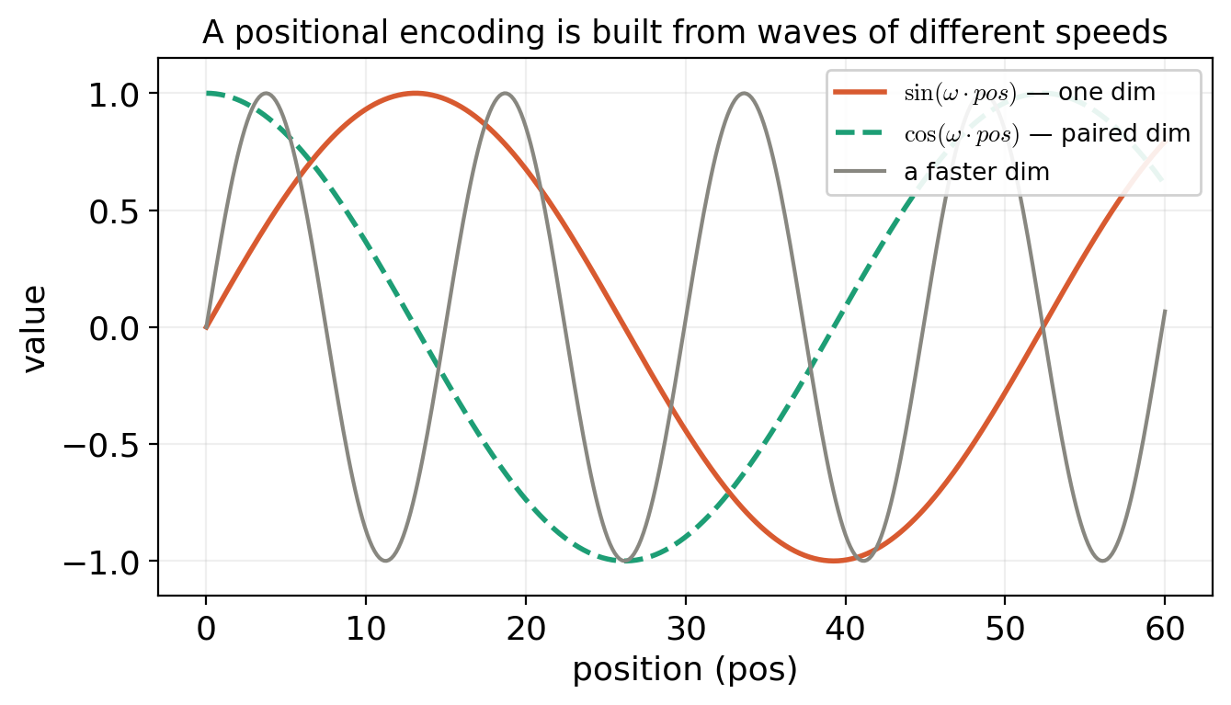
Each PE entry is a sine or cosine of the position. A sine and its paired cosine share a frequency (a quarter-cycle apart); other dimensions use faster or slower frequencies.

5.2 The load-bearing identity: 
A frequent confusion: it is the squared sum that equals , not 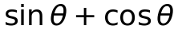. Numerically, at 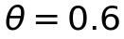: (not ), whereas .
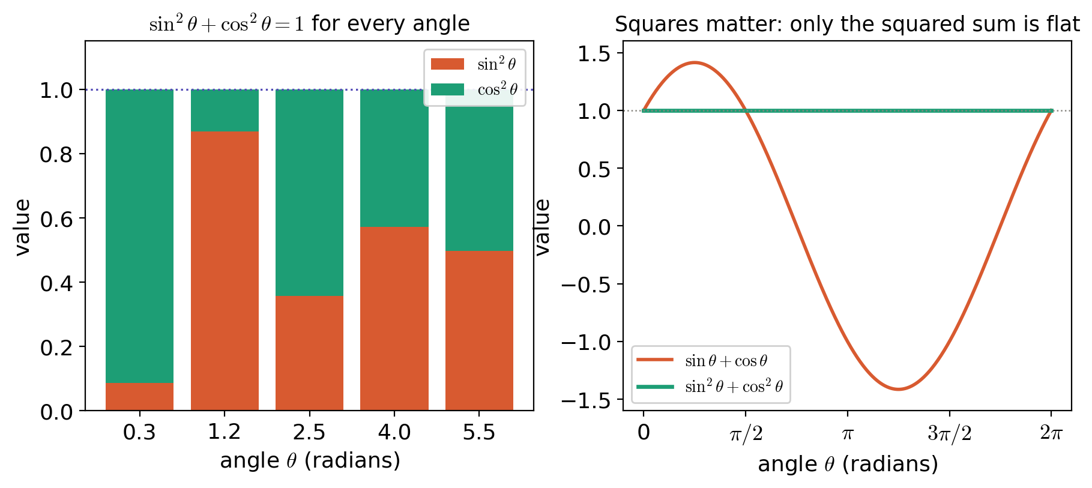
Left: for any angle, 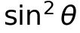 and 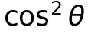 stack to exactly . Right:  (no squares) wanders between 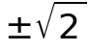 and only crosses at isolated points; only the squared sum is flat at .
Why is the squared version always ? It is the Pythagorean theorem in disguise. With 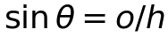 and 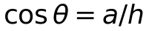 in a right triangle,
since 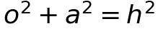 by Pythagoras. Equivalently: the point 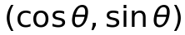 lies on the circle of radius , so its squared distance from the origin is .
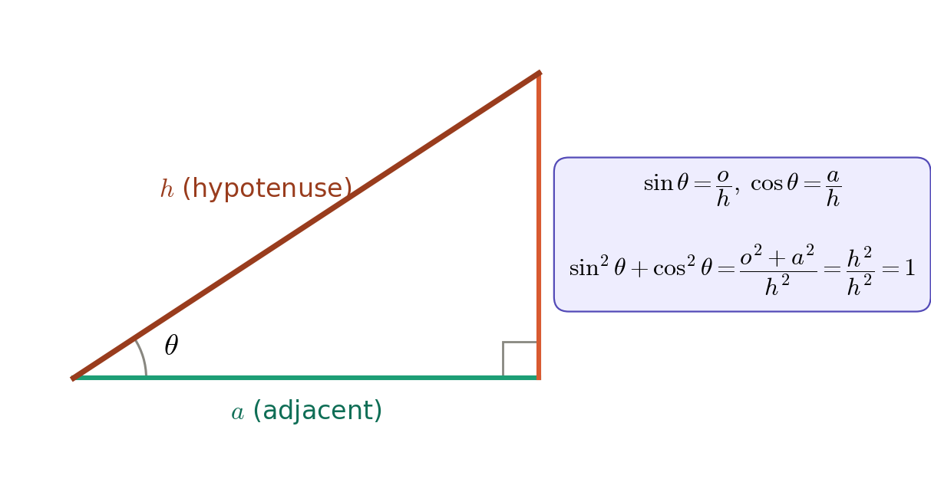
The identity is the Pythagorean theorem divided through by 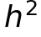.
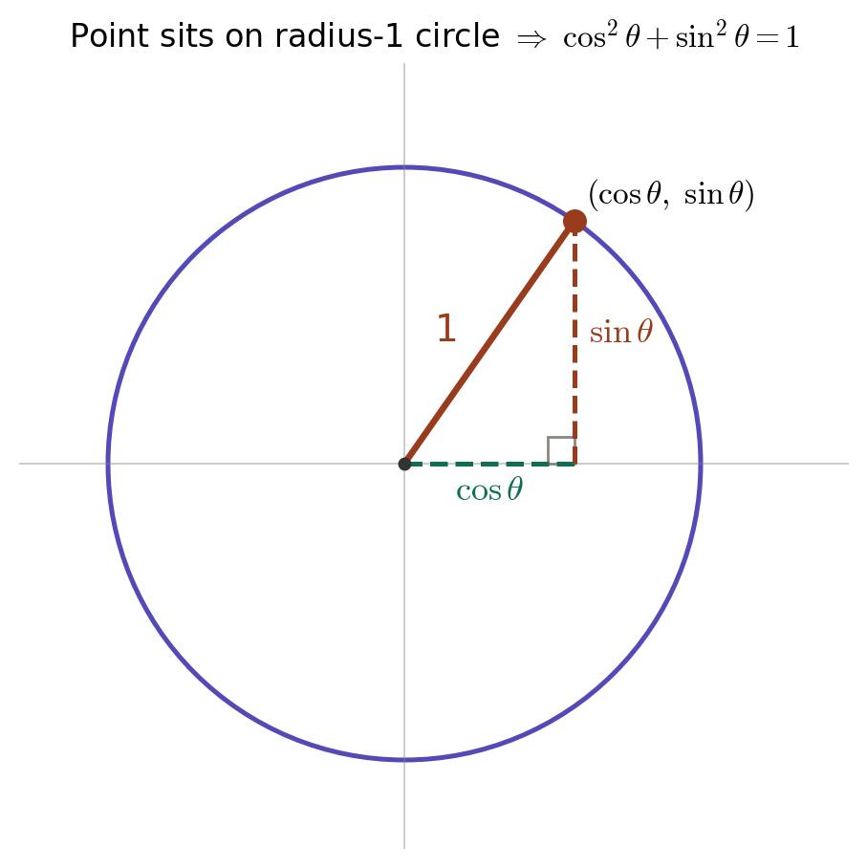
The unit-circle view: 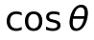 and 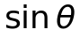 are the coordinates of a point on a circle of radius ; the radius is the fixed hypotenuse, so 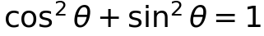 always.

5.3 The norm: 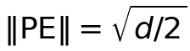
Stringing it together: the L2 norm needs the sum of the squares of all entries. Group them into the 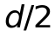 sine–cosine pairs. Each pair contributes exactly . Therefore
so . This is exact, and identical for every position. (An equivalent “mean-square ” argument: each individual entry’s square averages to via 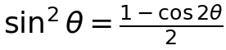, so  entries give . The pairing argument is cleaner because it needs no averaging.)

5.4 Same length, different direction: how position is stored
Because every positional vector has the same length , they all lie on one sphere (a circle in 2-D, a hypersphere in -D). What differs between positions is only the direction the vector points. The smallest case 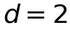 makes this literal: is a point that rides around the unit circle as  advances — the radius is locked, the angle is the position.
Using many frequencies (like clock hands at different speeds) avoids the wrap-around of a single circle: fast hands distinguish nearby positions, slow hands keep far-apart positions distinct, and the combination of all hand-angles pins down each position uniquely — while every hand keeps a fixed length, so the total norm stays fixed.
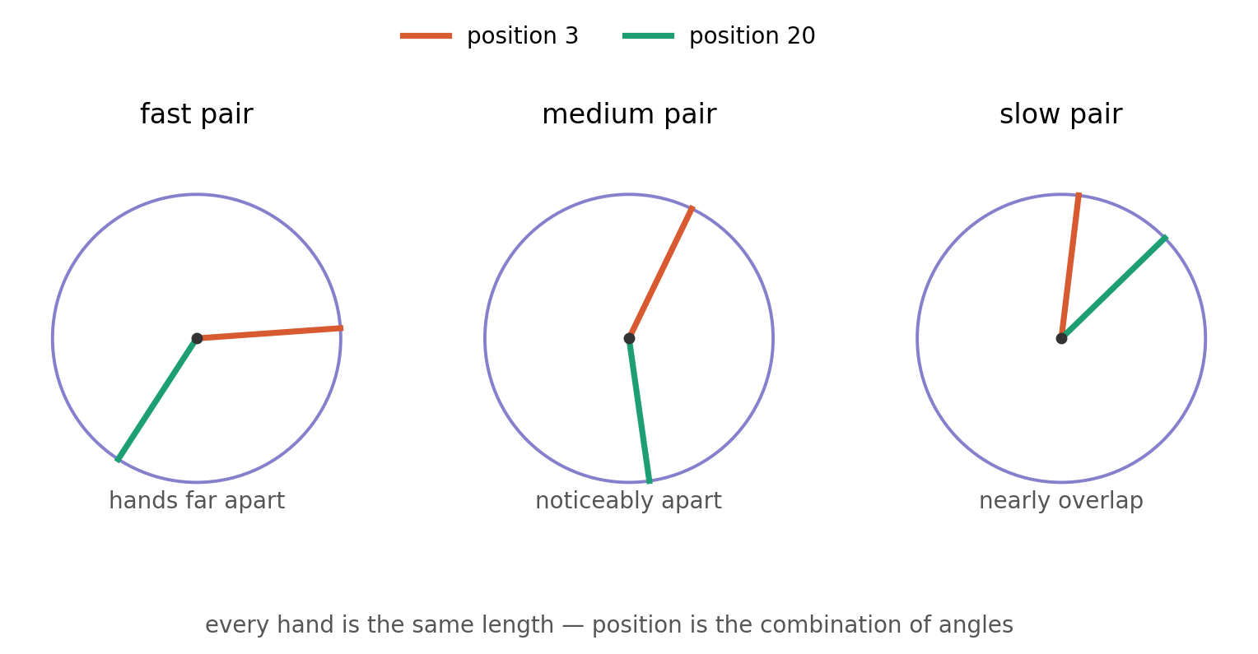
Two positions on three frequency dials. The fast hand swings far between positions and 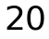; the slow hand barely moves. Position is the combination of angles; all hands keep equal length, so the total magnitude is unchanged.

6. Learned positional encoding
The learned variant replaces the fixed  formula with a trainable lookup table: nn.Embedding(max_seq_len, d_model). Row is the (learned) positional vector for position .

6.1 L2 norm: same recipe, different numbers
The norm is still 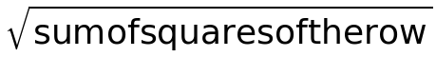 — but the numbers are learned parameters, so there is no closed-form value. Two regimes:
- At initialization, PyTorch fills the table from , so by the 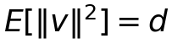 result, each row has norm . Unlike sinusoidal, this is not exact — each row is a different random draw, so the norms scatter. The squared norm follows a 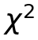 distribution with  degrees of freedom (mean ), and the norm itself concentrates around  with a standard deviation of only 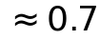, almost independent of .
- After training, backprop is free to lengthen or shorten each row independently; the tidy bell smears out and different positions can take different lengths. No identity holds anything fixed.
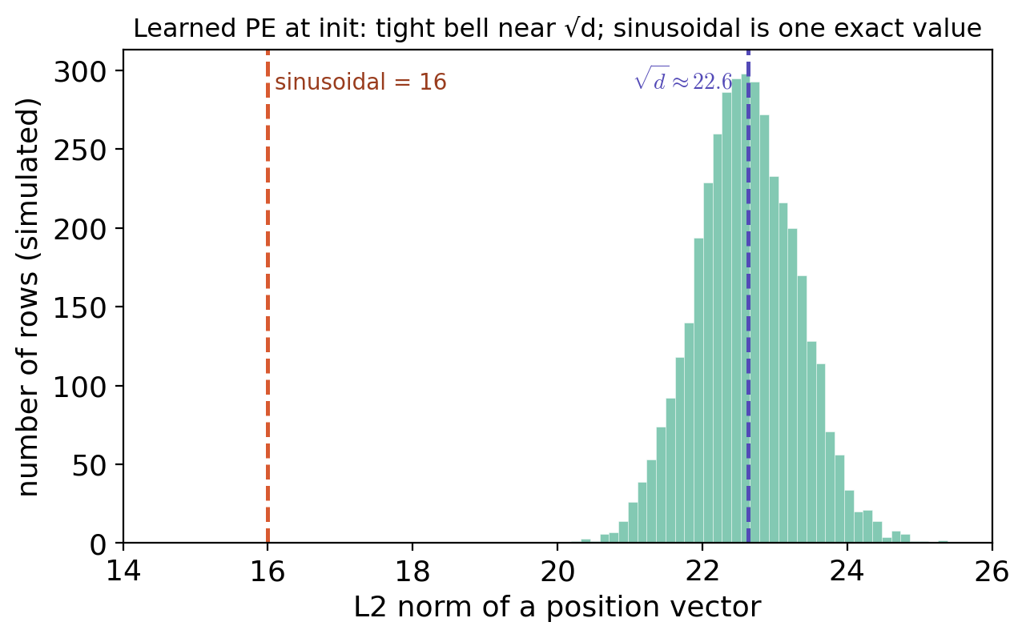
Simulated L2 norms of 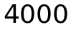 random -dimensional rows. They form a narrow bell around 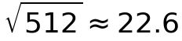 — a fuzzy shell, not the razor-thin single value 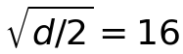 that sinusoidal encoding would give.

6.2 What the forward method does, step by step
For an input x of shape (batch, seq_len):
- seq_len = x.size(1) — read only the sequence length; the token ID values are ignored (position cares where, not what).
- positions = torch.arange(seq_len, device=x.device) — build the index list 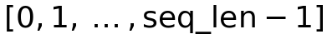 on the same device as x.
- self.position_embedding(positions) — look up those rows, giving shape (seq_len, d_model).
- .unsqueeze(0) — add a leading dimension to get (1, seq_len, d_model) so the same positional vectors broadcast across every sentence in the batch.
Edge case. The table has exactly max_seq_len rows. If an input arrives with seq_len > max_seq_len, arange produces indices past the end of the table and the lookup throws an index error — this scheme only handles sequences up to the length it was sized for. Sinusoidal encoding, by contrast, is defined for any position.

7. Are the two modules magnitude-compatible?
Putting the corrected TokenEmbedding next to the LearnedPositionalEncoding:
- Token embedding: init std 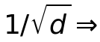 row norm ; forward 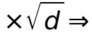 output norm .
- Learned PE: default  init  row norm ; returned raw (no scaling).
Both land at . At  that is  each — a 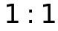 match, even tighter than the token-plus-sinusoidal pairing the docstring was written for ( vs. , a 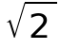 gap).
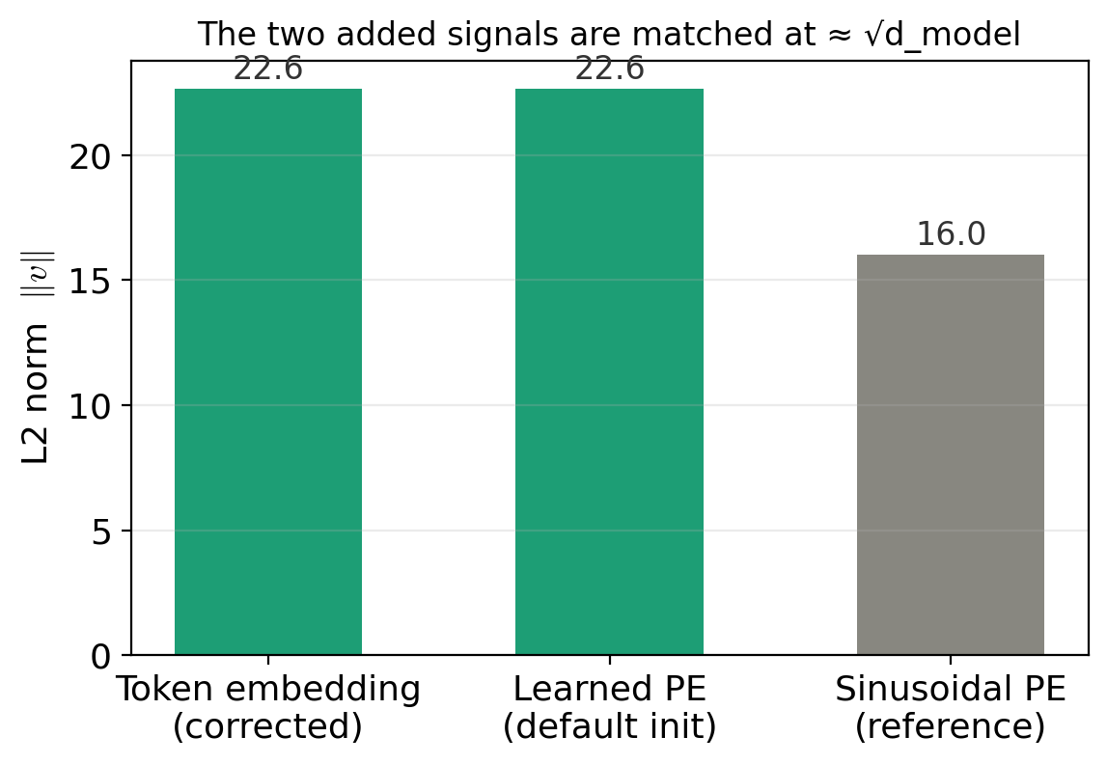
At  the token embedding and the learned positional encoding sit at the same norm . The sinusoidal value 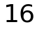 is shown for reference.
Answer: yes, at initialization. Three caveats: (1) it is an initialization-time, in-expectation statement — the learned PE drifts freely during training (which is fine; the model self-corrects); (2) both norms have 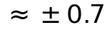 scatter; (3) the token-embedding docstring still references sinusoidal  and the stale “12×”, which describe a different partner than the learned PE actually wired up here. None of these are code bugs — they are documentation fixes plus the reminder that the match is a starting condition, not a guarantee.

8. One-page summary
The logical chain, end to end.
- L2 norm 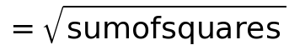 — the length of a vector.
- A vector of  unit-variance entries has , so 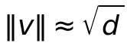 (from 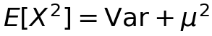).
- Token embedding: init at variance  (norm ), then  norm . The down-then-up is non-trivial only under weight tying.
- Sinusoidal PE: entries are  pairs; each pair’s squares sum to (Pythagoras), and  pairs give norm exactly , identical for every position; position is encoded in direction, not length.
- Learned PE: same norm recipe on learned parameters;  at init (tight 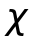 bell), free after training; capped at max_seq_len.
- Compatibility: corrected token embedding () and learned PE () are matched 1:1 at init — neither drowns the other.
Reference: Vaswani et al., Attention Is All You Need (2017), §3.4 for the  scaling and the sinusoidal positional encoding formula.

