Attention from the ground up
Masking, scaled dot-product attention, the dot product, and multi-head mechanics
A revision reference · built from a working-through of the Transformer attention code · 22 diagrams
How to use this document. Each chapter builds from intuition to mechanics to the exact shapes. The diagrams are the load-bearing part — skim the figures first, then read the prose around any that need unpacking. Code-level pitfalls are collected in Chapter 6, and a one-page cheat sheet closes the document.

Contents

1 Masking: hiding what attention must not see
Before attention can run, we often need to forbid certain query–key connections. Two masks do this: the padding mask (hide filler tokens) and the causal mask (hide the future). Both work the same way mechanically — they add 0 to allowed scores and −∞ to forbidden scores before the softmax.

1.1 Why padding exists, and what the mask does
Transformers process sequences in batches, but real sentences differ in length. To pack them into one rectangular tensor, shorter sequences are extended with a special <pad> token up to the longest length in the batch. Those pad tokens carry no information — they are just filler so the shapes line up.
The danger is that attention, left unchecked, would happily attend to those pad positions and let their meaningless values leak into the real tokens. create_padding_mask builds a vector that is 0 at real positions and −∞ at pad positions.
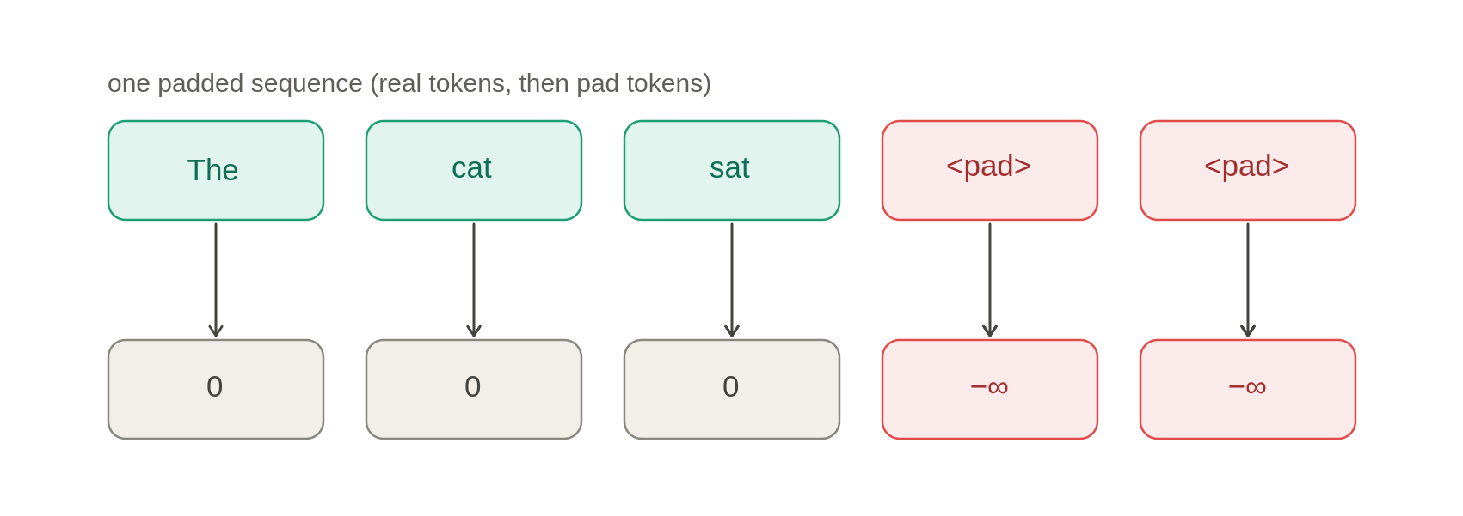
Figure 1. A padded sequence maps to a mask: 0 at real tokens, −∞ at pad tokens.

1.2 How the mask acts on attention
Attention computes a score for every (query, key) pair. The mask is added to these scores before softmax. Where the mask is 0, the score is unchanged; where it is −∞, the score becomes −∞, and since softmax exponentiates, e^(−∞) = 0. So pad keys get exactly zero weight. The mask is one row vector over the key dimension, added identically to every query row:
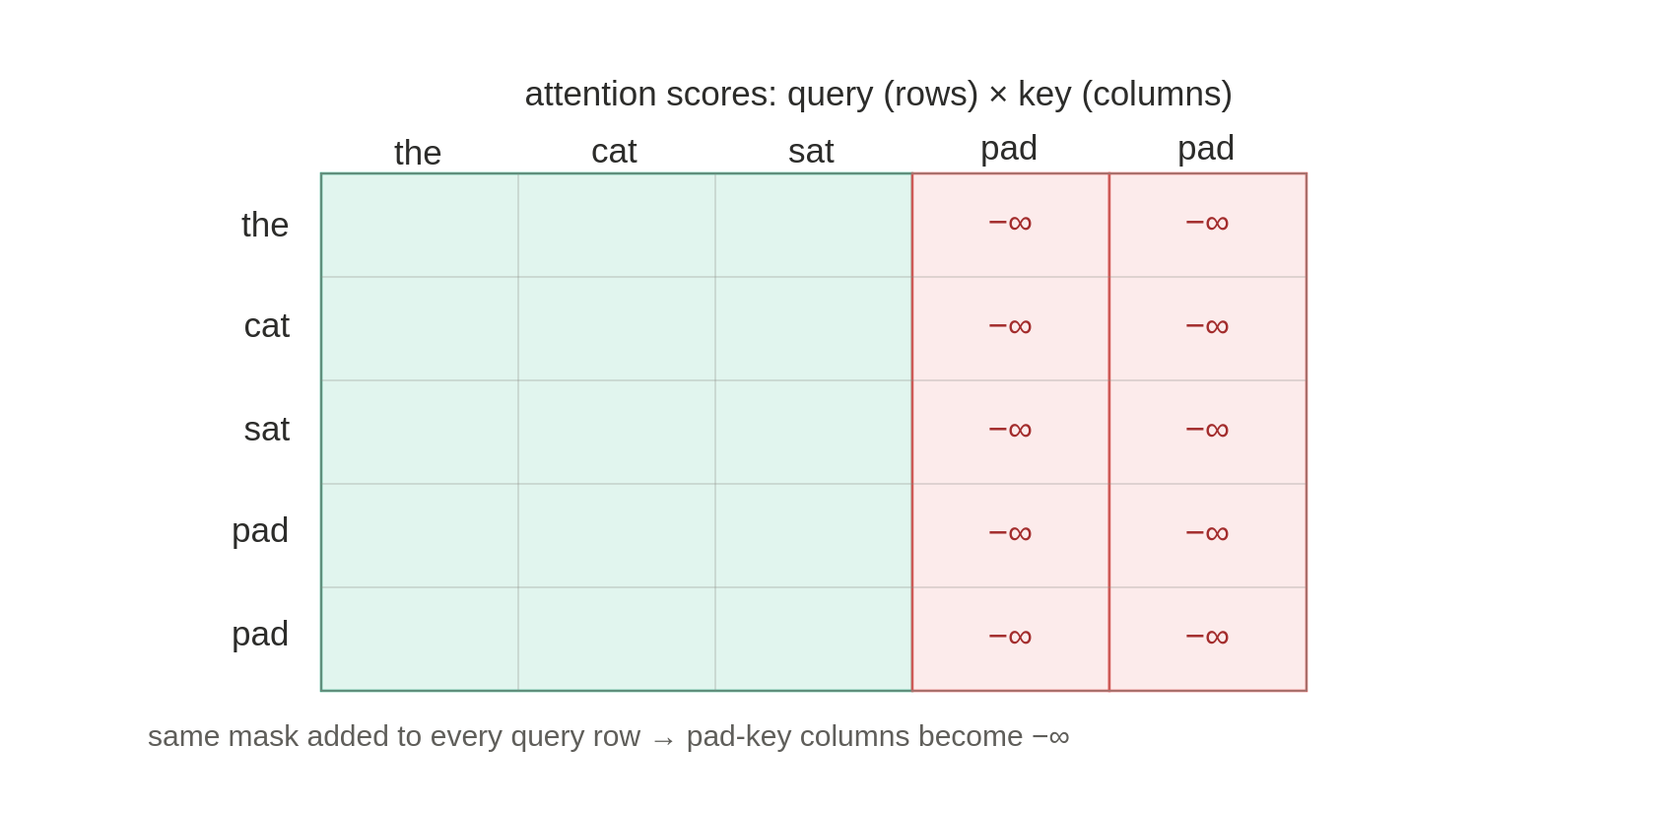
Figure 2. The padding mask zeros pad-key columns for every query row.
Key idea — mask keys, not queries. The padding mask hides pad keys (columns), not pad queries (rows). Masking a whole query row would make softmax compute 0/0 = NaN. Pad query rows are left alone because the column mask keeps real positions from reading them, and the loss ignores pad positions via ignore_index.

1.3 The shape (batch, 1, 1, seq_len)
Attention scores live in a 4-D tensor (batch, num_heads, seq_len_q, seq_len_k). The mask broadcasts cleanly onto that:
- batch — one distinct mask per sequence, since each has its own pad positions.
- the first 1 broadcasts across num_heads: every head hides the same pad keys.
- the second 1 broadcasts across query positions: masking depends only on which key, not which query.
- the final seq_len is the key dimension — the axis the mask operates on.

1.4 The causal mask: hiding the future
The causal mask is about time, not padding. The decoder predicts the next token; during training the whole target is fed in at once, so position 3 must not peek at positions 4, 5, 6… The rule: position i may attend only to positions ≤ i.
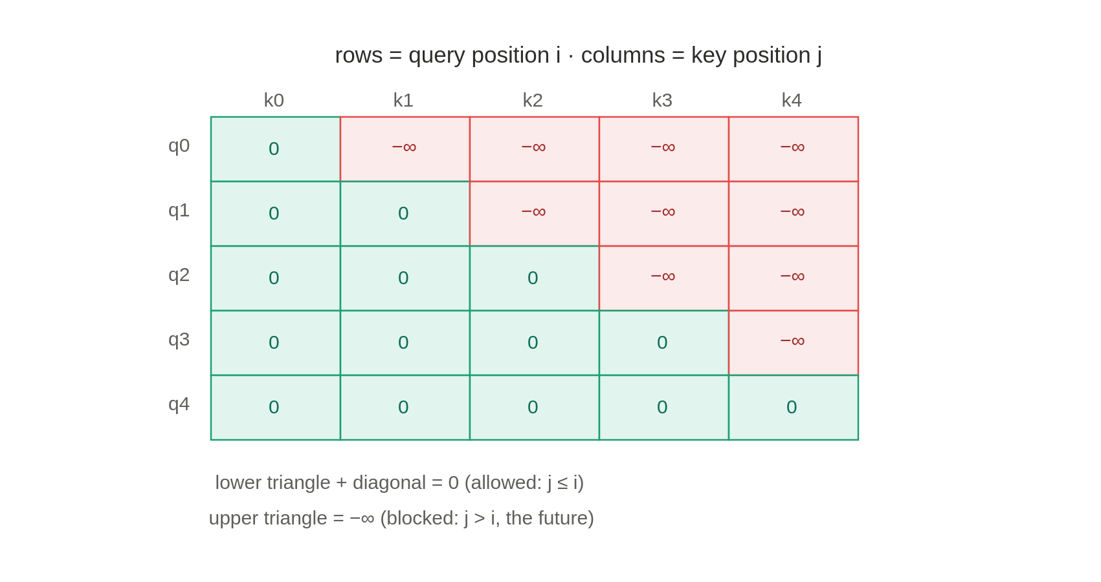
Figure 3. The causal mask: a triangle blocking the future (j > i).
Read row by row: q0 sees only k0; q2 sees k0,k1,k2; the last query sees everything. The boundary is the diagonal: cell (i,j) is allowed when j ≤ i. Hence lower triangle + diagonal = 0, upper triangle = −∞.

1.5 Padding vs causal: sizes and size conversion
Both masks end 4-D so they can be added onto scores, but they start from different shapes. The padding mask is born from the token-ID tensor (batch, seq_len), so the two new size-1 axes go in the middle. The causal mask is born from a (seq_len, seq_len) triangle, so they are prepended.
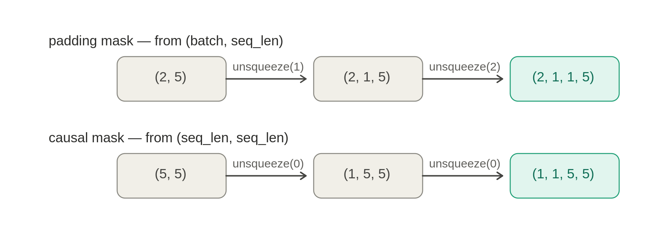
Figure 4. Padding inserts size-1 axes in the middle; causal prepends them.
Lining each final shape up against the scores, every axis must match or be 1 (a 1 gets stretched during the add):
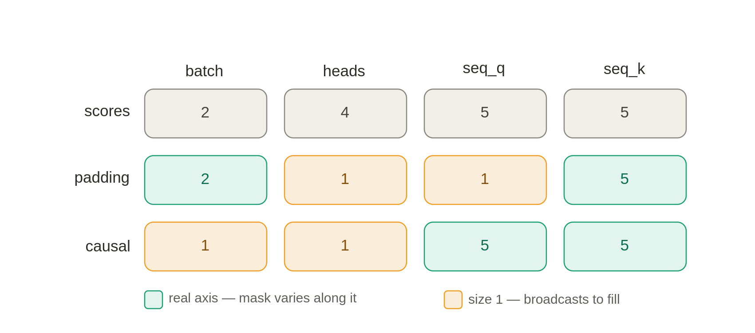
Figure 5. Axis alignment against the scores tensor: real vs broadcast.
The complementary pattern. Keys: real for both. Heads: size-1 for both. The swap: padding is real on batch but size-1 on query; causal is size-1 on batch but real on query. Padding is a per-key vector; causal is a per-pair square. Both being additive 0/−∞ tensors, the decoder can simply add them together.

2 Scaled dot-product attention
The core operation of every Transformer: Attention(Q,K,V) = softmax(Q Kᵀ / √d_k) V. Read it inside-out as a soft lookup.

2.1 The idea: a soft lookup
An ordinary dictionary does a hard lookup — one exact key returns one value. Attention does a soft lookup: a query is compared against every key, producing a relevance score for each, and the result is a blend of all values weighted by relevance. Each token carries three learned vectors: a query (what it seeks), a key (what it advertises), a value (what it contributes).
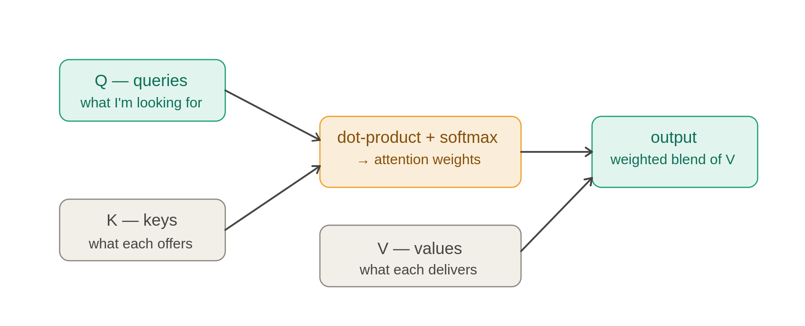
Figure 6. Attention as a soft lookup: compare queries to keys, blend values.
When Q, K, V come from the same sequence it is self-attention; when Q comes from one sequence and K, V from another it is cross-attention — which is why seq_len_q may differ from seq_len_k. Always seq_len_k == seq_len_v, since every key has one value.

2.2 The pipeline, with shapes
Two shape-changing matmuls bracket four shape-preserving steps:
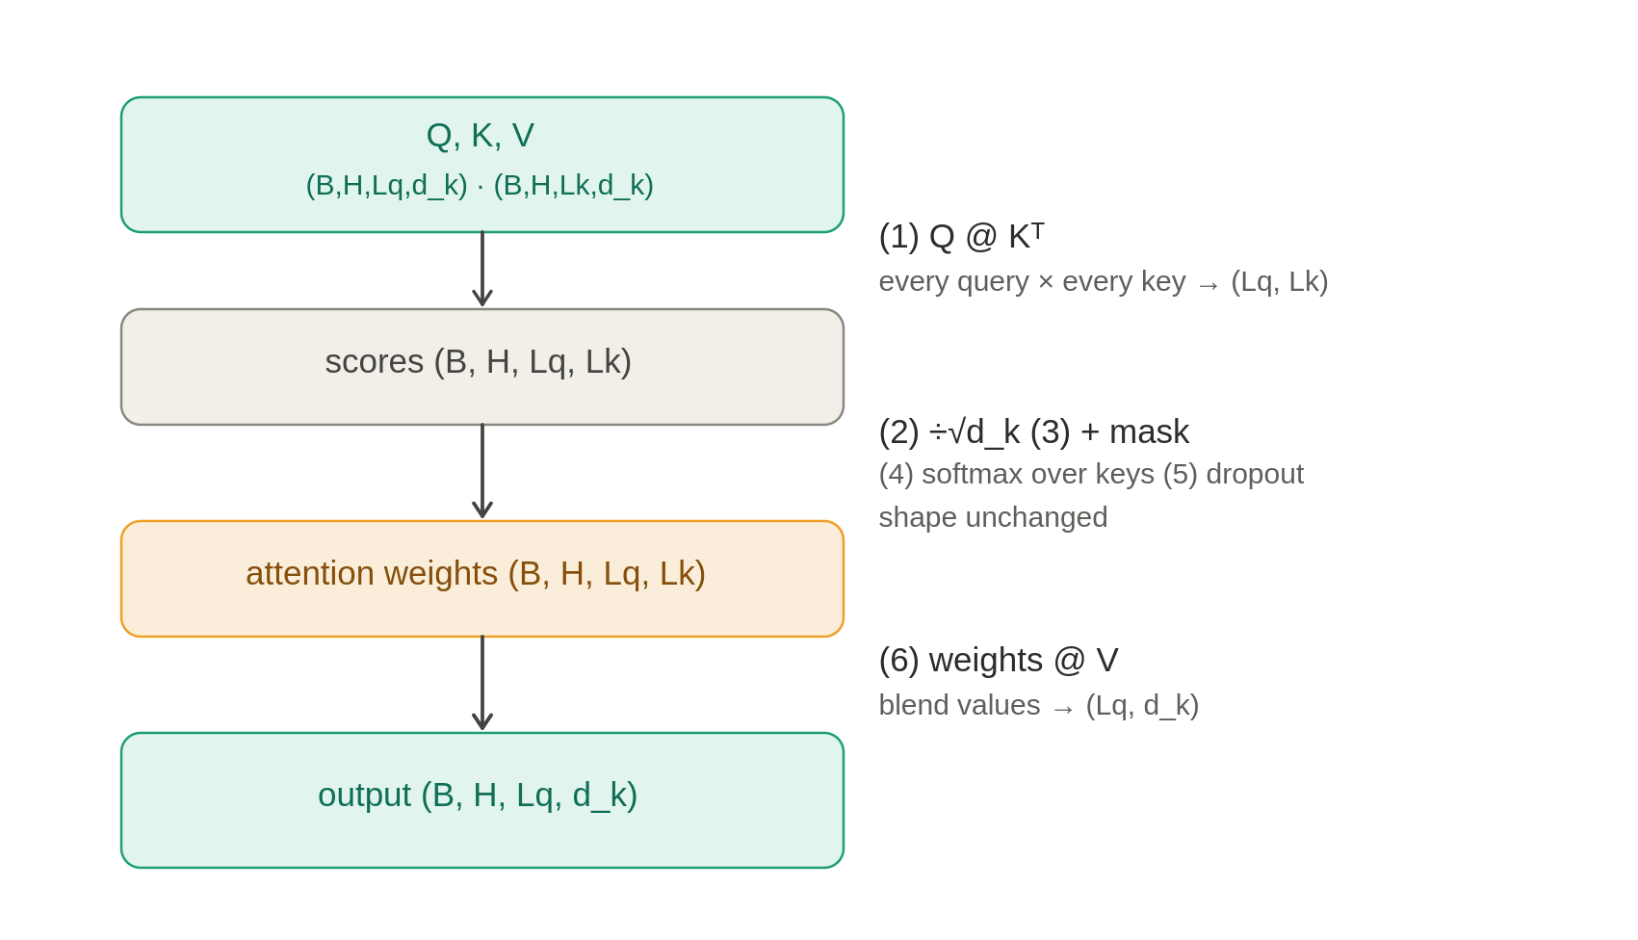
Figure 7. The attention pipeline and the shape at every step.
The function returns two things: output (blended values, fed onward) and attn_weights (the (Lq,Lk) distribution, returned for visualization since the final matmul otherwise discards it).

2.3 Step 1: Q Kᵀ — comparing every query to every key
The dot product is the similarity measure: aligned vectors give a large positive value, perpendicular vectors give zero. So q·k answers how relevant key j is to query i. Doing this for every pair fills a (Lq,Lk) grid; the shared d_k is summed over and disappears:
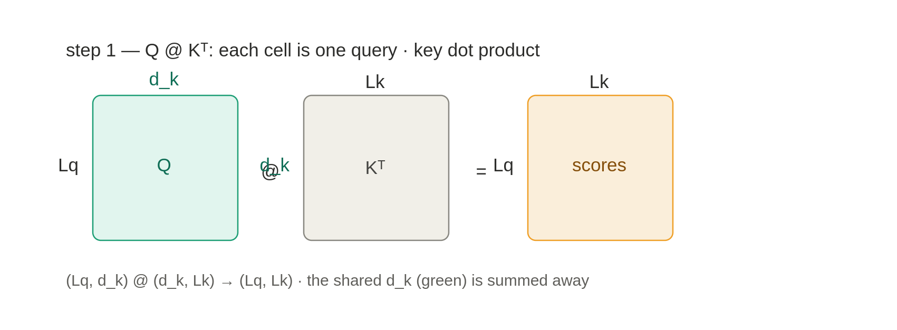
Figure 8. Q Kᵀ contracts the shared d_k to produce the score grid.
The Kᵀ (transpose of the last two axes) lines the d_k columns of Q up against the d_k of K. The 4-D version rides batch and num_heads along untouched.

2.4 Step 2: ÷ √d_k — taming the scale
If the d_k components have mean 0 and variance 1, their dot product is a sum of d_k terms each with variance ≈ 1. Variances add, so the dot product has variance ≈ d_k — its magnitude grows like √d_k. For d_k=64 that is ±8; for d_k=512, about ±23.
Large magnitude saturates softmax — nearly all weight piles onto one key, the gradient there nearly vanishes, and learning stalls. Dividing by √d_k rescales to variance ≈ 1 regardless of d_k:
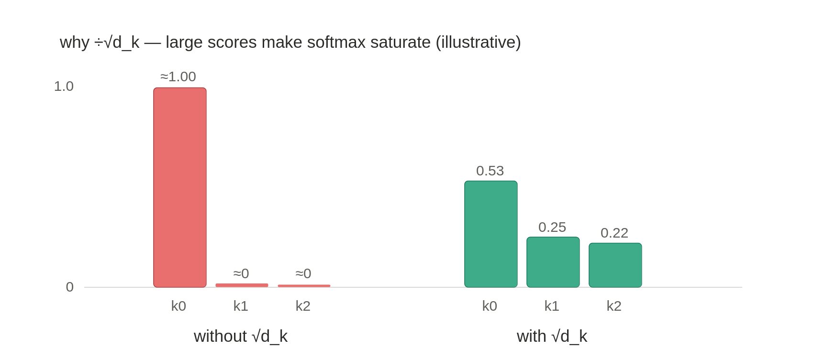
Figure 9. Large scores saturate softmax; √d_k restores a balanced distribution.
This is not cosmetic. Without the √d_k, a large head dimension pushes softmax into a flat, near-one-hot regime where gradients vanish and the model cannot train.

2.5 Steps 3–4: mask, then softmax
The mask is added to the scaled scores (0 leaves a score alone, −∞ forces it to vanish). Softmax then runs over the last axis — the keys — turning each query's row into a probability distribution: every weight ≥ 0, the row sums to 1. Masked positions come out as exactly 0. Dropout (step 5) is optional training-time regularization; at inference it is a no-op.

2.6 Step 6: weights V — the blend
Each query's output is the weighted sum of all value vectors, mixed by its attention distribution. This second matmul, (Lq,Lk)(Lk,d_k) → (Lq,d_k), contracts the key axis Lk:
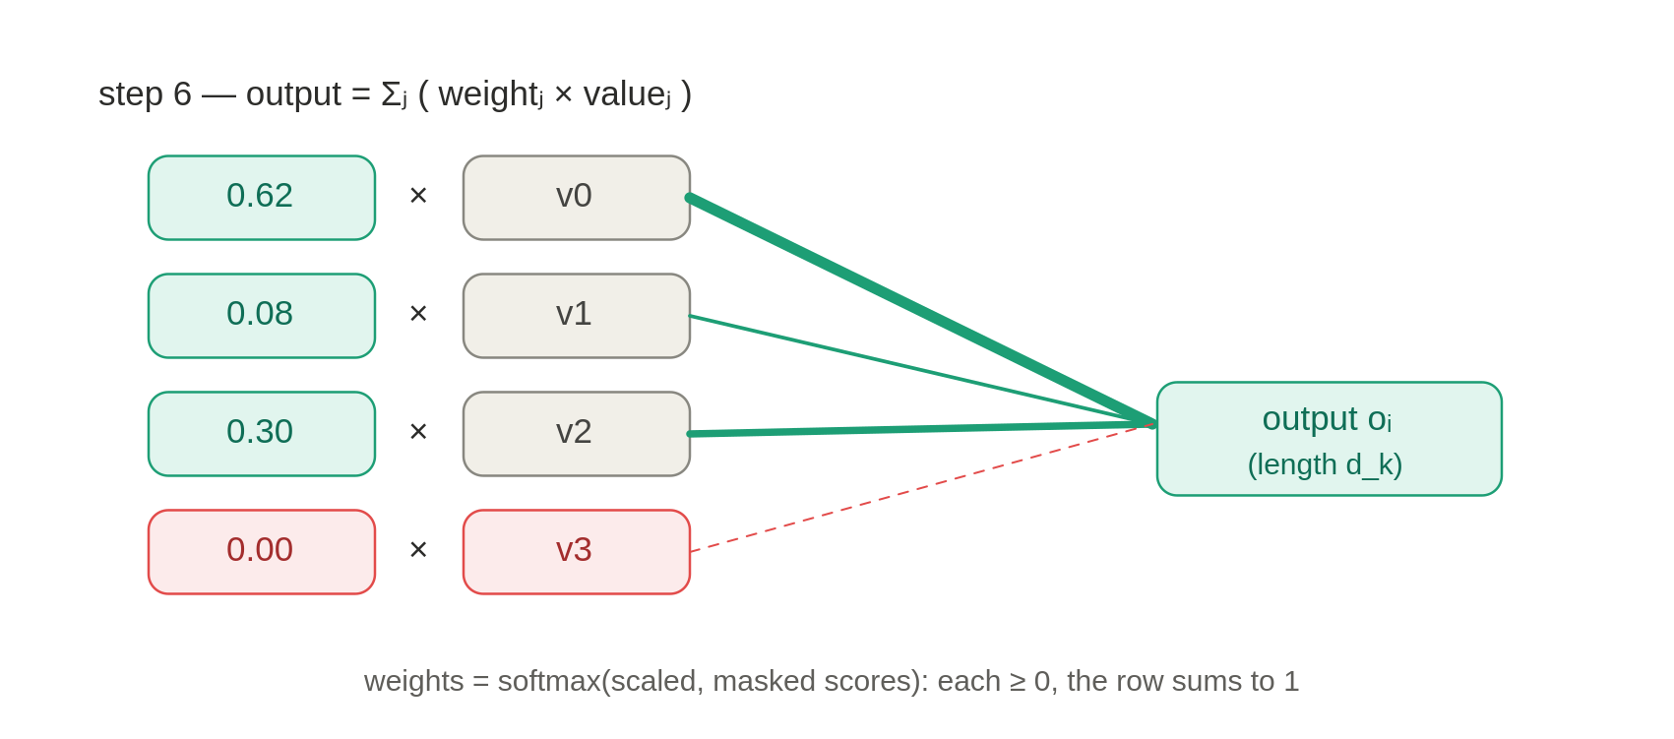
Figure 10. The output is a relevance-weighted blend of value vectors.
The masked value (weight 0) is dropped from the blend — the payoff of masking. The output lands at (B,H,Lq,d_k): one d_k-vector per query, now carrying context.
The symmetry. The first matmul sums over d_k to compare (d_k → Lk); the second sums over Lk to aggregate (Lk → d_k). d_k disappears then returns; Lk appears then disappears.

3 The dot product: why Σ a·b = |a||b|cos θ
The dot product has two faces — the component sum a₁b₁ + a₂b₂ + … (what the matmul computes) and the geometric |a||b|cos θ. They are the same number, and that equivalence is what makes the dot product a similarity measure.

3.1 The geometric meaning of alignment
The dot product is |a||b|cos θ, where θ is the angle between the vectors. Aligned → large positive; perpendicular → zero; opposing → negative. Since W_Q and W_K are learned, the model points a query and a relevant key the same way, making their dot product large:
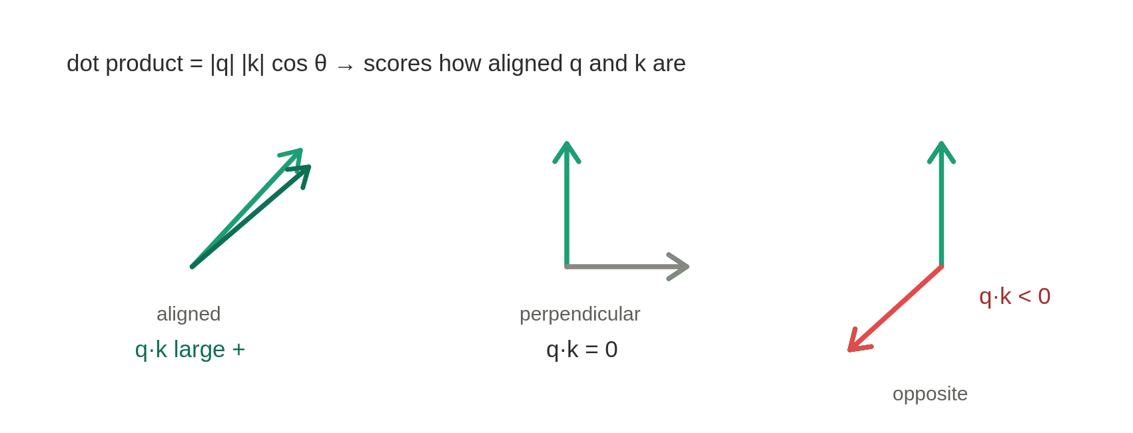
Figure 11. The dot product measures alignment between vectors.

3.2 The shadow (projection) picture
|b|cos θ is the length of b's shadow cast onto a's direction. So |a||b|cos θ = (length of a) × (length of b's shadow). When a lies on the x-axis it is (|a|, 0), so the component sum collapses to |a|·b₁ — and b₁ is its shadow, which equals |b|cos θ:
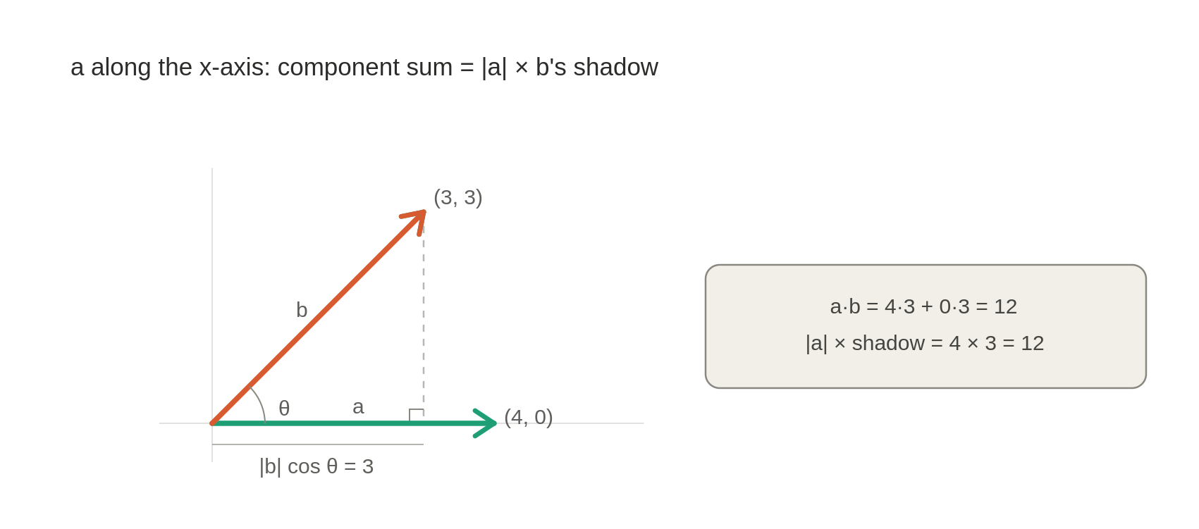
Figure 12. |b|cos θ is b's shadow on a's direction.

3.3 The general proof (law of cosines)
For any orientation, form the triangle of the two vectors and compute the third side b − a two ways:
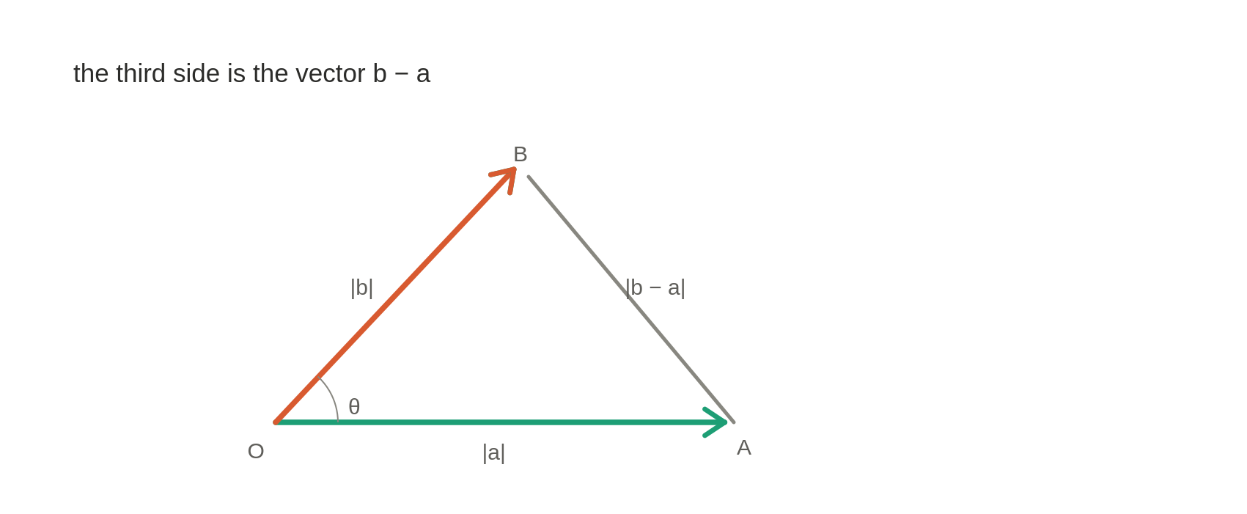
Figure 13. The law-of-cosines triangle used to prove the identity.
Geometry (law of cosines): |b−a|² = |a|² + |b|² − 2|a||b|cos θ.
Algebra (squared length = sum of squared components): |b−a|² = Σ(bᵢ−aᵢ)² = |b|² − 2(a·b) + |a|².
Setting them equal and cancelling |a|² and |b|² leaves a·b = |a||b|cos θ. It is Pythagoras generalized: at θ = 90°, perpendicular vectors have zero dot product.
Tie to attention. Each entry of Q Kᵀ is a row·column = component sum = |q||k|cos θ. So each score asks how aligned a query is with a key: relevant → large, orthogonal → ~0, opposing → negative.

4 Multi-head attention
Instead of one attention over the full d_model space, run num_heads independent attentions over d_k-dimensional subspaces, then concatenate and mix. Five stages: project, split, attend, merge, project.

4.1 Where Q, K, V come from
The function receives Q, K, V already formed; to understand their sizes you must see them born. Every token starts as an embedding of length d_model. A sentence of L tokens is an (L, d_model) matrix:
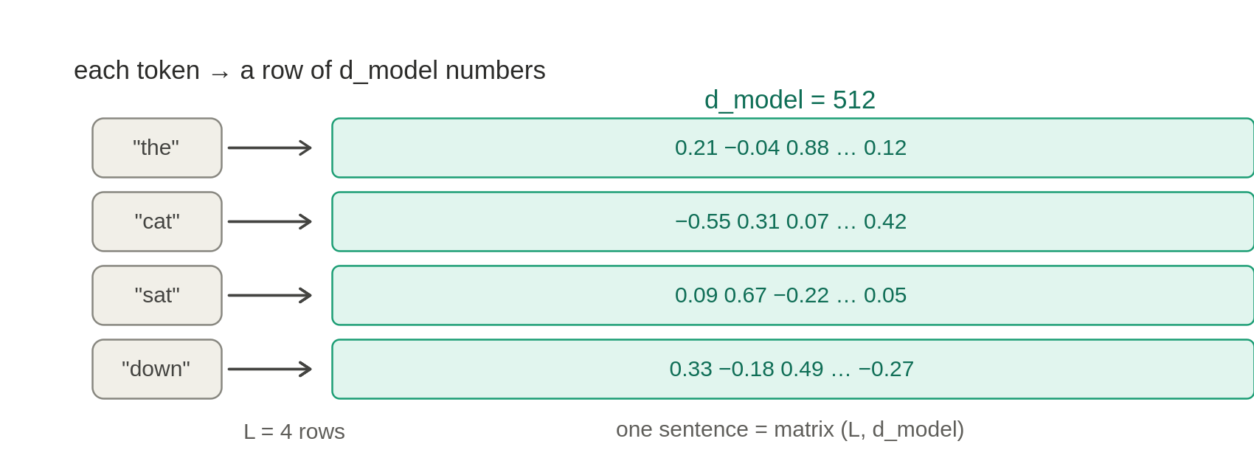
Figure 17. Each token becomes a row of d_model numbers.
Each of Q, K, V is the embedding matrix times a learned weight matrix of shape (d_model, d_k), projecting each token down to a d_k-vector. The three matrices W_Q, W_K, W_V are what the model learns:
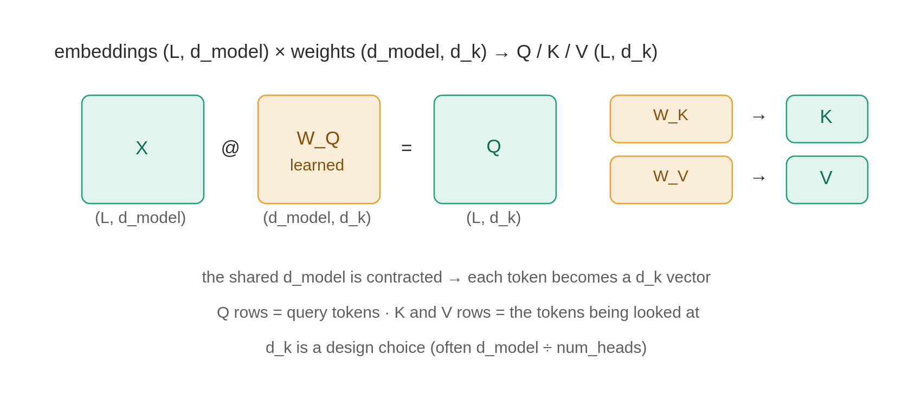
Figure 18. Q, K, V are produced by projecting embeddings with learned matrices.
This explains every size. d_k is the per-head width, usually d_model ÷ num_heads. Q and K must share d_k because step 1 dots them. seq_len_q and seq_len_k are the row counts of Q and K — equal in self-attention, possibly different in cross-attention.

4.2 The forward pass, end to end
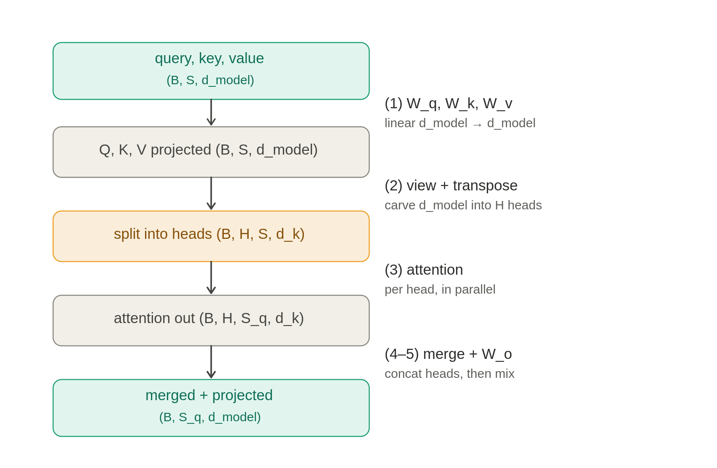
Figure 14. Multi-head attention: project, split, attend, merge, project.

Step 1: the projections
Q = self.W_q(query) applies an nn.Linear(d_model, d_model). A single (d_model, d_model) matrix computes all heads' projections at once — the split happens later by reshaping. Same math, one fused matmul.

Step 2: split into heads
Q.view(B,-1,H,d_k).transpose(1,2). The view reinterprets the contiguous d_model axis as (H,d_k) (no data moves; -1 infers S). The transpose pulls heads to a batch-like position so attention runs per head:
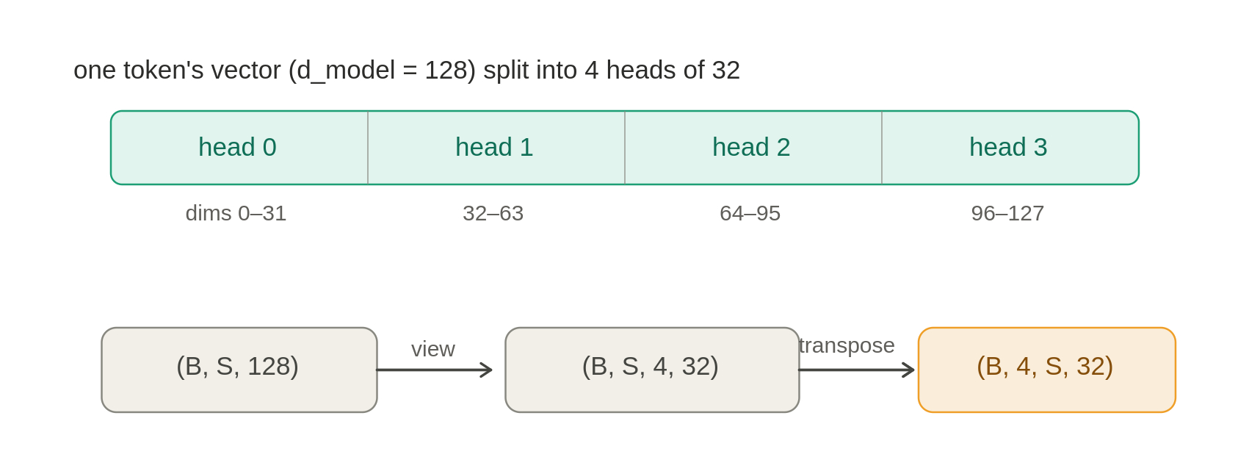
Figure 15. Splitting one d_model vector into H heads via view + transpose.

Step 4: merge heads (the exact inverse)
attn_out.transpose(1,2).reshape(B,-1,d_model). The transpose restores (…,S_q,H,d_k), then reshape glues (H,d_k) back into one d_model axis:
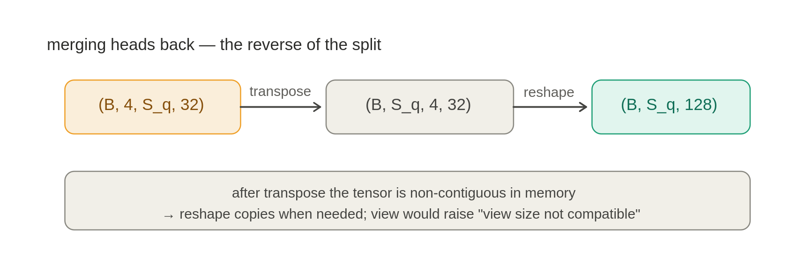
Figure 16. Merging heads back via transpose + reshape (the exact inverse).
Order matters: transpose then reshape. reshape (not view) is required because transpose leaves the tensor non-contiguous. And the transpose must come first — reshaping (B,H,S_q,d_k) directly would glue the head axis to the sequence axis and silently scramble the output.

4.3 Step 5: W_o and why the heads need it
After the merge, the four heads are just stacked side by side — dims 0–31 are purely head 0's work, 32–63 purely head 1's. The concatenation glued them together but did not combine them. W_o is the one step that lets information cross between heads:
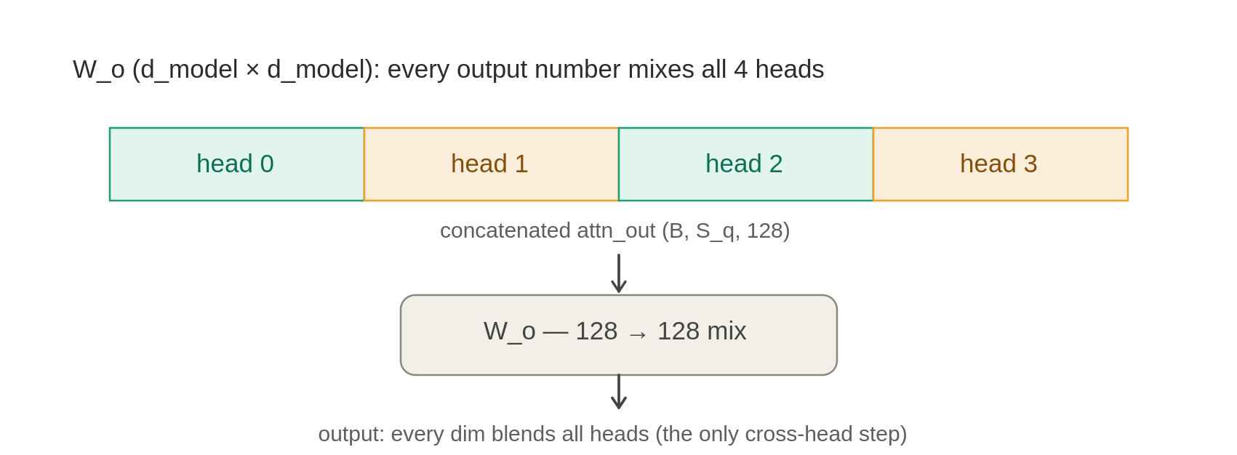
Figure 21. W_o is the only step where information crosses between heads.
Because W_o is a full (d_model, d_model) matrix, every output number is a weighted sum of all inputs — so every output draws on all four heads. That is the only place heads coordinate.

5 Linear layers and the matrix × vector multiply
Every projection (W_q, W_k, W_v, W_o) is one operation: nn.Linear running a matrix–vector multiply on each token.

5.1 What nn.Linear does to one vector
self.W_q = nn.Linear(d_model, d_model) holds a learned matrix W and bias b. Calling self.W_q(query) runs query @ Wᵀ + b. For one token, a d_model-vector goes in and a different d_model-vector comes out, each output number a learned mix of all inputs:
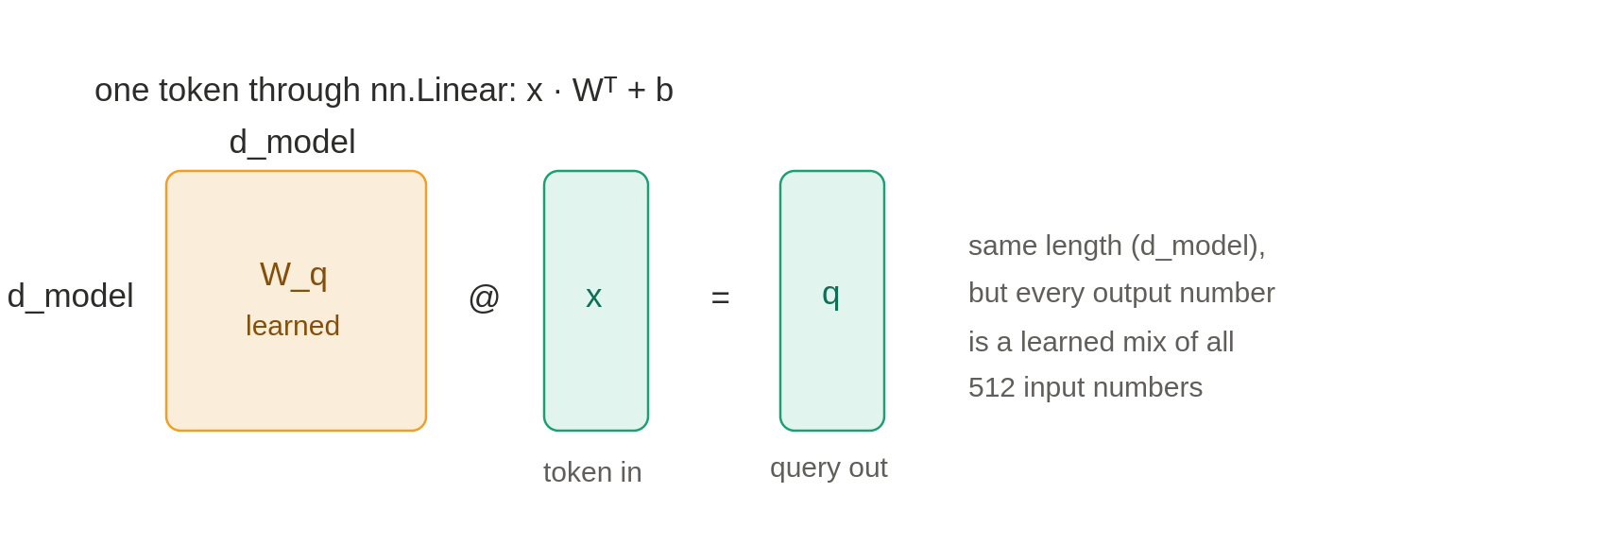
Figure 19. nn.Linear on one token: a learned mix into a same-length vector.

5.2 Why a 3-D tensor works unchanged
nn.Linear transforms only the last axis. It treats B and S as a stack of independent tokens and applies the same W to each. So (B,S,d_model) → (B,S,d_model): only the contents change; the scaffolding is untouched — the same idea that gives attention its batch and head axes.

5.3 Three roles from one token
The same token is pushed through three different learned matrices, producing three vectors. W_q makes a good 'what am I looking for', W_k a 'what do I offer', W_v a 'what will I pass along':
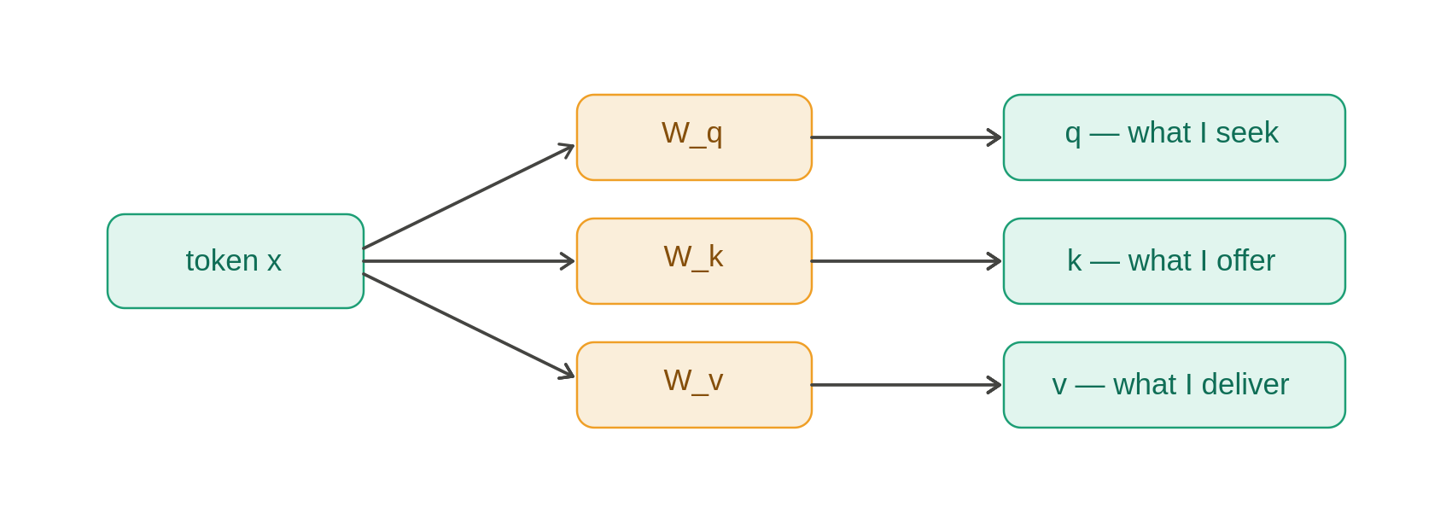
Figure 20. One token, three learned matrices, three roles.
This is why the module takes three inputs. Self-attention: attn(x,x,x). Cross-attention: attn(decoder_x, encoder_x, encoder_x) — the decoder asks, the encoder supplies.

5.4 First principles: matrix × vector, and why width is preserved
The rule: each output number is one row of the matrix, dotted with the whole input. A 3×3 example makes both facts visible:
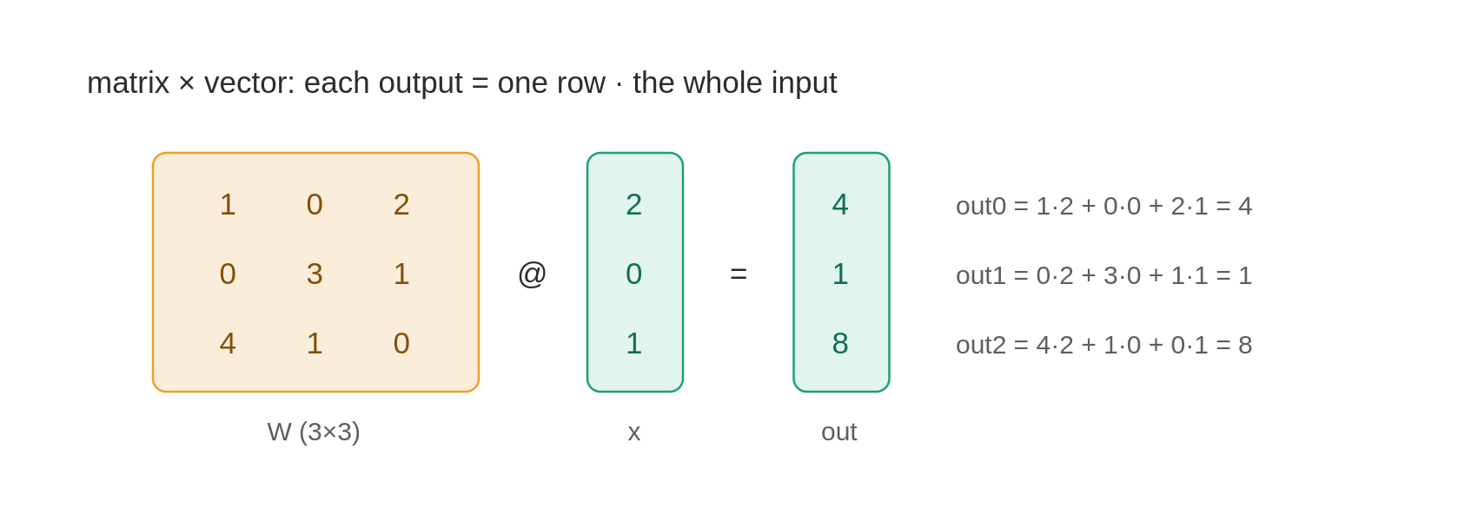
Figure 22. Matrix × vector: each output is one row dotted with the whole input.
Two observations: every output used all inputs (each row dots across the whole input), and the number of outputs equals the number of rows (one dot product per row).
Why W_o being square preserves the shape. A matrix's shape reads as (rows, cols) = (outputs, inputs). W_o is 128×128: 128 rows → 128 outputs, 128 cols accept a 128-vector. So width is preserved because the matrix is square. And because each output dots across all 128 inputs (the four heads concatenated), every output blends all heads. The (B, S_q) structure is untouched because this 128→128 multiply runs once per token.

6 Implementation notes and pitfalls

6.1 -inf vs torch.finfo(dtype).min
Filling masked positions with float('-inf') works on normal inputs but has a sharp edge: if an entire query row becomes -inf (a fully-padded sequence, or a causal row combined with padding so every allowed key is also pad), softmax computes 0/0 = NaN, which propagates silently and poisons the loss. torch.finfo(dtype).min — the most-negative finite value — avoids this: finite-but-equal values subtract to 0 and softmax falls back to a harmless uniform row.
Why not -1e9? In fp16, -1e9 overflows to -inf (max magnitude ~65504), reintroducing the NaN risk. finfo(dtype).min is always representable. Caveat: summing two masks that both use finfo.min can overflow to -inf; OR them as booleans and convert once.

6.2 Device and dtype
The padding mask gets its device for free via zeros_like(seq). The causal mask, built from a bare int, defaults to CPU — you must pass device explicitly or hit a 'tensors on different devices' error on GPU. Hard-coding float32 also forces an upcast when scores are bf16/fp16; match the mask dtype.

6.3 The mask convention is an additive-float footgun
scores = scores + mask only works for 0/-inf float masks. A boolean mask (where True means ignore) will not error — it silently adds 1.0 at every True and corrupts the scores. Handle both:
if mask is not None:
if mask.dtype == torch.bool:
scores = scores.masked_fill(mask, float("-inf"))
else:
scores = scores + mask

6.4 Why two values are returned
The function returns (output, attn_weights). The output is the blended values the network consumes — the forward pass needs only this. The attn_weights is the softmax distribution before it is collapsed against V; once weights @ V runs, that grid is gone, so it is surfaced here. It is the only interpretable part (the 'attention maps'), useful for visualization and checking masks. Callers usually write out, _ = ....
Dropout/return subtlety. If attn_weights = dropout(attn_weights) runs before the return, the weights you get back during training are perforated and rescaled — not the clean softmax. To plot clean maps, capture the pre-dropout weights or inspect in eval() mode.

6.5 Python return semantics: pass by object reference
Python is neither C++ pass-by-value nor pass-by-reference; it is pass by object reference. return output, attn_weights builds a tuple of references — no tensor data is copied. An in-place mutation (out.add_(1)) is seen by every reference; reassignment (out = out + 1) makes a new tensor. The function can never rebind the caller's name. For independent data, return output.clone().

6.6 Performance: the fused kernel tradeoff
The biggest speed lever is F.scaled_dot_product_attention (PyTorch 2.x), which dispatches to FlashAttention and never materializes the full (Lq,Lk) scores. The catch: those kernels do not return attention weights. A need_weights flag is the usual way to have both. For a from-scratch learning implementation, the explicit version is the right call.

7 One-page summary
Concept | The one-line takeaway
Padding mask | Per-key vector (B,1,1,S); -inf at pad keys so no query reads them.
Causal mask | Per-pair square (1,1,S,S); upper triangle -inf so no token sees the future.
Mask mechanism | Add to scores before softmax; e^(-inf)=0 gives zero weight.
Q Kᵀ | Compare; sums over d_k; produces (Lq,Lk) similarity grid.
√d_k scaling | Keeps dot-product variance ~1 so softmax doesn't saturate.
softmax | Per query row over keys; non-negative, sums to 1.
weights V | Aggregate; sums over Lk; restores (Lq,d_k).
dot product | Σ a·b = |a||b|cos θ — a signed alignment score (law of cosines).
Multi-head | Split d_model into H×d_k, attend per head, concat, mix with W_o.
Linear layer | Per-token x Wᵀ + b; touches last axis only; square keeps width.
W_o | The only cross-head step; square (d_model,d_model) blends all heads.
Two-value return | output feeds the network; attn_weights is for inspection.
NaN safety | Prefer finfo(dtype).min over -inf/-1e9 for masked fills.
End of reference. Built from the attention working-through — revise by skimming the 22 figures, then re-reading any section whose diagram doesn't yet feel obvious.

