SAS-NAS-Connector Documentation

Josh Thackray (thackray@rutgers.edu)  
September 2020

# Background

The SAS-NAS-Connector program (“the program”) is designed to simplify the process of mounting a share hosted on the School of Arts and Sciences (SAS) IT services’ managed Network Attached Storage (NAS) system to a modern (7/10) Windows-based machine. It is especially useful for users who may be inexperienced with using a terminal to connect to remote systems. The program simply automates the steps that would otherwise needed to be performed manually by the user.

Users are expected be comfortable with unzipping an archive and other minimal computer competencies.

# Installation and Startup

The program is a standalone executable and does not need to be formally “installed” onto a Windows system to function. From a release (for example: SAS-NAS-Connector - Release.zip), simply unzip the archive. Then navigate inside to the extracted files to find the file SAS-NAS-Connector.exe. Double clicking this file will run the program.

If you are working from off-campus, you will need to have an active connection to the DLS VPN. Information about how to set this up is available here: <https://sasooa.rutgers.edu/divisions/life-sciences/dls-it/vpn-access>.

# Interface

Upon launching the program, you will be greeted by the interface below:

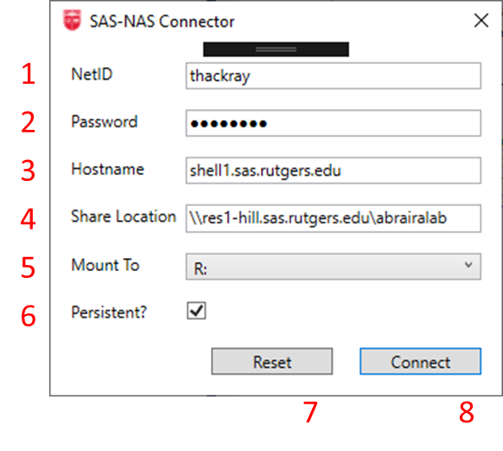

|  |  |  |
| --- | --- | --- |
| # | Setting Name | Description |
| 1 | NetID | Your Rutgers NetID username. |
| 2 | Password | Your Rutgers NetID password. |
| 3 | Hostname | Hostname of the server that must be connected to via SSH in order to cache your credentials. |
| 4 | Share Location | The UNC path to the file share, of the form \\server-name\share-folder |
| 5 | Mount To | Assigns a name (i.e. disk drive letter) to connect to the resource. The dropdown will populate with the available (i.e. unused) drive letters on the current system. |
| 6 | Persistent? | Controls the use of persistent network connections. **Checked** saves all connections as they are made, and restores them at next logon. **Unchecked** does not save the connection being made. |

# How to Connect to a Drive

1. Start by launching the program.
2. Enter your Rutgers NetID credentials into the boxes NetID and Password (#1 and #2 in the figure above).
3. You most likely do not need to change any of the information in boxes #3, #4, and #6.
4. You may choose the drive letter that the network location is mounted using the dropdown menu (#5 in the figure above).
5. Once satisfied with the settings, click the “Connect” button (#8 in the above figure). At this point the program will attempt to connect your network location. Once complete, a message box will show to inform you of the result of the operation. If successful, you will notice the network drive is now mounted under “My Computer”/”This PC”.
6. If the program failed to mount your network drive, please seek technical help and report the message shown in the message box.

# Advanced Configuration

This section is intended for advanced users or Information Technology professionals.

Internally, the program follows the protocol specified in Appendix 1 for connecting a user to the SAS-NAS system. More specifically, it:

1. Attempts to open a SSH connection to the host specified by the Hostname[3], and using the users NetID credentials (NetID[1], and Password[2]).
2. Attempts to use the net use system command to mount the share at Share Location[4] to Mount To[5] using the user’s NetID credentials.

The program gives its best effort to detect errors during this process and report them to the end user via a message box.

SAS-NAS-Connector can be configured to use specific values for as defaults for Hostname, Share Location, Mount Location, and Persistent mounting. These values are stored in the XML Configuration file SAS-NAS-Connector.exe.config. The table below describes the configuration names and how they map onto GUI parameters:

|  |  |
| --- | --- |
| Configuration Name | GUI Parameter |
| DefaultHost | Hostname |
| DefaultShare | Share Location |
| DefaultDrive | Mount To |
| DefaultPersistance | Persistent? |

# Appendix I

The next page contains the original documentation provided by DLS IT for connecting to the NAS, and provides the basis for this program.

Connecting to SAS-NAS from inside DLS

Initial Setup

Before SAS-NAS can authenticate you, you need to do a one-time login at an SSH prompt using your NetID credentials. Thereafter SAS-NAS will know that your NetID is a legitimate SAS-NAS credential.

From Mac or Linux open a terminal window and enter the following using your NetID:

ssh [NetID@shell1.sas.rutgers.edu](mailto:NetID@shell1.sas.rutgers.edu)

If this is the first time this computer has connected to shell1 it will prompt you to accept the key. Answer ‘yes’. Next enter your NetID password. Once you have logged in simply type ‘exit’ to complete the initial setup.

~$ ssh sfeldman@shell1.sas.rutgers.edu

The authenticity of host 'shell1.sas.rutgers.edu (172.17.0.246)' can't be established.

ECDSA key fingerprint is SHA256:s4p4cbMf7WNGrfzfaP40GOX/wVj/EkBnrU4WCyE2ytI.

Are you sure you want to continue connecting (yes/no/[fingerprint])? yes

Warning: Permanently added 'shell1.sas.rutgers.edu,172.17.0.246' (ECDSA) to the list of known hosts.

sfeldman@shell1.sas.rutgers.edu's password:

Last login: Tue Sep 1 09:10:32 2020 from 172.17.34.13

-bash-4.2$ exit

logout

Connection to shell1.sas.rutgers.edu closed.

If you are using a Windows based computer you have some choices. The easiest is to find a Mac or Linux machine for this initial setup and proceed as above. If you are already running Windows Subsystem for Linux (WSL) you can proceed as above from a WSL terminal window. You can do the same from a PowerShell prompt as well.

If none of these options are available you will need to install software that will allow you to make SSH connections. The recommended solution is MobaXterm <https://mobaxterm.mobatek.net/> although PuTTY <https://www.putty.org/> will also work.

**Connecting the share**

**On a Mac**

From the Finder’s Go menu select “Connect to Server” and enter:

smb://res1-hill.sas.rutgers.edu/abrairalab

Enter your NetID and password to authenticate.

**On Windows**

There are three ways to mount the share. The first will permanently map the share to a drive letter every time you log in. Choose an unused drive letter – for this example we’ll use ‘R’. From a command window type:

net use R: \\res1-hill.sas.rutgers.edu\abrairalab /USER:RAD\NetID /PERSISTENT: YES

You will be prompted for your password.

The second method is the same except it will only last until you logout. Simply omit “/PERSISTENT: YES” from the previous command. Finally, you can access the share directly in File Explorer by using the following path:

\\res1-hill.sas.rutgers.edu\abrairalab

You will be prompted for credentials and this access will last until you close the File Explorer window.