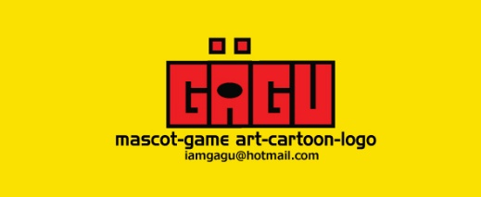

Hello there,

Thank you for purchasing my product.

BLACK CAT GAME SPRITE is one of my personal best.

You can resize and change the direction (left/ right) without decreasing the quality.

* You need Adobe Illustrator 10 or higher to open the files
* In case you are not familiar with Adobe Illustrator, the transparent PNG is available
* You get AI and EPS file if you want to customize it by yourself

If you have any doubts about the product just send me an email to **gamespritezstore@gmail.com** and I will be happy to help you.

I am also available for custom mascot, game asset, and cartoon projects commissions.

If you like it I would appreciate your rating. GBU☺

Have fun!

GAGU/AGUNGMALANG