Applicant: Amity University Total no. of sheets: 05 Sheet no: 01
FIG. 1 — System architecture
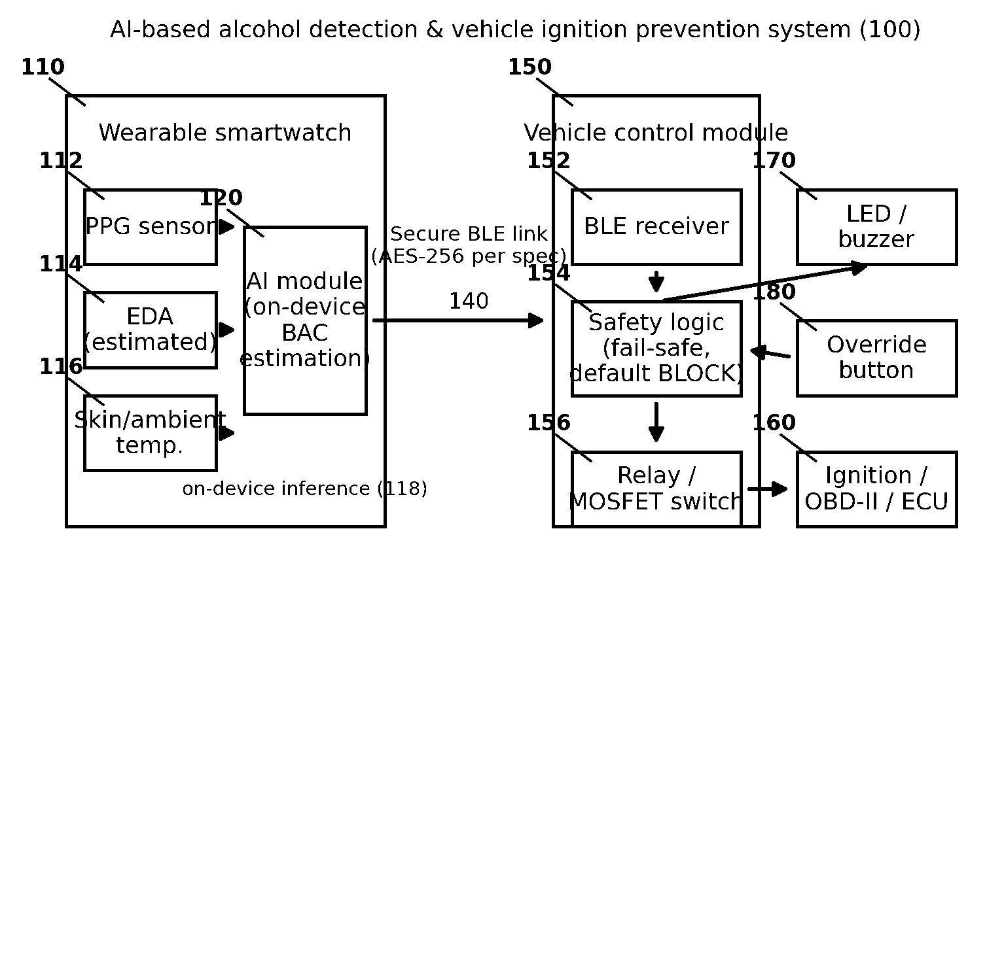

Applicant: Amity University Total no. of sheets: 05 Sheet no: 02
FIG. 2 — Sequence of system operation
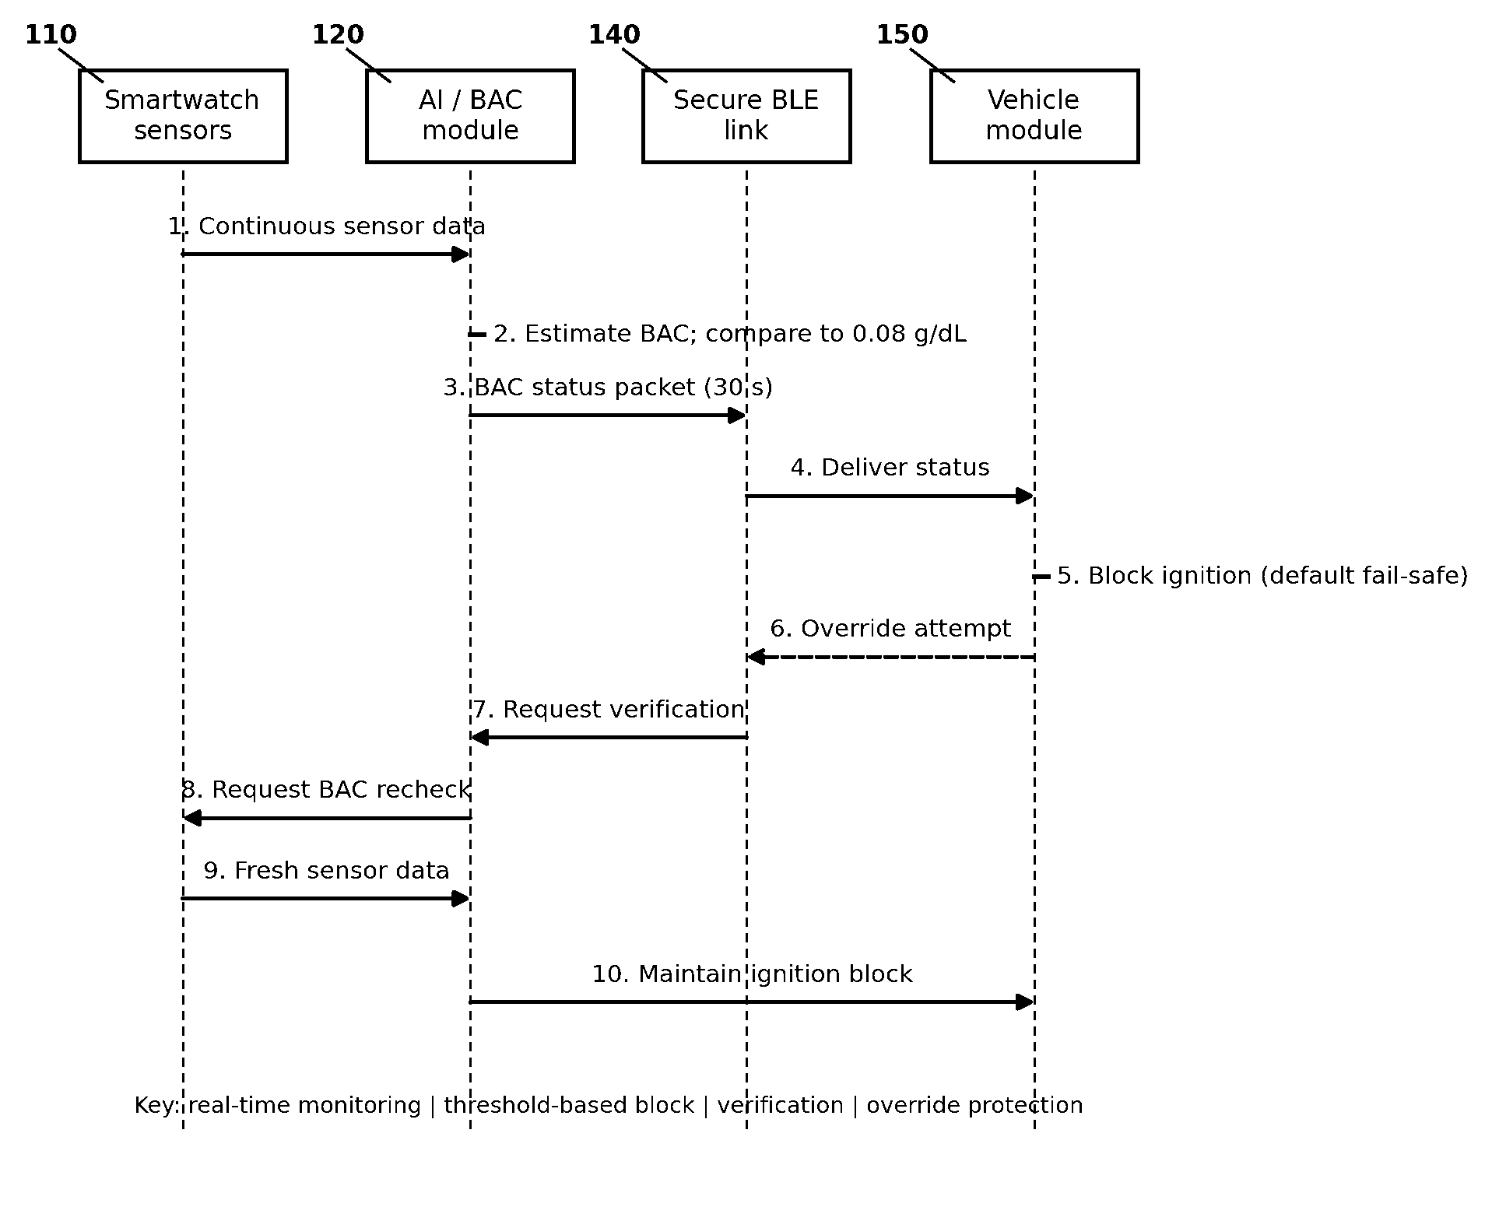

Applicant: Amity University Total no. of sheets: 05 Sheet no: 03
FIG. 3 — AI framework / signal-processing pipeline
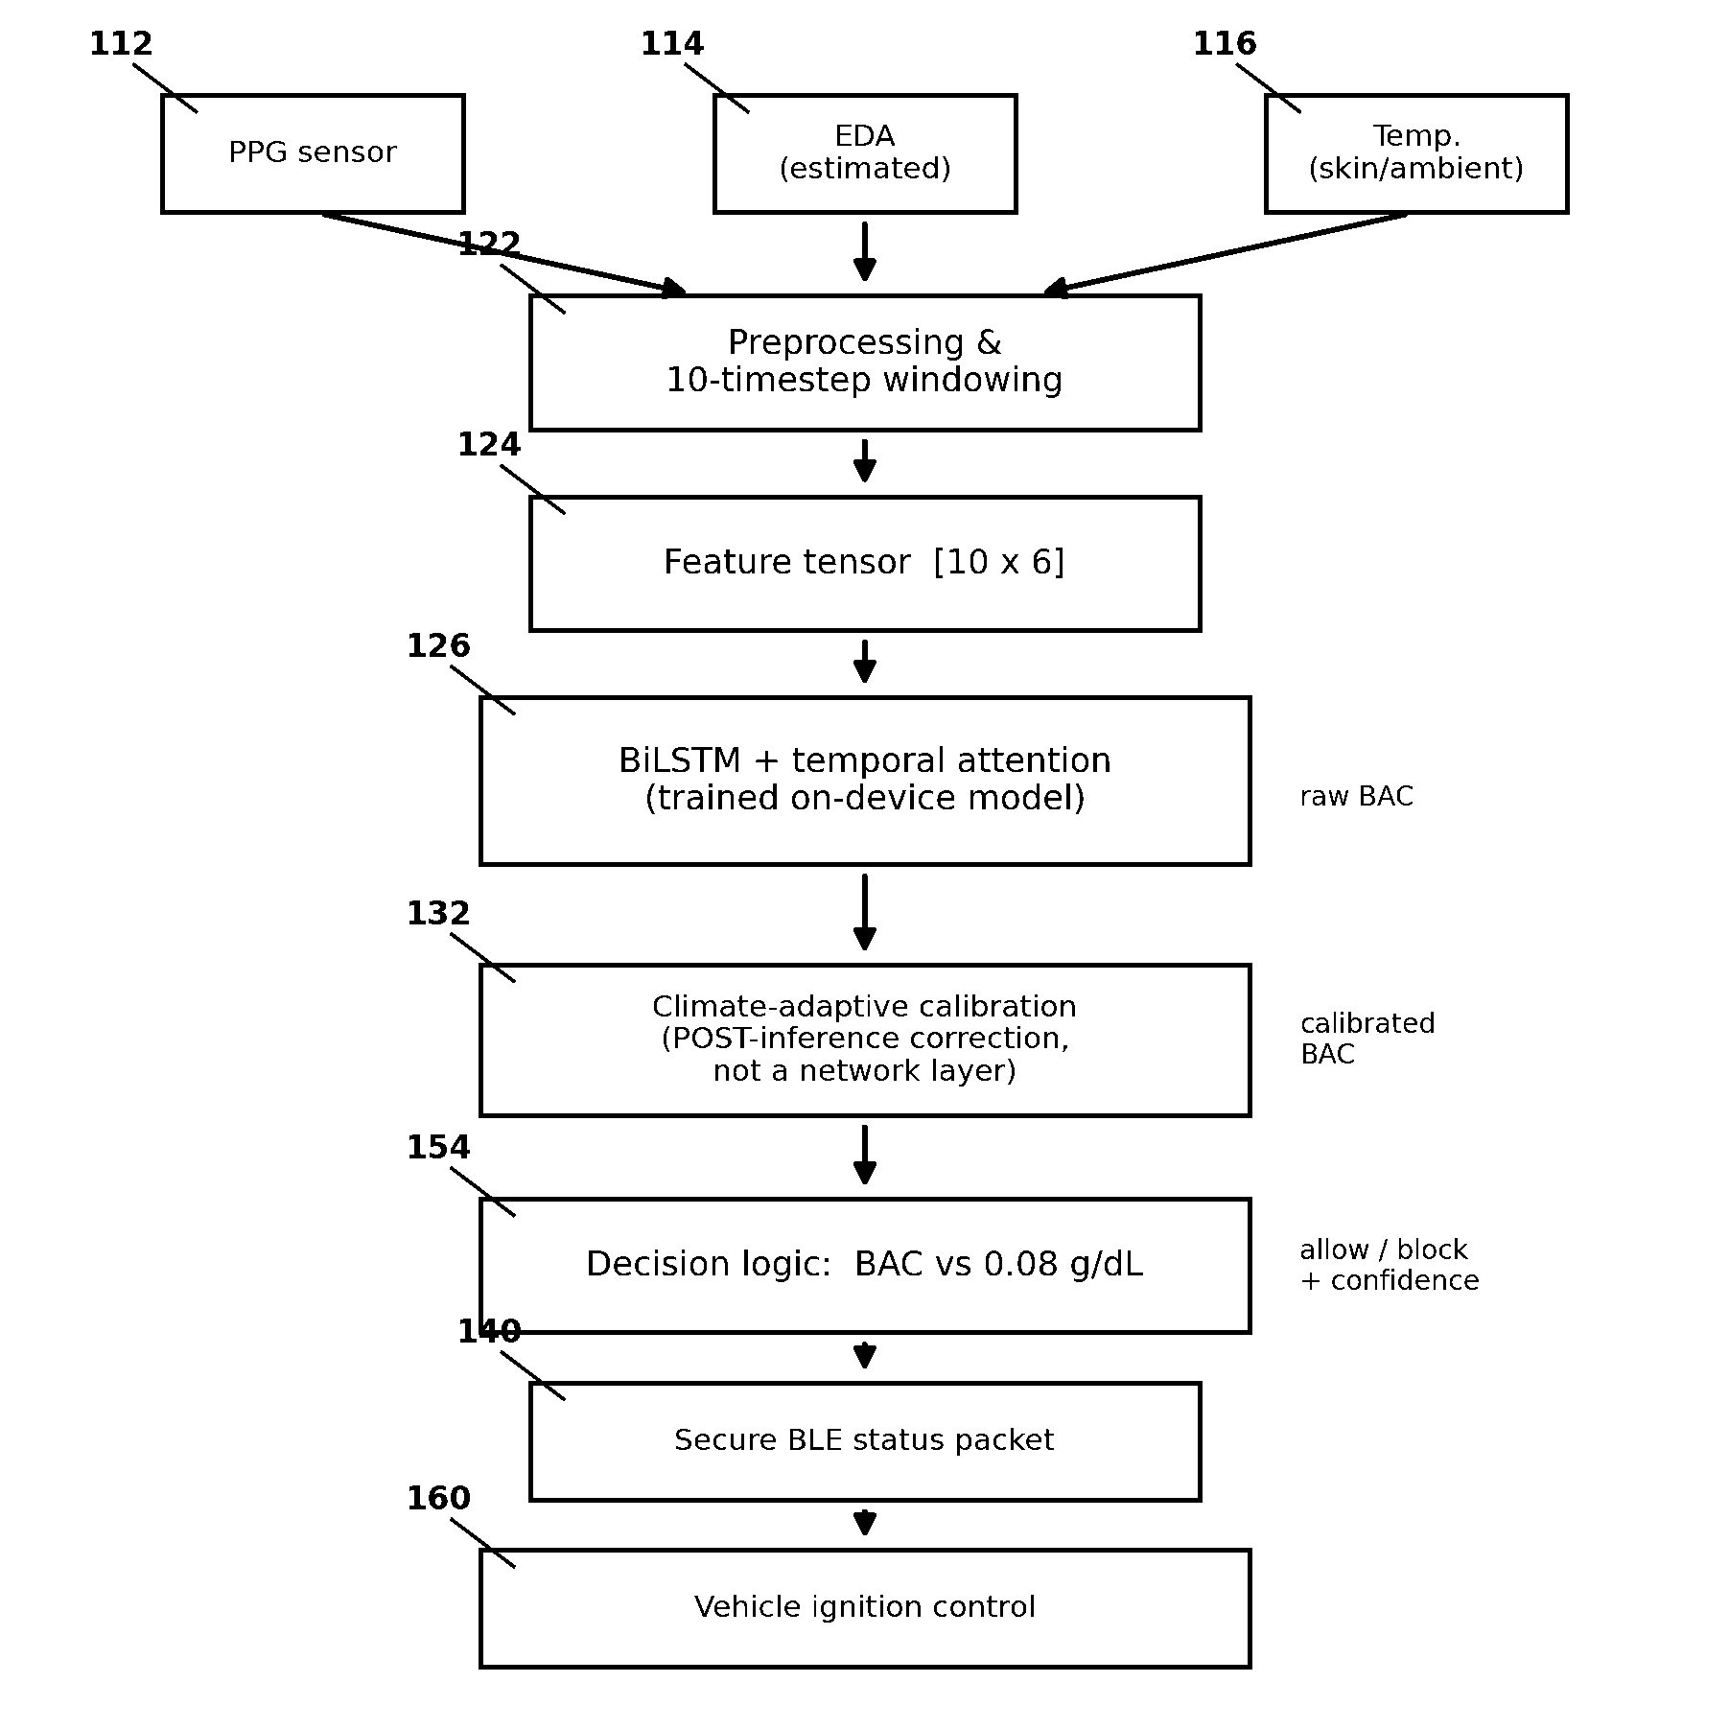

Applicant: Amity University Total no. of sheets: 05 Sheet no: 04
FIG. 4 — BiLSTM + temporal-attention model architecture
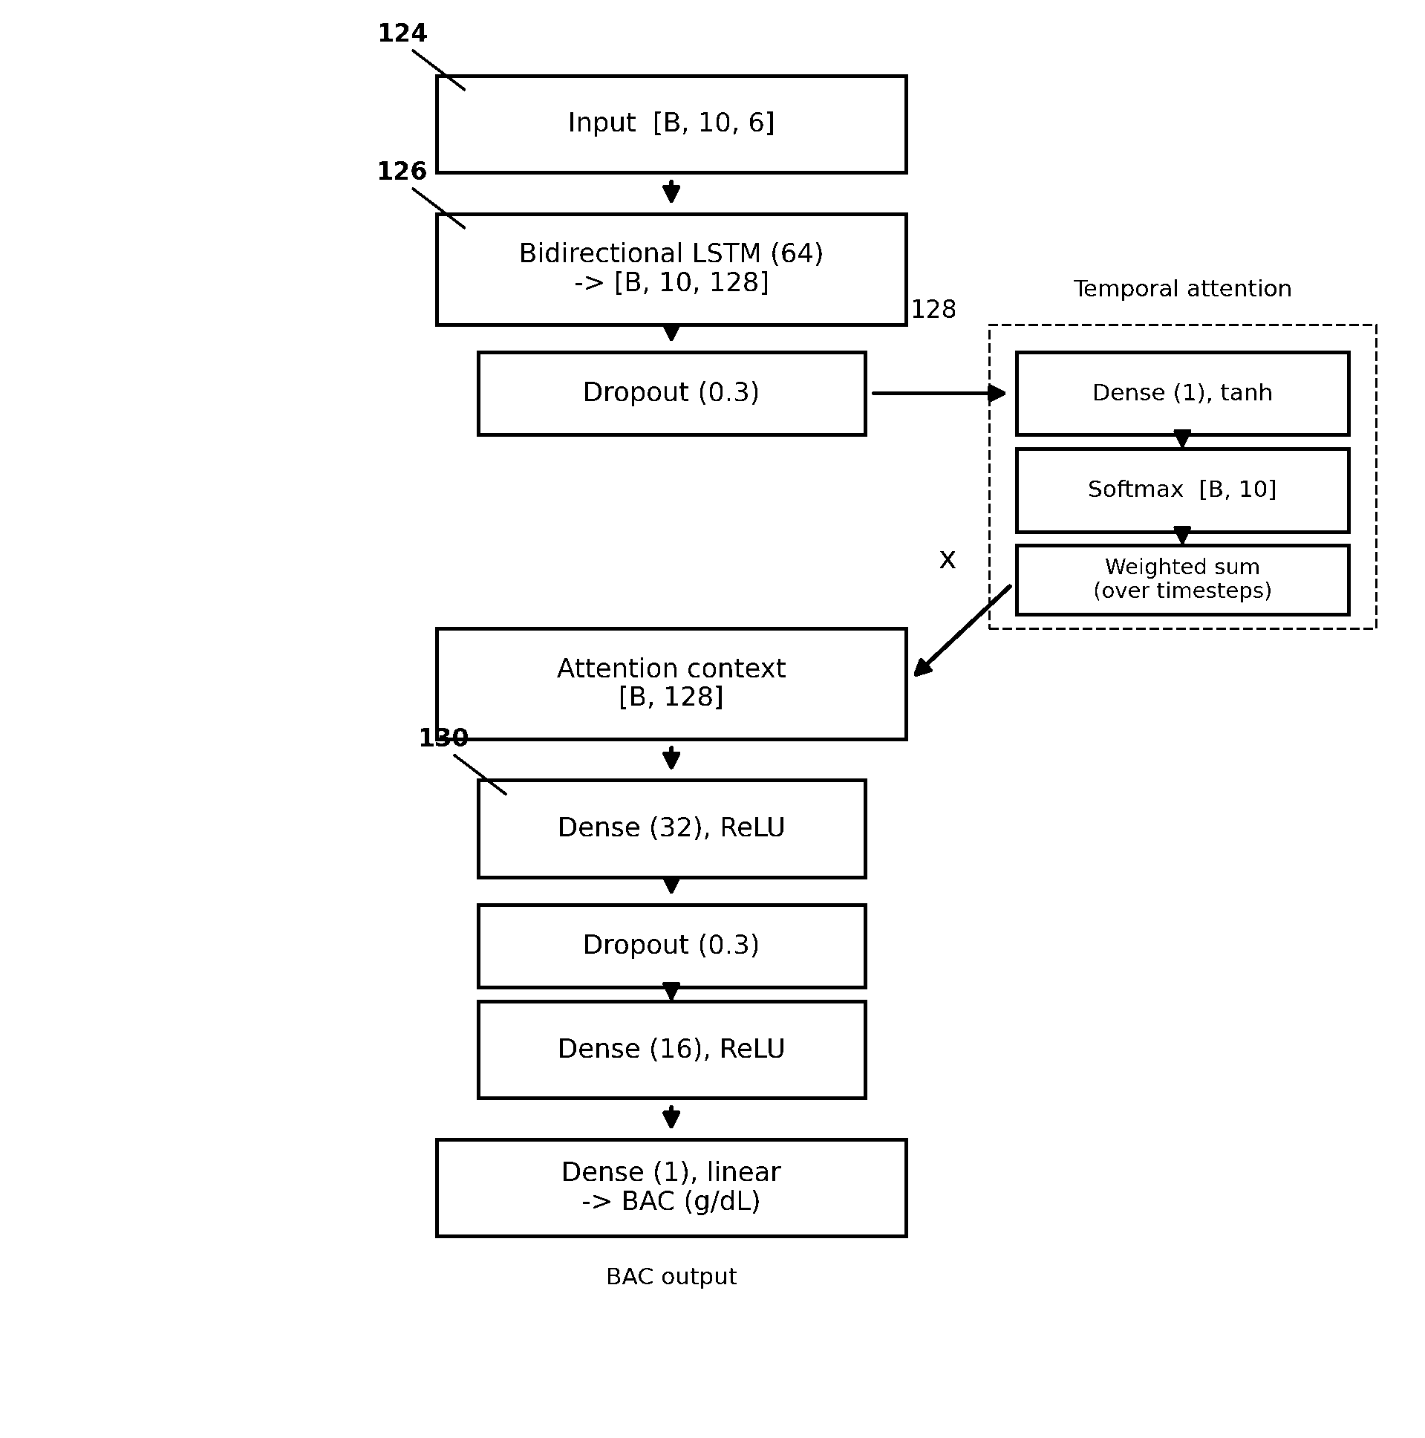

Applicant: Amity University Total no. of sheets: 05 Sheet no: 05
FIG. 5 — Fail-safe vehicle-control state machine
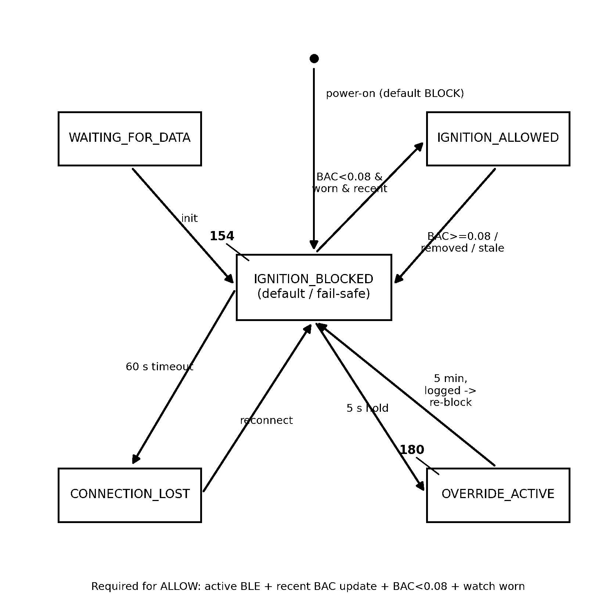

Amity University
Name of Applicant
Signature:

