NAWA PR → PO — live desk playbook
For Fayçal and the presenter · Desk language: English
URL: https://agentium.papai.ai/work/pr-to-po?workspace=nawa&lang=en
Live revision: cd40fe337285058120ec7236d587b1853ca72c42 (hard-reload the tab). Verified 31 August 2026.
This is an operator desk, not a numbered demo script. The four proofs live in this document. On screen you only see work.

Who gets what
Give this | To whom
This Word (or the markdown sibling) | Fayçal — proofs and walkthrough
nawa-pr-to-po-live-demo-presenter-fr.md | Presenter — one French page to hold during the talk

Open this URL
https://agentium.papai.ai/work/pr-to-po?workspace=nawa&lang=en
- Hard-reload once (Ctrl+Shift+R / Cmd+Shift+R).
- Workspace nawa. Title on screen: PR to PO.
- Presenter login: thibaud.ishacian@datategy.net.
- Live Hikma MCP. No HANA. Write stays Sealed.
Subtitle: System → Flow → Run → Decision. The factory reads Hikma, compiles a dossier, and writes nothing to SAP until you decide.

What Fayçal must see (four proofs)
The screen does not number these. You point at the matching card.
# | Proof | Where you point | What must be true
1 | Live SAP MCP | KPI row, stations, Read selected requisition, dossier facts | get_A_PurchaseRequisitionItem and _by_key return a real PR. listTaskCollection feeds the approval. fi_Validate / get_A_PurReqnAcctAssgmt feed budget. get_A_PurchaseOrder* feed orders, supplier, type. Compile shows python_recipe_v1.
2 | Small agentic task | Summarise in the compiled dossier | azure_llm_v1 POST /chat/completion prompt_type: factual. Two clear sentences. Invent nothing.
3 | PO POST package | Draft / Purchase order composed for SAP | hikma post_A_PurchaseOrder, type NB, Send Sealed. JSON sealed: true, called: false. Client 300 has no NB range; ZAPO is refused. Success = composed POST, not a live create.
4 | Nice-to-have | Ask the factory / Open the portal | Read-only. Chips: Majority supplier, Orders read, Next step, Write status. The write stays sealed.

If the Write station says Sealed, that is correct.

Walkthrough (about three minutes)
- Hard-reload. Header reads PR to PO. Four counts. Five stations. Write = Sealed.
- Click Run the factory. Wait until Compile is Done and the hero reads something like “Dossier compiled on STICKER WHITE — majority supplier 1000001737.”
- Proof 1 — Point at the counts and the tools under the stations. Click Read selected requisition if justification is empty.
- Proof 2 — Click Summarise. Two sentences appear via azure_llm_v1.
- Proof 3 — Scroll to Draft / Purchase order composed for SAP. Row: POST · hikma · post_A_PurchaseOrder · Send Sealed. Say: this is the POST we would send; it is not sent.
- Proof 4 — Chip Write status. Answer: the write stays sealed.
There is no button that posts a purchase order.
Talk track: “This is the PR to PO factory. It reads Hikma through MCP, compiles a dossier, and writes nothing until a human decides.”

Screen map

Top of the desk
Lineage, briefing, counts, stations, compiled dossier. Actions in the dossier header: Read selected requisition, Summarise.
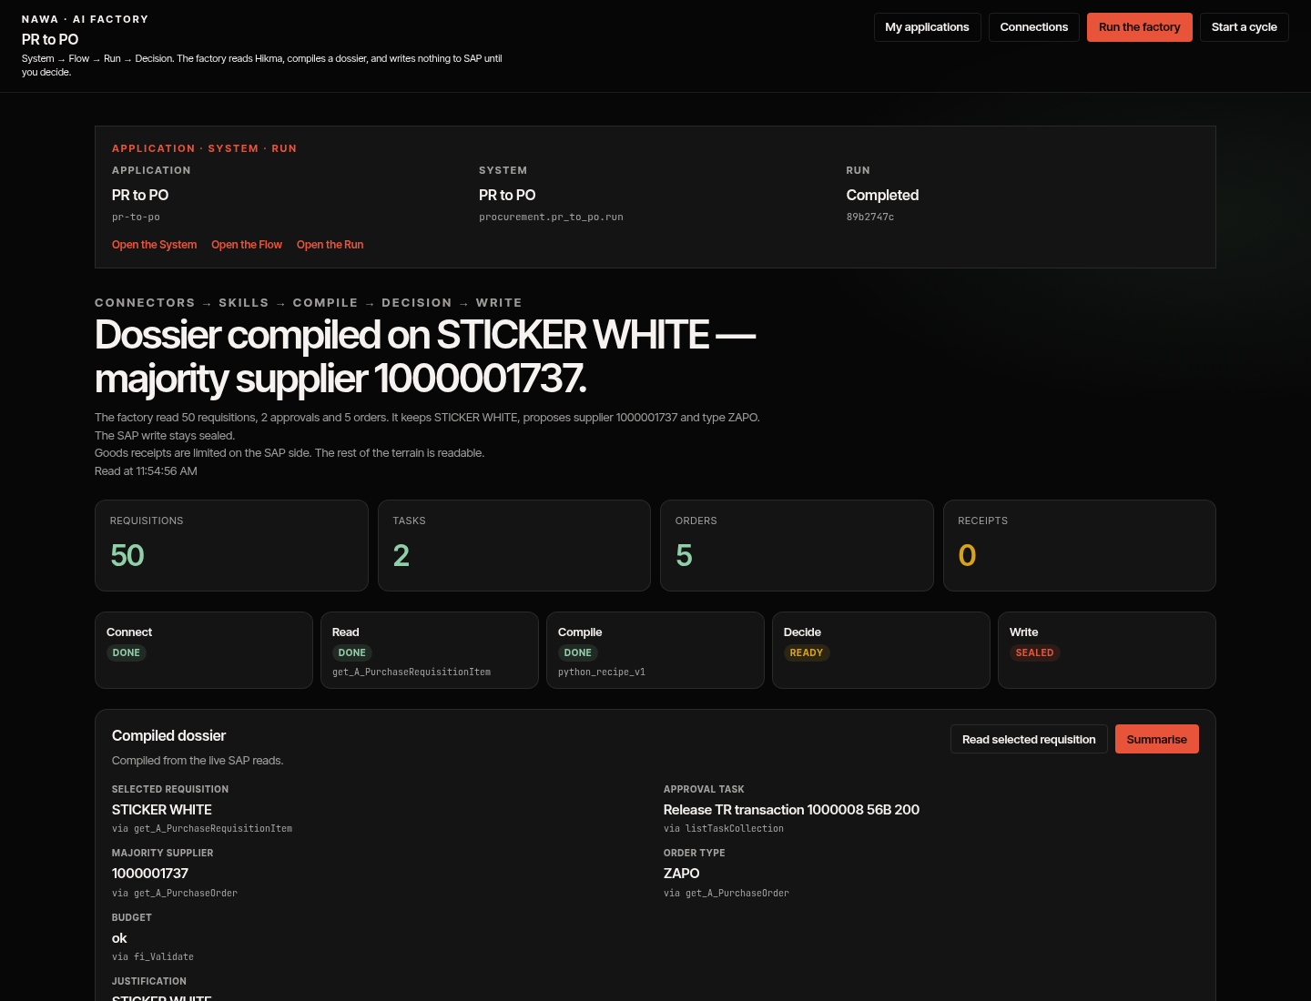
Figure 1 — Operator desk after a live read. Write stays Sealed.

Compiled dossier (proofs 1 and 2)
Facts name their tools. Justification via get_A_PurchaseRequisitionItem_by_key. Summary via azure_llm_v1.
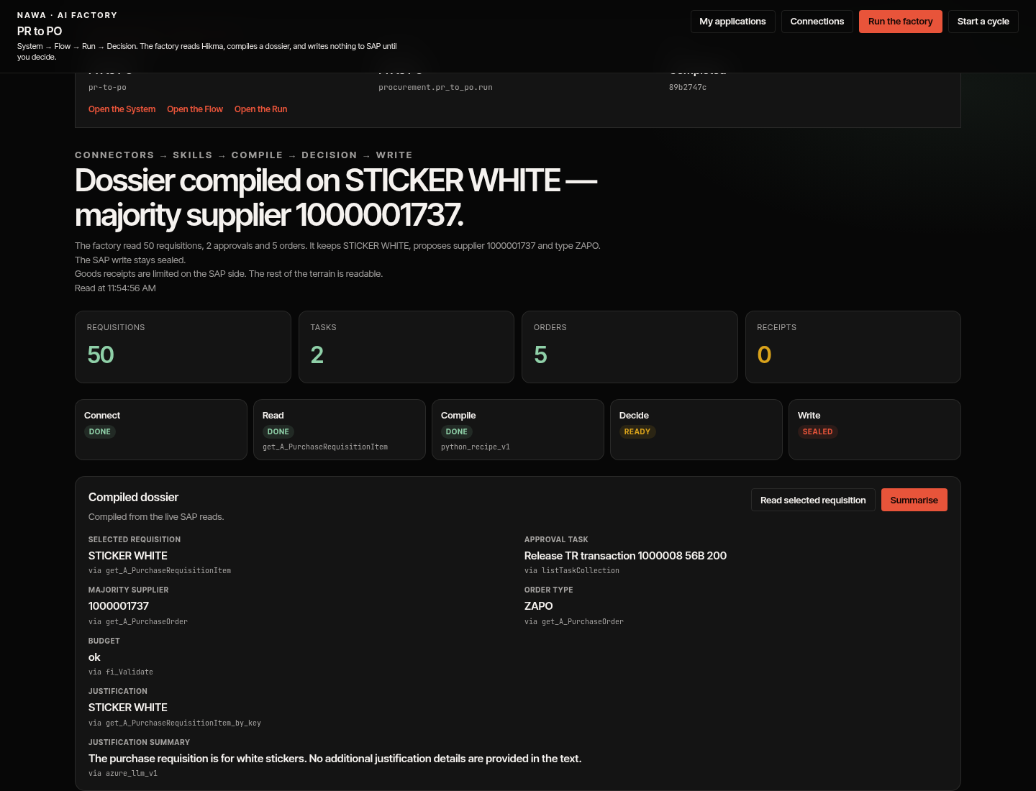
Figure 2 — Live counts, stations, and the compiled dossier.

Draft purchase order (proof 3)
- Kicker Draft. Title Purchase order composed for SAP.
- Hint: Draft purchase order. It is not sent; the write stays sealed.
- Row: Method POST · Server hikma · Tool post_A_PurchaseOrder · Send Sealed.
- Footnote: Client 300 has no NB number range. The API refuses ZAPO.
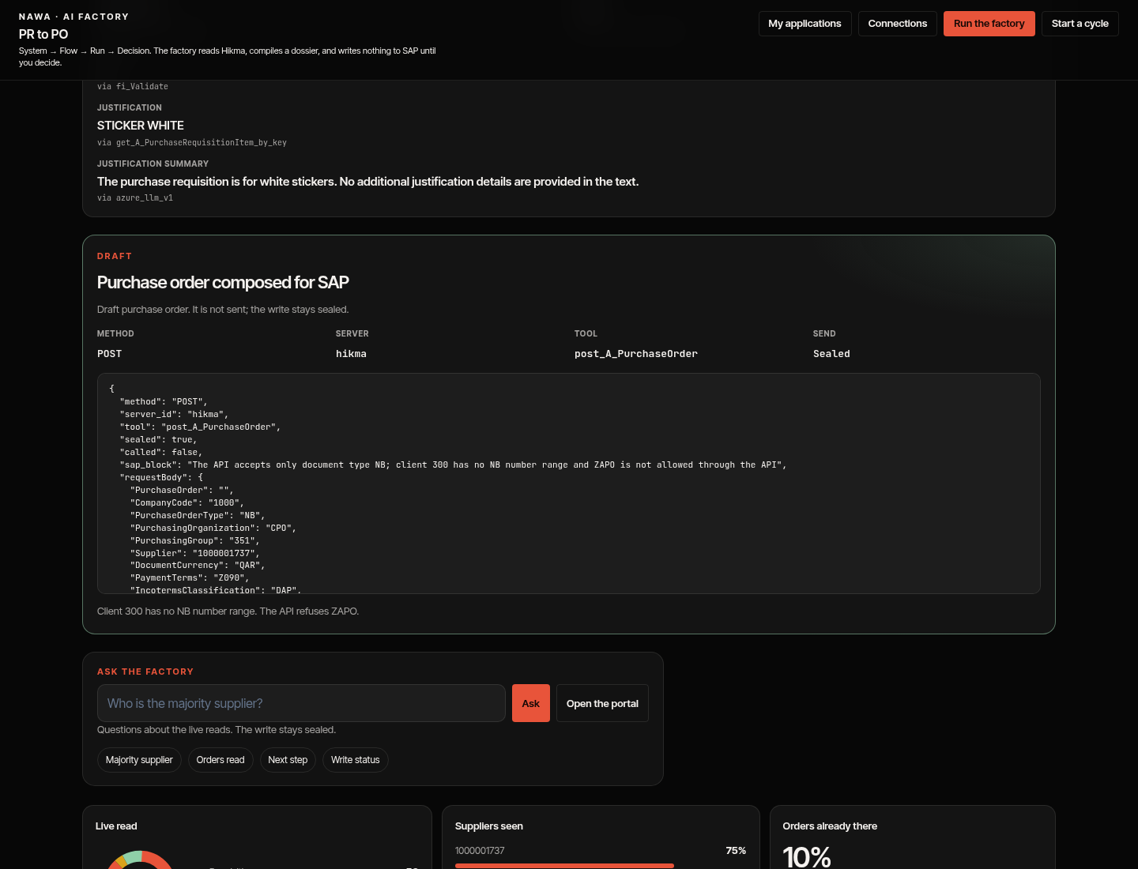
Figure 3 — Draft hikma POST: type NB, sealed, not sent.

Ask the factory (proof 4)
Hint: Questions about the live reads. The write stays sealed.
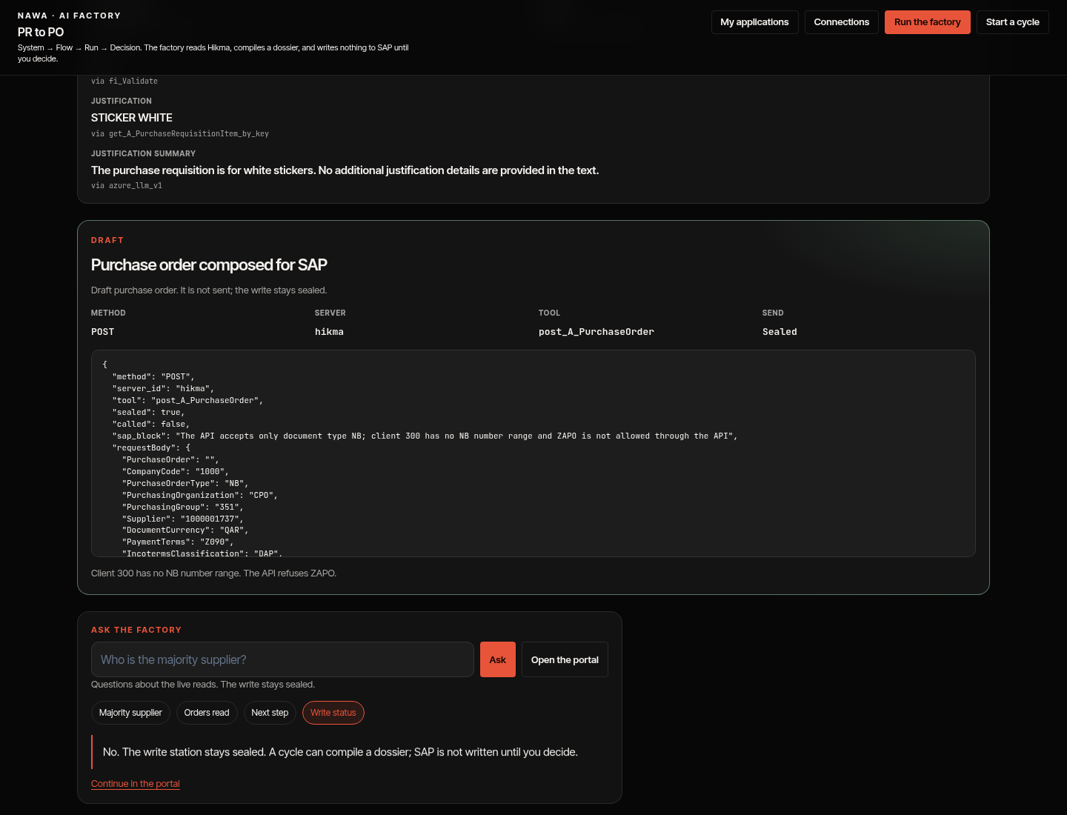
Figure 4 — Write status answers No; the write station stays sealed.

Portal
Hint: Answers from the requisitions and orders just read. The write stays sealed. Stay on get-PR / get-PO questions. Older summarise prompts in the portal thread are session history, not a second write.
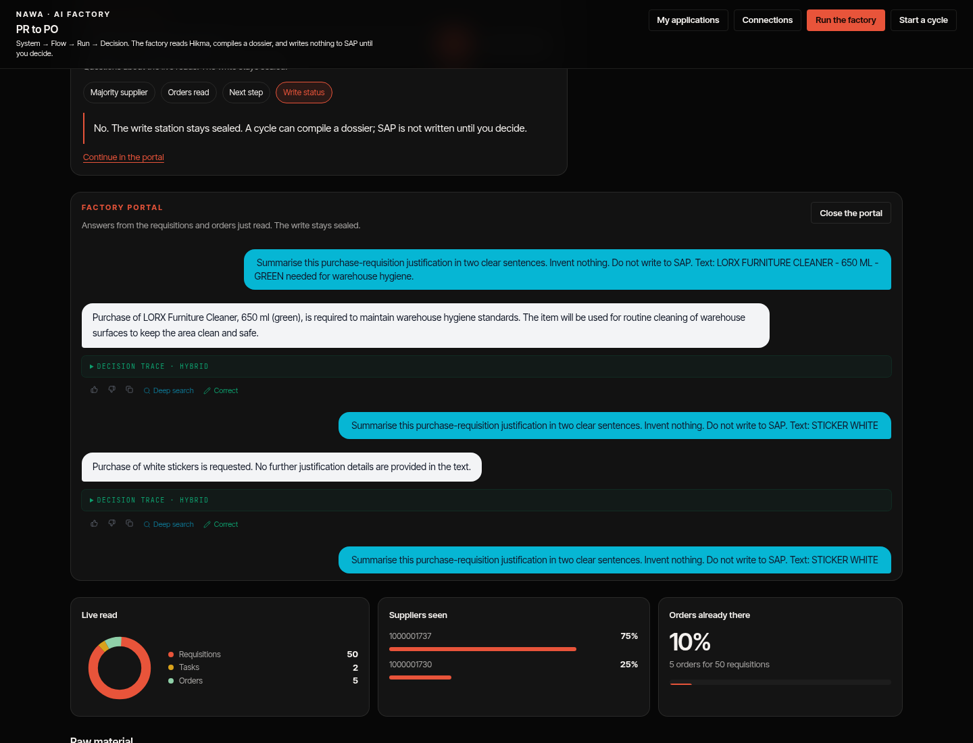
Figure 5 — Factory portal on the live reads. Write stays sealed.

Live example (31 August 2026, SHA cd40fe33)
Field | Value
Headline | Dossier compiled on STICKER WHITE — majority supplier 1000001737.
Counts | Requisitions 50 · Tasks 2 · Orders 5 · Receipts 0
Stations | Connect Done · Read Done (get_A_PurchaseRequisitionItem) · Compile Done (python_recipe_v1) · Decide Ready · Write Sealed
Selected requisition | STICKER WHITE via get_A_PurchaseRequisitionItem
Approval task | Release TR transaction 1000008 56B 200 via listTaskCollection
PR in the POST | 2000276449 item 10
Justification | STICKER WHITE via get_A_PurchaseRequisitionItem_by_key
Summary | The purchase requisition is for white stickers. No additional justification details are provided in the text. via azure_llm_v1
Supplier / type (read) | 1000001737 / ZAPO via get_A_PurchaseOrder
Budget | ok via fi_Validate
POST | hikma post_A_PurchaseOrder, PurchaseOrderType NB, PurchasingOrganization CPO, sealed true, called false

Ask → Write status: No. The write station stays sealed. A cycle can compile a dossier; SAP is not written until you decide.
The exact PR can move on a later read. The tools and the sealed POST must not.

Exact labels on the desk
Place | English
Title | PR to PO
Primary / secondary | Run the factory · Start a cycle
Dossier | Compiled dossier / Compiled from the live SAP reads.
Dossier actions | Read selected requisition · Summarise
Draft card | Draft · Purchase order composed for SAP
Ask chips | Majority supplier · Orders read · Next step · Write status
Portal | Open the portal · Factory portal
Write station | Sealed

Banned on this desk: pipeline, workflow, job. Removed: Success criteria, numbered beats 1–4, Shown / Play / Waiting, “Compose the POST is the success of this demo”.

Seven-minute script
- 0:00 — URL, nawa, English, hard-reload. “Operator desk. Not a slide.”
- 0:30 — Counts + stations. “Live SAP, through MCP. No HANA.”
- 1:30 — Dossier + Read selected requisition + Summarise. “One short model call. Two sentences. Nothing invented.”
- 3:00 — Draft card. “Type NB, sealed, not sent. Client 300 has no NB range.”
- 5:00 — Write status, then Open the portal if there is time.
- 6:30 — Stop. Write still Sealed. Offer Start a cycle only if they ask.

If something looks wrong
- Old tiles Shown / Play / Success criteria → hard-reload. Removed on cd40fe33.
- Blank desk / login loop → login, then hard-reload this desk URL. Do not open / first.
- token expired or HTTP 407 → restart the Hikma Cloud Foundry MCP apps, not the Agentium password.
- Counts at 0 → Run the factory once and wait.
- Empty justification → Read selected requisition once, then Summarise once.
- Write still Sealed after Run → correct.
- Receipts 0 / Limited read → expected. sap_gr is often 403.
- Someone asks to create the PO live → refuse. The composed POST is the artefact.

Do not
- Do not post a purchase order. No tools/call on post_A_PurchaseOrder.
- Do not call fi_EnableForPurchasing or fi_Discard.
- Do not invent MCP aliases (A_*, YY1_*). Do not turn HANA on.
- Do not seed nawa on this VM. Do not move the demo-agentic tag.
- Do not put the four proofs back on the screen as numbered tiles.
- Do not put a password or an OAuth secret on a slide.

Technical anchors
- Desk /work/pr-to-po · Binding procurement.pr_to_po.run · System 28345b5a-…
- Images agentium-{backend,worker,frontend}:cd40fe337285
- Rollback of this desk slice: AGENTIUM_IMAGE_TAG=3eb72f95f6b6
- Writes via /read → HTTP 400 “not a read”.
- Markdown source: docs/ops/nawa-pr-to-po-live-demo-playbook.md
- Presenter card (FR): docs/ops/nawa-pr-to-po-live-demo-presenter-fr.md
End of playbook. Walk the desk. Leave SAP sealed.

