**Name - Tisha Garg**

**Roll No - 2K20CSUN05020**

**Class - CSE CSTI**

**Subject - MATLAB**

**LAB 02**

**Ques-1 To find the area of**

1. **Circle**

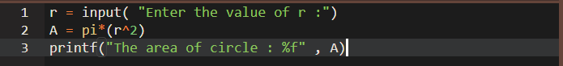

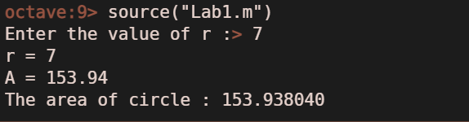

1. **Cylinder**

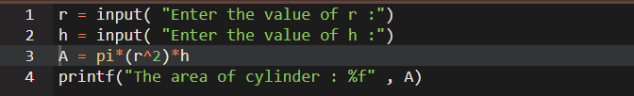

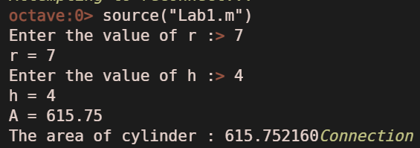

1. **Right circular cone**

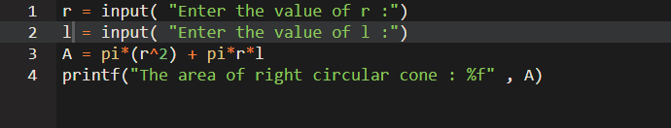

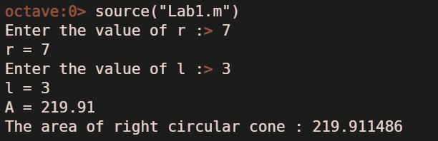

1. **Triangle**

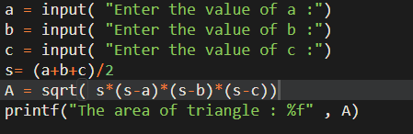

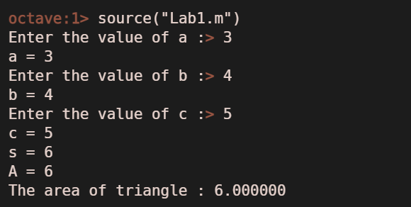

**Ques-2 To calculate the root of a quadratic polynomial.**

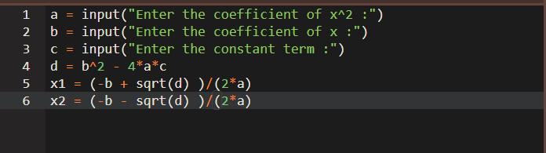

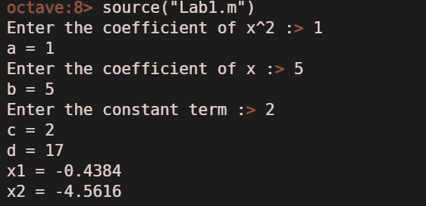

**Ques-3 To calculate the simple interest and compound interest simultaneously.**

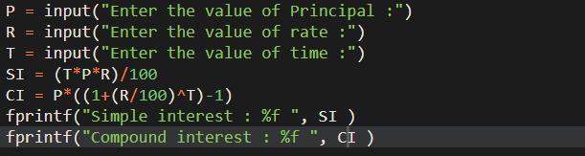

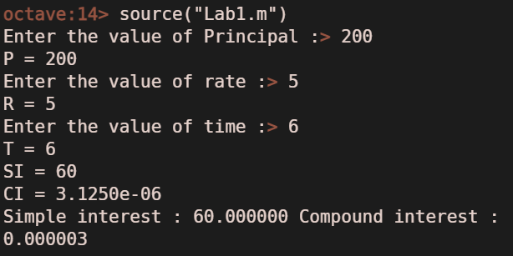

**Ques-4 In class, it was found that**

* **22 students studied maths**
* **25 students studied physics**
* **39 students studied chemistry**
* **9 students studied maths and physics**
* **17 students studied maths and chemistry**
* **20 students studied chemistry and physics**
* **6 students studied all subjects**
* **4 students studied none of them**

**How many students in the class?**

