Name - Tisha Garg

Class - CSE CSTI

Roll no - 2K20CSUN05020

**LAB 03**

**1. Write a MATLAB program which will ask the user for a number.If the number is positive it should print out the message The number is positive. If the number is negative it should print out The number is negative. Introduce disp and fprintf command.**

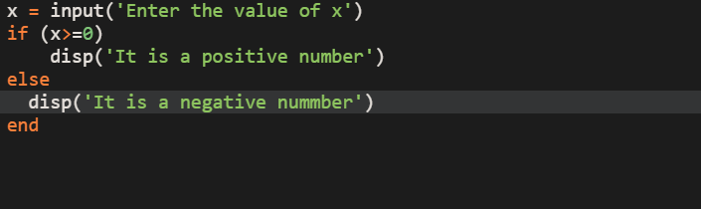

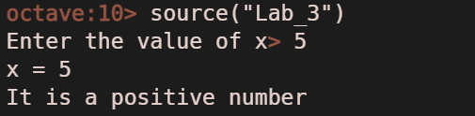

**2. Write a MATLAB program which will ask the user for two numbers (you can use the input function twice if you want). It should change the sign of the smaller of the two numbers and then add them. The program should print a message informing the user of the change in sign and also print out the final result.**

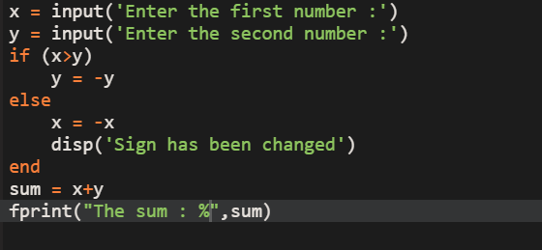

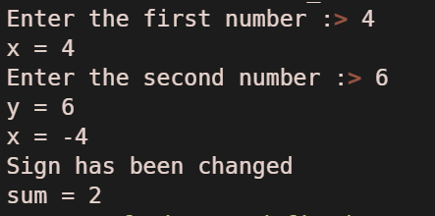

**3. Write aMATLAB program which asks the user to enter three numbers. The program should figure out the average value and print it out. Do not use the predefined MATLAB functions to compute the average.**

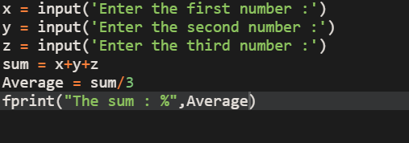

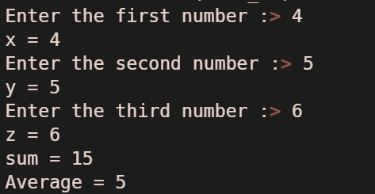

**4. Write a MATLAB program which will ask the user to input a number. The program should print out the square of that number if the number is negative.**

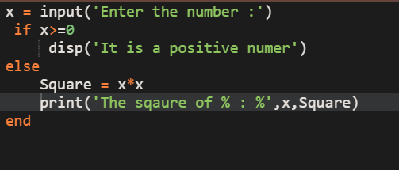

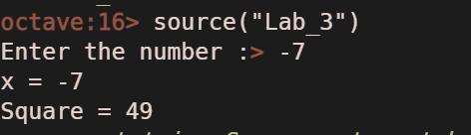

**5. Write a MATLAB program which will ask the user for a number. If the number is equal to two time’s a predefined number the program should print out a welcome message. Otherwise it should print out a message saying You are not authorized.**

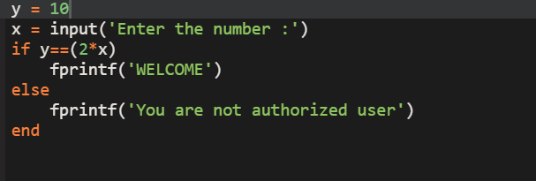

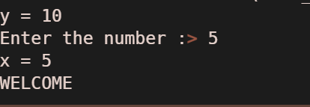

**6. Write a MATLAB program which will ask the user for their name.If the name matches a list of three predefined names the program should print out a welcome message. Otherwise it should print out a message saying You are not authorized.**

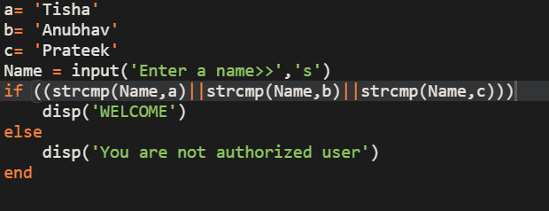

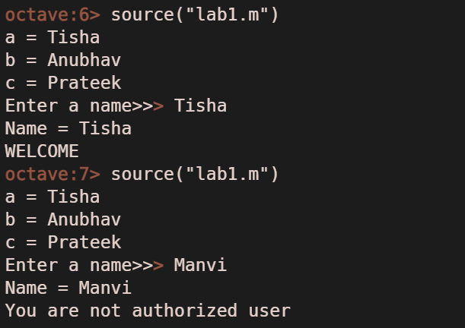

**7. Write aMATLAB program which will ask the user for a name and then for a password. The program should compare the name and password against a list. If both match it should print out a welcome message. If one matches it should say Name and password do not match. If neither matches it should say I do not know you.**

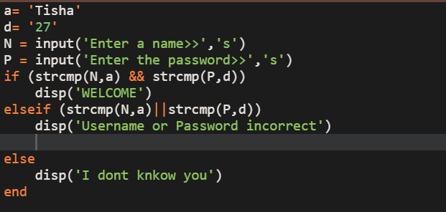

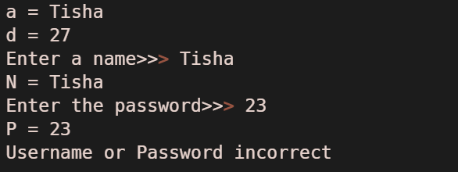

**8. Write a MATLAB program which will ask the user for their name.The program should check the name against a list of three predefined names. If it matches a name on the list the program should print out a welcome message which is different for each name. Otherwise it should print out a message saying You are not on my list.**

