**Name- Tisha Garg**

**Class - CSE CSTI**

**Roll No- 2K20CSUN05020**

**LAB -4**

**Ques-1** Write a MATLAB program to obtain the sum of all even numbers from 0 to 20, using a for loop.

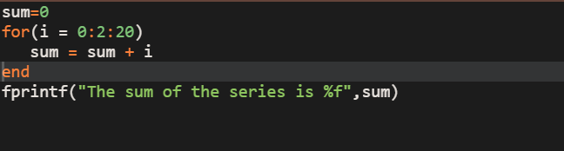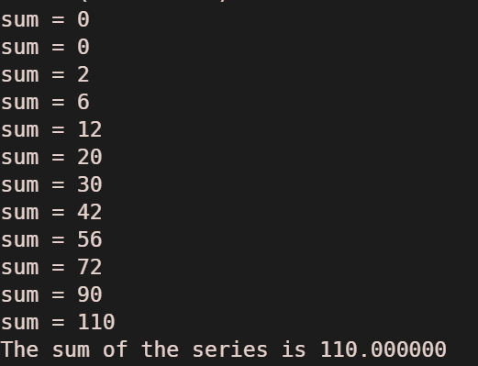

**Ques-2** Write a MATLAB program using the for construct which will ask the user to input a number. The program should print out the sum of all numbers from 1 to that number.

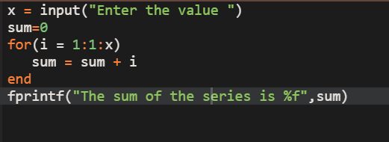

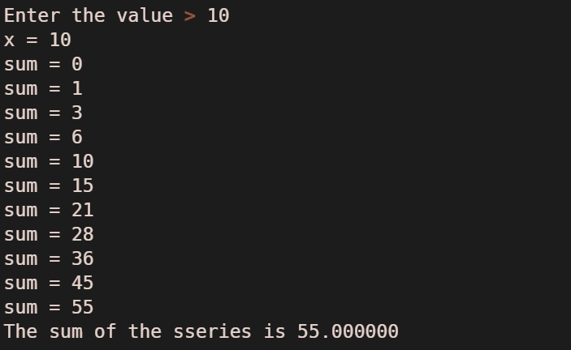

**Ques-3** Write a MATLAB program which will ask the user for two numbers k and I Use for loop to find the sum of the squares of all numbers between k and land print the square of each number and their sum.

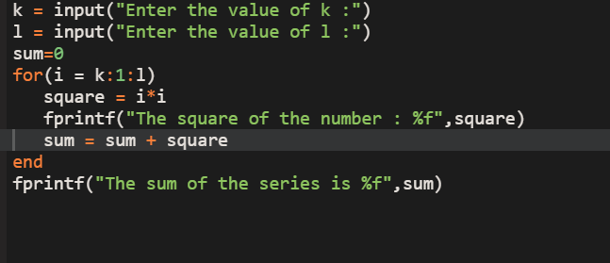

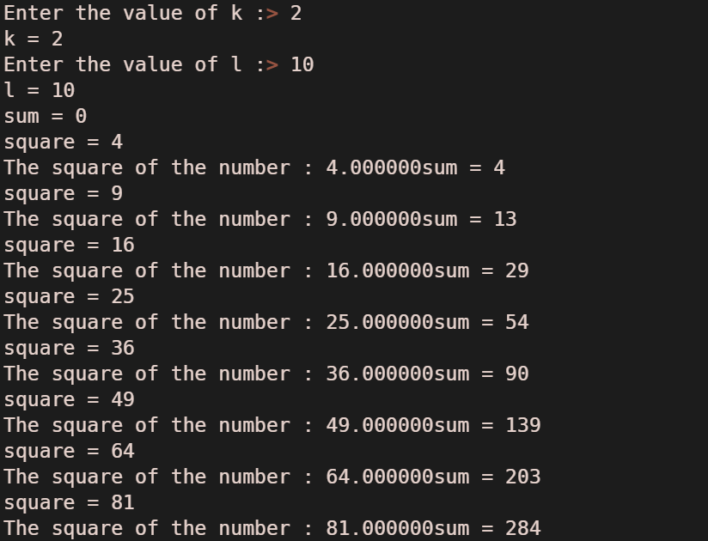

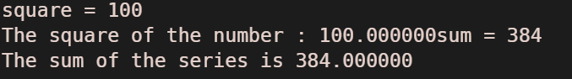

**Ques-4** Write a MATLAB program to obtain the sum of the first n terms of some series for a

given value of n.

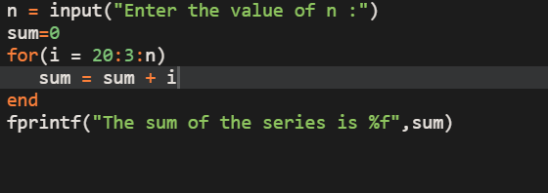

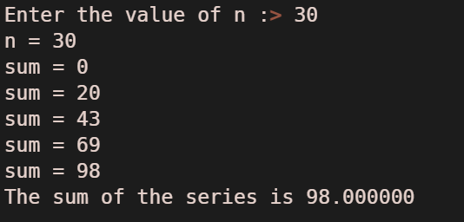

**Ques-5** Let's build a compound interest calculator. Given the initial value X and the annual interest rate R and the maximum number of years N use a for loop to calculate and print out the accumulated amount for each year.

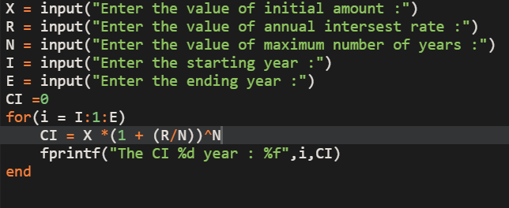

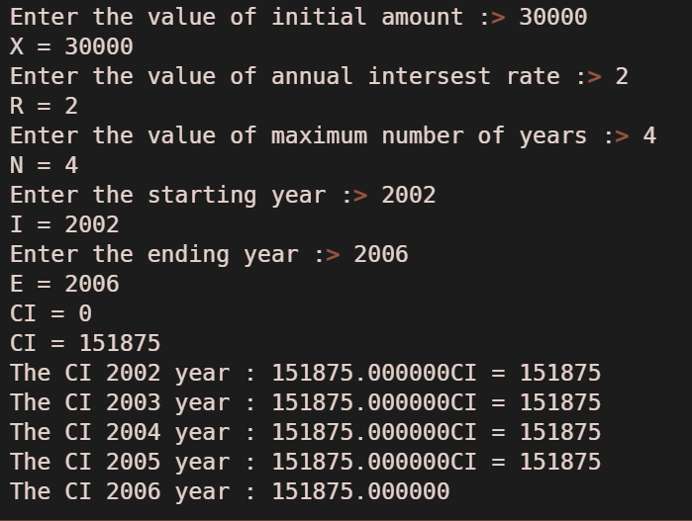

**Ques -6** Create a matrix using for loop whose entry can be formed by sum of square of successive increments of the variable from 1 to n and their reverse for a fix n.

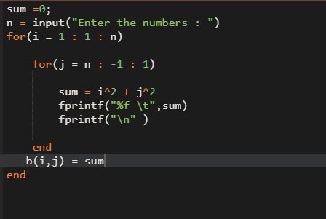

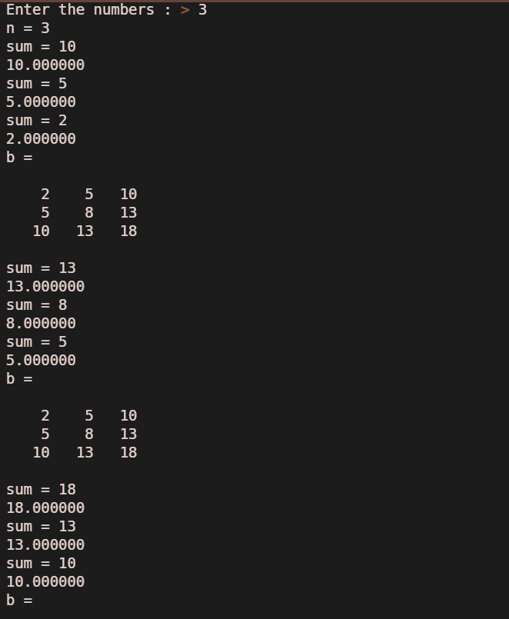 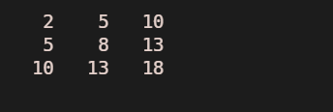

**Ques- 7** Enter a vector and write a MATLAB program that doubles the elements that are positive and are divisible by 3 and/or 5 and raise to the power of 3 the elements that are negative but greater than -5.

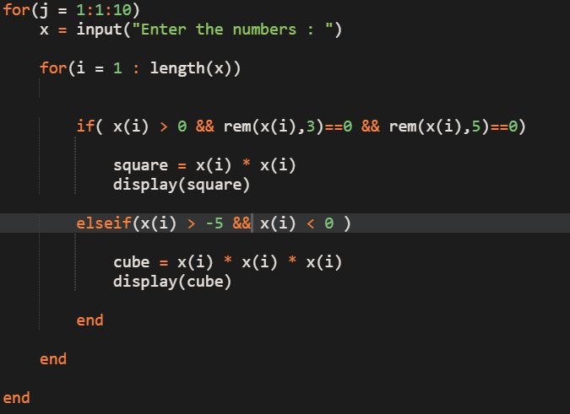

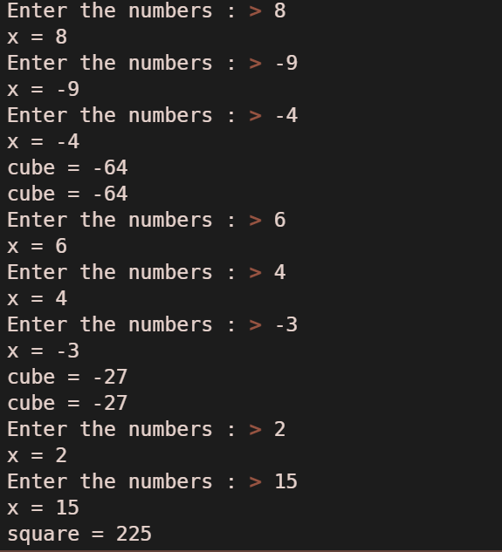

**Ques-8**

Enter the square matrix A, and write a program to find the matrix B by computing the square

roots of all the elements of A whose value is not less than 0, and adding 50 to each element that is negative.

**Ques-9** Write a MATLAB program to find the squares of integers less than 5, using a while loop.

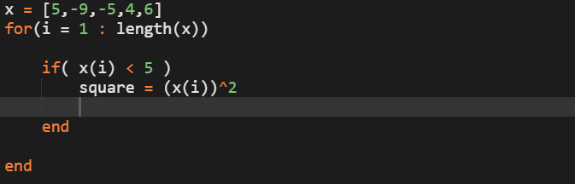

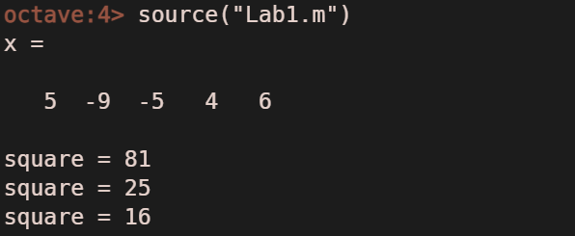

**Ques- 10** Write a MATLAB program to add the given number till the number entered is 0,

using a while loop.

