**Name - Tisha Garg**

**Class - CSE CSTI**

**Roll No- 2K20CSUN05020**

**LAB 5**

**Ques- 1** Define a function in a file named average.m that accepts an input vector, calculates the average of the values, and returns a single result.

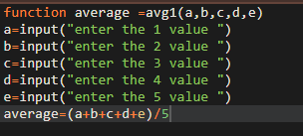

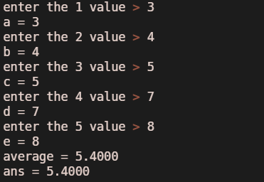

**Ques-2** Define a function filename fact.m that gives a factorial of a given input.

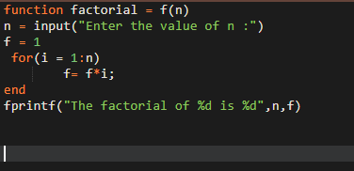

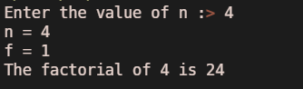

**Ques-3** Define a function that calculates two values, both the area and the circumference of a circle.

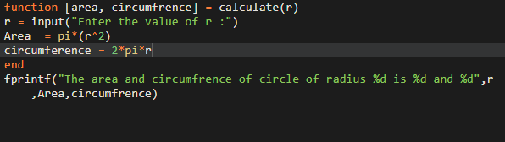

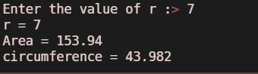

**Ques- 4** Define a function file that calculates the area/ surface area of the cylinder.

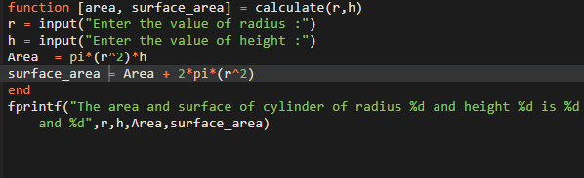

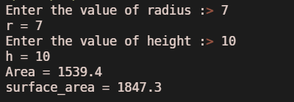

**Ques-5** Define a function file that calculates the root of a quadratic polynomial.

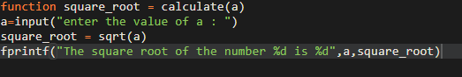

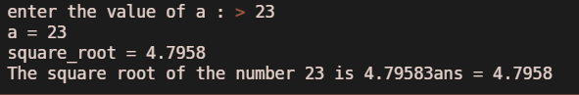

**Ques-6** Define a function file that calculates the simple interest and compound interest simultaneously.

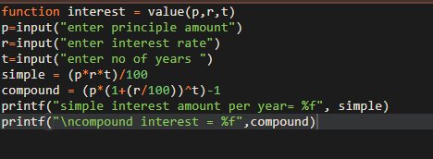

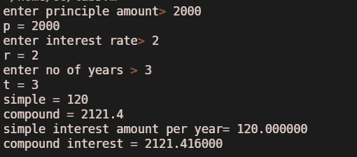

**Ques-7** Write a function perimarea that calculates and returns the perimeter and area of a rectangle. Pass the length and width of the rectangle as input arguments.

